Abdiyani, S. (2008). Keanekaragaman Jenis Tumbuhan Bawah Berkhasiat Obat. Jurnal Penelitian Hutan Dan Konservasi Alam.

Agoes, G. (2007). Teknologi Bahan Alam. Bandung: ITB.

Anggraini, Y. (2019). Uji Aktivitas Antibakteri Ekstrak Daun Tekelan (Chromolaena odorata (L.) R.M. King & H.Rob) Terhadap Streptococcus mutans Dan Lactobacillus acidophilus. Inderalaya: Fakultas Matematika Dan Ilmu Pengetahuan Alam Universitas Sriwijaya

Ansel, C.H. (2005). Pengantar Bentuk Sediaan Farmasi Edisi IV. Jakarta: Universitas Indonesia Press.

Benson, H.J. (2002). Microbiological Apllications Laboratory Manual in General Microbiology. New York: McGraw-Hill.

Brock, T.D., dan Madigan, M.T. (1991). Biology of microorganisms.Sixth ed. Prentice-Hall International, Inc.

Cappucino, J.G., dan Sherman, N. (2014). Microbiology: A Laboratory Manual. California: The Benjamin/Cummings Publishing Company, Inc.

Depkes RI. (1979). Farmakope Edisi III. Jakarta: Departemen Kesehatan RI.

Depkes RI. (1995). Farmakope Indonesia Edisi IV. Jakarta: Departemen Kesehatan RI.

Depkes RI. (1995). Materia Medika Indonesia Jilid VI. Cetakan keenam. Jakarta: Direktorat Jenderal Pengawasan Obat dan Makanan.

Depkes RI. (2014). Farmakope Indonesia. Edisi V. Jakarta : Departemen Kesehatan RI.

Dwidjoseputro, D. (1994). Dasar-Dasar Mikrobiologi. Jakarta: Djambatan.

Dwidjoseputro, D. (2005). Dasar-Dasar Mikrobiologi. Jakarta:Djambatan.

Fardiaz, S. (1987). Penuntun Praktikum Mikrobilogi Pangan. Lembaga Sumber Informasi. Bogor: Institut Pertanian Bogor.
Farnsworth, NR. (1966). Biological and Phytochemical Screening Of Plants. Journal Of Pharmaceutical Sciene.

Hadi, S. (2000). Metodologi Research. Yogyakarta: Fakultas Psikologi UGM

Hadiroseyani, Y., Hafifuddin, Alifuddin, M., dan Supriyadi, H. (2005). Potensi Daun Kirinyuh (Chromolaena odorata) Untuk Pengobatan Penyakit Cacar Pada Ikan Gurame (Osphronemus gauramy) Yang Disebabkan Aeromonas hydrophilla S26. Jurnal Akuakultur Indonesia.

Harborne, J.B. (1987). Metode Fitokimia (Penuntun Cara Modern Menganalisis Tumbuhan) Terbitan Kedua. Bandung: ITB.

Harimurti, S., Hidayaturahmah, R. (2016). Pengaruh Variasi Konsentrasi Karbomer Sebagai Gelling Agent Terhadap Viskositas dan pH Sediaan Gel Antiseptik Ekstrak Etanolik Daun Sirih Merah. FKIK

Jawetz, E., Melnick, J.L., dan Adelberg, E. A.(2001). Mikrobiologi Kedokteran Edisi XXII. Diterjemahkan oleh Maulany, R. F, dan Edinugroho. Jakarta: Salemba Medika.

Jawetz, E., Melnick, J.L., dan Adelberg, E. A.(2005). Mikrobiologi Kedokteran Buku 2. Diterjemahkan oleh Maulany, R. F, dan Edinugroho. Jakarta: Salemba Medika.

Jutono, J., Soedarsono, S., Hartadi, S., Kabirun, S., Suhadi, D., dan Soesanto.(1980). Pedoman Praktikum Mikrobiologi Umum (Untuk Perguruan Tinggi). Yogyakarta: UGM Press.

Lenny, A. A.(2016). Daya Hambat Ekstrak Buah Alpukat (Persea americana Mill) Terhadap Pertumbuhan Staphyloccocus aureus dan Staphylococcus epidermis. Skripsi.Universitas Muhammadiyah Semarang. Diakses pada tanggal 10 Agustus 2019.

Manus, N., Yamlean, P.V.Y., Kojong, N.S. (2016). Formulasi Sediaan Gel Minyak Atsiri Daun Sereh (Cyambopogon citrates) Sebagai Antiseptik Tangan. Pharmacon Jurnal Ilmiah Farmasi Unsrat.

Morales, G., Sierra, P., Mancilla., Parades, A., Loyola, A., Gallardo, O., dan Borquez, J. (2003). Secondary Metabolites From Four Medicinal Plants From Northen Chile, Antimicrobial Activity dan Bioticity Against Artemia salina. Jorunal Chile Chem .

Mushollaeni, W., dan E.Rusdiana.(2011). Karakteristik Natrium Alginat Dari Sargassum sp., Turbinaria sp., dan Padina sp. Jurnal Teknologi dan Industri Pangan.
Nailufa, Y. (2020). Formulasi Dan Evaluasi Gel Handsanitizer Dengan Moisturizer Alga Hijau (Spirulina platensis) Dan Vitamin E. Syntax Idea, Vol. 2, No. 6. Universitas Hang Tuah Surabaya.

Nuraini, A.D.(2007). Ekstraksi Komponen Antibakteri dan Antioksidan dari Biji Teratai (Nymphaeae pubescens Wild). Skripsi. Departemen Ilmu dan Teknologi Pangan. Bogor: Institut Pertanian Bogor.

Pelczar, M.J., dan Chan, E.C.S.(1988). Dasar-Dasar Mikrobiologi. Penerjemah: Hadocotomo, R.S., Imas, T., Tjitrosomoso, S., dan Lestari, S. Jakarta: UI Press.

Perdanakusuma, D. S. (2007). Anatomi Fisiologi Kulit Dan Penyembuhan Luka. Surabaya: Airlangga University School Of Medicine - Dr. Soetomo General Hospital.

Pratiwi, S.T. (2008). Mikrobiologi Farmasi. Jakarta: Erlangga.

Radji, M. (2011). Buku Ajar Mikrobilogi Panduan Mahasiswa Farmasi dan Kedokteran. Jakarta: Buku Kedokteran EGC.

Robinson, T. (1995). Kandungan Organik Tumbuhan Tinggi. Edisi ke-4 Terjemahan Kosasih Padmawinata. Bandung. ITB.

Rohmani, S., Kuncoro, M A.A. (2019). Uji Stabilitas Dan Aktivitas Gel Handsanitizer Ekstrak Daun Kemangi. Journal Of Pharmaceutical Science and Clinical Research.

Sari, R., Isadiarti, D. (2006). Studi Efektivitas Sediaan Gel Antiseptik Tangan Ekstrak Daun Sirih (Piper batle Linn.). Majalah Farmasi Indonesia.

Syamsuni, H.A.2006. Ilmu Resep. Jakarta: EGC.

Waluyo. (2014). Mikrobiologi Umum. Jakarta: Universitas Indonesia.

Widyawati, L., Mustariani, B. A.A., Purmafitriah, En. (2017). Formulasi Sediaan Gel Handsanitizer Ekstrak Etanol Daun Sirsak (Annona muricata Linn.) Sebagai Antibakteri Terhadap Staphylococcus aureus. Jurnal Farmasetis.

Yanhendri., Yenny, S.W. (2012). Berbagai Bentuk Sediaan Topikal Dalam Dermatologi. Padang: Ilmu Kesehatan Kulit dan Kelamin. Fakultas Kedokteran. Universitas Andalas Rs Dr. M.Djamil.
Yenti, R., Afrianti, R., Afriani, L. (2011). Formulasi Krim Ekstrak Etanol Daun Kirinyuh (Euphatorium odoratum (L.)) Untuk Penyembuhan Luka. Majalah Kesehatan Pharma Medika.

Yuliani, N.S. (2012). Efek Ekstrak Etanol Daun Tekelan (Chromolaena odorata (L.)) Terhadap Kesembuhan Luka Insisi Pada Sprague Dawley. Yogyakarta: Universitas Gajah Mada.

Lampiran 1. Surat Hasil Determinasi Daun Tekelan
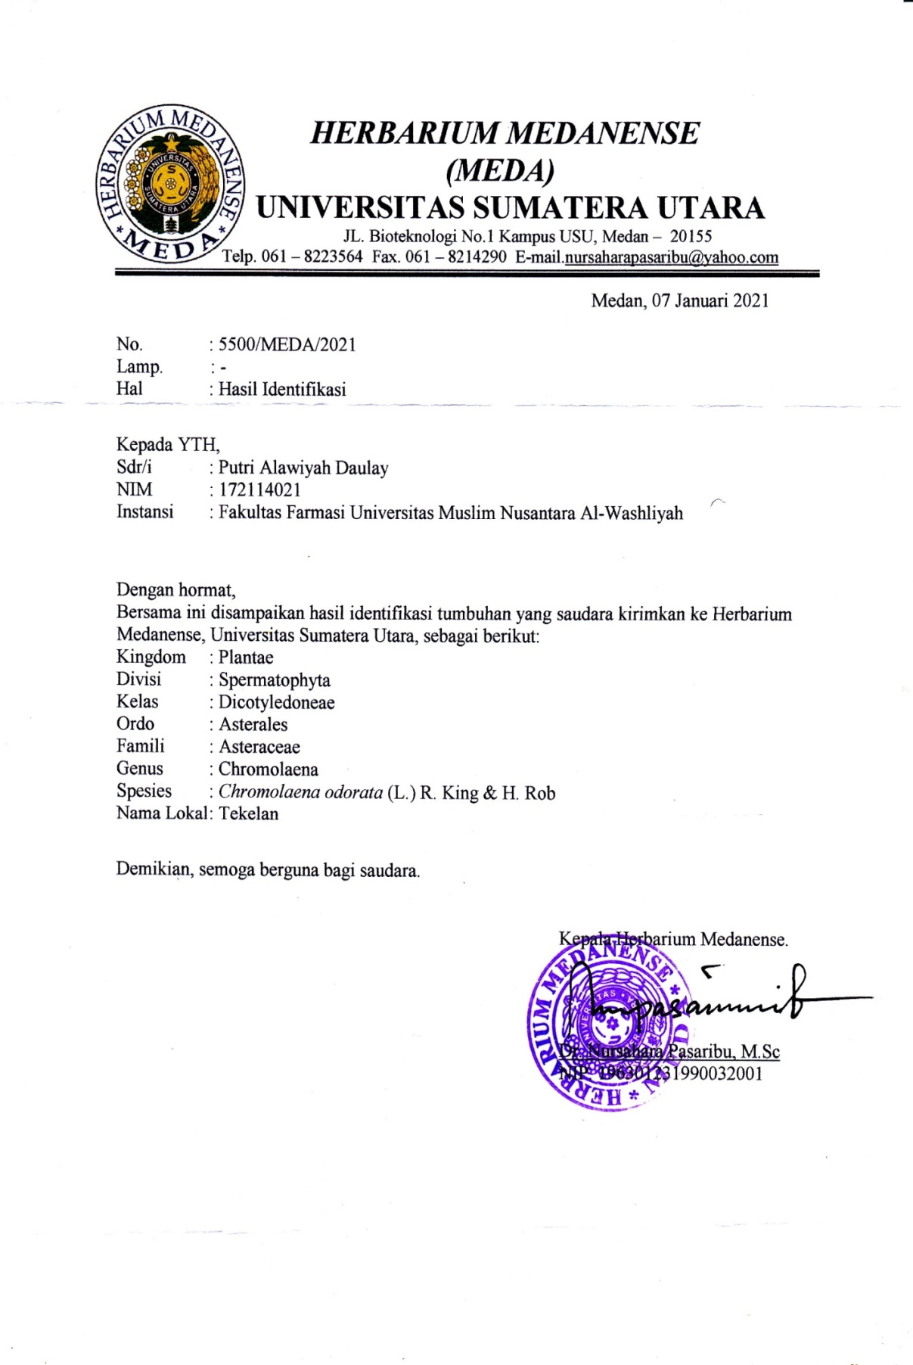

Lampiran 2. Tumbuhan Daun Tekelan
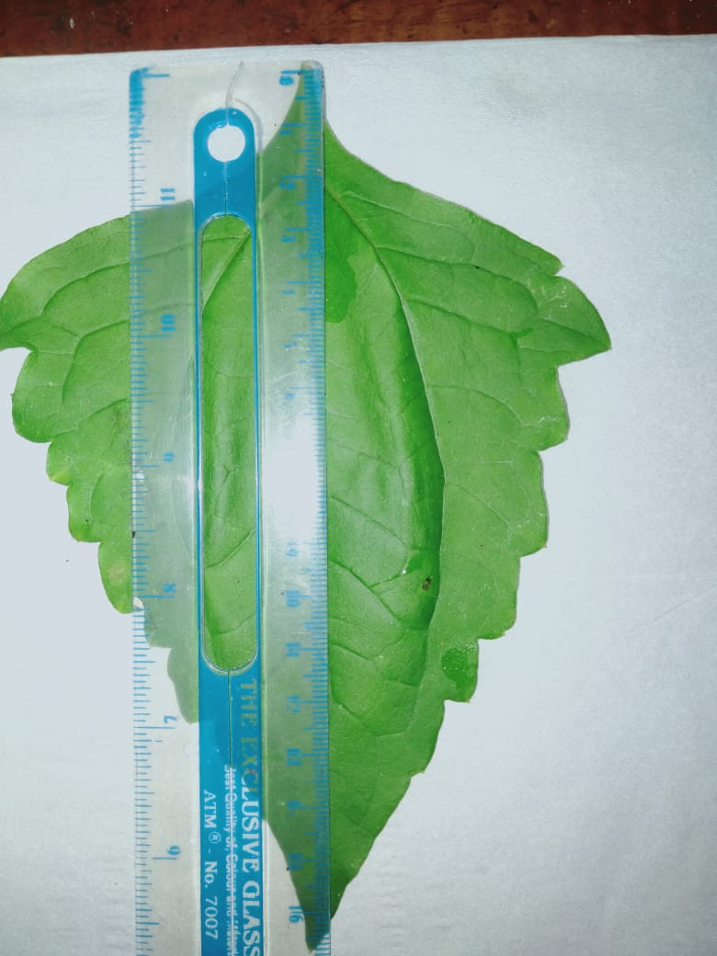
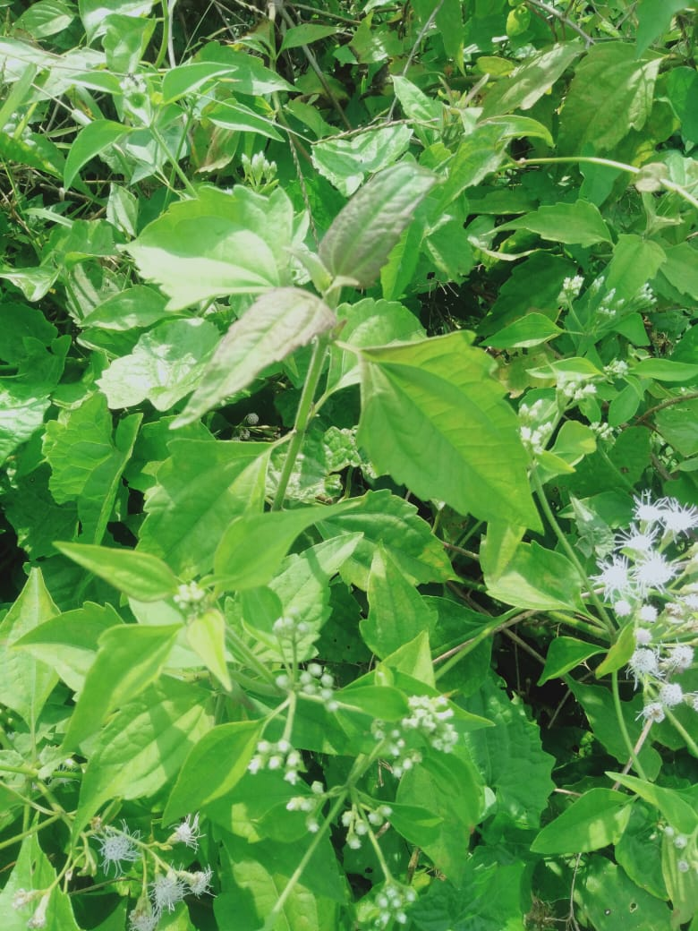

a. Tumbuhan Daun Tekelan b. Pengukuran Tinggi Daun Tekelan

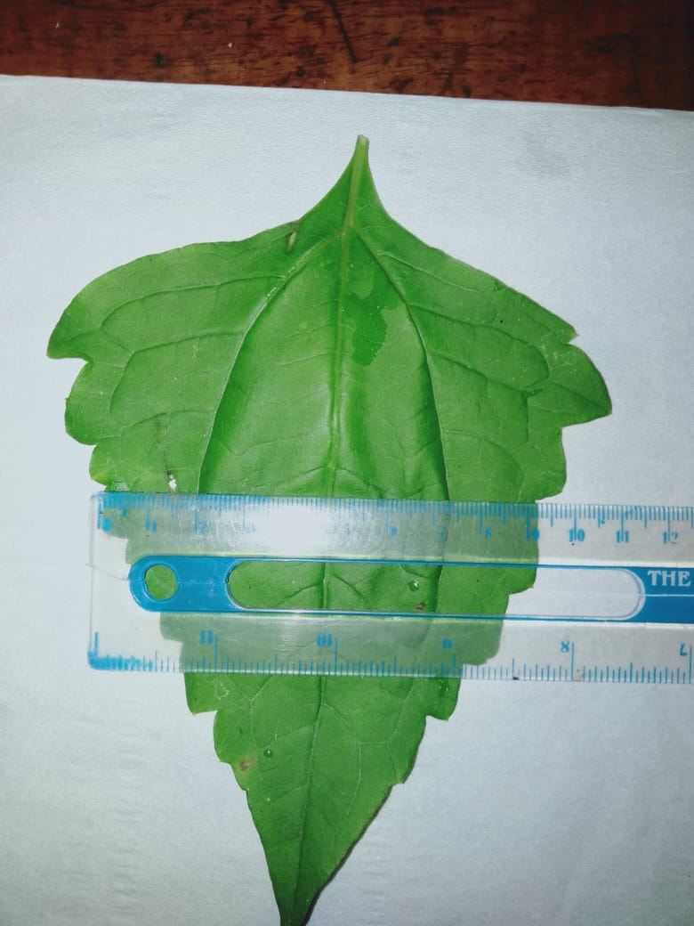
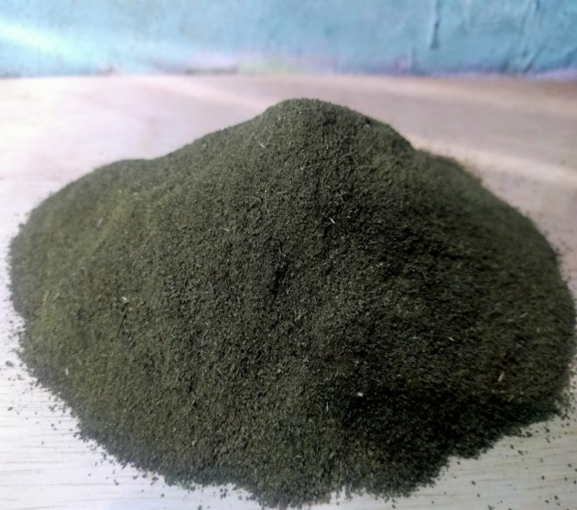

c. Serbuk Daun Tekelan d. Pengukuran Lebar Daun Tekelan

Lampiran 3. Bagan Alir Pembuatan Simplisia
Daun Tekelan 5 kg

Dibersihkan
Dicuci bersih

Ditiriskan

Berat basah 5 kg

Dikeringkan dilemari pengering

Disortasi kering
Berat kering 3 kg

Dihaluskan dengan menggunakan blender
1,6 kg serbuk simplisia

Lampiran 4. Bagan Alir Pembuatan Ekstrak Etanol Daun Tekelan

Serbuk Daun Tekelan
(500 gram)
Masukkan dalam bejana
Dituangkan dengan 75 bagian cairan penyari etanol 96% (3750 ml)

Ditutup dan dibiarkan selama 5 hari, sambil sesekali diaduk
Setelah 5 hari campuran diserkai dan ampasnya diperas dengan kain flanel

Maserat I
Ampas

Dicuci ampasnya dengan 25 bagian cairan penyari etanol 96% (1250 ml)

Maserat II

Ditambahkan Maserat I dan II dan diamkan selama 2 hari lalu disaring

Dipekatkan dengan bantuan alat rotary evaporator pada suhu 40°C

Diuapkan diatas waterbath
Suhu dibawah 50°C

Ekstrak etanol kental 44, 3 g

Lampiran 5. Bagan Alir Skrining Fitokimia dan Karakterisasi
Serbuk Simplisia Daun Tekelan
Serbuk simplisia Daun Tekelan

Serbuk Simplisia Daun Tekelan

Dimaserasi menggunakan pelarut etanol 96%
Skrining Fitokimia
Karakterisasi
Ekstrak Etanol Daun Tekelan

1.Pemeriksaan Alkaloida
2.Pemeriksaan Flavonoida
3. Pemeriksaan Tanin
4.Pemeriksaan Saponin
5.Pemeriksaan Steroid/Triterpenoida
1.Makroskopik
2.Penetapan Kadar Air
3.Penetapan Kadar Sari Larut Air
4.Penetapan Kadar Sari Larut Etanol
5.Penetapan Kadar Abu Total
6.Penetapan Kadar Abu Tidak Larut dalam Asam

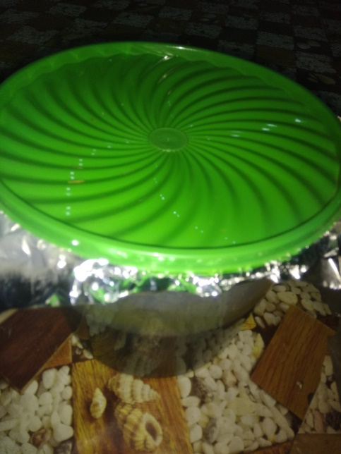
Lampiran 6. Maserasi dan Ekstrak Etanol Daun Tekelan

- Maserasi Daun Tekelan
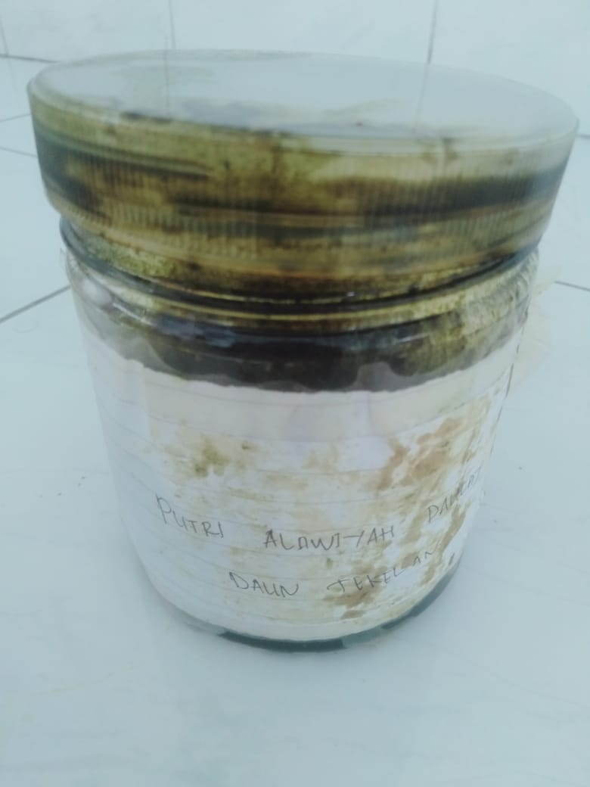

- Ekstrak Etanol Daun Tekelan

Lampiran 7. Alat Alat Azeotrop dan Rotary Evaporator
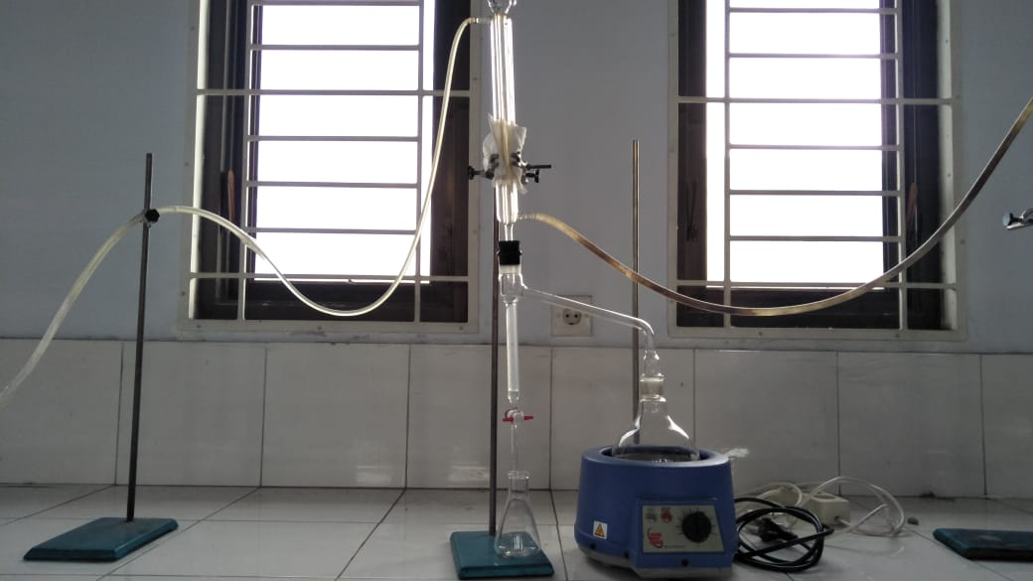

- Alat Azetrop (Penetapan Kadar Air)
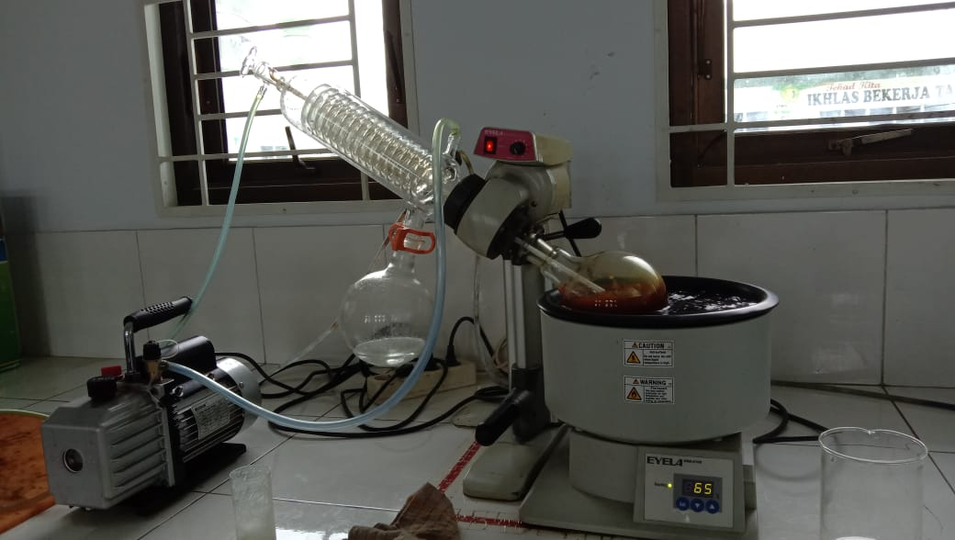

- Alat Rotary Evaporator

Lampiran 8. Data Karakterisasi Serbuk Simplisia Daun Tekelan
- Perhitungan Hasil Penetapan Kadar Air (Tidak lebih dari 10 %).
$$Kadar Air :\frac{Volume II-Volume I}{Berat Sampel}×100 \%$$

Sampel I
Berat Sampel : 5g
Volume I : 1,7
Volume II : 2,0
= $\frac{2,0ml-1,7 ml}{5 g}×100 \%$
= $\frac{0,3 ml}{5 g}×100 \%=6 \%$
Sampel II
Berat Sampel : 5g
Volume I : 1,8
Volume II : 2,1
= $\frac{2,1- 1, 8ml}{5 g}×100 \%$
= $\frac{0,3ml}{5 g}×100 \%=6 \%$
Sampel III
Berat Sampel : 5g
Volume I1 : 1, 7
Volume II : 2,0
= $\frac{2,0-1,7 ml}{5 g}×100 \%$
= $\frac{0,3ml}{5 g}×100 \%=6\%$ = $\frac{0,4 ml}{5 g}×100 \%=8$ = $\frac{0,4 ml}{5 g}×100 \%=8 \%$ = $\frac{2,0-1,7 ml}{5 g}×100 \%= \frac{2,0-1,7 ml}{5 g}×100 \%= \frac{2,0-1,7 ml}{5 g}×100 \%= \frac{2,0-1,7 ml}{5 g}×100 \%v$= $\frac{2,0-1,7 ml}{5 g}×100 \%$ = $\frac{0,4 ml}{5 g}×100 \%=8 \%$

Kadar rata-rata = 6%+6%+6% = 6%
3

Kadar air pada daun tekelan memenuhi syarat yaitu 6%, tidak lebih dari 10%

Lampiran 8. ( Lanjutan)
2. Perhitungan Kadar Sari Larut dalam Air (> 35 %).
$$Kadar Sari Larut Air=\frac{Berat cawan+Faktor pengenceran}{Berat sampel}×100\%$$

Sampel I
Berat Sampel : 5g
Berat cawan kosong : 32, 26g
Berat cawan + sampel : 32, 57g
=$\frac{\left(32, 57 g-32, 26 g\right)×5}{5 g}×100$%
=$\frac{1, 56 g}{5 g}×100 \%$ = 31, 34 %
Sampel II
Berat Sampel : 5g
Berat cawan kosong : 32, 25g
Berat cawan + sampel : 32, 56g
=$\frac{\left(32, 56 g-32, 25 g\right)×5}{5 g}×100$
=$\frac{1,55 g}{5 g}×100 \%$ = 31,47%
Sampel III
Berat Sampel : 5g
Berat cawan kosong :26,37g
Berat cawan + sampel :26,69g
=$\frac{\left(26,69 g-26,37 g\right)×5}{5 g}×100\%$
=$\frac{1,6g}{5 g}×100 \%$ = 32,49%
Kadar rata-rata = 31,34%+31,47%+32,49% = 31,76%
3
Kadar sari larut dalam air pada daun tekelan memenuhi syarat yaitu 31,76%, tidak lebih dari 35%.

Lampiran 8. (Lanjutan)
3.Perhitungan Kadar Sari Larut dalam Etanol
Kadar Sari Larut Dalam Etanol = $\frac{Berat Cawan+sampel (g)}{Berat sampel (g)}×100 \%$

Sampel I
Berat sampel : 5 g
Berat cawan kosong : 32, 25 g
Berat cawan$+$sampel : 32, 41 g
= $\frac{(32, 41 g-32, 25 g ×5}{5 g}×100$= 16, 09%
Sampel II
Berat sampel : 5 g
Berat cawan kosong : 26, 38 g
Berat cawan + sampel : 26, 61 g
= $\frac{(26, 61 g-26, 38g ×5}{5 g}×100$= 22,73 %
Sampel III
Berat sampel : 5 g
Berat cawan kosong : 32, 27 g
Berat cawan + sampel : 32, 46 g
= $\frac{(32, 46 g-32, 27g ×5}{5 g}×100$=19, 58%
Kadar rata-rata = 16, 09% + 22, 73% + 19,58 % = 19, 46%
3
Kadar sari larut dalam etanol pada daun tekelan memenuhi syarat yaitu 19, 46%, tidak lebih dari 26%.

Lampiran 8. (Lanjutan)
4.Perhitungan Penetapan Kadar Abu Total
Kadar Abu = $\frac{Berat abu (g)}{Berat sampel (g)}×100 \%$

Sampel I
Berat sampel : 2 g
Berat cawan kosong : 54, 39 g
Berat cawan + sampel : 54, 58 g
=$\frac{\left(54, 58 g-54, 39 g\right)}{2 g}×100 \%$ = 9, 32 %
Sampel II
Berat sampel : 2 g
Berat cawan kosong : 63, 00 g
Berat cawan + sampel : 63, 25 g
=$\frac{\left(63, 25 g-63, 00 g\right)}{2 g}×100 \%$ = 12, 34%
Sampel III
Berat sampel : 2 g
Berat cawan kosong : 61, 85 g
Berat cawan + sampel : 62, 08 g
=$\frac{\left(62, 08 g-61, 85 g\right)}{2 g}×100 \%$ =11, 49 %
Kadar rata-rata = 9, 32% + 12, 34% + 11, 49% = 11, 05%
3
Kadar abu total pada daun tekelan memenuhi syarat yaitu 11, 05%, tidak lebih dari 14%.

Lampiran 8. (Lanjutan)
5.Perhitungan Kadar Abu tidak Larut dalam Asam
Kadar abu tidak larut asam = $\frac{Berat abu larut asam (g)}{Berat sampel}×100 \%$

Sampel I
Berat sampel :0, 18 g
Berat cawan kosong : 54, 38 g
Berat cawan + sampel : 54, 38 g
=$\frac{\left(54, 38 g-54, 38 g\right)}{0, 18 g}×100 \%$ = 1, 87 %
Sampel II
Berat sampel : 0, 24 g
Berat cawan kosong : 62, 99 g
Berat cawan + sampel : 62, 99 g
=$\frac{\left(62, 99 g-62, 99 g\right)}{0, 24 g}×100 \%$ = 1, 33%
Sampel III
Berat sampel : 0, 22 g
Berat cawan kosong : 61, 84 g
Berat cawan + sampel : 61, 85 g
=$\frac{\left(61, 85 g-61, 84 g\right)}{0, 22 g}×100 \%$ = 1, 08 %
Kadar rata-rata = 1, 87% + 1, 33% + 1, 08% = 1,42 %
3
Kadar abu tidak larut dalam asam pada daun tekelan memenuhi syarat yaitu 1, 42%, tidak lebih dari 10%.

Lampiran 9. Hasil Uji Skrining Fitokimia
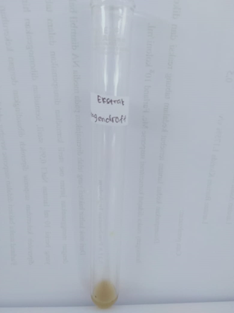
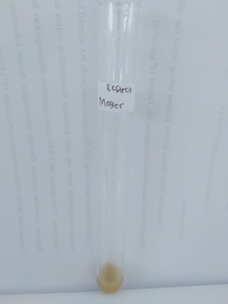
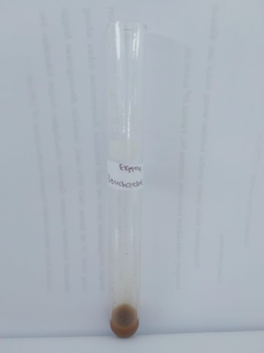
Mayer Dragendroff Bouchardat

(+) Alkaloid
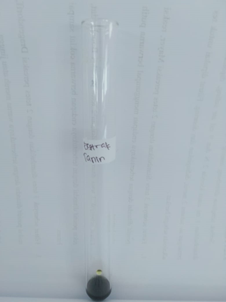
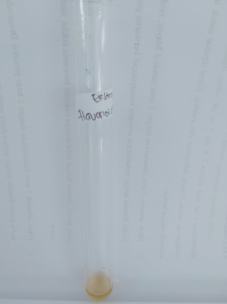

(+) Flavonoid (+) Tanin
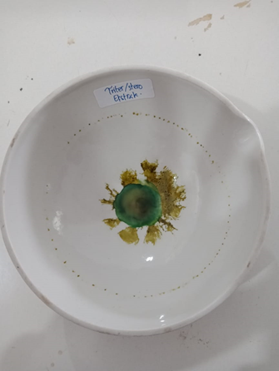

(+) Steroid
Lampiran 10. Gel Handsanitizer daun tekelan
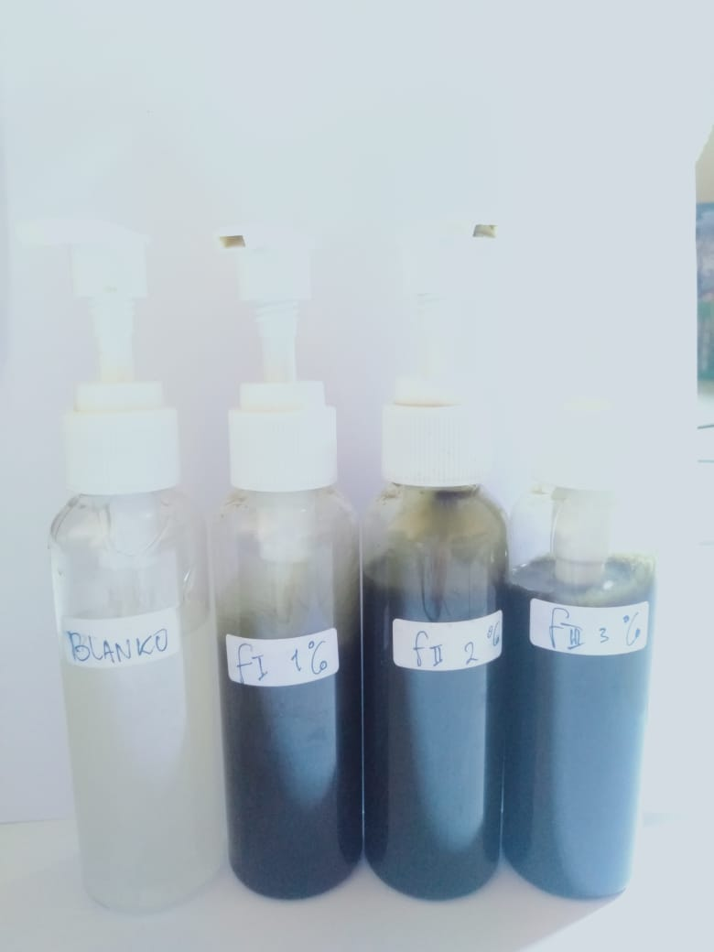

Sediaan Gel Handsanitizer

Lampiran 11. Bagan Alir Pengujian Antibakteri
Biakan Murni

Diambil dengan jarum Ose steril
Ditanam pada media NA miring
Diinkubasi pada suhu 36-37℃ 18-24 jam

Stock Kultur Bakteri

Diambil dengan jarum Ose Steril
Disuspensikan dalam 10 ml NaCL 0,9%
Dihomogenkan sampai kekeruhan Sama dengan
Mc.farland
Suspensi Bakteri 10⁸
CFU/ml

Dituang 20 ml MHA steril cair (45-50℃), biarkan memadat
Dipipet 0,1 ml kedalam cawan petri

Dicelupkan piper disk kedalam sediaan tunggu 5 menit
Inkubasi Pada suhu 37℃ selama 18-24 jam

Hasil Inkubasi

Diukur diameter zona hambat disekitar piper disk

Diameter Daya Hambat Bakteri

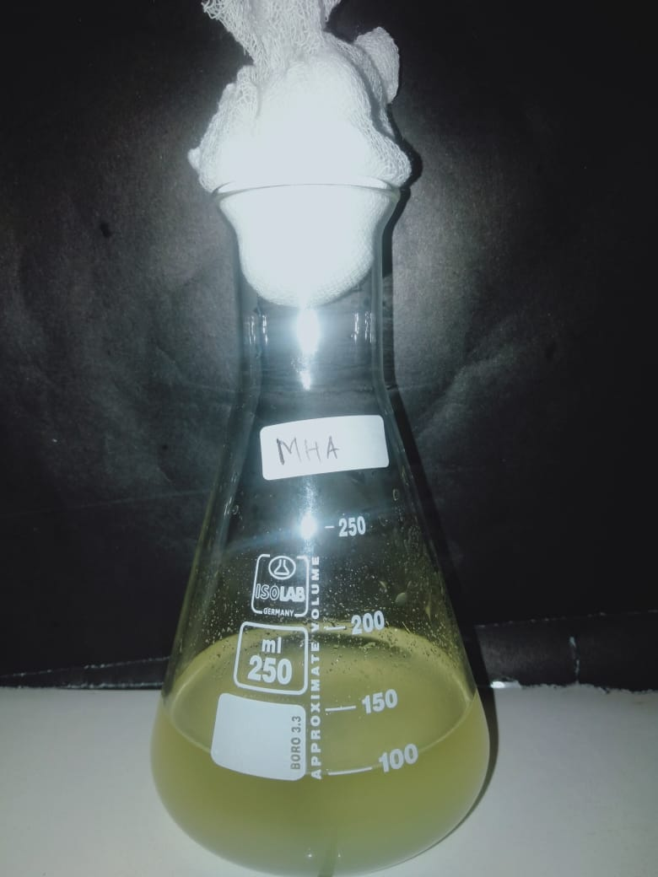
Lampiran 12. Hasil Pembuatan Media dan Larutan Uji

- Hasil Pembuatan Media MHA (Mueller Hinton Agar) 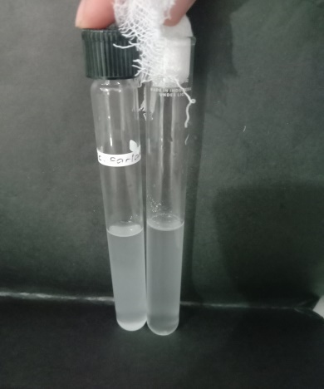
- Hasil Pembuatan Larutan Suspensi Bakteri dan Standar Mc. Farland

Lampiran 13. Hasil Uji Zona Hambat Antibakteri
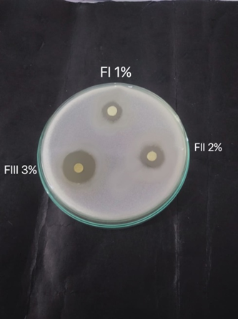
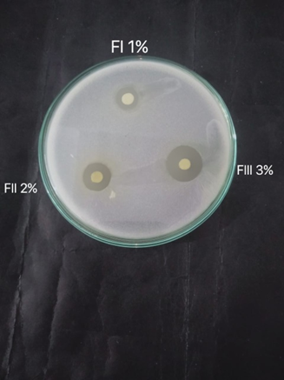

- Pengulangan 1 b. Pengulangan 2
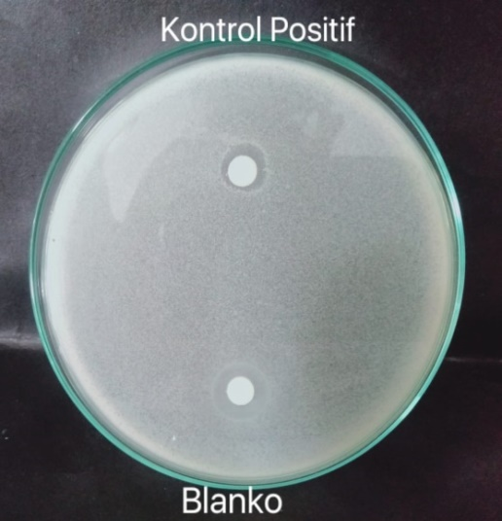
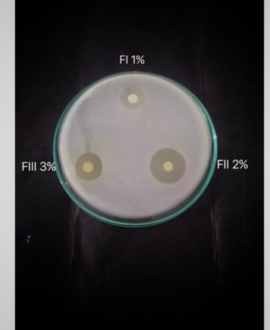

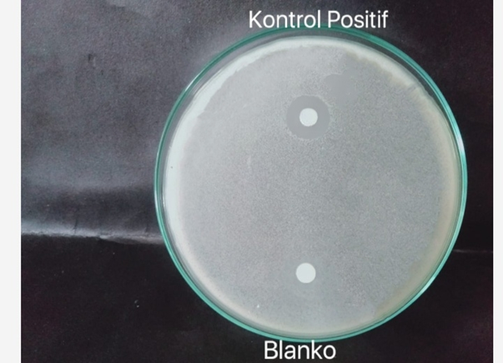

c. Pengulangan 3 d. Kontrol (+) dan Kontrol (-)

Lampiran 14. Hasil Analisis Variasi Dengan Metode SPSS Diameter Daya
Hambat Daun Tekelan Terhadap Staphylococcus epidermidis.

Descriptives
Diameter_Zona_Hambat
 | N |  |  |  | Mean |  |  | Std. Deviation |  |  |  | Std. Error |  |  | 95% Confidence Interval for Mean |  |  |  |  |  |  |  |  | Minimum |  |  | Maximum
 |  |  |  |  |  |  |  |  |  |  |  |  |  |  | Lower Bound |  |  |  | Upper Bound
F0 | 3 |  |  |  | ,000 |  |  | ,0000 |  |  |  | ,0000 |  |  | ,000 |  |  |  | ,000 |  |  |  |  | ,0 |  |  | ,0
F1 | 3 |  |  |  | 12,000 |  |  | 2,0000 |  |  |  | 1,1547 |  |  | 7,032 |  |  |  | 16,968 |  |  |  |  | 10,0 |  |  | 14,0
F2 | 3 |  |  |  | 14,667 |  |  | ,7638 |  |  |  | ,4410 |  |  | 12,769 |  |  |  | 16,564 |  |  |  |  | 14,0 |  |  | 15,5
F3 | 3 |  |  |  | 17,167 |  |  | 1,6073 |  |  |  | ,9280 |  |  | 13,174 |  |  |  | 21,159 |  |  |  |  | 16,0 |  |  | 19,0
Kontrol Positif | 3 |  |  |  | 10,000 |  |  | ,0000 |  |  |  | ,0000 |  |  | 10,000 |  |  |  | 10,000 |  |  |  |  | 10,0 |  |  | 10,0
Total | 15 |  |  |  | 10,767 |  |  | 6,1929 |  |  |  | 1,5990 |  |  | 7,337 |  |  |  | 14,196 |  |  |  |  | ,0 |  |  | 19,0
Test of Homogeneity of Variances
Diameter_Zona_Hambat
Levene Statistic |  |  | df1 |  |  |  |  |  | df2 |  |  | Sig.
3,433 |  |  | 4 |  |  |  |  |  | 10 |  |  | ,052
Tests of Normality^{a,c}
 |  |  |  |  |  | Percobaan |  |  |  |  |  |  | Kolmogorov-Smirnov^{b} |  |  |  |  |  |  |  |  |  | Shapiro-Wilk
 |  |  |  |  |  |  |  |  |  |  |  |  | Statistic |  |  |  |  | df |  | Sig. |  |  | Statistic |  |  |  |  | df |  |  | Sig.
Diameter_Zona_Hambat |  |  |  |  |  | F1 |  |  |  |  |  |  | ,175 |  |  |  |  | 3 |  | . |  |  | 1,000 |  |  |  |  | 3 |  |  | 1,000
 |  |  |  |  |  | F2 |  |  |  |  |  |  | ,253 |  |  |  |  | 3 |  | . |  |  | ,964 |  |  |  |  | 3 |  |  | ,637
 |  |  |  |  |  | F3 |  |  |  |  |  |  | ,328 |  |  |  |  | 3 |  | . |  |  | ,871 |  |  |  |  | 3 |  |  | ,298
a. Diameter_Zona_Hambat is constant when Percobaan = F0. It has been omitted.
b. Lilliefors Significance Correction
c. Diameter_Zona_Hambat is constant when Percobaan = Kontrol Positif. It has been omitted.
ANOVA
Diameter_Zona_Hambat
 |  |  |  | Sum of Squares |  |  |  |  |  | df |  |  |  | Mean Square |  |  |  |  |  |  |  | F |  |  |  | Sig.
Between Groups |  |  |  | 522,600 |  |  |  |  |  | 4 |  |  |  | 130,650 |  |  |  |  |  |  |  | 91,151 |  |  |  | ,000
Within Groups |  |  |  | 14,333 |  |  |  |  |  | 10 |  |  |  | 1,433
Total |  |  |  | 536,933 |  |  |  |  |  | 14
Diameter_Zona_Hambat
Duncanª
Percobaan |  | N |  |  |  |  | Subset for alpha = 0.05
 |  |  |  |  |  |  | 1 |  |  |  | 2 |  |  |  |  | 3 |  |  |  |  | 4
F0 |  | 3 |  |  |  |  | ,000
Kontrol Positif |  | 3 |  |  |  |  |  |  |  |  | 10,000
F1 |  | 3 |  |  |  |  |  |  |  |  | 12,000
F2 |  | 3 |  |  |  |  |  |  |  |  |  |  |  |  |  | 14,667
F3 |  | 3 |  |  |  |  |  |  |  |  |  |  |  |  |  |  |  |  |  |  | 17,167
Sig. |  |  |  |  |  |  | 1,000 |  |  |  | ,068 |  |  |  |  | 1,000 |  |  |  |  | 1,000
Means for groups in homogeneous subsets are displayed.
a. Uses Harmonic Mean Sample Size = 3,000.

