LAMPIRAN
TABULASI DATA

Lampiran
Uji Validitas

Uji Validitas Harga (x₁)
Correlations
 |  | X1.1 | X1.2 | X1.3 | X1.4 | X1.5 | X1
X1.1 | Pearson Correlation | 1 | .688** | .434** | .285** | .078 | .624**
 | Sig. (2-tailed) |  | .000 | .000 | .000 | .328 | .000
 | N | 160 | 160 | 160 | 160 | 160 | 160
X1.2 | Pearson Correlation | .688** | 1 | .370** | .204** | -.069 | .532**
 | Sig. (2-tailed) | .000 |  | .000 | .010 | .384 | .000
 | N | 160 | 160 | 160 | 160 | 160 | 160
X1.3 | Pearson Correlation | .434** | .370** | 1 | .500** | .108 | .715**
 | Sig. (2-tailed) | .000 | .000 |  | .000 | .174 | .000
 | N | 160 | 160 | 160 | 160 | 160 | 160
X1.4 | Pearson Correlation | .285** | .204** | .500** | 1 | .415** | .796**
 | Sig. (2-tailed) | .000 | .010 | .000 |  | .000 | .000
 | N | 160 | 160 | 160 | 160 | 160 | 160
X1.5 | Pearson Correlation | .078 | -.069 | .108 | .415** | 1 | .587**
 | Sig. (2-tailed) | .328 | .384 | .174 | .000 |  | .000
 | N | 160 | 160 | 160 | 160 | 160 | 160
X1 | Pearson Correlation | .624** | .532** | .715** | .796** | .587** | 1
 | Sig. (2-tailed) | .000 | .000 | .000 | .000 | .000
 | N | 160 | 160 | 160 | 160 | 160 | 160
**. Correlation is significant at the 0.01 level (2-tailed).

Uji Validitas Kualitas Pelayanan (x₂)
Correlations
 |  | X2.1 | X2.2 | X2.3 | X2.4 | X2.5 | X2
X2.1 | Pearson Correlation | 1 | .687** | .508** | .372** | .107 | .682**
 | Sig. (2-tailed) |  | .000 | .000 | .000 | .179 | .000
 | N | 160 | 160 | 160 | 160 | 160 | 160
X2.2 | Pearson Correlation | .687** | 1 | .591** | .302** | .149 | .708**
 | Sig. (2-tailed) | .000 |  | .000 | .000 | .060 | .000
 | N | 160 | 160 | 160 | 160 | 160 | 160
X2.3 | Pearson Correlation | .508** | .591** | 1 | .517** | .294** | .807**
 | Sig. (2-tailed) | .000 | .000 |  | .000 | .000 | .000
 | N | 160 | 160 | 160 | 160 | 160 | 160
X2.4 | Pearson Correlation | .372** | .302** | .517** | 1 | .445** | .767**
 | Sig. (2-tailed) | .000 | .000 | .000 |  | .000 | .000
 | N | 160 | 160 | 160 | 160 | 160 | 160
X2.5 | Pearson Correlation | .107 | .149 | .294** | .445** | 1 | .615**
 | Sig. (2-tailed) | .179 | .060 | .000 | .000 |  | .000
 | N | 160 | 160 | 160 | 160 | 160 | 160
X2 | Pearson Correlation | .682** | .708** | .807** | .767** | .615** | 1
 | Sig. (2-tailed) | .000 | .000 | .000 | .000 | .000
 | N | 160 | 160 | 160 | 160 | 160 | 160
**. Correlation is significant at the 0.01 level (2-tailed).

Uji Validitas Kepuasan Konsumen (Y)
Correlations
 |  | Y1.1 | Y1.2 | Y1.3 | Y1.4 | Y1.5 | Y
Y1.1 | Pearson Correlation | 1 | .769** | .504** | .440** | .273** | .733**
 | Sig. (2-tailed) |  | .000 | .000 | .000 | .000 | .000
 | N | 160 | 160 | 160 | 160 | 160 | 160
Y1.2 | Pearson Correlation | .769** | 1 | .497** | .320** | .342** | .725**
 | Sig. (2-tailed) | .000 |  | .000 | .000 | .000 | .000
 | N | 160 | 160 | 160 | 160 | 160 | 160
Y1.3 | Pearson Correlation | .504** | .497** | 1 | .541** | .306** | .767**
 | Sig. (2-tailed) | .000 | .000 |  | .000 | .000 | .000
 | N | 160 | 160 | 160 | 160 | 160 | 160
Y1.4 | Pearson Correlation | .440** | .320** | .541** | 1 | .519** | .800**
 | Sig. (2-tailed) | .000 | .000 | .000 |  | .000 | .000
 | N | 160 | 160 | 160 | 160 | 160 | 160
Y1.5 | Pearson Correlation | .273** | .342** | .306** | .519** | 1 | .696**
 | Sig. (2-tailed) | .000 | .000 | .000 | .000 |  | .000
 | N | 160 | 160 | 160 | 160 | 160 | 160
Y | Pearson Correlation | .733** | .725** | .767** | .800** | .696** | 1
 | Sig. (2-tailed) | .000 | .000 | .000 | .000 | .000
 | N | 160 | 160 | 160 | 160 | 160 | 160

Lampiran
Uji Reliabilitas

Uji Reliabilitas Harga
Reliability Statistics
Cronbach's Alpha | N of Items
.637 | 5

Uji Reliabilitas Kualitas pelayanan
Reliability Statistics
Cronbach's Alpha | N of Items
.751 | 5

Uji Reliabilitas Kepuasan Konsumen
Reliability Statistics
Cronbach's Alpha | N of Items
.783 | 5

Lampiran
Uji Asumsi Klasik
- Uji Normalitas
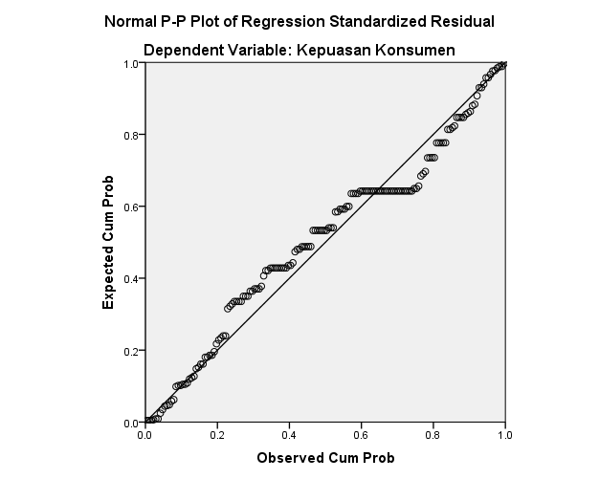
- Uji Multikolineritas
- Coefficientsª
Model |  | Unstandardized Coefficients |  | Standardized Coefficients | t | Sig. | Collinearity Statistics
 |  | B | Std. Error | Beta |  |  | Tolerance | VIF
1 | (Constant) | 4.834 | 1.932 |  | 2.502 | .013
 | Harga | .483 | .087 | .400 | 5.540 | .000 | .902 | 1.109
 | Kualitas Pelayanan | .242 | .080 | .219 | 3.030 | .003 | .902 | 1.109
a. Dependent Variable: Kepuasan Konsumen

- Uji Heteroskedastisitas
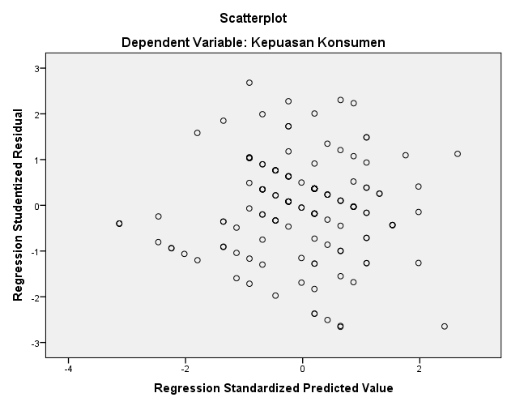

Lampiran
Uji Regresi Linier Berganda dan Uji Hipotesis
- Hasil pengujian regresi linier berganda
- Coefficientsª
Model |  | Unstandardized Coefficients |  | Standardized Coefficients | t | Sig.
 |  | B | Std. Error | Beta
1 | (Constant) | 4.834 | 1.932 |  | 2.502 | .013
 | Harga | .483 | .087 | .400 | 5.540 | .000
 | Kualitas Pelayanan | .242 | .080 | .219 | 3.030 | .003
a. Dependent Variable: Kepuasan konsumen

- Uji T (parsial)
Hasil uji T harga (x₁)
Coefficientsª
Model |  | Unstandardized Coefficients |  | Standardized Coefficients | t | Sig.
 |  | B | Std. Error | Beta
1 | (Constant) | 7.887 | 1.691 |  | 4.665 | .000
 | Harga | .566 | .085 | .469 | 6.666 | .000
a. Dependent Variable: Kepuasan Konsumen

Hasil uji T Kualitas Pelayanan (x₂)
Coefficientsª
Model |  | Unstandardized Coefficients |  | Standardized Coefficients | t | Sig.
 |  | B | Std. Error | Beta
1 | (Constant) | 11.720 | 1.612 |  | 7.271 | .000
 | Kualitas Pelayanan | .381 | .083 | .344 | 4.608 | .000
a. Dependent Variable: Kepuasan Konsumen

- Uji F (Simultan)
- ANOVAª
Model |  | Sum of Squares | Df | Mean Square | F | Sig.
1 | Regression | 188.034 | 2 | 94.017 | 27.959 | .000^{b}
 | Residual | 527.941 | 157 | 3.363
 | Total | 715.975 | 159
a. Dependent Variable: Kepuasan Konsumen
b. Predictors: (Constant), Kualitas Pelayanan, Harga

- Uji Koefisien Determinasi (R)²

Model Summary
Model | R | R Square | Adjusted R Square | Std. Error of the Estimate
1 | .809ª | .654 | .650 | 1.62160
a. Predictors: (Constant), Kualitas Pelayanan, Harga

