Lampiran 1.Perhitungan Nilai Rf
Nilai Rf pada kromatografi kertas dihitung sebagai berikut :
Rf= Jarak rambat yang ditempuh bercak noda

Jarak yang ditempuh eluen

Blanko :Rf = 9,4 cm
16 cm

= 0,59 cm
Sampel 1 :Rf = 9,2 cm
16 cm

= 0,58 cm
Sampel 2 :Rf = 9,1 cm
16 cm

= 0,57 cm
Sampel 3 :Rf = 8,9 cm
16 cm

= 0,56 cm
Sampel 4 :Rf = 8,8 cm
16 cm

= 0,55 cm
Sampel 5 :Rf = 8,6 cm
16 cm

= 0,54 cm

Lampiran 2. Pengenceran lemak babi standart
- Larutan standart 10%
V1.N1 = V2.N2
V1.100% = 100 ml.10%
V1 = 1000%
100%
V1 = 10 ml
- Larutan standard 15 %
V1.N1= V2.N2
V1.100% = 100 ml.15%
V1 = 1500%
100%
V1 = 15 ml
- Larutan standard 20%
V1.N1= V2.N2
V1.100% = 100 ml.20%
V1 = 2000%
100%
V1 = 20 ml

Lampiran 2. (Lanjutan)
- Larutan standard 25%
V1.N1= V2.N2
V1.100% = 100 ml.25%
V1 = 2500%
100%
V1 = 25 ml
- Larutan standard 30%
V1.N1=V2.N2
V1.100%= 100 ml.30%
V1 = 3000%
100%
V1 = 30 ml
Keterangan :
V1 = volume sebelum pengenceran
V2 = volume setelah pengenceran
N1 = konsentrasi sebelum pengenceran
N2 = konsentrasi setelah pengenceran

Lampiran 3. Perhitungan Persamaan Regresi

No | Konsentrasi (X) | Absorbansi (Y) | X² | Y² | XY
1 | 0,0 | 0 | 0 | 0 | 0
2 | 5 | 0,022 | 25 | 0,000484 | 0,11
3 | 10 | 0,023 | 100 | 0,000529 | 0,23
4 | 15 | 0,027 | 225 | 0,000729 | 0,405
5 | 20 | 0,033 | 400 | 0,001089 | 0,66
6 | 25 | 0,037 | 625 | 0,001369 | 0,925
∑ | 75 | 0,142 | 1.375 | 0,0042 | 2.33
Rata - rata | 12,5 | 0,0236 | 229,16 | 0.0007 | 0,3883

Perhitungan Intersep (a)

a. = Ʃxy – (Ʃx) / n
Ʃx²- (Ʃx)²/n

= 2,33 – (75) (0,142)² / 6
1.375 – (75)² / 6

= 2,33 – 10,65 / 6
1.375 – 5.625 / 6

= 2,33 – 1,775
1.375 – 937,5

= 0,555
437,5

= 0,0012

b. =ӯ – a x

= 0,0236 – 0,0012 . 12,5

= 0,0236–0,015

= 0,0086
Lampiran 3. (Lanjutan)

Perhitungan korelasi :
r =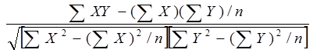
r =$\frac{2,33 -(75 X 0,142)/6}{√(1.375 -({75)}^{2} /6 x (0,0042-\left(0,142\right)2/6}$
r =$\frac{2,33 – 1,775}{\sqrt{437,5 }x 0,00084}$
r =$\frac{0,555}{√0,3675}$
r =0,555
0,6062

r = 0,915

Lampiran 4. Hasil uji spektrofotometri UV-Vis

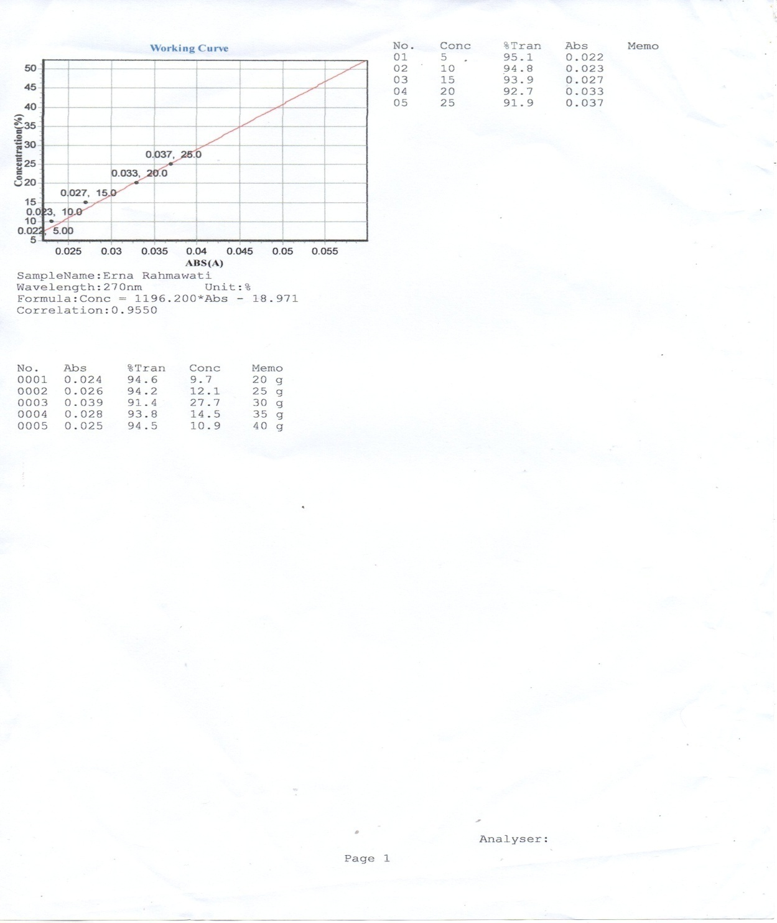

Lampiran 5. Sampel Lemak Babi Dan Cangkang Kerang
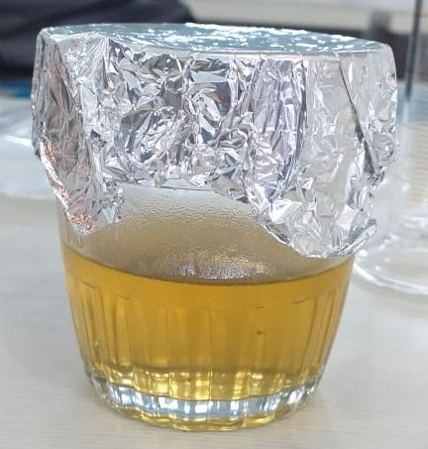
Aluminium Foil
Lemak Murni
Sampel Lemak Murni

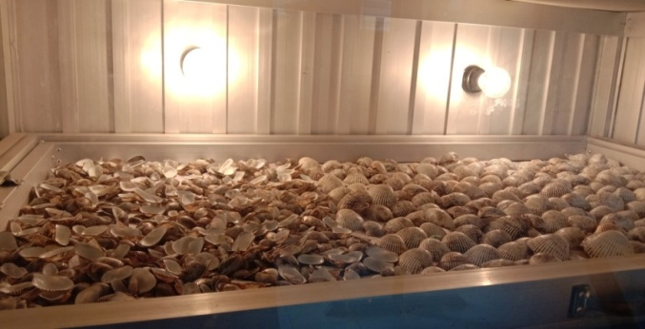
Proses Pengeringan Cangkang Kerang

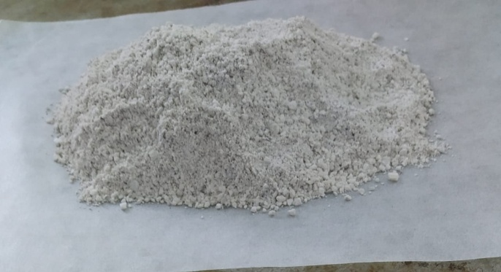
Serbuk Cangkang Kerang

Lampiran 6. Solit Phase Ektraction, Maserasi Elektrosintesis Coupling DanUji Kelarutan
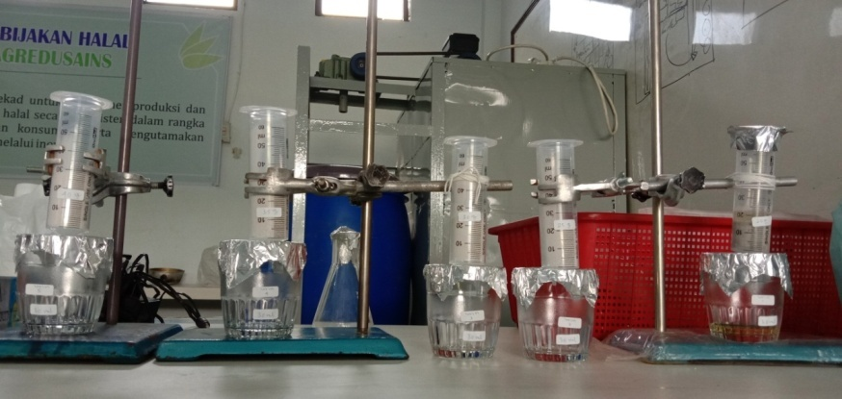
Proses Solit Phase Ektraction

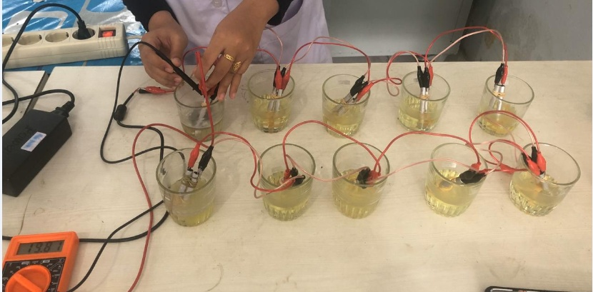
Proses Maserasi Elektrosintesis Coupling

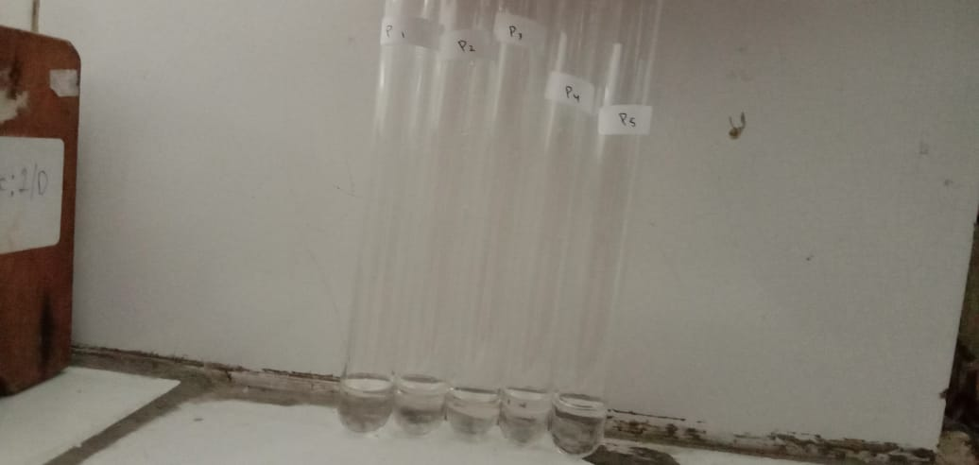
Hasil uji kelarutan

