Lampiran 1. Hasil Determinasi Tumbuhan

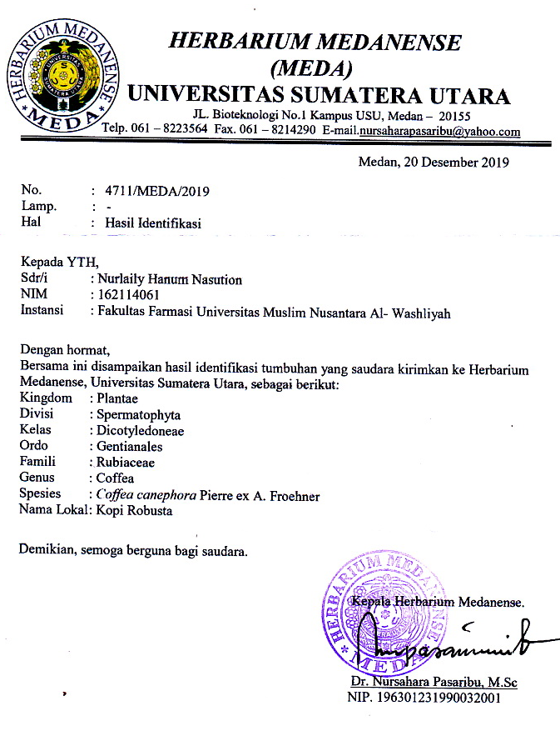

LAMPIRAN

Lampiran 2. Rekomendasi Persetujuan Etik Penelitian Kesehatan
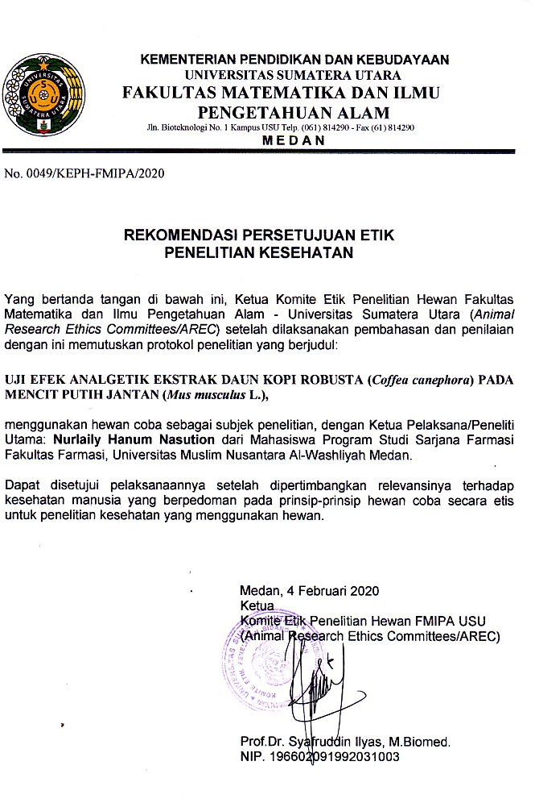

Lampiran 3. Bagan Alir Pembuatan Simplisia
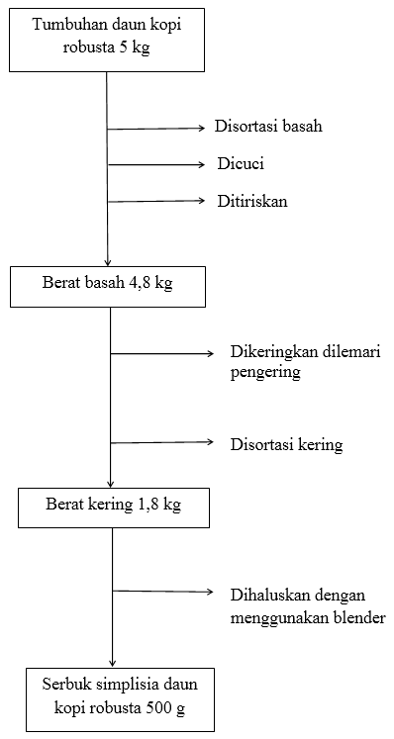

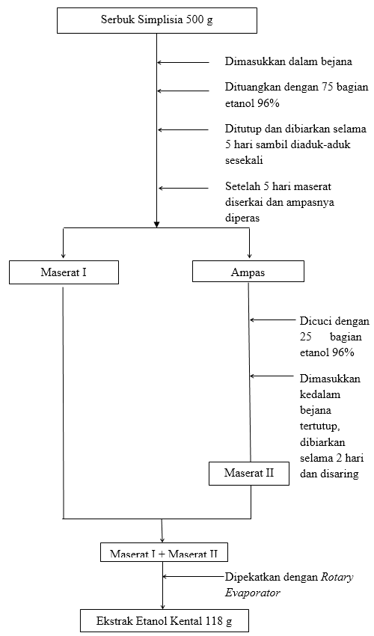
Lampiran 4. Bagan Alir Pembuatan Ekstrak Etanol Daun Kopi Robusta

Lampiran 5. Bagan Alir Skrining Fitokimia dan Karakterisasi
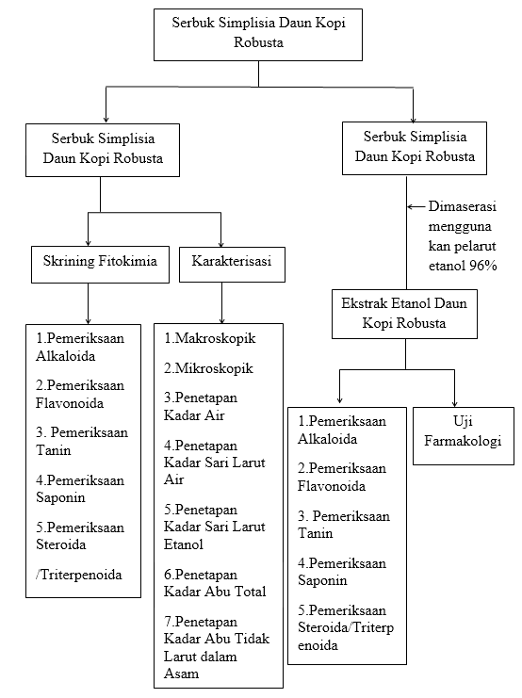

Lampiran 6. Bagan Alir Uji Efek Analgetik
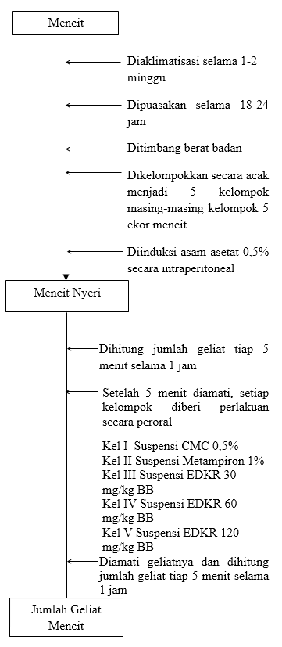
Lampiran 7. Daun Kopi Robusta Segar, Serbuk Simplisia DaunKopi Robusta
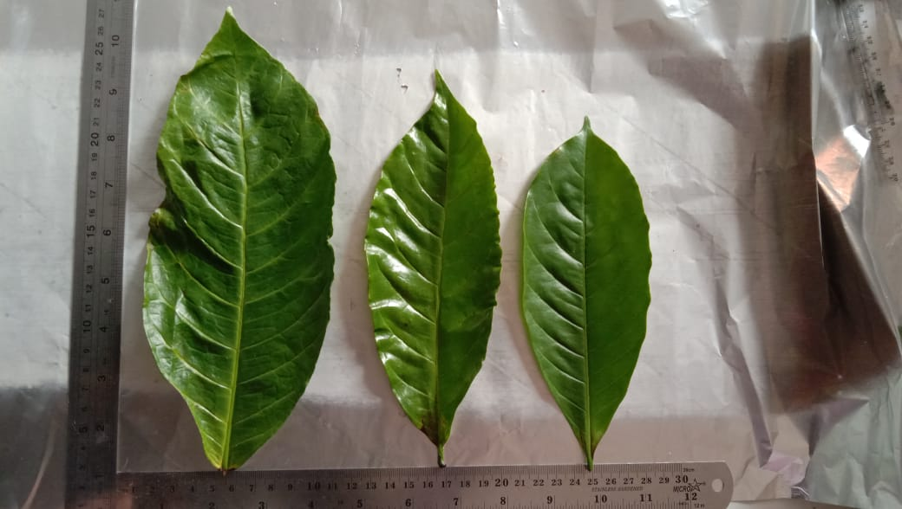
Daun Kopi Robusta Segar
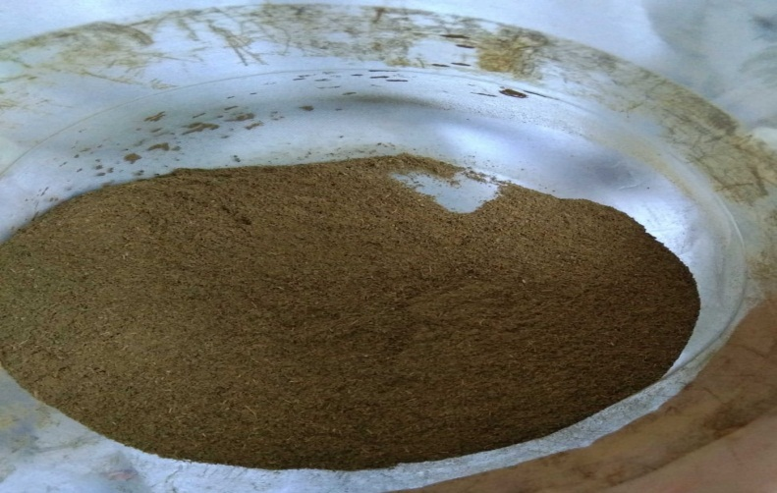
Serbuk Simplisia Daun Kopi Robusta

Lampiran 8. Mikroskopik Daun Kopi Robusta (Coffea canephora)
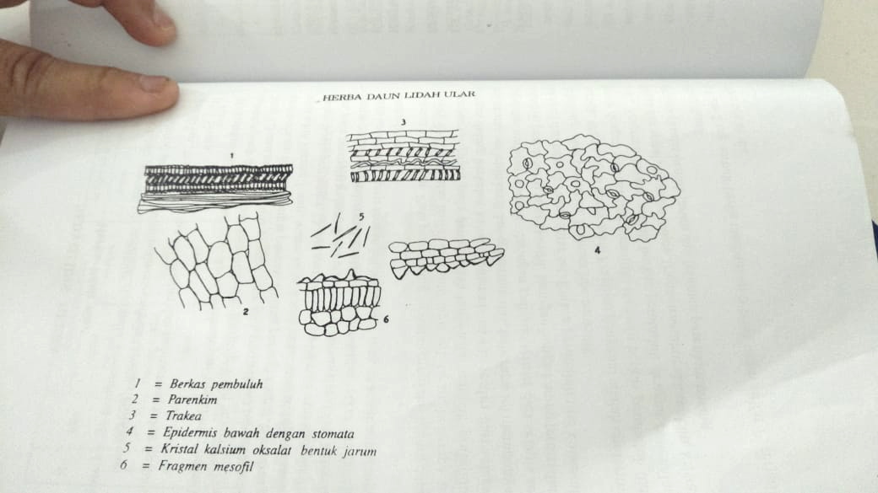

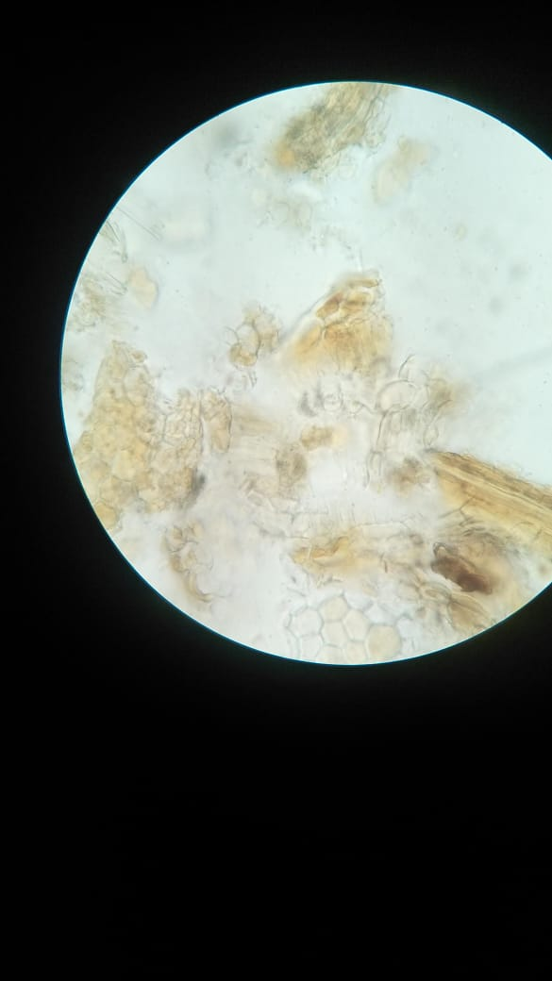

Epidermis bawah
Dengan stomata Parenkhim Berkas pembuluh

Lampiran 9. Maserasi dan Ekstrak Etanol Daun Kopi Robusta
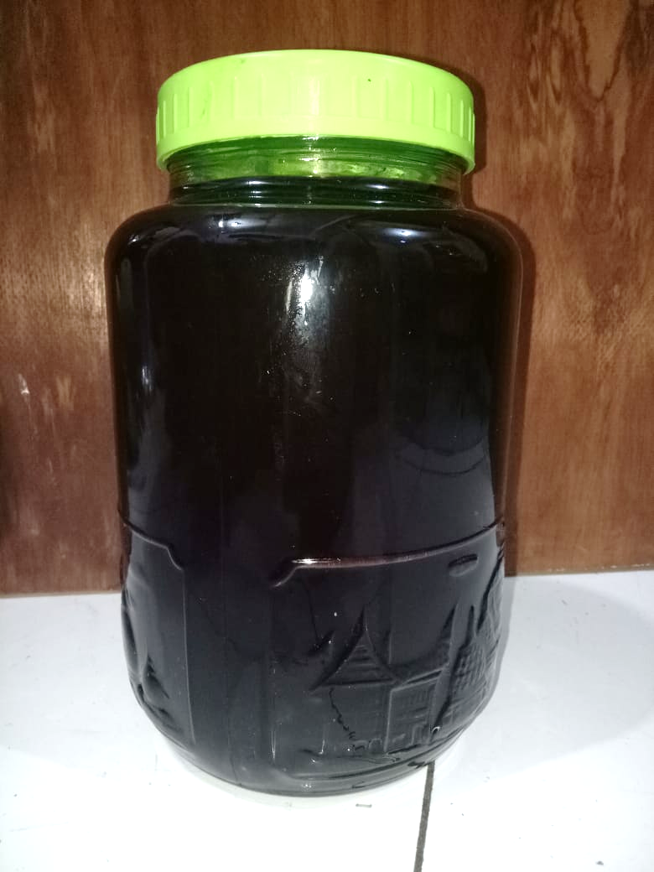
Ekstraksi Cara Maserasi Daun Kopi Robusta

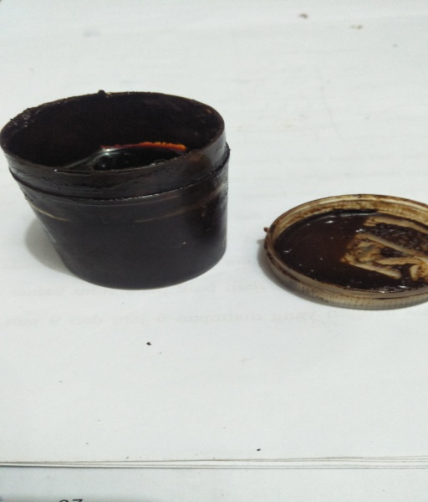
Ekstrak Etanol Daun Kopi Robusta

Lampiran 10. Mencit dan Geliat Mencit
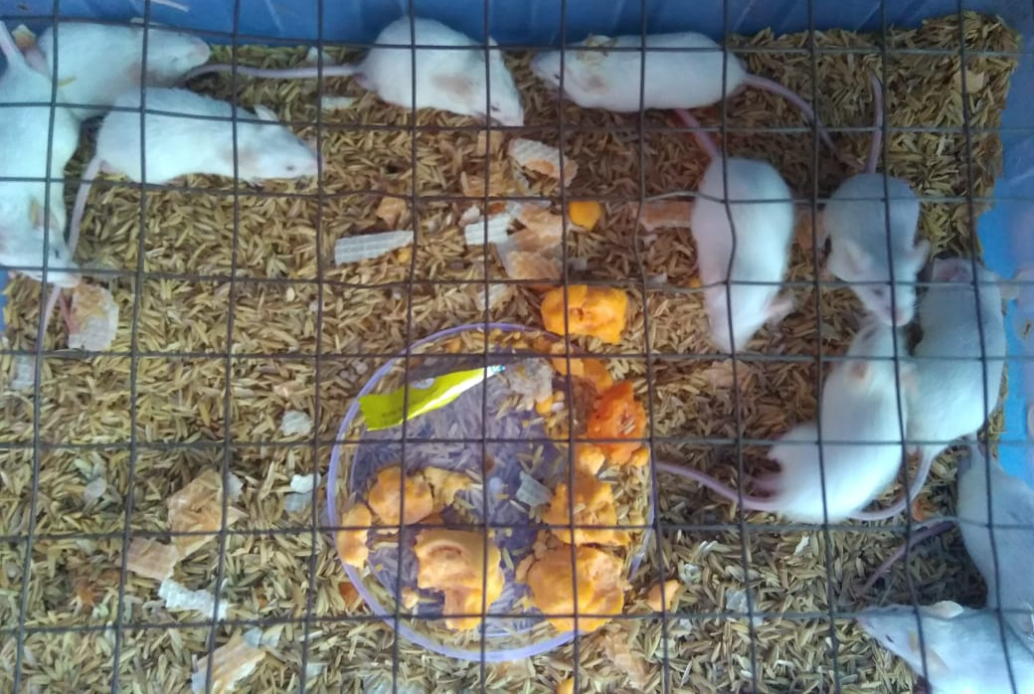
Mencit
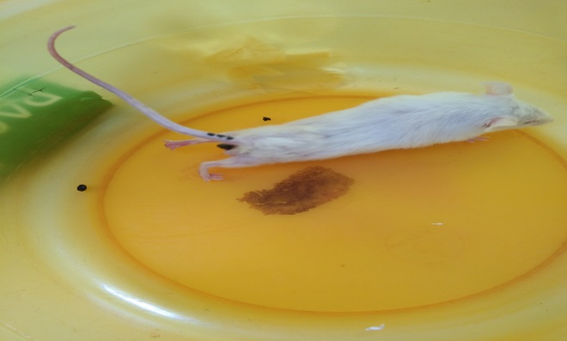
Geliat Mencit

Lampiran 11. Lampiran 11. Perhitungan Dosis Metampiron 1%, Suspensi CMC 0,5% dan Suspensi Ekstrak Daun Kopi Robusta
Konversi perhitungan dosis antar jenis hewan (Laurance dan Bacharach, 1964)
 | Mencit  20 g | Tikus  200 g | Marmut  400 g | Kelinci  1,5 Kg | Kera  4 Kg | Anjing  12 Kg | Manusia  70 Kg
Mencit  20 g | 1,0 | 7,0 | 12,25 | 27,8 | 64,1 | 124,3 | 787,9
Tikus  200 g | 0,14 | 1,0 | 1,74 | 3,0 | 9,2 | 17,8 | 56,0
Marmut  400 g | 0,08 | 0,57 | 1,0 | 2,2 | 5,2 | 10,2 | 31,5
Kelinci  1,5 Kg | 0,04 | 0,25 | 0,44 | 1,0 | 2,4 | 4,5 | 14,2
Kera  4 Kg | 0,016 | 0,11 | 0,19 | 0,42 | 1,0 | 1,9 | 6,1
Anjing  12 Kg | 0,008 | 0,6 | 0,10 | 0,22 | 0,52 | 1,0 | 3,1
Manusia  70 Kg | 0,0026 | 0,018 | 0,031 | 0,07 | 0,16 | 0,32 | 1,0

Dosis terapi metampiron pada manusia adalah 500-4000 mg sehari dalam 3-4 dosis (Tan dan Rahardja,2007).
Dosis terapi minimal : 500 mg
Dosis terapi maksimal : 4000 mg
Konversi dosis manusia (70kg) ke mencit (20g) = 0,0026
Dosis metampiron pada mencit = Dosis terapi manusia × 0,0026
= 500 mg × 0,0026
= 1,3 mg/ 20 g mencit
= $\frac{1000}{20}$× 1,3
= 65 mg/kg BB

Lampiran 11.(Lanjutan)
- Perhitungan dosis suspensi metampiron 1%
Stok larutan metampiron 1% b/v = 1 g/100 ml = 1000 mg/100 ml
= 10 mg/ml
Volume obat yang diberikan = 0,1 ml
Maka dosis untuk mencit 20 g = 1 mg
- Perhitungan dosis suspensi CMC 0,5 %
Suspensi CMC dibuat dengan cara melarutkan 500 mg CMC dalam 100 ml aquadest
Volume suspensi yang diberikan = 0,5 ml
Konsentrasi CMC = 500 mg/100 ml
= 5 mg/ ml
- Perhitungan dosis suspensi ekstrak daun kopi robusta dosis 30 mg/kg BB
Dosis untuk mencit 20 g = 30 mg/1000 × 20 g
= 0,6 mg
Volume ekstrak yang diberikan = 0,6 mg/5 mg/ml
= 0,12 ml
= 500 mg/ 100 ml (konsentrasi 0,5 %)
Suspensi ekstrak daun kopi robusta dibuat dengan cara melarutkan 500 mg ekstrak daun kopi robusta dengan CMC 0,5% dan dicukupkan hingga 100 ml.

Lampiran 11.(Lanjutan)
- Perhitungan dosis suspensi ekstrak daun kopi robusta dosis 60 mg/kg BB
Dosis untuk mencit 20 g = 60 mg / 1000 g × 20 g
= 1,2 mg
Volume ekstrak yang diberikan = 1,2 mg/ 5mg/ml
= 0,24 ml
= 500 mg/100 ml (konsentrasi 0,5 %)
Suspensi ekstrak daun kopi robusta dibuat dengan cara melarutkan 500 mg ekstrak daun kopi robusta dengan CMC 0,5% dan dicukupkan hingga 100 ml.

- Perhitungan dosis suspensi ekstrak daun kopi robusta dosis 120 mg/kg BB
Dosis untuk mencit 20 g = 120 mg / 1000 g × 20 g
= 2,4 mg
Volume ekstrak yang diberikan = 2,4 mg/ 5mg/ml
= 0,48 ml
= 500 mg/100 mL (konsentrasi 0,5 %)
Suspensi ekstrak daun kopi robusta dibuat dengan cara melarutkan 500 mg ekstrak daun kopi robusta dengan CMC 0,5% dan dicukupkan hingga 100 ml.

Lampiran 12. Lampiran 12. Tabel Volume Maksimum Larutan Sediaan Uji Yang Dapat Diberikan Pada Beberapa Hewan Uji (Mulyono,1984)
Jenis Hewan Uji | Volume maksimum (ml) sesuai jalur pemberian
 | i.v | i.m | i.p | s.c | p.o
Mencit (20-30 g) | 0,5 | 0,05 | 1,0 | 0,5-1,0 | 1,0
Tikus (200 g) | 1,0 | 0,1 | 2-5 | 2-5 | 5,0
Hamster (50 g) | - | 0,1 | 1-2 | 2,5 | 2,5
Marmut (250 g) | - | 0,25 | 2-5 | 5,0 | 10,0
Kelinci ( 3 kg) | 5-10 | 0,5 | 10-20 | 5-10 | 20.0
Kucing (3 kg) | 5-10 | 1,0 | 10-20 | 5-10 | 50,0
Anjing (5 kg) | 10-20 | 5,0 | 20-50 | 10,0 | 100,0

Lampiran 13. Jumlah Geliat Mencit Selang Waktu 5 Menit Selama 1 Jam
Perlakuan | Mencit ke- | Menit ke- |  |  |  |  |  |  |  |  |  |  | Jumlah Geliat
 |  | 10’ | 15’ | 20’ | 25’ | 30’ | 35’ | 40’ | 45’ | 50’ | 55’ | 60’
Kontrol Negatif CMC 0,5 % | 1 | 22 | 20 | 19 | 19 | 19 | 16 | 14 | 12 | 11 | 9 | 8 | 189
 | 2 | 24 | 23 | 20 | 18 | 16 | 13 | 12 | 11 | 11 | 10 | 8 | 188
 | 3 | 25 | 22 | 19 | 18 | 16 | 15 | 13 | 11 | 10 | 9 | 9 | 191
 | 4 | 26 | 21 | 19 | 17 | 16 | 15 | 12 | 11 | 10 | 10 | 9 | 188
 | 5 | 24 | 22 | 21 | 19 | 17 | 13 | 12 | 11 | 10 | 9 | 9 | 189
Kontrol Positif  Metampiron 1% | 1 | 11 | 9 | 8 | 7 | 6 | 4 | 4 | 3 | 2 | 0 | 0 | 61
 | 2 | 12 | 11 | 8 | 7 | 6 | 4 | 3 | 2 | 1 | 0 | 0 | 62
 | 3 | 12 | 10 | 6 | 6 | 5 | 4 | 4 | 3 | 2 | 1 | 0 | 61
 | 4 | 10 | 10 | 9 | 7 | 6 | 5 | 4 | 3 | 2 | 1 | 0 | 66
 | 5 | 12 | 10 | 9 | 8 | 5 | 4 | 4 | 3 | 2 | 1 | 0 | 65
Dosis I 30  mg/mg BB | 1 | 20 | 15 | 13 | 12 | 11 | 10 | 7 | 6 | 6 | 5 | 5 | 124
 | 2 | 16 | 15 | 13 | 12 | 11 | 9 | 8 | 7 | 7 | 6 | 5 | 121
 | 3 | 18 | 16 | 14 | 14 | 12 | 9 | 7 | 6 | 6 | 5 | 5 | 126
 | 4 | 20 | 14 | 13 | 12 | 10 | 9 | 8 | 7 | 7 | 6 | 5 | 126
 | 5 | 18 | 16 | 15 | 13 | 12 | 10 | 8 | 7 | 5 | 5 | 4 | 127
Dosis II 60 mg/kg BB | 1 | 17 | 16 | 14 | 12 | 10 | 8 | 7 | 6 | 5 | 4 | 4 | 113
 | 2 | 17 | 15 | 13 | 12 | 10 | 8 | 7 | 6 | 5 | 5 | 4 | 112
 | 3 | 16 | 14 | 12 | 11 | 10 | 9 | 7 | 5 | 5 | 5 | 5 | 110
 | 4 | 16 | 13 | 12 | 11 | 11 | 10 | 8 | 6 | 6 | 5 | 4 | 112
 | 5 | 16 | 15 | 13 | 12 | 11 | 8 | 6 | 6 | 5 | 4 | 4 | 112
Dosis III 120 mg/kg BB | 1 | 16 | 15 | 12 | 10 | 9 | 8 | 7 | 4 | 3 | 2 | 2 | 98
 | 2 | 14 | 13 | 11 | 10 | 9 | 8 | 6 | 5 | 4 | 3 | 2 | 96
 | 3 | 14 | 12 | 11 | 11 | 8 | 7 | 7 | 5 | 4 | 4 | 3 | 97
 | 4 | 14 | 13 | 11 | 10 | 9 | 7 | 6 | 4 | 4 | 3 | 2 | 93
 | 5 | 15 | 13 | 12 | 11 | 9 | 7 | 6 | 5 | 4 | 3 | 3 | 98

Lampiran 14. Data Karakterisasi Serbuk Simplisia Daun Kopi Robusta

Berat kering = 1800 gram
Berat serbuk = 500 gram
Berat ekstrak = 118 gram
% Randemen = $\frac{\text{Bobot ekstrak yang di dapat}}{\text{Bobot bahan simplisia yang di ekstrak}}×100\%$

=$\frac{\text{118 gram}}{\text{500 gram}}×100\%=$23,6 %

- Perhitungan Hasil Penetapan Kadar Air (Tidak lebih dari 10 %).
$$\text{Kadar Air }:\frac{\text{volume II-Volume I}}{\text{Berat Sampel}}\text{×}100 \%$$

Sampel I
Berat sampel : 5 g
Volume I : 0,2 ml
Volume II : 0,6 ml
= $\frac{\text{0,6 ml-0,2 ml}}{\text{5 g}}×100 \%$
= $\frac{\text{0,4 ml}}{\text{5 g}}\text{×}100 \%=8 \%$
Sampel II
Berat sampel : 5 g
Volume I : 0,2 ml
Volume II : 0,5 ml
= $\frac{\text{0,5 ml-0,2 ml}}{\text{5 g}}×100 \%$
= $\frac{\text{0,3 ml}}{\text{5 g}}×100 \%=6 \%$

Lampiran 14. (Lanjutan)
Sampel II
Berat sampel : 5 g
Volume I : 0,2 ml
Volume II : 0,7 ml
= $\frac{\text{0,7 ml-0,2 ml}}{\text{5 g}}×100 \%$
= $\frac{\text{0,3 ml}}{\text{5 g}}\text{×}100 \%=4 \%$
Kadar air pada daun kopi robusta memenuhi syarat yaitu 6%, tidak lebih dari 10%.

- Perhitungan Kadar Sari Larut dalam Air (>23,5 %).
$$\text{Kadar Sari Larut Air =}\frac{\text{Berat sari × Faktor pengenceran}}{\text{Berat sampel}}\text{×}100\%$$

Sampel 1
Berat sampel : 5 g
Berat cawan kosong : 57,5 g
Berat cawan$+$sampel : 57,8 g
=$\frac{\left(\text{57,5 g-57,8 g}\right)\text{×5}}{\text{5 g}}×100 \%$
=$\frac{0,3 g}{5g}×100\%$ = 30 %
Sampel II
Berat sampel :5 g
Berat cawan kosong :50,7 g
Beratcawan$+$ sampel :51,0 g
= $\frac{\left(\text{50,7 g-51,0 g }\right)\text{×5}}{\text{5 g}}100 \%$
=$\frac{\text{0,3 g}}{\text{5 g}}\text{×}100 \%$ = 30 %

Lampiran 14. (Lanjutan)
Sampel III
Berat sampel :5 g
Berat cawan kosong :50,8 g
Berat cawan$+$sampel :51,2 g
= $\frac{(51,2 g-50,8 g)}{5 g}×100 \%$
= $\frac{\text{0,4 g}}{\text{5 g}}×100 \%$ =40 %
Kadar sari larut dalam air rata-rata: = $\frac{30 \%+30 \%+40 \%}{3}$ = 33,33 %
Kadar sari larut dalam air pada daun kopi robusta memenuhi syarat yaitu 33.33%, lebih dari 23,5 %.

- Perhitungan Kadar Sari Larut dalam Etanol (> 13 %).
Kadar sari larutdalametanol= $\frac{\text{Berat sari × Faktor pengenceran}}{\text{Berat sampel}}×100 \%$

Sampel I
Berat sampel :5 g
Berat cawan kosong :60,8 g
Berat cawan$+$sampel :61,2 g
=$\frac{(61,2 g-60,8 g ×5}{5 g}×100 \%$
= $\frac{2 g }{5 g}×100 \%$ = 40 %
Sampel II
Berat sampel :5 g
Berat cawan kosong : 42,5g
Berat cawan$+$ sampel : 43 g
= $\frac{\left(43 g-42,5 g\right)×5}{5 g}×100 \%$
= $\frac{2,5g}{5 g}×100 \%$ = 50 %

Lampiran 14. (Lanjutan)
Sampel III
Berat sampel :5 g
Berat cawan kosong :47,3 g
Berat cawan$+$ sampel :47,8 g
= $\frac{\left(47,3 g-47,8 g\right)×5}{5 g}×100 \%$
= $\frac{2,5 g}{5 g}×100 \%$ = 50 %
Kadar sari larut dalam etanol rata-rata: = $\frac{40\%+50\%+50 \%}{3}$= 46.67 %
Kadar sari larut dalam etanol pada daun kopi robusta memenuhi syarat yaitu 46,67%, lebih dari 13 %.

- PerhitunganPenetapan Kadar Abu Total( Tidak lebih dari 4 %)
Kadar Abu = $\frac{\text{Berat abu}}{\text{Berat sampel}}\text{×}100 \%$

Sampel I
Berat sampel :2 g
Berat cawan kosong :64,47 g
Berat cawan$+$ sampel :64,72 g
= $\frac{\left(64,72 g-64,68, g\right)}{2g}×100 \%$
= $\frac{0,04 g}{2 g}×100 \%$ = 2 %
Sampel II
Berat sampel :2 g
Berat cawan kosong :58,25 g
Berat cawan$+$ sampel :57,99 g
= $\frac{(58,25 g-58,23g}{2 g}×100 \%$
= $\frac{0,02 g}{2 g}×100 \%$ = 1 %

Lampiran 14. (Lanjutan)
Sampel III
Berat sampel :2 g
Berat cawan kosong :64,35 g
Berat cawan$+$ sampel :64,50 g
= $\frac{(64,50 g-64,48 g)}{2 g}×100 \%$
= $\frac{0,15 g}{2 g}×100 \%$= 1 %
Kadar abu total rata-rata =$\frac{2 \% +1 \% +1 \%}{3}$= 1,33 %
Kadar abu total pada daun kopi robusta memenuhi syarat yaitu 1,33 %,tidak lebih dari 4 %.
- Perhitungan Kadar Abu tidak Larut dalam Asam (tidak lebih dari 1 %).
Kadar abutidaklarutasam = $\frac{\text{Berat abu}}{\text{Berat sampel}}\text{×}100 \%$

Sampel I
Berat sampel :2 g
Berat cawan kosong :59,14 g
Berat cawan$+$ sampel :59,15 g
= $\frac{(59,15 g-59,14 g }{2 g}×100 \%$
= $\frac{0,01 g}{2 g}×100 \%$ = 0,5 %
Sampel II
Berat sampel :2 g
Berat cawan kosong :63,62 g
Berat cawan$+$ sampel :63,66 g
= $\frac{(63,66 g-63,62 g)}{2 g}×100 \%$
= $\frac{0,04 g}{2g}×100 \%=2 \%$

Lampiran 14. (Lanjutan)
Sampel III
Berat sampel :2 g
Berat cawan kosong :63,84 g
Berat cawan$+$sampel :63,83 g
= $\frac{63,84 g-63,83g}{2 g}×100 \%$
= $\frac{0,01 g}{2 g}×100 \%$ = 0,5 %
Kadar abu tidak larut dalam asam rata-rata:= $\frac{0,5 \% +2 \% +0,5 \% }{3}$ = 1 %
Kadar abu tidak larut dalam asam pada daun kopi robusta memenuhi syarat yaitu 1 %, tidak lebih dari 1 %.

Lampiran 15. Uji Data Statistik
Uji Distribusi Normalitas Terhadap Jumlah Geliat Masing-Masing Kelompok
Tujuan : Untuk mengetahui distribusi normalitas jumlah geliat masing-masing kelompok
Hipotesis :
Ho : Data jumlah geliat terdistribusi normal
Ha : Data jumlah geliat tidak terdistribusi normal

Kriteria uji :
Ho ditolak bila Sig <0,05
Ho diterima bila Sig >0,05
Hasil :

Tests of Normality^{c}
 | Perlakuan | Kolmogorov-Smirnovª |  |  | Shapiro-Wilk
 |  | Statistic | df | Sig. | Statistic | df | Sig.
menit_5 | Kontrol negatif (CMC 0,5%) | .300 | 5 | .161 | .883 | 5 | .325
 | Kontrol positif (metampiron 1%) | .231 | 5 | .200* | .881 | 5 | .314
 | EDKR 30mg/ kg BB | .372 | 5 | .052 | .828 | 5 | .135
 | EDKR 60mg/ kg BB | .349 | 5 | .056 | .771 | 5 | .056
 | EDKR 120mg/ kg BB | .367 | 5 | .056 | .684 | 5 | .056
menit_10 | Kontrol negatif (CMC 0,5%) | .246 | 5 | .200* | .956 | 5 | .777
 | Kontrol positif (metampiron 1%) | .349 | 5 | .056 | .771 | 5 | .056
 | EDKR 30mg/ kg BB | .231 | 5 | .200* | .881 | 5 | .314
 | EDKR 60mg/ kg BB | .367 | 5 | .056 | .684 | 5 | .056
 | EDKR 120mg/ kg BB | .349 | 5 | .056 | .771 | 5 | .056
menit_15 | Kontrol negatif (CMC 0,5%) | .237 | 5 | .200* | .961 | 5 | .814
 | Kontrol positif (metampiron 1%) | .300 | 5 | .161 | .883 | 5 | .325
 | EDKR 30mg/ kg BB | .231 | 5 | .200* | .881 | 5 | .314
 | EDKR 60mg/ kg BB | .237 | 5 | .200* | .961 | 5 | .814
 | EDKR 120mg/ kg BB | .372 | 5 | .052 | .828 | 5 | .135
menit_20 | Kontrol negatif (CMC 0,5%) | .349 | 5 | .056 | .771 | 5 | .056
 | Kontrol positif (metampiron 1%) | .300 | 5 | .161 | .833 | 5 | .146
 | EDKR 30mg/ kg BB | .349 | 5 | .056 | .771 | 5 | .056
 | EDKR 60mg/ kg BB | .231 | 5 | .200* | .881 | 5 | .314
 | EDKR 120mg/ kg BB | .367 | 5 | .056 | .684 | 5 | .056
menit_25 | Kontrol negatif (CMC 0,5%) | .231 | 5 | .200* | .881 | 5 | .314
 | Kontrol positif (metampiron 1%) | .300 | 5 | .161 | .883 | 5 | .325
 | EDKR 30mg/ kg BB | .349 | 5 | .056 | .771 | 5 | .056
 | EDKR 60mg/ kg BB | .367 | 5 | .056 | .684 | 5 | .056
 | EDKR 120mg/ kg BB | .367 | 5 | .056 | .684 | 5 | .056
menit_30 | Kontrol negatif (CMC 0,5%) | .330 | 5 | .079 | .735 | 5 | .051
 | Kontrol positif (metampiron 1%) | .367 | 5 | .056 | .684 | 5 | .056
 | EDKR 30mg/ kg BB | .231 | 5 | .200* | .881 | 5 | .314
 | EDKR 60mg/ kg BB | .367 | 5 | .056 | .684 | 5 | .056
 | EDKR 120mg/ kg BB | .473 | 5 | .051 | .552 | 5 | .050
menit_35 | Kontrol negatif (CMC 0,5%) | .273 | 5 | .200* | .852 | 5 | .201
 | Kontrol positif (metampiron 1%) | .473 | 5 | .051 | .552 | 5 | .050
 | EDKR 30mg/ kg BB | .367 | 5 | .056 | .684 | 5 | .056
 | EDKR 60mg/ kg BB | .349 | 5 | .056 | .771 | 5 | .056
 | EDKR 120mg/ kg BB | .367 | 5 | .056 | .684 | 5 | .056
menit_40 | Kontrol negatif (CMC 0,5%) | .349 | 5 | .056 | .771 | 5 | .056
 | Kontrol positif (metampiron 1%) | .473 | 5 | .051 | .552 | 5 | .050
 | EDKR 30mg/ kg BB | .367 | 5 | .056 | .684 | 5 | .056
 | EDKR 60mg/ kg BB | .300 | 5 | .161 | .883 | 5 | .325
 | EDKR 120mg/ kg BB | .367 | 5 | .056 | .684 | 5 | .056
menit_45 | Kontrol negatif (CMC 0,5%) | .473 | 5 | .051 | .552 | 5 | .050
 | Kontrol positif (metampiron 1%) | .473 | 5 | .051 | .552 | 5 | .050
 | EDKR 30mg/ kg BB | .367 | 5 | .056 | .684 | 5 | .056
 | EDKR 60mg/ kg BB | .473 | 5 | .051 | .552 | 5 | .050
 | EDKR 120mg/ kg BB | .367 | 5 | .056 | .684 | 5 | .056
menit_50 | Kontrol negatif (CMC 0,5%) | .367 | 5 | .056 | .684 | 5 | .056
 | Kontrol positif (metampiron 1%) | .473 | 5 | .051 | .552 | 5 | .050
 | EDKR 30mg/ kg BB | .231 | 5 | .200* | .881 | 5 | .314
 | EDKR 60mg/ kg BB | .473 | 5 | .051 | .552 | 5 | .050
 | EDKR 120mg/ kg BB | .473 | 5 | .051 | .552 | 5 | .050
menit_55 | Kontrol negatif (CMC 0,5%) | .367 | 5 | .056 | .684 | 5 | .056
 | Kontrol positif (metampiron 1%) | .367 | 5 | .056 | .684 | 5 | .056
 | EDKR 30mg/ kg BB | .367 | 5 | .056 | .684 | 5 | .056
 | EDKR 60mg/ kg BB | .367 | 5 | .056 | .684 | 5 | .056
 | EDKR 120mg/ kg BB | .300 | 5 | .161 | .883 | 5 | .325
menit_60 | Kontrol negatif (CMC 0,5%) | .367 | 5 | .056 | .684 | 5 | .056
 | EDKR 30mg/ kg BB | .473 | 5 | .051 | .552 | 5 | .050
 | EDKR 60mg/ kg BB | .473 | 5 | .051 | .552 | 5 | .050
 | EDKR 120mg/ kg BB | .367 | 5 | .056 | .684 | 5 | .056

Keterangan : df = degree of freedom/derajat kebebasan adalah jumlah total pengamatan dalam sampel (N) dikurangi banyaknya kendali (linier) bebas
Sig = Signifikansi (p-value) adalah tingkat kepercayaan
Kesimpulan : Ho diterima artinya uji normalitas jumlah geliat seluruh kelompok hewan uji terdistribusi normal

Lampiran 15.(Lanjutan)
Uji Homogenitas Varians Terhadap Jumlah Geliat Masing-Masing Kelompok
Tujuan : Untuk mengetahui distribusi normalitas jumlah geliat masing- masing kelompok
Hipotesis :
Ho : Data jumlah geliat bervariasi homogen
Ha : Data jumlah geliat tidak bervariasi homogen

Kriteria uji :
Ho ditolak bila Sig <0,05
Ho diterima bila Sig >0,05
Hasil :

Test of Homogeneity of Variances
 | Levene Statistic | df1 | df2 | Sig.
menit_5 | .175 | 4 | 20 | .949
menit_10 | 1.278 | 4 | 20 | .312
menit_15 | .582 | 4 | 20 | .679
menit_20 | .306 | 4 | 20 | .871
menit_25 | .651 | 4 | 20 | .633
menit_30 | 1.769 | 4 | 20 | .175
menit_35 | 5.067 | 4 | 20 | .056
menit_40 | 1.022 | 4 | 20 | .420
menit_45 | .800 | 4 | 20 | .539
menit_50 | 1.231 | 4 | 20 | .329
menit_55 | .092 | 4 | 20 | .984
menit_60 | 5.714 | 4 | 20 | .053

Kesimpulan : Ho diterima artinya data bervariasi homogen

Lampiran 15.(Lanjutan)
Uji Analisis Varians Satu Arah Masing-Masing Kelompok Perlakuan Terhadap Jumlah geliat
Tujuan : Untuk mengetahui ada atau tidaknya perbedaan yang bermakna terhadap jumlah geliat antar kelompok
Hipotesis :
Ho : Data jumlah geliat antar kelompok perlakuan tidak berbeda secara bermakna
Ha : Data jumlah geliat antar kelompok perlakuan berbeda secara bermakna

Kriteria uji :
Ho ditolak bila Sig <0,05
Ho diterima bila Sig >0,05
Hasil :

ANOVA
 |  | Sum of Squares | df | Mean Square | F | Sig.
menit_5 | Between Groups | 605.840 | 4 | 151.460 | 151.460 | .000
 | Within Groups | 20.000 | 20 | 1.000
 | Total | 625.840 | 24
menit_10 | Between Groups | 456.400 | 4 | 114.100 | 82.681 | .000
 | Within Groups | 27.600 | 20 | 1.380
 | Total | 484.000 | 24
menit_15 | Between Groups | 359.840 | 4 | 89.960 | 89.960 | .000
 | Within Groups | 20.000 | 20 | 1.000
 | Total | 379.840 | 24
menit_20 | Between Groups | 357.440 | 4 | 89.360 | 108.976 | .000
 | Within Groups | 16.400 | 20 | .820
 | Total | 373.840 | 24
menit_25 | Between Groups | 332.560 | 4 | 83.140 | 159.885 | .000
 | Within Groups | 10.400 | 20 | .520
 | Total | 342.960 | 24
menit_30 | Between Groups | 335.360 | 4 | 83.840 | 131.000 | .000
 | Within Groups | 12.800 | 20 | .640
 | Total | 348.160 | 24
menit_35 | Between Groups | 274.400 | 4 | 68.600 | 100.882 | .000
 | Within Groups | 13.600 | 20 | .680
 | Total | 288.000 | 24
menit_40 | Between Groups | 205.840 | 4 | 51.460 | 122.524 | .000
 | Within Groups | 8.400 | 20 | .420
 | Total | 214.240 | 24
menit_45 | Between Groups | 197.200 | 4 | 49.300 | 205.417 | .000
 | Within Groups | 4.800 | 20 | .240
 | Total | 202.000 | 24
menit_50 | Between Groups | 205.840 | 4 | 51.460 | 160.813 | .000
 | Within Groups | 6.400 | 20 | .320
 | Total | 212.240 | 24
menit_55 | Between Groups | 211.200 | 4 | 52.800 | 155.294 | .000
 | Within Groups | 6.800 | 20 | .340
 | Total | 218.000 | 24
menit_60 | Between Groups | 202.000 | 4 | 50.500 | 252.500 | .000
 | Within Groups | 4.000 | 20 | .200
 | Total | 206.000 | 24

Kesimpulan : Ho ditolak,artinya jumlah geliat antar kelompok perlakuan berbeda secara bermakna

Lampiran 15.(Lanjutan)
Uji Tukey/Uji Beda Nyata Jujur (BNJ) Antar Kelompok Perlakuan
Tujuan : Untuk mengetahui pada kelompok mana terdapat perbedaan jumlah geliat yang bermakna
Hipotesis :
Ho : Data jumlah geliat antar kelompok perlakuan tidak berbeda secara bermakna
Ha : Data jumlah geliat antar kelompok perlakuan berbeda secara bermakna

Kriteria uji :
Ho ditolak bila Sig <0,05
Ho diterima bila Sig >0,05
Hasil :
Multiple Comparisons
Tukey HSD
Dependent Variable | (I) Perlakuan | (J) Perlakuan | Mean Difference (I-J) | Std. Error | Sig. | 95% Confidence Interval
 |  |  |  |  |  | Lower Bound | Upper Bound
menit_5 | Kontrol negatif (CMC 0,5%) | Kontrol positif (metampiron 1%) | 14.200* | .632 | .000 | 12.31 | 16.09
 |  | EDKR 30mg/ kg BB | 8.200* | .632 | .000 | 6.31 | 10.09
 |  | EDKR 60mg/ kg BB | 11.400* | .632 | .000 | 9.51 | 13.29
 |  | EDKR 120mg/ kg BB | 11.600* | .632 | .000 | 9.71 | 13.49
 | Kontrol positif (metampiron 1%) | Kontrol negatif (CMC 0,5%) | -14.200* | .632 | .000 | -16.09 | -12.31
 |  | EDKR 30mg/ kg BB | -6.000* | .632 | .000 | -7.89 | -4.11
 |  | EDKR 60mg/ kg BB | -2.800* | .632 | .002 | -4.69 | -.91
 |  | EDKR 120mg/ kg BB | -2.600* | .632 | .004 | -4.49 | -.71
 | EDKR 30mg/ kg BB | Kontrol negatif (CMC 0,5%) | -8.200* | .632 | .000 | -10.09 | -6.31
 |  | Kontrol positif (metampiron 1%) | 6.000* | .632 | .000 | 4.11 | 7.89
 |  | EDKR 60mg/ kg BB | 3.200* | .632 | .001 | 1.31 | 5.09
 |  | EDKR 120mg/ kg BB | 3.400* | .632 | .000 | 1.51 | 5.29
 | EDKR 60mg/ kg BB | Kontrol negatif (CMC 0,5%) | -11.400* | .632 | .000 | -13.29 | -9.51
 |  | Kontrol positif (metampiron 1%) | 2.800* | .632 | .002 | .91 | 4.69
 |  | EDKR 30mg/ kg BB | -3.200* | .632 | .001 | -5.09 | -1.31
 |  | EDKR 120mg/ kg BB | .200 | .632 | .998 | -1.69 | 2.09
 | EDKR 120mg/ kg BB | Kontrol negatif (CMC 0,5%) | -11.600* | .632 | .000 | -13.49 | -9.71
 |  | Kontrol positif (metampiron 1%) | 2.600* | .632 | .004 | .71 | 4.49
 |  | EDKR 30mg/ kg BB | -3.400* | .632 | .000 | -5.29 | -1.51
 |  | EDKR 60mg/ kg BB | -.200 | .632 | .998 | -2.09 | 1.69
menit_10 | Kontrol negatif (CMC 0,5%) | Kontrol positif (metampiron 1%) | 12.800* | .743 | .000 | 10.58 | 15.02
 |  | EDKR 30mg/ kg BB | 5.800* | .743 | .000 | 3.58 | 8.02
 |  | EDKR 60mg/ kg BB | 7.800* | .743 | .000 | 5.58 | 10.02
 |  | EDKR 120mg/ kg BB | 9.600* | .743 | .000 | 7.38 | 11.82
 | Kontrol positif (metampiron 1%) | Kontrol negatif (CMC 0,5%) | -12.800* | .743 | .000 | -15.02 | -10.58
 |  | EDKR 30mg/ kg BB | -7.000* | .743 | .000 | -9.22 | -4.78
 |  | EDKR 60mg/ kg BB | -5.000* | .743 | .000 | -7.22 | -2.78
 |  | EDKR 120mg/ kg BB | -3.200* | .743 | .003 | -5.42 | -.98
 | EDKR 30mg/ kg BB | Kontrol negatif (CMC 0,5%) | -5.800* | .743 | .000 | -8.02 | -3.58
 |  | Kontrol positif (metampiron 1%) | 7.000* | .743 | .000 | 4.78 | 9.22
 |  | EDKR 60mg/ kg BB | 2.000 | .743 | .091 | -.22 | 4.22
 |  | EDKR 120mg/ kg BB | 3.800* | .743 | .000 | 1.58 | 6.02
 | EDKR 60mg/ kg BB | Kontrol negatif (CMC 0,5%) | -7.800* | .743 | .000 | -10.02 | -5.58
 |  | Kontrol positif (metampiron 1%) | 5.000* | .743 | .000 | 2.78 | 7.22
 |  | EDKR 30mg/ kg BB | -2.000 | .743 | .091 | -4.22 | .22
 |  | EDKR 120mg/ kg BB | 1.800 | .743 | .150 | -.42 | 4.02
 | EDKR 120mg/ kg BB | Kontrol negatif (CMC 0,5%) | -9.600* | .743 | .000 | -11.82 | -7.38
 |  | Kontrol positif (metampiron 1%) | 3.200* | .743 | .003 | .98 | 5.42
 |  | EDKR 30mg/ kg BB | -3.800* | .743 | .000 | -6.02 | -1.58
 |  | EDKR 60mg/ kg BB | -1.800 | .743 | .150 | -4.02 | .42
menit_15 | Kontrol negatif (CMC 0,5%) | Kontrol positif (metampiron 1%) | 11.600* | .632 | .000 | 9.71 | 13.49
 |  | EDKR 30mg/ kg BB | 6.400* | .632 | .000 | 4.51 | 8.29
 |  | EDKR 60mg/ kg BB | 7.000* | .632 | .000 | 5.11 | 8.89
 |  | EDKR 120mg/ kg BB | 8.400* | .632 | .000 | 6.51 | 10.29
 | Kontrol positif (metampiron 1%) | Kontrol negatif (CMC 0,5%) | -11.600* | .632 | .000 | -13.49 | -9.71
 |  | EDKR 30mg/ kg BB | -5.200* | .632 | .000 | -7.09 | -3.31
 |  | EDKR 60mg/ kg BB | -4.600* | .632 | .000 | -6.49 | -2.71
 |  | EDKR 120mg/ kg BB | -3.200* | .632 | .001 | -5.09 | -1.31
 | EDKR 30mg/ kg BB | Kontrol negatif (CMC 0,5%) | -6.400* | .632 | .000 | -8.29 | -4.51
 |  | Kontrol positif (metampiron 1%) | 5.200* | .632 | .000 | 3.31 | 7.09
 |  | EDKR 60mg/ kg BB | .600 | .632 | .874 | -1.29 | 2.49
 |  | EDKR 120mg/ kg BB | 2.000* | .632 | .035 | .11 | 3.89
 | EDKR 60mg/ kg BB | Kontrol negatif (CMC 0,5%) | -7.000* | .632 | .000 | -8.89 | -5.11
 |  | Kontrol positif (metampiron 1%) | 4.600* | .632 | .000 | 2.71 | 6.49
 |  | EDKR 30mg/ kg BB | -.600 | .632 | .874 | -2.49 | 1.29
 |  | EDKR 120mg/ kg BB | 1.400 | .632 | .215 | -.49 | 3.29
 | EDKR 120mg/ kg BB | Kontrol negatif (CMC 0,5%) | -8.400* | .632 | .000 | -10.29 | -6.51
 |  | Kontrol positif (metampiron 1%) | 3.200* | .632 | .001 | 1.31 | 5.09
 |  | EDKR 30mg/ kg BB | -2.000* | .632 | .035 | -3.89 | -.11
 |  | EDKR 60mg/ kg BB | -1.400 | .632 | .215 | -3.29 | .49
menit_20 | Kontrol negatif (CMC 0,5%) | Kontrol positif (metampiron 1%) | 11.600* | .573 | .000 | 9.89 | 13.31
 |  | EDKR 30mg/ kg BB | 6.000* | .573 | .000 | 4.29 | 7.71
 |  | EDKR 60mg/ kg BB | 6.800* | .573 | .000 | 5.09 | 8.51
 |  | EDKR 120mg/ kg BB | 8.200* | .573 | .000 | 6.49 | 9.91
 | Kontrol positif (metampiron 1%) | Kontrol negatif (CMC 0,5%) | -11.600* | .573 | .000 | -13.31 | -9.89
 |  | EDKR 30mg/ kg BB | -5.600* | .573 | .000 | -7.31 | -3.89
 |  | EDKR 60mg/ kg BB | -4.800* | .573 | .000 | -6.51 | -3.09
 |  | EDKR 120mg/ kg BB | -3.400* | .573 | .000 | -5.11 | -1.69
 | EDKR 30mg/ kg BB | Kontrol negatif (CMC 0,5%) | -6.000* | .573 | .000 | -7.71 | -4.29
 |  | Kontrol positif (metampiron 1%) | 5.600* | .573 | .000 | 3.89 | 7.31
 |  | EDKR 60mg/ kg BB | .800 | .573 | .637 | -.91 | 2.51
 |  | EDKR 120mg/ kg BB | 2.200* | .573 | .008 | .49 | 3.91
 | EDKR 60mg/ kg BB | Kontrol negatif (CMC 0,5%) | -6.800* | .573 | .000 | -8.51 | -5.09
 |  | Kontrol positif (metampiron 1%) | 4.800* | .573 | .000 | 3.09 | 6.51
 |  | EDKR 30mg/ kg BB | -.800 | .573 | .637 | -2.51 | .91
 |  | EDKR 120mg/ kg BB | 1.400 | .573 | .144 | -.31 | 3.11
 | EDKR 120mg/ kg BB | Kontrol negatif (CMC 0,5%) | -8.200* | .573 | .000 | -9.91 | -6.49
 |  | Kontrol positif (metampiron 1%) | 3.400* | .573 | .000 | 1.69 | 5.11
 |  | EDKR 30mg/ kg BB | -2.200* | .573 | .008 | -3.91 | -.49
 |  | EDKR 60mg/ kg BB | -1.400 | .573 | .144 | -3.11 | .31
menit_25 | Kontrol negatif (CMC 0,5%) | Kontrol positif (metampiron 1%) | 11.200* | .456 | .000 | 9.84 | 12.56
 |  | EDKR 30mg/ kg BB | 5.600* | .456 | .000 | 4.24 | 6.96
 |  | EDKR 60mg/ kg BB | 6.600* | .456 | .000 | 5.24 | 7.96
 |  | EDKR 120mg/ kg BB | 7.800* | .456 | .000 | 6.44 | 9.16
 | Kontrol positif (metampiron 1%) | Kontrol negatif (CMC 0,5%) | -11.200* | .456 | .000 | -12.56 | -9.84
 |  | EDKR 30mg/ kg BB | -5.600* | .456 | .000 | -6.96 | -4.24
 |  | EDKR 60mg/ kg BB | -4.600* | .456 | .000 | -5.96 | -3.24
 |  | EDKR 120mg/ kg BB | -3.400* | .456 | .000 | -4.76 | -2.04
 | EDKR 30mg/ kg BB | Kontrol negatif (CMC 0,5%) | -5.600* | .456 | .000 | -6.96 | -4.24
 |  | Kontrol positif (metampiron 1%) | 5.600* | .456 | .000 | 4.24 | 6.96
 |  | EDKR 60mg/ kg BB | 1.000 | .456 | .223 | -.36 | 2.36
 |  | EDKR 120mg/ kg BB | 2.200* | .456 | .001 | .84 | 3.56
 | EDKR 60mg/ kg BB | Kontrol negatif (CMC 0,5%) | -6.600* | .456 | .000 | -7.96 | -5.24
 |  | Kontrol positif (metampiron 1%) | 4.600* | .456 | .000 | 3.24 | 5.96
 |  | EDKR 30mg/ kg BB | -1.000 | .456 | .223 | -2.36 | .36
 |  | EDKR 120mg/ kg BB | 1.200 | .456 | .102 | -.16 | 2.56
 | EDKR 120mg/ kg BB | Kontrol negatif (CMC 0,5%) | -7.800* | .456 | .000 | -9.16 | -6.44
 |  | Kontrol positif (metampiron 1%) | 3.400* | .456 | .000 | 2.04 | 4.76
 |  | EDKR 30mg/ kg BB | -2.200* | .456 | .001 | -3.56 | -.84
 |  | EDKR 60mg/ kg BB | -1.200 | .456 | .102 | -2.56 | .16
menit_30 | Kontrol negatif (CMC 0,5%) | Kontrol positif (metampiron 1%) | 11.200* | .506 | .000 | 9.69 | 12.71
 |  | EDKR 30mg/ kg BB | 5.600* | .506 | .000 | 4.09 | 7.11
 |  | EDKR 60mg/ kg BB | 6.400* | .506 | .000 | 4.89 | 7.91
 |  | EDKR 120mg/ kg BB | 8.000* | .506 | .000 | 6.49 | 9.51
 | Kontrol positif (metampiron 1%) | Kontrol negatif (CMC 0,5%) | -11.200* | .506 | .000 | -12.71 | -9.69
 |  | EDKR 30mg/ kg BB | -5.600* | .506 | .000 | -7.11 | -4.09
 |  | EDKR 60mg/ kg BB | -4.800* | .506 | .000 | -6.31 | -3.29
 |  | EDKR 120mg/ kg BB | -3.200* | .506 | .000 | -4.71 | -1.69
 | EDKR 30mg/ kg BB | Kontrol negatif (CMC 0,5%) | -5.600* | .506 | .000 | -7.11 | -4.09
 |  | Kontrol positif (metampiron 1%) | 5.600* | .506 | .000 | 4.09 | 7.11
 |  | EDKR 60mg/ kg BB | .800 | .506 | .525 | -.71 | 2.31
 |  | EDKR 120mg/ kg BB | 2.400* | .506 | .001 | .89 | 3.91
 | EDKR 60mg/ kg BB | Kontrol negatif (CMC 0,5%) | -6.400* | .506 | .000 | -7.91 | -4.89
 |  | Kontrol positif (metampiron 1%) | 4.800* | .506 | .000 | 3.29 | 6.31
 |  | EDKR 30mg/ kg BB | -.800 | .506 | .525 | -2.31 | .71
 |  | EDKR 120mg/ kg BB | 1.600* | .506 | .035 | .09 | 3.11
 | EDKR 120mg/ kg BB | Kontrol negatif (CMC 0,5%) | -8.000* | .506 | .000 | -9.51 | -6.49
 |  | Kontrol positif (metampiron 1%) | 3.200* | .506 | .000 | 1.69 | 4.71
 |  | EDKR 30mg/ kg BB | -2.400* | .506 | .001 | -3.91 | -.89
 |  | EDKR 60mg/ kg BB | -1.600* | .506 | .035 | -3.11 | -.09
menit_35 | Kontrol negatif (CMC 0,5%) | Kontrol positif (metampiron 1%) | 10.200* | .522 | .000 | 8.64 | 11.76
 |  | EDKR 30mg/ kg BB | 5.000* | .522 | .000 | 3.44 | 6.56
 |  | EDKR 60mg/ kg BB | 5.800* | .522 | .000 | 4.24 | 7.36
 |  | EDKR 120mg/ kg BB | 7.000* | .522 | .000 | 5.44 | 8.56
 | Kontrol positif (metampiron 1%) | Kontrol negatif (CMC 0,5%) | -10.200* | .522 | .000 | -11.76 | -8.64
 |  | EDKR 30mg/ kg BB | -5.200* | .522 | .000 | -6.76 | -3.64
 |  | EDKR 60mg/ kg BB | -4.400* | .522 | .000 | -5.96 | -2.84
 |  | EDKR 120mg/ kg BB | -3.200* | .522 | .000 | -4.76 | -1.64
 | EDKR 30mg/ kg BB | Kontrol negatif (CMC 0,5%) | -5.000* | .522 | .000 | -6.56 | -3.44
 |  | Kontrol positif (metampiron 1%) | 5.200* | .522 | .000 | 3.64 | 6.76
 |  | EDKR 60mg/ kg BB | .800 | .522 | .554 | -.76 | 2.36
 |  | EDKR 120mg/ kg BB | 2.000* | .522 | .008 | .44 | 3.56
 | EDKR 60mg/ kg BB | Kontrol negatif (CMC 0,5%) | -5.800* | .522 | .000 | -7.36 | -4.24
 |  | Kontrol positif (metampiron 1%) | 4.400* | .522 | .000 | 2.84 | 5.96
 |  | EDKR 30mg/ kg BB | -.800 | .522 | .554 | -2.36 | .76
 |  | EDKR 120mg/ kg BB | 1.200 | .522 | .186 | -.36 | 2.76
 | EDKR 120mg/ kg BB | Kontrol negatif (CMC 0,5%) | -7.000* | .522 | .000 | -8.56 | -5.44
 |  | Kontrol positif (metampiron 1%) | 3.200* | .522 | .000 | 1.64 | 4.76
 |  | EDKR 30mg/ kg BB | -2.000* | .522 | .008 | -3.56 | -.44
 |  | EDKR 60mg/ kg BB | -1.200 | .522 | .186 | -2.76 | .36
menit_40 | Kontrol negatif (CMC 0,5%) | Kontrol positif (metampiron 1%) | 8.800* | .410 | .000 | 7.57 | 10.03
 |  | EDKR 30mg/ kg BB | 5.000* | .410 | .000 | 3.77 | 6.23
 |  | EDKR 60mg/ kg BB | 5.600* | .410 | .000 | 4.37 | 6.83
 |  | EDKR 120mg/ kg BB | 6.200* | .410 | .000 | 4.97 | 7.43
 | Kontrol positif (metampiron 1%) | Kontrol negatif (CMC 0,5%) | -8.800* | .410 | .000 | -10.03 | -7.57
 |  | EDKR 30mg/ kg BB | -3.800* | .410 | .000 | -5.03 | -2.57
 |  | EDKR 60mg/ kg BB | -3.200* | .410 | .000 | -4.43 | -1.97
 |  | EDKR 120mg/ kg BB | -2.600* | .410 | .000 | -3.83 | -1.37
 | EDKR 30mg/ kg BB | Kontrol negatif (CMC 0,5%) | -5.000* | .410 | .000 | -6.23 | -3.77
 |  | Kontrol positif (metampiron 1%) | 3.800* | .410 | .000 | 2.57 | 5.03
 |  | EDKR 60mg/ kg BB | .600 | .410 | .596 | -.63 | 1.83
 |  | EDKR 120mg/ kg BB | 1.200 | .410 | .057 | -.03 | 2.43
 | EDKR 60mg/ kg BB | Kontrol negatif (CMC 0,5%) | -5.600* | .410 | .000 | -6.83 | -4.37
 |  | Kontrol positif (metampiron 1%) | 3.200* | .410 | .000 | 1.97 | 4.43
 |  | EDKR 30mg/ kg BB | -.600 | .410 | .596 | -1.83 | .63
 |  | EDKR 120mg/ kg BB | .600 | .410 | .596 | -.63 | 1.83
 | EDKR 120mg/ kg BB | Kontrol negatif (CMC 0,5%) | -6.200* | .410 | .000 | -7.43 | -4.97
 |  | Kontrol positif (metampiron 1%) | 2.600* | .410 | .000 | 1.37 | 3.83
 |  | EDKR 30mg/ kg BB | -1.200 | .410 | .057 | -2.43 | .03
 |  | EDKR 60mg/ kg BB | -.600 | .410 | .596 | -1.83 | .63
menit_45 | Kontrol negatif (CMC 0,5%) | Kontrol positif (metampiron 1%) | 8.400* | .310 | .000 | 7.47 | 9.33
 |  | EDKR 30mg/ kg BB | 4.600* | .310 | .000 | 3.67 | 5.53
 |  | EDKR 60mg/ kg BB | 5.400* | .310 | .000 | 4.47 | 6.33
 |  | EDKR 120mg/ kg BB | 6.600* | .310 | .000 | 5.67 | 7.53
 | Kontrol positif (metampiron 1%) | Kontrol negatif (CMC 0,5%) | -8.400* | .310 | .000 | -9.33 | -7.47
 |  | EDKR 30mg/ kg BB | -3.800* | .310 | .000 | -4.73 | -2.87
 |  | EDKR 60mg/ kg BB | -3.000* | .310 | .000 | -3.93 | -2.07
 |  | EDKR 120mg/ kg BB | -1.800* | .310 | .000 | -2.73 | -.87
 | EDKR 30mg/ kg BB | Kontrol negatif (CMC 0,5%) | -4.600* | .310 | .000 | -5.53 | -3.67
 |  | Kontrol positif (metampiron 1%) | 3.800* | .310 | .000 | 2.87 | 4.73
 |  | EDKR 60mg/ kg BB | .800 | .310 | .112 | -.13 | 1.73
 |  | EDKR 120mg/ kg BB | 2.000* | .310 | .000 | 1.07 | 2.93
 | EDKR 60mg/ kg BB | Kontrol negatif (CMC 0,5%) | -5.400* | .310 | .000 | -6.33 | -4.47
 |  | Kontrol positif (metampiron 1%) | 3.000* | .310 | .000 | 2.07 | 3.93
 |  | EDKR 30mg/ kg BB | -.800 | .310 | .112 | -1.73 | .13
 |  | EDKR 120mg/ kg BB | 1.200* | .310 | .007 | .27 | 2.13
 | EDKR 120mg/ kg BB | Kontrol negatif (CMC 0,5%) | -6.600* | .310 | .000 | -7.53 | -5.67
 |  | Kontrol positif (metampiron 1%) | 1.800* | .310 | .000 | .87 | 2.73
 |  | EDKR 30mg/ kg BB | -2.000* | .310 | .000 | -2.93 | -1.07
 |  | EDKR 60mg/ kg BB | -1.200* | .310 | .007 | -2.13 | -.27
menit_50 | Kontrol negatif (CMC 0,5%) | Kontrol positif (metampiron 1%) | 8.600* | .358 | .000 | 7.53 | 9.67
 |  | EDKR 30mg/ kg BB | 4.200* | .358 | .000 | 3.13 | 5.27
 |  | EDKR 60mg/ kg BB | 5.200* | .358 | .000 | 4.13 | 6.27
 |  | EDKR 120mg/ kg BB | 6.600* | .358 | .000 | 5.53 | 7.67
 | Kontrol positif (metampiron 1%) | Kontrol negatif (CMC 0,5%) | -8.600* | .358 | .000 | -9.67 | -7.53
 |  | EDKR 30mg/ kg BB | -4.400* | .358 | .000 | -5.47 | -3.33
 |  | EDKR 60mg/ kg BB | -3.400* | .358 | .000 | -4.47 | -2.33
 |  | EDKR 120mg/ kg BB | -2.000* | .358 | .000 | -3.07 | -.93
 | EDKR 30mg/ kg BB | Kontrol negatif (CMC 0,5%) | -4.200* | .358 | .000 | -5.27 | -3.13
 |  | Kontrol positif (metampiron 1%) | 4.400* | .358 | .000 | 3.33 | 5.47
 |  | EDKR 60mg/ kg BB | 1.000 | .358 | .074 | -.07 | 2.07
 |  | EDKR 120mg/ kg BB | 2.400* | .358 | .000 | 1.33 | 3.47
 | EDKR 60mg/ kg BB | Kontrol negatif (CMC 0,5%) | -5.200* | .358 | .000 | -6.27 | -4.13
 |  | Kontrol positif (metampiron 1%) | 3.400* | .358 | .000 | 2.33 | 4.47
 |  | EDKR 30mg/ kg BB | -1.000 | .358 | .074 | -2.07 | .07
 |  | EDKR 120mg/ kg BB | 1.400* | .358 | .007 | .33 | 2.47
 | EDKR 120mg/ kg BB | Kontrol negatif (CMC 0,5%) | -6.600* | .358 | .000 | -7.67 | -5.53
 |  | Kontrol positif (metampiron 1%) | 2.000* | .358 | .000 | .93 | 3.07
 |  | EDKR 30mg/ kg BB | -2.400* | .358 | .000 | -3.47 | -1.33
 |  | EDKR 60mg/ kg BB | -1.400* | .358 | .007 | -2.47 | -.33
menit_55 | Kontrol negatif (CMC 0,5%) | Kontrol positif (metampiron 1%) | 8.800* | .369 | .000 | 7.70 | 9.90
 |  | EDKR 30mg/ kg BB | 4.000* | .369 | .000 | 2.90 | 5.10
 |  | EDKR 60mg/ kg BB | 4.800* | .369 | .000 | 3.70 | 5.90
 |  | EDKR 120mg/ kg BB | 6.400* | .369 | .000 | 5.30 | 7.50
 | Kontrol positif (metampiron 1%) | Kontrol negatif (CMC 0,5%) | -8.800* | .369 | .000 | -9.90 | -7.70
 |  | EDKR 30mg/ kg BB | -4.800* | .369 | .000 | -5.90 | -3.70
 |  | EDKR 60mg/ kg BB | -4.000* | .369 | .000 | -5.10 | -2.90
 |  | EDKR 120mg/ kg BB | -2.400* | .369 | .000 | -3.50 | -1.30
 | EDKR 30mg/ kg BB | Kontrol negatif (CMC 0,5%) | -4.000* | .369 | .000 | -5.10 | -2.90
 |  | Kontrol positif (metampiron 1%) | 4.800* | .369 | .000 | 3.70 | 5.90
 |  | EDKR 60mg/ kg BB | .800 | .369 | .231 | -.30 | 1.90
 |  | EDKR 120mg/ kg BB | 2.400* | .369 | .000 | 1.30 | 3.50
 | EDKR 60mg/ kg BB | Kontrol negatif (CMC 0,5%) | -4.800* | .369 | .000 | -5.90 | -3.70
 |  | Kontrol positif (metampiron 1%) | 4.000* | .369 | .000 | 2.90 | 5.10
 |  | EDKR 30mg/ kg BB | -.800 | .369 | .231 | -1.90 | .30
 |  | EDKR 120mg/ kg BB | 1.600* | .369 | .003 | .50 | 2.70
 | EDKR 120mg/ kg BB | Kontrol negatif (CMC 0,5%) | -6.400* | .369 | .000 | -7.50 | -5.30
 |  | Kontrol positif (metampiron 1%) | 2.400* | .369 | .000 | 1.30 | 3.50
 |  | EDKR 30mg/ kg BB | -2.400* | .369 | .000 | -3.50 | -1.30
 |  | EDKR 60mg/ kg BB | -1.600* | .369 | .003 | -2.70 | -.50
menit_60 | Kontrol negatif (CMC 0,5%) | Kontrol positif (metampiron 1%) | 8.600* | .283 | .000 | 7.75 | 9.45
 |  | EDKR 30mg/ kg BB | 3.800* | .283 | .000 | 2.95 | 4.65
 |  | EDKR 60mg/ kg BB | 4.400* | .283 | .000 | 3.55 | 5.25
 |  | EDKR 120mg/ kg BB | 6.200* | .283 | .000 | 5.35 | 7.05
 | Kontrol positif (metampiron 1%) | Kontrol negatif (CMC 0,5%) | -8.600* | .283 | .000 | -9.45 | -7.75
 |  | EDKR 30mg/ kg BB | -4.800* | .283 | .000 | -5.65 | -3.95
 |  | EDKR 60mg/ kg BB | -4.200* | .283 | .000 | -5.05 | -3.35
 |  | EDKR 120mg/ kg BB | -2.400* | .283 | .000 | -3.25 | -1.55
 | EDKR 30mg/ kg BB | Kontrol negatif (CMC 0,5%) | -3.800* | .283 | .000 | -4.65 | -2.95
 |  | Kontrol positif (metampiron 1%) | 4.800* | .283 | .000 | 3.95 | 5.65
 |  | EDKR 60mg/ kg BB | .600 | .283 | .250 | -.25 | 1.45
 |  | EDKR 120mg/ kg BB | 2.400* | .283 | .000 | 1.55 | 3.25
 | EDKR 60mg/ kg BB | Kontrol negatif (CMC 0,5%) | -4.400* | .283 | .000 | -5.25 | -3.55
 |  | Kontrol positif (metampiron 1%) | 4.200* | .283 | .000 | 3.35 | 5.05
 |  | EDKR 30mg/ kg BB | -.600 | .283 | .250 | -1.45 | .25
 |  | EDKR 120mg/ kg BB | 1.800* | .283 | .000 | .95 | 2.65
 | EDKR 120mg/ kg BB | Kontrol negatif (CMC 0,5%) | -6.200* | .283 | .000 | -7.05 | -5.35
 |  | Kontrol positif (metampiron 1%) | 2.400* | .283 | .000 | 1.55 | 3.25
 |  | EDKR 30mg/ kg BB | -2.400* | .283 | .000 | -3.25 | -1.55
 |  | EDKR 60mg/ kg BB | -1.800* | .283 | .000 | -2.65 | -.95
*. The mean difference is significant at the 0.05 level.

Lampiran 15. (Lanjutan)

Homogeneous Subsets
menit_5
Tukey HSD
Perlakuan | N | Subset for alpha = 0.05
 |  | 1 | 2 | 3 | 4
Kontrol positif (metampiron 1%) | 5 | 7.80
EDKR 120mg/ kg BB | 5 |  | 10.40
EDKR 60mg/ kg BB | 5 |  | 10.60
EDKR 30mg/ kg BB | 5 |  |  | 13.80
Kontrol negatif (CMC 0,5%) | 5 |  |  |  | 22.00
Sig. |  | 1.000 | .998 | 1.000 | 1.000
Means for groups in homogeneous subsets are displayed.
a. Uses Harmonic Mean Sample Size = 5.000.

menit_10
Tukey HSD
Perlakuan | N | Subset for alpha = 0.05
 |  | 1 | 2 | 3 | 4
Kontrol positif (metampiron 1%) | 5 | 11.40
EDKR 120mg/ kg BB | 5 |  | 14.60
EDKR 60mg/ kg BB | 5 |  | 16.40 | 16.40
EDKR 30mg/ kg BB | 5 |  |  | 18.40
Kontrol negatif (CMC 0,5%) | 5 |  |  |  | 24.20
Sig. |  | 1.000 | .150 | .091 | 1.000
Means for groups in homogeneous subsets are displayed.
a. Uses Harmonic Mean Sample Size = 5.000.

menit_15
Tukey HSD
Perlakuan | N | Subset for alpha = 0.05
 |  | 1 | 2 | 3 | 4
Kontrol positif (metampiron 1%) | 5 | 10.00
EDKR 120mg/ kg BB | 5 |  | 13.20
EDKR 60mg/ kg BB | 5 |  | 14.60 | 14.60
EDKR 30mg/ kg BB | 5 |  |  | 15.20
Kontrol negatif (CMC 0,5%) | 5 |  |  |  | 21.60
Sig. |  | 1.000 | .215 | .874 | 1.000
Means for groups in homogeneous subsets are displayed.
a. Uses Harmonic Mean Sample Size = 5.000.

menit_20
Tukey HSD
Perlakuan | N | Subset for alpha = 0.05
 |  | 1 | 2 | 3 | 4
Kontrol positif (metampiron 1%) | 5 | 8.00
EDKR 120mg/ kg BB | 5 |  | 11.40
EDKR 60mg/ kg BB | 5 |  | 12.80 | 12.80
EDKR 30mg/ kg BB | 5 |  |  | 13.60
Kontrol negatif (CMC 0,5%) | 5 |  |  |  | 19.60
Sig. |  | 1.000 | .144 | .637 | 1.000
Means for groups in homogeneous subsets are displayed.
a. Uses Harmonic Mean Sample Size = 5.000.

menit_25
Tukey HSD
Perlakuan | N | Subset for alpha = 0.05
 |  | 1 | 2 | 3 | 4
Kontrol positif (metampiron 1%) | 5 | 7.00
EDKR 120mg/ kg BB | 5 |  | 10.40
EDKR 60mg/ kg BB | 5 |  | 11.60 | 11.60
EDKR 30mg/ kg BB | 5 |  |  | 12.60
Kontrol negatif (CMC 0,5%) | 5 |  |  |  | 18.20
Sig. |  | 1.000 | .102 | .223 | 1.000
Means for groups in homogeneous subsets are displayed.
a. Uses Harmonic Mean Sample Size = 5.000.

menit_30
Tukey HSD
Perlakuan | N | Subset for alpha = 0.05
 |  | 1 | 2 | 3 | 4
Kontrol positif (metampiron 1%) | 5 | 5.60
EDKR 120mg/ kg BB | 5 |  | 8.80
EDKR 60mg/ kg BB | 5 |  |  | 10.40
EDKR 30mg/ kg BB | 5 |  |  | 11.20
Kontrol negatif (CMC 0,5%) | 5 |  |  |  | 16.80
Sig. |  | 1.000 | 1.000 | .525 | 1.000
Means for groups in homogeneous subsets are displayed.
a. Uses Harmonic Mean Sample Size = 5.000.

menit_35
Tukey HSD
Perlakuan | N | Subset for alpha = 0.05
 |  | 1 | 2 | 3 | 4
Kontrol positif (metampiron 1%) | 5 | 4.20
EDKR 120mg/ kg BB | 5 |  | 7.40
EDKR 60mg/ kg BB | 5 |  | 8.60 | 8.60
EDKR 30mg/ kg BB | 5 |  |  | 9.40
Kontrol negatif (CMC 0,5%) | 5 |  |  |  | 14.40
Sig. |  | 1.000 | .186 | .554 | 1.000
Means for groups in homogeneous subsets are displayed.
a. Uses Harmonic Mean Sample Size = 5.000.

menit_40
Tukey HSD
Perlakuan | N | Subset for alpha = 0.05
 |  | 1 | 2 | 3
Kontrol positif (metampiron 1%) | 5 | 3.80
EDKR 120mg/ kg BB | 5 |  | 6.40
EDKR 60mg/ kg BB | 5 |  | 7.00
EDKR 30mg/ kg BB | 5 |  | 7.60
Kontrol negatif (CMC 0,5%) | 5 |  |  | 12.60
Sig. |  | 1.000 | .057 | 1.000
Means for groups in homogeneous subsets are displayed.
a. Uses Harmonic Mean Sample Size = 5.000.

menit_45
Tukey HSD
Perlakuan | N | Subset for alpha = 0.05
 |  | 1 | 2 | 3 | 4
Kontrol positif (metampiron 1%) | 5 | 2.80
EDKR 120mg/ kg BB | 5 |  | 4.60
EDKR 60mg/ kg BB | 5 |  |  | 5.80
EDKR 30mg/ kg BB | 5 |  |  | 6.60
Kontrol negatif (CMC 0,5%) | 5 |  |  |  | 11.20
Sig. |  | 1.000 | 1.000 | .112 | 1.000
Means for groups in homogeneous subsets are displayed.
a. Uses Harmonic Mean Sample Size = 5.000.

menit_50
Tukey HSD
Perlakuan | N | Subset for alpha = 0.05
 |  | 1 | 2 | 3 | 4
Kontrol positif (metampiron 1%) | 5 | 1.80
EDKR 120mg/ kg BB | 5 |  | 3.80
EDKR 60mg/ kg BB | 5 |  |  | 5.20
EDKR 30mg/ kg BB | 5 |  |  | 6.20
Kontrol negatif (CMC 0,5%) | 5 |  |  |  | 10.40
Sig. |  | 1.000 | 1.000 | .074 | 1.000
Means for groups in homogeneous subsets are displayed.
a. Uses Harmonic Mean Sample Size = 5.000.

menit_55
Tukey HSD
Perlakuan | N | Subset for alpha = 0.05
 |  | 1 | 2 | 3 | 4
Kontrol positif (metampiron 1%) | 5 | .60
EDKR 120mg/ kg BB | 5 |  | 3.00
EDKR 60mg/ kg BB | 5 |  |  | 4.60
EDKR 30mg/ kg BB | 5 |  |  | 5.40
Kontrol negatif (CMC 0,5%) | 5 |  |  |  | 9.40
Sig. |  | 1.000 | 1.000 | .231 | 1.000
Means for groups in homogeneous subsets are displayed.
a. Uses Harmonic Mean Sample Size = 5.000.

menit_60
Tukey HSD
Perlakuan | N | Subset for alpha = 0.05
 |  | 1 | 2 | 3 | 4
Kontrol positif (metampiron 1%) | 5 | .00
EDKR 120mg/ kg BB | 5 |  | 2.40
EDKR 60mg/ kg BB | 5 |  |  | 4.20
EDKR 30mg/ kg BB | 5 |  |  | 4.80
Kontrol negatif (CMC 0,5%) | 5 |  |  |  | 8.60
Sig. |  | 1.000 | 1.000 | .250 | 1.000
Means for groups in homogeneous subsets are displayed.
a. Uses Harmonic Mean Sample Size = 5.000.
Kesimpulan :
- Kontrol positif (suspensi Metampiron 1%) dan suspensi EDKR 30, 60 dan 120 mg/kg BB menunjukkan efek analgetik yang berbeda bermakna terhadap kelopok kontrol negatif
- Kelompok suspensi EDKR 30, 60 dan 120 mg/kg BB menunjukkan efek analgetik yang berbeda bermakna terhadap kelompok kontrol positif.

Lampiran 16. Persen Daya Analgetik
% Daya Analgetik = $\frac{Eksperimen}{Kontrol(-)}$× 100%

Kontrol (Suspensi Metampiron 1%)
Menit ke-10
= 100 - $\frac{11,4}{24,2}$ × 100% = 52,9%
Dengan cara yang sama dihitung % daya analgetik :
Menit 15 = 53,7%
Menit 20 = 59,19%
Menit 25 = 61,54%
Menit 30 = 66,67%
Menit 35 = 70,83%
Menit 40 = 71,43%
Menit 45 = 75%
Menit 50 = 82,7%
Menit 55 = 93,62%
Menit 60 = 100%
2. Suspensi Ekstrak Daun Kopi Robusta 30 mg/kg BB
Menit ke 10
= 100 - $\frac{18,4}{24,2}$ × 100% = 23,97%
Dengan cara yang sama dihitung % daya analgetik :
Menit 15 = 29,63%
Menit 20 = 30,61%
Menit 25 = 30,77 %
Menit 30 = 33,34%
Lampiran 16.(Lanjutan)
Menit 35 = 34,72%
Menit 40 = 39,68 %
Menit 45 = 40%
Menit 50 = 40,39%
Menit 55 = 42,56 %
Menit 60 = 44,19 %
2. Suspensi Ekstrak Daun Kopi Robusta 60 mg/kg BB
Menit ke 10
= 100 - $\frac{16,4}{24,2}$ × 100% = 32,22%
Dengan cara yang sama dihitung % daya analgetik :
Menit 15 = 32,4%
Menit 20 = 34,7%
Menit 25 = 36,26 %
Menit 30 = 38,1%
Menit 35 = 40,28%
Menit 40 = 44,45 %
Menit 45 = 47,27%
Menit 50 = 50%
Menit 55 = 51,06 %
Menit 60 = 51,16 %
2. Suspensi Ekstrak Daun Kopi Robusta 120 mg/kg BB
Menit ke 10
= 100 - $\frac{14,6}{24,2}$ × 100% = 39,67%

Lampiran 16.(Lanjutan)
Dengan cara yang sama dihitung % daya analgetik :
Menit 15 = 40,91%
Menit 20 = 41,84%
Menit 25 = 42,86 %
Menit 30 = 47,62%
Menit 35 = 48,61%
Menit 40 = 50,77 %
Menit 45 = 58,19%
Menit 50 = 63,47%
Menit 55 = 68,09%
Menit 60 = 72,1 %

