Lampiran 1. Hasil Kulit Jeruk Manis (Citrus sinensis L.) Osbeck

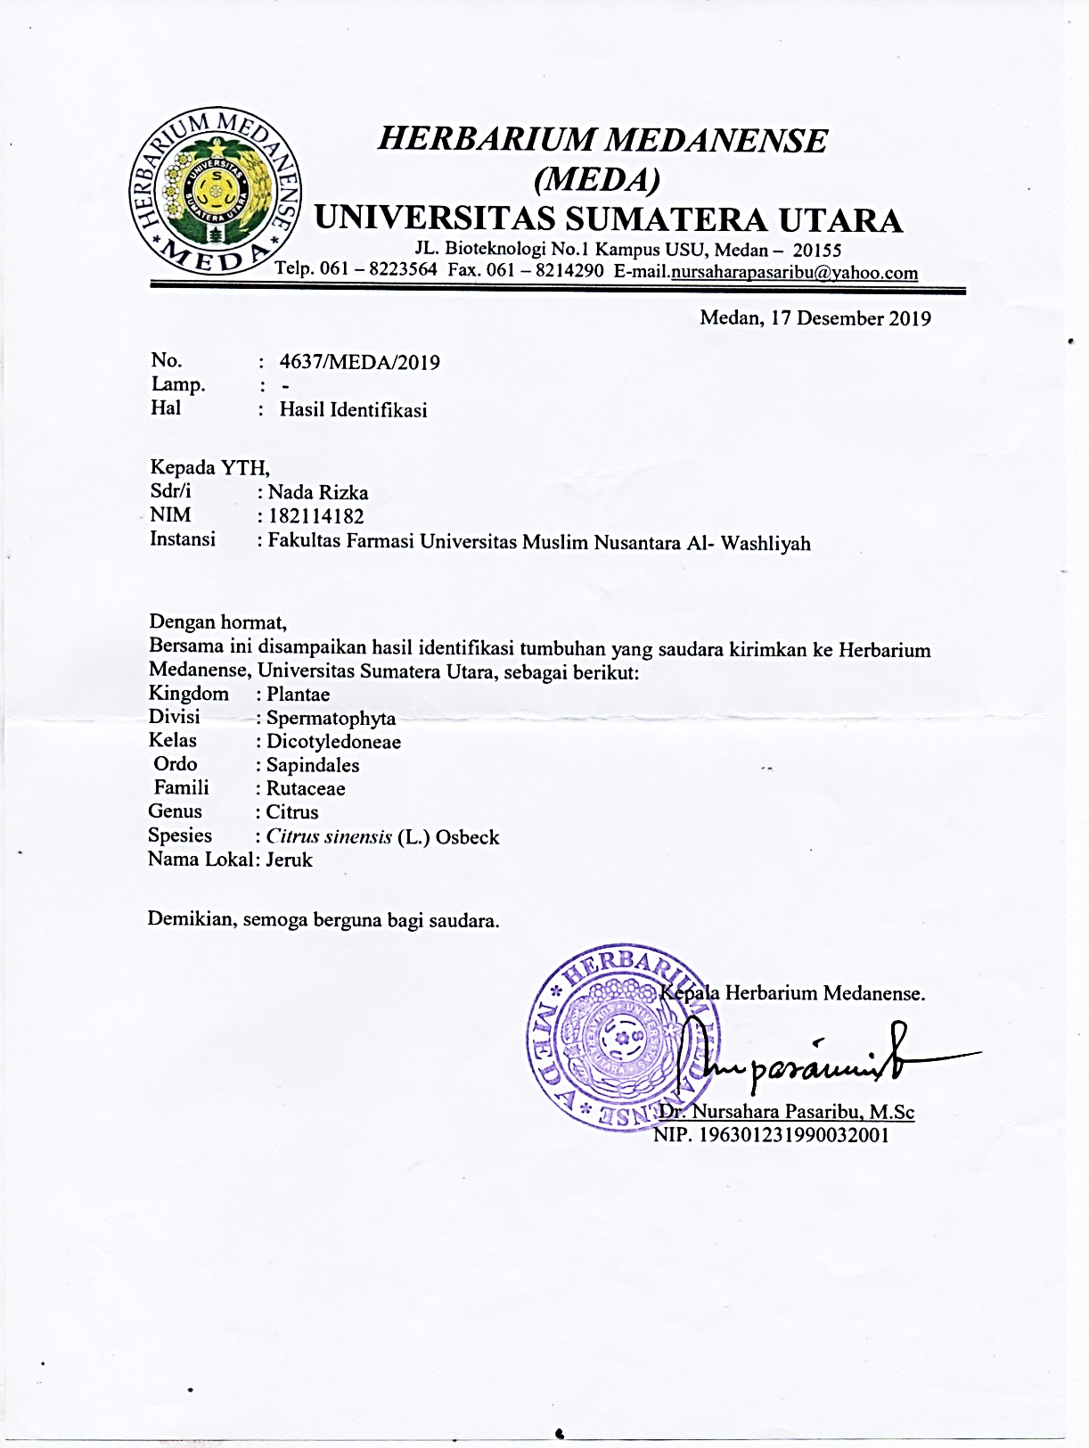

Lampiran 2. Etichal Clearance

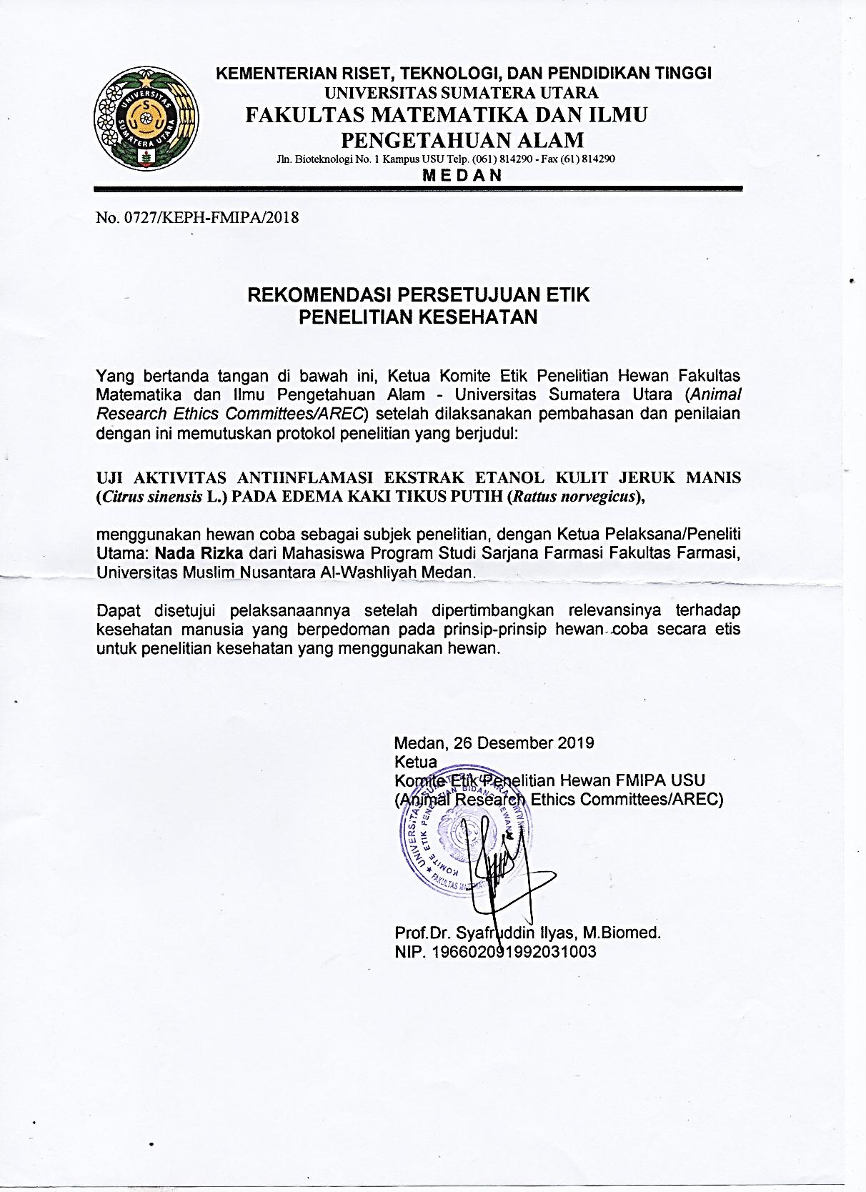

Lampiran 3. Pengolahan Sampel Kulit Jeruk Manis (Citrus sinensisn (L.) Osbeck

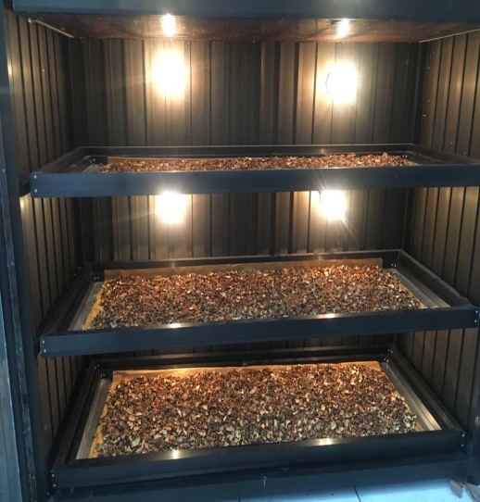
Proses pengeringan Kulit jeruk Manis

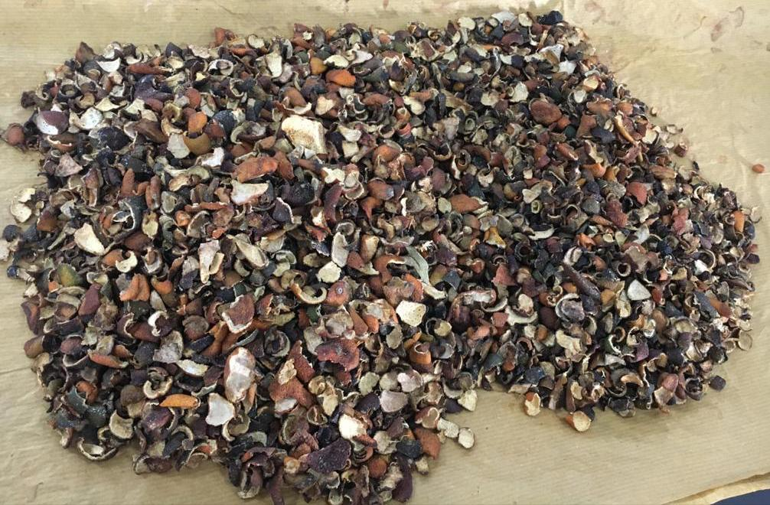
Simplisia kulit jeruk manis

Lampiran 3. (Lanjutan)

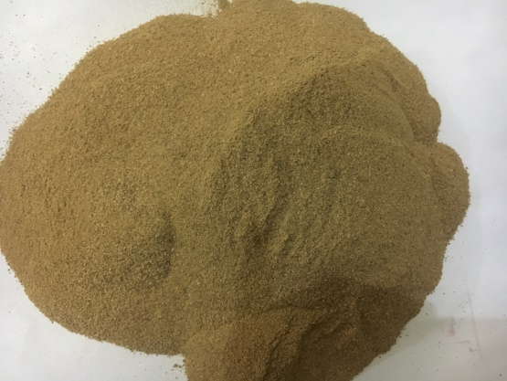
Serbuk Simplisia kulit jeruk manis

Lampiran 4. Pemeriksaan Makroskopis dan Mikroskopis Simplisia Kulit jeruk manis (Citrus sinensis L.) Osbeck)

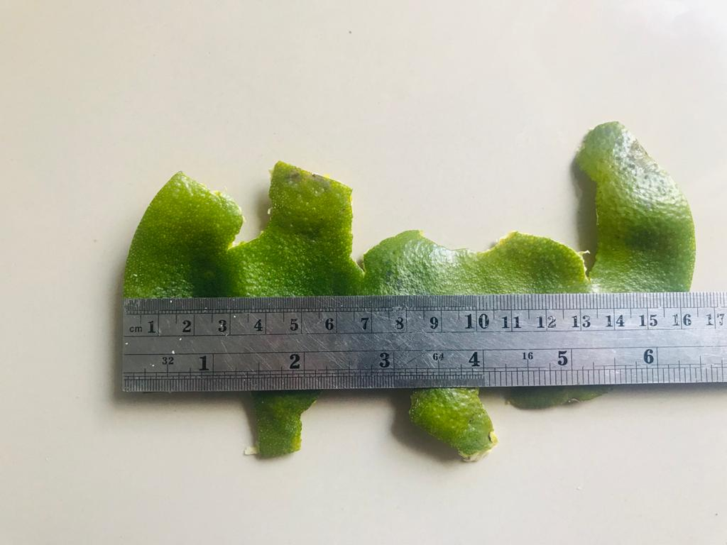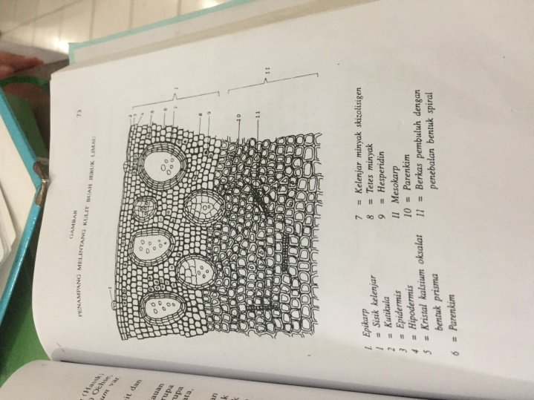
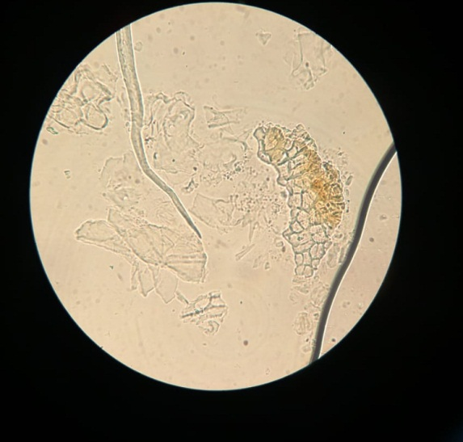
1
4
2
3
Perbesaran 10/0.25
Keterangan:
    - Epidermis
    - Stomata
    - Minyak atsiri
    - Kristal kalsium oksalat
Lampiran 5. Pengujian Hewan

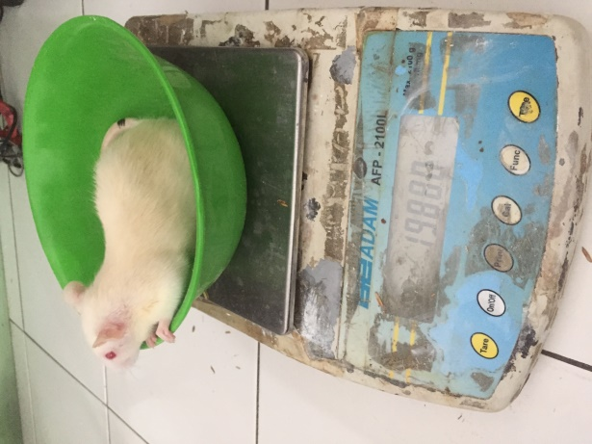
Timbangan tikus

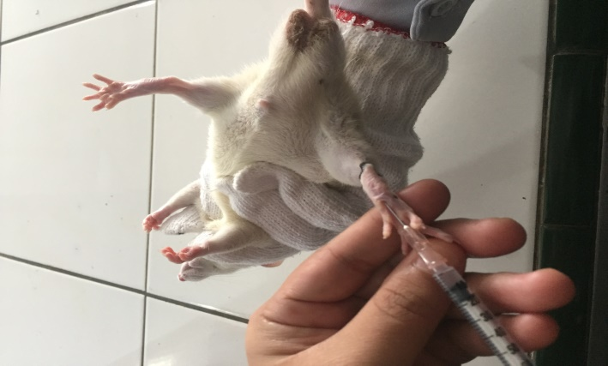
Penyuntikan kaki tikus secara intraplantar

Lampiran 5. (Lanjutan)
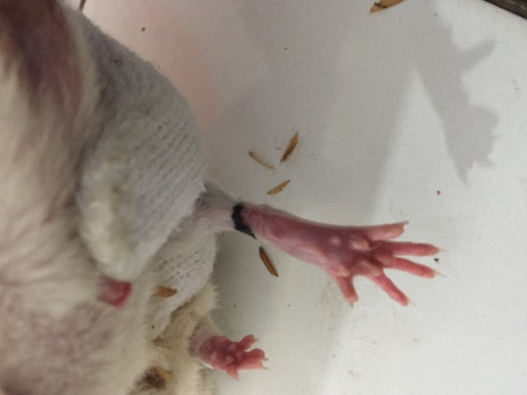
Kaki yang bengkak

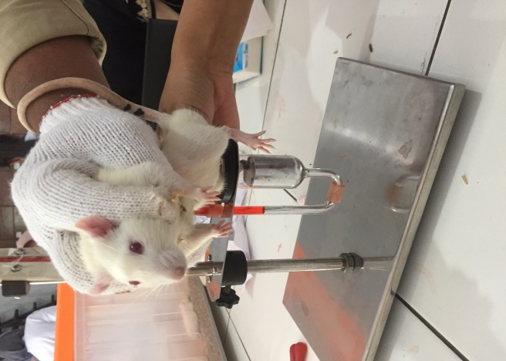
Pengukuran inflamasi dengan plestimometer

Lampiran 6. Bagan alir penelitian
Kulit Jeruk Manis

Dibersihkan
Dicuci bersih
Ditiriskan
Ditimbang
Kulit Jeruk Manis 6000 gr

Dikeringkan
Ditimbang
Simplisia kering 700 gr
Dihaluskan
Ditimbang
Serbuk simplisi 530 gr

Serbuk simplisia 500 gr
Pemeriksaan karakterisasi
Dilakukan skrining fitokimia serbuk dan ekstrak

Di maserasi
1. makroskopik
2. mikroskopik
3. penetapan kadar air
4.penetapan kadar sari larut dalam air
5.penetapan kadar sari larut dalam etanol
6.penetapan kadar abu total
7. penetapan kadar abu tidak larut dalam asam

Maserat
1. alkaloida
2. tanin
3. flavonida
4. glikosida
5. steroida/
triterpenoid
6. saponin

Diuapkan dengan
rotari evaporatory
Ekstrak kental 58,07 gr
Dilakukan uji antiinflamasi

Lampiran 7. Bagan alir pengujian farmakologi
25 ekor tikus putih jantan
Dipuasakan ± 18 jam

Kelompok 3
(5 ekor)
Kelompok 2
(5 ekor)
Kelompok 1
(5 ekor)
Kelompok 4
(5 ekor)
Kelompok 5
(5 ekor)

Pengukuran volume awal kaki tikus

Pengukuran volume awal 1 jam setelah pemberian λ-karagenan 1%

Diberi EEKJM 300 mg/kgBB
Diberi EEKJM 200 mg/kg BB
Kontrol positif diberi suspensi Na diklofenak

Kontrol negatif diberi suspensi CMC 0,5%
Diberi EEKJM 100 mg/kg BB

Pengukuran pengukuran volume kaki tikus setelah 1 jam sekali selama 6 jam

Analisis data

Lampiran 8. Perhitungan hasil pemeriksaan karakterisasi simplisia
- Perhitungan penetapan kadar air simplisia
Berat sampel | Volume awal | Volume akhir
5 g | 1.3 ml | 1.7 ml
5 g | 1.5 ml | 1.8 ml
5 g | 1.3 ml | 1.5 ml
% Kadar air simplisia = $\frac{Volume akhir-Volume awal}{Berat sampel}$ x 100%

- Berat simplisia I = 5 g
Volume air = 0.4 ml
% Kadar air = $\frac{1.7 ml-1.3 ml}{5 g}$ x 100% = 8 %

- Berat simplisia II = 5 g
Volume air = 0.3 ml
% Kadar air = $\frac{1,8 ml-1.5 ml}{5 g}$ x 100% = 6 %

- Berat simplisia III = 5 g
Volume air = 0.2 ml
% Kadar air = $\frac{1.5 ml-1.3ml}{5 g}$ x 100% = 4%

% Kadar air rata-rata = $\frac{8\%+ 6\%+4\%}{ 3}$ = 6%

Lampiran 8. (Lanjutan)
- Penetapan kadar sari larut dalam air
Berat sampel | Berat cawan kosong | Berat cawan berisi | Berat sari
5 g | 31.71 g | 31.98 g | 0.27 g
5 g | 31.74 g | 31.97 g | 0.23 g
5 g | 31.72 g | 31.98 g | 0.26 g
% Kadar sari larut dalam air = $\frac{\left(Berat cawan berisi - Berat cawan kosong\right) x 5}{Berat sampel}$ x 100%

- Berat simplisia I = 5 g
Berat sari = 0.27 g
% Kadar sari larut dalam air = $\frac{\left(31.98 g-31.71g\right)x 5}{5 g}$ x 100% = 27%

- Berat simplisia I I = 5 g
Berat sari = 0.35 g
% Kadar sari larut dalam air = $\frac{\left(31.97 g-31.74 g\right)x 5}{5 g}$ x 100% = 23%

- Berat simplisia I II = 5 g
Berat sari = 0.38 g
% Kadar sari larut dalam air = $\frac{\left(31.98 g-31.72 g\right)x 5}{5 g}$ x 100% = 26%

% Kadar sari rata-rata = $\frac{ 27\%+23\%+26\%}{3}$ = 25,3%

Lampiran 8. (Lanjutan)
- Penetapan kadar sari larut dalam etanol
Berat sampel | Berat cawan kosong | Berat cawan berisi | Berat sari
5 g | 32.30 g | 32.41 g | 0.11 g
5 g | 32.31 g | 32.40 g | 0.09 g
5 g | 32.32 g | 32.40 g | 0.08 g
% Kadar sari larut dalam etanol = $\frac{\left(Berat cawan berisi - Berat cawan kosong\right) x 5}{Berat sampel}$ x 100%

- Berat simplisia I = 5 g
Berat sari = 0.11 g
% Kadar sari larut etanol = $\frac{\left(34.41 g-32.30 g\right)x 5}{5 g}$ x 100% = 11%

- Berat simplisia I I = 5 g
Berat sari = 0.11 g
% Kadar sari larut etanol = $\frac{\left(32.40 g-32.31 g\right)x 5}{ 5 g}$ x 100% = 9%

- Berat simplisia I II = 5 g
Berat sari = 0.11 g
% Kadar sari larut etanol = $\frac{\left(32.40 g-32.32 g\right)x 5}{5 g}$ x 100% = 8%

% Kadar sari larut etanol rata-rata = $\frac{ 11\%+9\%+8\%}{3}$ = 9,33%

Lampiran 8. (Lanjutan)
- Penetapan kadar abu total
Berat sampel | Berat cawan kosong | Berat cawan berisi | Berat abu total
2 g | 60.04 g | 60.23 g | 0.19 g
2 g | 60.16 g | 60.22 g | 0.06 g
2 g | 59.19 g | 59.33 g | 0.04 g

% Kadar abu total = $\frac{\left(Berat cawan berisi - Berat cawan kosong\right)}{Berat sampel}$ x 100%

- Berat simplisia I = 2 g
Berat sari = 0.19 g
% Kadar abu total = $\frac{60.23 g-60.04 g}{2 g}$ x 100% = 9.5%

- Berat simplisia I I = 2 g
Berat sari = 0.06 g
% Kadar abu total = $\frac{60.22 g– 60.16 g}{2 g}$ x 100% = 3%

- Berat simplisia I II = 2 g
Berat sari = 0.04 g
% Kadar abu total = $\frac{59.23 g-59.19 g}{2 g}$ x 100% = 2%

% Kadar abu total rata-rata = $\frac{ 9.5\% + 3\% +2\%}{3}$ = 4.83%

Lampiran 8. (Lanjutan)
- Penetapan kadar abu tidak larut dalam asam
Berat sampel | Berat cawan kosong | Berat cawan berisi | Berat abu
2 g | 60.22 g | 60.23 g | 0.01 g
2 g | 60.21 g | 60.22 g | 0.01 g
2 g | 59.22 g | 59.23 g | 0.01 g

% Kadar abu tidak larut asam = $\frac{\left(Berat cawan berisi - Berat cawan kosong\right)}{Berat sampel}$ x 100%

- Berat simplisia I = 2 g
Berat sari = 0.01 g
% Kadar abu tidak larut asam = $\frac{60.23 g- 60.22 g}{2 g}$ x 100% = 0.5%

- Berat simplisia I I = 2 g
Berat sari = 0.01 g
% Kadar abu tidak larut asam = $\frac{60.22 g– 60.21 g}{2 g}$ x 100% = 0.5%

- Berat simplisia I II = 5 g
Berat sari = 0.01 g
% Kadar abu tidak larut asam = $\frac{59.23 g– 59.22 g}{2 g}$ x 100% = 0.5%

% Kadar abu tidak larut asam rata-rata = $\frac{ 0.5\% + 0.5\% + 0.5\%}{3}$ = 0.5%

Lampiran 9. Contoh Perhitungan Dosis
1. Perhitungan Dosis CMC 0,5%
CMC 0,5% = Jumlah cmc / Volume Suspensi
= 0,5 g / 100 ml
= 500 mg / 100 ml
= 5 mg / ml

Perhitungan CMC 0,5% pada tikus dengan BB =200 g
=$\frac{0,5}{100}$ x200 g
= 1 ml
2. Perhitungan Dosis Na Diklofenak
Konversi dosis dari manusia (70 kg) ke tikus (200 g) = 0,018
Dosis Na diklofenak untuk manusia dewasa dengan BB (70 kg) = 25 mg
Maka dosis pada tikus Na diklofenak = 25 mg x 0,018
= 0,45 mg / 0,2 kg
= 2,25 mg / kg BB
Konsentrasi Suspensi Na diklofenak
Suspensi Na diklofenak 0,025% = Jumlah Na diklofenak / Volume Suspensi
= 25 mg / 100 ml
= 0,25 mg/ml
Dosis untuk tikus (200 g) = $\frac{2,25 mg}{1000 g}$ x 200 g = 0,45 mg
Volume suspensi yang diambil = $\frac{Dosis Na diklofenak untuk tikus}{Konsentrasi suspensi Na diklofenak}$

= $\frac{0.45 mg}{0,25 mg/ml}$ = 1,8 ml

Lampiran 9. (Lanjutan)
3. Perhitungan Dosis EEKJM 100 mg/kg BB
- Konsentrasi suspensi EEKJM
Konsentrasi EEKJM 1% = Jumlah EEKJM / Volume Suspensi
= 1000 mg / 100 ml
= 10 mg/ml
- BB tikus 200 g atau 0,2 kg
- Perhitungan dosis 100 mg/kgBB
= $\frac{100}{1000}$ x 200 g
= 20 mg
Volume suspensi yang diberikan =$\frac{Dosis EEKJM}{Konsentrasi}$
= $\frac{20 mg}{10 mg/ml}$
= 2 ml
4. Perhitungan Dosis EEKJM 200 mg/kg BB
- Konsentrasi suspensi EEKJM
Konsentrasi EEKJM 2% = Jumlah EEKJM / Volume Suspensi
= 2000 mg / 100 ml
= 20 mg/ml
- BB tikus 200 g atau 0,2 kg
- Perhitungan dosis 200 mg/kgBB
= $\frac{200 mg}{1000 g}$ x 200 g
= 40 mg
- Volume suspensi yang diberikan =$\frac{Dosis EEKJM}{Konsentrasi}$
= $\frac{40 mg}{20 mg/ml}$
= 2 ml

Lampiran 9. (Lanjutan)
- Perhitungan Dosis EEKJM 300 mg/kg BB
- Konsentrasi suspensi EEKJM
Konsentrasi EEKJM 3% = Jumlah EEKJM / Volume Suspensi
= 3000 mg / 100 ml
= 30 mg/ml
- BB tikus 200 g atau 0,2 kg
- Perhitungan dosis 400 mg/kgBB
= $\frac{300 mg}{1000 g}$ x 200 g
= 60 mg
- Volume suspensi yang diberikan =$\frac{Dosis EEKJM}{Konsentrasi}$
= $\frac{60 mg}{30 mg/ml}$
= 2 ml

Lampiran 10. Contoh Perhitungan Persen Radang dan Persen Inhibisi Radang
- Persen Radang
$$\frac{Vt-V0}{V0}$$
Vt =Volume radang setelah waktu t
V0 = Volume awal kaki tikus
Misalnya:
Ekstrak kulit jeruk manis dosis 100 mg/kg BB pada menit ke- 60
Diketahui:
Vt = 0.077
Vo =0.06
$\frac{0.053-0.048}{0.048}$x 100% = 10.416
- Persen Inhibisi Radang
(%IR) = $\frac{a-b}{a}$x 100%
a = Persen radang rata-rata kelompok kontrol
b= Persen radang rata-rata kelompok perlakuan mendapat bahan uji atau obat pembanding
Misalnya
Ekstrak etanol kulit jeruk manis dosis 100 mg/kg BB pada menit ke 60
a= 16.68
b= 6.48
Persen radang inhibisi =$\frac{16.68-6.48}{6.48}$x 100%= 16.151

Lampiran 11. Tabel konversi dosis (g); tabel volume maksimum lambung pada hewan (ml) dan contoh perhitungan dosis parasetamol
Konvesi | Mencit 20 g | Tikus 200 g | Marmut 400 g | Kelinci 1,5 kg | Kucing 1,5 kg | Kera 4 kg | Anjing 12 kg | Manusi 70 kg
Mencit 20 g | 1,0 | 7,0 | 12,23 | 27,80 | 29,70 | 64,10 | 124,20 | 387,9
Tikus 200 g | 0,14 | 1,0 | 1,74 | 3,90 | 4,20 | 9,20 | 17,80 | 56,0
Marmut 400 g | 0,08 | 0,57 | 1,0 | 2,25 | 2,40 | 5,20 | 10,20 | 31,50
Kelinci 1,5 g | 0,04 | 0,25 | 0,44 | 1,0 | 1,08 | 2,40 | 4,50 | 14,20
Kucing 1,5 g | 0,03 | 0,23 | 0,41 | 0,92 | 1,0 | 2,20 | 4,10 | 13,0
Kera 4kg | 0,016 | 0,11 | 0,19 | 0,42 | 0,43 | 0,1 | 1,9 | 6,1
Anjing 12 kg | 0,008 | 0,06 | 0,10 | 0,22 | 1,24 | 0,52 | 1,0 | 3,10
Manusia 70 kg | 0,0026 | 0,018 | 0,031 | 0,07 | 0,076 | 0,16 | 0,32 | 1,0

Lampiran 11. (Lanjutan)
Tabel konversi dosis hewan percobaan dengan manusia
Jenis hewan uji | Volume maksimum (ml) sesuai jalur pemberian
 | i.v | i.m | i.p | s.c | p.o
Mencit  (20-30 g) | 0,5 | 0,05 | 1,0 | 0,5-1,0 | 1,0
Tikus  (200 g) | 1,0 | 0,1 | 2-5 | 2-5 | 5,0
Hamster  (50 g) | - | 0,1 | 1-2 | 2,5 | 2,5
Maemut  (250 g) | - | 0,25 | 2-5 | 5,0 | 10,0
Kelinci  (3 kg) | 5-10 | 0,5 | 10-20 | 5-10 | 20,0
Kucing  (3 kg) | 5-10 | 1,0 | 10-20 | 5-10 | 50,0
Anjing  (5 kg) | 10-20 | 5,0 | 20-50 | 10,0 | 100,0

Lampiran 12. Data Perlakuan Hewan Uji
Perlakuan | Vo | 60 menit |  | 120 menit |  | 180 menit |  | 240 menit |  | 300 menit |  | 360 menit
 |  | V1 | % Radang | V2 | % Radang | V3 | % Radang | V4 | % Radang | V5 | % Radang | V6 | % Radang
CMC  0,5% | 0,046  0,05  0,044  0,062  0,058 | 0,055  0,059  0,051  0,072  0,066 | 19,57  18,00  15,91  16,13  13,79 | 0,062  0,069  0,06  0,083  0,081 | 34,78  38,00  36,36  33,87  39,66 | 0,067  0,073  0,063  0,088  0,084 | 45,65  46,00  43,18  41,94  44,83 | 0,077  0,079  0,073  0,092  0,098 | 67,39  58,00  65,91  48,39  68,97 | 0,081  0,084  0,079  0,096  0,102 | 76,09  68,00  79,55  54,84  75,86 | 0,088  0,086  0,082  0,105  0,11 | 91,30  72,00  86,36  69,35  89,66
Rata-rata |  |  | 16,68 |  | 36,53 |  | 44,32 |  | 61,73 |  | 70,87 |  | 81,74
Na Diklofenak | 0,062  0,06  0,057  0,047  0,051 | 0,066  0,063  0,061  0,051  0,053 | 6,45  5,12  7,92  8,61  3,99 | 0,07  0,068  0,066  0,055  0,061 | 12,90  17,33  19,03  19,02  19,10 | 0,076  0,73  0,071  0,061  0,064 | 22,98  22,87  28,96  29,79  28,49 | 0,083  0,081  0,078  0,068  0,067 | 33,97  35,97  36,99  44,98  35,97 | 0,075  0,071  0,067  0,057  0,061 | 20,97  18,49  20,56  21,28  19,61 | 0,069  0,066  0,062  0,053  0,055 | 11,29  10,09  8,07  12,07  7,44
Rata-rata |  |  | 6,48 |  | 17,47 |  | 26,61 |  | 37,63 |  | 20,19 |  | 9,79
EEKJM 100 mg/kg bb | 0,048  0,054  0,058  0,062  0,056 | 0,053  0,062  0,069  0,068  0,065 | 10,42  14,81  18,97  9,68  16,07 | 0,059  0,067  0,073  0,081  0,071 | 22,92  24,07  25,86  30,68  26,79 | 0,068  0,074  0,079  0,086  0,075 | 41,67  37,04  36,21  38,71  33,93 | 0,076  0,080  0,084  0,091  0,086 | 58,33  48,15  44,83  46,77  53,57 | 0,073  0,078  0,080  0,086  0,079 | 52,08  44,46  37,93  38,71  41,07 | 0,069  0,075  0,077  0,081  0,072 | 43,75  38,89  32,76  30,65  28,57
Rata-rata |  |  | 13,99 |  | 26,06 |  | 37,51 |  | 50,33 |  | 42,85 |  | 34,92
EEKJM 200 | 0,054  0,062  0,061  0,043  0,047 | 0,063  0,068  0,066  0,049  0,052 | 16,67  9,68  8,20  13,95  9,70 | 0,069  0,075  0,071  0,054  0,058 | 27,78  20,97  16,39  25,58  22,38 | 0,075  0,083  0,082  0,059  0,063 | 38,89  33,87  34,43  37,21  32,91 | 0,079  0,088  0,086  0,065  0,068 | 46,30  41,94  40,98  51,16  43,48 | 0,074  0,082  0,080  0,058  0,061 | 37,04  32,26  31,15  34,88  28,69 | 0,071  0,078  0,076  0,052  0,056 | 31,48  25,81  24,59  20,93  18,14
Rata-rata |  |  | 11,64 |  | 22,62 |  | 35,46 |  | 44,77 |  | 32,80 |  | 24,19
EEKJM 300 mg/kg bb | 0,063  0,059  0,047  0,061  0,056 | 0,068  0,066  0,051  0,065  0,063 | 7,94  11,86  8,51  6,56  12,50 | 0,074  0,071  0,056  0,072  0,069 | 17,46  20,34  19,15  18,03  23,21 | 0,081  0,075  0,059  0,074  0,077 | 28,57  27,12  25,53  21,31  37,52 | 0,087  0,083  0,064  0,084  0,080 | 38,10  40,68  36,17  37,70  42,86 | 0,084  0,075  0,058  0,079  0,068 | 33,33  27,12  23,40  29,51  21,44 | 0,075  0,068  0,052  0,069  0,063 | 19,05  15,25  10,64  13,11  12,50
Rata-rata |  |  | 9,47 |  | 19,63 |  | 28,01 |  | 39,10 |  | 26,96 |  | 14,11

Lampiran 13. Hasil Uji Normalitas Radang
Tests of Normality
 | Kelompok | Kolmogorov-Smirnovª |  |  | Shapiro-Wilk
 |  | Statistic | df | Sig. | Statistic | df | Sig.
Menit_60 | CMC Na | .199 | 5 | .200* | .977 | 5 | .915
 | Na Diklofenak | .160 | 5 | .200* | .985 | 5 | .960
 | EEKJM 100 mg/kg bb | .219 | 5 | .200* | .930 | 5 | .594
 | EEKJM 200 mg/kg bb | .308 | 5 | .136 | .886 | 5 | .336
 | EEKJM 300 mg/kg bb | .246 | 5 | .200* | .900 | 5 | .408
Menit_120 | CMC Na | .172 | 5 | .200* | .967 | 5 | .856
 | Na Diklofenak | .208 | 5 | .200* | .939 | 5 | .658
 | EEKJM 100 mg/kg bb | .203 | 5 | .200* | .947 | 5 | .714
 | EEKJM 200 mg/kg bb | .154 | 5 | .200* | .979 | 5 | .931
 | EEKJM 300 mg/kg bb | .185 | 5 | .200* | .921 | 5 | .537
Menit_180 | CMC Na | .217 | 5 | .200* | .919 | 5 | .521
 | Na Diklofenak | .216 | 5 | .200* | .926 | 5 | .572
 | EEKJM 100 mg/kg bb | .165 | 5 | .200* | .987 | 5 | .968
 | EEKJM 200 mg/kg bb | .260 | 5 | .200* | .917 | 5 | .512
 | EEKJM 300 mg/kg bb | .262 | 5 | .200* | .929 | 5 | .590
Menit_240 | CMC Na | .287 | 5 | .200* | .865 | 5 | .248
 | Na Diklofenak | .262 | 5 | .200* | .893 | 5 | .373
 | EEKJM 100 mg/kg bb | .253 | 5 | .200* | .922 | 5 | .543
 | EEKJM 200 mg/kg bb | .225 | 5 | .200* | .909 | 5 | .460
 | EEKJM 300 mg/kg bb | .247 | 5 | .200* | .947 | 5 | .715
Menit_300 | CMC Na | .293 | 5 | .186 | .860 | 5 | .228
 | Na Diklofenak | .162 | 5 | .200* | .956 | 5 | .778
 | EEKJM 100 mg/kg bb | .221 | 5 | .200* | .880 | 5 | .310
 | EEKJM 200 mg/kg bb | .166 | 5 | .200* | .986 | 5 | .962
 | EEKJM 300 mg/kg bb | .173 | 5 | .200* | .975 | 5 | .903
Menit_360 | CMC Na | .273 | 5 | .200* | .838 | 5 | .161
 | Na Diklofenak | .156 | 5 | .200* | .978 | 5 | .926
 | EEKJM 100 mg/kg bb | .235 | 5 | .200* | .929 | 5 | .593
 | EEKJM 200 mg/kg bb | .175 | 5 | .200* | .978 | 5 | .923
 | EEKJM 300 mg/kg bb | .222 | 5 | .200* | .946 | 5 | .709
*. This is a lower bound of the true significance.
a. Lilliefors Significance Correction

Lanjutan 13. (Lanjutan)

Test of Homogeneity of Variances
 | Levene Statistic | df1 | df2 | Sig.
Menit_60 | 1.978 | 4 | 20 | .137
Menit_120 | .655 | 4 | 20 | .630
Menit_180 | 1.037 | 4 | 20 | .413
Menit_240 | 2.190 | 4 | 20 | .107
Menit_300 | 2.695 | 4 | 20 | .060
Menit_360 | 7.616 | 4 | 20 | .001

ANOVA
 |  | Sum of Squares | Df | Mean Square | F | Sig.
Menit_60 | Between Groups | 327.081 | 4 | 81.770 | 9.627 | .000
 | Within Groups | 169.869 | 20 | 8.493
 | Total | 496.950 | 24
Menit_120 | Between Groups | 1253.028 | 4 | 313.257 | 33.704 | .000
 | Within Groups | 185.886 | 20 | 9.294
 | Total | 1438.914 | 24
Menit_180 | Between Groups | 1206.042 | 4 | 301.510 | 23.875 | .000
 | Within Groups | 252.571 | 20 | 12.629
 | Total | 1458.613 | 24
Menit_240 | Between Groups | 2036.928 | 4 | 509.232 | 16.592 | .000
 | Within Groups | 613.811 | 20 | 30.691
 | Total | 2650.739 | 24
Menit_300 | Between Groups | 7877.096 | 4 | 1969.274 | 58.007 | .000
 | Within Groups | 678.983 | 20 | 33.949
 | Total | 8556.079 | 24
Menit_360 | Between Groups | 16680.025 | 4 | 4170.006 | 112.594 | .000
 | Within Groups | 740.715 | 20 | 37.036
 | Total | 17420.740 | 24

Lanjutan 13. (Lanjutan)

Homogeneous Subsets

Menit_60
Tukey HSDª
Kelompok | N | Subset for alpha = 0.05
 |  | 1 | 2 | 3
Na Diklofenak | 5 | 6.4800
EEKJM 300 mg/kg bb | 5 | 9.4740 | 9.4740
EEKJM 200 mg/kg bb | 5 | 11.6400 | 11.6400 | 11.6400
EEKJM 100 mg/kg bb | 5 |  | 13.9900 | 13.9900
CMC Na | 5 |  |  | 16.6800
Sig. |  | .053 | .143 | .084
Means for groups in homogeneous subsets are displayed.
a. Uses Harmonic Mean Sample Size = 5.000.

Menit_120
Tukey HSDª
Kelompok | N | Subset for alpha = 0.05
 |  | 1 | 2 | 3 | 4
Na Diklofenak | 5 | 17.4700
EEKJM 300 mg/kg bb | 5 | 19.6380 | 19.6380
EEKJM 200 mg/kg bb | 5 |  | 22.6260 | 22.6260
EEKJM 100 mg/kg bb | 5 |  |  | 26.0680
CMC Na | 5 |  |  |  | 36.5340
Sig. |  | .290 | .547 | .409 | 1.000
Means for groups in homogeneous subsets are displayed.
a. Uses Harmonic Mean Sample Size = 5.000.

Lanjutan 13. (Lanjutan)
Menit_180
Tukey HSDª
Kelompok | N | Subset for alpha = 0.05
 |  | 1 | 2 | 3
Na Diklofenak | 5 | 26.6180
EEKJM 300 mg/kg bb | 5 | 28.0160
EEKJM 200 mg/kg bb | 5 |  | 35.4620
EEKJM 100 mg/kg bb | 5 |  | 37.5120
CMC Na | 5 |  |  | 44.3200
Sig. |  | .624 | .889 | 1.000
Means for groups in homogeneous subsets are displayed.
a. Uses Harmonic Mean Sample Size = 5.000.

Menit_240
Tukey HSDª
Kelompok | N | Subset for alpha = 0.05
 |  | 1 | 2 | 3
Na Diklofenak | 5 | 37.6320
EEKJM 300 mg/kg bb | 5 | 39.1020
EEKJM 200 mg/kg bb | 5 | 44.7780 | 44.7780
EEKJM 100 mg/kg bb | 5 |  | 50.3300
CMC Na | 5 |  |  | 61.7320
Sig. |  | .156 | .522 | 1.000
Means for groups in homogeneous subsets are displayed.
a. Uses Harmonic Mean Sample Size = 5.000.

Menit_300
Tukey HSDª
Kelompok | N | Subset for alpha = 0.05
 |  | 1 | 2 | 3 | 4
Na Diklofenak | 5 | 20.1900
EEKJM 300 mg/kg bb | 5 | 26.9680 | 26.9680
EEKJM 200 mg/kg bb | 5 |  | 32.8040 | 32.8040
EEKJM 100 mg/kg bb | 5 |  |  | 42.8560
CMC Na | 5 |  |  |  | 70.8780
Sig. |  | .351 | .522 | .085 | 1.000
Means for groups in homogeneous subsets are displayed.
a. Uses Harmonic Mean Sample Size = 5.000.
Lampiran 13. (Lanjutan)
Menit_360
Tukey HSDª
Kelompok | N | Subset for alpha = 0.05
 |  | 1 | 2 | 3 | 4
Na Diklofenak | 5 | 9.7940
EEKJM 300 mg/kg bb | 5 | 14.1100 | 14.1100
EEKJM 200 mg/kg bb | 5 |  | 24.1900 | 24.1900
EEKJM 100 mg/kg bb | 5 |  |  | 34.9240
CMC Na | 5 |  |  |  | 81.7440
Sig. |  | .837 | .104 | .075 | 1.000
Means for groups in homogeneous subsets are displayed.
a. Uses Harmonic Mean Sample Size = 5.000.

Lampiran 14. Hasil Uji Normalitas Inhibisi
Tests of Normality
 | Kelompok | Kolmogorov-Smirnovª |  |  | Shapiro-Wilk
 |  | Statistic | df | Sig. | Statistic | df | Sig.
Menit_60 | CMC Na | .199 | 5 | .200* | .977 | 5 | .915
 | Na Diklofenak | .160 | 5 | .200* | .985 | 5 | .960
 | EEKJM 100 mg/kg bb | .219 | 5 | .200* | .930 | 5 | .594
 | EEKJM 200 mg/kg bb | .308 | 5 | .136 | .886 | 5 | .336
 | EEKJM 300 mg/kg bb | .246 | 5 | .200* | .900 | 5 | .408
Menit_120 | CMC Na | .172 | 5 | .200* | .967 | 5 | .856
 | Na Diklofenak | .208 | 5 | .200* | .939 | 5 | .658
 | EEKJM 100 mg/kg bb | .203 | 5 | .200* | .947 | 5 | .714
 | EEKJM 200 mg/kg bb | .154 | 5 | .200* | .979 | 5 | .931
 | EEKJM 300 mg/kg bb | .185 | 5 | .200* | .921 | 5 | .537
Menit_180 | CMC Na | .217 | 5 | .200* | .919 | 5 | .521
 | Na Diklofenak | .216 | 5 | .200* | .926 | 5 | .572
 | EEKJM 100 mg/kg bb | .165 | 5 | .200* | .987 | 5 | .968
 | EEKJM 200 mg/kg bb | .260 | 5 | .200* | .917 | 5 | .512
 | EEKJM 300 mg/kg bb | .262 | 5 | .200* | .929 | 5 | .590
Menit_240 | CMC Na | .287 | 5 | .200* | .865 | 5 | .248
 | Na Diklofenak | .262 | 5 | .200* | .893 | 5 | .373
 | EEKJM 100 mg/kg bb | .253 | 5 | .200* | .922 | 5 | .543
 | EEKJM 200 mg/kg bb | .225 | 5 | .200* | .909 | 5 | .460
 | EEKJM 300 mg/kg bb | .247 | 5 | .200* | .947 | 5 | .715
Menit_300 | CMC Na | .293 | 5 | .186 | .860 | 5 | .228
 | Na Diklofenak | .162 | 5 | .200* | .956 | 5 | .778
 | EEKJM 100 mg/kg bb | .221 | 5 | .200* | .880 | 5 | .310
 | EEKJM 200 mg/kg bb | .166 | 5 | .200* | .986 | 5 | .962
 | EEKJM 300 mg/kg bb | .173 | 5 | .200* | .975 | 5 | .903
Menit_360 | CMC Na | .273 | 5 | .200* | .838 | 5 | .161
 | Na Diklofenak | .156 | 5 | .200* | .978 | 5 | .926
 | EEKJM 100 mg/kg bb | .235 | 5 | .200* | .929 | 5 | .593
 | EEKJM 200 mg/kg bb | .175 | 5 | .200* | .978 | 5 | .923
 | EEKJM 300 mg/kg bb | .222 | 5 | .200* | .946 | 5 | .709
*. This is a lower bound of the true significance.
- Lilliefors Significance Correction

Lanjutan 14. (Lanjutan)
Test of Homogeneity of Variances
 | Levene Statistic | df1 | df2 | Sig.
Menit_60 | .853 | 3 | 16 | .485
Menit_120 | 4.037 | 3 | 16 | .026
Menit_180 | .265 | 3 | 16 | .850
Menit_240 | .394 | 3 | 16 | .759
Menit_300 | .696 | 3 | 16 | .568
Menit_360 | 1.451 | 3 | 16 | .265

ANOVA
 |  | Sum of Squares | df | Mean Square | F | Sig.
Menit_60 | Between Groups | 3763.365 | 3 | 1254.455 | 4.844 | .014
 | Within Groups | 4143.467 | 16 | 258.967
 | Total | 7906.832 | 19
Menit_120 | Between Groups | 2241.847 | 3 | 747.282 | 7.626 | .002
 | Within Groups | 1567.881 | 16 | 97.993
 | Total | 3809.728 | 19
Menit_180 | Between Groups | 2762.991 | 3 | 920.997 | 10.974 | .000
 | Within Groups | 1342.815 | 16 | 83.926
 | Total | 4105.806 | 19
Menit_240 | Between Groups | 1367.268 | 3 | 455.756 | 2.539 | .093
 | Within Groups | 2871.904 | 16 | 179.494
 | Total | 4239.171 | 19
Menit_300 | Between Groups | 2906.848 | 3 | 968.949 | 10.896 | .000
 | Within Groups | 1422.824 | 16 | 88.927
 | Total | 4329.673 | 19
Menit_360 | Between Groups | 2797.775 | 3 | 932.592 | 26.155 | .000
 | Within Groups | 570.503 | 16 | 35.656
 | Total | 3368.278 | 19

Lampiran 14. (Lanjutan)

Homogeneous Subsets

Menit_60
Tukey HSDª
Kelompok | N | Subset for alpha = 0.05
 |  | 1 | 2
EEKJM 100 mg/kg bb | 5 | 16.1270
EEKJM 200 mg/kg bb | 5 | 30.2158
EEKJM 300 mg/kg bb | 5 | 43.2254 | 43.2254
Na Diklofenak | 5 |  | 61.1510
Sig. |  | .548 | .206
Means for groups in homogeneous subsets are displayed.
a. Uses Harmonic Mean Sample Size = 5.000.

Menit_120
Tukey HSDª
Kelompok | N | Subset for alpha = 0.05
 |  | 1 | 2 | 3
EEKJM 100 mg/kg bb | 5 | 28.6613
EEKJM 200 mg/kg bb | 5 | 38.0782 | 38.0782
EEKJM 300 mg/kg bb | 5 |  | 46.2633 | 46.2633
Na Diklofenak | 5 |  |  | 52.1762
Sig. |  | .471 | .516 | .361
Means for groups in homogeneous subsets are displayed.
a. Uses Harmonic Mean Sample Size = 5.000.

Menit_180
Tukey HSDª
Kelompok | N | Subset for alpha = 0.05
 |  | 1 | 2
EEKJM 100 mg/kg bb | 5 | 15.3655
EEKJM 200 mg/kg bb | 5 | 19.9909
EEKJM 300 mg/kg bb | 5 |  | 36.8005
Na Diklofenak | 5 |  | 39.9593
Sig. |  | .857 | .655
Means for groups in homogeneous subsets are displayed.
a. Uses Harmonic Mean Sample Size = 5.000.
Lampiran 14. (Lanjutan)
Menit_240
Tukey HSDª
Kelompok | N | Subset for alpha = 0.05
 |  | 1
EEKJM 100 mg/kg bb | 5 | 18.4675
EEKJM 200 mg/kg bb | 5 | 27.4744
EEKJM 300 mg/kg bb | 5 | 36.6596
Na Diklofenak | 5 | 39.0409
Sig. |  | .091
Means for groups in homogeneous subsets are displayed.
a. Uses Harmonic Mean Sample Size = 5.000.

Menit_300
Tukey HSDª
Kelompok | N | Subset for alpha = 0.05
 |  | 1 | 2 | 3
EEKJM 100 mg/kg bb | 5 | 39.5371
EEKJM 200 mg/kg bb | 5 | 53.7180 | 53.7180
EEKJM 300 mg/kg bb | 5 |  | 61.9585 | 61.9585
Na Diklofenak | 5 |  |  | 71.5112
Sig. |  | .132 | .521 | .305
Means for groups in homogeneous subsets are displayed.
a. Uses Harmonic Mean Sample Size = 5.000.

Menit_360
Tukey HSDª
Kelompok | N | Subset for alpha = 0.05
 |  | 1 | 2 | 3
EEKJM 100 mg/kg bb | 5 | 57.2791
EEKJM 200 mg/kg bb | 5 |  | 70.4061
EEKJM 300 mg/kg bb | 5 |  |  | 82.7379
Na Diklofenak | 5 |  |  | 88.0229
Sig. |  | 1.000 | 1.000 | .605
Means for groups in homogeneous subsets are displayed.
a. Uses Harmonic Mean Sample Size = 5.000.

