**Lampiran 1.** Surat Determinasi Strawberry

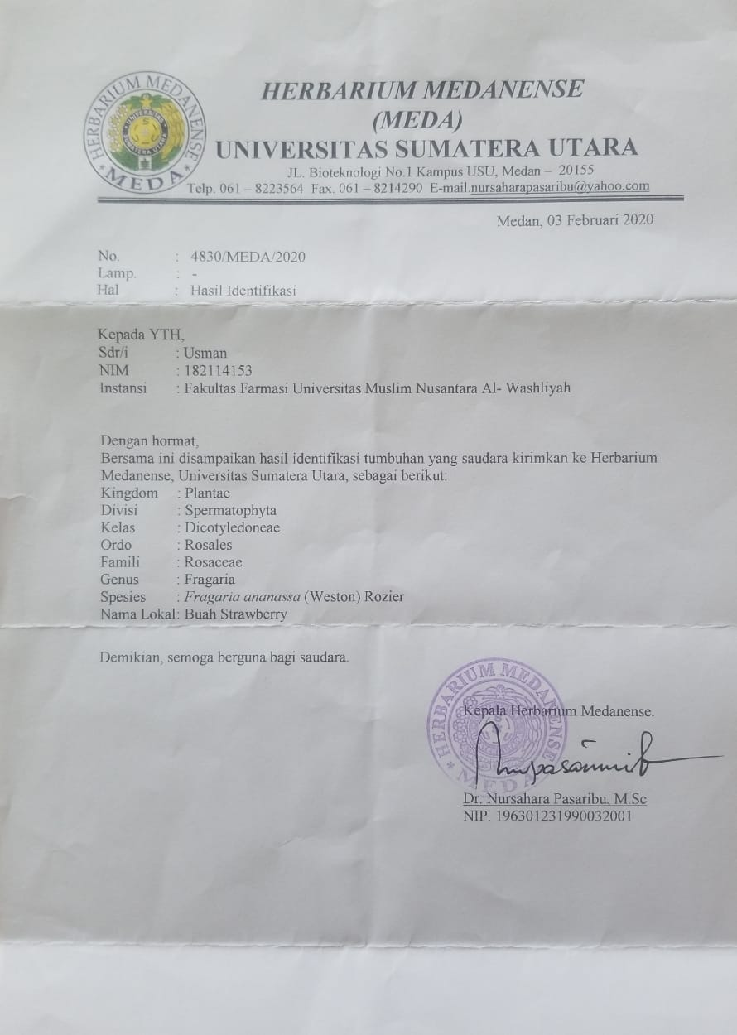

**Lampiran 2.** Surat Keterangan Laboratorium LPPOM MUI Kota Medan

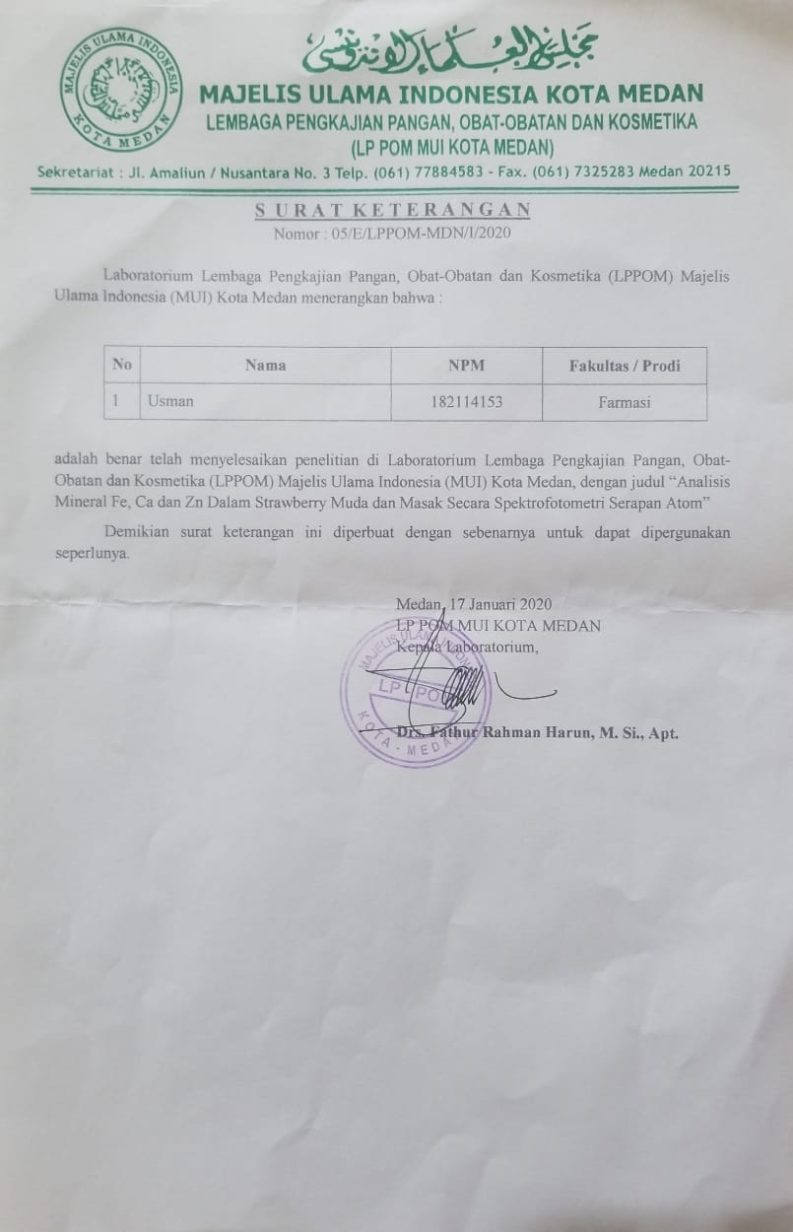

**Lampiran 3.** Bagan Alir Proses Destruksi Basah Sampel

Sampel Buah Strawberry

Buah strawberry dikupas kulitnya

Daging strawberry dicuci lalu di haluskan

Ditimbang seksama sebanyak 25 gram

Dimasukkan dalam erlenmayer

Ditambahkan HNO3 psebanyak 20 mL

Didiamkan selama 4 jam

Di destruksi diatas hot plate sampai destruksi sempurna

Larutan Sampel

**Lampiran 4.** Bagan Alir Proses Pembuatan Larutan sampel

Sampel Hasil Dekstruksi

Disaring dengan kertas saring whatman no.42

Dimasukkan kedalam labu tentukur 100 mL  
Dicukupkan dengan aqua demineralisata sampai garis tanda

Larutan Sampel

Dilakukan analisis kuantitatif

Diukur pada panjang gelombang 248,3 nm untuk besi, 422,7 untuk kalsium dan 213,9 untuk seng

Hasil

**Lampiran 5.** Bagan Alir Pembuatan Kurva Kalibrasi Besi

Larutan standar besi

Di pipet 1 mL

Dimasukkan ke dalam labu tentukur 100mL

Dicukupkan dengan aqua demineralisata hingga garis tanda

LIB I (10 µg/mL)

Dipipet masing-masing 1,6 mL; 3,2 mL; 4,8 mL; 6,4 mL; 8 mL

Dimasukkan kedalam labu tentukur 50 mL

Dicukupkan dengan aqua demineralisata hingga garis tanda ( konsentrasi masing-masing 1,6 µg/mL; 3,2 µg/mL; 4,8 µg/mL; 6,4 µg/mL; dan 8 µg/mL

Dilakukan analisis kuantitatif dengan spektrofotometri serapan atom pada panjang gelombang 248,3 nm

Hasil

**Lampiran 6.** Bagan Alir Pembuatan Kurva Kalibrasi Kalsium

Larutan standar kalsium

Di pipet 1 mL

Dimasukkan ke dalam labu tentukur 100mL

Dicukupkan dengan aqua demineralisata hingga garis tanda

LIB I (10 µg/mL)

Dipipet masing-masing 1 mL; 2 mL; 3 mL; 4 mL; 5 mL

Dimasukkan kedalam labu tentukur 10 mL

Dicukupkan dengan aqua demineralisata hingga garis tanda ( konsentrasi masing-masing 1 µg/mL; 2 µg/mL; 3 µg/mL; 4 µg/mL; dan 5 µg/mL

Dilakukan analisis kuantitatif dengan spektrofotometri serapan atom pada panjang gelombang 422,7 nm

Hasil

**Lampiran 7.** Bagan Alir Pembuatan Kurva Kalibrasi Seng

Larutan standar seng

Di pipet 1 mL

Dimasukkan ke dalam labu tentukur 100mL

Dicukupkan dengan aqua demineralisata hingga garis tanda

LIB I (10 µg/mL)

Dipipet masing-masing 1 mL; 2 mL; 3 mL; 4 mL; 5 mL

Dimasukkan kedalam labu tentukur 50 mL

Dicukupkan dengan aqua demineralisata hingga garis tanda ( konsentrasi masing-masing 0,2 µg/mL; 0,4 µg/mL; 0,6 µg/mL; dan 0,8 µg/mL; 1 µg/mL

Dilakukan analisis kuantitatif dengan spektrofotometri serapan atom pada panjang gelombang 213,9 nm

Hasil

**Lampiran 8.** Data Hasil pengukuran Absorbansi Larutan Standar Besi, Kalsium dan Seng

1. Data hasil pengkuran absorbansi larutan besi

|  |  |
| --- | --- |
| Konsentrasi (µg/mL)  (X) | Absorbansi  (Y) |
| 1,6000 | 0.0542 |
| 3.2000 | 0,1310 |
| 4,8000 | 0,1973 |
| 6,4000 | 0,2529 |
| 8,0000 | 0,3066 |

1. Data hasil pengkuran absorbansi larutan kalsium

|  |  |
| --- | --- |
| Konsentrasi (µg/mL)  (X) | Absorbansi  (Y) |
| 1,0000 | 0,0072 |
| 2,0000 | 0,0191 |
| 3,0000 | 0,0272 |
| 4,0000 | 0,0337 |
| 5,0000 | 0,0429 |

1. Data hasil pengkuran absorbansi larutan seng

|  |  |
| --- | --- |
| Konsentrasi (µg/mL)  (X) | Absorbansi  (Y) |
| 0,2000 | 0,0907 |
| 0,4000 | 0,2290 |
| 0,6000 | 0,3549 |
| 0,8000 | 0,4672 |
| 1,0000 | 0,5812 |

**Lampiran 9.** Perhitungan Garis Regresi Besi

|  |  |  |  |  |  |
| --- | --- | --- | --- | --- | --- |
| No. | X  (konsentrasi) | Y  (absorbansi) | X2 | Y2 | XY |
| 1. | 1,6000 | 0.0542 | 2,5600 | 0,00293 | 0,08672 |
| 2. | 3.2000 | 0,1310 | 10,2400 | 0,01716 | 0,4192 |
| 3. | 4,8000 | 0,1973 | 23,0400 | 0,03892 | 0,94704 |
| 4. | 6,4000 | 0,2529 | 40,9600 | 0,06395 | 1,61856 |
| 5. | 8,0000 | 0,3066 | 64,0000 | 0,09400 | 2,4528 |
|  | ∑X= 24,000  =4,80000 | ∑X=0,9420  = 0,1884 | ∑X2 = 140,8000 | ∑Y2 = 0,21696 | ∑XY = 5,52432 |

a = 

= 

= 0,03916

= a + b

b = − a

= 0,1884 – (0,03916) (4,8000)

= 0,00044

**Maka persamaan garis regresi adalah: Y = 0,03916 X + 0,00044**

**Lampiran 9**. (Lanjutan)

**Koefisien Korelasi**



= 

= 

= 0,99728

**Lampiran 9.** (Lanjutan)Perhitungan Garis Regresi Kalsium

|  |  |  |  |  |  |
| --- | --- | --- | --- | --- | --- |
| No. | X  (konsentrasi) | Y  (absorbansi) | X2 | Y2 | XY |
| 1. | 1,0000 | 0,0072 | 1 | 0,00005184 | 0,0072 |
| 2. | 2,0000 | 0,0191 | 4 | 0,00036401 | 0,0382 |
| 3. | 3,0000 | 0,0272 | 9 | 0,00073984 | 0,0816 |
| 4. | 4,0000 | 0,0337 | 16 | 0,00113569 | 0,1348 |
| 5. | 5,0000 | 0,0429 | 25 | 0,00184041 | 0,2145 |
|  | ∑X= 15  =3 | ∑X=0,1301  = 0,02602 | ∑X2 = 55 | ∑Y2 = 0,004113259 | ∑XY = 0,4763 |

a = 

= 

= 0,0086

= a + b

b = − a

= 0,02602 – (0,0086) (3)

= 0,00022

**Maka persamaan garis regresi adalah: Y = 0,0086 X + 0,00022**

**Lampiran 9**. (Lanjutan)

**Koefisien Korelasi**



= 

= 

= 0,9947

**Lampiran 9.** (Lanjutan)Perhitungan Garis Regresi Seng

|  |  |  |  |  |  |
| --- | --- | --- | --- | --- | --- |
| No. | X  (konsentrasi) | Y  (absorbansi) | X2 | Y2 | XY |
| 1. | 0,2000 | 0,0907 | 0,04 | 0,00822 | 0,01814 |
| 2. | 0,4000 | 0,2290 | 0,16 | 0,05244 | 0,0916 |
| 3. | 0,6000 | 0,3549 | 0,36 | 0,12595 | 0,21294 |
| 4. | 0,8000 | 0,4672 | 0,64 | 0,21827 | 0,37376 |
| 5. | 1,0000 | 0,5812 | 1 | 0,33779 | 0,5812 |
|  | ∑X= 3  =0,6 | ∑X=1,723  = 0,3446 | ∑X2 = 2,2 | ∑Y2 = 0,74267 | ∑XY = 1,27764 |

a = 

= 

= 0,6096

= a + b

b = − a

= 0,3446 – (0,6096) (0,6)

= -0,02116

**Maka persamaan garis regresi adalah: Y = 0,6096 X - 0,02116**

**Lampiran 9**. (Lanjutan)

**Koefisien Korelasi**



= 

= 

= 0,99905

**Lampiran 10.** Hasil Analisis Kadar Besi, Kalsium, dan Seng pada Stroberi Muda

1. Hasil Analisis Besi

Hasil Analisis Kadar Besi Stroberi Muda

|  |  |  |  |  |
| --- | --- | --- | --- | --- |
| Sampel | Berat Sampel (gram) | Absorbani (A) | Konsentrasi (µg/mL) | Kadar (mg/100g) |
| 1 | 25,2643 | 0,2484 | 6,3310 | 6,26595 |
| 2 | 25,2574 | 0,2472 | 6,3005 | 6,23710 |
| 3 | 25,2711 | 0,2503 | 6,3795 | 6,31204 |
| 4 | 25,2674 | 0,2527 | 6,4406 | 6,37359 |
| 5 | 25,2594 | 0,2494 | 6,3565 | 6,29221 |
| 6 | 25,2554 | 0,2492 | 6,3514 | 6,28816 |

2. Hasil Analisis Kalsium

Hasil Analisis Kadar Kalsium Stroberi Muda

|  |  |  |  |  |
| --- | --- | --- | --- | --- |
| Sampel | Berat Sampel (gram) | Absorbani (A) | Konsentrasi (µg/mL) | Kadar (mg/100g) |
| 1 | 25,2634 | 0,0390 | 4,5035 | 43,81734 |
| 2 | 25,2574 | 0,0400 | 4,6180 | 45,78440 |
| 3 | 25,2711 | 0,0397 | 4,5843 | 45,41442 |
| 4 | 25,2674 | 0,0381 | 4,4342 | 43,95274 |
| 5 | 25,2594 | 0,0392 | 4,5266 | 44,86003 |
| 6 | 25,2554 | 0,0394 | 4,5497 | 45,09738 |

**Lampiran 10.** (Lanjutan)

3. Hasil Analisis Seng

Hasil Analisis Kadar Seng Stroberi Muda

|  |  |  |  |  |
| --- | --- | --- | --- | --- |
| Sampel | Berat Sampel (gram) | Absorbani (A) | Konsentrasi (µg/mL) | Kadar (mg/100g) |
| 1 | 25,2634 | 0,1301 | 0,2240 | 0,13749 |
| 2 | 25,2574 | 0,1303 | 0,2244 | 0,13771 |
| 3 | 25,2711 | 0,1280 | 0,2204 | 0,13555 |
| 4 | 25,2674 | 0,1293 | 0,2226 | 0,13675 |
| 5 | 25,2594 | 0,1290 | 0,2221 | 0,13652 |
| 6 | 25,2554 | 0,1322 | 0,2276 | 0,13945 |

**Lampiran 11.** Hasil Analisis Kadar Besi, Kalsium, dan Seng pada Stroberi Masak

1. Hasil Analisis Besi

Hasil Analisis Kadar Besi Stroberi Masak

|  |  |  |  |  |
| --- | --- | --- | --- | --- |
| Sampel | Berat Sampel (gram) | Absorbani (A) | Konsentrasi (µg/mL) | Kadar (mg/100g) |
| 1 | 25,1957 | 0,1741 | 4,4373 | 4,40017 |
| 2 | 25,2014 | 0,1777 | 4,5291 | 4,49037 |
| 3 | 25,1917 | 0,1701 | 4,3351 | 4,29951 |
| 4 | 25,1832 | 0,1662 | 4,2360 | 4,20209 |
| 5 | 25,1896 | 0,1676 | 4,2717 | 4,23651 |
| 6 | 25,1924 | 0,1738 | 4,4297 | 4,39135 |

2. Hasil Analisis Kalsium

Hasil Analisis Kadar Kalsium Stroberi Masak

|  |  |  |  |  |
| --- | --- | --- | --- | --- |
| Sampel | Berat Sampel (gram) | Absorbani (A) | Konsentrasi (µg/mL) | Kadar (mg/100g) |
| 1 | 25,1957 | 0,0183 | 2,1132 | 20,86032 |
| 2 | 25,2014 | 0,0174 | 2,0092 | 19,81705 |
| 3 | 25,1917 | 0,0168 | 1,9400 | 19,13267 |
| 4 | 25,1832 | 0,0175 | 2,0208 | 19,94682 |
| 5 | 25,1896 | 0,0171 | 1,9746 | 19,48016 |
| 6 | 25,1924 | 0,0175 | 2.0208 | 19,93954 |

**Lampiran 11.** (Lanjutan)

3. Hasil Analisis Seng

Hasil Analisis Kadar Seng Stroberi Masak

|  |  |  |  |  |
| --- | --- | --- | --- | --- |
| Sampel | Berat Sampel (gram) | Absorbani (A) | Konsentrasi (µg/mL) | Kadar (mg/100g) |
| 1 | 25,1957 | 0,1298 | 0,2235 | 0,13759 |
| 2 | 25,2014 | 0,1291 | 0,2223 | 0,13692 |
| 3 | 25,1917 | 0,1297 | 0,2233 | 0,13752 |
| 4 | 25,1832 | 0,1293 | 0,2226 | 0,13720 |
| 5 | 25,1896 | 0,1309 | 0,2254 | 0,13863 |
| 6 | 25,1924 | 0,1292 | 0,2225 | 0,13705 |

**Lampiran 12.** Contoh Perhitungan Kadar Besi, Kalsium dan Seng pada Stroberi Muda

**Kadar Besi Pada Stroberi Muda**

1. Perhitungan Kadar Besi Pada Stroberi Muda

Berat sampel yang ditimbang = 25,2634 g

Absorbansi (Y) = 0,2484

Persamaan Regresi: Y **=** 0,03916 X + 0,00044

X = $\frac{\text{0,}\text{2484}\text{ - 0,00044}}{\text{0,03916}}$

= 6,33197 µg/mL

Konsentrasi Besi = 6,33197 µg/mL

Kadar Logam (µg/mL) = $\frac{\text{Konsentrasi }{\text{(}\text{µ}\text{g}}/{\text{mL}\text{)}}\text{ x Volume }\left(\text{mL}\right)\text{x Fp }}{\text{Berat Sampel (g)}}$

Kadar Besi (mg/100g) = $\frac{ {\text{6,33197 }\text{µg}}/{\text{mL}\text{ x 100 }\text{mL}\text{ x }\text{2,5}}}{\text{25,2634}\text{ g}}$

= 62,65951 µg/gr

= 6,26595 mg/100gr

1. Perhitungan Kadar Besi Pada Stroberi Muda

Berat sampel yang ditimbang = 25,2574 g

Absorbansi (Y) = 0,2472

Persamaan Regresi: Y **=** 0,03916 X + 0,00044

X = $\frac{\text{0,}\text{2472}\text{ - 0,00044}}{\text{0,03916}}$

= 6,30132 µg/mL

Konsentrasi Besi = 6,30132 µg/mL

Kadar Logam (µg/mL) = $\frac{\text{Konsentrasi }{\text{(}\text{µ}\text{g}}/{\text{mL}\text{)}}\text{ x Volume }\left(\text{mL}\right)\text{x Fp }}{\text{Berat Sampel (g)}}$

Kadar Besi (mg/100g) = $\frac{ { 6,30132 \text{µg}}/{\text{mL}\text{ x 100 }\text{mL}\text{ x }\text{2,5}}}{\text{25,2574}\text{ g}}$

= 62,37102 µg/gr

= 6,23710 mg/100gr

**Lampiran 12.** (Lanjutan)

3. Perhitungan Kadar Besi Pada Stroberi Muda

Berat sampel yang ditimbang = 25,2711 g

Absorbansi (Y) = 0,2503

Persamaan Regresi: Y **=** 0,03916 X + 0,00044

X = $\frac{\text{0,}\text{2503}\text{ - 0,00044}}{\text{0,03916}}$

= 6,38049 µg/mL

Konsentrasi Besi = 6,38049 µg/mL

Kadar Logam (µg/mL) = $\frac{\text{Konsentrasi }{\text{(}\text{µ}\text{g}}/{\text{mL}\text{)}}\text{ x Volume }\left(\text{mL}\right)\text{x Fp }}{\text{Berat Sampel (g)}}$

Kadar Besi (mg/100g) = $\frac{ { 6,38049 \text{µg}}/{\text{mL}\text{ x 100 }\text{mL}\text{ x }\text{2,5}}}{\text{25,2711}\text{ g}}$

= 63,12042 µg/gr

= 6,31204 mg/100gr

4. Perhitungan Kadar Besi Pada Stroberi Muda

Berat sampel yang ditimbang = 25,2674 g

Absorbansi (Y) = 0,2527

Persamaan Regresi: Y **=** 0,03916 X + 0,00044

X = $\frac{\text{0,}\text{2527}\text{ - 0,00044}}{\text{0,03916}}$

= 6,44177 µg/mL

Konsentrasi Besi = 6,44177 µg/mL

Kadar Logam (µg/mL) = $\frac{\text{Konsentrasi }{\text{(}\text{µ}\text{g}}/{\text{mL}\text{)}}\text{ x Volume }\left(\text{mL}\right)\text{x Fp }}{\text{Berat Sampel (g)}}$

Kadar Besi (mg/100g) = $\frac{ { 6,44177 \text{µg}}/{\text{mL}\text{ x 100 }\text{mL}\text{ x }\text{2,5}}}{\text{25,2674}\text{ g}}$

= 63,73597 µg/gr

= 6,37359 mg/100gr

**Lampiran 12.** (Lanjutan)

5. Perhitungan Kadar Besi Pada Stroberi Muda

Berat sampel yang ditimbang = 25,2594 g

Absorbansi (Y) = 0,2494

Persamaan Regresi: Y **=** 0,03916 X + 0,00044

X = $\frac{\text{0,}\text{2494}\text{ - 0,00044}}{\text{0,03916}}$

= 6,35750 µg/mL

Konsentrasi Besi = 6,35750 µg/mL

Kadar Logam (µg/mL) = $\frac{\text{Konsentrasi }{\text{(}\text{µ}\text{g}}/{\text{mL}\text{)}}\text{ x Volume }\left(\text{mL}\right)\text{x Fp }}{\text{Berat Sampel (g)}}$

Kadar Besi (mg/100g) = $\frac{ { 6,35750 \text{µg}}/{\text{mL}\text{ x 100 }\text{mL}\text{ x }\text{2,5}}}{\text{25,2595}\text{ g}}$

= 62,92212 µg/gr

= 6,29221 mg/100gr

6. Perhitungan Kadar Besi Pada Stroberi Muda

Berat sampel yang ditimbang = 25,2554 g

Absorbansi (Y) = 0,2492

Persamaan Regresi: Y **=** 0,03916 X + 0,00044

X = $\frac{\text{0,}\text{2492}\text{ - 0,00044}}{\text{0,03916}}$

= 6,35240 µg/mL

Konsentrasi Besi = 6,35240 µg/mL

Kadar Logam (µg/mL) = $\frac{\text{Konsentrasi }{\text{(}\text{µ}\text{g}}/{\text{mL}\text{)}}\text{ x Volume }\left(\text{mL}\right)\text{x Fp }}{\text{Berat Sampel (g)}}$

Kadar Besi (mg/100g) = $\frac{ { 6,35240 \text{µg}}/{\text{mL}\text{ x 100 }\text{mL}\text{ x }\text{2,5}}}{\text{25,2554}\text{ g}}$

= 62,88160 µg/gr

= 6,28816 mg/100gr

**Lampiran 12.** (Lanjutan)

**Kadar Kalsium Pada Stroberi Muda**

1. Perhitungan Kadar Kalsium Pada Stroberi Muda

Berat sampel yang ditimbang = 25,2634 g

Absorbansi (Y) = 0,0390

Persamaan Regresi: Y **=** 0,0086 X + 0,00022

X = $\frac{\text{0,}\text{0390 }\text{- 0,000}\text{22}}{\text{0,}\text{0086}}$

= 4,42790 µg/mL

Konsentrasi Kalsium = 4,42790 µg/mL

Kadar Logam (µg/mL) = $\frac{\text{Konsentrasi }{\text{(}\text{µ}\text{g}}/{\text{mL}\text{)}}\text{ x Volume }\left(\text{mL}\right)\text{x Fp }}{\text{Berat Sampel (g)}}$

Kadar Kalsium (mg/100g) = $\frac{ { 4,42790 \text{µg}}/{\text{mL}\text{ x 100 }\text{mL}\text{ x }\text{25}}}{\text{25,2634}\text{ g}}$

= 438,17340 µg/gr

= 43,81734 mg/100gr

2. Perhitungan Kadar Kalsium Pada Stroberi Muda

Berat sampel yang ditimbang = 25,2574 g

Absorbansi (Y) = 0,0400

Persamaan Regresi: Y **=** 0,0086 X + 0,00022

X = $\frac{\text{0,}\text{0400 }\text{- 0,000}\text{22}}{\text{0,}\text{0086}}$

= 4,62558 µg/mL

Konsentrasi Kalsium = 4,62558 µg/mL

Kadar Logam (µg/mL) = $\frac{\text{Konsentrasi }{\text{(}\text{µ}\text{g}}/{\text{mL}\text{)}}\text{ x Volume }\left(\text{mL}\right)\text{x Fp }}{\text{Berat Sampel (g)}}$

Kadar Kalsium (mg/100g) = $\frac{ {4,62558 \text{µg}}/{\text{mL}\text{ x 100 }\text{mL}\text{ x }\text{25}}}{\text{25,2574}\text{ g}}$

= 457,84403 µg/gr

= 45,78440 mg/100gr

**Lampiran 12.** (Lanjutan)

3. Perhitungan Kadar Kalsium Pada Stroberi Muda

Berat sampel yang ditimbang = 25,2711 g

Absorbansi (Y) = 0,0397

Persamaan Regresi: Y **=** 0,0086 X + 0,00022

X = $\frac{\text{0,}\text{0397 }\text{- 0,000}\text{22}}{\text{0,}\text{0086}}$

= 4,59069 µg/mL

Konsentrasi Kalsium = 4,59069 µg/mL

Kadar Logam (µg/mL) = $\frac{\text{Konsentrasi }{\text{(}\text{µ}\text{g}}/{\text{mL}\text{)}}\text{ x Volume }\left(\text{mL}\right)\text{x Fp }}{\text{Berat Sampel (g)}}$

Kadar Kalsium (mg/100g) = $\frac{ {4,59069 \text{µg}}/{\text{mL}\text{ x 100 }\text{mL}\text{ x }\text{25}}}{\text{25,2711}\text{ g}}$

= 454,14425 µg/gr

= 45,41442 mg/100gr

4. Perhitungan Kadar Kalsium Pada Stroberi Muda

Berat sampel yang ditimbang = 25,2674 g

Absorbansi (Y) = 0,0384

Persamaan Regresi: Y **=** 0,0086 X + 0,00022

X = $\frac{\text{0,}\text{0384 }\text{- 0,000}\text{22}}{\text{0,}\text{0086}}$

= 4,43953 µg/mL

Konsentrasi Kalsium = 4,43953 µg/mL

Kadar Logam (µg/mL) = $\frac{\text{Konsentrasi }{\text{(}\text{µ}\text{g}}/{\text{mL}\text{)}}\text{ x Volume }\left(\text{mL}\right)\text{x Fp }}{\text{Berat Sampel (g)}}$

Kadar Kalsium (mg/100g) = $\frac{ {4,43953 \text{µg}}/{\text{mL}\text{ x 100 }\text{mL}\text{ x }\text{25}}}{\text{25,2674}\text{ g}}$

= 439,25743 µg/gr

= 43,95274 mg/100gr

**Lampiran 12.** (Lanjutan)

5. Perhitungan Kadar Kalsium Pada Stroberi Muda

Berat sampel yang ditimbang = 25,2595 g

Absorbansi (Y) = 0,0392

Persamaan Regresi: Y **=** 0,0086 X + 0,00022

X = $\frac{\text{0,}\text{0392 }\text{- 0,000}\text{22}}{\text{0,}\text{0086}}$

= 4,53255 µg/mL

Konsentrasi Kalsium = 4,53255 µg/mL

Kadar Logam (µg/mL) = $\frac{\text{Konsentrasi }{\text{(}\text{µ}\text{g}}/{\text{mL}\text{)}}\text{ x Volume }\left(\text{mL}\right)\text{x Fp }}{\text{Berat Sampel (g)}}$

Kadar Kalsium (mg/100g) = $\frac{ {4,53255 \text{µg}}/{\text{mL}\text{ x 100 }\text{mL}\text{ x }\text{25}}}{\text{25,2594}\text{ g}}$

= 448,60032 µg/gr

= 44,86003 mg/100gr

6. Perhitungan Kadar Kalsium Pada Stroberi Muda

Berat sampel yang ditimbang = 25,2554 g

Absorbansi (Y) = 0,0394

Persamaan Regresi: Y **=** 0,0086 X + 0,00022

X = $\frac{\text{0,}\text{0394 }\text{- 0,000}\text{22}}{\text{0,}\text{0086}}$

= 4,55581 µg/mL

Konsentrasi Kalsium = 4,55581 µg/mL

Kadar Logam (µg/mL) = $\frac{\text{Konsentrasi }{\text{(}\text{µ}\text{g}}/{\text{mL}\text{)}}\text{ x Volume }\left(\text{mL}\right)\text{x Fp }}{\text{Berat Sampel (g)}}$

Kadar Kalsium (mg/100g) = $\frac{ {4,55581 \text{µg}}/{\text{mL}\text{ x 100 }\text{mL}\text{ x }\text{25}}}{\text{25,2554}\text{ g}}$

= 450,97385 µg/gr

= 45,09738 mg/100gr

**Lampiran 12.** (Lanjutan)

**Kadar Seng Pada Stroberi Muda**

1. Perhitungan Kadar Seng Pada Stroberi Muda

Berat sampel yang ditimbang = 25,2634 g

Absorbansi (Y) = 0,1301

Persamaan Regresi: Y **=** 0,6096 X - 0,02116

X = $\frac{\text{0,}\text{1301 }\text{+ 0,02116}}{\text{0,6096}}$

= 0,24812 µg/mL

Konsentrasi Seng = 0,24812 µg/mL

Kadar Logam (µg/mL) = $\frac{\text{Konsentrasi }{\text{(}\text{µ}\text{g}}/{\text{mL}\text{)}}\text{ x Volume }\left(\text{mL}\right)\text{x Fp }}{\text{Berat Sampel (g)}}$

Kadar Seng (mg/100g) = $\frac{ {0,24812 \text{µg}}/{\text{mL}\text{ x 100 }\text{mL}\text{ x }\text{1,4}}}{\text{25,2634}\text{ g}}$

= 1,37498 µg/gr

= 0,13749 mg/100gr

2. Perhitungan Kadar Seng Pada Stroberi Muda

Berat sampel yang ditimbang = 25,2574 g

Absorbansi (Y) = 0,1303

Persamaan Regresi: Y **=** 0,6096 X - 0,02116

X = $\frac{\text{0,}\text{1303 }\text{+ 0,02116}}{\text{0,6096}}$

= 0,24845 µg/mL

Konsentrasi Seng = 0,24845 µg/mL

Kadar Logam (µg/mL) = $\frac{\text{Konsentrasi }{\text{(}\text{µ}\text{g}}/{\text{mL}\text{)}}\text{ x Volume }\left(\text{mL}\right)\text{x Fp }}{\text{Berat Sampel (g)}}$

Kadar Seng (mg/100g) = $\frac{ {0,24845 \text{µg}}/{\text{mL}\text{ x 100 }\text{mL}\text{ x }\text{1,4}}}{\text{25,2574}\text{ g}}$

= 1,37714 µg/gr

= 0,13771 mg/100gr

**Lampiran 12.** (Lanjutan)

3. Perhitungan Kadar Seng Pada Stroberi Muda

Berat sampel yang ditimbang = 25,2711 g

Absorbansi (Y) = 0,1280

Persamaan Regresi: Y **=** 0,6096 X - 0,02116

X = $\frac{\text{0,}\text{1280 }\text{+ 0,02116}}{\text{0,6096}}$

= 0,24468 µg/mL

Konsentrasi Seng = 0,24468 µg/mL

Kadar Logam (µg/mL) = $\frac{\text{Konsentrasi }{\text{(}\text{µ}\text{g}}/{\text{mL}\text{)}}\text{ x Volume }\left(\text{mL}\right)\text{x Fp }}{\text{Berat Sampel (g)}}$

Kadar Seng (mg/100g) = $\frac{ {0,24468 \text{µg}}/{\text{mL}\text{ x 100 }\text{mL}\text{ x }\text{1,4}}}{\text{25,2711}\text{ g}}$

= 1,35550 µg/gr

= 0,13555 mg/100gr

4. Perhitungan Kadar Seng Pada Stroberi Muda

Berat sampel yang ditimbang = 25,2674 g

Absorbansi (Y) = 0,1293

Persamaan Regresi: Y **=** 0,6096 X - 0,02116

X = $\frac{\text{0,}\text{1293 }\text{+ 0,02116}}{\text{0,6096}}$

= 0,24681 µg/mL

Konsentrasi Seng = 0,24681 µg/mL

Kadar Logam (µg/mL) = $\frac{\text{Konsentrasi }{\text{(}\text{µ}\text{g}}/{\text{mL}\text{)}}\text{ x Volume }\left(\text{mL}\right)\text{x Fp }}{\text{Berat Sampel (g)}}$

Kadar Seng (mg/100g) = $\frac{ {0,24681 \text{µg}}/{\text{mL}\text{ x 100 }\text{mL}\text{ x }\text{1,4}}}{\text{25,2674}\text{ g}}$

= 1,36750 µg/gr

= 0,13675 mg/100gr

**Lampiran 12.** (Lanjutan)

5. Perhitungan Kadar Seng Pada Stroberi Muda

Berat sampel yang ditimbang = 25,2594 g

Absorbansi (Y) = 0,1290

Persamaan Regresi: Y **=** 0,6096 X - 0,02116

X = $\frac{\text{0,}\text{1290 }\text{+ 0,02116}}{\text{0,6096}}$

= 0,24632 µg/mL

Konsentrasi Seng = 0,24632 µg/mL

Kadar Logam (µg/mL) = $\frac{\text{Konsentrasi }{\text{(}\text{µ}\text{g}}/{\text{mL}\text{)}}\text{ x Volume }\left(\text{mL}\right)\text{x Fp }}{\text{Berat Sampel (g)}}$

Kadar Seng (mg/100g) = $\frac{ {0,24632 \text{µg}}/{\text{mL}\text{ x 100 }\text{mL}\text{ x }\text{1,4}}}{\text{25,2594}\text{ g}}$

= 1,36522 µg/gr

= 0,13652 mg/100gr

6. Perhitungan Kadar Seng Pada Stroberi Muda

Berat sampel yang ditimbang = 25,2554 g

Absorbansi (Y) = 0,1322

Persamaan Regresi: Y **=** 0,6096 X - 0,02116

X = $\frac{\text{0,}\text{1322 }\text{+ 0,02116}}{\text{0,6096}}$

= 0,25157 µg/mL

Konsentrasi Seng = 0,25157 µg/mL

Kadar Logam (µg/mL) = $\frac{\text{Konsentrasi }{\text{(}\text{µ}\text{g}}/{\text{mL}\text{)}}\text{ x Volume }\left(\text{mL}\right)\text{x Fp }}{\text{Berat Sampel (g)}}$

Kadar Seng (mg/100g) = $\frac{ {0,25157 \text{µg}}/{\text{mL}\text{ x 100 }\text{mL}\text{ x }\text{1,4}}}{\text{25,2554}\text{ g}}$

= 1,39454 µg/gr

= 0,13945 mg/100gr

**Lampiran 13.** Contoh Perhitungan Kadar Besi, Kalsium dan Seng pada Stroberi Masak

**Kadar Besi Pada Stroberi Masak**

1. Perhitungan Kadar Besi Pada Stroberi Masak

Berat sampel yang ditimbang = 25,1957 g

Absorbansi (Y) = 0,1741

Persamaan Regresi: Y **=** 0,03916 X + 0,00044

X = $\frac{\text{0,}\text{1741}\text{ - 0,00044}}{\text{0,03916}}$

= 4,43462 µg/mL

Konsentrasi Besi = 4,43462 µg/mL

Kadar Logam (µg/mL) = $\frac{\text{Konsentrasi }{\text{(}\text{µ}\text{g}}/{\text{mL}\text{)}}\text{ x Volume }\left(\text{mL}\right)\text{x Fap }}{\text{Berat Sampel (g)}}$

Kadar Besi (mg/100g) = $\frac{ {\text{4,43462 }\text{µg}}/{\text{mL}\text{ x 100 }\text{mL}\text{ x }\text{2,5}}}{\text{25,1957}\text{ g}}$

= 44,00175 µg/gr

= 4,40017 mg/100gr

2. Perhitungan Kadar Besi Pada Stroberi Masak

Berat sampel yang ditimbang = 25,2014 g

Absorbansi (Y) = 0,1777

Persamaan Regresi: Y **=** 0,03916 X + 0,00044

X = $\frac{\text{0,}\text{1777}\text{ - 0,00044}}{\text{0,03916}}$

= 4,52655 µg/mL

Konsentrasi Besi = 4,52655 µg/mL

Kadar Logam (µg/mL) = $\frac{\text{Konsentrasi }{\text{(}\text{µ}\text{g}}/{\text{mL}\text{)}}\text{ x Volume }\left(\text{mL}\right)\text{x Fp }}{\text{Berat Sampel (g)}}$

Kadar Besi (mg/100g) = $\frac{{\text{4,52655 }\text{µg}}/{\text{mL}\text{ x 100 }\text{mL}\text{ x }\text{2,5}}}{\text{25,2014}\text{ g}}$

= 44,90375 µg/gr

= 4,49037 mg/100gr

**Lampiran 13.** (Lanjutan)

3. Perhitungan Kadar Besi Pada Stroberi Masak

Berat sampel yang ditimbang = 25,1917 g

Absorbansi (Y) = 0,1701

Persamaan Regresi: Y **=** 0,03916 X + 0,00044

X = $\frac{\text{0,}\text{1701}\text{ - 0,00044}}{\text{0,03916}}$

= 4,33248 µg/mL

Konsentrasi Besi = 4,33248 µg/mL

Kadar Logam (µg/mL) = $\frac{\text{Konsentrasi }{\text{(}\text{µ}\text{g}}/{\text{mL}\text{)}}\text{ x Volume }\left(\text{mL}\right)\text{x Fp }}{\text{Berat Sampel (g)}}$

Kadar Besi (mg/100g) = $\frac{ {\text{4,33248 }\text{µg}}/{\text{mL}\text{ x 100 }\text{mL}\text{ x }\text{2,5}}}{\text{25,1917}\text{ g}}$

= 42,99511 µg/gr

= 4,29951 mg/100gr

4. Perhitungan Kadar Besi Pada Stroberi Muda

Berat sampel yang ditimbang = 25,1832 g

Absorbansi (Y) = 0,1662

Persamaan Regresi: Y **=** 0,03916 X + 0,00044

X = $\frac{\text{0,}\text{1662}\text{ - 0,00044}}{\text{0,03916}}$

= 4,23289 µg/mL

Konsentrasi Besi = 4,23289 µg/mL

Kadar Logam (µg/mL) = $\frac{\text{Konsentrasi }{\text{(}\text{µ}\text{g}}/{\text{mL}\text{)}}\text{ x Volume }\left(\text{mL}\right)\text{x Fp }}{\text{Berat Sampel (g)}}$

Kadar Besi (mg/100g) = $\frac{ {\text{4,23289 }\text{µg}}/{\text{mL}\text{ x 100 }\text{mL}\text{ x }\text{2,5}}}{\text{25,1832}\text{ g}}$

= 42,02097 µg/gr

= 4,20209 mg/100gr

**Lampiran 13.** (Lanjutan)

5. Perhitungan Kadar Besi Pada Stroberi Masak

Berat sampel yang ditimbang = 25,1896 g

Absorbansi (Y) = 0,1676

Persamaan Regresi: Y **=** 0,03916 X + 0,00044

X = $\frac{\text{0,}\text{1676}\text{ - 0,00044}}{\text{0,03916}}$

= 4,26864 µg/mL

Konsentrasi Besi = 4,26864 µg/mL

Kadar Logam (µg/mL) = $\frac{\text{Konsentrasi }{\text{(}\text{µ}\text{g}}/{\text{mL}\text{)}}\text{ x Volume }\left(\text{mL}\right)\text{x Fp }}{\text{Berat Sampel (g)}}$

Kadar Besi (mg/100g) = $\frac{ {\text{4,26864 }\text{µg}}/{\text{mL}\text{ x 100 }\text{mL}\text{ x }\text{2,5}}}{\text{25,1896}\text{ g}}$

= 42,36510 µg/gr

= 4,23651 mg/100gr

6. Perhitungan Kadar Besi Pada Stroberi Masak

Berat sampel yang ditimbang = 25,1924 g

Absorbansi (Y) = 0,1738

Persamaan Regresi: Y **=** 0,03916 X + 0,00044

X = $\frac{\text{0,}\text{1738}\text{ - 0,00044}}{\text{0,03916}}$

= 4,42696 µg/mL

Konsentrasi Besi = 4,42696 µg/mL

Kadar Logam (µg/mL) = $\frac{\text{Konsentrasi }{\text{(}\text{µ}\text{g}}/{\text{mL}\text{)}}\text{ x Volume }\left(\text{mL}\right)\text{x Fp }}{\text{Berat Sampel (g)}}$

Kadar Besi (mg/100g) = $\frac{ {\text{4,42696 }\text{µg}}/{\text{mL}\text{ x 100 }\text{mL}\text{ x }\text{2,5}}}{\text{25,1924}\text{ g}}$

= 43,93150 µg/gr

= 4,39315 mg/100gr

**Lampiran 13.** (Lanjutan)

**Kadar Kalsium Pada Stroberi Masak**

1. Perhitungan Kadar Kalsium Pada Stroberi Masak

Berat sampel yang ditimbang = 25,1957 g

Absorbansi (Y) = 0,0183

Persamaan Regresi: Y **=** 0,0086 X + 0,00022

X = $\frac{\text{0,}\text{0183 }\text{- 0,000}\text{22}}{\text{0,}\text{0086}}$

= 2,10232 µg/mL

Konsentrasi Kalsium = 2,10232 µg/mL

Kadar Logam (µg/mL) = $\frac{\text{Konsentrasi }{\text{(}\text{µ}\text{g}}/{\text{mL}\text{)}}\text{ x Volume }\left(\text{mL}\right)\text{x Fp }}{\text{Berat Sampel (g)}}$

Kadar Kalsium (mg/100g) = $\frac{ {2,10232 \text{µg}}/{\text{mL}\text{ x 100 }\text{mL}\text{ x }\text{25}}}{\text{25,1957}\text{ g}}$

= 208,60322 µg/gr

= 20,86032 mg/100gr

2. Perhitungan Kadar Kalsium Pada Stroberi Masak

Berat sampel yang ditimbang = 25,2014 g

Absorbansi (Y) = 0,0174

Persamaan Regresi: Y **=** 0,0086 X + 0,00022

X = $\frac{\text{0,}\text{0174 }\text{- 0,000}\text{22}}{\text{0,}\text{0086}}$

= 1,99767 µg/mL

Konsentrasi Kalsium = 1,99767 µg/mL

Kadar Logam (µg/mL) = $\frac{\text{Konsentrasi }{\text{(}\text{µ}\text{g}}/{\text{mL}\text{)}}\text{ x Volume }\left(\text{mL}\right)\text{x Fp }}{\text{Berat Sampel (g)}}$

Kadar Kalsium (mg/100g) = $\frac{ {1,99767 \text{µg}}/{\text{mL}\text{ x 100 }\text{mL}\text{ x }\text{25}}}{\text{25}\text{,}\text{2014}\text{ g}}$

= 198,17053 µg/gr

= 19,81705 mg/100gr

**Lampiran 13.** (Lanjutan)

3. Perhitungan Kadar Kalsium Pada Stroberi Masak

Berat sampel yang ditimbang = 25,1917 g

Absorbansi (Y) = 0,0168

Persamaan Regresi: Y **=** 0,0086 X + 0,00022

X = $\frac{\text{0,}\text{0186 }\text{- 0,000}\text{22}}{\text{0,}\text{0086}}$

= 1,92790 µg/mL

Konsentrasi Kalsium = 1,92790 µg/mL

Kadar Logam (µg/mL) = $\frac{\text{Konsentrasi }{\text{(}\text{µ}\text{g}}/{\text{mL}\text{)}}\text{ x Volume }\left(\text{mL}\right)\text{x Fp }}{\text{Berat Sampel (g)}}$

Kadar Kalsium (mg/100g) = $\frac{ {1,92790 \text{µg}}/{\text{mL}\text{ x 100 }\text{mL}\text{ x }\text{25}}}{\text{25,1912}\text{ g}}$

= 191,32673 µg/gr

= 19,13267 mg/100gr

4. Perhitungan Kadar Kalsium Pada Stroberi Masak

Berat sampel yang ditimbang = 25,1832 g

Absorbansi (Y) = 0,0175

Persamaan Regresi: Y **=** 0,0086 X + 0,00022

X = $\frac{\text{0,}\text{0175 }\text{- 0,000}\text{22}}{\text{0,}\text{0086}}$

= 2,00930 µg/mL

Konsentrasi Kalsium = 2,00930 µg/mL

Kadar Logam (µg/mL) = $\frac{\text{Konsentrasi }{\text{(}\text{µ}\text{g}}/{\text{mL}\text{)}}\text{ x Volume }\left(\text{mL}\right)\text{x Fp }}{\text{Berat Sampel (g)}}$

Kadar Kalsium (mg/100g) = $\frac{ {2,00930 \text{µg}}/{\text{mL}\text{ x 100 }\text{mL}\text{ x }\text{25}}}{\text{25,1832}\text{ g}}$

= 199,46829 µg/gr

= 19,94682 mg/100gr

**Lampiran 13.** (Lanjutan)

5. Perhitungan Kadar Kalsium Pada Stroberi Masak

Berat sampel yang ditimbang = 25,1896 g

Absorbansi (Y) = 0,0171

Persamaan Regresi: Y **=** 0,0086 X + 0,00022

X = $\frac{\text{0,}\text{0171 }\text{- 0,000}\text{22}}{\text{0,}\text{0086}}$

= 1,96279 µg/mL

Konsentrasi Kalsium = 1,96279 µg/mL

Kadar Logam (µg/mL) = $\frac{\text{Konsentrasi }{\text{(}\text{µ}\text{g}}/{\text{mL}\text{)}}\text{ x Volume }\left(\text{mL}\right)\text{x Fp }}{\text{Berat Sampel (g)}}$

Kadar Kalsium (mg/100g) = $\frac{ {1,96279 \text{µg}}/{\text{mL}\text{ x 100 }\text{mL}\text{ x }\text{25}}}{\text{25,1896}\text{ g}}$

= 194,80162 µg/gr

= 19,48016 mg/100gr

6. Perhitungan Kadar Kalsium Pada Stroberi Masak

Berat sampel yang ditimbang = 25,1924 g

Absorbansi (Y) = 0,0175

Persamaan Regresi: Y **=** 0,0086 X + 0,00022

X = $\frac{\text{0,}\text{0175 }\text{- 0,000}\text{22}}{\text{0,}\text{0086}}$

= 2,00930 µg/mL

Konsentrasi Kalsium = 2,00930 µg/mL

Kadar Logam (µg/mL) = $\frac{\text{Konsentrasi }{\text{(}\text{µ}\text{g}}/{\text{mL}\text{)}}\text{ x Volume }\left(\text{mL}\right)\text{x Fp }}{\text{Berat Sampel (g)}}$

Kadar Kalsium (mg/100g) = $\frac{ {2,00930 \text{µg}}/{\text{mL}\text{ x 100 }\text{mL}\text{ x }\text{125}}}{\text{25,1924}\text{ g}}$

= 199,39545 µg/gr

= 19,93954 mg/100gr

**Lampiran 13.** (Lanjutan)

**Kadar Seng Pada Stroberi Masak**

1. Perhitungan Kadar Seng Pada Stroberi Masak

Berat sampel yang ditimbang = 25,1957 g

Absorbansi (Y) = 0,1298

Persamaan Regresi: Y **=** 0,6096 X - 0,02116

X = $\frac{\text{0,}\text{1298 }\text{+ 0,02116}}{\text{0,6096}}$

= 0,24763 µg/mL

Konsentrasi Seng = 0,24763 µg/mL

Kadar Logam (µg/mL) = $\frac{\text{Konsentrasi }{\text{(}\text{µ}\text{g}}/{\text{mL}\text{)}}\text{ x Volume }\left(\text{mL}\right)\text{x Fp }}{\text{Berat Sampel (g)}}$

Kadar Seng (mg/100g) = $\frac{ {0,24763 \text{µg}}/{\text{mL}\text{ x 100 }\text{mL}\text{ x }\text{1,4}}}{\text{25,1957}\text{ g}}$

= 1,37595 µg/gr

= 0,13759 mg/100gr

2. Perhitungan Kadar Seng Pada Stroberi Masak

Berat sampel yang ditimbang = 25,2014 g

Absorbansi (Y) = 0,1291

Persamaan Regresi: Y **=** 0,6096 X - 0,02116

X = $\frac{\text{0,}\text{1291 }\text{+ 0,02116}}{\text{0,6096}}$

= 0,24648 µg/mL

Konsentrasi Seng = 0,24648 µg/mL

Kadar Logam (µg/mL) = $\frac{\text{Konsentrasi }{\text{(}\text{µ}\text{g}}/{\text{mL}\text{)}}\text{ x Volume }\left(\text{mL}\right)\text{x Fp }}{\text{Berat Sampel (g)}}$

Kadar Seng (mg/100g) = $\frac{ {0,24648 \text{µg}}/{\text{mL}\text{ x 100 }\text{mL}\text{ x }\text{1,4}}}{\text{25,2014}\text{ g}}$

= 1,36925 µg/gr

= 0,13692 mg/100gr

**Lampiran 13.** (Lanjutan)

3. Perhitungan Kadar Seng Pada Stroberi Masak

Berat sampel yang ditimbang = 25,1917 g

Absorbansi (Y) = 0,1297

Persamaan Regresi: Y **=** 0,6096 X - 0,02116

X = $\frac{\text{0,}\text{1297 }\text{+ 0,02116}}{\text{0,6096}}$

= 0,24747 µg/mL

Konsentrasi Seng = 0,24747 µg/mL

Kadar Logam (µg/mL) = $\frac{\text{Konsentrasi }{\text{(}\text{µ}\text{g}}/{\text{mL}\text{)}}\text{ x Volume }\left(\text{mL}\right)\text{x Fp }}{\text{Berat Sampel (g)}}$

Kadar Seng (mg/100g) = $\frac{ {0,24747 \text{µg}}/{\text{mL}\text{ x 100 }\text{mL}\text{ x }\text{1,4}}}{\text{25,1917}\text{ g}}$

= 1,37528 µg/gr

= 0,13752 mg/100gr

4. Perhitungan Kadar Seng Pada Melon Kuning

Berat sampel yang ditimbang = 25,1832 g

Absorbansi (Y) = 0,1293

Persamaan Regresi: Y **=** 0,6096 X - 0,02116

X = $\frac{\text{0,}\text{1293 }\text{+ 0,02116}}{\text{0,6096}}$

= 0,24681 µg/mL

Konsentrasi Seng = 0,24681 µg/mL

Kadar Logam (µg/mL) = $\frac{\text{Konsentrasi }{\text{(}\text{µ}\text{g}}/{\text{mL}\text{)}}\text{ x Volume }\left(\text{mL}\right)\text{x Fp }}{\text{Berat Sampel (g)}}$

Kadar Seng (mg/100g) = $\frac{ {0,24681 \text{µg}}/{\text{mL}\text{ x 100 }\text{mL}\text{ x }\text{1,4}}}{\text{25,1832}\text{ g}}$

= 1,37208 µg/gr

= 0,13720 mg/100gr

**Lampiran 13.** (Lanjutan)

5. Perhitungan Kadar Seng Pada Stroberi Masak

Berat sampel yang ditimbang = 25,1896 g

Absorbansi (Y) = 0,1309

Persamaan Regresi: Y **=** 0,6096 X - 0,02116

X = $\frac{\text{0,}\text{1309 }\text{+ 0,02116}}{\text{0,6096}}$

= 0,24944 µg/mL

Konsentrasi Seng = 0,24944 µg/mL

Kadar Logam (µg/mL) = $\frac{\text{Konsentrasi }{\text{(}\text{µ}\text{g}}/{\text{mL}\text{)}}\text{ x Volume }\left(\text{mL}\right)\text{x Fp }}{\text{Berat Sampel (g)}}$

Kadar Seng (mg/100g) = $\frac{ {0,24944 \text{µg}}/{\text{mL}\text{ x 100 }\text{mL}\text{ x }\text{1,4}}}{\text{25,1896}\text{ g}}$

= 1,38634 µg/gr

= 0,13863 mg/100gr

6. Perhitungan Kadar Seng Pada Stroberi Masak

Berat sampel yang ditimbang = 25,1924 g

Absorbansi (Y) = 0,1292

Persamaan Regresi: Y **=** 0,6096 X - 0,02116

X = $\frac{\text{0,}\text{1292 }\text{+ 0,02116}}{\text{0,6096}}$

= 0,24665 µg/mL

Konsentrasi Seng = 0,24665 µg/mL

Kadar Logam (µg/mL) = $\frac{\text{Konsentrasi }{\text{(}\text{µ}\text{g}}/{\text{mL}\text{)}}\text{ x Volume }\left(\text{mL}\right)\text{x Fp }}{\text{Berat Sampel (g)}}$

Kadar Seng (mg/100g) = $\frac{ {0,24665 \text{µg}}/{\text{mL}\text{ x 100 }\text{mL}\text{ x }\text{1,4}}}{\text{25,1924}\text{ g}}$

= 1,37052 µg/gr

= 0,13705 mg/100gr

**Lampiran 14**. Perhitungan Statistik Kadar Besi dalam Sampel Stroberi Muda

|  |  |  |  |
| --- | --- | --- | --- |
| No. | Xi  Kadar (mg/100g) | Xi - | (Xi - )2 |
| 1 | 6,26595 | -0,02889 | 0,00083 |
| 2 | 6,23710 | -0,05774 | 0,00333 |
| 3 | 6,31204 | 0,0172 | 0,00029 |
| 4 | 6,37359 | 0,07875 | 0,00620 |
| 5 | 6,29221 | -0,00263 | 0,000006 |
| 6 | 6,29484 | -0,00668 | 0,00004 |
|  | ∑X = 37,76905 $\overline{x}$ = 6,29484 |  | ∑( Xi - )2 = 0,010696 |

SD = $\sqrt{\frac{\sum{\left(X-Xi\right)2}}{n-1}}$

= $\sqrt{\frac{0.00}{5}}$

= 0,04625

Pada interval kepercayaan 99% dengan nilai α = 0,01, dk = n-1 = 6-1= 5 diperoleh nilai

t tabel = 1/2α , dk = 4,0321.

Data diterima jika t hitung < t tabel.

t hitung  = 

t hitung 1 =  = 1,53019

t hitung 2 =  = 3,05826

**Lampiran 14.** (Lanjutan)

t hitung 3 = = 0,91101

t hitung 4 = = 4,17108

t hitung 5 =  = 0,13930

t hitung 6 =  = 0,35381

Data ke 4 ditolak karena t hitung > t tabel untuk itu perhitungan diulangi dengan cara tanpa mengikutsertakan data ke-4

|  |  |  |  |
| --- | --- | --- | --- |
| No. | Xi  Kadar (mg/100g) | Xi - | (Xi - )2 |
| 1 | 6,26595 | -0,01314 | 0,00017 |
| 2 | 6,23710 | -0,04199 | 0,00176 |
| 3 | 6,31204 | 0,03295 | 0,00108 |
| 4 | 6,29221 | 0,01312 | 0,00017 |
| 5 | 6,28816 | 0,00907 | 0,00008 |
|  | ∑X = 31,39546 $\overline{x}$ = 6,27909 |  | ∑( Xi - )2 = 0,00326 |

SD = $\sqrt{\frac{\sum{\left(X-Xi\right)2}}{n-1}}$

= $\sqrt{\frac{0.00}{5}}$

= 0,02854

Pada interval kepercayaan 99% dengan nilai α = 0,01, dk = n-2 = 6-2 = 4 diperoleh nilai t tabel = 1/2α , dk = 4,6041.

**Lampiran 14**. (Lanjutan)

Data diterima jika t hitung < t tabel.

t hitung  = 

t hitung 1 =  = 1,02978

t hitung 2 =  = 3,29075

t hitung 3 = = 2,58228

t hitung 4 = = 1,02821

t hitung 5 = = 0,71081

Semua data dapat diterima karena t hitung < t tabel, maka kadar sebenarnya adalah µ (mg/100g) = $\overline{x}$ ± (t (1/2α, dk) x SD / √n )

= 6,27909 ± (4,6041 x 0,02854 / √5 )

= 6,27909 ± 0,05876 mg/100g

**Lampiran 15**. Perhitungan Statistik Kadar Kalsium dalam Sampel Stroberi Muda

|  |  |  |  |
| --- | --- | --- | --- |
| No. | Xi  Kadar (mg/100g) | Xi - | (Xi - )2 |
| 1 | 43,81734 | -1,00371 | 1,00743 |
| 2 | 45,78440 | 0,96335 | 0,92804 |
| 3 | 45,41442 | 0,59337 | 0,35708 |
| 4 | 43,95274 | -0,86831 | 0,75396 |
| 5 | 44,86003 | 0,03898 | 0,00151 |
| 6 | 45,09738 | 0,27633 | 0,07635 |
|  | ∑X = 268,92631 $\overline{x}$ = 44,82105 |  | ∑( Xi - )2 = 3,12437 |

SD = $\sqrt{\frac{\sum{\left(X-Xi\right)2}}{n-1}}$

= $\sqrt{\frac{0.00}{5}}$

= 0,79048

Pada interval kepercayaan 99% dengan nilai α = 0,01, dk = n-1 = 6-1= 5 diperoleh nilai t tabel = 1/2α , dk = 4,0321.

Data diterima jika t hitung < t tabel.

t hitung  = 

t hitung 1 =  = 3,11025

t hitung 2 =  = 2,98518

**Lampiran 15.** (Lanjutan)

t hitung 3 = = 1,83870

t hitung 4 = = 2,69068

t hitung 5 =  = 0,12078

t hitung 6 =  = 0,85267

Semua data dapat diterima karena t hitung < t tabel, maka kadar sebenarnya adalah µ (mg/100g) = $\overline{x}$ ± (t (1/2α, dk) x SD / √n )

= 44,82105 ± (4,0321 x 0,79048 / √6 )

= 44,82105 ± 1,30121 mg/100g

**Lampiran 16**. Perhitungan Statistik Kadar Seng dalam Sampel Stroberi Muda

|  |  |  |  |
| --- | --- | --- | --- |
| No. | Xi  Kadar (mg/100g) | Xi - | (Xi - )2 |
| 1 | 0,13749 | 0,00025 | 0,00000006 |
| 2 | 0,13771 | 0,00047 | 0,00000022 |
| 3 | 0,13555 | -0,00169 | 0,00000285 |
| 4 | 0,13675 | -0,00049 | 0,00000024 |
| 5 | 0,13652 | -0,00072 | 0,00000051 |
| 6 | 0,13947 | 0,00221 | 0,00000488 |
|  | ∑X = 0,82347 $\overline{x}$ = 0,13724 |  | ∑( Xi - )2 = 0,00000876 |

SD = $\sqrt{\frac{\sum{\left(X-Xi\right)2}}{n-1}}$

= $\sqrt{\frac{0.00}{5}}$

= 0,00132

Pada interval kepercayaan 99% dengan nilai α = 0,01, dk = n-1 = 6-1= 5 diperoleh nilai t tabel = 1/2α , dk = 4,0321.

Data diterima jika t hitung < t tabel.

t hitung  = 

t hitung 1 =  = 0,47169

t hitung 2 =  = 0,88679

**Lampiran 16**. (Lanjutan )

t hitung 3 = = 3,18867

t hitung 4 = = 0,95452

t hitung 5 =  = 1,35849

t hitung 6 =  = 4,16981

Data ke 6 ditolak karena t hitung > t tabel untuk itu perhitungan diulangi dengan cara tanpa mengikutsertakan data ke-6

|  |  |  |  |
| --- | --- | --- | --- |
| No. | Xi  Kadar (mg/100g) | Xi - | (Xi - )2 |
| 1 | 0,13749 | 0,00069 | 0,000000476 |
| 2 | 0,13771 | 0,00091 | 0,000000878 |
| 3 | 0,13555 | 0,00125 | 0,000001562 |
| 4 | 0,13675 | 0,00005 | 0,000000002 |
| 5 | 0,13652 | -0,00028 | 0,000002946 |
|  | ∑X = 0,68402 $\overline{x}$ = 0,13680 |  | ∑( Xi - )2 = 0,000002946 |

SD = $\sqrt{\frac{\sum{\left(X-Xi\right)2}}{n-1}}$

= $\sqrt{\frac{0.00}{5}}$

= 0,00085

Pada interval kepercayaan 99% dengan nilai α = 0,01, dk = n-2 = 6-2 = 4 diperoleh nilai t tabel = 1/2α , dk = 4,6041.

**Lampiran 16**. (Lanjutan )

Data diterima jika t hitung < t tabel

t hitung  = 

t hitung 1 =  = 1,81578

t hitung 2 =  = 2,39473

t hitung 3 = = 3,28947

t hitung 4 = = 0,13157

t hitung 5 = = 0,73684

Semua data dapat diterima karena t hitung < t tabel, maka kadar sebenarnya adalah µ (mg/100g) = $\overline{x}$ ± (t (1/2α, dk) x SD / √n )

= 0,13680 ± (4,6041 x 0,00085 / √5 )

= 0,13680 ± 0,00174 mg/100g

**Lampiran 17**. Perhitungan Statistik Kadar Besi dalam Sampel Stroberi Masak

|  |  |  |  |
| --- | --- | --- | --- |
| No. | Xi  Kadar (mg/100g) | Xi - | (Xi - )2 |
| 1 | 4,40017 | 0,06321 | 0,00399 |
| 2 | 4,49037 | 0,15341 | 0,02353 |
| 3 | 4,29951 | -0,03745 | 0,00140 |
| 4 | 4,20209 | -0,13487 | 0,001818 |
| 5 | 4,23651 | -0,10045 | 0,01009 |
| 6 | 4,39315 | 0,05619 | 0,00315 |
|  | ∑X = 26,0218 $\overline{x}$ = 4,33696 |  | ∑( Xi - )2 = 0,06034 |

SD = $\sqrt{\frac{\sum{\left(X-Xi\right)2}}{n-1}}$

= $\sqrt{\frac{0.00}{5}}$

= 0,10985

Pada interval kepercayaan 99% dengan nilai α = 0,01, dk = n-1 = 6-1= 5 diperoleh nilai t tabel = 1/2α , dk = 4,0321.

Data diterima jika t hitung < t tabel.

t hitung  = 

t hitung 1 =  = 1,40967

t hitung 2 =  = 3,42127

**Lampiran 17**. (Lanjutan)

t hitung 3 = = 0,83519

t hitung 4 = = 3,00780

t hitung 5 = = 2,24018

t hitung 6 = = 1,25312

Semua data dapat diterima karena t hitung < t tabel, maka kadar sebenarnya adalah µ (mg/100g) = $\overline{x}$ ± (t (1/2α, dk) x SD / √n )

= 4,33696 ± (4,0321 x 0,10985 / √6 )

= 4,33696 ± 0,18082 mg/100g

**Lampiran 18**. Perhitungan Statistik Kadar Kalsium dalam Sampel Stroberi Masak

|  |  |  |  |
| --- | --- | --- | --- |
| No. | Xi  Kadar (mg/100g) | Xi - | (Xi - )2 |
| 1 | 20,86032 | 0,99756 | 0,99512 |
| 2 | 19,81705 | -0,04571 | 0,00208 |
| 3 | 19,13267 | -0,73009 | 0,53303 |
| 4 | 19,94628 | 0,08406 | 0,00706 |
| 5 | 19,48016 | -0,3826 | 0,14638 |
| 6 | 19,93954 | 0,07678 | 0,00589 |
|  | ∑X = 119,17656 $\overline{x}$ = 19,86276 |  | ∑( Xi - )2 = 1,68956 |

SD = $\sqrt{\frac{\sum{\left(X-Xi\right)2}}{n-1}}$

= $\sqrt{\frac{0.00}{5}}$

= 0,58130

Pada interval kepercayaan 99% dengan nilai α = 0,01, dk = n-1 = 6-1= 5 diperoleh nilai t tabel = 1/2α , dk = 4,0321.

Data diterima jika t hitung < t tabel.

t hitung  = 

t hitung 1 =  = 4,20361

t hitung 2 =  = 0,19261

**Lampiran 18**. (Lanjutan)

t hitung 3 = = 3,07652

t hitung 4 = = 0,35422

t hitung 5 = = 1,61223

t hitung 6 = = 0,32143

Data ke 1 ditolak karena t hitung > t tabel untuk itu perhitungan diulangi dengan cara tanpa mengikutsertakan data ke-1

|  |  |  |  |
| --- | --- | --- | --- |
| No. | Xi  Kadar (mg/100g) | Xi - | (Xi - )2 |
| 1 | 19,81705 | 0,15381 | 0,02365 |
| 2 | 19,13267 | -0,53057 | 0,28150 |
| 3 | 19,94628 | 0,28358 | 0,08041 |
| 4 | 19,48016 | 0,18308 | 0,03351 |
| 5 | 19,93954 | 0,2763 | 0,07634 |
|  | ∑X = 98,31624 $\overline{x}$ = 19,66324 |  | ∑( Xi - )2 = 0,49541 |

SD = $\sqrt{\frac{\sum{\left(X-Xi\right)2}}{n-1}}$

= $\sqrt{\frac{0.00}{5}}$

= 0,35192

Pada interval kepercayaan 99% dengan nilai α = 0,01, dk = n-2 = 6-2 = 4 diperoleh nilai t tabel = 1/2α , dk = 4,6041.

**Lampiran 18**. (Lanjutan)

Data diterima jika t hitung < t tabel.

t hitung  = 

t hitung 1 =  = 0,97731

t hitung 2 =  = 3,37126

t hitung 3 = = 1,80188

t hitung 4 = = 1,16329

t hitung 5 = = 1,75562

Semua data dapat diterima karena t hitung < t tabel, maka kadar sebenarnya adalah µ (mg/100g) = $\overline{x}$ ± (t (1/2α, dk) x SD / √n )

= 19,66324 ± (4,6041 x 0,35192 / √5 )

= 19,66324 ± 0,72460 mg/100g

**Lampiran 19**. Perhitungan Statistik Kadar Seng dalam Sampel Stroberi Masak

|  |  |  |  |
| --- | --- | --- | --- |
| No. | Xi  Kadar (mg/100g) | Xi - | (Xi - )2 |
| 1 | 0,13759 | 0,00011 | 0,000000012 |
| 2 | 0,13692 | 0,00056 | 0,000000313 |
| 3 | 0,13752 | 0,00004 | 0,000000001 |
| 4 | 0,13720 | -0,00028 | 0,000000078 |
| 5 | 0,13863 | 0,00115 | 0,000001322 |
| 6 | 0,13705 | -0,00043 | 0,000000181 |
|  | ∑X = 0,82491 $\overline{x}$ = 0,13748 |  | ∑( Xi - )2 = 0,00000191 |

SD = $\sqrt{\frac{\sum{\left(X-Xi\right)2}}{n-1}}$

= $\sqrt{\frac{0.00}{5}}$

= 0,00061

Pada interval kepercayaan 99% dengan nilai α = 0,01, dk = n-1 = 6-1= 5 diperoleh nilai t tabel = 1/2α , dk = 4,0321.

Data diterima jika t hitung < t tabel.

t hitung  = 

t hitung 1 =  = 0,45833

t hitung 2 =  = 2,33333

**Lampiran 19**. (Lanjutan)

t hitung 3 = = 0,16666

t hitung 4 = = 1,16666

t hitung 5 = = 4,79166

t hitung 6 = = 1,79166

Data ke 5 ditolak karena t hitung > t tabel untuk itu perhitungan diulangi dengan cara tanpa mengikutsertakan data ke-5

|  |  |  |  |
| --- | --- | --- | --- |
| No. | Xi  Kadar (mg/100g) | Xi - | (Xi - )2 |
| 1 | 0,13759 | 0,00034 | 0,000000115 |
| 2 | 0,13692 | -0,00033 | 0,000000108 |
| 3 | 0,13752 | 0,00027 | 0,000000072 |
| 4 | 0,13720 | -0,00005 | 0,000000002 |
| 5 | 0,13705 | 0,0002 | 0,00000004 |
|  | ∑X = 0,68628 $\overline{x}$ = 0,13725 |  | ∑( Xi - )2 = 0,000000337 |

SD = $\sqrt{\frac{\sum{\left(X-Xi\right)2}}{n-1}}$

= $\sqrt{\frac{0.00}{5}}$

= 0,00029

Pada interval kepercayaan 99% dengan nilai α = 0,01, dk = n-1 = 6-2= 4 diperoleh nilai t tabel = 1/2α , dk = 4,6041.

**Lampiran 19**. (Lanjutan)

Data diterima jika t hitung < t tabel.

t hitung  = 

t hitung 1 =  = 2,83333

t hitung 2 =  = 2,75000

t hitung 3 = = 2,25000

t hitung 4 = = 0,41666

t hitung 5 = = 1,66666

Semua data dapat diterima karena t hitung < t tabel, maka kadar sebenarnya adalah µ (mg/100g) = $\overline{x}$ ± (t (1/2α, dk) x SD / √n )

= 0,13725 ± (4,6041 x 0,00029 / √5 )

= 0,13725 ± 0,00059 mg/100g

**Lampiran 20**. Perhitungan Batas Deteksi dan Batas Kuantitasi

1. Perhitungan Batas Deteksi dan Batas Kuantitasi Besi

Y = 0,03916 X + 0,00044

Slope = 0,03916

|  |  |  |  |  |  |
| --- | --- | --- | --- | --- | --- |
| NO | Konsentrasi  (µg/mL)  X | Absorbansi  Y | Yi  (µg/mL) | Y-Yi  (µg/mL) | (Y-Yi)2  (µg/mL) |
| 1 | 1,6 | 0.0542 | 0,063096 | 0,008896 | 0,0000791 |
| 2 | 3.2 | 0,1310 | 0,125752 | 0,005248 | 0,0000275 |
| 3 | 4,8 | 0,1973 | 0,18840 | 0,0089 | 0,000079 |
| 4 | 6,4 | 0,2529 | 0,25102 | 0,00188 | 0,00000353 |
| 5 | 8,0 | 0,3066 | 0,31368 | 0,00708 | 0,0000501 |
| ∑ | 24,0 |  |  |  | 0,000239 |

Sy/x = $\sqrt{\frac{\sum{\left(X-Xi\right)2}}{n-1}}$

= 

= 0,008921 µg/mL

LOD = $\frac{3 X Sy/x}{slope}$

= $\frac{3 X 0,008921 µg/mL }{0,03916}$

= 0,683426 µg/mL

**Lampiran 20.** (Lanjutan)

LOQ = $\frac{10 X Sy/x}{slope}$

= $\frac{10 X 0,008921 µg/mL}{0,03916}$

= 2,278089 µg/mL

**Lampiran 21**. Perhitungan Batas Deteksi dan Batas Kuantitasi

1. Perhitungan Batas Deteksi dan Batas Kuantitasi Kalsium

Y = 0,0086 X + 0,00022

Slope = 0,0086

|  |  |  |  |  |  |
| --- | --- | --- | --- | --- | --- |
| NO | Konsentrasi  (µg/mL)  X | Absorbansi  Y | Yi  (µg/mL) | Y-Yi  (µg/mL) | (Y-Yi)2  (µg/mL) |
| 1 | 1,0 | 0,0072 | 0,01398 | 0,00678 | 0,0000459 |
| 2 | 2,0 | 0,0191 | 0,01742 | 0,00168 | 0,0000028 |
| 3 | 3,0 | 0,0272 | 0,02602 | 0,00118 | 0,0000013 |
| 4 | 4,0 | 0,0337 | 0,03462 | 0,00092 | 0,0000008 |
| 5 | 5,0 | 0,0429 | 0,04322 | 0,00032 | 0,0000001 |
| ∑ | 15 |  |  |  | 0,0000509 |

Sy/x = $\sqrt{\frac{\sum{\left(X-Xi\right)2}}{n-1}}$

= 

= 0,00411 µg/mL

LOD = $\frac{3 X Sy/x}{slope}$

= $\frac{3 X 0,00411 µg/mL }{0,0086}$

= 1,43372 µg/mL

**Lampiran 21.** (Lanjutan)

LOQ = $\frac{10 X Sy/x}{slope}$

= $\frac{10 X 0,00411 µg/mL}{0,0086}$

= 4,77906 µg/mL

**Lampiran 22**. Perhitungan Batas Deteksi dan Batas Kuantitasi

1. Perhitungan Batas Deteksi dan Batas Kuantitasi Seng

Y = 0,6096 X - 0,02116

Slope = 0,6096

|  |  |  |  |  |  |
| --- | --- | --- | --- | --- | --- |
| NO | Konsentrasi  (µg/mL)  X | Absorbansi  Y | Yi  (µg/mL) | Y-Yi  (µg/mL) | (Y-Yi)2  (µg/mL) |
| 1 | 0,2 | 0,0907 | 0,10076 | 0,01006 | 0,0001012 |
| 2 | 0,4 | 0,2290 | 0,22268 | 0,00632 | 0,0000399 |
| 3 | 0,6 | 0,3549 | 0,3446 | 0,0103 | 0,0001060 |
| 4 | 0,8 | 0,4672 | 0,46652 | 0,00068 | 0,0000004 |
| 5 | 1,0 | 0,5812 | 0,58844 | 0,00724 | 0,0000524 |
| ∑ | 3 |  |  |  | 0,0002999 |

Sy/x = $\sqrt{\frac{\sum{\left(X-Xi\right)2}}{n-1}}$

= 

= 0,009994 µg/mL

LOD = $\frac{3 X Sy/x}{slope}$

= $\frac{3 X 0,009994 µg/mL }{0,6096}$

= 0,049183 µg/mL

**Lampiran 22.** (Lanjutan)

LOQ = $\frac{10 X Sy/x}{slope}$

= $\frac{10 X 0,009994 µg/mL}{0,6096}$

= 0,163943 µg/mL

**Lampiran 23.** Gambar

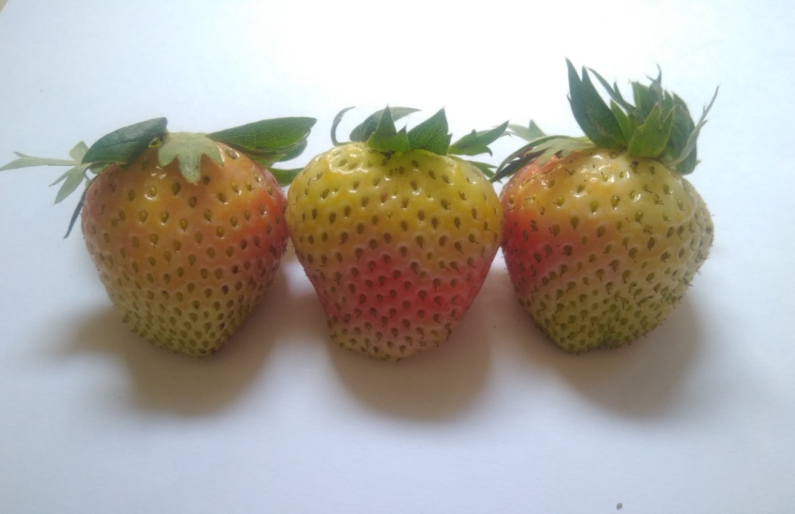

**Gambar 1.** Strawberry Muda

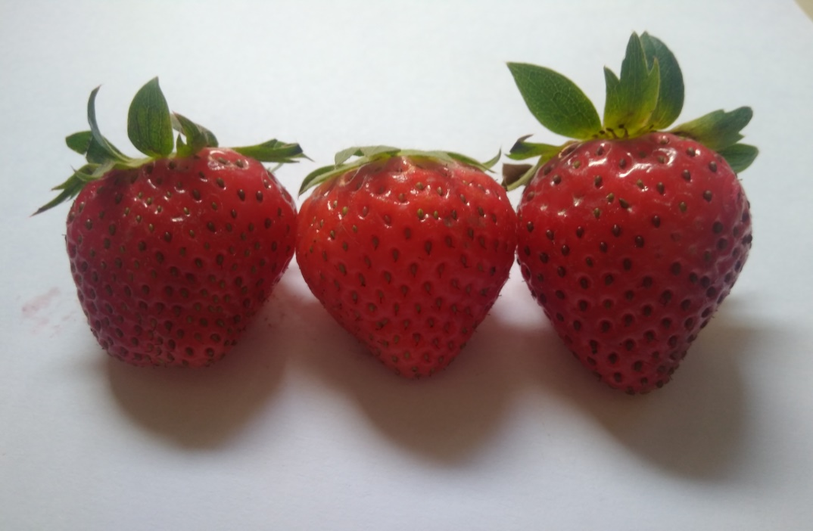

**Gambar 2.** Strawberry Masak

**Lampiran 24.** (Lanjutan)

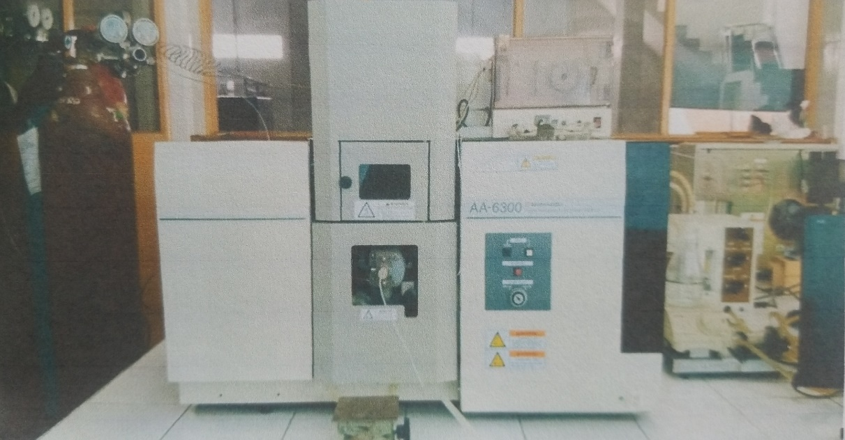

**Gambar 3**. Alat *Atomic Absorption Spektrophotometry* (AAS)

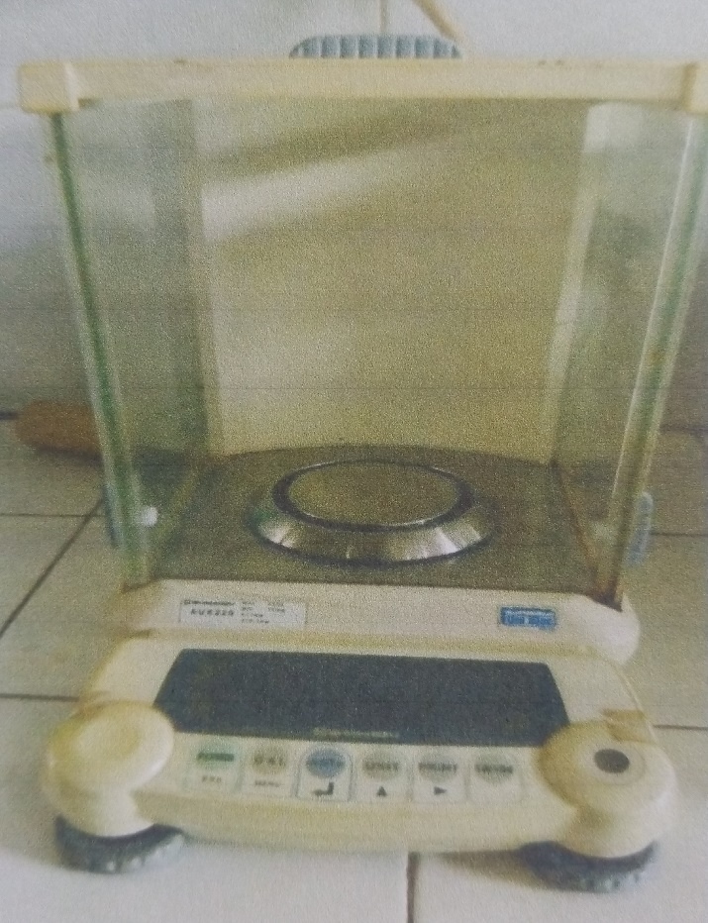

**Gambar 4**. Neraca Analitik

**Lampiran 25.** (Lanjutan)

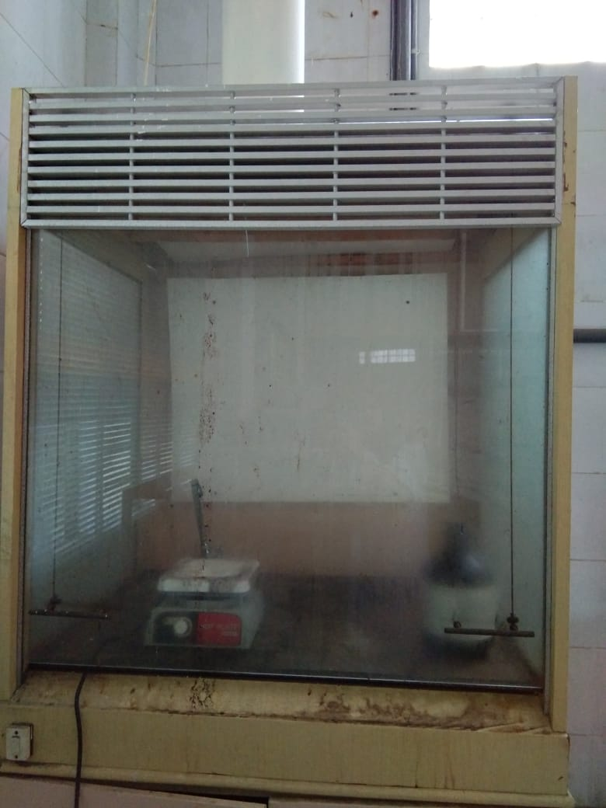

**Gambar 5.** Lemari Asam

**Lampiran 26.** Tabel distribusi

