Lampiran 1. Hasil Identifikasi Wortel (Daucus carota L.)

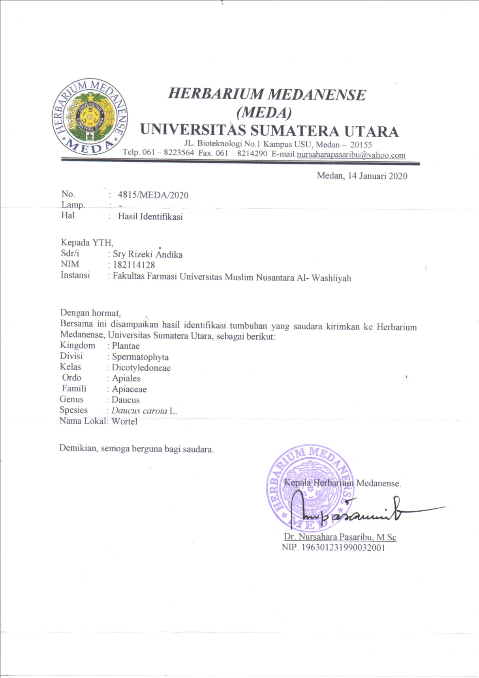

63
Lampiran 2. Bagan Alir Pembuatan Sari Wortel (Daucus carota L.)
Wortel (Daucus carota L.)

Dikupas dan dibersihkan dengan air mengalir

Ditimbang 1,5 kg
Diparut dan disaring

Sari Wortel (Daucus carota L.)

Dimasukkan kedalam oven pada suhu 60ºC selama ± 3 jam

Sari kental
Skrining Fitokimia

- Alkaloid
- Flavonoid
- Saponin
- Tanin
- Steroid/triterpenoid
- Glikosida

Lampiran 3. Bagan Alir Pembuatan Sediaan Gummy candies Sari Wortel (Daucus carota L.)
Manitol + Sirup jagung
Gom arab + Aquadest panas
Dipanaskan
Aduk ad larut
Minyak jagung
Gelatin aktif
Aduk ad homogen
Sari Wortel
Dipanaskan
Sukrosa
Essens

Laktosa
Aduk ad homogen
Pencetakan Gummy candies

Evaluasi
- Organoleptis
- pH
- Keseragaman Bobot
- Stabilitas
- Elastisitas
- Hedonik

Lampiran 4. Pembuatan Sediaan Gummy Candies SariWortel (Daucus carota L.)

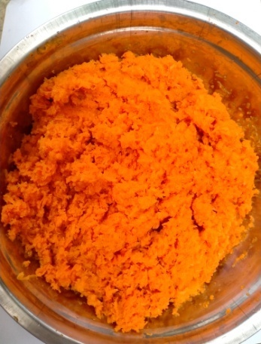
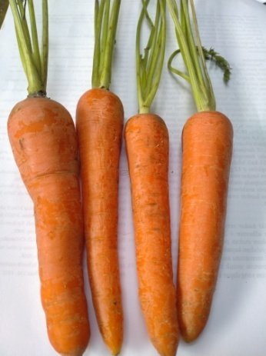
Wortel yang sudah diparut

Wortel (Daucus carota L.)

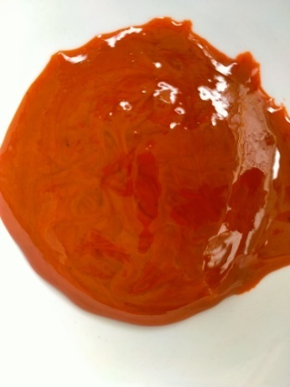
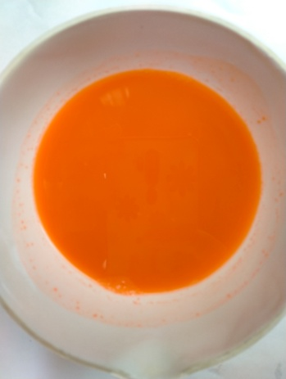

Sari wortel kental
Sari wortel segar

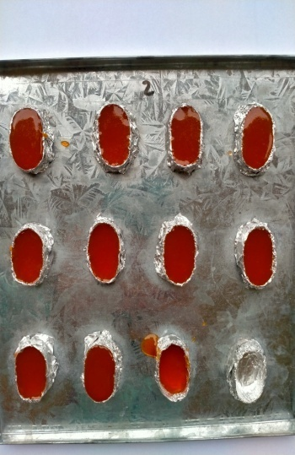
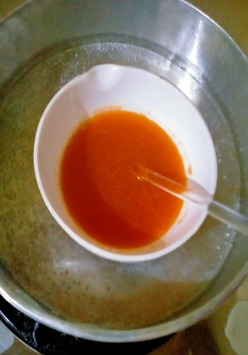

Dimasukkan dalam cetakan
Bahan sediaan gummy candies ditambahkan sari
Lampiran 5. Hasil Sediaan Gummy Candies Sari Wortel (Daucus carota L.)
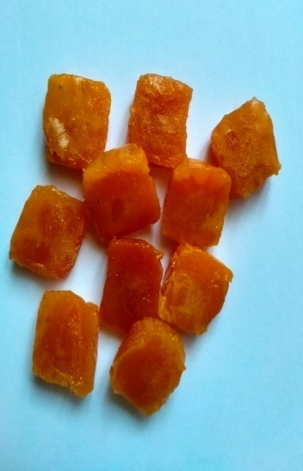
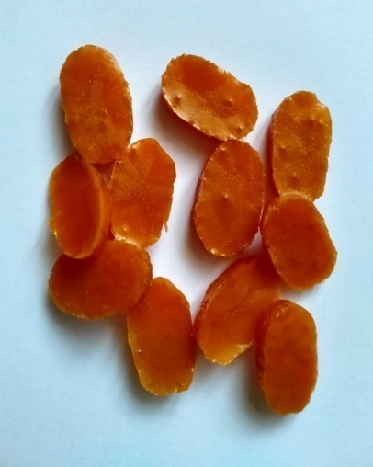

Formulasi 2
Formula 1

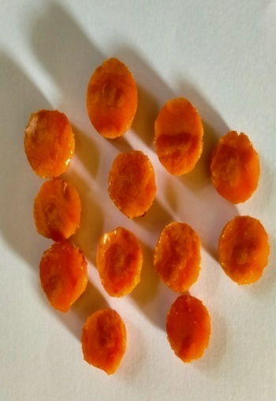
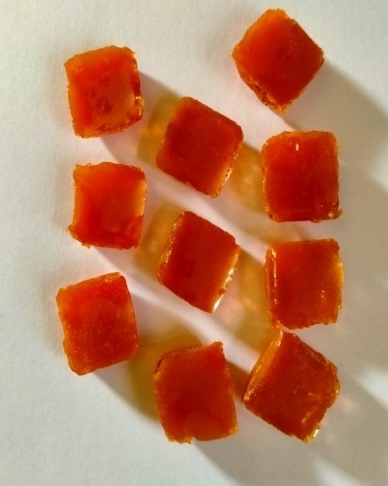

Formula 4
Formulasi 3
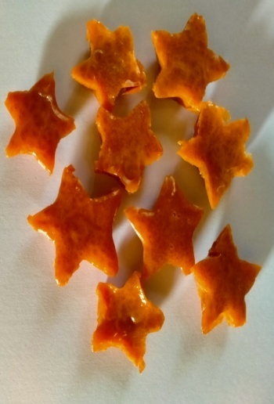
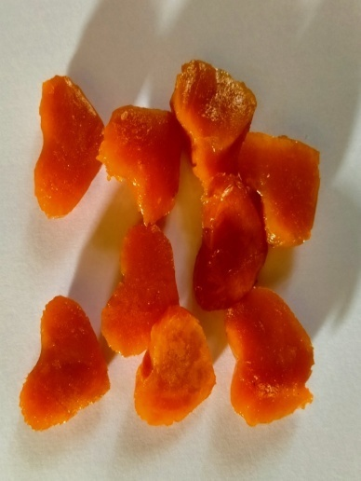

Formula 6
Formulasi 5

Lampiran 6. Hasil uji keseragaman bobot gummy candies
- Uji keseraman bobot gummy candies formula 1 dengan perbandingan (manitol 50% : gelatin 50%).
Berat 10 gummy candies = 1,12 gram / 10 = 0,112 gram = 112 mg
SD = x - xi
= 112 – 110 = 2 mg
SD = x - xi
= 112 – 100 = 12 mg
Ket:
SD = Standar Deviasi
x = Rata-rata berat 10 gummy candies (dalam mg)
xi = Berat 1 gummy (dalam mg)

CV = $\frac{SD}{x}×100 \%$
= $\frac{3}{112}×100 \%$
= 2,67 %
Ket:
CV = Koefisiensi Variasi
SD = Standar Deviasi
x = Rata-rata berat 10 gummy candies (dalam mg)
Jadi, hasil keseragaman bobot gummy candies berdasarkan nilai CV pada formula 1 memenuhi persyaratan karena tidak menyimpang dari kolom A, yaitu tidak lebih dari 10%.

Lampiran 6. (Lanjutan)
- Uji keseraman bobot gummy candies formula 2 dengan perbandingan (manitol 40% : gelatin 60%).
Berat 10 gummy candies = 1,06 gram / 10 = 0,106 gram = 106 mg
SD = x - xi
= 106 – 100 = 6 mg
SD = x - xi
= 106 – 110 = -4 mg
Ket:
SD = Standar Deviasi
x = Rata-rata berat 10 gummy candies (dalam mg)
xi = Berat 1 gummy (dalam mg)

CV = $\frac{SD}{x}×100 \%$
= $\frac{2}{106}×100 \%$
= 1,88 %
Ket:
CV = Koefisiensi Variasi
SD = Standar Deviasi
x = Rata-rata berat 10 gummy candies (dalam mg)
Jadi, hasil keseragaman bobot gummy candies berdasarkan nilai CV pada formula 2 memenuhi persyaratan karena tidak menyimpang dari kolom A, yaitu tidak lebih dari 10%.

Lampiran 6. (Lanjutan)
- Uji keseraman bobot gummy candies formula 3 dengan perbandingan (manitol 25% : gelatin 75%).
Berat 10 gummy candies = 1,05 gram / 10 = 0,105 gram = 105 mg
SD = x - xi
= 105 – 110 = -5 mg
SD = x - xi
= 105 – 100 = 5 mg
SD = x - xi
= 105 – 108 = -3 mg
Ket:
SD = Standar Deviasi
x = Rata-rata berat 10 gummy candies (dalam mg)
xi = Berat 1 gummy (dalam mg)

CV = $\frac{SD}{x}×100 \%$
= $\frac{0,5}{105}×100 \%$
= 1,14 %
Ket:
CV = Koefisiensi Variasi
SD = Standar Deviasi
x = Rata-rata berat 10 gummy candies (dalam mg)

Lampiran 6. (Lanjutan)
Jadi, hasil keseragaman bobot gummy candies berdasarkan nilai CV pada formula 3 memenuhi persyaratan karena tidak menyimpang dari kolom A, yaitu tidak lebih dari 10%.
- Uji keseraman bobot gummy candies formula 4 dengan perbandingan (manitol 60% : gelatin 40%).
Berat 10 gummy candies = 1,02 gram / 10 = 0,102 gram = 102 mg
SD = x - xi
= 102 – 90 = 12 mg
SD = x - xi
= 102 – 100 = 2 mg
SD = x - xi
= 102 – 101 = 1 mg
Ket:
SD = Standar Deviasi
x = Rata-rata berat 10 gummy candies (dalam mg)
xi = Berat 1 gummy (dalam mg)
CV = $\frac{SD}{x}×100 \%$
= $\frac{4,8}{102}×100 \%$
= 4,70 %
Ket:
CV = Koefisiensi Variasi
SD = Standar Deviasi
x = Rata-rata berat 10 gummy candies (dalam mg)
Lampiran 6. (Lanjutan)
Jadi, hasil keseragaman bobot gummy candies berdasarkan nilai CV pada formula 4 memenuhi persyaratan karena tidak menyimpang dari kolom A, yaitu tidak lebih dari 10%.
- Uji keseraman bobot gummy candies formula 5 dengan perbandingan (manitol 75% : gelatin 25%).
Berat 10 gummy candies = 1,08 gram / 10 = 0,108 gram = 108 mg
SD = x - xi
= 108 – 106 = 2 mg
SD = x - xi
= 108 – 107 = 1 mg
SD = x - xi
= 108 – 110 = -2 mg
Ket:
SD = Standar Deviasi
x = Rata-rata berat 10 gummy candies (dalam mg)
xi = Berat 1 gummy (dalam mg)
CV = $\frac{SD}{x}×100 \%$
= $\frac{1,2}{108}×100 \%$
= 1,11 %
Ket:
CV = Koefisiensi Variasi
SD = Standar Deviasi
x = Rata-rata berat 10 gummy candies (dalam mg)
Lampiran 6. (Lanjutan)
Jadi, hasil keseragaman bobot gummy candies berdasarkan nilai CV pada formula 5 memenuhi persyaratan karena tidak menyimpang dari kolom A, yaitu tidak lebih dari 10%.
- Uji keseraman bobot gummy candies blanko tanpa essen dengan perbandingan (manitol 50% : gelatin 50%).
Berat 10 gummy candies = 1,03 gram / 10 = 0,103 gram = 103 mg
SD = x - xi
= 103 – 101 = 2 mg
SD = x - xi
= 103 – 102 = 1 mg
SD = x - xi
= 103 – 106 = -3 mg
Ket:
SD = Standar Deviasi
x = Rata-rata berat 10 gummy candies (dalam mg)
xi = Berat 1 gummy (dalam mg)
CV = $\frac{SD}{x}×100 \%$
= $\frac{1,4}{103}×100 \%$
= 1,35 %
Ket:
CV = Koefisiensi Variasi
SD = Standar Deviasi
x = Rata-rata berat 10 gummy candies (dalam mg)
Lampiran 6. (Lanjutan)
Jadi, hasil keseragaman bobot gummy candies berdasarkan nilai CV pada formula 6 memenuhi persyaratan karena tidak menyimpang dari kolom A, yaitu tidak lebih dari 10%.

Lampiran 7. Soal Uji Hedonik Mohon kesediaan saudara/teman-teman untuk mengisikan jawabannya sesuai pendapatnya.

Nama :
Umur :
- Perhatikan Rasa dari masing-masing formula dan mohon beri jawaban pada pertanyaan.
      - Bagaimana penilaian saudara/teman-teman mengenai Rasa dari sediaan Gummy candies “Formula I ” ini
- TM b. M c. SM

      - Bagaimana penilaian saudara/teman-teman mengenai Rasa dari sediaan Gummy candies “ Formula II” ini
- TM b. M c. SM

        - Bagaimana penilaian saudara/teman-teman mengenai Rasa dari sediaan Gummy candies “ Formula III” ini
- TM b. M c. SM

        - Bagaimana penilaian saudara/teman-teman mengenai Rasa dari sediaan Gummy candies “ Formula IV” ini
- TM b. M c. SM

          - Bagaimana penilaian saudara/teman-teman mengenai Rasa dari sediaan Gummy candies “ Formula V” ini
        - TM b. M c. SM

          - Bagaimana penilaian saudara/teman-teman mengenai Rasa dari sediaan Gummy candies “Blanko Tanpa Essen” ini
        - TM b. M c. SM

Keterangan :
TM = Tidak Manis
M = Manis
SM = Sangat Manis

Lampiran 7. (Lanjutan)

- Perhatikan Kekenyalan dari masing-masing formula dan mohon beri jawaban pada pertanyaan.

      - Bagaimana penilaian saudara/teman teman mengenai Kekenyalan dari sediaan Gummy candies “Formula I” ini
        - TK b. K c. SK

      - Bagaimana penilaian saudara/teman-teman mengenai Kekenyalan dari sediaan Gummy candies “ Formula II” ini
        - TK b. K c. SK

      - Bagaimana penilaian saudara/teman-teman mengenai Kekenyalan dari sediaan Gummy candies “ Formula III” ini
        - TK b. K c. SK

      - Bagaimana penilaian saudara/teman-teman mengenai Kekenyalan dari sediaan Gummy candies “ Formula IV” ini
        - TK b. K c. SK

      - Bagaimana penilaian saudara/teman-teman mengenai Kekenyalan dari sediaan Gummy candies “ Formula V” ini
        - TK b. K c. SK

      - Bagaimana penilaian saudara/teman-teman mengenai Kekenyalan dari sediaan Gummy candies “Blanko Tanpa Essen” ini
        - TK b. K c. SK

Keterangan :
TK = Tidak Kenyal
K = Kenyal
SK = Sangat Kenyal

Lampiran 7. (Lanjutan)

- Perhatikan Kesukaan dari masing-masing formula dan mohon beri jawaban pada pertanyaan.

      - Bagaimana penilaian saudara/teman-teman mengenai Kesukaan dari sediaan Gummy candies “Formula I” ini
- TS b. S c. SS

      - Bagaimana penilaian saudara/teman-teman mengenai Kesukaan dari sediaan Gummy candies “ Formula II” ini
- TS b. S c. SS

      - Bagaimana penilaian saudara/teman-teman mengenai Kesukaan dari sediaan Gummy candies “ Formula III” ini
- TS b. S c. SS

      - Bagaimana penilaian saudara/teman-teman mengenai Kesukaan dari sediaan Gummy candies “ Formula IV” ini
- TS b. S c. SS

      - Bagaimana penilaian saudara/teman-teman mengenai Kesukaan dari sediaan Gummy candies “ Formula V” ini
        - TS b. S c. SS

      - Bagaimana penilaian saudara/teman-teman mengenai Kesukaan dari sediaan Gummy candies “Blanko Tanpa Essen” ini
        - TS b. S c. SS

Keterangan :
TS = TidakSuka
S = Suka
SS = SangatSuka

Lampiran 8. Hasil Uji ANOVA Elastisitas Sediaan Gummy Candies

Tests of Normality^{b}
 | Formula | Kolmogorov-Smirnovª |  |  | Shapiro-Wilk
 |  | Statistic | df | Sig. | Statistic | df | Sig.
Pengukuran | Pasaran | .253 | 3 | . | .964 | 3 | .637
 | Formula 1 | .349 | 3 | . | .832 | 3 | .194
 | Formula 2 | .292 | 3 | . | .923 | 3 | .463
 | Formula 3 | .219 | 3 | . | .987 | 3 | .780
 | Formula 4 | .175 | 3 | . | 1.000 | 3 | 1.000
a. Lilliefors Significance Correction
b. Pengukuran is constant when Formula = Formula 5. It has been omitted.

ANOVA
Pengukuran
 | Sum of Squares | df | Mean Square | F | Sig.
Between Groups | 13.244 | 5 | 2.649 | 41.461 | .000
Within Groups | .767 | 12 | .064
Total | 14.011 | 17

Pengukuran
Tukey HSDª
Formula | N | Subset for alpha = 0.05
 |  | 1 | 2 | 3 | 4 | 5
Formula 4 | 3 | 1.600
Formula 5 | 3 | 2.100 | 2.100
Formula 1 | 3 |  | 2.667 | 2.667
Formula 2 | 3 |  |  | 3.133 | 3.133
Formula 3 | 3 |  |  |  | 3.733 | 3.733
Pasaran | 3 |  |  |  |  | 4.033
Sig. |  | .223 | .136 | .280 | .105 | .697
Means for groups in homogeneous subsets are displayed.
a. Uses Harmonic Mean Sample Size = 3.000.

Lampiran 9. Hasil Uji ANOVA Hedonik (kesukaan) Sediaan Gummy Candies

Tests of Normality
 | Formula | Kolmogorov-Smirnovª |  |  | Shapiro-Wilk
 |  | Statistic | df | Sig. | Statistic | df | Sig.
Rasa | Formula 1 | .292 | 3 | . | .923 | 3 | .463
 | Formula 2 | .253 | 3 | . | .964 | 3 | .637
 | Formula 3 | .349 | 3 | . | .832 | 3 | .194
 | Formula 4 | .292 | 3 | . | .923 | 3 | .463
 | Formula 5 | .385 | 3 | . | .750 | 3 | .000
 | Formula 6 | .204 | 3 | . | .993 | 3 | .843
Kekenyalan | Formula 1 | .349 | 3 | . | .832 | 3 | .194
 | Formula 2 | .292 | 3 | . | .923 | 3 | .463
 | Formula 3 | .385 | 3 | . | .750 | 3 | .000
 | Formula 4 | .385 | 3 | . | .750 | 3 | .000
 | Formula 5 | .385 | 3 | . | .750 | 3 | .000
 | Formula 6 | .292 | 3 | . | .923 | 3 | .463
Suka | Formula 1 | .204 | 3 | . | .993 | 3 | .843
 | Formula 2 | .253 | 3 | . | .964 | 3 | .637
 | Formula 3 | .328 | 3 | . | .871 | 3 | .298
 | Formula 4 | .385 | 3 | . | .750 | 3 | .000
 | Formula 5 | .385 | 3 | . | .750 | 3 | .000
 | Formula 6 | .349 | 3 | . | .832 | 3 | .194
a. Lilliefors Significance Correction

ANOVA
 |  | Sum of Squares | df | Mean Square | F | Sig.
Rasa | Between Groups | .000 | 5 | .000 | .000 | 1.000
 | Within Groups | 228.000 | 12 | 19.000
 | Total | 228.000 | 17
Kekenyalan | Between Groups | .000 | 5 | .000 | .000 | 1.000
 | Within Groups | 268.000 | 12 | 22.333
 | Total | 268.000 | 17
Suka | Between Groups | .000 | 5 | .000 | .000 | 1.000
 | Within Groups | 246.000 | 12 | 20.500
 | Total | 246.000 | 17

Rasa
Tukey HSDª
Formula | N | Subset for alpha = 0.05
 |  | 1
Formula 1 | 3 | 3.333
Formula 2 | 3 | 3.333
Formula 3 | 3 | 3.333
Formula 4 | 3 | 3.333
Formula 5 | 3 | 3.333
Formula 6 | 3 | 3.333
Sig. |  | 1.000
Means for groups in homogeneous subsets are displayed.
a. Uses Harmonic Mean Sample Size = 3.000.

Kekenyalan
Tukey HSDª
Formula | N | Subset for alpha = 0.05
 |  | 1
Formula 1 | 3 | 3.333
Formula 2 | 3 | 3.333
Formula 3 | 3 | 3.333
Formula 4 | 3 | 3.333
Formula 5 | 3 | 3.333
Formula 6 | 3 | 3.333
Sig. |  | 1.000
Means for groups in homogeneous subsets are displayed.
a. Uses Harmonic Mean Sample Size = 3.000.

Suka
Tukey HSDª
Formula | N | Subset for alpha = 0.05
 |  | 1
Formula 1 | 3 | 3.333
Formula 2 | 3 | 3.333
Formula 3 | 3 | 3.333
Formula 4 | 3 | 3.333
Formula 5 | 3 | 3.333
Formula 6 | 3 | 3.333
Sig. |  | 1.000
Means for groups in homogeneous subsets are displayed.
a. Uses Harmonic Mean Sample Size = 3.000.

Lampiran 10. Sertifikat Gelatin Halal (Food Grade)

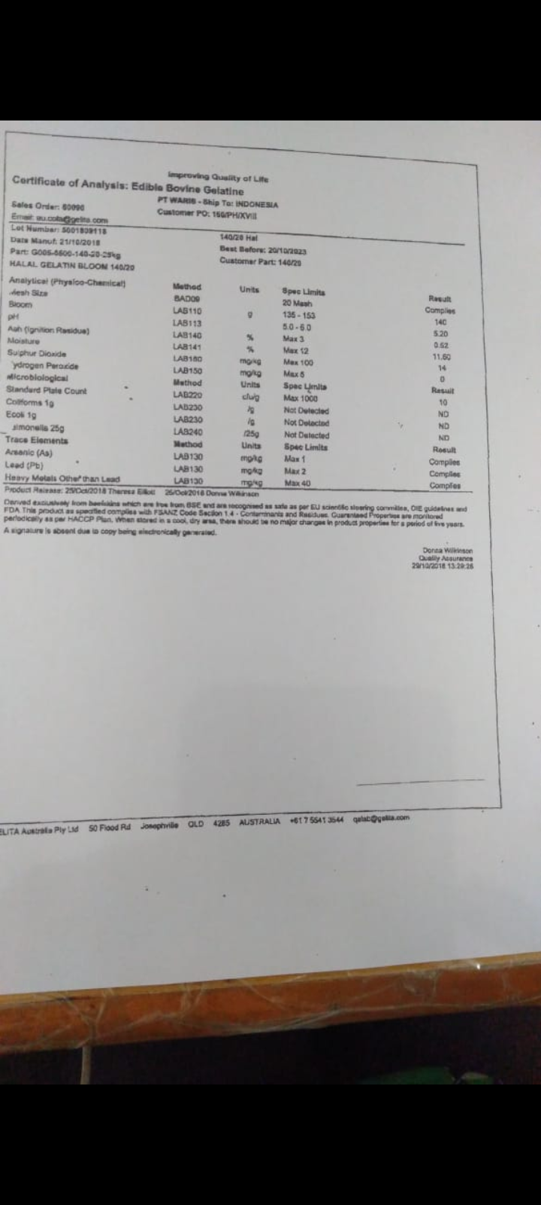

Lampiran 11. Sertifikat Gom Arab

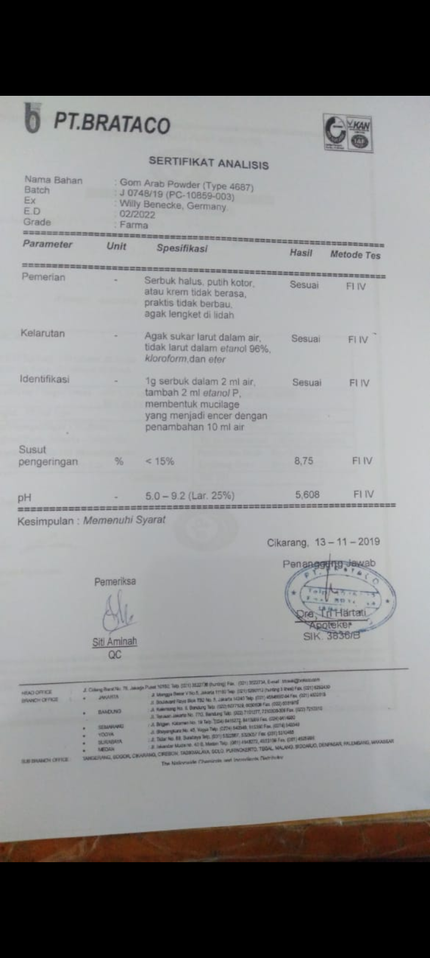

Lampiran 12. Sertifika Laktosa

