DAFTAR PUSTAKA

Anastasia, H. 2009. Cantik, Sehat & Sukses Berbisnis Spa. Yogyakarta: Kanisius. Hal. 90.

Anief M. 1997. Ilmu Meracik Obat. Yogyakarta: Gadjah Mada University Press.

Ardhi, M.A. 2011. Radikal Bebas dan Peran Antioksidan dalam Mencegah Penuaan. Jakarta: Scientific Journal Of Pharmaceutical Development and Medical Apliction. Vol. 24., No. 1. Hal: 4-9

Armadany, Fery Indradewi., Hasnawati., dan Sirait Morita. 2015. Formulasi Sediaan Masker Gel Peel-off Antioksidan dari Ekstrak Sari Tomat (Solanum lycopersicum L. var. cucurbita). Fakultas Farmasi Universitas Halu Oleo. Kendari. Pharmauho Majalah Farmasi, Sains, dan Kesehatan. Volume 1. Nomor 2. Halaman: 29-32.

Basuki KS. Tampil Cantik Dengan Perawatan Sendiri. Jakarta: PT Gramedia Pustaka Utama; 2007.

Daimunon, Regita C., Yamlean, Paulina V.Y., dan Jayanto, Imam. 2019. Formulasi Dan Efek Antibakteri Masker Peel-Off Ekstrak Etanol Daun Kersen (Muntingia Calabura L.) Terhadap Bakteri Staphlococcous epidermidis. Program Studi Farmasi FMIPA UNSRAT. Manado. PHARMACON Jurnal Ilmiah Farmasi UNSRAT. Vol. 8 No. 3. Hal:

Dasopang ES, Simutuah A. Formulasi Sediaan Gel Antiseptik Tangan dan Uji Aktivitas Antibakteri dari Ekstrak Etanol Daun Pandan Wangi (Pandanus amaryllifolius Roxb). Biolink. 2016;3(1). Hal: 84.

Ditjen POM. Farmakope Indonesia. Edisi III. Jakarta: Departemen Kesehatan Republik Indonesia; 1979. Hal: 33

Ditjen POM. 1985. Formularium Kosmetika Indonesia. Jakarta: Depkes RI. Hal. 32-36.

Departemen Kesehatan RI. 2000. Parameter Standar Umum Ekstrak Tumbuhan Obat. Jakarta: Direktorat Jendral Obat dan Makanan. Hal 3, 10-11.

Departemen Kesehatan RI. 1979. Materia Medika Indonesia. Edisi III. Jakarta: Direktorat Jendral Obat dan Makanan. Hal 155-159, 693, 696, 733, 748.

Departemen Kesehatan RI. 1980. Materia Medika Indonesia, Jilid IV. Jakarta: Direktorat Jendral Pengawas Obat dan Makanan. Hal 94-98.

Departemen Kesehatan RI. 1989. Materia Medika Indonesia, Edisi V. Jakarta: Direktorat Jendral Pengawas Obat dan Makanan. Hal 536-540.

Departemen Kesehatan RI. 1995. Farmakope Indonesi, Edisi IV. Jakarta: Direktorat Jendral Obat dan Makanan. Hal 155-159.

Ellis, L. 2017. It’s About Your Flare Of Beauty. Solo: PT. Tiga Serangkai Pustaka Mandiri. Hal: 52-57.

Emilan T, Kurnia A, Utami B, Diyani LN, Maulana A. 2011. Konsep Herbal Indonesia : Pemastian Mutu Produk Herbal. Thesis-Dissertation. Jakarta: Universitas Indonesia. Hal:27.

Farnsworth, N.R. 1966. Biological and Phytochemical Screening of Plants. Journal of Pharmaceutical Sciences. 55(3): 262-264.

Garg A, Aggarwal D, Garg S, Singla AK. 2002. Spreading of Semisolid Formulations. In: An Update, Pharmacy Technology. Hal: 84-102.

Gibson, Jhon. 2002. Fisiologi & Anatomi Modern Untuk Perawat Edisi 2. Jakarta: Egc. Hal: 230-231.

Hariana, H. Arif. 2004. Tumbuhan Obat dan Khasiatnya. Depok: Niaga Swadaya. Hal: 36-38.

Harry R, Rieger M. Harry’s Cosmeticology. Boston: Chemical Pub. Co.; 2000.

Hasim., Arifin, Yupi Yulianita., Andrianto, Dimas., Faridah, Didah Nur. 2019. Ekstrak Etanol Daun Belimbing Wuluh (Averrhoa bilimbi) sebagai Antioksidan dan Antiinflamasi. Jurnal Aplikasi Teknologi Pangan. Volume 8. Nomor 3. Halaman: 86-93.

Jaelani. 2009. Kosmetik Nabati. Jakarta: Pustaka Populer Obor. Hal: 153-154.

Jusup, L. 2010. Kiat Mencegah Proses Penuaan Lebih Cepat. Jakarta: PT. Gramedia Pustaka Utama. Hal: 6.

Lachman, L. 1994. Teori dan Praktek Farmasi Industri Edisi 2. Jakarta: Universitas Indonesia.

Maharani, A. 2015. Penyakit kulit. Yogyakarta: Pustaka Baru Press. Hal: 1-3.

Muhlisah, Fauziah. 2007. Tanaman Obat Keluarga. Depok: Niaga Swadaya. Hal: 15-17.

Muliyawan, D dan Neti, S. 2013. A-Z Tentang Kosmetik. Jakarta: PT. Elex Media Komputindo.

Masithah, 2010, Ekstraksi Dan Pengujian Aktifitas Antibakteri Senyawa Tanin Pada Daun Belimbing Wuluh (Averrhoa bilimbi L.). Malang Universitas Maulana Malik Ibrahim.

Noer SF. 2011. Pengaruh Kadar Etanol dalam Sediaan Gel Antiseptika Terhadap Pertumbuhan Bakteri Salmonella thyposa. Iltek. Vol.6., No.12. Hal:887-891.

Novita, W. 2009. Merawat Kecantikan di Rumah. Jakarta: PT. Gramedia Pustaka Utama. Hal: 45.

Purwaningsih, Eko. 2007. Multiguna Belimbing Wuluh. Bekasi: Ganeca exact. Hal: 6-8.

Putro, D.S. 1997. Agar Awet Muda. Purwodadi: Trubus Agrisarana. Hal. 8-9.

Pearce, Evelyn C. 2010. Anatomi Dan Fisiologi Untuk Paramedis. Jakarta: PT. Gramadia. Hal: 242-243.

Pendit PA, Zubaidah E, Sriherfyna FH. 2016. Karakteristik Fisik-Kimia dan Aktivitas Antibakteri Ekstrak Daun Belimbing Wuluh (Averrhoa bilimbi L.) Jurnal Pangan dan Agroindstri. Volume 4. Nomor 1. Hal: 400-409.

Pertiwi, Putri Laras. 2012. Formulasi Gel Masker Peel-Off Ekstrak Bongkahan Gambir (Uncaria gambir Roxb.) dengan Basis Kitosan dan Polivinil Alkohol (PVA). Skripsi. Jakarta: Fakultas Kedokteran dan Ilmu Kesehatan: UIN Syarif Hidayatullah Jakarta.

Priani Sani E., Irawati Irma., dan Darma Gita C. E. 2015. Formulasi Masker Gel Peel-Off Kulit Buah Manggis (Garcinia mangostana Linn.) Fakultas Matematika dan Ilmu Pengetahuan Alam Universitas Islam Bandung. Bandung. IJPST. Volume 2. Nomor 3. Hal: 90-95.

Ramadhan, P. 2015. Mengenal Antioksidan. Yogyakarta: Graha Ilmu. Hal: 27.

Rawlins E. A. 2003. Bentleys of Pharmaceutics. London: Baillierre Tindal. Hal: 355.

Rieger, M.M. 2000. Harry’s Cosmetology 8th Edition. New York: Chemical Publishing Co. Inc. Hal: 471-483.

Rowe R., Sheskey P., dan Quinn M. 2009. Handbook of Pharmaceutical Excipients. London: Pharmaceutical Press.

Sari, Anna Khumaira., Ayuchecaria, Noverda., Febrianti, Dwi Rizki., Alfiannor, Moch Maulidie., dan Regitasari, Vitalika. 2019. Analisis Kuantitatif Kadar Flavonoid Ekstrak Etanol Daun Belimbing Wuluh (Averrhoa Bilimbi L.) Di Banjarmasin Dengan Metode Spektrofotometri Uv-Visible. Akademi Farmasi ISFI Banjarmasin. Jurnal Insan Farmasi Indonesia. Volume 2. Nomor 1. Halaman: 7-17.

Siagian, Priska. 2012. Keajaiban Antioksidan: Menabung Antioksidan Dengan Menikmati Buah dan Sayuran Super Agar Sehat dan Awet Muda. Jakarta: PT. Gramedia Pustaka Utama. Hal: 3.

Sudewo, B. 2009. Buku Pintar Hidup Sehat Cara Mas Dewo. Ciganjur, Jagakarsa, Jakarta Selatan: PT. Agro Media Pustaka. Hal. 74.

Sutriningsih, Dan Astuti, Irna Wati. 2017. Uji Antioksidan Dan Formulasi Sediaan Masker Peel-Off Dari Ekstrak Biji Alpukat (Persea Americanamill.) Dengan Perbedaan Konsentrasi Pva (Polivinil Alkohol). Fakultas Farmasi Universitas 17 Agustus 1945. Indonesia Natural Research Pharmaceutical Journal. Jakarta. Vol. 1. No. 2. Hal: 68.

Septiani S, Wathoni N, Mita SR. 2011. Formulasi Sediaan Masker Gel Antioksidan dari Ekstrak Etanol Biji Melinjo (Gnetun gnemon Linn). Fak Farm Univ Padjadjaran. Hal: 1-27.

Syamsuni HA. 2015. Ilmu Resep. Jakarta: PT EGC.

Thomas A.N.S. 1992. Tanaman Obat Tradisional. Edisi 2. Yogyakarta: Kanisius. Hal: 17.

Tranggono RI, Latifah F. 2007. Buku Pegangan Ilmu Pengetahuan Kosmetik. Jakarta: PT. Gramedia Pustaka Utama.

Voight R. 1994. Buku Pelajaran Teknologi Farmasi. Yogyakarta: Gajah Mada Universitas Press.

Waji RA, Sugrani A. Makalah Kimia Organik Bahan Alam Flavonoid (Quercetin). FMIPA Univ Hasanuddin. 2009.

Wasitaatmadja, S.M. 1997. Penuntun Ilmu Kosmetik Medik. Jakarta: Penerbit UI- Press. Hal. 58-62.

Wibowo, S. Daniel. 2005. Anatomi Tubuh Manusi. Jakarta: Pt. Grasindo. Hal: 25- 26.

Winarsi, Hery. 2007. Antioksidan Alami Dan Radikal Bebas. Yogyakarta: Kanisius Hal: 11-25.

Yuslianti, Euis Reni. 2018. Pengantar Radikal Bebas Dan Antioksidan. Yogyakarta: Deepublish. Hal: 2-34.

Zainuddin., Widyastuti, Sry., Usman, Samsidar., dan Wulan, Citra. 2019. Formulasi Sediaan Masker Peel Off Dari Ekstrak Daun Belimbing Wuluh (Averrhoa Bilimbi L) Menggunakan Basis Carbopol 934. Fakultas Farmasi Universitas Indonesia Timur. Media Farmasi. Volume 15. Nomor 2. Halaman: 185-191.

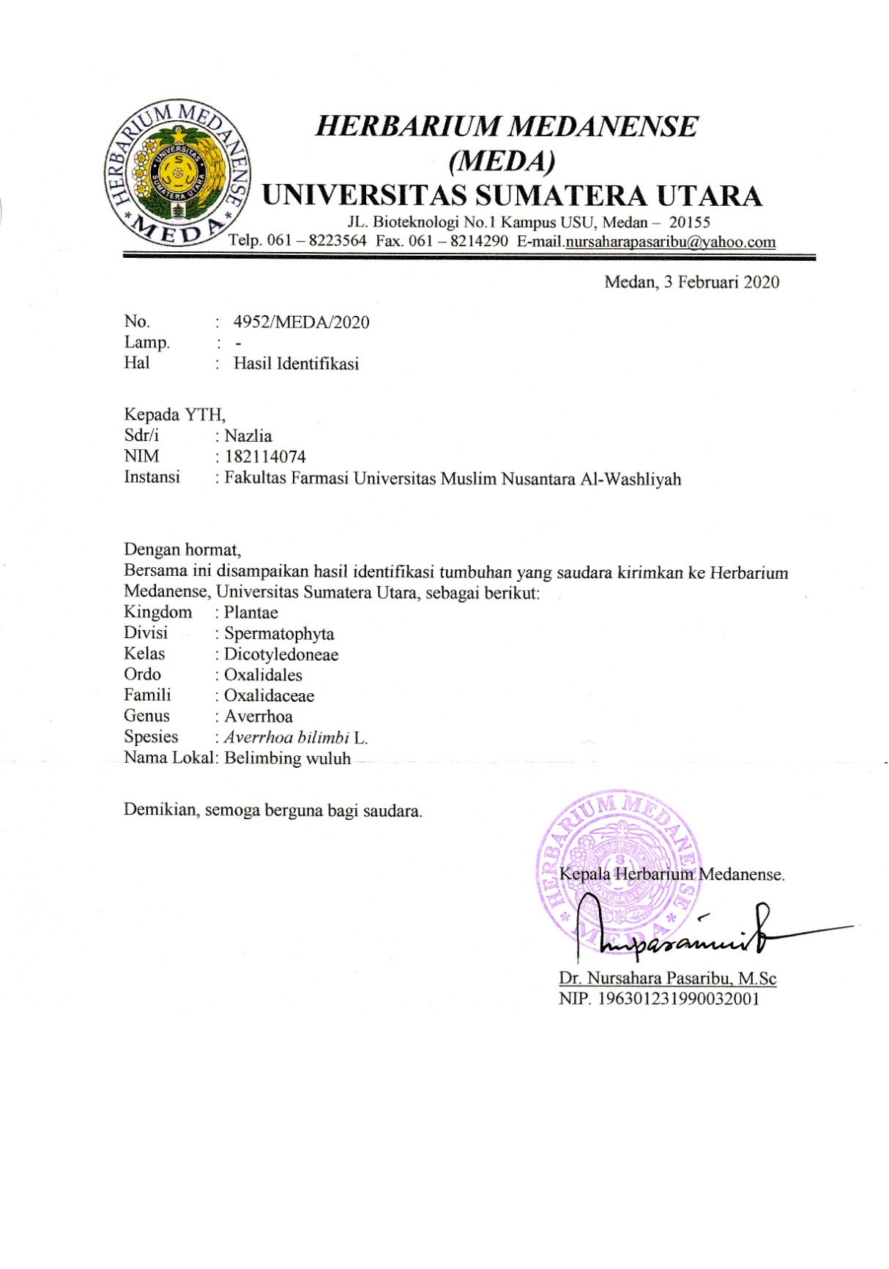
Lampiran 1. Hasil Identifikasi Sampel Daun Belimbing Wuluh (Averrhoa bilimbi L.)

Lampiran 2. Pengolahan Sampel

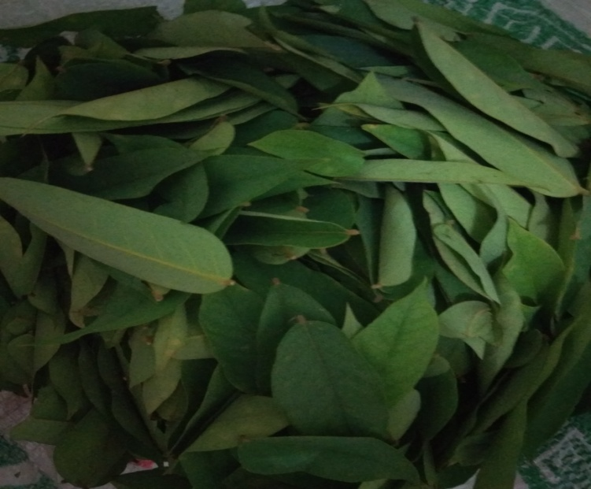
Sampel Segar Daun Belimbing Wuluh (Averrhoa bilimbi L.)

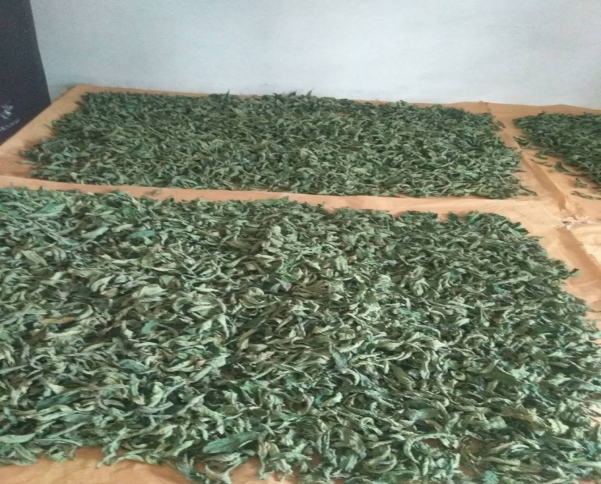
Simplisia Daun Belimbing Wuluh (Averrhoa bilimbi L.)

Lampiran 2. (lanjutan)

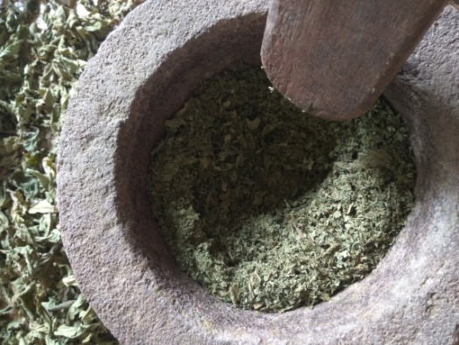
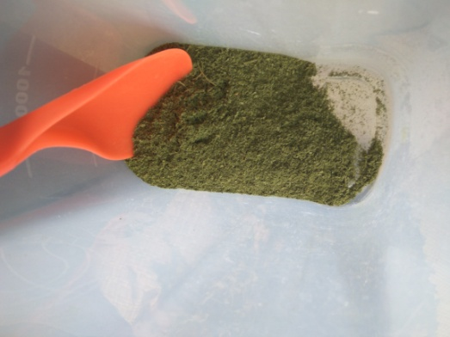

Serbuk simplisia Daun Belimbing Wuluh (Averrhoa bilimbi L.)

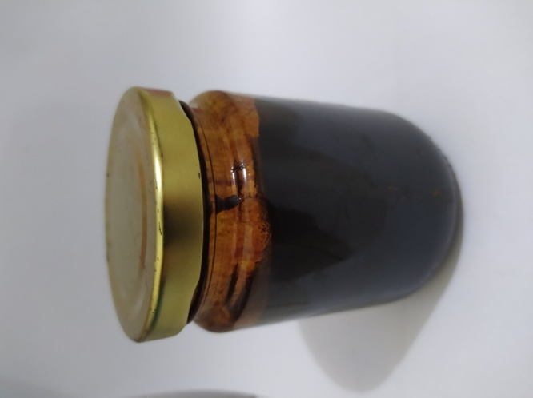

Ekstrak Etanol Daun Belimbing Wuluh (Averrhoa bilimbi L.)

Lampiran 3. Gambar makroskopis dan mikroskopis daun belimbing wuluh (Averrhoa bilimbi L.)

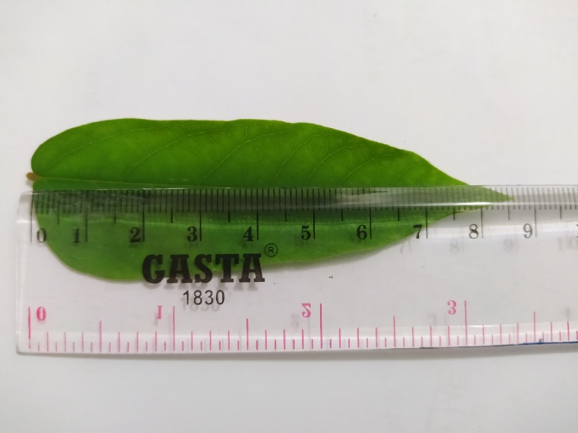
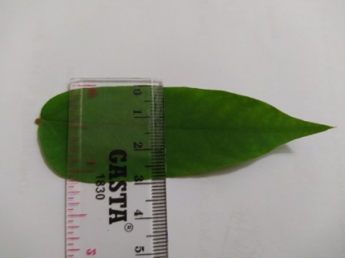
- Uji Makroskopis
Lampiran 3. (Lanjutan)

- Uji Mikroskopis

Daun belimbing wuluh segar

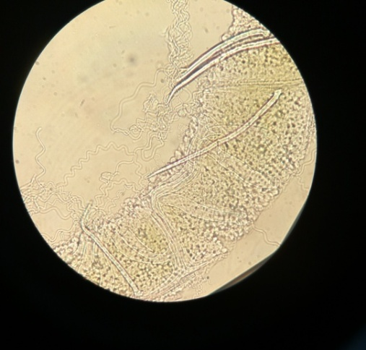
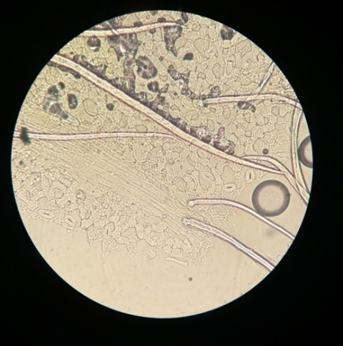

Perbesaran 40x Perbesaran 40x

Serbuk simplisia daun belimbing wuluh
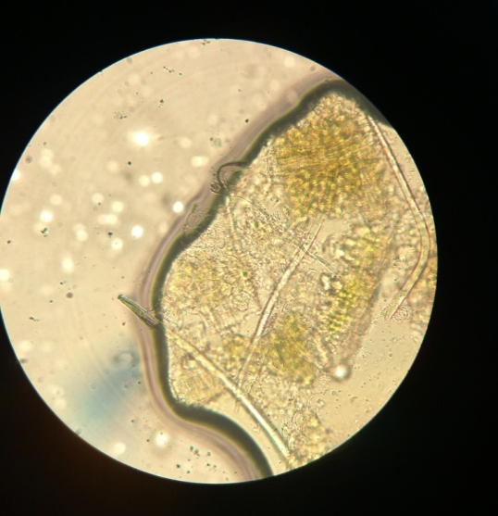

Perbesaran 40x

Lampiran 4. Perhitungan penetapan kadar air simplisia daun belimbing wuluh (Averrhoa bilimbi L.)

%Kadar air = $\frac{Volume akhir-volume awal}{Berat sampel (gr)}$x 100%

No | Berat Sampel (gr) | Volume akhir - Volume awal (ml)
1. | 5 | 0,2
2. | 5 | 0,15
3. | 5 | 0,1

- %Kadar air = $\frac{1,9-1,7}{5 (gr)}$x 100% = 4%

- %Kadar air = $\frac{1,9-1,75}{5(gr)}$x 100% = 3%

- %Kadar air = $\frac{1,8-1,7}{5 (gr)}$x 100%= 2%

Rata-Rata = = $\frac{4\%+3\%+2\%}{3}$= 3%
Syarat: Tidak boleh dari 10%

Lampiran 5. Perhitungan penetapan kadar sari larut dalam air simplisia daun belimbing wuluh (Averrhoa bilimbi L.)

%Kadar = $\frac{Cawan isi-cawan kosong x 5}{Berat sampel (gr)}$x 100%

No | Berat Sampel (gr) | Berat Cawan Kosong | Berat Setelah Diuapkan (gr)
1. | 5 | 59,75 | 59,92
2. | 5 | 64,50 | 64,68
3. | 5 | 29,11 | 29,30

- %Kadar = $\frac{0,17 x 5}{5 (gr)}$x 100% = 17 %

- %Kadar = $\frac{0,18 x 5}{5 (gr)}$x 100% = 18 %

- %Kadar = $\frac{0,19 x 5}{5 (gr)}$x 100% = 19 %

Rata-rata = $\frac{17+18+19}{3}$= 18 %
Syarat: Tidak kurang dari 8%

Lampiran 6. Perhitungan penetapan kadar sari larut dalam etanol simplisia daun belimbing wuluh (Averrhoa bilimbi L.)

%Kadar = $\frac{Cawan isi-cawan kosong x 5}{Berat sampel (gr)}$x 100%

No | Berat Sampel (gr) | Berat Cawan Kosong | Berat Setelah Diuapkan (gr)
1. | 5 | 55,21 | 55,41
2. | 5 | 64,49 | 64,72
3. | 5 | 53,46 | 53,61

- %Kadar = $\frac{0,2 x 5}{5 (gr)}$x 100% = 20 %

- %Kadar = $\frac{0,23x 5}{5 (gr)}$x 100% = 23 %

- %Kadar = $\frac{0,15 x 5}{5 (gr)}$x 100% = 15 %

Rata-rata = $\frac{20+23+15}{3}$= 19,33 %
Syarat: Tidak kurang dari 6,5 %

Lampiran 7. Perhitungan penetapan kadar abu total simplisia daun belimbing wuluh (Averrhoa bilimbi L.)

%Kadar = $\frac{Cawan isi-cawan kosong }{Berat sampel (gr)}$x 100%

No | Berat Sampel (gr) | Berat Cawan Kosong | Berat Setelah Dipijar (gr)
1. | 2 | 60,99 | 61,16
2. | 2 | 68,55 | 68,65
3. | 2 | 67,21 | 67,31

- %Kadar = $\frac{0,17}{2(gr)}$x 100% = 8,5%

- %Kadar = $\frac{0,1}{2(gr)}$x 100% = 5%

- %Kadar = $\frac{0,1 }{2 (gr)}$x 100% = 5%

Rata-rata = $\frac{8,5+5+5}{3}$= 6,16%
Syarat: Tidak lebih dari 8%

Lampiran 8. Perhitungan penetapan kadar abu tidak larut asam simplisia daun belimbing wuluh (Averrhoa bilimbi L.)

%Kadar = $\frac{Cawan isi-cawan kosong }{Berat sampel (gr)}$x 100%

No | Berat Sampel (gr) | Berat Cawan Kosong | Berat Setelah Diuapkan (gr)
1. | 2 | 60,99 | 61,00
2. | 2 | 68,55 | 68,60
3. | 2 | 67,21 | 67,23

- %Kadar = $\frac{0,01}{2(gr)}$x 100% = 0,5%

- %Kadar = $\frac{0,05}{2(gr)}$x 100% = 2,5%

- %Kadar = $\frac{0,02 }{2 (gr)}$x 100% = 1%

Rata-rata = $\frac{0,5+2,5+1}{3}$= 1,33 %
Syarat: Tidak lebih dari 2 %

Lampiran 9. Perhitungan susut pengeringan dan persen rendemen

Berat segar | 6,5 kg
Berat kering | 2,9 kg
Berat serbuk | 2,3 kg
Berat ekstrak | 132,97 g

Susut pengeringan = $\frac{Berat basah-berat kering (g)}{Berat basah (g)}$x 100%
= $\frac{6,5 - 2,9 (g)}{6,5 (g)}$x 100%
= 55,38 %

% Rendemen = $\frac{Bobot Ekstrak (g)}{Bobot Simplisia (g)}$x 100%

% Rendemen = $\frac{132, 97 (g)}{900 (g)}$x 100% = 14,77 %

Lampiran 10. Bagan alir pembuatan ekstrak etanol daun belimbing wuluh (Averrhoa bilimbi L.)

Daun belimbing wuluh segar

Disortasi dan dicuci
Ditiriskan
Ditimbang
Daun belimbing wuluh 6,5 kg

Dikeringkan dan dihaluskan
Ditimbang
Serbuk simplisia 2,3 kg

Dimaserasi dengan 6.750 mL etanol 96% selama 5 hari
Disaring
Residu
Filtrat I

Dimaserasi dengan 2.250 mL etanol 96% selama 2 hari, lalu disaring
Filtrat I + Filtrat II 7000 mL

Dipekatkan dengan rotary evaporator
Ekstrak kental 132,97 gram

Lampiran 11. Bagan alir pembuatan sediaan masker gel peel-off ekstrak daun belimbing wuluh (Averrhoa bilimbi L.)

Hidroksipropilmetilcellulosa (HPMC)
Polivinil alkohol (PVA)

Ditimbang
Ditambahkan air panas
Digerus sampai homogen
Ditimbang
Ditambahkan air panas
Dipanaskan hingga larut

Lampiran 12. Sediaan masker gel peel-off ekstrak etanol daun belimbing wuluh (Averrhoa bilimbi L.)
Dilarutkan
Masker gel peel-off ekstrak daun belimbing wuluh
Ditambahkan ekstrak daun belimbing wuluh konsentrasi 6%, 9% dan 12%
Basis masker gel peel-off
Digerus sampai tercampur dan homogen
Campuran
Massa 3
Propilenglikol, propil paraben dan metil paraben
Massa 2
Massa 1

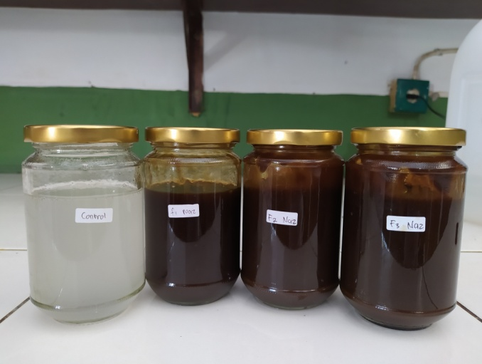

Keterangan:
F0: Blanko
F1: Konsentrasi EEDBW 6%
F2: Konsentrasi EEDBW 9%
F3: Konsentrasi EEDBW 12%

Lampiran 13. Uji Homogenitas

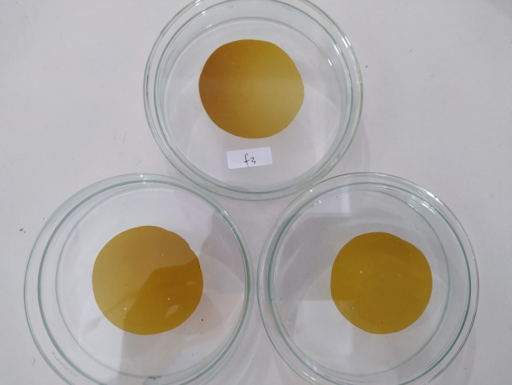

a

c
b

Keterangan: a. Pengulangan 1
b. Pengulangan 2
c. Pengulangan 3

Lampiran 14. Hasil Uji pH

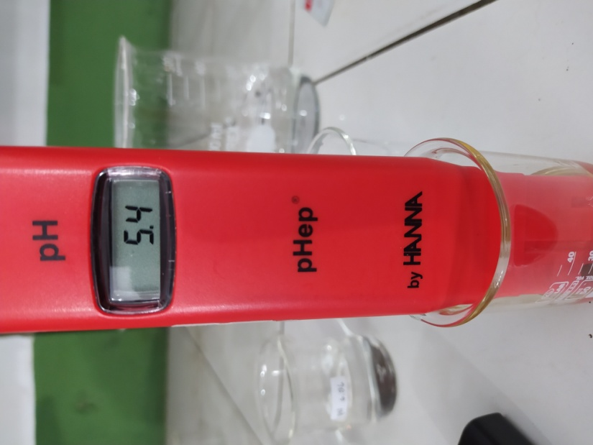

Lampiran 15. Hasil Uji Daya Sebar

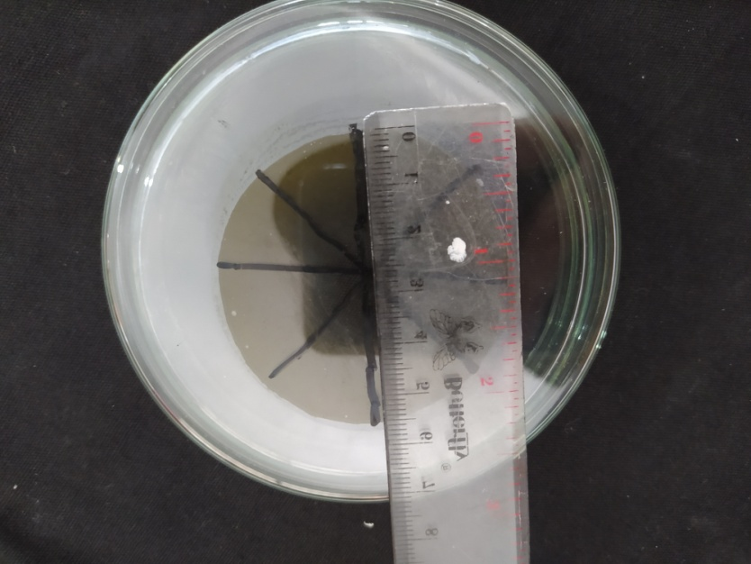

Lampiran 16. Hasil Uji Viskositas
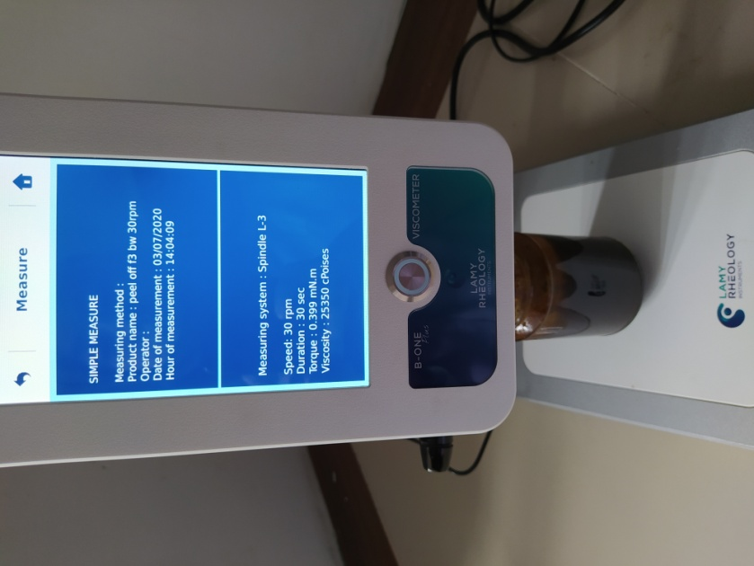
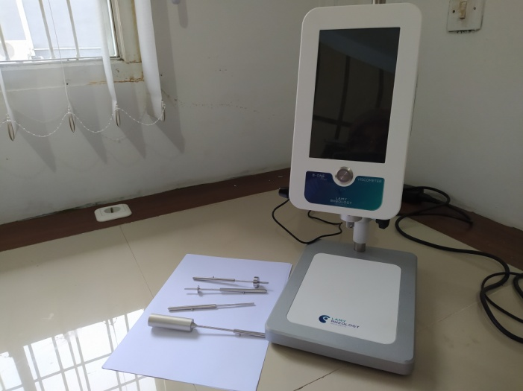

Lampiran 17. Hasil Uji iritasi terhadap sediaan Masker Gel Peel-off Ekstrak Etanol Daun Belimbing Wuluh

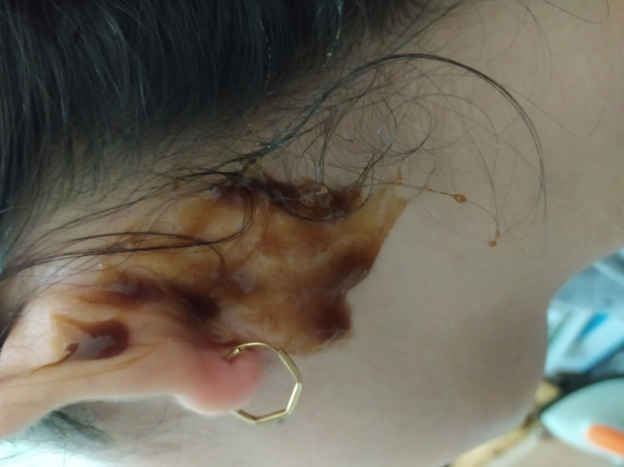

Saat dioleskan pada bagian belakang telinga

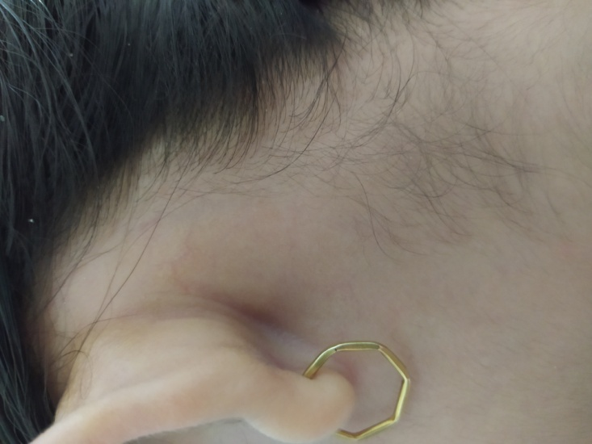

Hasil setelah pengolesan uji iritas

Lampiran 18. Hasil Uji Waktu Kering

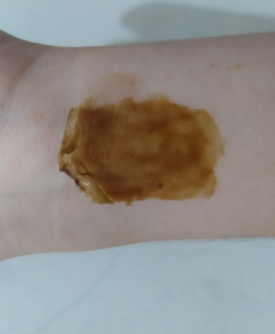
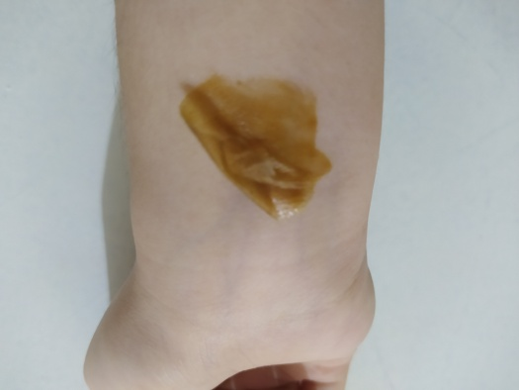
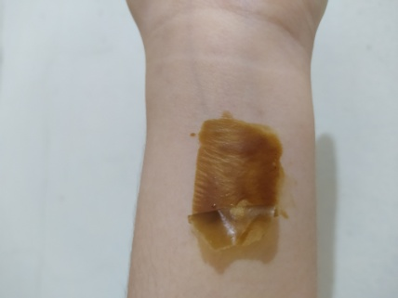
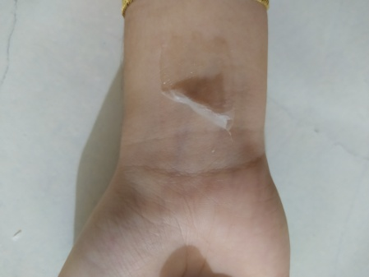
F1 6%
F2 9%
F4 12%
F0 Blanko

Lampiran19. Penggunaan Masker Pada Penelis

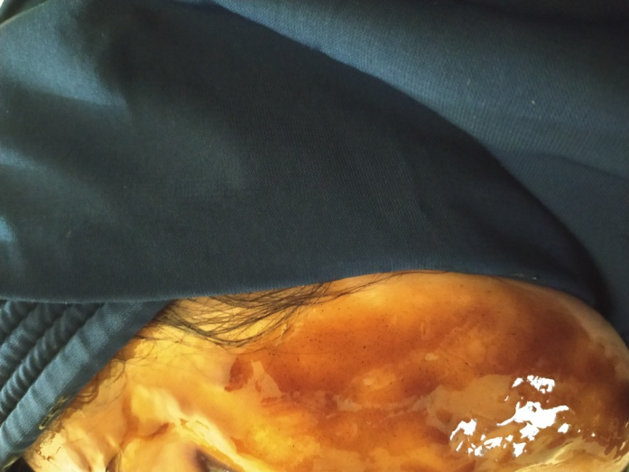

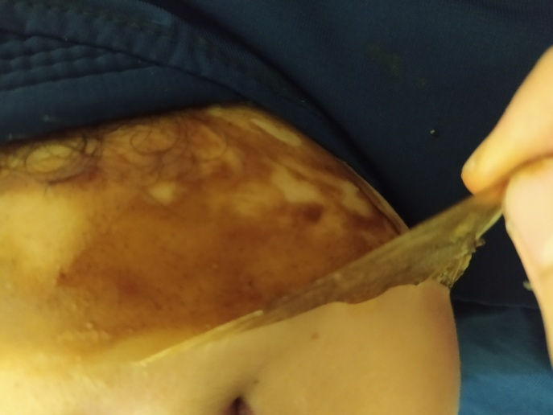

Lampiran 20. Hasil uji Masker gel peel-off dengan alat skin analyzer pada kulit wajah sukarelawan

- Moisture (Kelembaban)
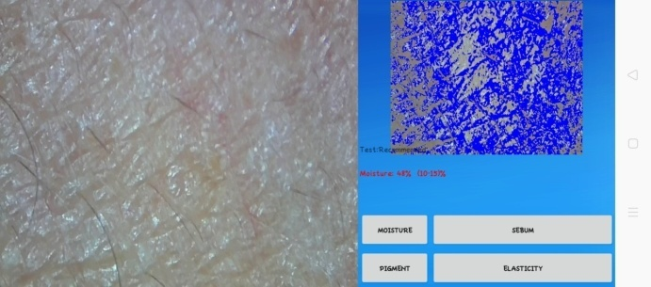

Minggu awal

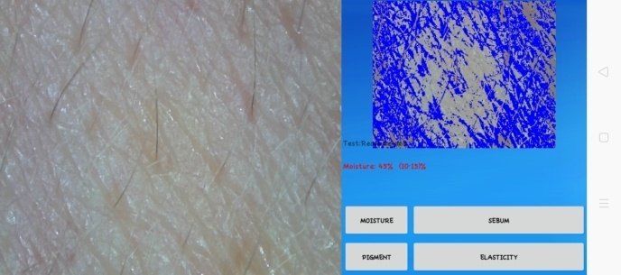

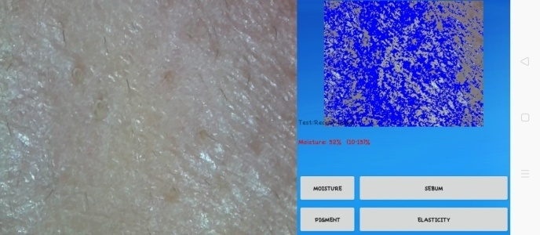
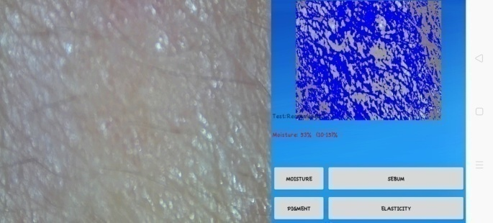
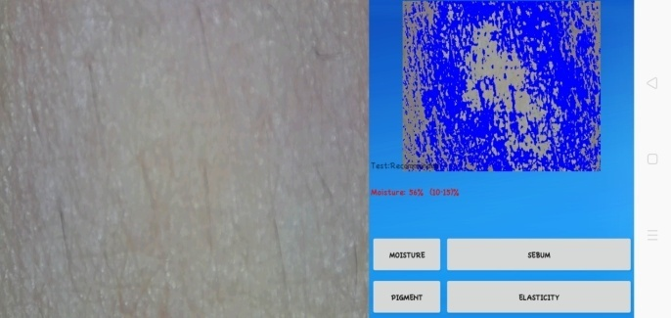
Minggu 1

Minggu 2

Minggu 3

Minggu 4
Lampiran 20. (Lanjutan)

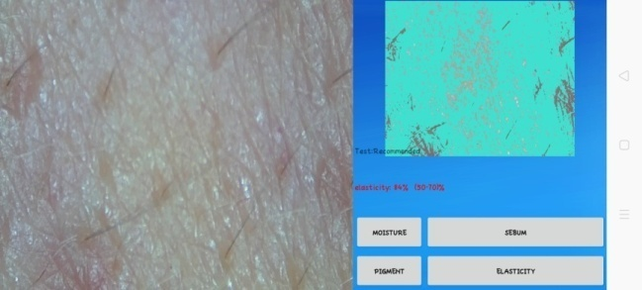
- Elastisitas
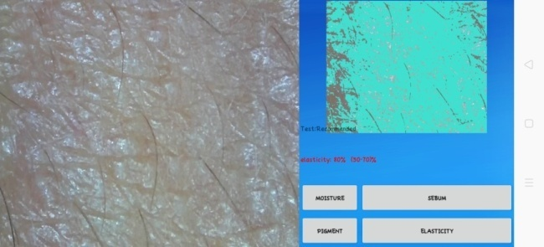

Minggu awal

Minggu 1

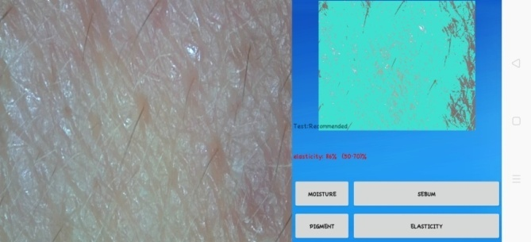

Minggu 2

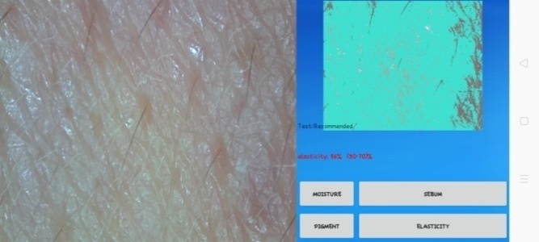

Minggu 3

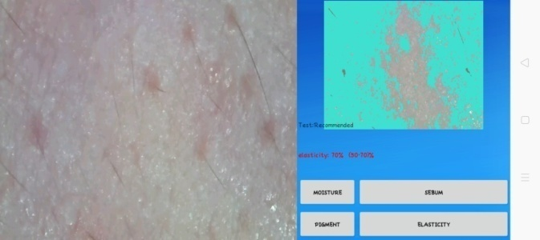

Minggu 4

Lampiran 20. (Lanjutan)
- Pigment
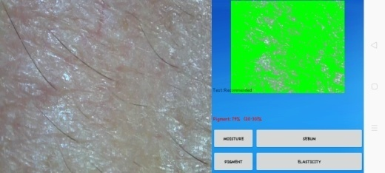

Minggu awal

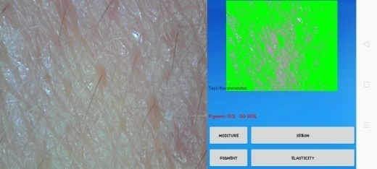

Minggu 1

Minggu 2

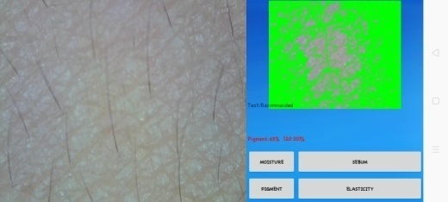

Minggu 3

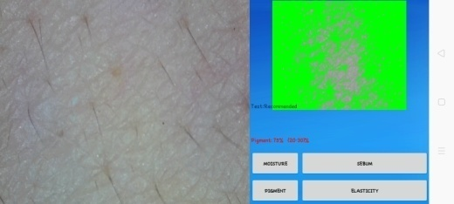

Minggu 4

Lampiran 21. Contoh format surat pernyataan sukarelawan

Surat Pernyataan

Saya yang bertanda tangan di bawah ini:
Nama :
Umur :
Alamat :
Telah mendapat penjelasan secukupnya bahwa wajah saya akan digunakan sebagai daerah yang akan dianalisis. Setelah mendapat penjelasan secukupnya tentang manfaat penelitian ini maka saya menyatakan setuju untuk ikut serta dalam penelitian dari Nazlia dengan judul “Formulasi Dan Uji Efektivitas Anti-Aging Masker Gel Peel-off Dari Ekstrak Etanol Daun Belimbing Wuluh (Averrhoa Bilimbi L.)” sebagai usaha untuk mengetahui apakah sediaan masker gel peel-off yang dihasilkan mampu memberikan efek anti-aging. Saya menyatakan sukarela dan bersedian untuk mengikuti prosedur penelitian yang telah ditetapkan
Persetujuan ini saya buat dengan penuh kesadaran dan tanpa paksaan dari pihak manapun. Demikian surat pernyataan ini dibuat untuk dapat dipergunakan sebagaimana mestinya.
Peneliti, Sukarelawan,

Lampiran 22. Data SPSS

        - Kelembaban (Moisture)

Tests of Normality
 | KELEMBABAN | Kolmogorov-Smirnovª |  |  | Shapiro-Wilk
 |  | Statistic | df | Sig. | Statistic | df | Sig.
F0 | M0 | ,253 | 3 | . | ,964 | 3 | ,637
 | M1 | ,175 | 3 | . | 1,000 | 3 | 1,000
 | M2 | ,253 | 3 | . | ,964 | 3 | ,637
 | M3 | ,175 | 3 | . | 1,000 | 3 | 1,000
 | M4 | ,253 | 3 | . | ,964 | 3 | ,637
F1 | M0 | ,219 | 3 | . | ,987 | 3 | ,780
 | M1 | ,328 | 3 | . | ,871 | 3 | ,298
 | M2 | ,328 | 3 | . | ,871 | 3 | ,298
 | M3 | ,314 | 3 | . | ,893 | 3 | ,363
 | M4 | ,175 | 3 | . | 1,000 | 3 | 1,000
F2 | M0 | ,175 | 3 | . | 1,000 | 3 | 1,000
 | M1 | ,253 | 3 | . | ,964 | 3 | ,637
 | M2 | ,175 | 3 | . | 1,000 | 3 | 1,000
 | M3 | ,253 | 3 | . | ,964 | 3 | ,637
 | M4 | ,175 | 3 | . | 1,000 | 3 | 1,000
F3 | M0 | ,276 | 3 | . | ,942 | 3 | ,537
 | M1 | ,314 | 3 | . | ,893 | 3 | ,363
 | M2 | ,328 | 3 | . | ,871 | 3 | ,298
 | M3 | ,337 | 3 | . | ,855 | 3 | ,253
 | M4 | ,337 | 3 | . | ,855 | 3 | ,253
a. Lilliefors Significance Correction

Test of Homogeneity of Variances
 | Levene Statistic | df1 | df2 | Sig.
F0 | ,286 | 4 | 10 | ,881
F1 | ,500 | 4 | 10 | ,737
F2 | ,450 | 4 | 10 | ,770
F3 | ,315 | 4 | 10 | ,861

Lampiran 22. (Lanjutan)
ANOVA
 |  | Sum of Squares | df | Mean Square | F | Sig.
F0 | Between Groups | 26,933 | 4 | 6,733 | 2,806 | ,045
 | Within Groups | 24,000 | 10 | 2,400
 | Total | 50,933 | 14
F1 | Between Groups | 89,733 | 4 | 22,433 | 2,952 | ,035
 | Within Groups | 76,000 | 10 | 7,600
 | Total | 165,733 | 14
F2 | Between Groups | 88,400 | 4 | 22,100 | 10,359 | ,001
 | Within Groups | 21,333 | 10 | 2,133
 | Total | 109,733 | 14
F3 | Between Groups | 210,267 | 4 | 52,567 | 5,087 | ,017
 | Within Groups | 103,333 | 10 | 10,333
 | Total | 313,600 | 14

F0
Duncanª
KELEMBABAN | N | Subset for alpha = 0.05
 |  | 1 | 2
M0 | 3 | 37,67
M1 | 3 | 38,00
M2 | 3 | 39,33 | 39,33
M3 | 3 | 40,00 | 40,00
M4 | 3 |  | 41,33
Sig. |  | ,116 | ,162
Means for groups in homogeneous subsets are displayed.
a. Uses Harmonic Mean Sample Size = 3,000.

Lampiran 22. (Lanjutan)
F1
Duncanª
KELEMBABAN | N | Subset for alpha = 0.05
 |  | 1 | 2
M1 | 3 | 40,33
M0 | 3 | 40,67
M2 | 3 | 41,33
M3 | 3 | 43,00 | 43,00
M4 | 3 |  | 47,00
Sig. |  | ,295 | ,106
Means for groups in homogeneous subsets are displayed.
a. Uses Harmonic Mean Sample Size = 3,000.

F2
Duncanª
KELEMBABAN | N | Subset for alpha = 0.05
 |  | 1 | 2 | 3 | 4
M0 | 3 | 44,00
M1 | 3 |  | 46,67
M2 | 3 |  | 48,00 | 48,00
M3 | 3 |  |  | 49,67 | 49,67
M4 | 3 |  |  |  | 51,00
Sig. |  | 1,000 | ,290 | ,192 | ,290
Means for groups in homogeneous subsets are displayed.
a. Uses Harmonic Mean Sample Size = 3,000.

F3
Duncanª
KELEMBABAN | N | Subset for alpha = 0.05
 |  | 1 | 2 | 3
M0 | 3 | 44,00
M1 | 3 | 47,00 | 47,00
M2 | 3 | 49,67 | 49,67 | 49,67
M3 | 3 |  | 51,33 | 51,33
M4 | 3 |  |  | 55,00
Sig. |  | ,066 | ,146 | ,081
Means for groups in homogeneous subsets are displayed.
a. Uses Harmonic Mean Sample Size = 3,000.
Lampiran 22. (Lanjutan)
        - Elastisitas (elasticity)

Tests of Normality
 | ELASTISITAS | Kolmogorov-Smirnovª |  |  | Shapiro-Wilk
 |  | Statistic | df | Sig. | Statistic | df | Sig.
F0 | M0 | ,175 | 3 | . | 1,000 | 3 | 1,000
 | M1 | ,253 | 3 | . | ,964 | 3 | ,637
 | M2 | ,253 | 3 | . | ,964 | 3 | ,637
 | M3 | ,253 | 3 | . | ,964 | 3 | ,637
 | M4 | ,253 | 3 | . | ,964 | 3 | ,637
F1 | M0 | ,253 | 3 | . | ,964 | 3 | ,637
 | M1 | ,292 | 3 | . | ,923 | 3 | ,463
 | M2 | ,219 | 3 | . | ,987 | 3 | ,780
 | M3 | ,292 | 3 | . | ,923 | 3 | ,463
 | M4 | ,292 | 3 | . | ,923 | 3 | ,463
F2 | M0 | ,175 | 3 | . | 1,000 | 3 | 1,000
 | M1 | ,175 | 3 | . | 1,000 | 3 | 1,000
 | M2 | ,175 | 3 | . | 1,000 | 3 | 1,000
 | M3 | ,253 | 3 | . | ,964 | 3 | ,637
 | M4 | ,175 | 3 | . | 1,000 | 3 | 1,000
F3 | M0 | ,253 | 3 | . | ,964 | 3 | ,637
 | M1 | ,175 | 3 | . | 1,000 | 3 | 1,000
 | M2 | ,253 | 3 | . | ,964 | 3 | ,637
 | M3 | ,253 | 3 | . | ,964 | 3 | ,637
 | M4 | ,175 | 3 | . | 1,000 | 3 | 1,000
a. Lilliefors Significance Correction

Test of Homogeneity of Variances
 | Levene Statistic | df1 | df2 | Sig.
F0 | ,262 | 4 | 10 | ,896
F1 | ,212 | 4 | 10 | ,926
F2 | ,327 | 4 | 10 | ,854
F3 | 3,130 | 4 | 10 | ,065

Lampiran 22. (Lanjutan)

ANOVA
 |  | Sum of Squares | df | Mean Square | F | Sig.
F0 | Between Groups | 24,933 | 4 | 6,233 | 3,016 | ,041
 | Within Groups | 20,667 | 10 | 2,067
 | Total | 45,600 | 14
F1 | Between Groups | 62,000 | 4 | 15,500 | 3,577 | ,046
 | Within Groups | 43,333 | 10 | 4,333
 | Total | 105,333 | 14
F2 | Between Groups | 214,667 | 4 | 53,667 | 42,368 | ,000
 | Within Groups | 12,667 | 10 | 1,267
 | Total | 227,333 | 14
F3 | Between Groups | 306,267 | 4 | 76,567 | 13,837 | ,000
 | Within Groups | 55,333 | 10 | 5,533
 | Total | 361,600 | 14

F0
Duncanª
ELASTISITAS | N | Subset for alpha = 0.05
 |  | 1 | 2
M0 | 3 | 77,00
M1 | 3 | 77,67
M2 | 3 | 78,33 | 78,33
M3 | 3 | 79,33 | 79,33
M4 | 3 |  | 80,67
Sig. |  | ,093 | ,087
Means for groups in homogeneous subsets are displayed.
a. Uses Harmonic Mean Sample Size = 3,000.

Lampiran 22. (Lanjutan)
F1
Duncanª
ELASTISITAS | N | Subset for alpha = 0.05
 |  | 1 | 2
M0 | 3 | 79,33
M1 | 3 | 79,67
M2 | 3 | 80,33
M3 | 3 | 82,67 | 82,67
M4 | 3 |  | 84,67
Sig. |  | ,097 | ,267
Means for groups in homogeneous subsets are displayed.
a. Uses Harmonic Mean Sample Size = 3,000.

F2
Duncanª
ELASTISITAS | N | Subset for alpha = 0.05
 |  | 1 | 2 | 3 | 4
M0 | 3 | 79,00
M1 | 3 |  | 82,00
M2 | 3 |  | 84,00
M3 | 3 |  |  | 86,67
M4 | 3 |  |  |  | 90,00
Sig. |  | 1,000 | ,055 | 1,000 | 1,000
Means for groups in homogeneous subsets are displayed.
a. Uses Harmonic Mean Sample Size = 3,000.

F3
Duncanª
ELASTISITAS | N | Subset for alpha = 0.05
 |  | 1 | 2 | 3
M0 | 3 | 81,67
M1 | 3 | 85,00 | 85,00
M2 | 3 | 86,00 | 86,00
M3 | 3 |  | 89,33
M4 | 3 |  |  | 95,00
Sig. |  | ,056 | ,056 | 1,000
Means for groups in homogeneous subsets are displayed.
Lampiran 22. (Lanjutan)
        - Kecerahan (Pigment)

Tests of Normality
 | PIGMENT | Kolmogorov-Smirnovª |  |  | Shapiro-Wilk
 |  | Statistic | df | Sig. | Statistic | df | Sig.
F0 | M0 | ,175 | 3 | . | 1,000 | 3 | 1,000
 | M1 | ,175 | 3 | . | 1,000 | 3 | 1,000
 | M2 | ,175 | 3 | . | 1,000 | 3 | 1,000
 | M3 | ,253 | 3 | . | ,964 | 3 | ,637
 | M4 | ,253 | 3 | . | ,964 | 3 | ,637
F1 | M0 | ,253 | 3 | . | ,964 | 3 | ,637
 | M1 | ,175 | 3 | . | 1,000 | 3 | 1,000
 | M2 | ,253 | 3 | . | ,964 | 3 | ,637
 | M3 | ,253 | 3 | . | ,964 | 3 | ,637
 | M4 | ,253 | 3 | . | ,964 | 3 | ,637
F2 | M0 | ,253 | 3 | . | ,964 | 3 | ,637
 | M1 | ,253 | 3 | . | ,964 | 3 | ,637
 | M2 | ,175 | 3 | . | 1,000 | 3 | 1,000
 | M3 | ,175 | 3 | . | 1,000 | 3 | 1,000
 | M4 | ,253 | 3 | . | ,964 | 3 | ,637
F3 | M0 | ,343 | 3 | . | ,842 | 3 | ,220
 | M1 | ,253 | 3 | . | ,964 | 3 | ,637
 | M2 | ,292 | 3 | . | ,923 | 3 | ,463
 | M3 | ,175 | 3 | . | 1,000 | 3 | 1,000
 | M4 | ,175 | 3 | . | 1,000 | 3 | 1,000
a. Lilliefors Significance Correction

Test of Homogeneity of Variances
 | Levene Statistic | df1 | df2 | Sig.
F0 | ,453 | 4 | 10 | ,769
F1 | ,045 | 4 | 10 | ,995
F2 | ,421 | 4 | 10 | ,790
F3 | 2,313 | 4 | 10 | ,129

Lampiran 22. (Lanjutan)

ANOVA
 |  | Sum of Squares | df | Mean Square | F | Sig.
F0 | Between Groups | 22,400 | 4 | 5,600 | 3,652 | ,044
 | Within Groups | 15,333 | 10 | 1,533
 | Total | 37,733 | 14
F1 | Between Groups | 71,067 | 4 | 17,767 | 6,662 | ,007
 | Within Groups | 26,667 | 10 | 2,667
 | Total | 97,733 | 14
F2 | Between Groups | 186,400 | 4 | 46,600 | 25,889 | ,000
 | Within Groups | 18,000 | 10 | 1,800
 | Total | 204,400 | 14
F3 | Between Groups | 321,600 | 4 | 80,400 | 10,673 | ,001
 | Within Groups | 75,333 | 10 | 7,533
 | Total | 396,933 | 14

F0
Duncanª
PIGMENT | N | Subset for alpha = 0.05
 |  | 1 | 2
M0 | 3 | 66,00
M1 | 3 | 66,00
M2 | 3 | 68,00 | 68,00
M3 | 3 |  | 68,67
M4 | 3 |  | 68,67
Sig. |  | ,088 | ,543
Means for groups in homogeneous subsets are displayed.
a. Uses Harmonic Mean Sample Size = 3,000.

Lampiran 22. (Lanjutan)
F1
Duncanª
PIGMENT | N | Subset for alpha = 0.05
 |  | 1 | 2 | 3
M0 | 3 | 65,33
M1 | 3 | 67,00 | 67,00
M2 | 3 |  | 68,67 | 68,67
M3 | 3 |  |  | 70,33
M4 | 3 |  |  | 71,33
Sig. |  | ,240 | ,240 | ,085
Means for groups in homogeneous subsets are displayed.
a. Uses Harmonic Mean Sample Size = 3,000.

F2
Duncanª
PIGMENT | N | Subset for alpha = 0.05
 |  | 1 | 2 | 3 | 4
M0 | 3 | 70,33
M1 | 3 | 72,33 | 72,33
M2 | 3 |  | 74,00
M3 | 3 |  |  | 77,00
M4 | 3 |  |  |  | 80,33
Sig. |  | ,098 | ,159 | 1,000 | 1,000
Means for groups in homogeneous subsets are displayed.
a. Uses Harmonic Mean Sample Size = 3,000.

F3
Duncanª
PIGMENT | N | Subset for alpha = 0.05
 |  | 1 | 2 | 3 | 4
M0 | 3 | 72,00
M1 | 3 | 75,33 | 75,33
M2 | 3 |  | 79,33 | 79,33
M3 | 3 |  |  | 82,00 | 82,00
M4 | 3 |  |  |  | 85,00
Sig. |  | ,168 | ,105 | ,262 | ,210
Means for groups in homogeneous subsets are displayed.
a. Uses Harmonic Mean Sample Size = 3,000.

