Lampiran 1. Hasil Identifikasi Tanaman Aren
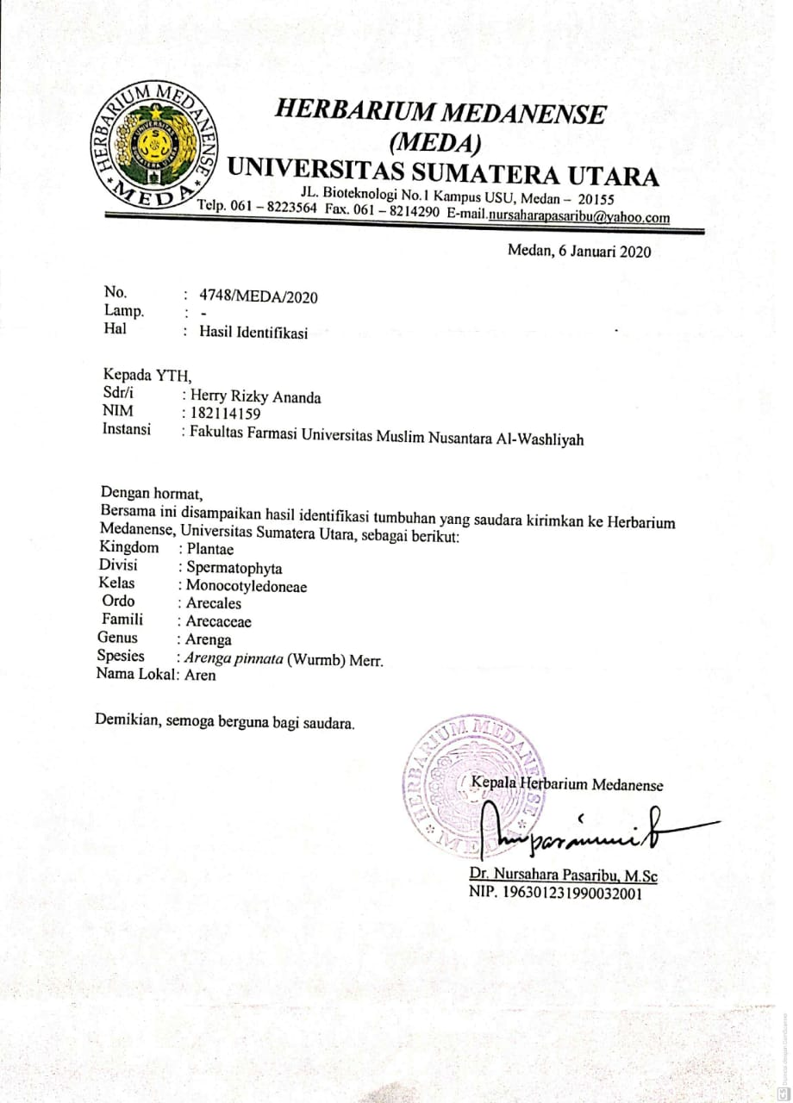

Lampiran 2. Hasil Etical Clearen
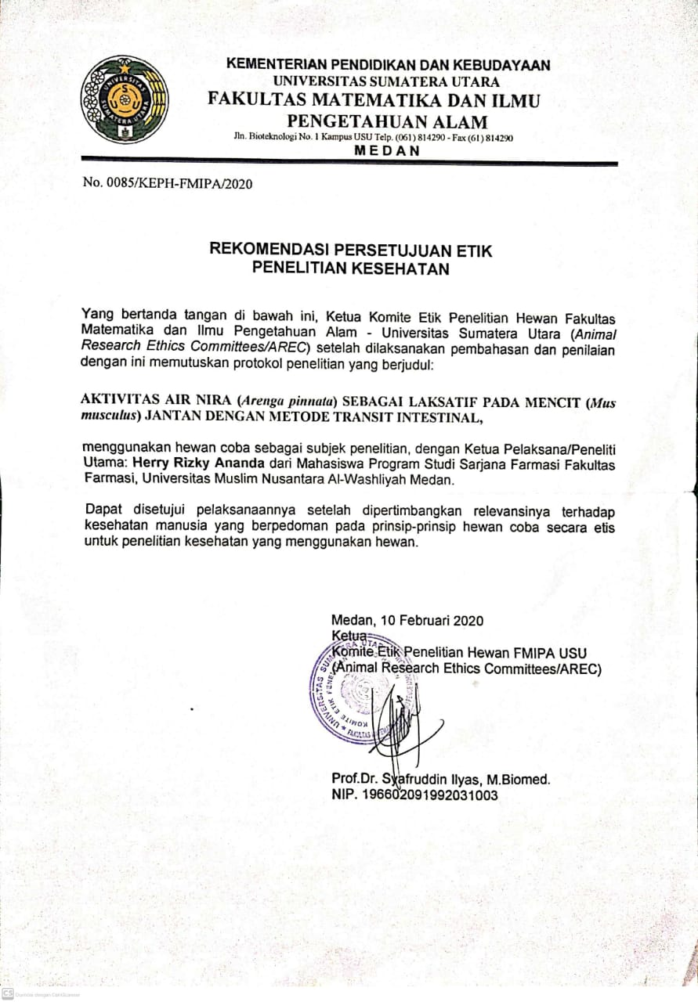

Lampiran 3. Tumbuhan Aren Dan Air Nira

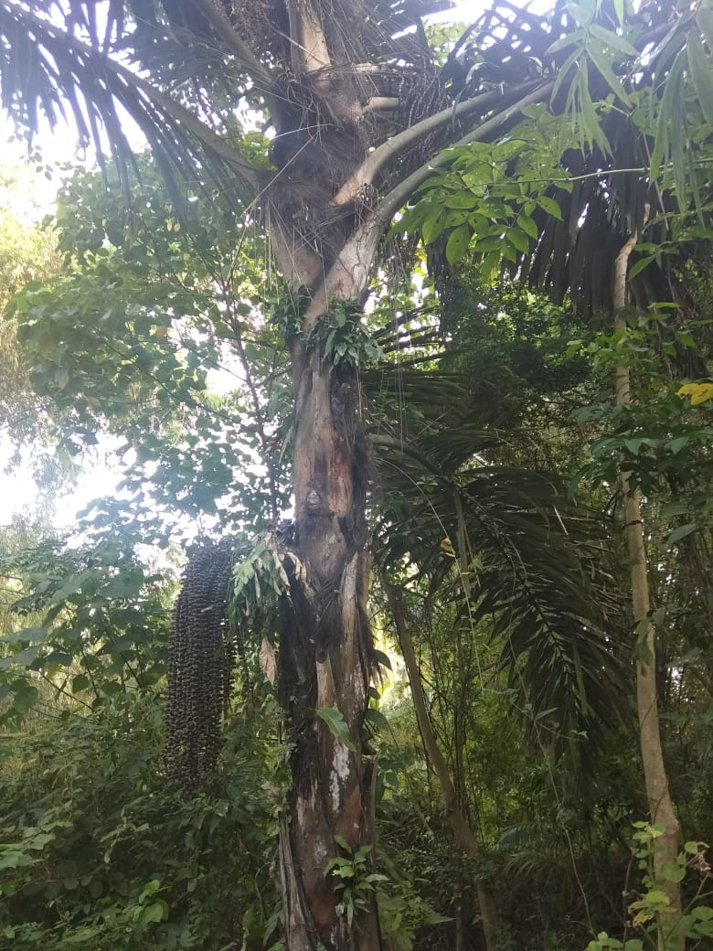
Tumbuhan aren
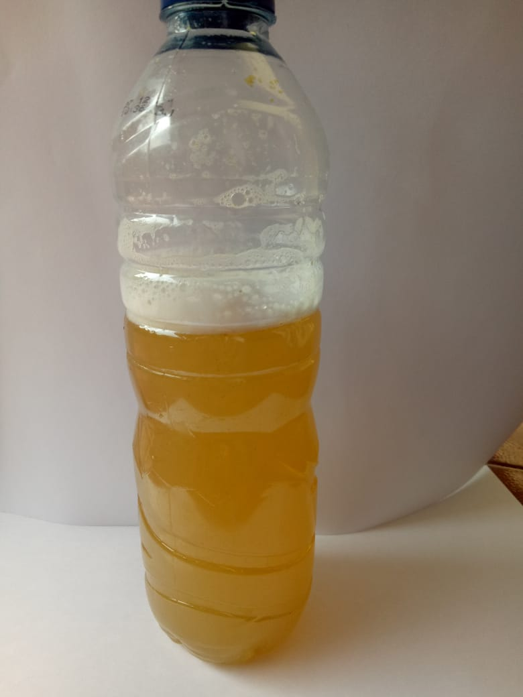
Air nira

Lampiran 4. Hasil Skrining Fitokimia Air Nira

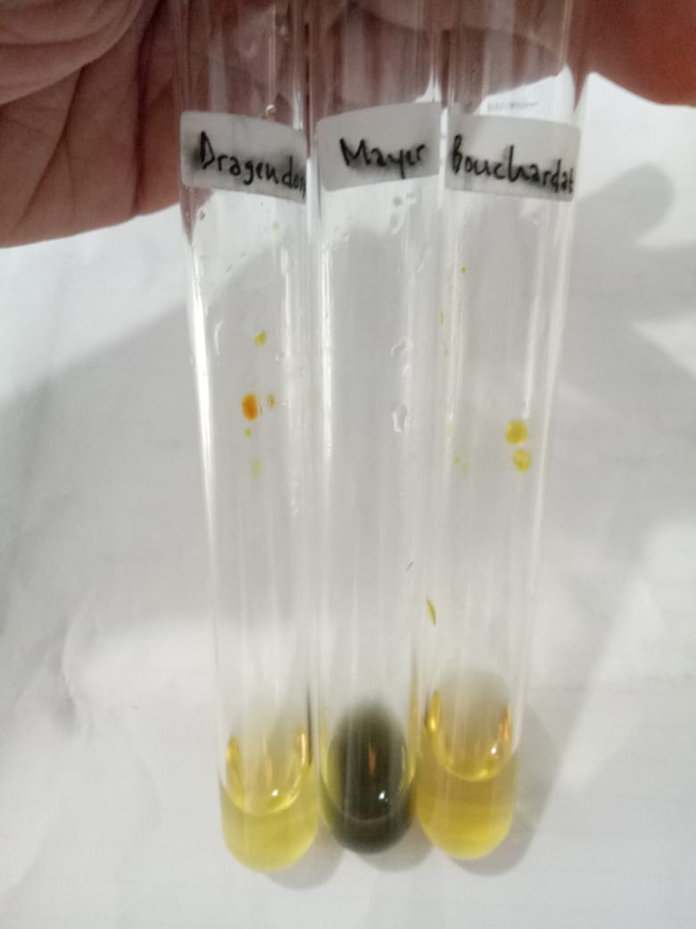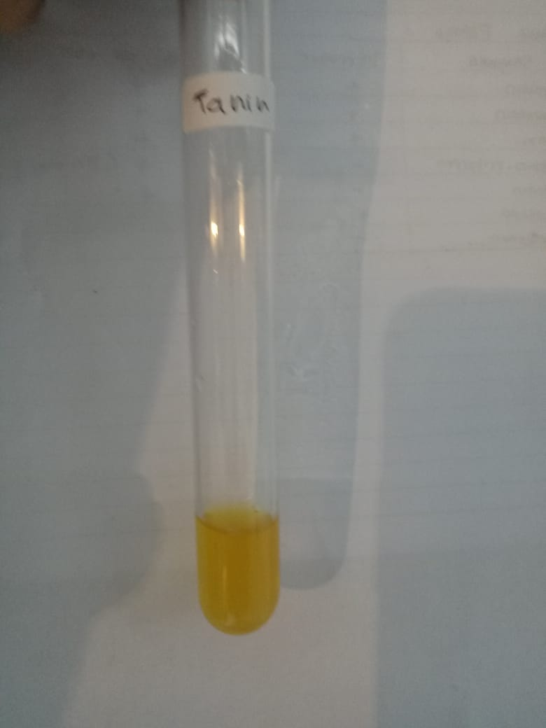
Alkaloid (-) Tanin (-)

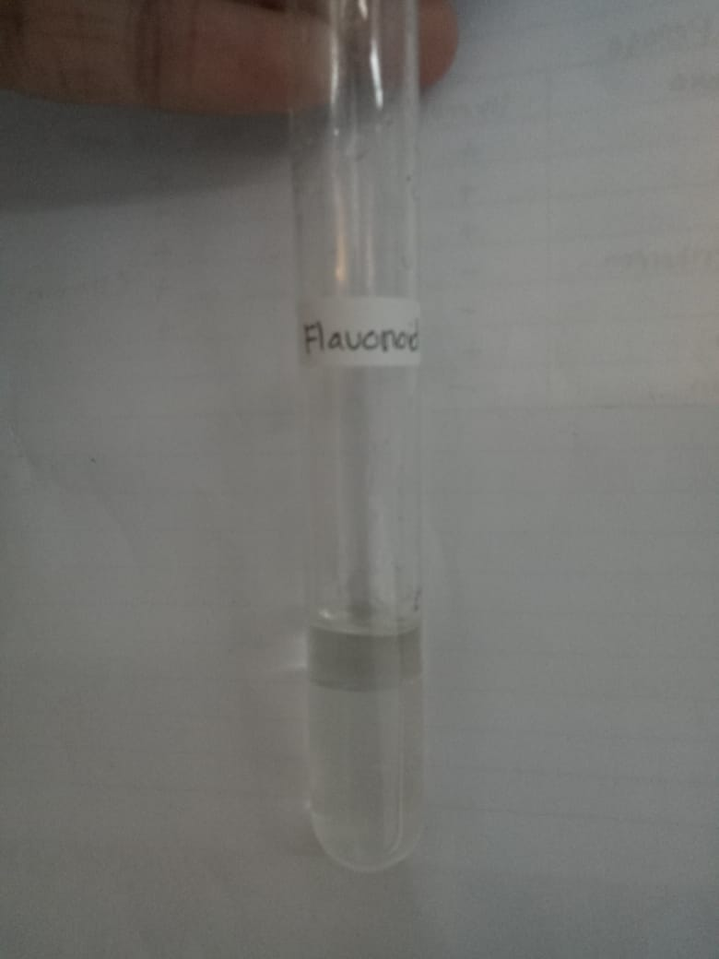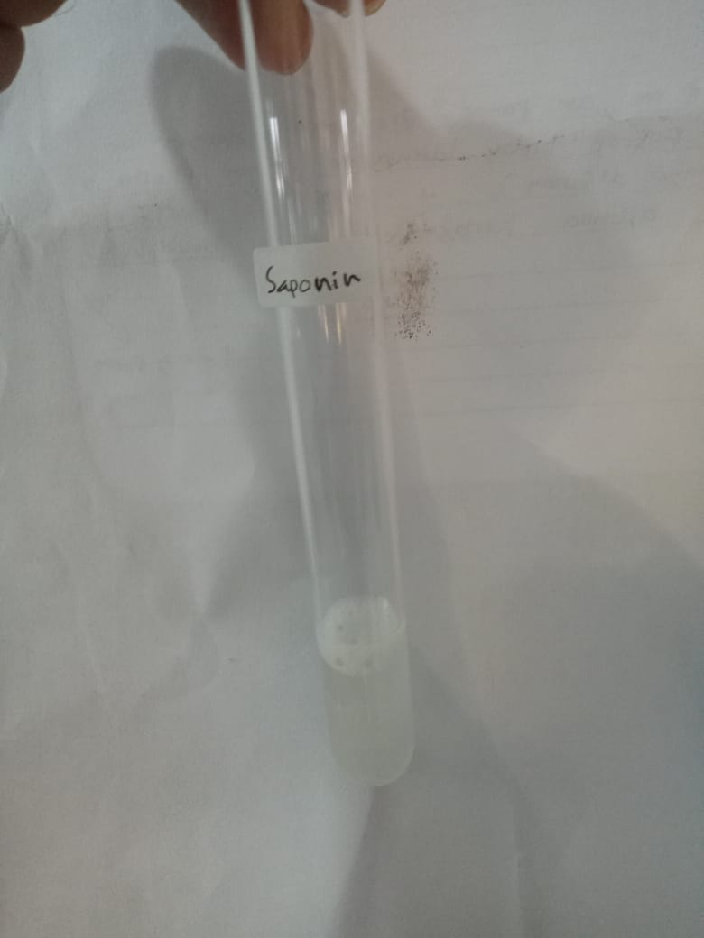
Flavanoid (-) Saponin (+)

Lampiran 4. (lanjutan)
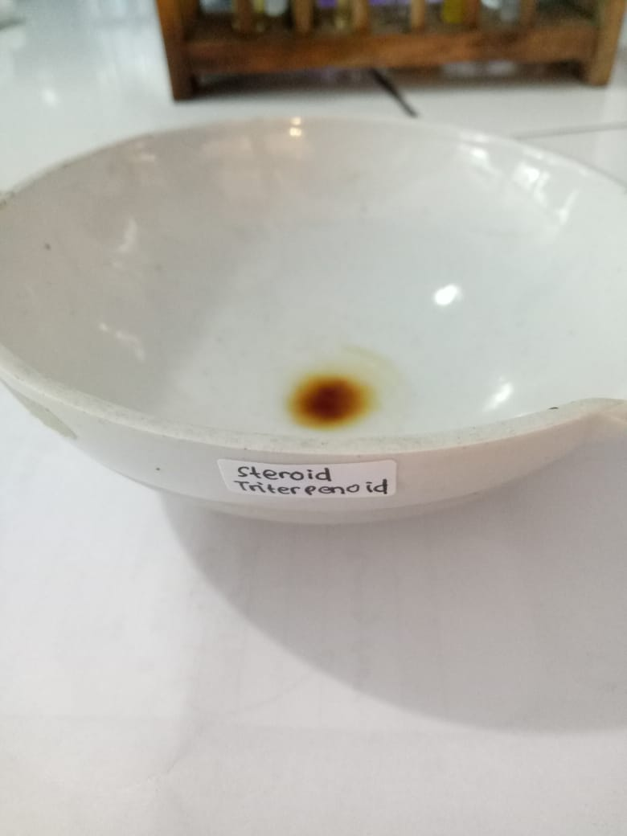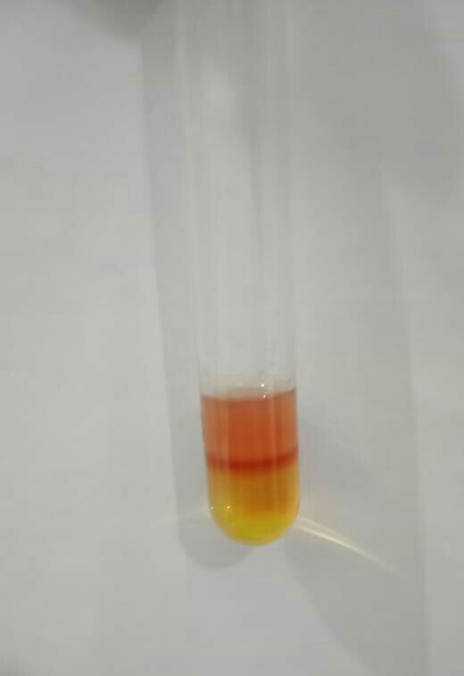
Steroid tertefenoid (-) Antrakuinon (+)

Lampiran 5. Pembedahan dan Pengamatan Panjang Lintasan Norit

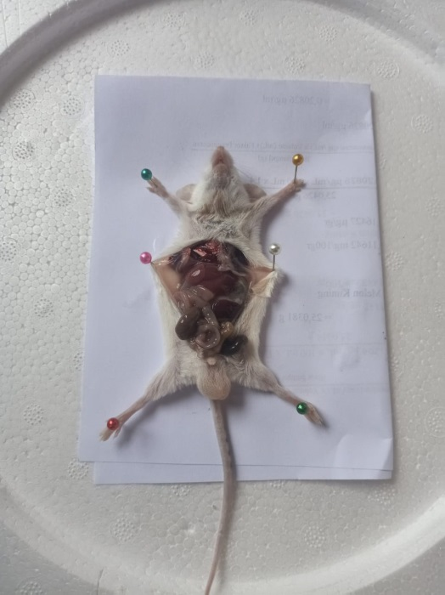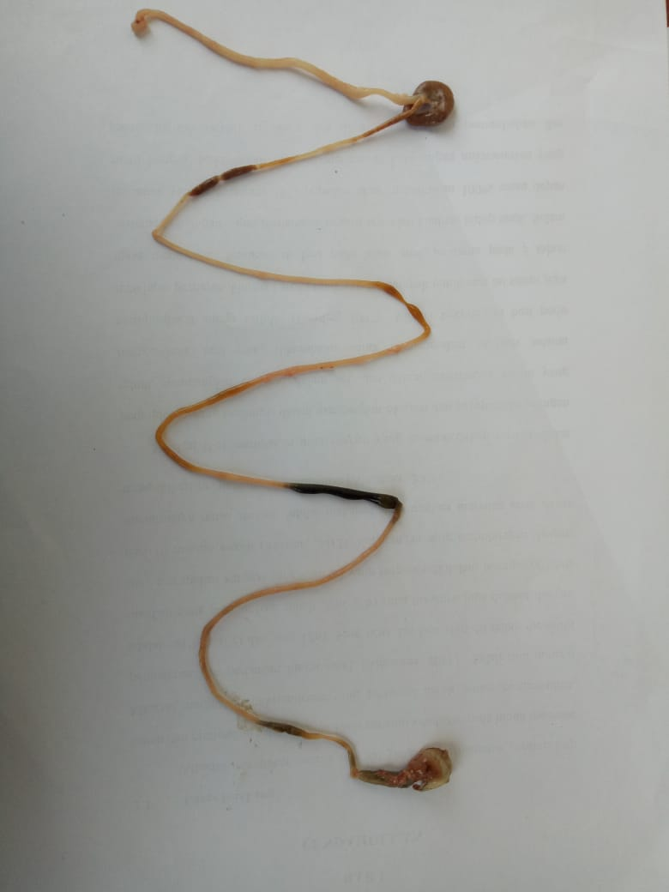
Proses pembedahan Kontrol (-) Aquadest

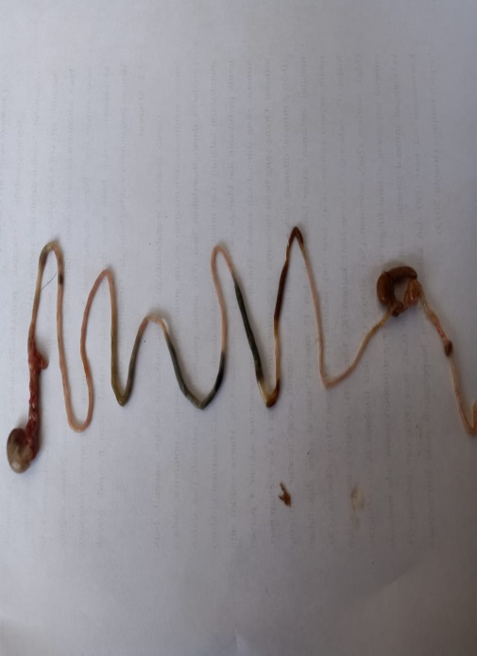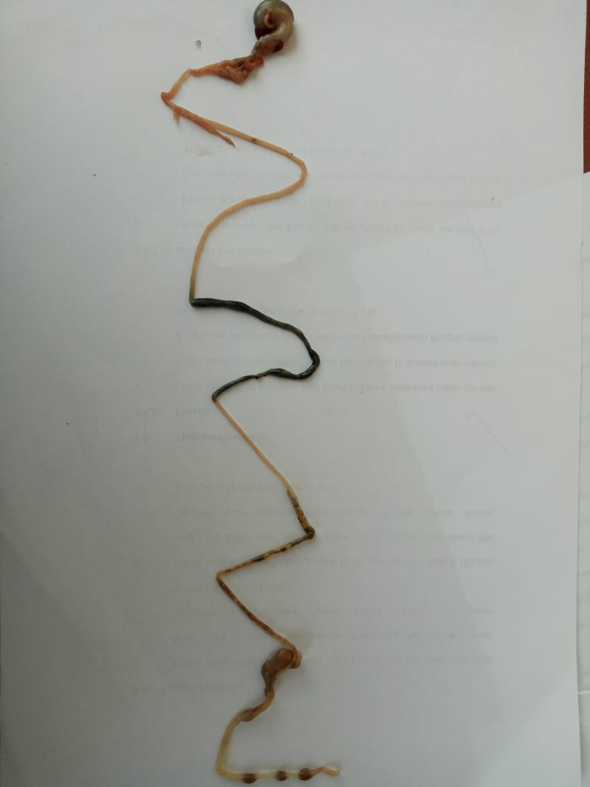
Kontrol (+) Bisacodyl 2 mg/20 g BB Air nira 0,4 ml/20 g BB

Lampiran 5. (lanjutan)
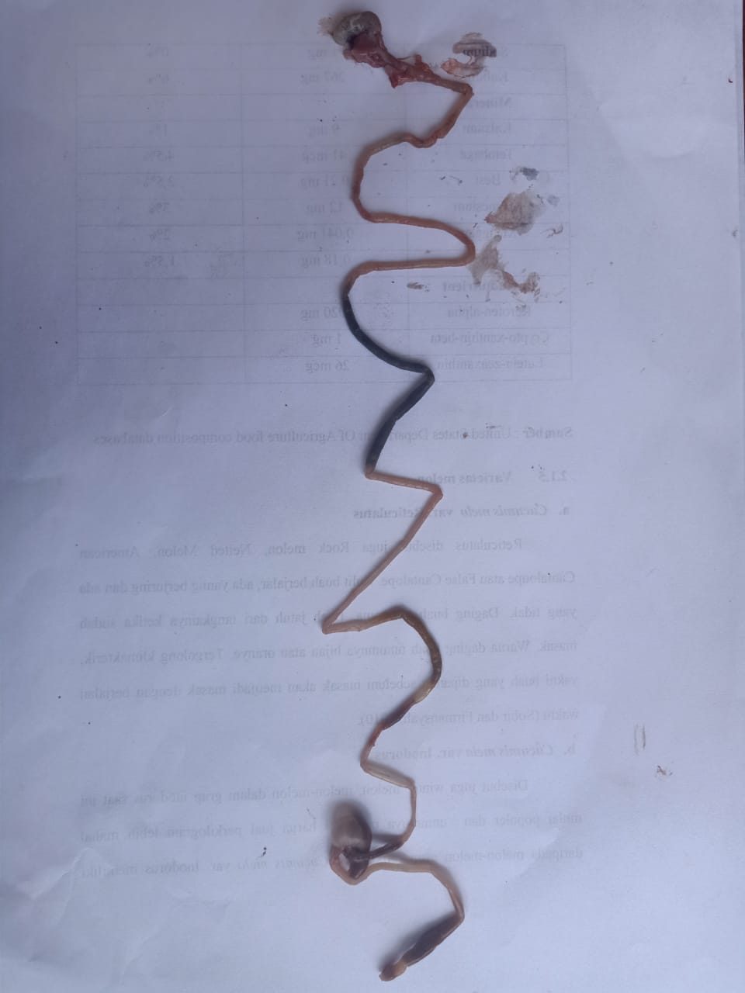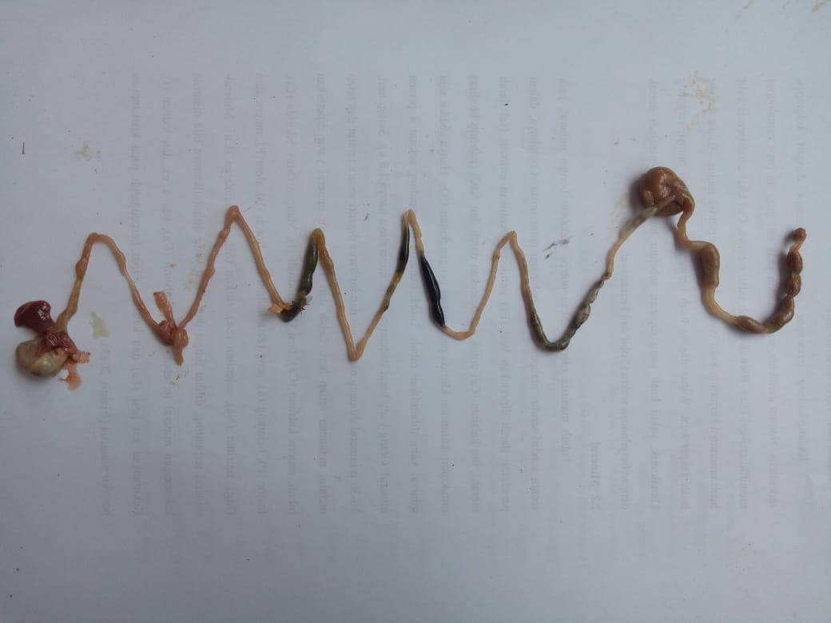
Air nira 0,5ml/20 g BB Air nira 0,6ml/20 g BB

Lampiran 6. Bagan Alir Penelitian
Air nira
Skrining fitokimia
- Alkaloid
- Flavonoid
- Tanin
- Steroid / triterpenoid
- Saponin
- Glikosida Antrakinon

Hasil

Uji Efek Laksatif

Lampiran 7. Bagan Alir Pengujian Efek Laksatif
25 ekor mencit jantan
Diaklimatisasi selama 2 minggu
Diberi penandaan pada setiap ekor mencit

Ditimbang berat mencit satu-persatu

Diinduksi gambir 3 g/kg BB secara oral selama 2 hari
Dipuasakan selama 18 jam
Diukur panjang lintasan usus yang dilalui norit dan panjang keseluruhan usus
Dihitung persentase rasio lintasan norit
Persentase rasio lintasan norit
Semua mencit dimatikan lalu dibedah
Didiamkan selama 30 menit
Diberi suspensi norit 1%
Didiamkan selama 45 menit
Air nira 0,6 ml/20 g BB
Air nira 0,4 ml/20 g BB
Air nira 0,5 ml/20 g BB
Kontrol (+)
Bisacodyl
2 mg/20 g BB
Aquadest(-)
Setiap mencit diberi perlakuan sesuai dengan kelompoknya

Lampiran 8. Perhitungan Dosis

- Dosis pemberian gambir
- Dosis gambir = 3 g/kg BB
- Dosis gambir pada mencit = $\frac{3 g}{1000 g}$ x 20 g
= 0,06 g
= 60 mg
- Konsentrasi infusa gambir 20% = $\frac{20 g}{100 ml}$
= $\frac{20000 mg}{100 ml}$
= 200 mg/ml
- Volume pemberian gambir pada mencit = $\frac{60 mg}{200 mg/ml}$

= 0,3 ml/20 g BB mencit

- Dosis pemberian bisacodyl
- Dosis bisacodyl = 100 mg/kg BB
- Dosis bisacodyl pada mencit = $\frac{100 mg}{1000 g}$ x 20 g
= $\frac{0,1 g}{1000 g}$ x 20 g
= 0,002 g
= 2 mg

Lampiran 8. (lanjutan)
- Konsentrasi suspensi bisacodyl 1% = $\frac{1 g}{100 ml}$
= $\frac{1000 mg}{100 ml}$
= 10 mg/ml
- Volume pemberian bisacodyl pada mencit = $\frac{2 mg}{10 mg/ml}$
= 0,2 ml/20 g BB mencit

- Dosis pemberian Air nira
- Air nira = 0,4 ml/20 g BB
- Air nira = 0,5 ml/20 g BB
- Air nira = 0,6 ml/20 g BB

- Dosis pemberian Norit 1%
BB Mencit = 20 g
Volume pemberian = $\frac{1 g}{100 ml}$ x 20 g
= 0,2 ml/20 g BB

Lampiran 9. Hasil persentase rasio lintasan norit
No. Mencit | Perlakuan | BB Mencit (g) | A (cm) | Rata-rata ± SD | B (cm) | Rata-rata ± SD | Rasio Lintasan Norit (%) | Rata-rata
1 | Kontrol (-) Aquadest | 23 | 10 | 8,2  ± 1,30 | 43 | 36,5 ± 3,71 | 23,25 | 22,51 ± 2,69
2 |  | 23 | 7 |  | 35 |  | 20
3 |  | 20 | 9 |  | 34 |  | 26,47
4 |  | 20 | 8 |  | 35 |  | 22,85
5 |  | 22 | 7 |  | 35 |  | 20
6 | Kontrol (+) Bisacodyl  2 mg/20 g BB | 23 | 25 | 27  ± 3,53 | 35 | 43,6 ± 5,22 | 71,42 | 62,22 ± 7,13
7 |  | 20 | 32 |  | 49 |  | 65,30
8 |  | 26 | 29 |  | 46 |  | 63,04
9 |  | 23 | 23 |  | 44 |  | 52,27
10 |  | 23 | 26 |  | 44 |  | 59,09
11 | Air Nira  0,4 ml/20 g BB | 23 | 21 | 19,8 ± 2,16 | 41 | 45 ± 3,12 | 51,21 | 44,12 ± 5,28
12 |  | 24 | 18 |  | 45 |  | 40
13 |  | 25 | 22 |  | 50 |  | 44
14 |  | 23 | 17 |  | 44,5 |  | 38,20
15 |  | 26 | 21 |  | 44,5 |  | 47,19
16 | Air Nira  0,5 ml/20 g BB | 23 | 22,5 | 27,3 ± 3,38 | 47 | 45,8 ± 2,28 | 47,87 | 59,67 ± 7,29
17 |  | 26 | 31 |  | 46 |  | 67,39
18 |  | 26 | 27 |  | 46 |  | 58,69
19 |  | 21 | 30 |  | 48 |  | 62,5
20 |  | 23 | 26 |  | 42 |  | 61,90
21 | Air Nira  0,6 ml/20 g BB | 24 | 31 | 33  ±  2 | 43,5 | 47 ± 2,73 | 71,26 | 70,21 ± 1,25
22 |  | 23 | 35 |  | 49,5 |  | 70,70
23 |  | 26 | 33 |  | 46,5 |  | 70,96
24 |  | 26 | 35 |  | 50 |  | 70
25 |  | 23 | 31 |  | 45,5 |  | 68,13

Lampiran 10. Perhitungan Persentase Rasio Lintasan Norit
Contoh:
Perlakuan | Panjang usus yang dilalui norit (cm) | Panjang usus seluruhnya (cm)
Kontrol (-) Aquadest | 10 | 43
Kontrol (+) Bisacodyl 2mg/20 g BB | 25 | 35
Air Nira 0,4 ml/20 g BB | 21 | 41
Air Nira 0,5 ml/20 g BB | 22,5 | 47
Air Nira 0,6 ml/20 g BB | 31 | 43,5
Persentase rasio lintasan norit dihitung dengan rumus sebagai berikut:
$\frac{panjang usus yang dilalui norit}{panjang usus seluruhnya}$ x 100%
- Kontrol (-) Aquadest = $\frac{10}{43}$ x 100% = 23,25%
- Kontrol (+) Bisacodyl 2mg/20 g BB = $\frac{25}{35}$ x 100% = 71,42%
- Air Nira 0,4 ml/20 g BB = $\frac{21}{41}$ x 100% = 51,21%
- Air Nira 0,5 ml/20 g BB = $\frac{22,5}{47}$ x 100% = 47,87%
- Air Nira 0,6 ml/20 g BB = $\frac{31}{43,5}$ x 100% = 71,26%

Lampiran 11. Hasil uji ANOVA
- Hasil uji Normalitas
Tests of Normality
Kelompok Perlakuan |  | Kolmogorov-Smirnovª |  |  | Shapiro-Wilk
 |  | Statistic | Df | Sig. | Statistic | df | Sig.
Persentase panjang lintasan norit | Kontrol (-) aquadest | .225 | 5 | .200* | .893 | 5 | .373
 | Kontrol (+) Bisacodyl 2mg/20 g BB | .146 | 5 | .200* | .994 | 5 | .992
 | Air nira 0,4 ml/ 20 g BB | .182 | 5 | .200* | .965 | 5 | .841
 | Air nira 0,5 ml/ 20 g BB | .247 | 5 | .200* | .907 | 5 | .451
 | Air nira 0,6 ml/ 20 g BB | .252 | 5 | .200* | .852 | 5 | .200
*. This is a lower bound of the true significance.
a. Lilliefors Significance Correction

- Hasil uji Homogenitas
Test of Homogeneity of Variances
Persentase panjang lintasan norit
Levene Statistic | df1 | df2 | Sig.
1.964 | 4 | 20 | .139

- Hasil uji ANOVA
ANOVA
Persentase panjang lintasan norit
 | Sum of Squares | Df | Mean Square | F | Sig.
Between Groups | 7130.816 | 4 | 1782.704 | 63.292 | .000
Within Groups | 563.327 | 20 | 28.166
Total | 7694.144 | 24

Lampiran 12. Hasil Uji Lanjut Tukey
Multiple Comparisons
Dependent Variable: Persentase panjang lintasan norit
Tukey HSD

(I) Kelompok Perlakuan | (J) Kelompok Perlakuan | Mean Difference (I-J) | Std. Error | Sig. | 95% Confidence Interval
 |  |  |  |  | Lower Bound | Upper Bound
Kontrol (-) Aquadest | Kontrol (+) Bisacodyl 2mg/20 g BB | -39.71000* | 3.35657 | .000 | -49.7541 | -29.6659
 | Air Nira 0,4 ml/ 20 g BB | -21.60600* | 3.35657 | .000 | -31.6501 | -11.5619
 | Air Nira 0,5 ml/ 20 g BB | -37.15600* | 3.35657 | .000 | -47.2001 | -27.1119
 | Air Nira 0,6 ml/ 20 g BB | -47.69600* | 3.35657 | .000 | -57.7401 | -37.6519
Kontrol (+) Bisacodyl 2mg/20 g BB | Kontrol (-) Aquadest | 39.71000* | 3.35657 | .000 | 29.6659 | 49.7541
 | Air Nira 0,4 ml/ 20 g BB | 18.10400* | 3.35657 | .000 | 8.0599 | 28.1481
 | Air Nira 0,5 ml/ 20 g BB | 2.55400 | 3.35657 | .939 | -7.4901 | 12.5981
 | Air Nira 0,6 ml/ 20 g BB | -7.98600 | 3.35657 | .162 | -18.0301 | 2.0581
Air Nira 0,4 ml/ 20 g BB | Kontrol (-) Aquadest | 21.60600* | 3.35657 | .000 | 11.5619 | 31.6501
 | Kontrol (+) Bisacodyl 2mg/20 g BB | -18.10400* | 3.35657 | .000 | -28.1481 | -8.0599
 | Air Nira 0,5 ml/ 20 g BB | -15.55000* | 3.35657 | .001 | -25.5941 | -5.5059
 | Air Nira 0,6 ml/ 20 g BB | -26.09000* | 3.35657 | .000 | -36.1341 | -16.0459
Air Nira 0,5 ml/ 20 g BB | Kontrol (-) Aquadest | 37.15600* | 3.35657 | .000 | 27.1119 | 47.2001
 | Kontrol (+) Bisacodyl 2mg/20 g BB | -2.55400 | 3.35657 | .939 | -12.5981 | 7.4901
 | Air Nira 0,4 ml/ 20 g BB | 15.55000* | 3.35657 | .001 | 5.5059 | 25.5941
 | Air Nira 0,6 ml/ 20 g BB | -10.54000* | 3.35657 | .037 | -20.5841 | -.4959
Air Nira 0,6 ml/ 20 g BB | Kontrol (-) Aquadest | 47.69600* | 3.35657 | .000 | 37.6519 | 57.7401
 | Kontrol (+) Bisacodyl 2mg/20 g BB | 7.98600 | 3.35657 | .162 | -2.0581 | 18.0301
 | Air Nira 0,4 ml/ 20 g BB | 26.09000* | 3.35657 | .000 | 16.0459 | 36.1341
 | Air Nira 0,5 ml/ 20 g BB | 10.54000* | 3.35657 | .037 | .4959 | 20.5841
*. The mean difference is significant at the 0.05 level.

Lampiran 12. (lanjutan)
Persentase panjang lintasan norit
Kelompok Perlakuan |  | N | Subset for alpha = 0.05
 |  |  | 1 | 2 | 3 | 4
Tukey HSDª | Kontrol (-) aquadest | 5 | 22.5140
 | Air nira 0,4 ml/ 20 g BB | 5 |  | 44.1200
 | Air nira 0,5 ml/ 20 g BB | 5 |  |  | 59.6700
 | Kontrol (+) Bisacodyl 2mg/20 g BB | 5 |  |  | 62.2240 | 62.2240
 | Air nira 0,6 ml/ 20 g BB | 5 |  |  |  | 70.2100
 | Sig. |  | 1.000 | 1.000 | .939 | .162
Means for groups in homogeneous subsets are displayed.
a. Uses Harmonic Mean Sample Size = 5.000.

