Lampiran 1. Hasil identifikasi tanaman biji nangka (Artocarpus heterophyllus Lam.)
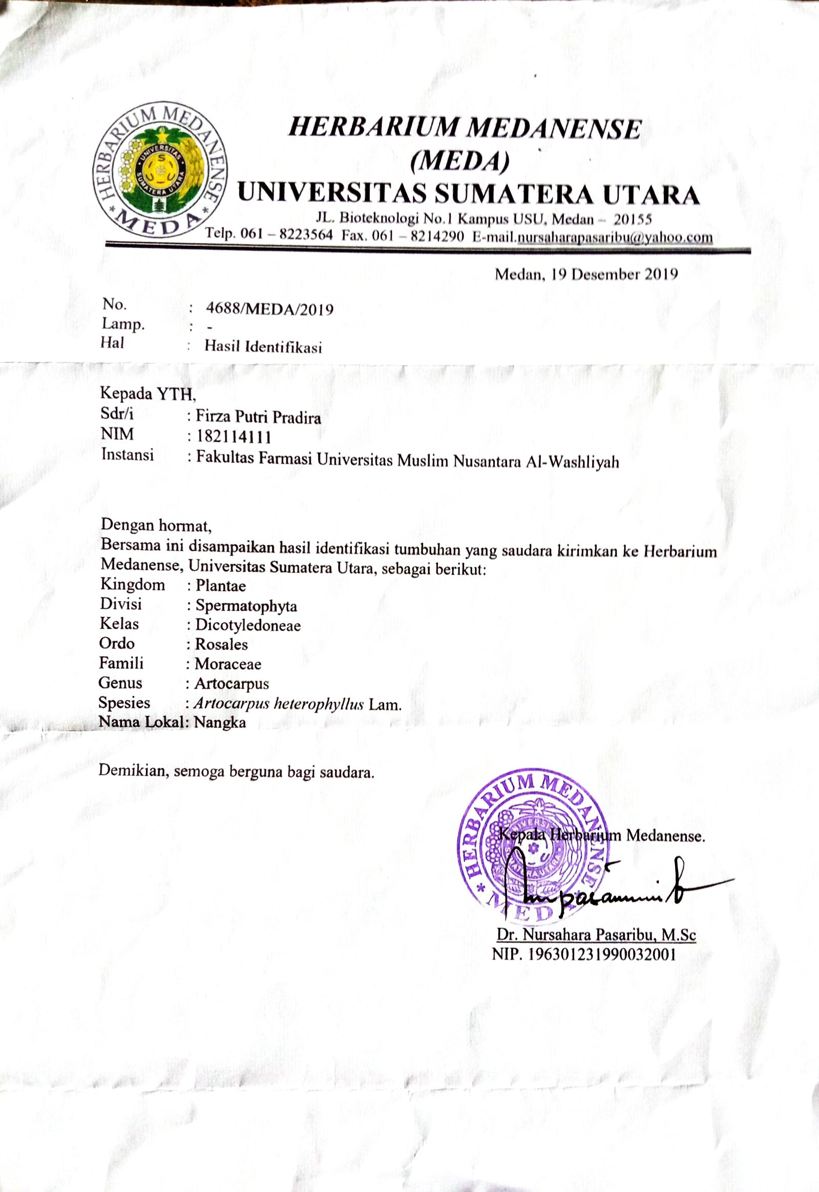
Lampiran 2. Bagan alir penelitian pengolahan biji nangka

Biji nangka segar 3.200 gram
Disortasi basah, dicuci, dikeringkan dilemari pengering. Disortasi kering dan ditimbang.
Simplisia kering 1.400 gram
Dihaluskan dengan blender, ditimbang dan disimpan dalam wadah tertutup
Serbuk simplisia 1.200 gram
Skrining biji nangka
Karakterisasi simplisia
Pembuatan Ekstrak Etanol Biji Nangka (EEBJ)
- Alkaloid
- Flavonoid
- Tanin
- Steroid / triterpenoid
- Saponin
- Glikosida

- Makroskopis
- Mikroskopis
- Kadar Air
- Kadar Sari Larut Air
- Kadar Sari Larut Etanol
- Kdar Abu Total
- Kadar Abu Tidak Larut Asam
Ekstraksi dilakukan dengan metode maserasi menggunakan pelarut etanol 96% dan diuapkan dengan Rotary Evaporator
Ekstrak
Hasil

Lampiran 3. Bagan alir uji sitotoksisitas terhadap larva udang Artemia salina Leach

Dilarutkan dalam labu tentukur 100 ml
Larutan Induk
1 gram ekstrak etanol biji nangka

Dibuat variasi konsentrasi dari larutan induk

3000 μg/ml
500 μg/ml
Kontrol
3500 μg/ml
1500 μg/ml
2500 μg/ml
2000 μg/ml
1000 μg/ml
4000 μg/ml

- Masing-masing konsentrasi dibuat sebanyak 3 kali pengulangan
- Dimasukkan ke dalam masing-masing vial
- Ditambahkan 10 ml ekstrak etanol biji pinang dan 10 ekor nauplii
- Vial diletakkan di tempat terang
- mortalitas dihitung setelah 24 jam

Lampiran 4. Pengolahan simplisia biji nangka

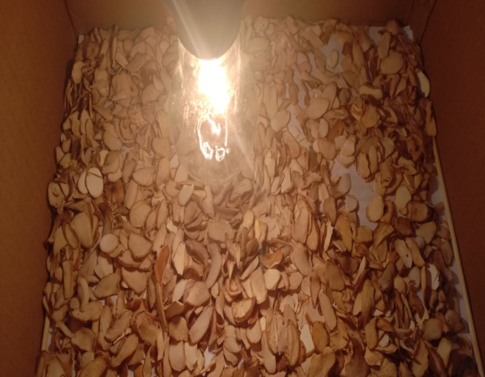

Biji nangka yang dikeringkan

Serbuk biji nangka

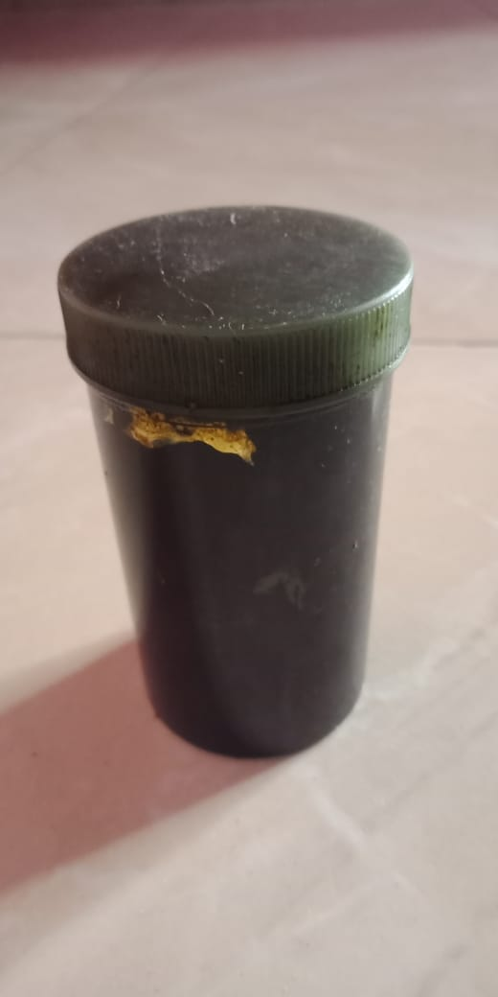

Ekstrak biji nangka
Lampiran 5. Pengujian Ekstrak Etanol Biji Nangka

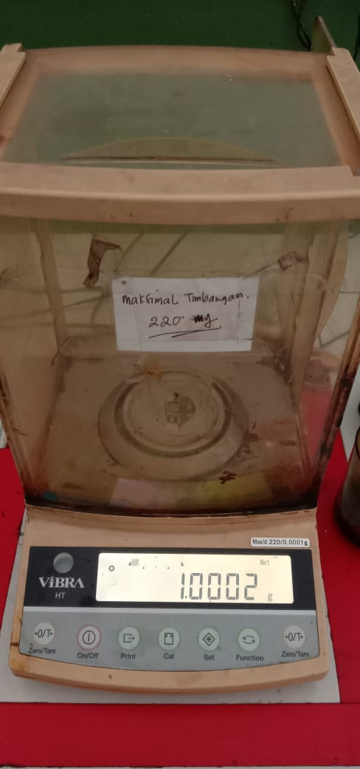

Penimbangan ektrak etanol biji nangka yang digunakan

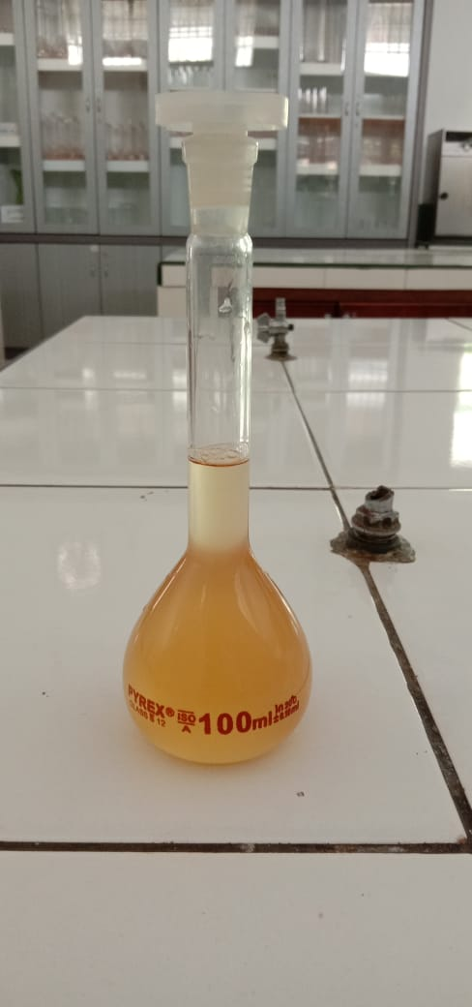

Larutan Induk Baku

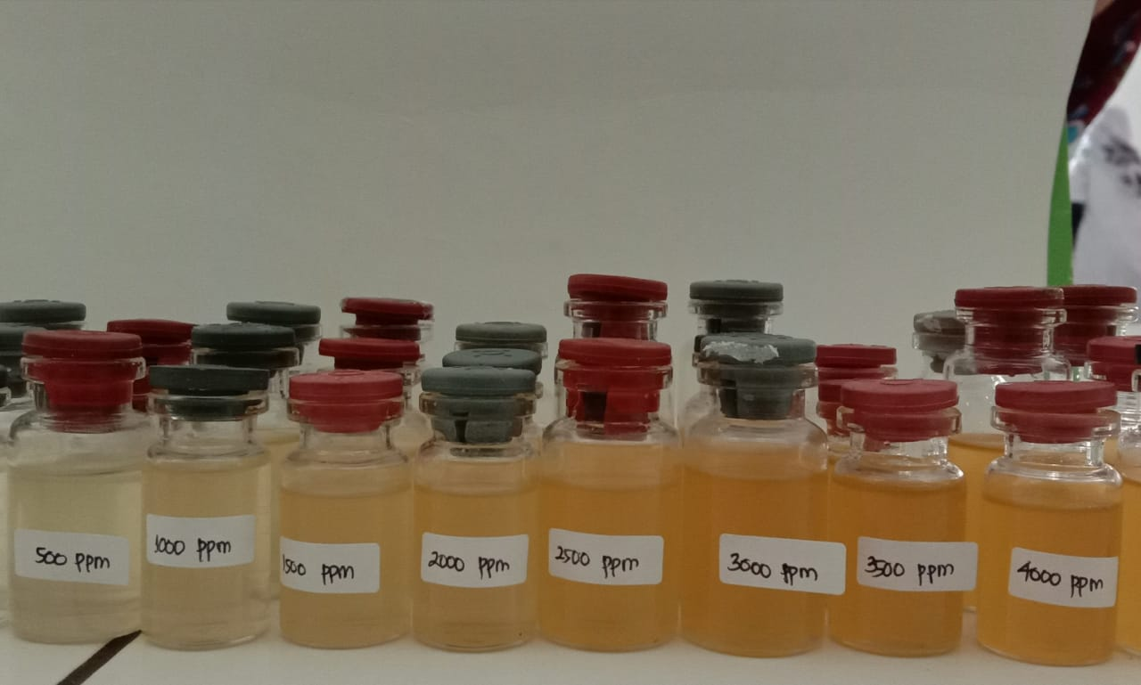

Larutan uji yang digunakan
Lampiran 6. Hasil mikroskopik simplisia

Hasil mikroskopik pada biji nangka dapat dilihat pada gambar sebagai berikut:

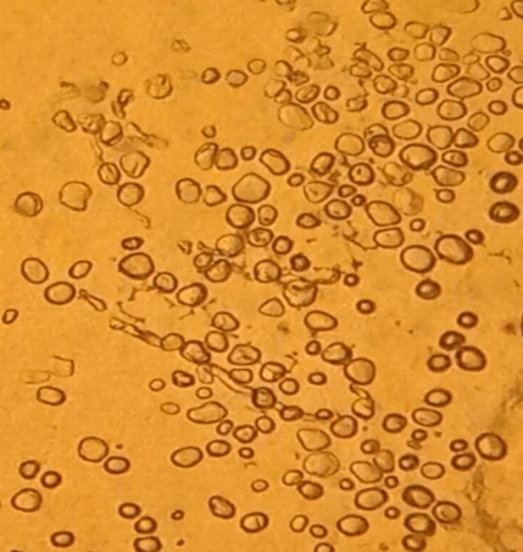

1

Keterangan:
1. Pati biji nangka

Hasil mikroskopik pada batang nangka menurut MMI sebagai berikut:
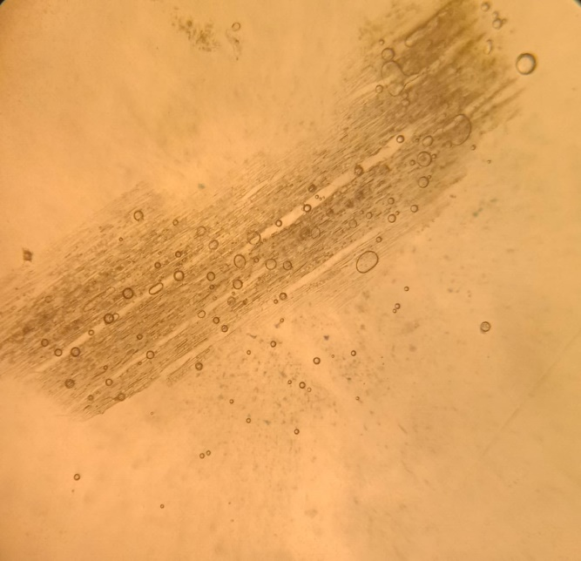

1

2
3
4

5

Keterangan :
- Trakea
- Pati
- Serabut
- Hablur Kalsium Oksalat
- Jari-jari empelur
Lampiran 7. Perhitungan karakterisasi simplisia
- Perhitungan kadar air

Berat sampel | Volume awal | Volume akhir | Volume air
5 g | 1,2 ml | 1,4 ml | 0,2 ml
5 g | 1,3 m l | 1,7 ml | 0,4 ml
5 g | 1,4 ml | 1,7 ml | 0,3 ml

%Kadar air = $\frac{\left(volume akhir-volume awal\right)ml}{(berat simplisia)g}$x 100%
- Berat simplisia I = 5 g
Volume air = 0,2 ml
% Kadar air = $\frac{(1,8 -1,5) ml}{(5) g}$ x 100% = 6%
- Berat simplisia II = 5 g
Volume air = 0,4 ml
% Kadar air = $\frac{\left(1,7 -1,3\right)ml}{(5) g}$ x 100% = 8%
- Berat simplisia III = 5 g
Volume air = 0,3 ml
% Kadar air = $\frac{\left(1,7-1,4\right)ml}{(5) g}$ x 100% = 6%
% Kadar air rata-rata =$\frac{4\%+8\%+6\%}{3}$ = 6%

Lampiran 7. (Lanjutan)
- Penetapan kadar sari larut dalam air
Berat sampel | Bobot awal | Bobot akhir | Berat sari
5 g | 33,08 g | 33,25 g | 0,17 g
5 g | 32,22 g | 32,42 g | 0,20 g
5 g | 31,19 g | 31,38 g | 0,19 g

%Kadar sari larut dalam air = $\frac{Berat sari }{bobot simplisia}x\frac{100}{20}x$ 100%

- Berat simplisia I = 5 g
Berat sari = 0,17 g
%Kadar sari larut dalam air = $\frac{0,17g }{5 g}x\frac{100}{20}$x 100% = 17%

- Berat simplisia II = 5 g
Berat sari = 0,20 g
%Kadar sari larut dalam air = $\frac{0,20 g }{5 g}x\frac{100}{20}$ x 100% = 20%

- Berat simplisia III = 5 g
Berat sari = 0,19 g
%Kadar sari larut dalam air = $\frac{0,19 g }{5 g}x\frac{100}{20}$x 100% = 19%

%Kadar sari larut dalam air rata-rata = $\frac{17\%+20\%+19\%}{3}$ = 18,6%

Lampiran 7. (Lanjutan)
- Penetapan kadar sari larut dalam etanol
Berat sampel | Berat cawan kosong | Berat cawan berisi | Berat sari
5 g | 23,71 g | 23,82 g | 0,11 g
5 g | 31,73 g | 31,87 g | 0,14 g
5 g | 32,55 g | 32,70 g | 0,15 g

%Kadar sari larut dalam etanol = $\frac{Berat sari }{bobot simplisia}x\frac{100}{20}x 100\%$

- Berat simplisia I = 5 g
Berat sari = 0,11 g
%Kadar sari larut dalam etanol = $\frac{0,11}{5 g}$ x $\frac{100}{20}$ x 100% = 11%

- Berat simplisia II = 5 g
Berat sari = 0,14 g
%Kadar sari larut dalam etanol = $\frac{ 0,14}{5 g }$x $\frac{100}{20}$ x 100% = 14%

- Berat simplisia III = 5 g
Berat sari = 0,15 g
%Kadar sari larut dalam etanol = $\frac{0,15}{5 g}$ x $\frac{100}{20}$ x 100% = 15%

%Kadar sari larut dalam etanol rata-rata = $\frac{11\%+14\%+15\%}{3}$
= 13,33%

Lampiran 7. (Lanjutan)
- Penetapan kadar abu total
Berat sampel | Berat abu total
2 g | 0,05 g
2 g | 0,04 g
2 g | 0,03 g

%Kadar abu total = $\frac{Berat abu}{bobot simplisia}$ x100%

- Berat simplisia I = 2 g
Berat abu = 0,05 g
%Kadar abu total = $\frac{0,05 g }{2 g}$ x100% = 2,88%

- Berat simplisia II = 2 g
Berat abu = 0,04 g
%Kadar abu total = $\frac{0,04 g }{2 g}$ x100% = 2,05%

- Berat simplisia III = 2 g
Berat abu = 0,03 g
%Kadar abu total = $\frac{0,03 g }{2 g}$ x100% = 1,61%

%Kadar abu total rata-rata = $\frac{2,88 \%+2,05 \%+1,61\%}{3}$ =2,18%

Lampiran 7. (Lanjutan)
- Penetapan kadar abu tidak larut dalam asam
Berat sampel | Berat abu
2 g | 0,01 g
2 g | 0,01 g
2 g | 0 g

%Kadar abu tidak larut dalam asam = $\frac{Berat abu}{Bobot simplisia}$ x 100%

- Berat simplisia I = 2 g
Berat abu = 0,01 g
%Kadar abu tidak larut dalam asam = $\frac{0,01 }{2 g}$ x100%
= 0,5%

- Berat simplisia II = 2 g
Berat abu = 0,01 g
%Kadar abu tidak larut dalam asam = $\frac{ 0,01}{2 g}$ x100%
= 0,5%

- Berat simplisia II = 2 g
Berat abu = 0 g
%Kadar abu tidak larut dalam asam = $\frac{0 }{2 g}$ x100%
= 0%

%Kadar abu tidak larut dalam asam rata-rata = $\frac{0,5\%+0,5\%+0\% }{3}$
= 0,333%

Lampiran 8. Perhitungan konsentrasi larutan uji sitotoksisitas
LIB = $\frac{Berat sampel}{volume labu tentukur}$
= $\frac{1 gram}{100 ml}$
= $\frac{1000 mg}{100 ml}$
= $\frac{1.000.000μg}{100 ml}$
=10.000μg/ml
Perhitungan volume konsentrasi larutan yang di ambil dari LIB
Konsentrasi LIB x Vol. konsentrasi = (Konsentrasi x Vol.) yang akan di ambil
C500 → C₁ x V₁ = C₂ x V₂
10.000 x V₁= 500 x 30
= $\frac{15.000}{10.000}$
= 1,5 ml
C1000 → C₁ x V₁ = C₂ x V₂
10.000 x V₁= 1000 x 30
= $\frac{30.000}{10.000}$
= 3 ml
C1500 → C₁ x V₁ = C₂ x V₂
10.000 x V₁= 1500 x 30
= $\frac{45.000}{10.000}$
= 4,5 ml
C2000 → C₁ x V₁ = C₂ x V₂
10.000 x V₁= 2000 x 30
= $\frac{60.000}{10.000}$
= 6 ml
C2500 → C₁ x V₁ = C₂ x V₂
10.000 x V₁= 2500 x 30
= $\frac{75.000}{10.000}$
= 7,5 ml
C3000 → C₁ x V₁ = C₂ x V₂
10.000 x V₁= 3000 x 30
= $\frac{90.000}{10.000}$
= 9 ml
C3500 → C₁ x V₁ = C₂ x V₂
10.000 x V₁= 3500 x 30
= $\frac{105.000}{10.000}$
= 10,5 ml
C4000 → C₁ x V₁ = C₂ x V₂
10.000 x V₁= 4000 x 30
= $\frac{120.000}{10.000}$
= 12 ml

Lampiran 9. Perhitungan mortalitas hewan uji
mortalitas = $\frac{Jumlah kematian hewan uji (Larva artemia salina Leach)}{Jumlah seluruh hewan uji dalam konsentrasi yang sama}$ x 100%

Konsentrasi 0 ppm = $\frac{0}{0}$ x 100
= 0%
Konsentrasi 500 ppm = $\frac{11}{30}$ x 100%
= 36,67%
Konsentrasi 1000 ppm = $\frac{12}{30}$ x 100%
= 40%
Konsentrasi 1500 ppm = $\frac{15}{30}$ x 100%
= 50%
Konsentrasi 2000 ppm = $\frac{17}{30}$ x 100%
= 56,67%
Konsentrasi 2500 ppm = $\frac{19}{30}$ x 100%
= 63,33%
Konsentrasi 3000 ppm = $\frac{22}{30}$ x 100%
= 73,33
Konsentrasi 3500 ppm =$\frac{23}{30}$ x 100%
= 76,67%
Konsentrasi 4000 ppm =$\frac{25}{30}$ x 100%
= 83,33%
Lampiran 10. Perhitungan Nilai LC₅₀
Nilai slope (b)= | n(ΣXY)-(ΣX ΣY)
 | n(ΣX²)-(ΣX)²
b= | 8(139,2149974)-((26,19728056)(42,2234))
 | 8(86,44041681)-(26,19728056)²
b= | 8(139,2149974)-(1106,138256)
 | 691,5233345-686,2975086
b= | 1113,719979-1106,138256
 | 691,5233345-686,2975086
b= | 7,581723412
 | 5,225825832
b= | 1,450818

Inter slop a= | ΣY-b ΣX
 | n
a= | 42,2234-1,450818(26,19728056)
 | 8
a= | 42,2234-38,00748618
 | 8
a= | 4,215913815
 | 8
a= | 0,526989227

Nilai regresi :
Y = | 1,450818 x + 0,526989227
5 = | 1,450818 x + 0,526989227
1,450818x = | 5 – 0,526989227
1,450818x = | 4,473010773
x = | 3,083096

Nilai LC₅₀ antilog 3,809568 = | 1210,86 µg/ml

Lampiran 11. Kurva hubungan antara log konsentrasi dan nilai probit (y)

Variables Entered/Removedª
Model | Variables Entered | Variables Removed | Method
1 | Log C^{b} | . | Enter
a. Dependent Variable: Nilai Probit
b. All requested variables entered.

Model Summary
Model | R | R Square | Adjusted R Square | Std. Error of the Estimate
1 | .944ª | .890 | .872 | .168
a. Predictors: (Constant), Log C
ANOVAª
Model |  |  | Sum of Squares |  | df | Mean Square |  | F |  | Sig.
1 | Regression |  | 1.375 |  | 1 | 1.375 |  | 48.779 |  | .000^{b}
 | Residual |  | .169 |  | 6 | .028
 | Total |  | 1.544 |  | 7
a. Dependent Variable: Nilai Probit
b. Predictors: (Constant), Log C

Coefficientsª
Model |  | Unstandardized Coefficients |  |  |  |  | Standardized Coefficients |  | t |  | Sig.
 |  | B |  | Std. Error |  |  | Beta
1 | (Constant) | .526 |  | .683 |  |  |  |  | .770 |  | .470
 | Log C | 1.451 |  | .208 |  |  | .944 |  | 6.984 |  | .000
a. Dependent Variable: Nilai Probit

Lampiran 12. Tabel nilai probit

