Lampiran 1. Hasil Identifikasi Tumbuhan
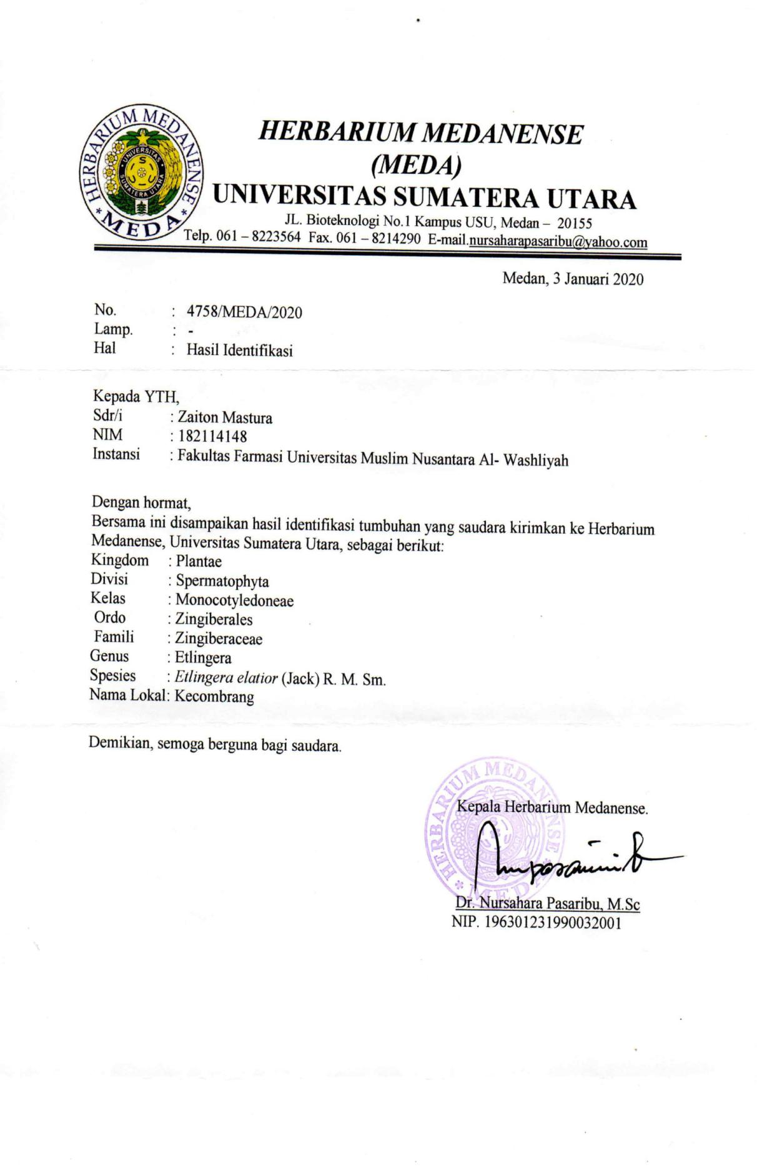

Lampiran 2. Rekomendasi Persetujuan Etik Penelitian Kesehatan
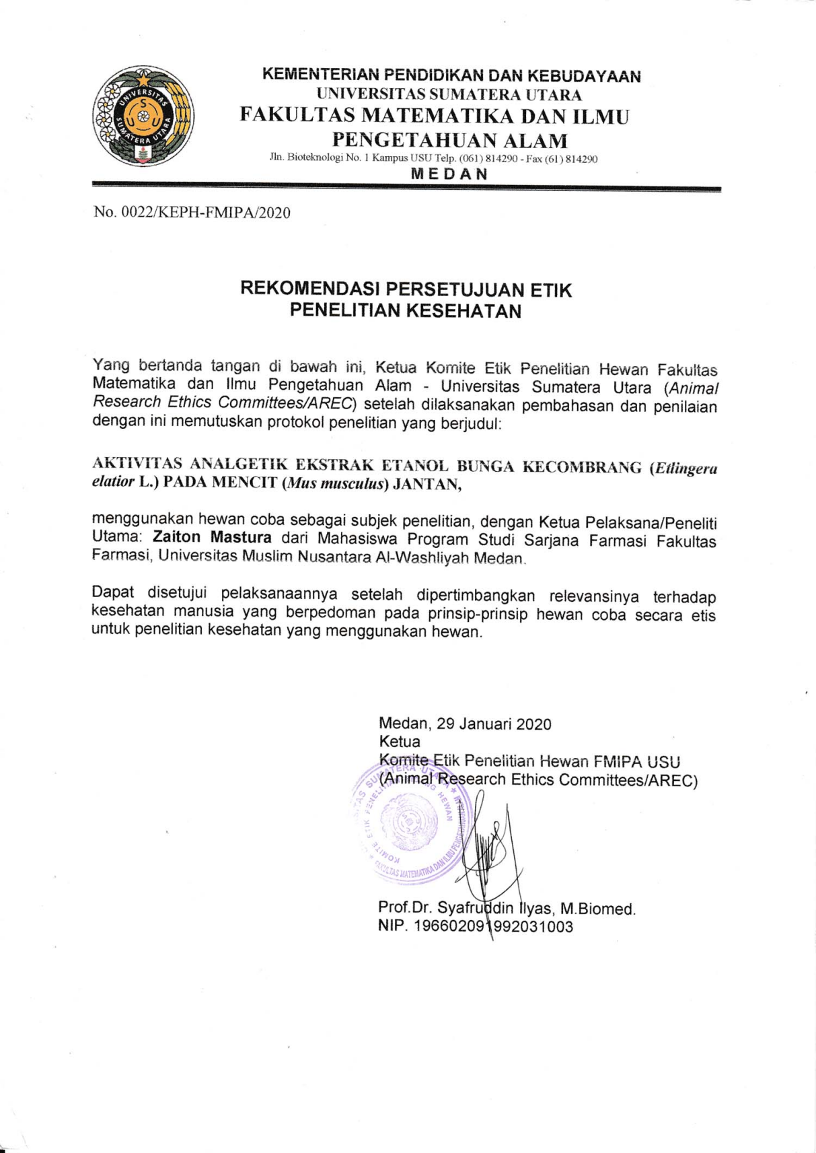

Lampiran 3. Makroskopis sampel bunga kecombrang

Tangkai

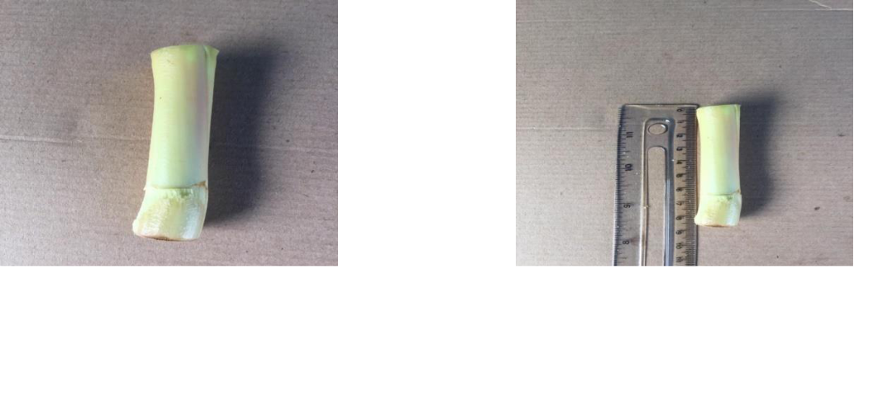

Tangkai bunga kecombrang Tangkai bunga dengan
panjang 8,5 cm

Bunga

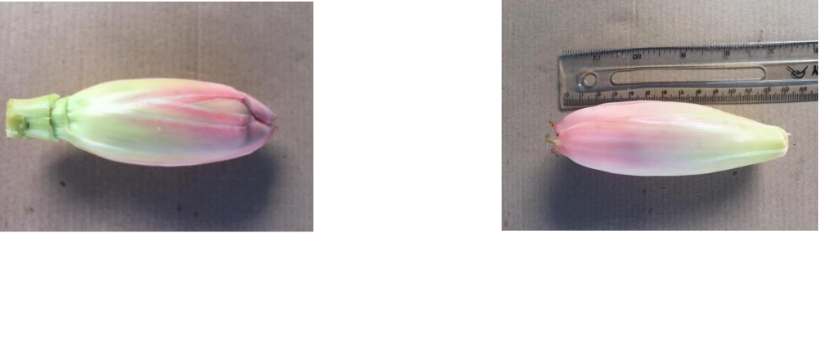

Bunga berbentuk bonggol Bonggol bunga dengan
panjang 13 cm

Helaian bunga

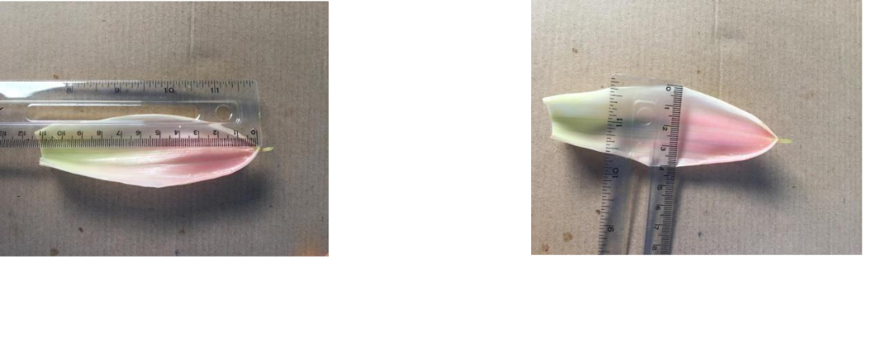

Panjang helaian bunga 11 cm Lebar helaian bunga 4 cm

Lampiran 4. Mikroskopik serbuk bunga kecombrang (Etlingera elatior (Jack) R.M (Sm.) perbesaran 400×
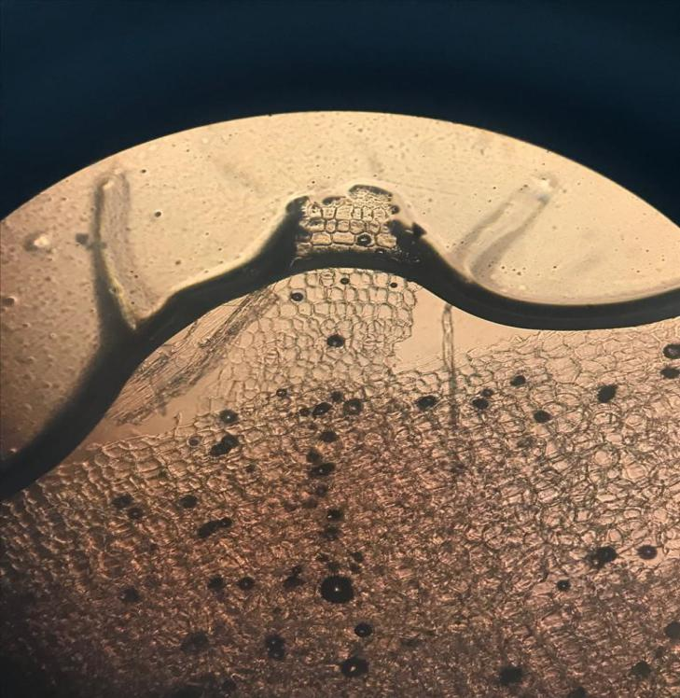
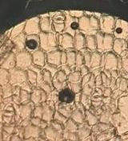
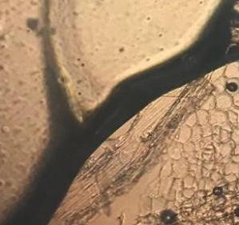
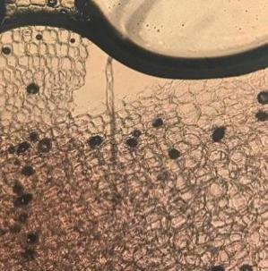
1

2

3

Keterangan gambar :
1.
Ruang antar sel berisi kalsium oksalat
2.
Epidermis
3.
Parenkim

Lampiran 5. Perhitungan Karakterisasi Simplisia
- Perhitungan Hasil Penetapan Kadar air

No | Berat Sampel (g) | Volume Awal (V0)  (ml) | Volume Akhir (V1)  (ml)
1 | 5 | 0,2 | 0,5
2 | 5 | 0,3 | 0,5
3 | 5 | 0,2 | 0,6
Kadar air = $\frac{Volume akhir air \left(V1\right)-Volume awal air (V0)}{Berat Sampel mula-mula (g)}x 100\%$

Pengulangan 1
V₀ = 0,2 ml
V₁ = 0,5 ml
Sampel = 5 g

Kadar air = $\frac{V1-V0}{Berat Sampel }x 100\%$
= $\frac{0,5 ml -0,2 ml}{5 gram}x 100\%$
= 6%
Pengulangan 2
V₀ = 0,3 ml
V₁ = 0,5 ml
Sampel = 5 g
Kadar air =$\frac{V1-V0}{Berat Sampel }x 100\%$
= $\frac{0,5 ml -0,3 ml}{5 gram}x 100\%$
= 4%
Pengulangan 3
V₀ = 0,2 ml
V₁ = 0,6 ml
Sampel = 5 g
Kadar air =$\frac{V1-V0}{Berat Sampel }x 100\%$

= $\frac{0,6 ml -0,2 ml}{5 gram}x 100\%$
= 8 %
Rata-rata kadar air = $\frac{6\% + 4\% + 8\%}{3}$
= 6%

Lampiran 5. (Lanjutan)

- Perhitungan Hasil Penetapan Kadar Sari larut dalam Air

No | Berat Sampel (g) | Berat Cawan Kosong (g) | Berat Setelah Diuapkan (g)
1 | 5 | 35,9146 | 35,9765
2 | 5 | 28,9432 | 28,8613
3 | 5 | 42,6679 | 42,6170

% Kadar sari larut dalam air =$\frac{Bobot sari setelah dikeringkan (g)X5}{Bobot simplisia (g)}$x 100%

Pengulangan 1
% Kadar sari larut dalam air $=\frac{0,06 g x 5}{5 g}$$=\frac{0,06 g x 5}{5 g}$ x 100%
= 6 %
Pengulangan 2

% Kadar sari larut dalam air$=\frac{0,08 g x 5}{5 g}$x 100 %
$=8\%$
Pengulangan 3

% Kadar sari larut dalam air$=\frac{0,05g x 5}{5 g}$x 100 %
$=5\%$

% Rata-Rata kadar sari larut dalam air= $\frac{6\%+8\%+5\%}{3}$
$=6,3 \%$

- Perhitungan Hasil Penetapan Kadar Sari Larut Dalam Etanol

No | Berat Sampel (g) | Berat Cawan Kosong (g) | Berat Setelah Diuapkan (g)
1 | 5 | 36,8853 | 36,8453
2 | 5 | 32,1257 | 32,9702
3 | 5 | 36,8837 | 36,8456

% Kadar sari larut dalam etanol=$\frac{Bobot sari setelah dikeringkan (g)X5}{Bobot simplisia (g)}$x 100%

Lampiran 5. (Lanjutan)

Pengulangan 1

% Kadar sari larut dalam etanol $=\frac{0,042 g x 5}{5 g}$x 100 %
$=4\%$

Pengulangan 2

% Kadar sari larut dalam etanol $=\frac{0,04 g x 5}{5 g}$x 100 %
$=4 \%$

Pengulangan 3
% Kadar sari larut dalam etanol $=\frac{0,03 g x 5}{5 g}$x 100 %
$=3\%$

% Rata-Rata kadar sari larut etanol = $\frac{4\%+4\%+3\%}{3}$
=$3,6 \%$

- Perhitungan Hasil Penetapan Kadar Abu Total

No | Berat Sampel (g) | Berat Krus Kosong (g) | Berat Krus Setelah Dipijar (g)
1 | 2 | 60,8648 | 61,0897
2 | 2 | 59,8621 | 60,0837
3 | 2 | 52,0128 | 52,2396
% Kadar Abu Total = $\frac{bobot abu yang diperoleh (g)}{Bobot simplisia (g)}$ x 100%

Pengulangan 1
% Kadar Abu Total = $\frac{0,22093}{2}$ x 100%
= $11,045\%$
Pengulangan 2
% Kadar Abu Total = $\frac{0,2216}{2}$ x 100%
$=11,08$%
Pengulangan 3
% Kadar Abu Total = $\frac{0,2268}{2}$ x 100%
$=11,34$%

% Rata-Rata kadar abu total $=\frac{11,04\%+11,08\%+11,34}{3}$
= 11,15%

Lampiran 5. (Lanjutan)

- Perhitungan Hasil Penetapan Kadar Abu Tidak Larut Asam

No | Berat Sampel (g) | Berat Krus Kosong (g) | Berat Krus Setelah Dipijar (g)
1 | 0,0333 | 60,8648 | 60,8619
2 | 0,0301 | 59,8621 | 59,8657
3 | 0,0297 | 52,0128 | 52,0177

% Kadar Abu Tidak Larut Asam= $\frac{bobot abu sisa dipijar (g)}{Bobot sampel abu mula-mula(g)}$ x 100%

Pengulangan 1
% Kadar Abu tidak larut asam = $\frac{0,0029}{2}$ x 100%
= $0,14 \%$
Pengulangan 2
% Kadar Abu tidak larut asam = $\frac{0,0036}{2}$ x 100%
= $0,18 \%$
Pengulangan 3
% Kadar Abu tidak larut asam = $\frac{0,00491}{2}$ x 100%
= $0,24 \%$

% Rata-Rata kadar abu tidak larut asam $=\frac{0,14\%+0,18\%+0,24\%}{3}$
= 0,19 %

Lampiran 6. Perhitungan dosis

- Perhitungan dosis pemberian metampiron 2%
Dosis metampiron = 500 mg
larutan metampiron 2% b/v
= 2 g/100ml =2000 mg/100ml
=20 mg/ml
Volume pemberian =0,1 ml
- Perhitunga dosis pemberian CMC 0,5%
BB Mencit = 20 g
Volume pemberian = $\frac{0,5 g}{100 ml}$ × 20 g
= 0,1 ml/20 gBB
- Perhitungan dosis suspensi EEBK dosis 50 mg/kgBB
Dosis untuk mencit 20g = $\frac{dosis \left(g\right)×BB (g)}{konsentrasi}$
Volume ekstrak yang diberikan =$\frac{0,05 g ×20 g}{5}=0,2 ml$
- Perhitungan dosis suspensi EEBK dosis 100 mg/kgBB
Dosis untuk mencit 20g = $\frac{dosis \left(g\right)×BB \left(g\right)}{konsentrasi}$
Volume ekstrak yang diberikan =$\frac{0,1 g ×20 g}{5}=0,4 ml$
- Perhitungan dosis suspensi EEBK dosis 200 mg/kgBB
Dosis untuk mencit 20g = $\frac{dosis \left(g\right)×BB \left(g\right)}{konsentrasi}$
Volume ekstrak yang diberikan =$\frac{0,2 g ×20 g}{5}=0,8 ml$
Lampiran 7. Skema Kerja
Skema Kerja Pembuatan Ekstrak Etanol Bunga Kecombrang
Bunga Kecombrang (Etlingera elatior)

Dicuci Bunga Kecombrang dengan air mengalir.

Dirajang, dikeringkan kemudian dihaluskan dan diayak.
Simplisia Bunga Kecombrang

Serbuk simplisia 500 gram dimasukkan kedalam bejana
dituangkan 5000 ml cairan penyari etanol lalu ditutup dan dibiarkan selama 5 hari (Sambil sesekali diaduk)
Setelah 5 hari campuran diserkai dan ampasnya diperas
dicuci ampasnya dengan cairan penyari etanol secukupnya sehingga diperoleh 5000 ml maserat
Dipindahkan kedalam bejana tertutup, dibiarkan selama 2 hari kemudian disaring
Maserat dipekatkan dengan alat Rotary evaporator
Kemudian diuapkan diatas penangas
Ekstrak Bunga Kecombrang

Lampiran 7. (Lanjutan)

Skema Kerja Pembuatan Suspensi EEBK
Ekstrak Etanol Bunga Kecombrang

Ekstrak ditimbang sebanyak 10 g
Kemudian dimasukkan kedalam lumpang yang berisi sedikit suspensi CMC 0,5% digerus homogen
Dicukupkan dengan suspensi CMC 0,5% hingga 100 ml dimasukkan kedalam labu tentukur 100 ml.
Suspensi EEBK

Skema Kerja Pembuatan Asam Asetat 1%
1 ml larutan asam asetat glasial

Masukkan kedalam labu tentukur 100 mL dan tambahkan aquadest hingga 100 mL
Masukkan kedalam vial tutup dengan aluminium foil
Asam Asetat 1%

Lampiran 7. (Lanjutan)

Skema Kerja Pembuatan CMC 0,5% b/v
CMC

Ditimbang CMC 500 gram
Dimasukkan kedalam mortir gerus ad halus
Kemudian dimasukkan kedalam cawan porselin yang berisi air suling panas sebanyak 1/3 dari bagian air
Ditambahkan aquadest sedikit demi sedikit lalu dimasukkan kedalam labu tentukur 100 ml
Volume dicukupkan dengan aquadest hingga 100 ml
CMC 0,5%

Skema Kerja Pembuatan Suspensi Metampiron 2%
Metampiron

Diambil 4 tablet metampiron digerus halus
Disuspensikan dengan larutan CMC 0,5% sedikit demi sedikit
Dimasukkan kedalam labu tentukur 100 mL
Suspensi Metampiron 2%

Lampiran 7. (Lanjutan)

Skema Kerja Pengujian Analgetik
25 Ekor Mencit

Mencit diadaptasikan selama 1 minggu dengan diberikan makan dan air minum

Diberi penandaan pada ekor mencit
Dipuasakan selama 18 jam, tetapi tetap diberi minum

Ditimbang masing-masing mencit
Dihitung volume masing-masing perlakuan
Diinduksikan Asam Asetat 1% (0,5 ml) secara intraperitonel
Diamati geliatnya dan dihitung jumlah geliat selama 5 menit
Setelah 5 menit kemudian setiap kelompok diberi perlakuan secara oral
Perlakuan

EEBK dosis 200 mg/kgBB
EEBK dosis 100 mg/kgBB
EEBK dosis 50 mg/kgBB

Kontrol (+) Metampiron 2%
Kontrol (-) CMC 0,5%

Dicatat Geliat setiap 5 menit selama 1 jam

Lampiran 8. Dokumentasi penelitian
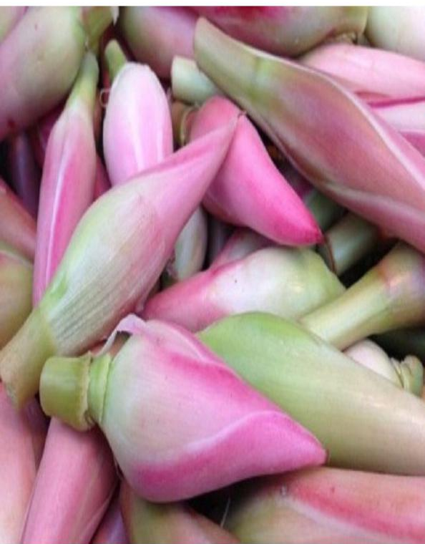
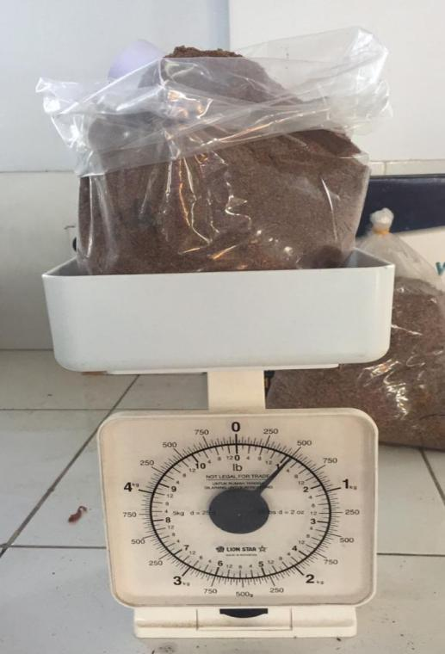
Bunga Kecombrang Simplisia 500 gram

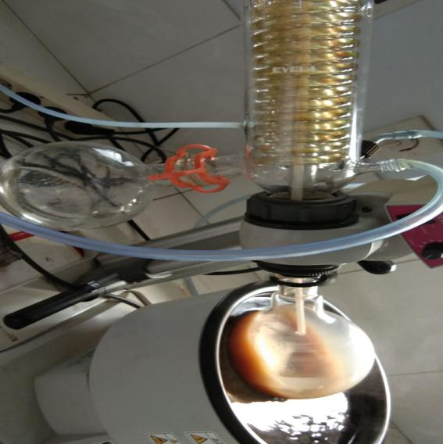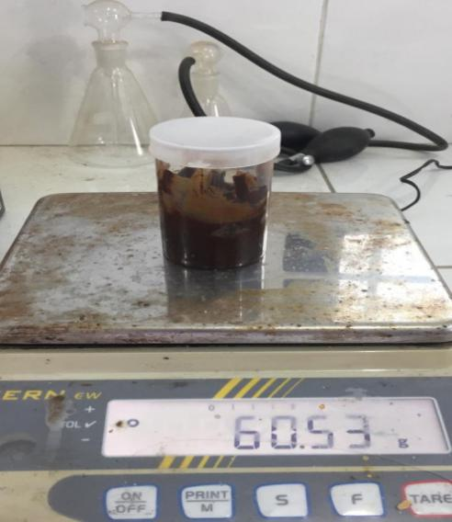
Proses Rotary Hasil Ekstrak

Lampiran 8. (Lanjutan)
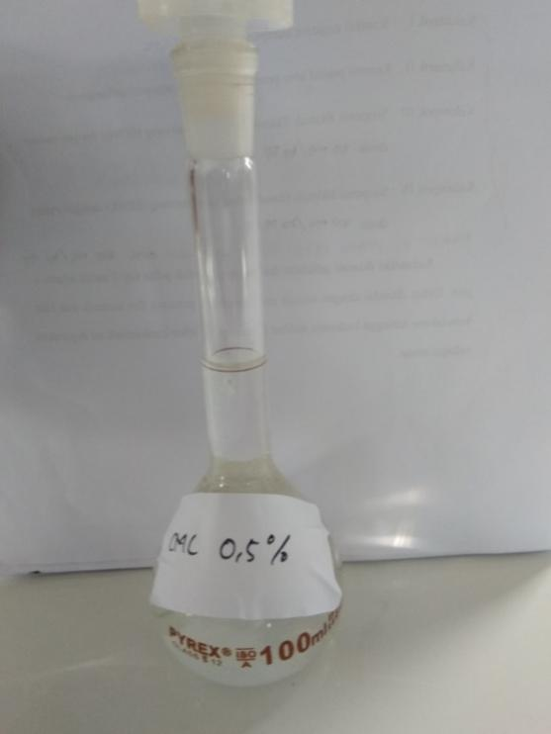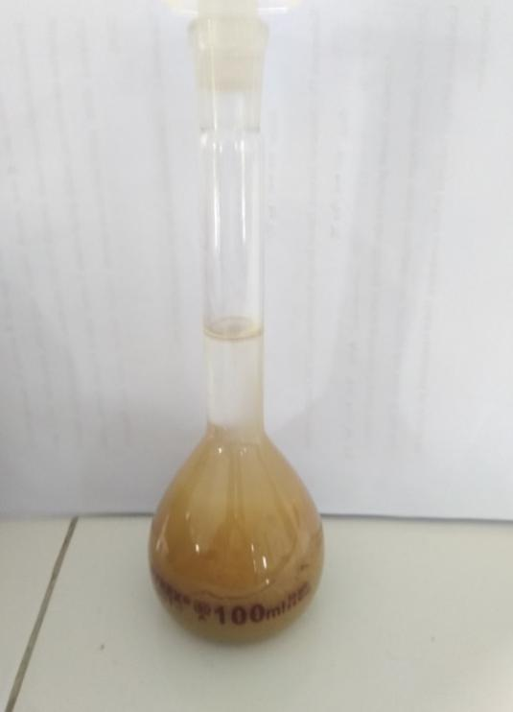
Suspensi CMC 0.5% Suspensi EEBK

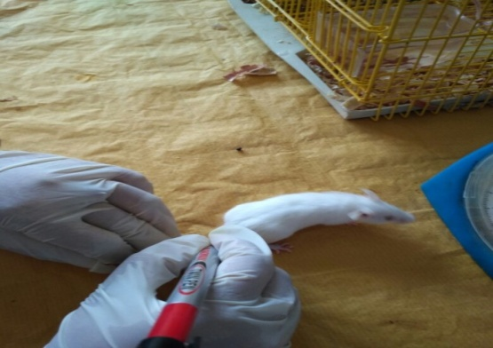
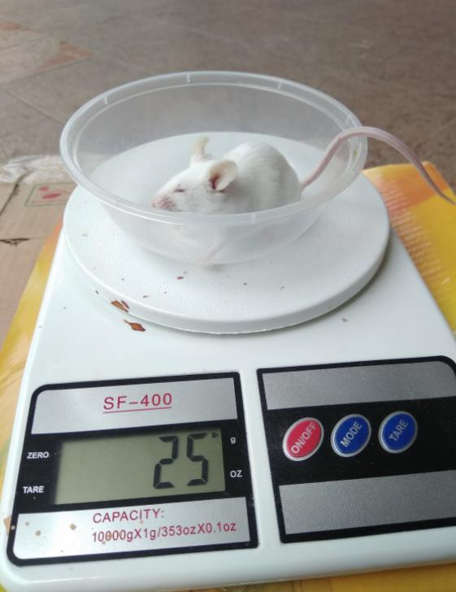
Penimbangan Mencit Penandaan Mencit

Lampiran 8. (Lanjutan)
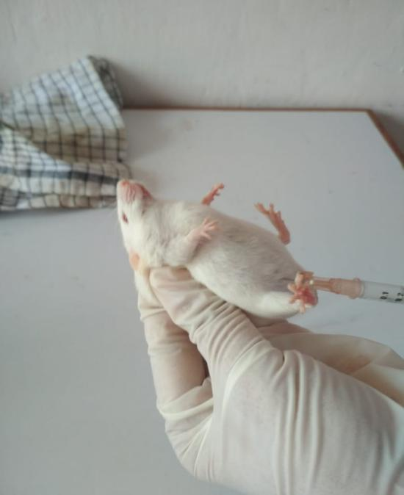
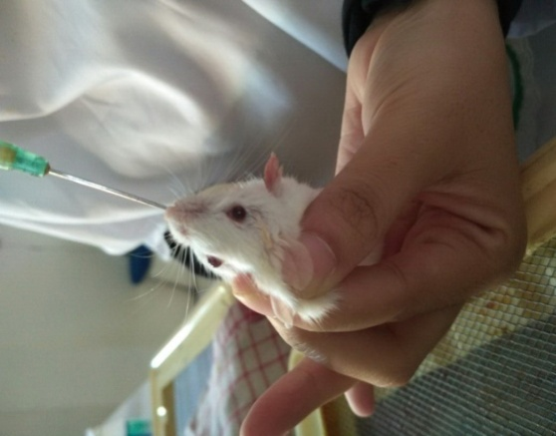

Pemberian secara IP Pemberian secara Oral

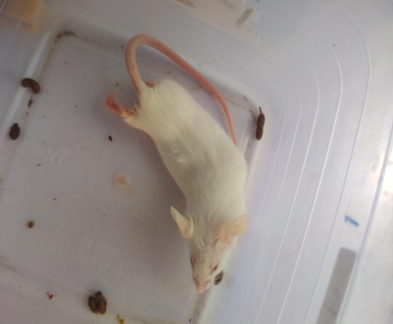

Mencit Bergeliat

Lampiran 9. Hasil Orientasi Asam Asetat
Data rata-rata jumlah geliat mencit jantan yang diinduksi asam asetat 1% masing-masing volume pemberian sebanyak 0,1 ml, 0,2 ml, 0,3 ml, 0,4 ml, dan 0,5 ml secara intraperitoneal dengan selang waktu 5 menit selama 1 jam
Asam asetat 1% | Waktu (menit) |  |  |  |  |  |  |  |  |  |  |  | Jumlah geliat
 | 5’ | 10’ | 15’ | 20’ | 25’ | 30’ | 35’ | 40’ | 45’ | 50’ | 55’ | 60’
0,1 ml | 13,5 | 12,5 | 15,5 | 8,5 | 8 | 8 | 5 | 9 | 6,5 | 4,5 | 3,5 | 2,5 | 97
0,2 ml | 7,5 | 10 | 14,5 | 15 | 14,5 | 12,5 | 9,5 | 8,5 | 7,5 | 5,5 | 4,5 | 1,5 | 111
0,3 ml | 26 | 10 | 21,5 | 18,5 | 17 | 12,5 | 12 | 9,5 | 7,5 | 6,5 | 5,5 | 4 | 150,5
0,4 ml | 10,5 | 28 | 24,5 | 22,5 | 20 | 18,5 | 15,5 | 13,5 | 11 | 10 | 7,5 | 5,5 | 187
0,5 ml | 7 | 21 | 32 | 27,5 | 26,5 | 23,5 | 21 | 19,5 | 17,5 | 14,5 | 7 | 10,5 | 227,5

Data rata-rata jumlah geliat mencit jantan yang diinduksi asam asetat 0,5% masing-masing volume pemberian sebanyak 0,1 ml, 0,2 ml, 0,3 ml, 0,4 ml, dan 0,5 ml secara intraperitoneal dengan selang waktu 5 menit selama 1 jam
Asam asetat 0,5% | Waktu (menit) |  |  |  |  |  |  |  |  |  |  |  | Jumlah geliat
 | 5’ | 10’ | 15’ | 20’ | 25’ | 30’ | 35’ | 40’ | 45’ | 50’ | 55’ | 60’
0,1 ml | 0 | 6 | 4 | 4,5 | 5,5 | 5,5 | 5,5 | 5 | 5,5 | 3 | 3 | 4 | 48,5
0,2 ml | 2,5 | 3 | 4,5 | 6 | 10,5 | 10,5 | 7,5 | 7,5 | 5 | 3,5 | 1,5 | 1,5 | 63,5
0,3 ml | 0,5 | 2,5 | 4,5 | 7,5 | 14 | 14 | 8 | 8 | 5 | 2,5 | 2,5 | 1,5 | 70,5
0,4 ml | 5 | 3,5 | 3,5 | 8,5 | 11,5 | 11,5 | 9,5 | 12,5 | 9,5 | 4 | 4 | 3,5 | 86,5
0,5 ml | 13,5 | 14,5 | 11 | 7,5 | 7,5 | 4,5 | 5,5 | 6,5 | 5,5 | 6 | 6 | 4,5 | 92,5

Lampiran 10. Data Hasil Pengamatan Geliat Mencit Putih Jantan Setelah Pemberian Suspensi CMC 0,5%, Suspensi Metampiron 2%, Suspensi Ekstrak Etanol Bunga Kecombrang Dosis 50, 100 dan 200 mg/kgBB Selang Waktu 5 menit Selama 1 Jam.

Mencit ke | CMC 0,5% volume pemberian sebanyak 0,5 ml  Waktu (menit) ke- |  |  |  |  |  |  |  |  |  |  |  |  |  | Jumlah geliat
 | 5’ | 10’ | Setelah diberikan suspensi  CMC 0,5% | 15’ | 20’ | 25’ | 30’ | 35’ | 40’ | 45’ | 50’ | 55’ | 60’
1 | 14 | 29 |  | 27 | 25 | 24 | 21 | 17 | 15 | 14 | 12 | 8 | 5 |  | 211
2 | 14 | 27 |  | 25 | 23 | 21 | 19 | 16 | 14 | 12 | 10 | 9 | 7 |  | 197
3 | 16 | 30 |  | 28 | 26 | 19 | 18 | 17 | 15 | 13 | 11 | 10 | 6 |  | 209
4 | 15 | 28 |  | 26 | 24 | 20 | 19 | 18 | 15 | 13 | 10 | 9 | 7 |  | 204
5 | 16 | 29 |  | 27 | 22 | 19 | 17 | 18 | 16 | 15 | 13 | 12 | 8 |  | 212
Rata-rata | 15 | 28,6 |  | 26,6 | 24 | 20,6 | 18,8 | 17,2 | 15 | 13,4 | 11,2 | 9,6 | 6,6 |  | 206,6
Mencit ke | Metampiron 2% volume pemberian sebanyak 0,5 ml  Waktu (menit) ke- |  |  |  |  |  |  |  |  |  |  |  |  |  | Jumlah geliat
 | 5’ | 10’ | Setelah diberikan suspensi  Metampiron 2% | 15’ | 20’ | 25’ | 30’ | 35’ | 40’ | 45’ | 50’ | 55’ |  | 60’
1 | 13 | 16 |  | 15 | 12 | 9 | 7 | 6 | 4 | 3 | 2 | 2 |  | 1 | 90
2 | 13 | 15 |  | 14 | 12 | 10 | 8 | 6 | 4 | 3 | 3 | 3 |  | 2 | 93
3 | 12 | 14 |  | 13 | 11 | 8 | 7 | 5 | 4 | 3 | 2 | 2 |  | 1 | 82
4 | 14 | 15 |  | 14 | 13 | 11 | 8 | 7 | 5 | 4 | 3 | 3 |  | 1 | 98
5 | 12 | 16 |  | 13 | 10 | 8 | 6 | 4 | 3 | 2 | 1 | 1 |  | 0 | 82
Rata-rata | 12,8 | 15,2 |  | 13,8 | 11,6 | 9,2 | 7,2 | 5,6 | 4 | 3 | 2,2 | 2,2 |  | 1 | 87,8

Lampiran 10. (Lanjutan)
Mencit ke | EEBK dosis 50 mg/kgBB volume pemberian sebanyak 0,2 ml  Waktu (menit) ke- |  |  |  |  |  |  |  |  |  |  |  |  |  |  |  |  | Jumlah geliat
 | 5’ | 10’ |  | Setelah diberikan suspensi  EEBK 50 mg | 15’ | 20’ | 25’ | 30’ | 35’ |  | 40’ |  | 45’ |  | 50’ | 55’ | 60’
1 | 10 | 20 |  |  | 18 | 19 | 20 | 13 | 13 |  | 10 |  | 11 |  | 7 | 7 | 2 | 150
2 | 13 | 20 |  |  | 17 | 17 | 15 | 12 | 11 |  | 10 |  | 7 |  | 5 | 5 | 1 | 133
3 | 10 | 19 |  |  | 19 | 17 | 11 | 11 | 7 |  | 7 |  | 9 |  | 7 | 3 | 2 | 122
4 | 9 | 17 |  |  | 15 | 15 | 9 | 10 | 8 |  | 9 |  | 5 |  | 6 | 4 | 2 | 109
5 | 7 | 15 |  |  | 16 | 11 | 12 | 10 | 7 |  | 6 |  | 7 |  | 5 | 3 | 2 | 101
Rata-rata | 9,8 | 18,2 |  |  | 17 | 15,8 | 13,4 | 11,2 | 9,2 |  | 8,4 |  | 7,8 |  | 6 | 4,4 | 1,8 | 123
Mencit ke | EEBK dosis 100 mg/kgBB volume pemberian sebanyak 0,4 ml  Waktu (menit) ke- |  |  |  |  |  |  |  |  |  |  |  |  |  |  |  |  | Jumlah geliat
 | 5’ | 10’ | Setelah diberikan suspensi  EEBK 100 mg |  | 15’ | 20’ | 25’ | 30’ | 35’ | 40’ |  | 45’ |  | 50’ |  | 55’ | 60’
1 | 10 | 18 |  |  | 19 | 20 | 18 | 15 | 15 | 11 |  | 7 |  | 7 |  | 6 | 1 | 147
2 | 12 | 17 |  |  | 17 | 17 | 15 | 13 | 11 | 9 |  | 7 |  | 6 |  | 5 | 1 | 130
3 | 13 | 19 |  |  | 15 | 15 | 13 | 10 | 9 | 9 |  | 7 |  | 5 |  | 3 | 2 | 120
4 | 11 | 15 |  |  | 13 | 11 | 11 | 10 | 9 | 7 |  | 5 |  | 4 |  | 2 | 1 | 99
5 | 11 | 12 |  |  | 11 | 7 | 7 | 9 | 7 | 5 |  | 8 |  | 5 |  | 1 | 1 | 84
Rata-rata | 11,4 | 16,2 |  |  | 15 | 14 | 12,8 | 11,4 | 10,2 | 8,2 |  | 6,8 |  | 5,4 |  | 3,4 | 1,2 | 116
Mencit ke | EEBK dosis 200 mg/kgBB volume pemberian sebanyak 0,8 ml  Waktu (menit) ke- |  |  |  |  |  |  |  |  |  |  |  |  |  |  |  |  | Jumlah geliat
 | 5’ | 10’ | Setelah diberikan suspensi  EEBK 200 mg |  | 15’ | 20’ | 25’ | 30’ | 35’ | 40’ |  | 45’ |  | 50’ |  | 55’ | 60’
1 | 11 | 15 |  |  | 17 | 17 | 14 | 13 | 12 | 9 |  | 7 |  | 7 |  | 3 | 1 | 126
2 | 12 | 13 |  |  | 17 | 15 | 15 | 10 | 10 | 9 |  | 5 |  | 5 |  | 2 | 1 | 114
3 | 12 | 15 |  |  | 15 | 13 | 12 | 10 | 10 | 7 |  | 7 |  | 5 |  | 2 | 1 | 109
4 | 11 | 13 |  |  | 11 | 10 | 12 | 9 | 9 | 5 |  | 5 |  | 4 |  | 2 | 1 | 92
5 | 10 | 13 |  |  | 9 | 10 | 8 | 13 | 7 | 5 |  | 6 |  | 2 |  | 1 | 0 | 84
Rata-rata | 11,2 | 13,8 |  |  | 13,8 | 13 | 12,2 | 11 | 9,6 | 7 |  | 6 |  | 4,6 |  | 2 | 0,8 | 105

Lampiran 11. Distribusi Normalitas Terhadap Jumlah Geliat Masing-masing Kelompok

Hipotesis : Ho : Data jumlah geliat terdistribusi normal Ha : Data jumlah geliat tidak terdistribusi normal Kriteria uji : Ho ditolak bila Sig. <0,05 Ha diterima bila Sig. >0,05 Hasil

Tests of Normality
 | Perlakuan | Kolmogorov-Smirnovª |  |  | Shapiro-Wilk
 |  | Statistic | Df | Sig. | Statistic | Df | Sig.
Menit_5 | Kontrol negatif (CMC 0,5%) | .241 | 5 | .200* | .821 | 5 | .119
 | Kontrol positif (Metampiron 2%) | .231 | 5 | .200* | .881 | 5 | .314
 | EEBK 50 mg/kgBB | .263 | 5 | .200* | .951 | 5 | .747
 | EEBK 100 mg/kgBB | .237 | 5 | .200* | .961 | 5 | .814
 | EEBK 200 mg/kgBB | .231 | 5 | .200* | .881 | 5 | .314
Menit_10 | Kontrol negatif (CMC 0,5%) | .237 | 5 | .200* | .961 | 5 | .814
 | Kontrol positif (Metampiron 2%) | .231 | 5 | .200* | .881 | 5 | .314
 | EEBK 50 mg/kgBB | .244 | 5 | .200* | .871 | 5 | .272
 | EEBK 100 mg/kgBB | .213 | 5 | .200* | .939 | 5 | .656
 | EEBK 200 mg/kgBB | .367 | 5 | .026 | .684 | 5 | .006
Menit_15 | Kontrol negatif (CMC 0,5%) | .237 | 5 | .200* | .961 | 5 | .814
 | Kontrol positif (Metampiron 2%) | .231 | 5 | .200* | .881 | 5 | .314
 | EEBK 50 mg/kgBB | .136 | 5 | .200* | .987 | 5 | .967
 | EEBK 100 mg/kgBB | .136 | 5 | .200* | .987 | 5 | .967
 | EEBK 200 mg/kgBB | .229 | 5 | .200* | .867 | 5 | .254
Menit_2 | Kontrol negatif (CMC 0,5%) | .136 | 5 | .200* | .987 | 5 | .967
 | Kontrol positif (Metampiron 2%) | .237 | 5 | .200* | .961 | 5 | .814
 | EEBK 50 mg/kgBB | .254 | 5 | .200* | .914 | 5 | .492
 | EEBK 100 mg/kgBB | .178 | 5 | .200* | .979 | 5 | .927
 | EEBK 200 mg/kgBB | .235 | 5 | .200* | .903 | 5 | .429
Menit_25 | Kontrol negatif (CMC 0,5%) | .224 | 5 | .200* | .842 | 5 | .171
 | Kontrol positif (Metampiron 2%) | .221 | 5 | .200* | .902 | 5 | .421
 | EEBK 50 mg/kgBB | .228 | 5 | .200* | .936 | 5 | .636
 | EEBK 100 mg/kgBB | .132 | 5 | .200* | .996 | 5 | .995
 | EEBK 200 mg/kgBB | .270 | 5 | .200* | .916 | 5 | .502
Menit_30 | Kontrol negatif (CMC 0,5%) | .246 | 5 | .200* | .956 | 5 | .777
 | Kontrol positif (Metampiron 2%) | .231 | 5 | .200* | .881 | 5 | .314
 | EEBK 50 mg/kgBB | .221 | 5 | .200* | .902 | 5 | .421
 | EEBK 100 mg/kgBB | .312 | 5 | .127 | .881 | 5 | .314
 | EEBK 200 mg/kgBB | .304 | 5 | .149 | .817 | 5 | .111
Menit_35 | Kontrol negatif (CMC 0,5%) | .231 | 5 | .200* | .881 | 5 | .314
 | Kontrol positif (Metampiron 2%) | .237 | 5 | .200* | .961 | 5 | .814
 | EEBK 50 mg/kgBB | .273 | 5 | .200* | .852 | 5 | .201
 | EEBK 100 mg/kgBB | .254 | 5 | .200* | .914 | 5 | .492
 | EEBK 200 mg/kgBB | .213 | 5 | .200* | .963 | 5 | .826
Menit_40 | Kontrol negatif (CMC 0,5%) | .300 | 5 | .161 | .883 | 5 | .325
 | Kontrol positif (Metampiron 2%) | .300 | 5 | .161 | .883 | 5 | .325
 | EEBK 50 mg/kgBB | .229 | 5 | .200* | .867 | 5 | .254
 | EEBK 100 mg/kgBB | .237 | 5 | .200* | .961 | 5 | .814
 | EEBK 200 mg/kgBB | .241 | 5 | .200* | .821 | 5 | .119
Menit_45 | Kontrol negatif (CMC 0,5%) | .237 | 5 | .200* | .961 | 5 | .814
 | Kontrol positif (Metampiron 2%) | .300 | 5 | .161 | .883 | 5 | .325
 | EEBK 50 mg/kgBB | .237 | 5 | .200* | .961 | 5 | .814
 | EEBK 100 mg/kgBB | .372 | 5 | .022 | .828 | 5 | .135
 | EEBK 200 mg/kgBB | .241 | 5 | .200* | .821 | 5 | .119
Menit_50 | Kontrol negatif (CMC 0,5%) | .221 | 5 | .200* | .902 | 5 | .421
 | Kontrol positif (Metampiron 2%) | .231 | 5 | .200* | .881 | 5 | .314
 | EEBK 50 mg/kgBB | .241 | 5 | .200* | .821 | 5 | .119
 | EEBK 100 mg/kgBB | .237 | 5 | .200* | .961 | 5 | .814
 | EEBK 200 mg/kgBB | .213 | 5 | .200* | .963 | 5 | .826
Menit_55 | Kontrol negatif (CMC 0,5%) | .254 | 5 | .200* | .914 | 5 | .492
 | Kontrol positif (Metampiron 2%) | .231 | 5 | .200* | .881 | 5 | .314
 | EEBK 50 mg/kgBB | .201 | 5 | .200* | .881 | 5 | .314
 | EEBK 100 mg/kgBB | .180 | 5 | .200* | .952 | 5 | .754
 | EEBK 200 mg/kgBB | .300 | 5 | .161 | .883 | 5 | .325
Menit_60 | Kontrol negatif (CMC 0,5%) | .237 | 5 | .200* | .961 | 5 | .814
 | Kontrol positif (Metampiron 2%) | .300 | 5 | .161 | .883 | 5 | .325
 | EEBK 50 mg/kgBB | .473 | 5 | .001 | .552 | 5 | .000
 | EEBK 100 mg/kgBB | .473 | 5 | .001 | .552 | 5 | .000
 | EEBK 200 mg/kgBB | .473 | 5 | .001 | .552 | 5 | .000
*. This is a lower bound of the true significance.
a. Lilliefors Significance Correction

Keterangan :
df = degroe of freedom/ derajat kebebasan adalah jumlah total pengamatan dalam sampel (N) dikurangi banyaknya kendali (linier) bebas
Sig = Signifikan (p-value) adalah tingkat kepercayaan
Kesimpulan : Ho diterima artinya uji normalitas jumlah geliat seluruh kelompok hewan uji terdistribusi normal.

Lampiran 12. Uji Homogenitas Varians terhadap Jumlah Geliat Masing-masing Kelompok

Tujuan : Untuk mengetahui homogenitas varians jumlah geliat masing-masing kelompok Hipotesis : Ho : Data jumlah geliat bervariasi homogeny Ha : Data jumlah geliat tidak bervariasi homogen Kriteria uji : Ho ditolak bila Sig. <0,05 Ha diterima bila Sig. >0,05 Hasil

Test of Homogeneity of Variances
 | Levene Statistic | df1 | df2 | Sig.
Menit_5 | .902 | 4 | 20 | .482
Menit_10 | 3.211 | 4 | 20 | .034
Menit_15 | 4.751 | 4 | 20 | .007
Menit_20 | 3.063 | 4 | 20 | .040
Menit_25 | 1.557 | 4 | 20 | .224
Menit_30 | 3.075 | 4 | 20 | .040
Menit_35 | 2.507 | 4 | 20 | .075
Menit_40 | 3.654 | 4 | 20 | .022
Menit_45 | 2.378 | 4 | 20 | .086
Menit_50 | .641 | 4 | 20 | .639
Menit_55 | 2.373 | 4 | 20 | .087
Menit_60 | 1.755 | 4 | 20 | .178
Kesimpulan : Ho diterima artinya data bervariasi homogen

Lampiran 13. Analisa Varians Satu Arah Masing-masing Kelompok Perlakuan Terhadap Jumlah Geliat
ANOVA
 |  | Sum of Squares | Df | Mean Square | F | Sig.
Menit_5 | Between Groups | 77.360 | 4 | 19.340 | 11.512 | .000
 | Within Groups | 33.600 | 20 | 1.680
 | Total | 110.960 | 24
Menit_10 | Between Groups | 701.600 | 4 | 175.400 | 56.218 | .000
 | Within Groups | 62.400 | 20 | 3.120
 | Total | 764.000 | 24
Menit_15 | Between Groups | 581.760 | 4 | 145.440 | 26.253 | .000
 | Within Groups | 110.800 | 20 | 5.540
 | Total | 692.560 | 24
Menit_20 | Between Groups | 479.440 | 4 | 119.860 | 12.357 | .000
 | Within Groups | 194.000 | 20 | 9.700
 | Total | 673.440 | 24
Menit_25 | Between Groups | 354.960 | 4 | 88.740 | 9.111 | .000
 | Within Groups | 194.800 | 20 | 9.740
 | Total | 549.760 | 24
Menit_30 | Between Groups | 356.240 | 4 | 89.060 | 30.924 | .000
 | Within Groups | 57.600 | 20 | 2.880
 | Total | 413.840 | 24
Menit_35 | Between Groups | 356.960 | 4 | 89.240 | 20.562 | .000
 | Within Groups | 86.800 | 20 | 4.340
 | Total | 443.760 | 24
Menit_40 | Between Groups | 324.240 | 4 | 81.060 | 30.022 | .000
 | Within Groups | 54.000 | 20 | 2.700
 | Total | 378.240 | 24
Menit_45 | Between Groups | 289.200 | 4 | 72.300 | 39.293 | .000
 | Within Groups | 36.800 | 20 | 1.840
 | Total | 326.000 | 24
Menit_50 | Between Groups | 218.640 | 4 | 54.660 | 34.162 | .000
 | Within Groups | 32.000 | 20 | 1.600
 | Total | 250.640 | 24
Menit_55 | Between Groups | 193.040 | 4 | 48.260 | 22.764 | .000
 | Within Groups | 42.400 | 20 | 2.120
 | Total | 235.440 | 24
Menit_60 | Between Groups | 119.440 | 4 | 29.860 | 62.208 | .000
 | Within Groups | 9.600 | 20 | .480
 | Total | 129.040 | 24

Lampiran 14. Uji Tukey/ Uji beda Nyata Antar Kelompok Perlakuan

Tujuan : Untuk mengetahui pada kelompok mana terdapat perbedaan jumlah geliat yang bermakna

Hipotesis :
Ho : Data jumlah geliat antar kelompok perlakuan tidak berbeda secara bermakna
Ha : Data jumlah geliat antar kelompok perlakuan berbeda secara bermakna
Kriteria hasil uji : Ho ditolak bila Sig. <0,05 Ha diterima bila Sig. >0,05 Hasil :

Menit_5
Tukey HSD
Perlakuan | N | Subset for alpha = 0.05
 |  | 1 | 2 | 3
EEBK 50 mg/kgBB | 5 | 9.80
EEBK 200 mg/kgBB | 5 | 11.20 | 11.20
EEBK 100 mg/kgBB | 5 | 11.40 | 11.40
Kontrol positif (Metampiron 2%) | 5 |  | 12.80 | 12.80
Kontrol negatif (CMC 0,5%) | 5 |  |  | 15.00
Sig. |  | .324 | .324 | .092
Means for groups in homogeneous subsets are displayed.
a. Uses Harmonic Mean Sample Size = 5.000.

Menit_10
Tukey HSD
Perlakuan | N | Subset for alpha = 0.05
 |  | 1 | 2 | 3
EEBK 200 mg/kgBB | 5 | 13.80
Kontrol positif (Metampiron 2%) | 5 | 15.20 | 15.20
EEBK 100 mg/kgBB | 5 | 16.20 | 16.20
EEBK 50 mg/kgBB | 5 |  | 18.20
Kontrol negatif (CMC 0,5%) | 5 |  |  | 28.60
Sig. |  | .239 | .092 | 1.000
Means for groups in homogeneous subsets are displayed.
a. Uses Harmonic Mean Sample Size = 5.000.

Menit_15
Tukey HSD
Perlakuan |  |  |  |  |  |  |  | N |  |  |  |  |  |  |  | Subset for alpha = 0.05
 |  |  |  |  |  |  |  |  |  |  |  |  |  |  |  | 1 |  |  |  |  |  |  |  |  | 2
Kontrol positif (Metampiron 2%) |  |  |  |  |  |  |  | 5 |  |  |  |  |  |  |  | 13.80
EEBK 200 mg/kgBB |  |  |  |  |  |  |  | 5 |  |  |  |  |  |  |  | 13.80
EEBK 100 mg/kgBB |  |  |  |  |  |  |  | 5 |  |  |  |  |  |  |  | 15.00
EEBK 50 mg/kgBB |  |  |  |  |  |  |  | 5 |  |  |  |  |  |  |  | 17.00
Kontrol negatif (CMC 0,5%) |  |  |  |  |  |  |  | 5 |  |  |  |  |  |  |  |  |  |  |  |  |  |  |  |  | 26.60
Sig. |  |  |  |  |  |  |  |  |  |  |  |  |  |  |  | .239 |  |  |  |  |  |  |  |  | 1.000
Means for groups in homogeneous subsets are displayed.
a. Uses Harmonic Mean Sample Size = 5.000.
Menit_20
Tukey HSD
Perlakuan |  |  |  |  |  |  | N |  |  |  |  |  |  |  | Subset for alpha = 0.05
 |  |  |  |  |  |  |  |  |  |  |  |  |  |  | 1 |  |  |  |  |  |  |  | 2
Kontrol positif (Metampiron 2%) |  |  |  |  |  |  | 5 |  |  |  |  |  |  |  | 11.60
EEBK 200 mg/kgBB |  |  |  |  |  |  | 5 |  |  |  |  |  |  |  | 13.00
EEBK 100 mg/kgBB |  |  |  |  |  |  | 5 |  |  |  |  |  |  |  | 14.00
EEBK 50 mg/kgBB |  |  |  |  |  |  | 5 |  |  |  |  |  |  |  | 15.80
Kontrol negatif (CMC 0,5%) |  |  |  |  |  |  | 5 |  |  |  |  |  |  |  |  |  |  |  |  |  |  |  | 24.00
Sig. |  |  |  |  |  |  |  |  |  |  |  |  |  |  | .246 |  |  |  |  |  |  |  | 1.000
Means for groups in homogeneous subsets are displayed.
a. Uses Harmonic Mean Sample Size = 5.000.
Menit_25
Tukey HSD
Perlakuan |  |  |  |  |  | N |  |  |  |  |  |  |  | Subset for alpha = 0.05
 |  |  |  |  |  |  |  |  |  |  |  |  |  | 1 |  |  |  |  |  |  |  | 2
Kontrol positif (Metampiron 2%) |  |  |  |  |  | 5 |  |  |  |  |  |  |  | 9.20
EEBK 200 mg/kgBB |  |  |  |  |  | 5 |  |  |  |  |  |  |  | 12.20
EEBK 100 mg/kgBB |  |  |  |  |  | 5 |  |  |  |  |  |  |  | 12.80
EEBK 50 mg/kgBB |  |  |  |  |  | 5 |  |  |  |  |  |  |  | 13.40
Kontrol negatif (CMC 0,5%) |  |  |  |  |  | 5 |  |  |  |  |  |  |  |  |  |  |  |  |  |  |  | 20.60
Sig. |  |  |  |  |  |  |  |  |  |  |  |  |  | .247 |  |  |  |  |  |  |  | 1.000
Means for groups in homogeneous subsets are displayed.
a. Uses Harmonic Mean Sample Size = 5.000.
Menit_30
Tukey HSD
Perlakuan |  |  |  |  | N |  |  |  |  |  |  |  | Subset for alpha = 0.05
 |  |  |  |  |  |  |  |  |  |  |  |  | 1 |  |  |  |  |  |  |  | 2 |  |  |  |  |  |  |  | 3
Kontrol positif (Metampiron 2%) |  |  |  |  | 5 |  |  |  |  |  |  |  | 7.20
EEBK 200 mg/kgBB |  |  |  |  | 5 |  |  |  |  |  |  |  |  |  |  |  |  |  |  |  | 11.00
EEBK 50 mg/kgBB |  |  |  |  | 5 |  |  |  |  |  |  |  |  |  |  |  |  |  |  |  | 11.20
EEBK 100 mg/kgBB |  |  |  |  | 5 |  |  |  |  |  |  |  |  |  |  |  |  |  |  |  | 11.40
Kontrol negatif (CMC 0,5%) |  |  |  |  | 5 |  |  |  |  |  |  |  |  |  |  |  |  |  |  |  |  |  |  |  |  |  |  |  | 18.80
Sig. |  |  |  |  |  |  |  |  |  |  |  |  | 1.000 |  |  |  |  |  |  |  | .996 |  |  |  |  |  |  |  | 1.000
Means for groups in homogeneous subsets are displayed.
a. Uses Harmonic Mean Sample Size = 5.000.
Menit_35
Tukey HSD
Perlakuan |  |  |  | N |  |  |  |  |  |  |  | Subset for alpha = 0.05
 |  |  |  |  |  |  |  |  |  |  |  | 1 |  |  |  |  |  |  |  | 2 |  |  |  |  |  |  |  | 3
Kontrol positif (Metampiron 2%) |  |  |  | 5 |  |  |  |  |  |  |  | 5.60
EEBK 50 mg/kgBB |  |  |  | 5 |  |  |  |  |  |  |  | 9.20 |  |  |  |  |  |  |  | 9.20
EEBK 200 mg/kgBB |  |  |  | 5 |  |  |  |  |  |  |  |  |  |  |  |  |  |  |  | 9.60
EEBK 100 mg/kgBB |  |  |  | 5 |  |  |  |  |  |  |  |  |  |  |  |  |  |  |  | 10.20
Kontrol negatif (CMC 0,5%) |  |  |  | 5 |  |  |  |  |  |  |  |  |  |  |  |  |  |  |  |  |  |  |  |  |  |  |  | 17.20
Sig. |  |  |  |  |  |  |  |  |  |  |  | .084 |  |  |  |  |  |  |  | .939 |  |  |  |  |  |  |  | 1.000
Means for groups in homogeneous subsets are displayed.
a. Uses Harmonic Mean Sample Size = 5.000.
Menit_40
Tukey HSD
Perlakuan |  |  | N |  |  |  |  |  |  |  | Subset for alpha = 0.05
 |  |  |  |  |  |  |  |  |  |  | 1 |  |  |  |  |  |  |  | 2 |  |  |  |  |  |  |  | 3
Kontrol positif (Metampiron 2%) |  |  | 5 |  |  |  |  |  |  |  | 4.00
EEBK 200 mg/kgBB |  |  | 5 |  |  |  |  |  |  |  | 7.00 |  |  |  |  |  |  |  | 7.00
EEBK 100 mg/kgBB |  |  | 5 |  |  |  |  |  |  |  |  |  |  |  |  |  |  |  | 8.20
EEBK 50 mg/kgBB |  |  | 5 |  |  |  |  |  |  |  |  |  |  |  |  |  |  |  | 8.40
Kontrol negatif (CMC 0,5%) |  |  | 5 |  |  |  |  |  |  |  |  |  |  |  |  |  |  |  |  |  |  |  |  |  |  |  | 15.00
Sig. |  |  |  |  |  |  |  |  |  |  | .062 |  |  |  |  |  |  |  | .666 |  |  |  |  |  |  |  | 1.000
Means for groups in homogeneous subsets are displayed.
a. Uses Harmonic Mean Sample Size = 5.000.
Menit_45
Tukey HSD
Perlakuan |  | N |  |  |  |  |  |  |  | Subset for alpha = 0.05
 |  |  |  |  |  |  |  |  |  | 1 |  |  |  |  |  |  |  | 2 |  |  |  |  |  |  |  | 3
Kontrol positif (Metampiron 2%) |  | 5 |  |  |  |  |  |  |  | 3.00
EEBK 200 mg/kgBB |  | 5 |  |  |  |  |  |  |  |  |  |  |  |  |  |  |  | 6.00
EEBK 100 mg/kgBB |  | 5 |  |  |  |  |  |  |  |  |  |  |  |  |  |  |  | 6.80
EEBK 50 mg/kgBB |  | 5 |  |  |  |  |  |  |  |  |  |  |  |  |  |  |  | 7.80
Kontrol negatif (CMC 0,5%) |  | 5 |  |  |  |  |  |  |  |  |  |  |  |  |  |  |  |  |  |  |  |  |  |  |  | 13.40
Sig. |  |  |  |  |  |  |  |  |  | 1.000 |  |  |  |  |  |  |  | .259 |  |  |  |  |  |  |  | 1.000
Means for groups in homogeneous subsets are displayed.
a. Uses Harmonic Mean Sample Size = 5.000.
Menit_50
Tukey HSD
Perlakuan | N |  |  |  |  |  |  |  | Subset for alpha = 0.05
 |  |  |  |  |  |  |  |  | 1 |  |  |  |  |  |  |  | 2 |  |  |  |  |  |  | 3
Kontrol positif (Metampiron 2%) | 5 |  |  |  |  |  |  |  | 2.20
EEBK 200 mg/kgBB | 5 |  |  |  |  |  |  |  |  |  |  |  |  |  |  |  | 4.60
EEBK 100 mg/kgBB | 5 |  |  |  |  |  |  |  |  |  |  |  |  |  |  |  | 5.40
EEBK 50 mg/kgBB | 5 |  |  |  |  |  |  |  |  |  |  |  |  |  |  |  | 6.00
Kontrol negatif (CMC 0,5%) | 5 |  |  |  |  |  |  |  |  |  |  |  |  |  |  |  |  |  |  |  |  |  |  | 11.20
Sig. |  |  |  |  |  |  |  |  | 1.000 |  |  |  |  |  |  |  | .428 |  |  |  |  |  |  | 1.000
Means for groups in homogeneous subsets are displayed.
a. Uses Harmonic Mean Sample Size = 5.000.

Menit_55
Tukey HSD
Perlakuan |  | N |  | Subset for alpha = 0.05
 |  |  |  | 1 |  | 2
EEBK 200 mg/kgBB |  | 5 |  | 2.00
Kontrol positif (Metampiron 2%) |  | 5 |  | 2.20
EEBK 100 mg/kgBB |  | 5 |  | 3.40
EEBK 50 mg/kgBB |  | 5 |  | 4.40
Kontrol negatif (CMC 0,5%) |  | 5 |  |  |  | 9.60
Sig. |  |  |  | .107 |  | 1.000
Means for groups in homogeneous subsets are displayed.
a. Uses Harmonic Mean Sample Size = 5.000.
Menit_60
Tukey HSD
Perlakuan | N |  | Subset for alpha = 0.05
 |  |  | 1 |  | 2
EEBK 200 mg/kgBB | 5 |  | .80
Kontrol positif (Metampiron 2%) | 5 |  | 1.00
EEBK 100 mg/kgBB | 5 |  | 1.20
EEBK 50 mg/kgBB | 5 |  | 1.80
Kontrol negatif (CMC 0,5%) | 5 |  |  |  | 6.60
Sig. |  |  | .192 |  | 1.000
Means for groups in homogeneous subsets are displayed.
a. Uses Harmonic Mean Sample Size = 5.000.
Kesimpulan :
- Kontrol positif (suspensi Metampiron 2%) dan suspensi EEBK 50, 100 dan 200 mg/kgBB menunjukkan efek analgetik yang berbeda bermakna terhadap kelompok kontrol negatif
- Kontrol positif (suspensi Metampiron 2%) menunjukkan efek analgetik yang berbeda bermakna terhadap kelompok kontrol negatif (CMC 0,5%)

