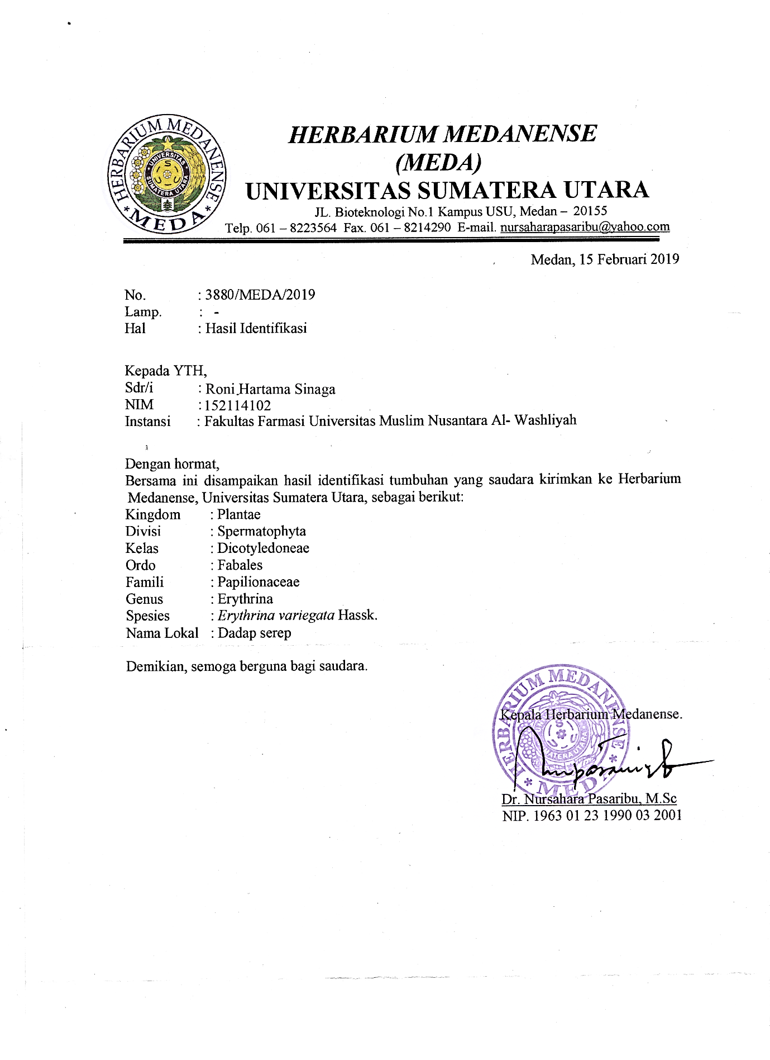
Lampiran 1. Surat Hasil Identifikasi Sampel Daun Dadap Serep

Lampiran 2. Tumbuhan Dadap Serep (Erythrina variegata Hassk.)
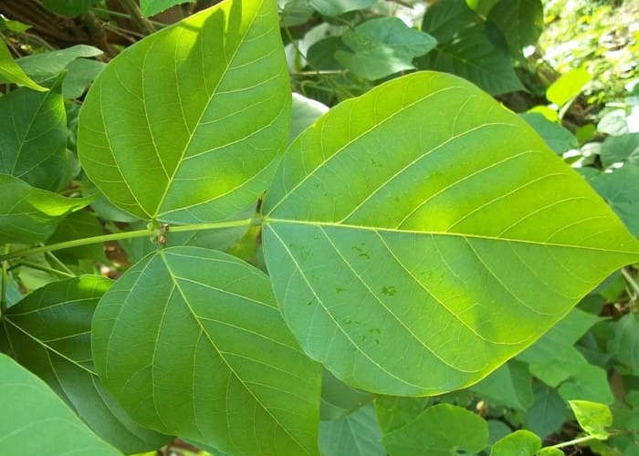

Tumbuhan Dadap Serep (Erythrina variegata Hassk.)

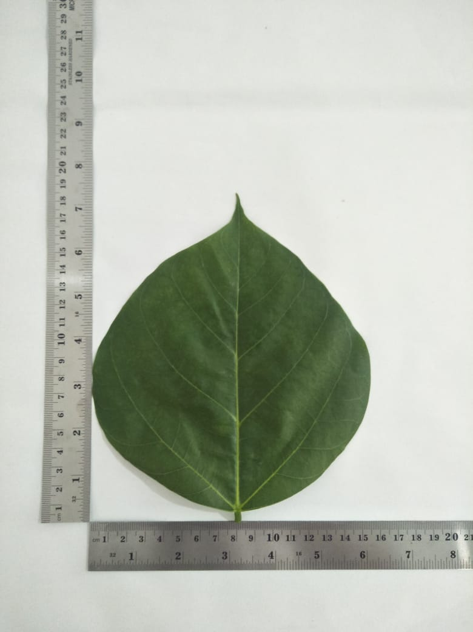

Daun Segar Dadap Serep (Erythrina variegata Hassk.)
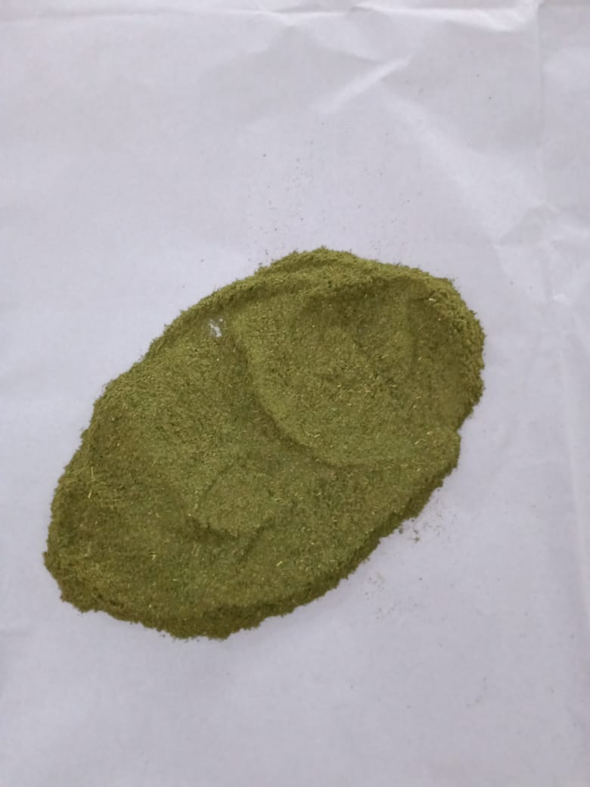
Lampiran 3. Serbuk Simplisia dan Ekstrak Etanol Daun dadap serep (Erythrina variegata Hassk.)

Serbuk simplisia daun dadap serep (Erythrinae variegatae Folium)

Ekstrak etanol daun dadap serep (Erythrina variegata)

Lampiran 4. Bagan Alir Pembuatan Simplisia Daun Dadap Serep (Erythrina variegata Hassk.)
Daun Dadap Serep
Disortasi basah
Dicuci dengan air mengalir
Ditiriskan
Dikeringkan dengan cara
diangain-anginkan
Ditimbang
Daun Dadap Serep

Dikeringkan di lemari pengering suhu 40°C
Disortasi kering
Ditimbang kembali
Simplisia

Dihaluskan menggunakan blender
Dimasukkan ke dalam wadah
tertutup
Serbuk Simplisia

Karakteristik Simplisia
- Kadar air
- Kadar sari larut
dalam etanol
- Kadar abu total
- Kadar abu tidak
larut asam
- Makroskopik simplisia
- Mikroskopik simplisia

SkriningFitokimia
- Alkaloid
- Flavonoid
- Saponin
- Tannin
- Steroid/triterpenoid
- Etanol

Lampiran 5. Bagan Alir Pembuatan Ekstrak Etanol Daun Dadap Serep
1.2 kg serbuk daun dadap serep

Dimasukan kedalam wadah
Direndam dengan etil asetat 9 liter
Didiamkan selama 5 hari
Disaring

Maserat I
Ampas I

Dibilas dengan etanol
3 liter

Maserat II
Ampas II

Maserat I dan II

Didiamkan selama 2 hari, dienaptuangkan
Ekstrak cair

Diuapkan dengan alat rotary evaporator
Ekstrak kental

Lampiran 6. Bagan Alir Pembuatan Inokulum Bakteri
Strain Murni

Diambil dengan jarum ose steril
Ditanam pada media agar miring NA
Diinkubasi pada suhu 35-37⁰ C

Stok Kultur

Diambil dengan jarum ose steril
Disuspensi dalam 10 ml larutan NaCl 0,9% steril
Dihomogenkan sampai kekeruhan yang sama dengan Mc.Farland
Suspensi bakteri 10⁸ CFU/ml

Dipipet 0,1 ml ke dalam tabung reaksi steril
Ditambahkan 9,9 ml NaCl 0,9% steril dan dihomogenkan
Suspensi bakteri 10⁶ CFU/ml

Lampiran 7. Mikroskopik Daun Dadap Serep
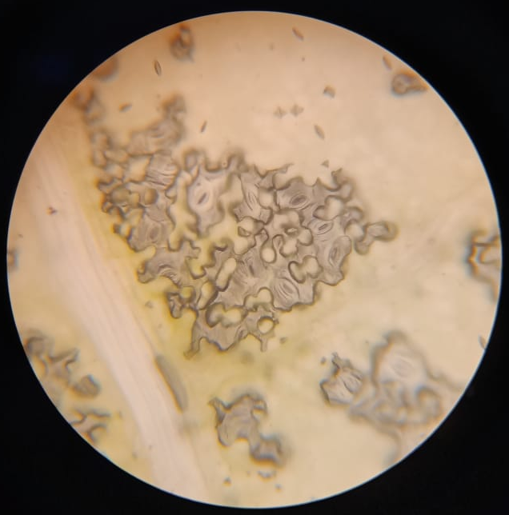

Stomata

Serabut

Berkas Pembuluh
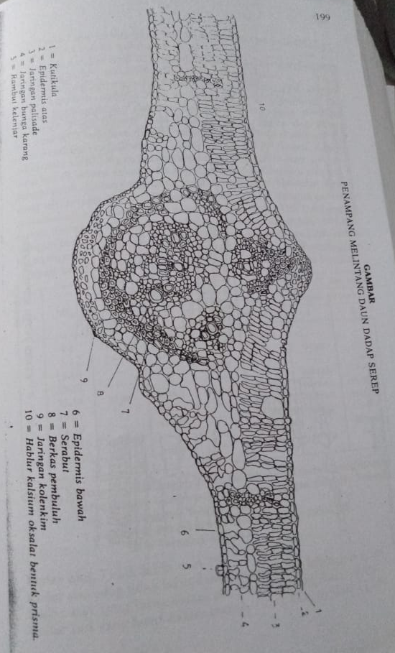
Daun dadap serep secara mikroskopik

Mikroskopik Daun Dadap Serep Menurut MMI

Lampiran 8. Hasil Uji Spesifik Bakteri Staphylococcus aureus dan Escherichia coli
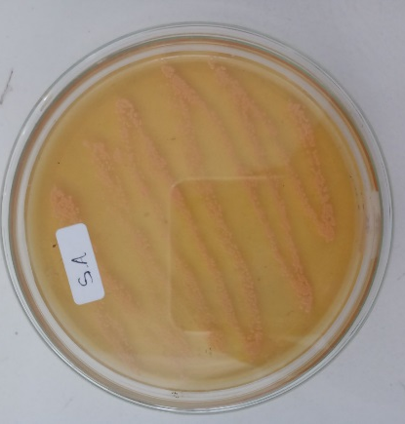

Bakteri Staphylococcus aureus
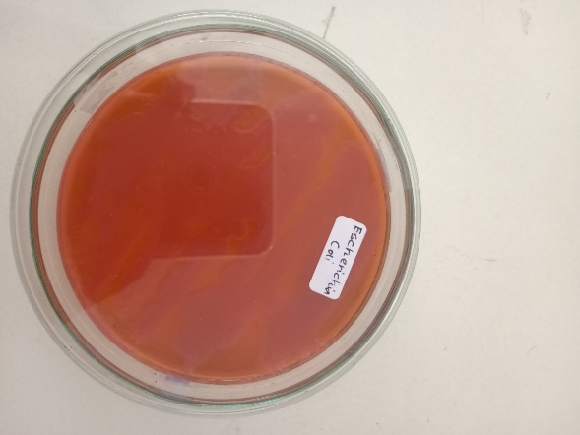

Bakteri Escherichia coli

Lampiran 9. Hasil Mikroskopik Pewarnaan Bakteri
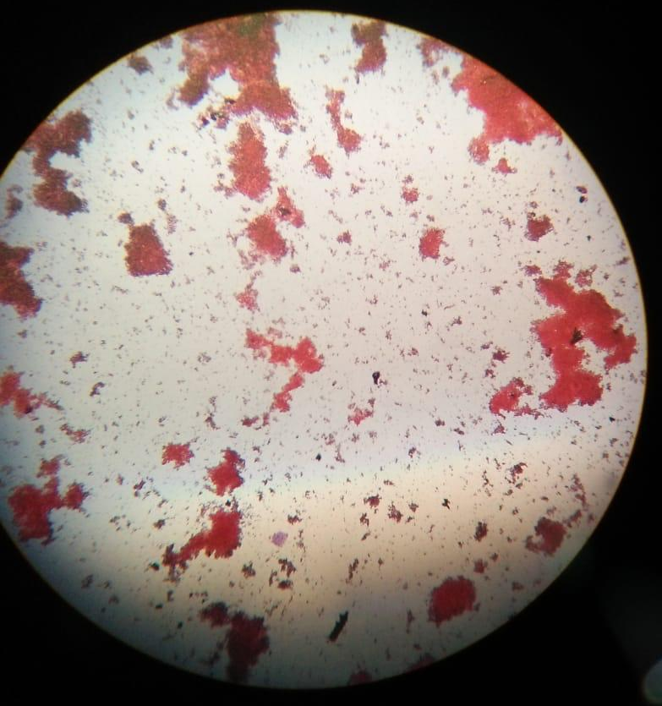

Bakteri Escherichia coli
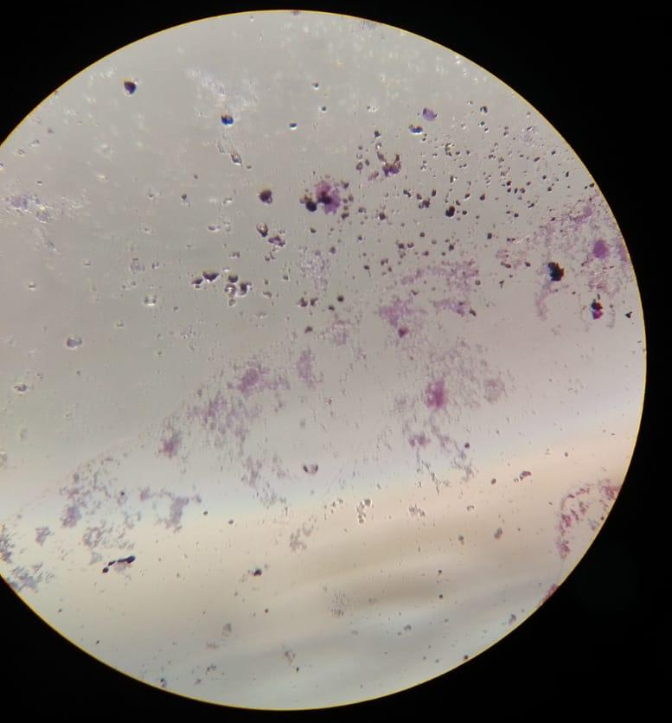

Bakteri Staphylococcus aureus

Lampiran 10. Hasil Uji Aktivitas Antibakteri
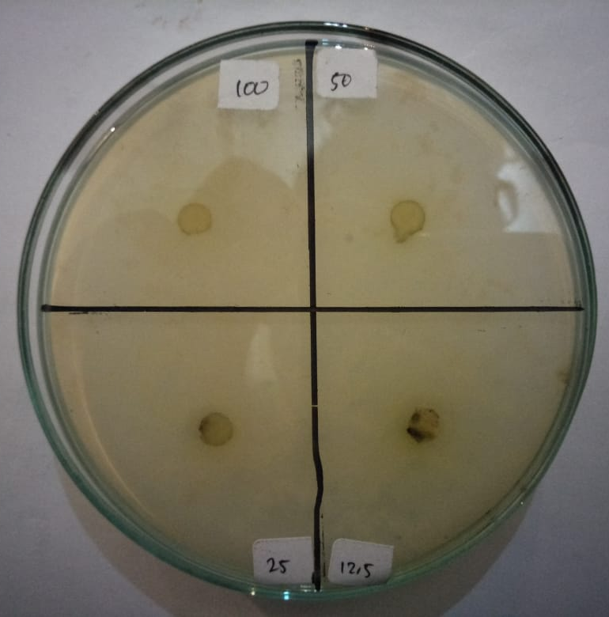
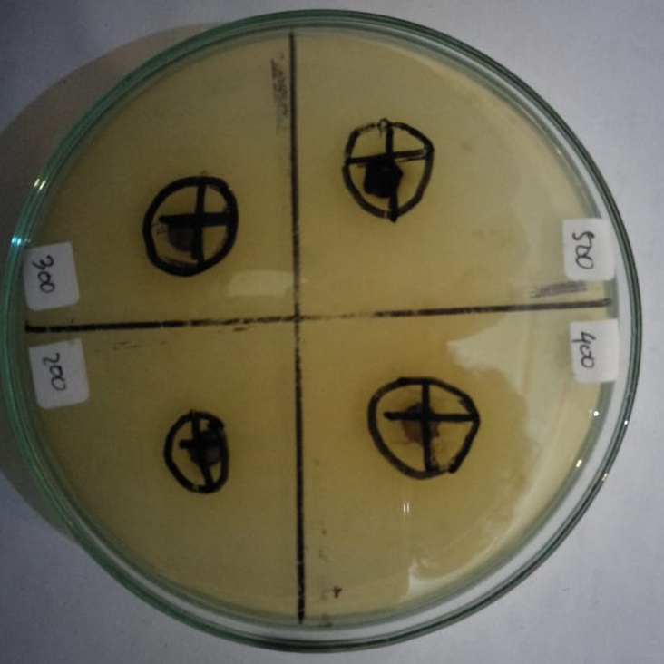
F
E
B
A

H
G
D
C
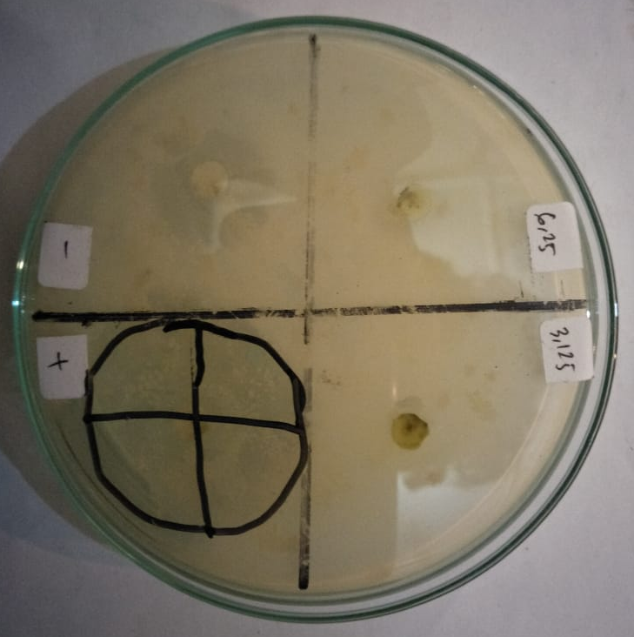
J
I

K
L

Ekstrak Etanol Daun Dadap Serep Terhadap Bakteri Escherichia coli
Keterangan : A. Konsentrasi 500 mg/ml I. Konsentrasi 6,25 mg/ml
B. Konsentrasi 400 mg/ml J. Konsentrasi 3,125 mg/ml
C. Konsentrasi 300 mg/ml K. Kontrol Positif
D. Konsentrasi 200 mg/ml L. Kontrol Negatif
E. Konsentrasi 100 mg/ml
F. Konsentrasi 50 mg/ml
G. Konsentrasi 25 mg/ml
H. Konsentrasi 12,5 mg/ml

Lampiran 10. Lanjutan
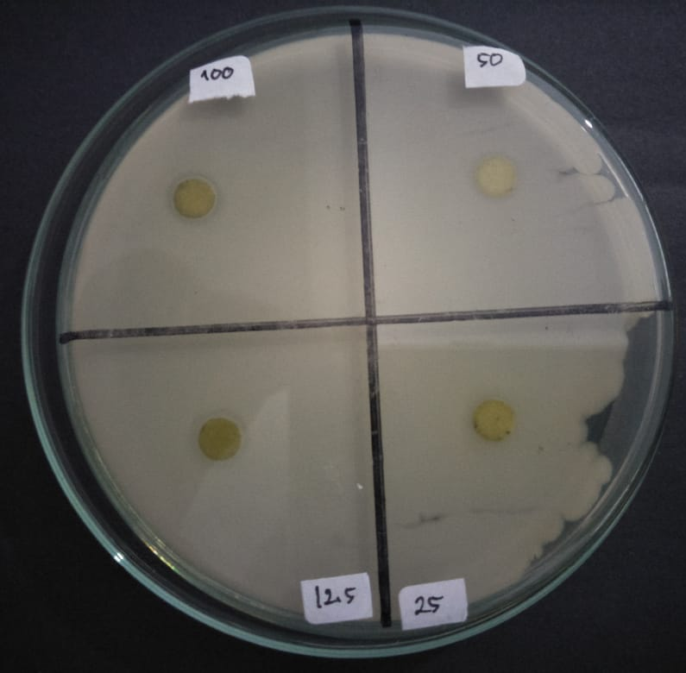
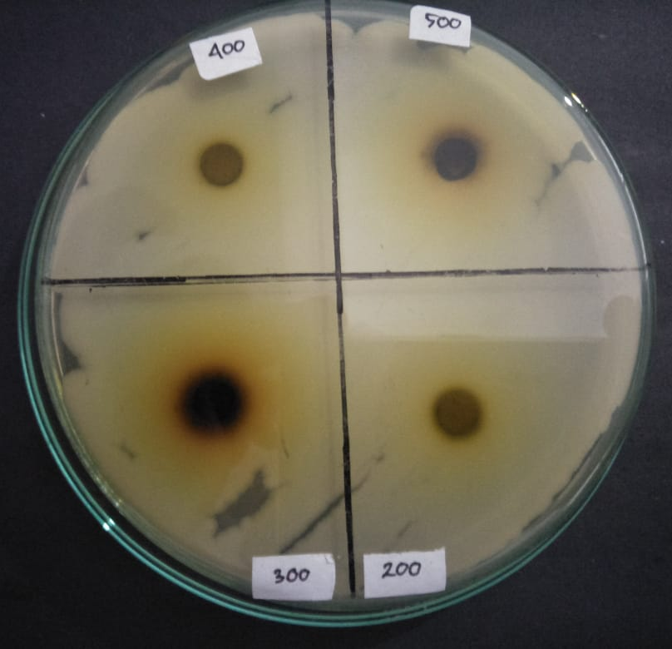
F
B
A
E

H
G
D
C
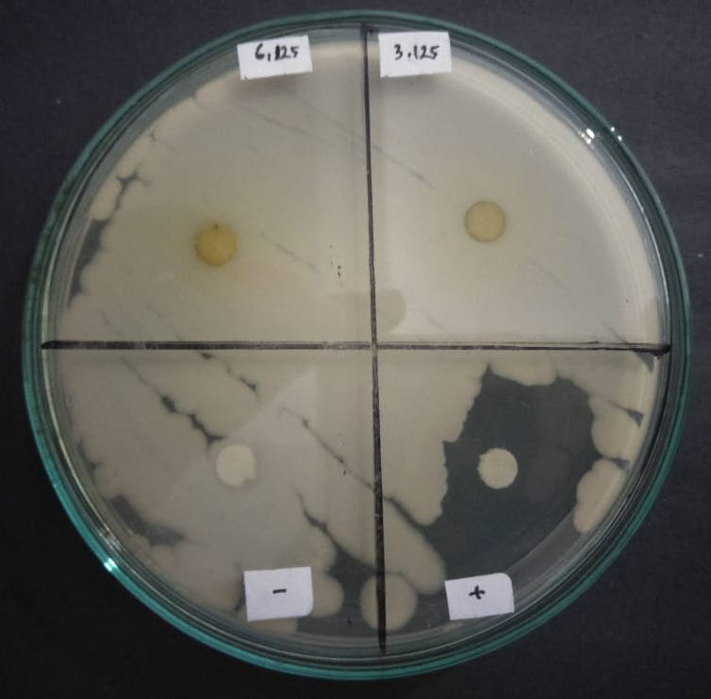
J
I

K
L

Ekstrak Etanol Daun Dadap Serep Terhadap Bakteri Staphylococcus aureus
Keterangan : A. Konsentrasi 500 mg/ml I. Konsentrasi 6,25 mg/ml
B. Konsentrasi 400 mg/ml J. Konsentrasi 3,125 mg/ml
C. Konsentrasi 300 mg/ml K. Kontrol Positif
D. Konsentrasi 200 mg/ml L. Kontrol Negatif
E. Konsentrasi 100 mg/ml
F. Konsentrasi 50 mg/ml
G. Konsentrasi 25 mg/ml
H. Konsentrasi 12,5 mg/ml

Lampiran 11. Perhitungan Karakterisasi
- Penetapan Kadar Air
Kadar air =$\frac{v2-v1}{Beratsampel (g)}$ x 100%

- Sampel l
- Berat sampel = 5 gram
- V1 = 0,4 ml
- V2 = 0,7 ml
Kadar air = $\frac{0,7-0,4}{5 g}x 100\%$ = 6%
- sampel 2

- Berat sampel = 5 gram
- V1 = 0,3 ml
- v2 = 0,5 ml
Kadar air = $\frac{0,5-0,3}{5 g} 100\%$ = 4%
- Sampel 3

- Berat sampel = 5 gram
- V1 = 0,5
- V2 = 0,8

Kadar air = $\frac{0,8-0,5}{5 g}x 100\%$ = 6%
Kadar air rata-rata = $\frac{6+4+6}{3} =5,3\%$

Lampiran 11. (Lanjutan)
- Penetapan Kadar Sari Larut Air
Kadar sari larut air =$\frac{(Berat cawan berisi – Berat cawan)}{Berat sampel\left(g\right)}x 100\%$
- Sampel l

- Berat sampel = 5 gram
- Kadar sari larut air = $\frac{\left(48,52-48,24\right)x 5}{5 g}x 100 \%=28$%
- Sampel 2

- Berat sampel = 5 gram
- Kadar sari larut air = $\frac{\left(48,76-48,46\right)x 5}{5 g}x 100\%=29\%$
- Sampel 3

- Berat sampel = 5 gram
- Kadar sari larut air = $\frac{\left(48,70-48,43\right)x 5}{5 g}x 100 \%=27\%$

Kadar sari larut air rata-rata = $\frac{28+29+37}{3} =28\%$

Lampiran 11. (Lanjutan)
- Penetapan kadar sari larut etanol
- Sampel l
Kadar sari larut etanol = $\frac{(Beratcawanberisi-Beratcawan}{Beratsampel\left(g\right)}x 100\%$
- Berat sampel : 5 g
- Kadar sari larut etanol = $\frac{\left(58,63-58,46\right)x 5}{5 g}x 100 \%=17$%
- Sampel 2

- Berat sampel : 5 g
- Kadar sari larut etanol = $\frac{\left(60,54-60,34\right)x 5}{5 g}x 100\%=20\%$
- Sampel 3

- Berat sampel : 5 g
- Kadar sari larut etanol = $\frac{\left(67,58-67,37\right)x 5}{5 g}x 100 \%=21 \%$
Kadar sari larut etanol rata-rata = $\frac{17\%+20\%+21\%}{3} =19,33\%$

Lampiran 11. (Lanjutan)
- Penetapan Kadar abu total
Kadar abu total = $\frac{Beratcawanberisi-beratcawankosong}{Beratsampel}x 100\%$
- sampel l

- Berat sampel = 2g
- Kadar abu total = $\frac{32,03-31,99}{2 g}x 10\%=2\%$
- Sampel 2

- Berat sampel = 2 g
- Kadar abu total = $\frac{33,78-33,73}{2 g}x 100\%=2,5\%$
- Sampel 3

- Berat sampel = 2 g
- Kadar abu total = $\frac{51,18-51,15}{2 g}x 100 \%=1,5\%$

Kadar abu total rata-rata = $\frac{2+2,5+1,5}{3}x 100\%=2\%$

Lampiran 11. (Lanjutan)
- Penetapan Kadar Abu Tidak Larut Asam
% Kadar abu tidak larut asam = $\frac{Beratcawabberisi-beratcawankosong}{Beratsampel}x 100\%$
- Sampel 1

- Berat sampel = 2 g
- Kadar tidak larut asam = $\frac{32.09-31,97}{2 g}x 100\%=0,5\%$
- Sampel 2

- Berat sampel = 2 g
- Kadar tidak larut asam = $\frac{33,74-33,73}{2 g}x 100\%=0,5\%$
- Sampel 3

- Berat sampel = 2 g
- Kadar tidak larut asam = $\frac{51,16-51-15}{2 g}x 100 \%=0,5 \%$
% kadar abu tidak larut asam rata-rata = $\frac{0,5+0,5+0,5}{3}=0,5\%$

Lampiran 12. Hasil Data Statistik

Descriptives
 |  | N | Mean | Std. Deviation | Std. Error | 95% Confidence Interval for Mean |  | Minimum | Maximum
 |  |  |  |  |  | Lower Bound | Upper Bound
Staphylococcus aureus | kontrol negatif | 3 | ,0000 | ,00000 | ,00000 | ,0000 | ,0000 | ,00 | ,00
 | kontrol positif | 3 | 33,6667 | 1,04083 | ,60093 | 31,0811 | 36,2522 | 32,50 | 34,50
 | kons. 500 | 3 | 13,6667 | ,76376 | ,44096 | 11,7694 | 15,5640 | 13,00 | 14,50
 | kons. 400 | 3 | 14,6667 | 1,04083 | ,60093 | 12,0811 | 17,2522 | 13,50 | 15,50
 | kons. 300 | 3 | 13,5000 | 1,32288 | ,76376 | 10,2138 | 16,7862 | 12,00 | 14,50
 | kons. 200 | 3 | 11,0000 | 1,00000 | ,57735 | 8,5159 | 13,4841 | 10,00 | 12,00
 | kons. 100 | 3 | ,0000 | ,00000 | ,00000 | ,0000 | ,0000 | ,00 | ,00
 | kons. 50 | 3 | ,0000 | ,00000 | ,00000 | ,0000 | ,0000 | ,00 | ,00
 | kons. 25 | 3 | ,0000 | ,00000 | ,00000 | ,0000 | ,0000 | ,00 | ,00
 | kons. 12,5 | 3 | ,0000 | ,00000 | ,00000 | ,0000 | ,0000 | ,00 | ,00
 | kons. 6,25 | 3 | ,0000 | ,00000 | ,00000 | ,0000 | ,0000 | ,00 | ,00
 | kons. 3,125 | 3 | ,0000 | ,00000 | ,00000 | ,0000 | ,0000 | ,00 | ,00
 | Total | 36 | 7,2083 | 10,22069 | 1,70345 | 3,7501 | 10,6665 | ,00 | 34,50
E.coli | kontrol negatif | 3 | ,0000 | ,00000 | ,00000 | ,0000 | ,0000 | ,00 | ,00
 | kontrol positif | 3 | 20,1667 | 6,21155 | 3,58624 | 4,7363 | 35,5970 | 13,00 | 24,00
 | kons. 500 | 3 | 13,5000 | 2,29129 | 1,32288 | 7,8081 | 19,1919 | 11,50 | 16,00
 | kons. 400 | 3 | 10,1667 | 1,04083 | ,60093 | 7,5811 | 12,7522 | 9,00 | 11,00
 | kons. 300 | 3 | 13,0000 | ,50000 | ,28868 | 11,7579 | 14,2421 | 12,50 | 13,50
 | kons. 200 | 3 | 9,5000 | 1,80278 | 1,04083 | 5,0217 | 13,9783 | 7,50 | 11,00
 | kons. 100 | 3 | ,0000 | ,00000 | ,00000 | ,0000 | ,0000 | ,00 | ,00
 | kons. 50 | 3 | ,0000 | ,00000 | ,00000 | ,0000 | ,0000 | ,00 | ,00
 | kons. 25 | 3 | ,0000 | ,00000 | ,00000 | ,0000 | ,0000 | ,00 | ,00
 | kons. 12,5 | 3 | ,0000 | ,00000 | ,00000 | ,0000 | ,0000 | ,00 | ,00
 | kons. 6,25 | 3 | ,0000 | ,00000 | ,00000 | ,0000 | ,0000 | ,00 | ,00
 | kons. 3,125 | 3 | ,0000 | ,00000 | ,00000 | ,0000 | ,0000 | ,00 | ,00
 | Total | 36 | 5,5278 | 7,27318 | 1,21220 | 3,0669 | 7,9887 | ,00 | 24,00

Tests of Normality^{a,c,d,e,f,g,h,i,j,k,l,m,n,o}
 | perlakuan | Kolmogorov-Smirnov^{b} |  |  | Shapiro-Wilk
 |  | Statistic | df | Sig. | Statistic | df | Sig.
Staphylococcus aureus | kontrol positif | ,292 | 3 | . | ,923 | 3 | ,463
 | kons. 500 | ,253 | 3 | . | ,964 | 3 | ,637
 | kons. 400 | ,292 | 3 | . | ,923 | 3 | ,463
 | kons. 300 | ,314 | 3 | . | ,893 | 3 | ,363
 | kons. 200 | ,175 | 3 | . | 1,000 | 3 | 1,000
E.coli | kontrol positif | ,371 | 3 | . | ,784 | 3 | ,077
 | kons. 500 | ,253 | 3 | . | ,964 | 3 | ,637
 | kons. 400 | ,292 | 3 | . | ,923 | 3 | ,463
 | kons. 300 | ,175 | 3 | . | 1,000 | 3 | 1,000
 | kons. 200 | ,276 | 3 | . | ,942 | 3 | ,537

ANOVA
 |  |  |  | Sum of Squares | df | Mean Square | F | Sig.
Staphylococcus aureus | Between Groups | (Combined) |  | 3645,188 | 11 | 331,381 | 723,012 | ,000
 |  | Linear Term | Contrast | 1437,337 | 1 | 1437,337 | 3136,008 | ,000
 |  |  | Deviation | 2207,851 | 10 | 220,785 | 481,713 | ,000
 | Within Groups |  |  | 11,000 | 24 | ,458
 | Total |  |  | 3656,188 | 35
E.coli | Between Groups | (Combined) |  | 1754,639 | 11 | 159,513 | 39,535 | ,000
 |  | Linear Term | Contrast | 738,855 | 1 | 738,855 | 183,124 | ,000
 |  |  | Deviation | 1015,783 | 10 | 101,578 | 25,176 | ,000
 | Within Groups |  |  | 96,833 | 24 | 4,035
 | Total |  |  | 1851,472 | 35

Staphylococcus aureus
Duncanª
perlakuan | N | Subset for alpha = 0.05
 |  | 1 | 2 | 3 | 4
kontrol negatif | 3 | ,0000
kons. 100 | 3 | ,0000
kons. 50 | 3 | ,0000
kons. 25 | 3 | ,0000
kons. 12,5 | 3 | ,0000
kons. 6,25 | 3 | ,0000
kons. 3,125 | 3 | ,0000
kons. 200 | 3 |  | 11,0000
kons. 300 | 3 |  |  | 13,5000
kons. 500 | 3 |  |  | 13,6667
kons. 400 | 3 |  |  | 14,6667
kontrol positif | 3 |  |  |  | 33,6667
Sig. |  | 1,000 | 1,000 | ,056 | 1,000
Means for groups in homogeneous subsets are displayed.
a. Uses Harmonic Mean Sample Size = 3,000.
Escherichia coli
Duncanª
perlakuan | N | Subset for alpha = 0.05
 |  | 1 | 2 | 3 | 4
kontrol negatif | 3 | ,0000
kons. 100 | 3 | ,0000
kons. 50 | 3 | ,0000
kons. 25 | 3 | ,0000
kons. 12,5 | 3 | ,0000
kons. 6,25 | 3 | ,0000
kons. 3,125 | 3 | ,0000
kons. 200 | 3 |  | 9,5000
kons. 400 | 3 |  | 10,1667 | 10,1667
kons. 300 | 3 |  | 13,0000 | 13,0000
kons. 500 | 3 |  |  | 13,5000
kontrol positif | 3 |  |  |  | 20,1667
Sig. |  | 1,000 | ,053 | ,065 | 1,000
Means for groups in homogeneous subsets are displayed.
a. Uses Harmonic Mean Sample Size = 3,000.

