Lampiran 1. Hasil Determinasi Tumbuhan
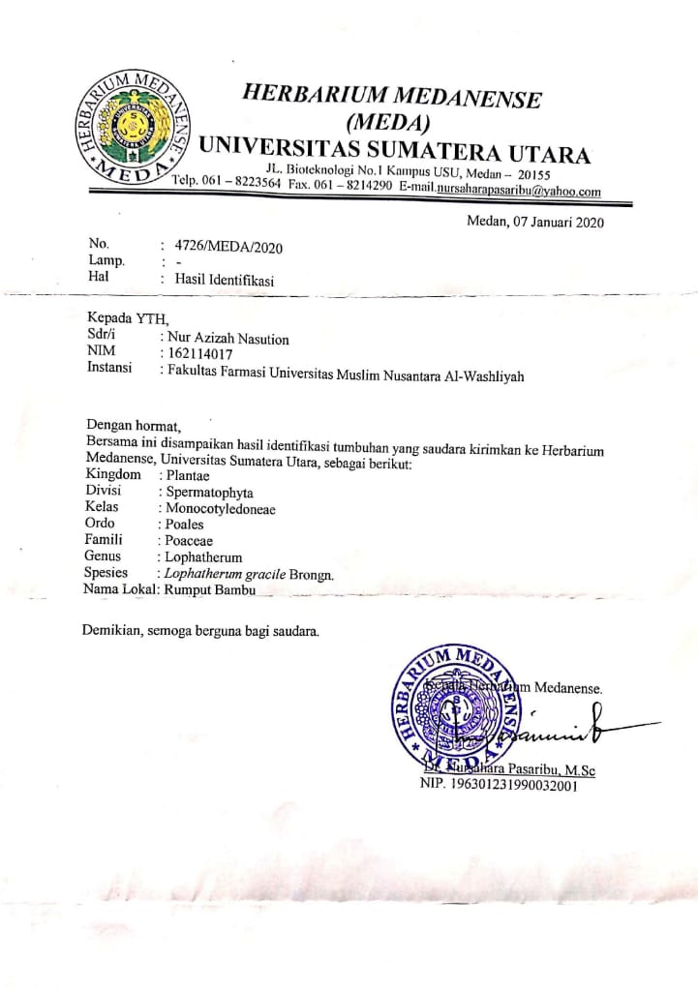
Lampiran 2. Rekomendasi Persetujuan Etik Penelitian Kesehatan
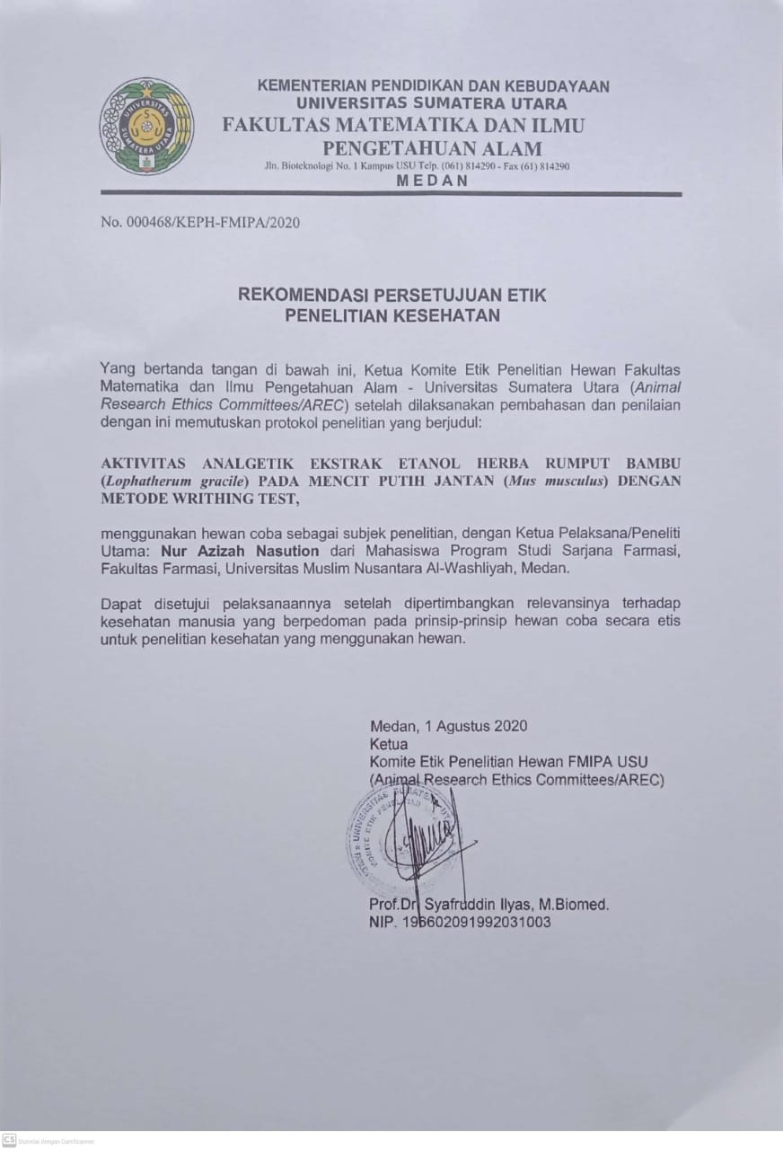
Lampiran 3. Bagan Alir Pembuatan Simplisia
Herba Rumput Bambu 5 kg

Dibersihkan
Dicuci bersih

Ditiriskan

Berat basah 5 kg

Dikeringkan dilemari pengering

Disortasi kering
Berat kering 1,1 kg

Dihaluskan dengan menggunakan blender
Serbuk simplisia ekstrak herba rumput bambu 500 g

Lampiran 4. Bagan Alir Pembuatan Ekstrak Etanol Herba Rumput Bambu
Serbuk Simplisia 500 g

Dimasukkan dalam bejana
Dituangkan dengan 75 bagian etanol 96%
Ditutup dan dibiarkan selama 5 hari sambil diaduk-aduk sesekali
Setelah 5 hari maserat diserkai dan ampasnya diperas
Maserat I
Ampas

Dicuci dengan 25 bagian etanol 96%
Dimasukkan kedalam bejana tertutup, dibiarkan selama 2 hari dan disaring
Maserat II

Maserat I + Maserat II
Dipekatkan dengan Rotary Evaporator
Ekstrak Etanol Kental 60 g
Lampiran 5. Bagan Alir Skrining Fitokimia dan Karakterisasi
Serbuk Simplisia Herba Rumput Bambu
Serbuk Simplisia Herba Rumput Bambu
Serbuk Simplisia Herba Rumput Bambu

Dimaserasi menggunakan pelarut etanol 96%
Skrining Fitokimia
Karakterisasi
Ekstrak Etanol Herba Rumput Bambu

1.Pemeriksaan Alkaloida
2.Pemeriksaan Flavonoida
3. Pemeriksaan Tanin
4.Pemeriksaan Saponin
5.Pemeriksaan Steroida
/Triterpenoida
1.Makroskopik
2.Mikroskopik
3.Penetapan Kadar Air
4.Penetapan Kadar Sari Larut Air
5.Penetapan Kadar Sari Larut Etanol
6.Penetapan Kadar Abu Total
7.Penetapan Kadar Abu Tidak Larut dalam Asam
1.Pemeriksaan Alkaloida
2.Pemeriksaan Flavonoida
3. Pemeriksaan Tanin
4.Pemeriksaan Saponin
5.Pemeriksaan Steroida/Triterpenoida
Uji Farmakologi

Lampiran 6. Bagan Alir Analgetik
Mencit

Diaklimatisasi selama 1-2 minggu
Dipuasakan selama 18-24 jam
Ditimbang berat badan
Dikelompokkan secara acak menjadi 5 kelompok masing-masing kelompok 5 ekor mencit
Diinduksi dengan Asam Asetat 0,5% hewan secara intraperitoneal
Mencit Nyeri

Dihitung jumlah geliat tiap 5 menit sampai menit ke 10
Setelah 10 menit diamati, setiap kelompok setiap kelompok diberi perlakuan secara peroral :
Kel 1 : CMC 0,5%
Kel 2 : Methampiron
Kel 3 : EEHRB 250 mg/kgBB
Kel 4 : EEHRB 500 mg/kgBB
Kel 5 : EEHRB 750 mg/kgBB
Diamati geliatnya dan dihitung jumlah geliat tiap 5 menit sampai menit ke 60
Jumlah Geliat
Lampiran 7. Serbuk Simplisia Herba Rumput Bambu
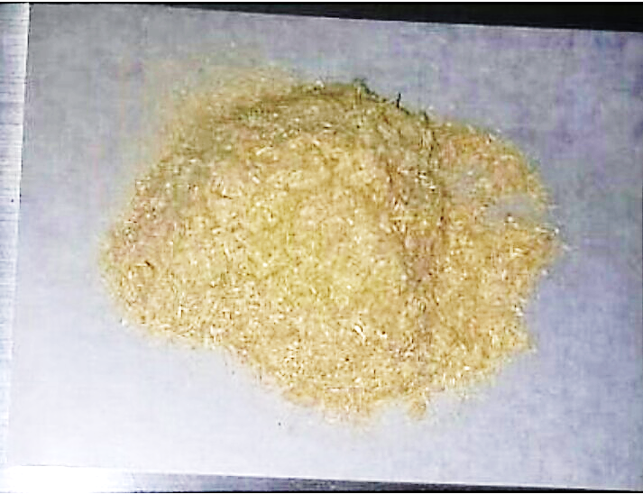
Serbuk Simplisia Herba Rumput Bambu

Lampiran 8. Mikroskopik Herba Rumput Bambu (lophatherum gracile)

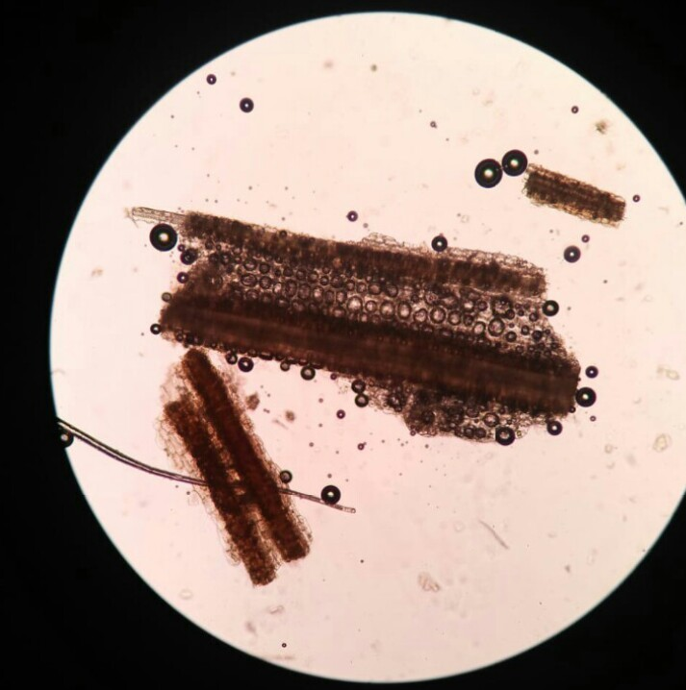
parenkim
Serabut
Trikoma(rambut)

Lampiran 9. Maserasi dan Ekstrak Etanol Herba Rumput Bambu
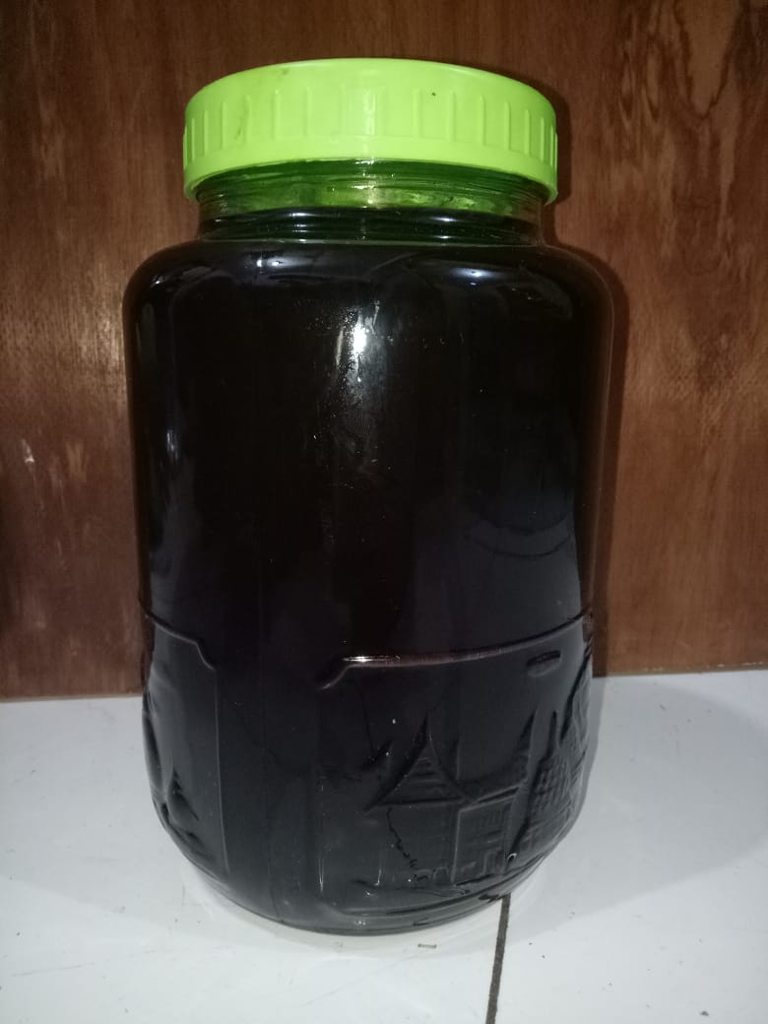

Ekstraksi Cara Maserasi Herba Rumput Bambu
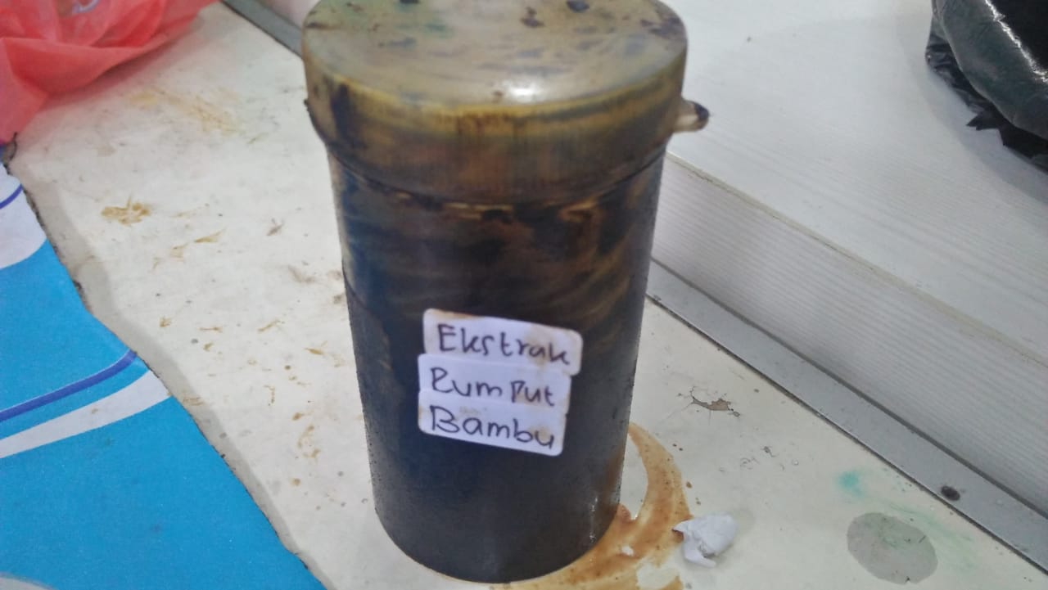

Ekstrak Etanol Herba Rumput Bambu

Lampiran 10. Alat Rotary Evaporator dan Alat Azeotrop
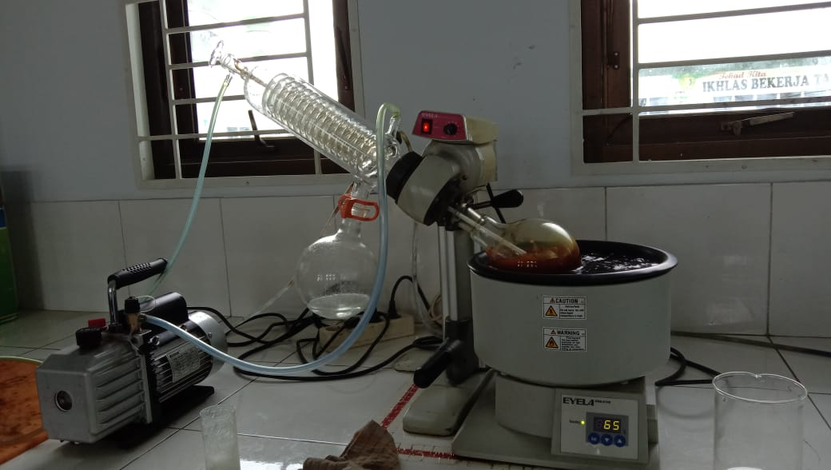

Alat Rotary Evaporator
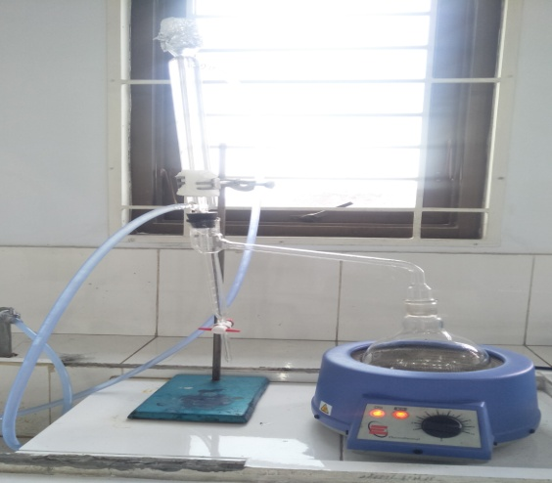

Alat Azeotrop (Penetapan Kadar Air)

Lampiran 11 Perlakuan dengan Mencit
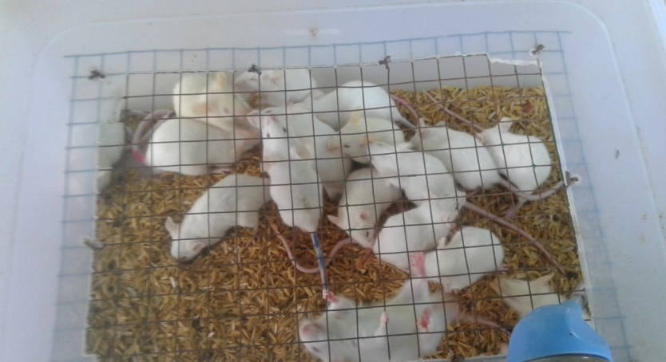
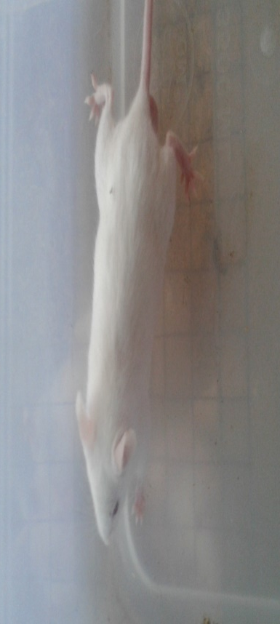
Geliat Mencit
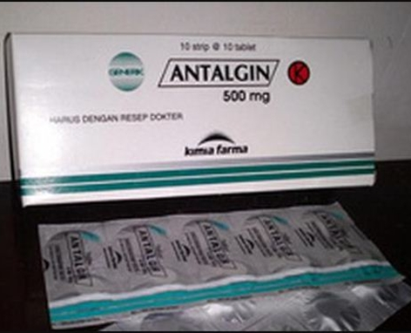
Metampiron (Antalgin) 2% (Kontrol Positif)

Lampiran 12. Tabel Konversi Dosis dan Tabel Volume Maksimum lambung pada hewan
 | Mencit  20 g | Tikus  200 g | Marmut  400 g | Kelinci  1,5 Kg | Kera  4 Kg | Anjing  12 Kg | Manusia  70 Kg
Mencit  20 g | 1,0 | 7,0 | 12,25 | 27,80 | 64,10 | 124,3 | 787,9
Tikus  200 g | 0,14 | 1,0 | 1,74 | 3,90 | 9,20 | 17,80 | 56,0
Marmut  400 g | 0,08 | 0,57 | 1,0 | 2,25 | 5,20 | 10,20 | 31,50
Kelinci  1,5 Kg | 0,04 | 0,25 | 0,44 | 1,0 | 2,40 | 4,50 | 14,20
Kera  4 Kg | 0,016 | 0,11 | 0,19 | 0,92 | 0,1 | 1,9 | 6,1
Anjing  12 Kg | 0,008 | 0,6 | 0,10 | 0,42 | 0,52 | 1,0 | 3,10
Manusia  70 Kg | 0,0026 | 0,018 | 0,031 | 0,07 | 0,16 | 0,32 | 1,0

Tabel Volume Maksimum lambung pada hewan (ml)
Jenis Hewan Uji | Volume maksimum (ml) sesuai jalur pemberian
 | i.v | i.m | i.p | s.c | p.o
Mencit(20-30 g) | 0,05 | 0,05 | 1,0 | 0,5-1,0 | 1,0
Tikus(200 g) | 0,1 | 0,1 | 2-5 | 2-5 | 5,0
Hamster(50 g) | 0,1 | 0,1 | 1-2 | 2,5 | 2,5
Marmut (250 g) | 0,25 | 0,25 | 2-5 | 5,0 | 10,0
Kelinci ( 3 kg) | 0,5 | 0,5 | 10-20 | 5-10 | 20.0
Kucing (3 kg) | 1,0 | 1,0 | 10-20 | 5-10 | 50,0
Anjing (5 kg) | 5,0 | 5,0 | 20-50 | 10,0 | 100,0

Lampiran 13. Perhitungan Dosis
1. Perhitungan Konversi Dosis Metampiron
Dosis terapi Metampiron pada manusia adalah 500 mg
Dosis sekali minum : 500 mg
Dosis tiga kali minum : 1500 mg
Konversi dosis manusia (70 kg) ke mencit (20 g) : 0,0026
Dosis antalgin pada mencit : 500 mg x 0,0026 = 1,3 mg
Maka :
Mencit (20 g) = $\frac{1,3 mg}{0,02 kg}$ = 65 mg/kgBB
Dosis = $\frac{65 mg}{1000 g}$ x 20 g = 1,3 mg
Metampiron 2% = ${2g}/{100 ml}$ = 20 mg/ml
Volume = $\frac{Dosis}{Konsentrasi}$ = $\frac{1,3 mg}{20 mg/ml}$ = 0,06 ml
2. Perhitungan Dosis Suspensi CMC 0,5 %
CMC 0,5% = Jumlah cmc / volum suspensi
= 0,5 g / 100 ml
= 500 mg/100 ml
= 5 mg/ ml
3. Perhitungan Dosis Suspensi Ekstrak Etanol Herba Rumput Bambu Dosis 250 mg/kg BB
Konsentrasi EEHRB 2% = Jumlah EEHRB / volume suspensi
= 2000 mg / 100 ml
= 20 mg/ml
Lampiran 13. (lanjutan)
BB mencit 20 g
Perhitungan dosis 250 mg/kgBB
$\frac{Dosis x BB (g)}{Konsentrasi}$ = $\frac{0,25 x 20}{20}=0,22 ml$
4. Perhitungan Dosis Suspensi Ekstrak Etanol Herba Rumput Bambu Dosis 500 mg/kg BB
Konsentrasi EEHRB 2% = Jumlah EEHRB / volume suspensi
= 2000 mg / 100 ml
= 20 mg/ml
BB mencit 20 g
Perhitungan dosis 500 mg/kgBB
$\frac{Dosis x BB (g)}{Konsentrasi}$ = $\frac{0,5 x 20}{20}=0,5 ml$
5. Perhitungan Dosis Suspensi Ekstrak Etanol Herba Rumput Bambu Dosis 750 mg/kgBB
Konsentrasi EEHRB 2% = Jumlah EEHRB / volume suspensi
= 2000 mg / 100 ml
= 20 mg/ml
BB mencit 20 g
Perhitungan dosis 750 mg/kgBB
$\frac{Dosis x BB (g)}{Konsentrasi}$ = $\frac{0,75 x 20}{20}=0,75 ml$
Lampiran 14 Data rata – rata jumlah geliat mencit putih jantan yang diinduksi asam asetat 0,5% dalam waktu 10 menit
No. | Diinduksi Asam Asetat 0,5% Selama 10 menit |  |  |  |  | Jumlah Geliat
1 | 26 | 24 | 20 | 20 | 22 | 112
2 | 25 | 25 | 20 | 22 | 20 | 112
3 | 20 | 25 | 23 | 20 | 21 | 109
4 | 25 | 23 | 20 | 22 | 20 | 110
5 | 20 | 24 | 20 | 20 | 20 | 104

Lampiran 15. Data hasil pengamatan geliat mencit jantan setelah perlakuan suspensi CMC 0,5%, suspensi metampiron 2%, suspense EEHRB dosis 250 mg/kgBB, dosis 500 mg/kgBB, dosis 750 mg/kgBB
Perlakuan | Mencit | Waktu (menit) |  |  |  |  |  | Jumlah Geliat
 |  | 5 | 10 | 20 | 30 | 45 | 60
Suspensi CMC 0,5% | 1 | 12 | 24 | 20 | 18 | 15 | 8 | 97
 | 2 | 12 | 25 | 22 | 20 | 16 | 10 | 105
 | 3 | 14 | 22 | 18 | 14 | 12 | 7 | 87
 | 4 | 15 | 26 | 22 | 18 | 12 | 10 | 103
 | 5 | 14 | 24 | 20 | 17 | 10 | 8 | 93
Rata – Rata |  | 13,4 | 24,2 | 20,4 | 17,4 | 13 | 8,6 | 97
SD |  | 1,3 | 1,5 | 1,7 | 2,2 | 2,4 | 1,3
Suspensi Metampiron 2% | 1 | 10 | 18 | 15 | 12 | 8 | 4 | 67
 | 2 | 12 | 16 | 14 | 10 | 6 | 5 | 63
 | 3 | 13 | 14 | 11 | 7 | 5 | 3 | 53
 | 4 | 12 | 15 | 12 | 8 | 6 | 4 | 57
 | 5 | 10 | 14 | 10 | 6 | 4 | 2 | 46
Rata – Rata |  | 11,4 | 15,4 | 12,4 | 8,6 | 5,8 | 3,6 | 57,2
SD |  | 1,3 | 1,7 | 2,1 | 2,4 | 1,5 | 1,1
Suspensi EEHRB 250mg/kg BB | 1 | 6 | 15 | 10 | 6 | 4 | 2 | 43
 | 2 | 8 | 14 | 11 | 8 | 5 | 4 | 50
 | 3 | 8 | 16 | 14 | 11 | 7 | 3 | 59
 | 4 | 9 | 15 | 12 | 10 | 6 | 2 | 54
 | 5 | 7 | 16 | 12 | 8 | 5 | 2 | 50
Rata – Rata |  | 7,6 | 15,2 | 11,8 | 8,6 | 5,4 | 2,6 | 51,2
SD |  | 1,1 | 0,8 | 1,5 | 1,9 | 1,1 | 0,9
Suspensi EEHRB 500mg/kg BB | 1 | 6 | 15 | 12 | 10 | 5 | 3 | 51
 | 2 | 6 | 14 | 10 | 8 | 4 | 2 | 44
 | 3 | 8 | 16 | 15 | 10 | 8 | 4 | 61
 | 4 | 7 | 15 | 13 | 8 | 6 | 4 | 53
 | 5 | 7 | 16 | 12 | 8 | 5 | 2 | 50
Rata – Rata |  | 6,8 | 15,2 | 12,4 | 8,8 | 5,6 | 3 | 51,8
SD |  | 0,8 | 0,8 | 1,8 | 1,1 | 1,5 | 1,0
Suspensi EEHRB 750mg/kg BB | 1 | 7 | 14 | 12 | 8 | 6 | 2 | 49
 | 2 | 6 | 10 | 7 | 5 | 5 | 3 | 36
 | 3 | 8 | 13 | 8 | 6 | 5 | 2 | 42
 | 4 | 7 | 12 | 9 | 6 | 5 | 2 | 41
 | 5 | 8 | 14 | 10 | 8 | 6 | 3 | 49
Rata – Rata |  | 7,2 | 12,6 | 9,2 | 6,6 | 5,4 | 2,4 | 43,4
SD |  | 0,8 | 1,7 | 1,9 | 1,3 | 0,5 | 0,5
Lampiran 16. Data Karakterisasi Serbuk Simplisia Herba Rumput Bambu
- Perhitungan Hasil Penetapan Kadar Air (Tidak lebih dari 10 %).
$$Kadar Air :\frac{volume II-Volume I}{Berat Sampel}×100 \%$$

Sampel I
Berat sampel : 5 g
Volume I : 1,8 ml
Volume II : 2,2 ml
= $\frac{2,2 ml-1,8 ml}{5 g}×100 \%$
= $\frac{0,4 ml}{5 g}×100 \%=8 \%$
Sampel II
Berat sampel : 5 g
Volume I : 1,9 ml
Volume II : 2,3 ml
= $\frac{2,3 ml-1,9 ml}{5 g}×100 \%$
= $\frac{0,4 ml}{5 g}×100 \%=8 \%$
Sampel III
Berat sampel : 5 g
Volume I : 1,8 ml
Volume II : 2,2 ml
= $\frac{2,2 ml-1,8 ml}{5 g}×100 \%$
= $\frac{0,4}{5 g}×100 \%=8 \%$

Kadar air rata-rata: = $\frac{8 \%+8 \%+8 \%}{3}$ = 8 %
Kadar air pada herba rumput bambu memenuhi syarat yaitu 8 %, tidak lebih dari 10%.
Lampiran 16. (lanjutan)
- Perhitungan Kadar Sari Larut dalam Air (>23,5 %).
$$Kadar Sari Larut Air=\frac{Berat cawan+Faktor pengenceran}{Berat sampel}×100\%$$

Sampel 1
Berat sampel : 5 g
Berat cawan kosong : 59,86 g
Berat cawan$+$sampel : 60,12 g
=$\frac{\left(60,12 g-59,86 g\right)×5}{5 g}×100 \%$
=$\frac{1,3 g}{5g}×100\%$ = 26 %
Sampel II
Berat sampel : 5 g
Berat cawan kosong : 64,49 g
Beratcawan$+$ sampel : 64,85 g
= $\frac{\left(64,85g-64,49 g \right)×5}{5 g}100 \%$
=$\frac{1,8 g}{5 g}×100 \%$ = 36 %
Sampel III
Berat sampel : 5 g
Berat cawan kosong : 68,07 g
Berat cawan$+$sampel : 68,33 g
= $\frac{(68,33 g-68,07 g)}{5 g}×100 \%$
= $\frac{1,3 g}{5 g}×100 \%$ = 26 %
Kadar sari larut dalam air rata-rata: = $\frac{26\%+36 \%+26 \%}{3}$ = 29,3 %
Kadar sari larut dalam air pada herba rumput bambu memenuhi syarat yaitu 29,3%, lebih dari 23,5 %.
Lampiran 16. (lanjutan)
- Perhitungan Kadar Sari Larut dalam Etanol
Kadar Sari Larut Dalam Etanol = $\frac{Berat Cawan+sampel (g)}{Berat sampel (g)}×100 \%$

Sampel I
Berat sampel : 5 g
Berat cawan kosong : 65,44 g
Berat cawan$+$sampel : 65,78 g
= $\frac{(65,78 g-65,44 g ×5}{5 g}×100$= 34 %
Sampel II
Berat sampel : 5 g
Berat cawan kosong : 68,07g
Berat cawan$+$ sampel : 68,34 g
= $\frac{\left(68,34 g-68,07 g\right)×5}{5 g}×100 \%$ = 27 %
Sampel III
Berat sampel : 5 g
Berat cawan kosong : 64,48 g
Berat cawan$+$ sampel : 64,76 g
= $\frac{\left(64,78 g-64,48 g\right)×5}{5 g}×100 \%$ = 28 %

Kadar sari larut dalam etanol rata-rata: = $\frac{34\%+27\%+28\%}{3}$= 29,66 %

Kadar sari larut dalam etanol pada herba rumput bambu memenuhi syarat yaitu

Lampiran 16. (lanjutan)
- Perhitungan Penetapan Kadar Abu ( Tidak lebih dari 4 %)

Kadar Abu = $\frac{Berat abu (g)}{Berat sampel (g)}×100 \%$

Sampel I
Berat sampel : 2 g
Berat Abu : 0,08 g

Kadar abu total = $\frac{0,08 g}{2 g}×100 \%$ = 4 %

Sampel II
Berat sampel : 2 g
Berat Abu : 0,05 g

Kadar abu total = $\frac{0,05 g}{2 g}×100 \%$ = 2,5 %
Sampel III
Berat sampel : 2 g
Berat Abu : 0,06 g

Kadar abu total = $\frac{0,06 g}{2 g}×100 \%$= 3 %
Kadar abu total rata-rata =$\frac{4+2,5 \% +3 \%}{3}$= 3,17 %

Kadar abu total pada herba rumput bambu memenuhi syarat yaitu 3,17 %, tidak lebih dari 4 %.

Lampiran 16. (lanjutan)
- Perhitungan Kadar Abu tidak Larut dalam Asam (tidak lebih dari 3,5 %).
Kadar abu tidak larut asam = $\frac{Berat abu larut asam (g)}{Berat sampel}×100 \%$

Sampel I
Berat sampel : 2 g
Berat Abu : 0,01 g
= $\frac{0,01 g}{2 g}×100 \%$ = 0,5 %

Sampel ll
Berat sampel : 2 g
Berat Abu : 0,01
= $\frac{0,01 g}{2g}×100 \%=0,5 \%$

Sampel III
Berat sampel : 2 g
Berat Abu : 63,84 g
= $\frac{0,01 g}{2 g}×100 \%$ = 0,5 %
Kadar abu tidak larut dalam asam rata-rata:= $\frac{0,5 \% +0,5\% +0,5 \% }{3}$ = 0,5 %
Kadar abu tidak larut dalam asam pada herba rumput bambu memenuhi syarat yaitu 0,5 %, tidak lebih dari 3,5 %.

Lampiran 17. Perhitungan Persentase Daya Analgetik
Rumus % daya analgetik
$$\% Daya analgetik=100-\left\{\frac{rata-rata geliat}{kontrol negatif} x 100\%\right\}$$
1. Kontrol Positif (Metampiron 2%)
Menit ke 5 = 100 ₋ $\frac{11,4}{13,4}$ x 100% = 14,92%
Menit ke 10 = 100 ₋ $\frac{15,4}{24,2}$ x 100% = 36,36%
Menit ke 20 = 100 ₋ $\frac{12,4}{20,4}$ x 100% = 39,21%
Menit ke 30 = 100 ₋ $\frac{8,6}{17,4}$ x 100% = 50,57%
Menit ke 45 = 100 ₋ $\frac{5,8}{13}$ x 100% = 55,38%
Menit ke 60 = 100 ₋ $\frac{3,6}{8,6}$ x 100% = 58,13%

Lampiran 17. (Lanjutan)
2. Ekstrak Etanol Herba Rumput Bambu Dosis 250 mg/kgBB
Menit ke 5 = 100 ₋ $\frac{7,6}{13,4}$ x 100% = 43,28%
Menit ke 10 = 100 ₋ $\frac{15,2}{24,2}$ x 100% = 37,19%
Menit ke 20 = 100 ₋ $\frac{11,8}{20,4}$ x 100% = 42,15%
Menit ke 30 = 100 ₋ $\frac{8,6}{17,4}$ x 100% = 50,57%
Menit ke 45 = 100 ₋ $\frac{5,4}{13}$ x 100% = 58,46%
Menit ke 60 = 100 ₋ $\frac{2,6}{8,6}$ x 100% = 69,76%

Lampiran 17. (Lanjutan)
3. Ekstrak Etanol Herba Rumput Bambu Dosis 500 mg/kgBB
Menit ke 5 = 100 ₋ $\frac{6,8}{13,4}$ x 100% = 49,25%
Menit ke 10 = 100 ₋ $\frac{15,2}{24,2}$ x 100% = 37,19%
Menit ke 20 = 100 ₋ $\frac{12,4}{20,4}$ x 100% = 39,21%
Menit ke 30 = 100 ₋ $\frac{8,8}{17,4}$ x 100% = 49,42%
Menit ke 45 = 100 ₋ $\frac{5,6}{13}$ x 100% = 56,92%
Menit ke 60 = 100 ₋ $\frac{3}{8,6}$ x 100% = 65,11%

Lampiran 17. (Lanjutan)
4. Ekstrak Etanol Herba Rumput Bambu Dosis 750 mg/kgBB
Menit ke 5 = 100 ₋ $\frac{7,2}{13,4}$ x 100% = 46,26%
Menit ke 10 = 100 ₋ $\frac{12,6}{24,2}$ x 100% = 47,93%
Menit ke 20 = 100 ₋ $\frac{9,2}{20,4}$ x 100% = 54,90%
Menit ke 30 = 100 ₋ $\frac{6,6}{17,4}$ x 100% = 62,06%
Menit ke 45 = 100 ₋ $\frac{5,4}{13}$ x 100% = 58,46%
Menit ke 60 = 100 ₋ $\frac{2,4}{8,6}$ x 100% = 72,09%

Lampiran 18. Hasil Descriptives
Descriptives
 |  | N | Mean | Std. Deviation | Std. Error | 95% Confidence Interval for Mean |  | Minimum | Maximum
 |  |  |  |  |  | Lower Bound | Upper Bound
Menit5 | 1 | 5 | 13.40 | 1.342 | .600 | 11.73 | 15.07 | 12 | 15
 | 2 | 5 | 11.40 | 1.342 | .600 | 9.73 | 13.07 | 10 | 13
 | 3 | 5 | 7.60 | 1.140 | .510 | 6.18 | 9.02 | 6 | 9
 | 4 | 5 | 6.80 | .837 | .374 | 5.76 | 7.84 | 6 | 8
 | 5 | 5 | 7.20 | .837 | .374 | 6.16 | 8.24 | 6 | 8
 | Total | 25 | 9.28 | 2.880 | .576 | 8.09 | 10.47 | 6 | 15
Menit10 | 1 | 5 | 24.20 | 1.483 | .663 | 22.36 | 26.04 | 22 | 26
 | 2 | 5 | 15.40 | 1.673 | .748 | 13.32 | 17.48 | 14 | 18
 | 3 | 5 | 15.20 | .837 | .374 | 14.16 | 16.24 | 14 | 16
 | 4 | 5 | 15.20 | .837 | .374 | 14.16 | 16.24 | 14 | 16
 | 5 | 5 | 12.60 | 1.673 | .748 | 10.52 | 14.68 | 10 | 14
 | Total | 25 | 16.52 | 4.244 | .849 | 14.77 | 18.27 | 10 | 26
Menit20 | 1 | 5 | 20.40 | 1.673 | .748 | 18.32 | 22.48 | 18 | 22
 | 2 | 5 | 12.40 | 2.074 | .927 | 9.83 | 14.97 | 10 | 15
 | 3 | 5 | 11.80 | 1.483 | .663 | 9.96 | 13.64 | 10 | 14
 | 4 | 5 | 12.40 | 1.817 | .812 | 10.14 | 14.66 | 10 | 15
 | 5 | 5 | 9.20 | 1.924 | .860 | 6.81 | 11.59 | 7 | 12
 | Total | 25 | 13.24 | 4.186 | .837 | 11.51 | 14.97 | 7 | 22
Menit30 | 1 | 5 | 17.40 | 2.191 | .980 | 14.68 | 20.12 | 14 | 20
 | 2 | 5 | 8.60 | 2.408 | 1.077 | 5.61 | 11.59 | 6 | 12
 | 3 | 5 | 8.60 | 1.949 | .872 | 6.18 | 11.02 | 6 | 11
 | 4 | 5 | 8.80 | 1.095 | .490 | 7.44 | 10.16 | 8 | 10
 | 5 | 5 | 6.60 | 1.342 | .600 | 4.93 | 8.27 | 5 | 8
 | Total | 25 | 10.00 | 4.223 | .845 | 8.26 | 11.74 | 5 | 20
Menit45 | 1 | 5 | 13.00 | 2.449 | 1.095 | 9.96 | 16.04 | 10 | 16
 | 2 | 5 | 5.80 | 1.483 | .663 | 3.96 | 7.64 | 4 | 8
 | 3 | 5 | 5.40 | 1.140 | .510 | 3.98 | 6.82 | 4 | 7
 | 4 | 5 | 5.60 | 1.517 | .678 | 3.72 | 7.48 | 4 | 8
 | 5 | 5 | 5.40 | .548 | .245 | 4.72 | 6.08 | 5 | 6
 | Total | 25 | 7.04 | 3.360 | .672 | 5.65 | 8.43 | 4 | 16
Menit60 | 1 | 5 | 8.60 | 1.342 | .600 | 6.93 | 10.27 | 7 | 10
 | 2 | 5 | 3.60 | 1.140 | .510 | 2.18 | 5.02 | 2 | 5
 | 3 | 5 | 2.60 | .894 | .400 | 1.49 | 3.71 | 2 | 4
 | 4 | 5 | 3.00 | 1.000 | .447 | 1.76 | 4.24 | 2 | 4
 | 5 | 5 | 2.40 | .548 | .245 | 1.72 | 3.08 | 2 | 3
 | Total | 25 | 4.04 | 2.541 | .508 | 2.99 | 5.09 | 2 | 10

Lampiran 19. Hasil Homogenitas
Test of Homogeneity of Variances
 | Levene Statistic | df1 | df2 | Sig.
Menit5 | 1.229 | 4 | 20 | .330
Menit10 | .950 | 4 | 20 | .456
Menit20 | .294 | 4 | 20 | .878
Menit30 | .831 | 4 | 20 | .521
Menit45 | 2.665 | 4 | 20 | .062
Menit60 | 1.466 | 4 | 20 | .250

Lampiran 20. Hasil Anova
ANOVA
 |  | Sum of Squares | df | Mean Square | F | Sig.
Menit5 | Between Groups | 173.840 | 4 | 43.460 | 34.492 | .000
 | Within Groups | 25.200 | 20 | 1.260
 | Total | 199.040 | 24
Menit10 | Between Groups | 395.440 | 4 | 98.860 | 53.728 | .000
 | Within Groups | 36.800 | 20 | 1.840
 | Total | 432.240 | 24
Menit20 | Between Groups | 355.360 | 4 | 88.840 | 27.252 | .000
 | Within Groups | 65.200 | 20 | 3.260
 | Total | 420.560 | 24
Menit30 | Between Groups | 358.400 | 4 | 89.600 | 25.747 | .000
 | Within Groups | 69.600 | 20 | 3.480
 | Total | 428.000 | 24
Menit45 | Between Groups | 222.560 | 4 | 55.640 | 22.992 | .000
 | Within Groups | 48.400 | 20 | 2.420
 | Total | 270.960 | 24
Menit60 | Between Groups | 134.160 | 4 | 33.540 | 32.250 | .000
 | Within Groups | 20.800 | 20 | 1.040
 | Total | 154.960 | 24

Lampiran 21. Hasil Tukey
Menit5
Tukey HSD
Perlakuan | N | Subset for alpha = 0.05
 |  | 1 | 2
4 | 5 | 6.80
5 | 5 | 7.20
3 | 5 | 7.60
2 | 5 |  | 11.40
1 | 5 |  | 13.40
Sig. |  | .791 | .071
Means for groups in homogeneous subsets are displayed.
a. Uses Harmonic Mean Sample Size = 5.000.

Menit10
Tukey HSD
Perlakuan | N | Subset for alpha = 0.05
 |  | 1 | 2 | 3
5 | 5 | 12.60
3 | 5 |  | 15.20
4 | 5 |  | 15.20
2 | 5 |  | 15.40
1 | 5 |  |  | 24.20
Sig. |  | 1.000 | .999 | 1.000
Means for groups in homogeneous subsets are displayed.
a. Uses Harmonic Mean Sample Size = 5.000.

Menit20
Tukey HSD
Perlakuan | N | Subset for alpha = 0.05
 |  | 1 | 2
5 | 5 | 9.20
3 | 5 | 11.80
2 | 5 | 12.40
4 | 5 | 12.40
1 | 5 |  | 20.40
Sig. |  | .073 | 1.000
Means for groups in homogeneous subsets are displayed.
a. Uses Harmonic Mean Sample Size = 5.000.

Menit30
Tukey HSD
Perlakuan | N | Subset for alpha = 0.05
 |  | 1 | 2
5 | 5 | 6.60
2 | 5 | 8.60
3 | 5 | 8.60
4 | 5 | 8.80
1 | 5 |  | 17.40
Sig. |  | .367 | 1.000
Means for groups in homogeneous subsets are displayed.
a. Uses Harmonic Mean Sample Size = 5.000.

Menit45
Tukey HSD
Perlakuan | N | Subset for alpha = 0.05
 |  | 1 | 2
3 | 5 | 5.40
5 | 5 | 5.40
4 | 5 | 5.60
2 | 5 | 5.80
1 | 5 |  | 13.00
Sig. |  | .994 | 1.000
Means for groups in homogeneous subsets are displayed.
a. Uses Harmonic Mean Sample Size = 5.000.

Menit60
Tukey HSD
Perlakuan | N | Subset for alpha = 0.05
 |  | 1 | 2
5 | 5 | 2.40
3 | 5 | 2.60
4 | 5 | 3.00
2 | 5 | 3.60
1 | 5 |  | 8.60
Sig. |  | .369 | 1.000
Means for groups in homogeneous subsets are displayed.
a. Uses Harmonic Mean Sample Size = 5.000.

Lampiran 22. Hasil Multiple Comparisons
Multiple Comparisons
Tukey HSD
Dependent Variable | (I) Perlakuan | (J) Perlakuan | Mean Difference (I-J) | Std. Error | Sig. | 95% Confidence Interval
 |  |  |  |  |  | Lower Bound | Upper Bound
Menit5 | 1 | 2 | 2.000 | .710 | .071 | -.12 | 4.12
 |  | 3 | 5.800* | .710 | .000 | 3.68 | 7.92
 |  | 4 | 6.600* | .710 | .000 | 4.48 | 8.72
 |  | 5 | 6.200* | .710 | .000 | 4.08 | 8.32
 | 2 | 1 | -2.000 | .710 | .071 | -4.12 | .12
 |  | 3 | 3.800* | .710 | .000 | 1.68 | 5.92
 |  | 4 | 4.600* | .710 | .000 | 2.48 | 6.72
 |  | 5 | 4.200* | .710 | .000 | 2.08 | 6.32
 | 3 | 1 | -5.800* | .710 | .000 | -7.92 | -3.68
 |  | 2 | -3.800* | .710 | .000 | -5.92 | -1.68
 |  | 4 | .800 | .710 | .791 | -1.32 | 2.92
 |  | 5 | .400 | .710 | .979 | -1.72 | 2.52
 | 4 | 1 | -6.600* | .710 | .000 | -8.72 | -4.48
 |  | 2 | -4.600* | .710 | .000 | -6.72 | -2.48
 |  | 3 | -.800 | .710 | .791 | -2.92 | 1.32
 |  | 5 | -.400 | .710 | .979 | -2.52 | 1.72
 | 5 | 1 | -6.200* | .710 | .000 | -8.32 | -4.08
 |  | 2 | -4.200* | .710 | .000 | -6.32 | -2.08
 |  | 3 | -.400 | .710 | .979 | -2.52 | 1.72
 |  | 4 | .400 | .710 | .979 | -1.72 | 2.52
Menit10 | 1 | 2 | 8.800* | .858 | .000 | 6.23 | 11.37
 |  | 3 | 9.000* | .858 | .000 | 6.43 | 11.57
 |  | 4 | 9.000* | .858 | .000 | 6.43 | 11.57
 |  | 5 | 11.600* | .858 | .000 | 9.03 | 14.17
 | 2 | 1 | -8.800* | .858 | .000 | -11.37 | -6.23
 |  | 3 | .200 | .858 | .999 | -2.37 | 2.77
 |  | 4 | .200 | .858 | .999 | -2.37 | 2.77
 |  | 5 | 2.800* | .858 | .028 | .23 | 5.37
 | 3 | 1 | -9.000* | .858 | .000 | -11.57 | -6.43
 |  | 2 | -.200 | .858 | .999 | -2.77 | 2.37
 |  | 4 | .000 | .858 | 1.000 | -2.57 | 2.57
 |  | 5 | 2.600* | .858 | .046 | .03 | 5.17
 | 4 | 1 | -9.000* | .858 | .000 | -11.57 | -6.43
 |  | 2 | -.200 | .858 | .999 | -2.77 | 2.37
 |  | 3 | .000 | .858 | 1.000 | -2.57 | 2.57
 |  | 5 | 2.600* | .858 | .046 | .03 | 5.17
 | 5 | 1 | -11.600* | .858 | .000 | -14.17 | -9.03
 |  | 2 | -2.800* | .858 | .028 | -5.37 | -.23
 |  | 3 | -2.600* | .858 | .046 | -5.17 | -.03
 |  | 4 | -2.600* | .858 | .046 | -5.17 | -.03
Menit20 | 1 | 2 | 8.000* | 1.142 | .000 | 4.58 | 11.42
 |  | 3 | 8.600* | 1.142 | .000 | 5.18 | 12.02
 |  | 4 | 8.000* | 1.142 | .000 | 4.58 | 11.42
 |  | 5 | 11.200* | 1.142 | .000 | 7.78 | 14.62
 | 2 | 1 | -8.000* | 1.142 | .000 | -11.42 | -4.58
 |  | 3 | .600 | 1.142 | .984 | -2.82 | 4.02
 |  | 4 | .000 | 1.142 | 1.000 | -3.42 | 3.42
 |  | 5 | 3.200 | 1.142 | .073 | -.22 | 6.62
 | 3 | 1 | -8.600* | 1.142 | .000 | -12.02 | -5.18
 |  | 2 | -.600 | 1.142 | .984 | -4.02 | 2.82
 |  | 4 | -.600 | 1.142 | .984 | -4.02 | 2.82
 |  | 5 | 2.600 | 1.142 | .193 | -.82 | 6.02
 | 4 | 1 | -8.000* | 1.142 | .000 | -11.42 | -4.58
 |  | 2 | .000 | 1.142 | 1.000 | -3.42 | 3.42
 |  | 3 | .600 | 1.142 | .984 | -2.82 | 4.02
 |  | 5 | 3.200 | 1.142 | .073 | -.22 | 6.62
 | 5 | 1 | -11.200* | 1.142 | .000 | -14.62 | -7.78
 |  | 2 | -3.200 | 1.142 | .073 | -6.62 | .22
 |  | 3 | -2.600 | 1.142 | .193 | -6.02 | .82
 |  | 4 | -3.200 | 1.142 | .073 | -6.62 | .22
Menit30 | 1 | 2 | 8.800* | 1.180 | .000 | 5.27 | 12.33
 |  | 3 | 8.800* | 1.180 | .000 | 5.27 | 12.33
 |  | 4 | 8.600* | 1.180 | .000 | 5.07 | 12.13
 |  | 5 | 10.800* | 1.180 | .000 | 7.27 | 14.33
 | 2 | 1 | -8.800* | 1.180 | .000 | -12.33 | -5.27
 |  | 3 | .000 | 1.180 | 1.000 | -3.53 | 3.53
 |  | 4 | -.200 | 1.180 | 1.000 | -3.73 | 3.33
 |  | 5 | 2.000 | 1.180 | .459 | -1.53 | 5.53
 | 3 | 1 | -8.800* | 1.180 | .000 | -12.33 | -5.27
 |  | 2 | .000 | 1.180 | 1.000 | -3.53 | 3.53
 |  | 4 | -.200 | 1.180 | 1.000 | -3.73 | 3.33
 |  | 5 | 2.000 | 1.180 | .459 | -1.53 | 5.53
 | 4 | 1 | -8.600* | 1.180 | .000 | -12.13 | -5.07
 |  | 2 | .200 | 1.180 | 1.000 | -3.33 | 3.73
 |  | 3 | .200 | 1.180 | 1.000 | -3.33 | 3.73
 |  | 5 | 2.200 | 1.180 | .367 | -1.33 | 5.73
 | 5 | 1 | -10.800* | 1.180 | .000 | -14.33 | -7.27
 |  | 2 | -2.000 | 1.180 | .459 | -5.53 | 1.53
 |  | 3 | -2.000 | 1.180 | .459 | -5.53 | 1.53
 |  | 4 | -2.200 | 1.180 | .367 | -5.73 | 1.33
Menit45 | 1 | 2 | 7.200* | .984 | .000 | 4.26 | 10.14
 |  | 3 | 7.600* | .984 | .000 | 4.66 | 10.54
 |  | 4 | 7.400* | .984 | .000 | 4.46 | 10.34
 |  | 5 | 7.600* | .984 | .000 | 4.66 | 10.54
 | 2 | 1 | -7.200* | .984 | .000 | -10.14 | -4.26
 |  | 3 | .400 | .984 | .994 | -2.54 | 3.34
 |  | 4 | .200 | .984 | 1.000 | -2.74 | 3.14
 |  | 5 | .400 | .984 | .994 | -2.54 | 3.34
 | 3 | 1 | -7.600* | .984 | .000 | -10.54 | -4.66
 |  | 2 | -.400 | .984 | .994 | -3.34 | 2.54
 |  | 4 | -.200 | .984 | 1.000 | -3.14 | 2.74
 |  | 5 | .000 | .984 | 1.000 | -2.94 | 2.94
 | 4 | 1 | -7.400* | .984 | .000 | -10.34 | -4.46
 |  | 2 | -.200 | .984 | 1.000 | -3.14 | 2.74
 |  | 3 | .200 | .984 | 1.000 | -2.74 | 3.14
 |  | 5 | .200 | .984 | 1.000 | -2.74 | 3.14
 | 5 | 1 | -7.600* | .984 | .000 | -10.54 | -4.66
 |  | 2 | -.400 | .984 | .994 | -3.34 | 2.54
 |  | 3 | .000 | .984 | 1.000 | -2.94 | 2.94
 |  | 4 | -.200 | .984 | 1.000 | -3.14 | 2.74
Menit60 | 1 | 2 | 5.000* | .645 | .000 | 3.07 | 6.93
 |  | 3 | 6.000* | .645 | .000 | 4.07 | 7.93
 |  | 4 | 5.600* | .645 | .000 | 3.67 | 7.53
 |  | 5 | 6.200* | .645 | .000 | 4.27 | 8.13
 | 2 | 1 | -5.000* | .645 | .000 | -6.93 | -3.07
 |  | 3 | 1.000 | .645 | .544 | -.93 | 2.93
 |  | 4 | .600 | .645 | .882 | -1.33 | 2.53
 |  | 5 | 1.200 | .645 | .369 | -.73 | 3.13
 | 3 | 1 | -6.000* | .645 | .000 | -7.93 | -4.07
 |  | 2 | -1.000 | .645 | .544 | -2.93 | .93
 |  | 4 | -.400 | .645 | .970 | -2.33 | 1.53
 |  | 5 | .200 | .645 | .998 | -1.73 | 2.13
 | 4 | 1 | -5.600* | .645 | .000 | -7.53 | -3.67
 |  | 2 | -.600 | .645 | .882 | -2.53 | 1.33
 |  | 3 | .400 | .645 | .970 | -1.53 | 2.33
 |  | 5 | .600 | .645 | .882 | -1.33 | 2.53
 | 5 | 1 | -6.200* | .645 | .000 | -8.13 | -4.27
 |  | 2 | -1.200 | .645 | .369 | -3.13 | .73
 |  | 3 | -.200 | .645 | .998 | -2.13 | 1.73
 |  | 4 | -.600 | .645 | .882 | -2.53 | 1.33
*. The mean difference is significant at the 0.05 level.

