TEACHING VOCABULARY TO HIGH SCHOOL STUDENTS THROUGH YOU RAISE ME UP SONG

THESIS

By:

ELISKA YOULANDA
NPM. 161244164

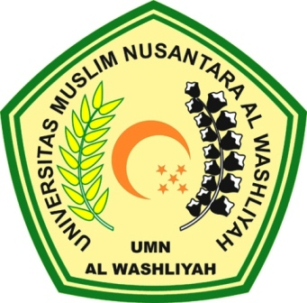

FAKULTAS KEGURUAN DAN ILMU PENDIDIKAN
UNIVERSITAS MUSLIM NUSANTARA AL WASHLIYAH
MEDAN
2020

TEACHING VOCABULARY TO HIGH SCHOOL STUDENTS THROUGH YOU RAISE ME UP SONG

A Thesis
Submitted to the Department of English Language Education in Partial Fulfillment of the Requirements for the Degree of Bachelor of Education

By:

ELISKA YOULANDA
Registration Number : 161244164
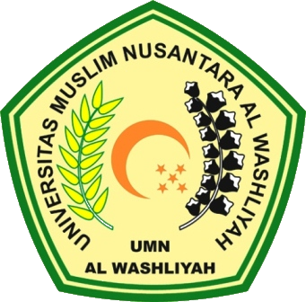

FACULTY OF TEACHER TRAINING AND EDUCATION
UNIVERSITAS MUSLIM NUSANTARA AL WASHLIYAH
MEDAN
2020

