ACKNOWLEDGEMENTS

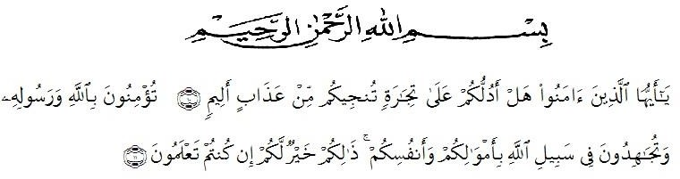
Artinya : “Hai orang –orang yang beriman, sukakah kamu Aku tunjukkan suatu perniagaan yang dapat menyelamatkanmu dari azab yang pedih? ( 10) (yaitu) kamu yang beriman kepada Allah dan Rasulnya dan berjihad di jalan Allah dengan harta dan jiwamu. Itulah yang lebih baik bagimu, jika kamu mengetahui. (11) (as-shaff ayat 10-11)”.
In the name of Allah SWT, the Most Almighty, the Most Gracious and the Most Merciful. Praise to be Allah SWT, firstly the Researcher would like to express thanks to Allah SWT the most Almighty for giving his ideas and inspiration in finishing and completing the thesis. Secondly, bless and peace be upon the prophet Muhammad SAW as the figure of good civilization, intellectual, braveness, and loving knowledge.
This thesis entitled “A Descriptive Study on The Analysis of The Students’ Ability in Writing Procedure Text by Eleventh Grade Students of SMK Al-Washliyah 12 Sei Rampah in academic years 2019-2020” It was not easy for the Researcher in finishing this thesis. There were many difficulties and problems faced by him, physically and mentally. Without helping the following people, it might be impossible for him to finish it. Therefore, the Researcher would like to thank and express his gratitude and appreciation to:

- H. Hardi Mulyono Surbakti S.E., M.AP, the Rector of Universitas Muslim Nusantara Al Washliyah Medan, who had encouraged along his education in UMN AW Medan.
- Drs. Mhd. Ayyub Lubis, M.Pd., Ph.D., the Dean and his staff of FKIP UMN Al Washliyah for the facilities given to him and who has encouraged along his education in UMN AW Medan.
- Zulfitri,S.Pd,M.A the Head of English Education Department of FKIP UMN Al Washliyah who had given suggestion in implementing this research.
- Junaidi,S.Pd,M.Si, the first consultant who never stopped of guiding in the completion this research.
- Rini Fadhillah Putri,S.Pd.,M.Hum., as the second consultant, who has never stopped taking the time, helping in guiding and correcting the pattern of this research.
- All lecturers, especially those of English Education Department for their guidance, advices, suggestions, and encouragements during her academic years at UMN Al Washliyah Medan.
- The Headmaster of SMK AL-WASHLIYAH 12 SEI RAMPAH Academic years 2019-2020 who had given permission for him to conduct this research at that school.
- The Researcher’s beloved father Adi Samudra and my strongest woman Rita Wati Napitupulu who has given every affection, prayer and endless support, and strunggle and sacrifice which has been done for the Researcher so far.

- The Researcher’s teachers of SMP Negeri 4 Sei Rampah who always support and motivate him in finishing his study.
- The Researcher’s best teacher Juanda,S.Pd, who always support, care and helped him in finishing this study. Thanks for the motivation, supports, and experience provided.
- The Researcher’s friends of Nasyid Al-Aski Group who give encourage and support him in finishing his study
- The Researcher’s best friend Siti Hartati,S.Pd, Eva Susan,S.Pd, Silvi Ramadhani,S.Pd, Windi Herdianti Putri,S.Pd, Hafiza Haque Lubis, and Afrahul Khoiroh Siregar who always support and care.
- Finally, for all people whose names cannot mentioned, thank you for everything, may Allah SWT bless us. Aamiin.

Medan,29 April 2020

The Researcher,

Khairul Bakti

