# LAMPIRAN

Lampiran 1. Hasil Determinasi Tumbuhan

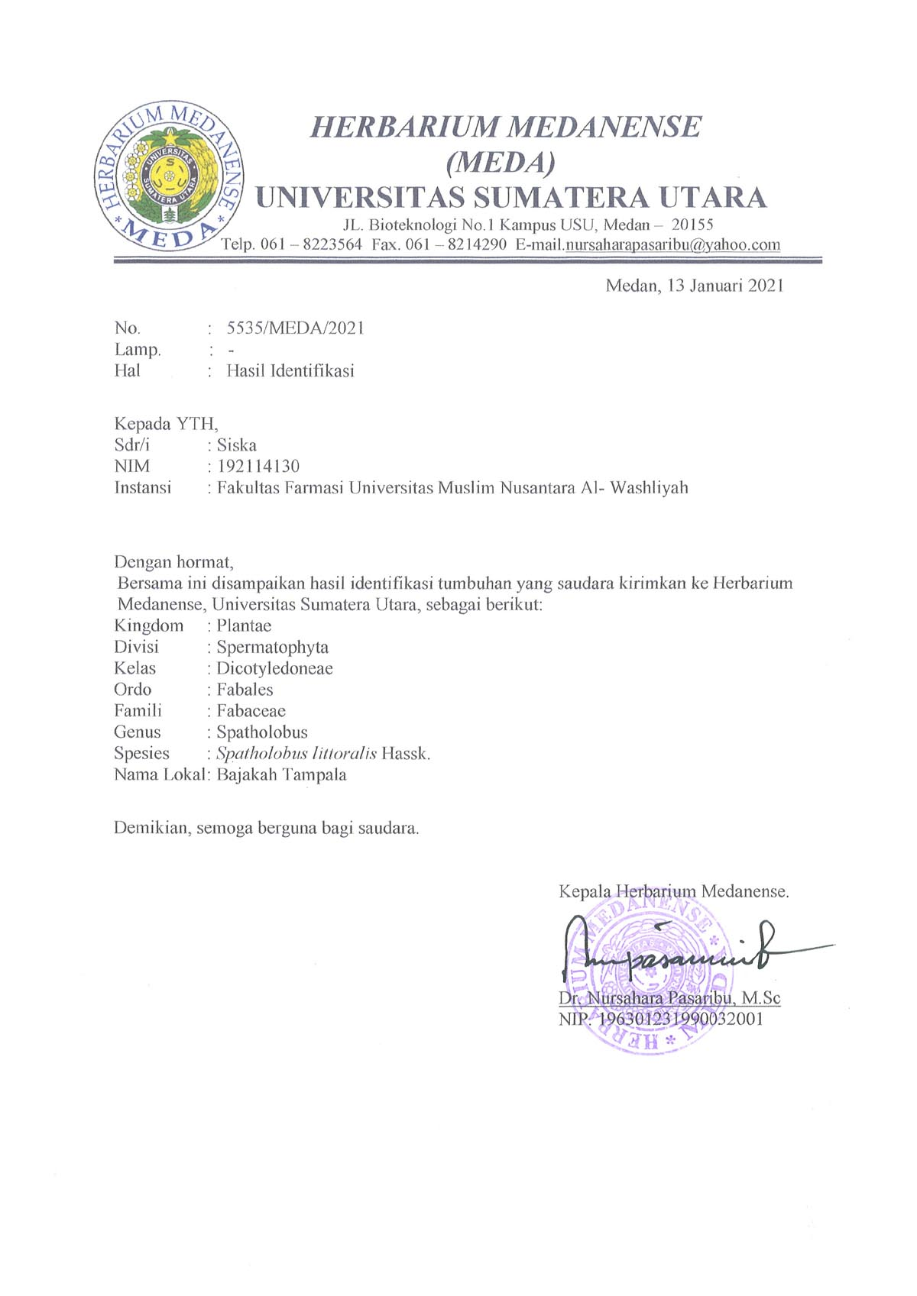

Lampiran 2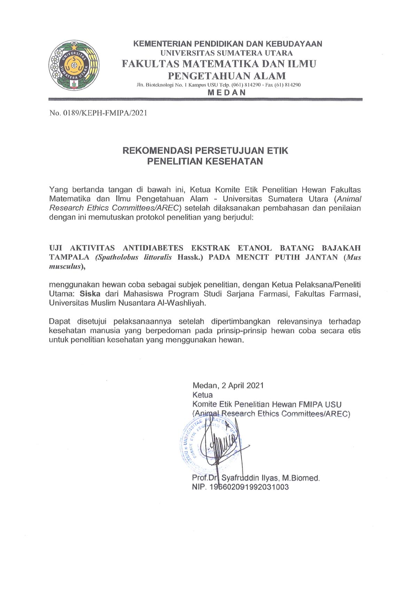. Surat Persetujuan Etik Penelitian Kesehatan

Lampiran 3. Bagan Alir Skrining Fitokimia, Karakterisasi dan Ekstrak

Serbuk Simplisia Batang Bajakah

Serbuk Simplisia Batang Bajakah

Serbuk Simplisia Batang Bajakah

Diperkolasi

Menggunakan

Pelarut etanol

Karakterisasi Simplisia

Skrining Fitokimia

96%

Ekstrak Etanol Batang Bajakah

1. Pemeriksaan Alkaloid
2. Pemeriksaan Flavonoid
3. Pemeriksaan Saponin
4. Pemeriksaan Tanin
5. Pemeriksaan Steroid/Triterpenoid
6. Pemeriksaan Glikosida
7. Makroskopik
8. Mikroskopik
9. Penetapan Kadar Air
10. Penetapan Kadar Sari Larut Dalam Air
11. Penetapan Kadar Sari Larut Dalam Etanol
12. Penetapan Kadar Abu Total
13. Penetapan Kadar Abu Yang Tidak Larut Dalam Asam

Uji Farmakologi

1. Pemeriksaan Alkaloid
2. Pemeriksaan Flavonoid
3. Pemeriksaan Saponin
4. Pemeriksaan Tanin
5. Pemeriksaan Steroid/Triterpenoid
6. Pemeriksaan Glikosida

Lampiran 4. Bagan Alir Pembuatan Ekstrak Etanol Batang Bajakah

Serbuk Simplisia 500 g

Dimasukkan dalam bejana tertutup

Dibasahi dengan cairan penyari etanol 96%, diperkolasi selama 3 jam

Dimasukkan dalam perkolator

Simplisia Basah Dalam Perkolator

Cairan penyari dituangkan sampai simplisia terendam dan terdapat lapisan cairan penyari di atasnya

Perkolator ditutup, dibiarkan

selama 24 jam

Simplisia Terendam Dalam Cairan Penyari

Dibuka kran perkolator dengan kecepatan pengaliran 20 tetes/menit

Perkolasi dihentikan jika cairan penyari sudah tidak berwarna lagi

Ekstrak Etanol Cairair

Diuapkan dengan alat Rotary

Evaporator

Dipekatkan di Waterbath

Ekstrak Etanol Kentalair

Lampiran 5. Bagan Alir Uji Aktivitas Antidiabetes

Mencit

Dikondisikan selama 2 minggu

Dipuasakan selama 18 jam

Ditimbang berat badan

Diukur kadar gula darah puasa dengan cara mengambil darah melalui vena bagian ekor yang ditusuk dengan jarum suntik

Diteteskan darah yang keluar pada test strip yang terpasang pada glucotest

Kadar gula darah puasa (mg/dl)

Diberikan larutan glukosa 50%

Diukur kadar gula darah setelah 30 menit

Mencit diabetes

Diberikan perlakuan secara oral pada setiap kelompok:

1. Diberikan Suspensi Na CMC 0,5%
2. Diberikan Suspensi Glibenklamid 0,01%
3. Diberikan Ekstrak Etanol Batang Bajakah 200 mg/kgBB
4. Diberikan Ekstrak Etanol Batang Bajakah 300 mg/kgBB
5. Diberikan Ekstrak Etanol Batang Bajakah 400 mg/kgBB

Diukur KGD pada mencit ke-60, 90, 120, 150, dan 180

Kadar gula darah mencit (mg/dl)

Lampiran 6. Tumbuhan Batang Bajakah

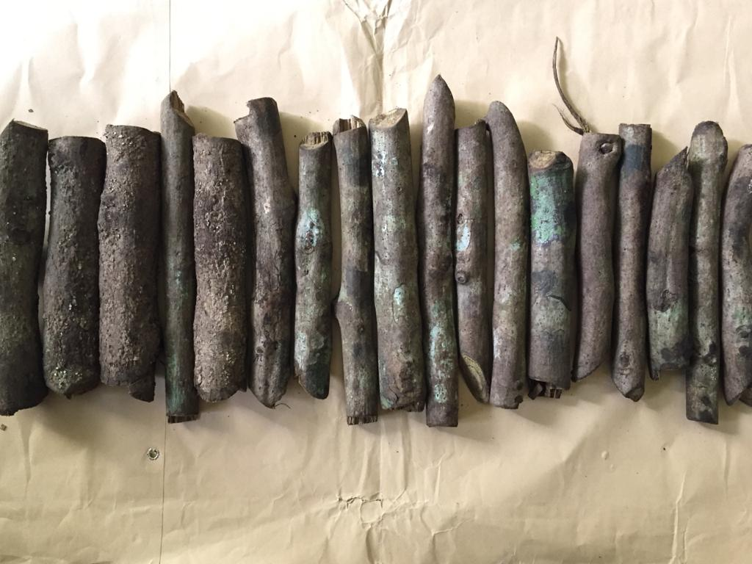

Batang Bajakah Tampala

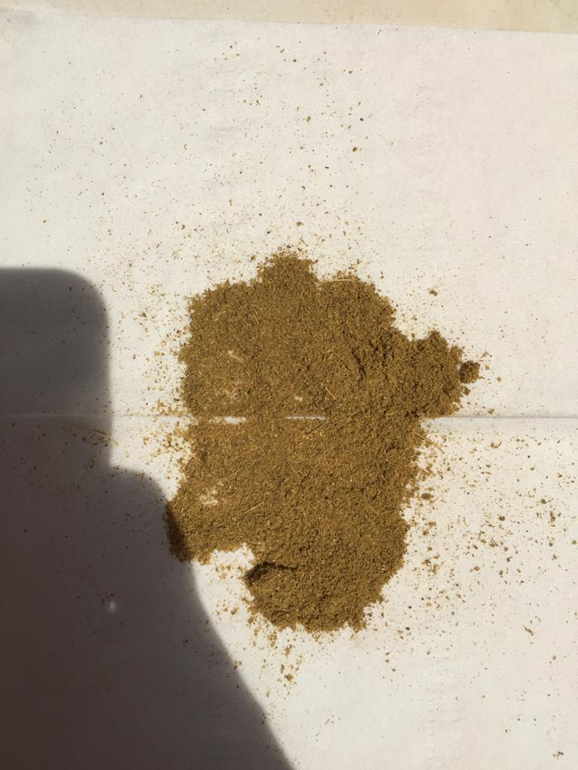

Serbuk Simplisia Batang Bajakah

Lampiran 7. Mikroskopik Batang Bajakah Tampala (*Spatholobus littoralis* Hassk.)

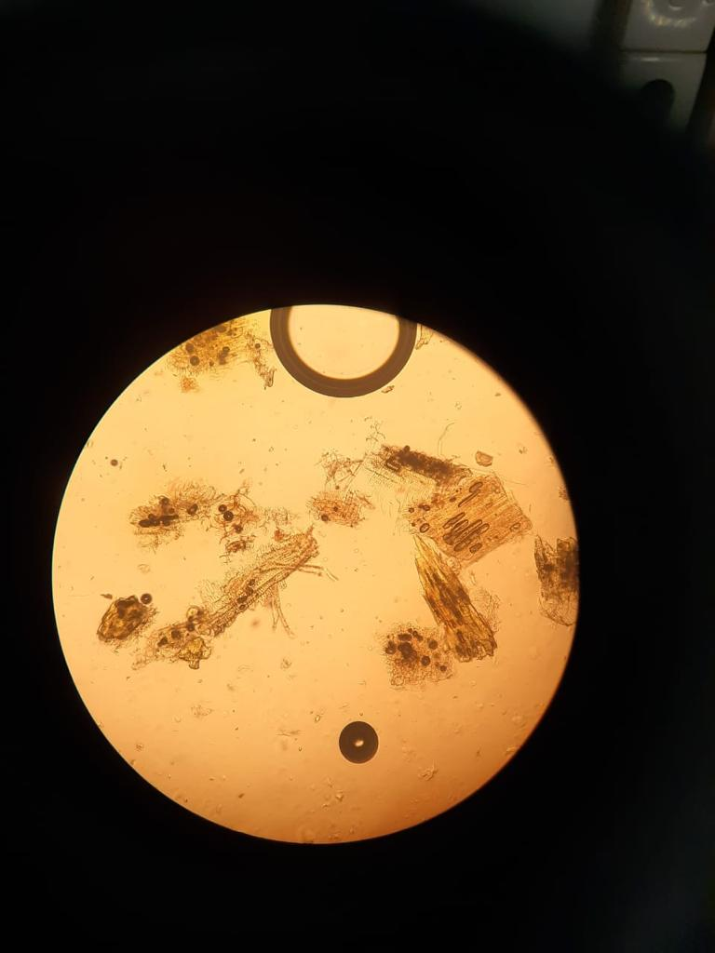

B

D

C

AA

Keterangan gambar

A = Serabut xilem dan pembuluh kayu bernoktah

B = Trikoma (rambut)

C = Serabut xilem

D = Serabut xilem dengan hablur kalsium oksalat

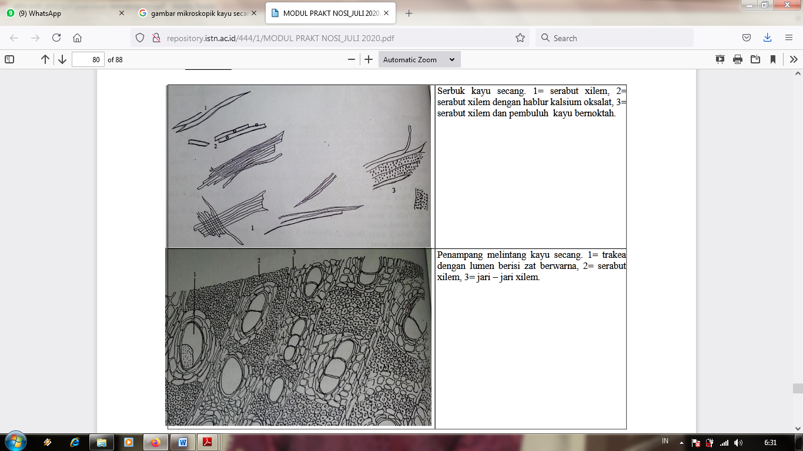

Gambar Mikroskopik Kayu Secang (*Caesalpinia sappan* L.) di MMI (Materia Medika Indonesia)

Lampiran 8. Ekstrak Etanol Batang Bajakah

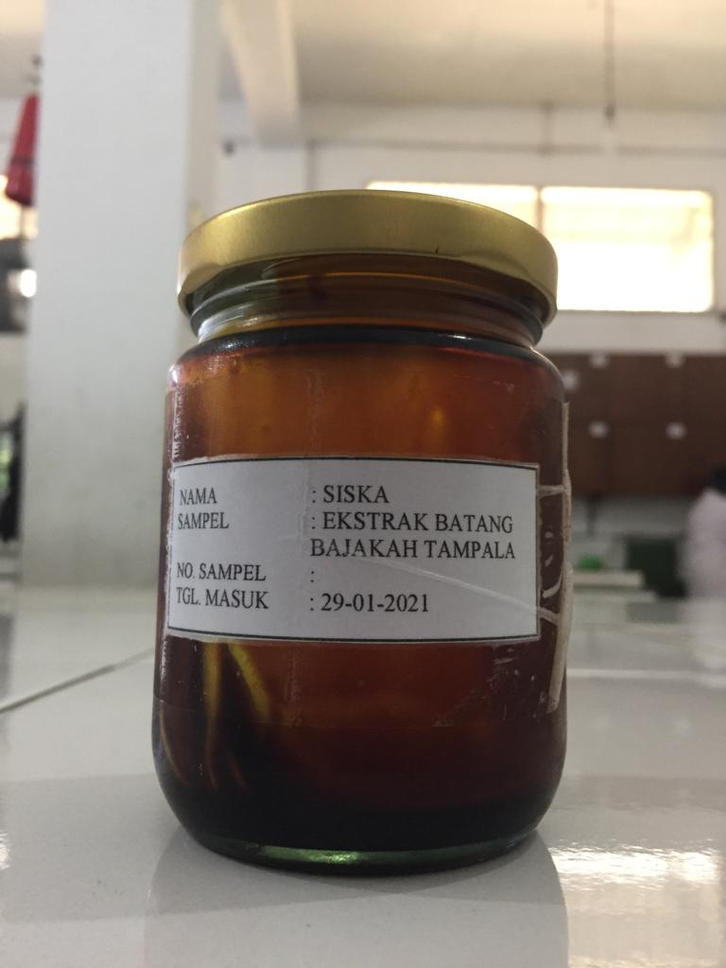

Ekstrak Etanol Batang Bajakah

Lampiran 9. Alat Rotary Evaporator dan Alat Azeotrop

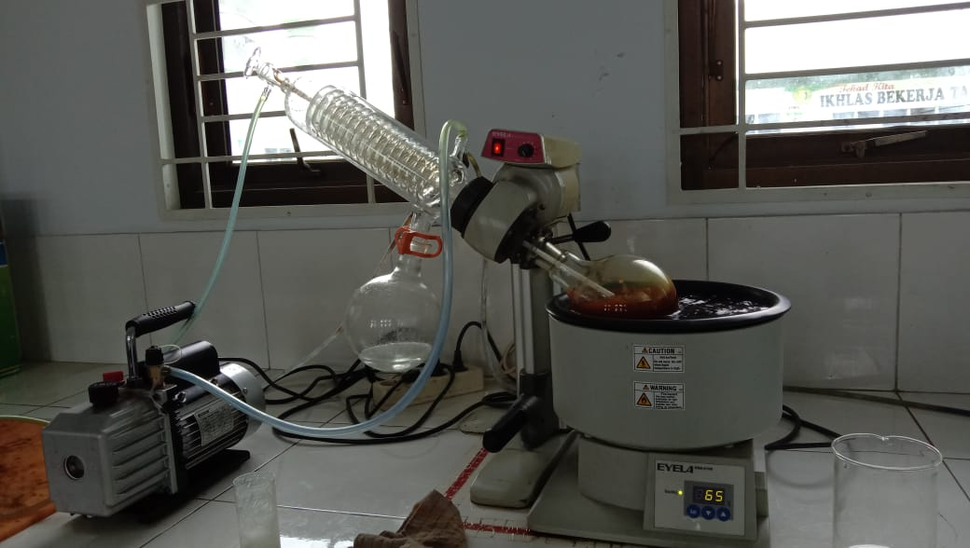

Alat Rotary Evaporator

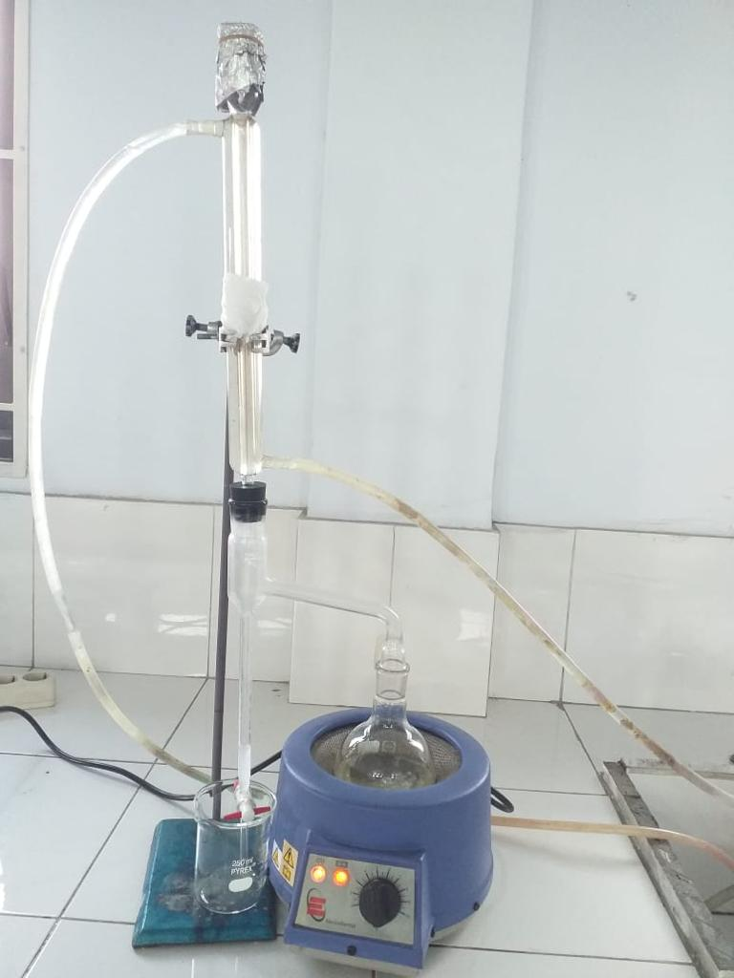

Alat Azeotrop

Lampiran 10. Perlakuan dengan Mencit

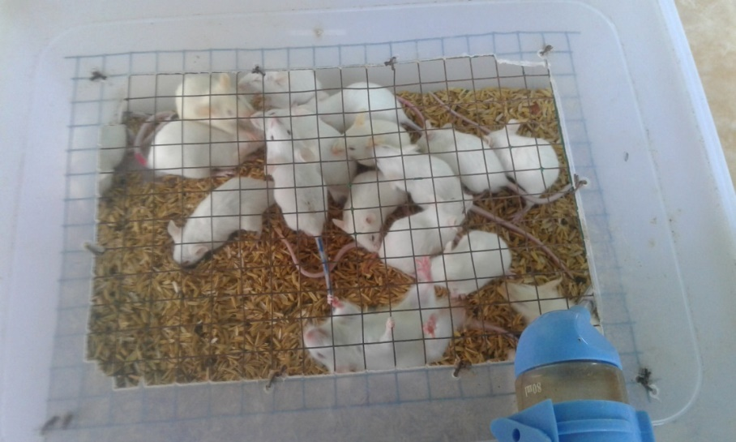

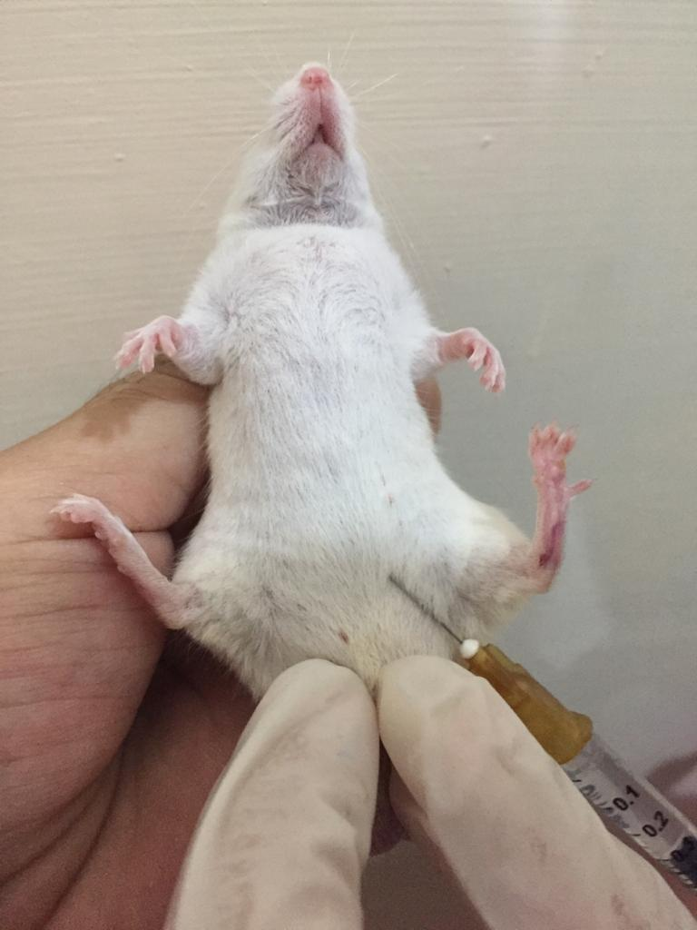

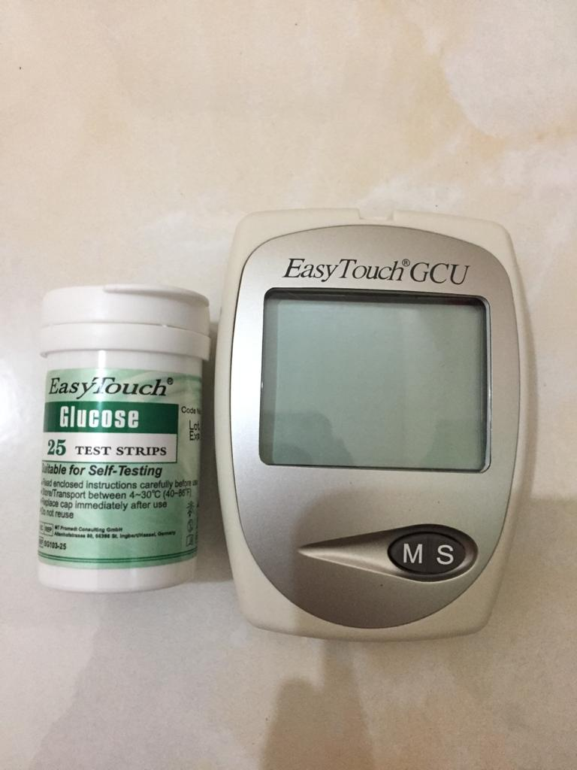

Alat Glukotest Easy Touch

Lampiran 11. Tabel Konversi Dosis dan Tabel Volume Maksimum Lambung Pada Hewan

Tabel konversi Dosis

|  |  |  |  |  |  |  |  |  |
| --- | --- | --- | --- | --- | --- | --- | --- | --- |
| Dicari  Diketahui | Mencit20 g | Tikus  200 g | Marmut  400 g | Kelinci  1,5 kg | Kucing  1,5 kg | Kera  4 kg | Anjing  12 kg | Manusia  70 kg |
| Mencit  20 g | 1,0 | 7,0 | 12,23 | 27,80 | 29,7 | 64,10 | 124,20 | 387,9 |
| Tikus  200 g | 0,14 | 1,0 | 1,74 | 3,9 | 4,20 | 9,20 | 17,80 | 56,0 |
| Marmut  400 g | 0,08 | 0,57 | 1,0 | 2,25 | 2,40 | 5,20 | 10,20 | 31,50 |
| Kelinci  1,5 kg | 0,04 | 0,25 | 0,44 | 1,0 | 1,08 | 2,40 | 4,50 | 14,20 |
| Kucing  1,5 kg | 0,03 | 0,23 | 0,41 | 0,91 | 1,0 | 2,20 | 4,10 | 13,0 |
| Kera  4 kg | 0,016 | 0,11 | 0,19 | 0,42 | 0,43 | 0,1 | 1,9 | 6,1 |
| Anjing  12 kg | 0,008 | 0,06 | 0,10 | 0,22 | 1,24 | 0,52 | 1,0 | 3,10 |
| Manusia  70 kg | 0,0026 | 0,018 | 0,31 | 0,07 | 0,076 | 0,16 | 0,32 | 1,0 |

Tabel Volume Maksimum lambung pada hewan (ml)

|  |  |  |  |  |  |
| --- | --- | --- | --- | --- | --- |
| Jenis Hewan Uji | Volume maksimum (ml) sesuai jalur pemberian | | | | |
| i.v | i.m | i.p | s.c | p.o |
| Mencit (20-30 g) | 0,05 | 0,05 | 1,0 | 0,5-1,0 | 1,0 |
| Tikus (200 g) | 0,1 | 0,1 | 2-5 | 2-5 | 5,0 |
| Hamster (50 g) | 0,1 | 0,1 | 1-2 | 2,5 | 2,5 |
| Marmut (250 g) | 0,25 | 0,25 | 2-5 | 5,0 | 10,0 |
| Kelinci (3 kg) | 0,5 | 0,5 | 10-20 | 5-10 | 20.0 |
| Kucing (3 kg) | 1,0 | 1,0 | 10-20 | 5-10 | 50,0 |
| Anjing (5 kg) | 5,0 | 5,0 | 20-50 | 10,0 | 100,0 |

Lampiran 12. Perhitungan Dosis

1. Perhitungan konversi dosis glibenklamid 0,01%

Dosis terapi glibenklamid pada manusia = 5 mg

Korelasi dosis mencit x dosis Glibenklamid untuk manusia (5mg)

Dosis glibenklamid pada mencit (bobot 20 g = 0,0026 x 5 mg = 0,013 mg)

Maka :

Mencit (20 g) = $\frac{0,013 mg}{0,02 kg}$ = 0,65 mg/kg BB

Dosis = $\frac{0,65 mg}{1000 g}$ x 20 g = 0,013 mg

Konsentrasi Suspensi glibenklamid 0,01% = $\frac{0,01 g}{100 ml}$ = $\frac{10 mg}{100 ml}$ = 0,1 mg/ml

Volume suspensi glibenklamid yang diberikan = $\frac{Dosis }{Konsentrasi }$ = $\frac{0,013 mg}{0,1 mg/ml }$ = 0,13 ml

1. Perhitungan dosis suspensi Na CMC 0,5%

CMC 0,5% = jumlah cmc / volume suspensi

= 0,5 g / 100 ml

= 500 mg / 100 ml

Perhitungan untuk 1 ekor mencit

$\frac{50 mg}{10 ml}$ = 5 mg/ml

$\frac{50 mg}{1000 g}$ x 20 g = 1 mg

Volume yang diberikan = $\frac{1 mg}{5 mg/ml}$ = 0,2 ml

1. Perhitungan suspensi Ekstrak Etanol Batang Bajakah (EEBB) 2%
   1. Dosis 200 mg/kgBB

$\frac{200 mg}{1000 g}$ X 20 g = 4 mg

Konsentrasi ekstrak 2% = $\frac{2 g}{100 ml}$ = $\frac{2000 mg}{100 ml}$ = 20 mg/ml

**Lampiran 12.** (lanjutan)

Volume suspensi ekstrak yang diberikan = = 0,2 ml

* 1. Dosis 300 mg/kgBB

$\frac{300 mg}{1000 g}$ X 20 g = 6 mg

Konsentrasi ekstrak 2% = $\frac{2 g}{100 ml}$ = $\frac{2000 mg}{100 ml}$ = 20 mg/ml

Volume suspensi ekstrak yang diberikan = = 0,3 ml

* 1. Dosis 400 mg/kgBB

$\frac{400 mg}{1000 g}$ X 20 g = 8 mg

Konsentrasi ekstrak 2% = $\frac{2 g}{100 ml}$ = $\frac{2000 mg}{100 ml}$ = 20 mg/ml

Volume suspensi ekstrak yang diberikan = $\frac{8 mg}{20 mg/ml}$ = 0,4 ml

1. Perhitungan suspensi Glukosa 50%

Glukosa 50% = $\frac{50 g}{100 ml}$ = $\frac{50000 mg}{100 ml}$

Perhitungan untuk 1 ekor mencit

$\frac{5000 mg}{10 ml}$ = 500 mg/ml

$\frac{5000 mg}{1000 g}$ X 20 g = 100 mg

Volume yang diberikan = $\frac{100 mg}{500 mg/ml}$ = 0,2 ml

**Lampiran 12.** (lanjutan)

1. Contoh Perhitungan Dosis Ekstrak Untuk Manusia

Dosis absolut mencit 20 gr = 400 mg/kgBB x 0,02 kg

= 8 mg

Dosis Manusia = 8 mg x 387,9

= 3103,2 mg

Untuk Manusia = 3103,2 mg / 70 kg

= 44,33 mg/kgBB

Lampiran 13. Tabel Data Hasil Pengukuran Rata-rata Kadar Gula Darah Mencit Putih Jantan

|  |  |  |  |  |  |  |  |  |
| --- | --- | --- | --- | --- | --- | --- | --- | --- |
| **Kel** | **BB**  **Mencit**  **(g)** | **KGD**  **Puasa**  **(mg/dl)** | **KGD**  **Setelah**  **30**  **Menit**  **Pemberian**  **Larutan**  **Gluosa**  **50%**  **(mg/dl)** | **KGD setelah perlakuan berdasarkan waktu**  **(mg/dl)** | | | | |
| **60** | **90** | **120** | **150** | **180** |
| I | 20 | 132 | 260 | 230 | 194 | 185 | 165 | 146 |
| 30 | 126 | 236 | 210 | 190 | 179 | 156 | 149 |
| 25 | 127 | 240 | 212 | 192 | 187 | 170 | 154 |
| 31 | 128 | 250 | 230 | 195 | 180 | 163 | 150 |
| 20 | 124 | 260 | 235 | 200 | 190 | 184 | 162 |
| SD | | 637 | 1246 | 1117 | 971 | 921 | 838 | 761 |
| Rata-rata | | 127,4 | 249,2 | 223,4 | 194,2 | 184,2 | 167,6 | 152,2 |
| II | 33 | 130 | 387 | 196 | 182 | 150 | 120 | 102 |
| 33 | 128 | 242 | 182 | 175 | 169 | 130 | 98 |
| 34 | 130 | 321 | 190 | 160 | 129 | 120 | 106 |
| 34 | 125 | 321 | 196 | 175 | 150 | 120 | 106 |
| 30 | 129 | 242 | 190 | 160 | 150 | 120 | 98 |
| SD | | 642 | 1513 | 954 | 852 | 748 | 610 | 510 |
| Rata-rata | | 128,4 | 302,6 | 190,8 | 170,4 | 149,6 | 122 | 102 |
| III | 29 | 126 | 321 | 198 | 185 | 156 | 123 | 103 |
| 28 | 125 | 290 | 190 | 175 | 140 | 103 | 95 |
| 26 | 122 | 242 | 194 | 187 | 144 | 114 | 104 |
| 27 | 126 | 300 | 194 | 172 | 156 | 114 | 102 |
| 29 | 125 | 320 | 198 | 182 | 144 | 123 | 104 |
| SD | | 624 | 1473 | 974 | 901 | 740 | 577 | 508 |
| Rata-rata | | 124,8 | 294,6 | 194,8 | 180,2 | 148 | 115,4 | 101,6 |
| IV | 25 | 128 | 292 | 195 | 180 | 142 | 112 | 95 |
| 23 | 120 | 310 | 189 | 156 | 129 | 93 | 89 |
| 30 | 132 | 316 | 184 | 175 | 130 | 106 | 100 |
| 29 | 130 | 315 | 189 | 170 | 142 | 112 | 93 |
| 27 | 122 | 310 | 186 | 180 | 140 | 100 | 90 |
| SD | | 632 | 1543 | 943 | 861 | 683 | 523 | 467 |
| Rata-rata | | 126,4 | 308,6 | 188,6 | 172,2 | 136,6 | 104,6 | 93,4 |
| V | 27 | 122 | 318 | 187 | 160 | 132 | 108 | 89 |
| 25 | 127 | 305 | 179 | 135 | 115 | 85 | 79 |
| 29 | 125 | 212 | 179 | 158 | 123 | 90 | 85 |
| 30 | 128 | 325 | 170 | 158 | 132 | 90 | 79 |
| 28 | 126 | 295 | 172 | 156 | 123 | 92 | 85 |
| SD | | 628 | 1455 | 887 | 767 | 625 | 465 | 417 |
| Rata-rata | | 125,6 | 291 | 177,4 | 153,4 | 125 | 93 | 83,4 |

Lampiran 14. Data Karakterisasi Serbuk Simplisia Batang Bajakah

1. Perhitungan Hasil Penetapan Kadar Air (Tidak lebih dari 10%)

$$Kadar Air :\frac{volume II-Volume I}{Berat Sampel}×100 \%$$

Sampel I

Berat sampel : 5 g

Volume I : 1,5 ml

Volume II : 1,9 ml

= $\frac{1,9 ml-1,5 ml}{5 g}$ x 100%

$=8 \%$

Sampel II

Berat sampel : 5 g

Volume I : 1,8 ml

Volume II : 2,2 ml

= $\frac{2,2 ml-1,8 ml}{5 g}$ x 100%

$=8 \%$

Sampel III

Berat sampel : 5 g

Volume I : 1,7 ml

Volume II : 2 ml

= $\frac{2 ml-1,7 ml}{5 g}$ x 100%

$=6 \%$

Kadar air rata-rata: = $\frac{8 \%+8 \%+6 \%}{3}$ = 7,3 %

Kadar air pada batang bajakah memenuhi syarat yaitu 7,3%, sedangkan syarat nya tidak lebih dari 10%.

**Lampiran 14. (**lanjutan)

1. Perhitungan Kadar Sari Larut dalam Air (Tidak Kurang dari 9%)

$$Kadar Sari Larut Air=\frac{Berat sari x Faktor pengenceran}{Berat sampel}×100\%$$

Sampel 1

Berat sampel : 5 g

Berat cawan kosong : 61,24 g

Berat cawan $+$ sampel : 61,35 g

= $\frac{\left(61,35 g-61,24 g\right)×5}{5 g}$ x 100%

= $\frac{0,11 g ×5 }{5 g}$ x 100% = 11 %

Sampel II

Berat sampel : 5 g

Berat cawan kosong : 69,34 g

Beratcawan $+$ sampel : 69,48 g

= $\frac{\left(69,48 g-64,34 g \right)×5}{5 g}$ x 100%

= $\frac{0,14 g x 5}{5 g}$ x 100% = 14 %

Sampel III

Berat sampel : 5 g

Berat cawan kosong : 57,73 g

Berat cawan $+$ sampel : 57,88 g

= $\frac{\left(57,88 g-57,73 g\right)×5}{5 g}$ x 100%

= $\frac{0,15 g x 5}{5 g}$ x 100% = 15 %

Kadar sari larut dalam air rata-rata: = $\frac{11\%+14 \%+15 \%}{3}$ = 13,3%

Kadar sari larut dalam air pada batang bajakah memenuhi syarat yaitu 13,3%, sedangkan syarat nya tidak kurang dari 9%.

**Lampiran 14. (**lanjutan)

1. Perhitungan Kadar Sari Larut Etanol (Tidak kurang dari 7%)

$$Kadar Sari Larut Etanol=\frac{Berat sari x Faktor pengenceran}{Berat sampel}×100\%$$

Sampel I

Berat sampel : 5 g

Berat cawan kosong : 68,11 g

Berat cawan $+$ sampel : 68,25 g

= $\frac{(0,14 g) ×5}{5 g}$ x 100% = 14 %

Sampel II

Berat sampel : 5 g

Berat cawan kosong : 68,14g

Berat cawan $+$ sampel : 68,30 g

= $\frac{\left( 0,16 g\right)×5}{5 g}$ x 100% = 16 %

Sampel III

Berat sampel : 5 g

Berat cawan kosong : 68,13 g

Berat cawan $+$ sampel : 68,31 g

= $\frac{\left(0,18 g\right)×5}{5 g}$ x 100% = 18 %

Kadar sari larut dalam etanol rata-rata: = $\frac{14\%+16\%+18\%}{3}$ = 16 %

Kadar sari larut dalam etanol pada batang bajakah memenuhi syarat yaitu 16%, sedangkan syarat nya tidak kurang dari 7%.

**Lampiran 14.** (lanjutan)

1. Perhitungan Penetapan Kadar Abu (Tidak lebih dari 10%)

Kadar Abu = $\frac{Berat abu (g)}{Berat sampel (g)}×100 \%$

Sampel I

Berat sampel : 2 g

Berat Abu : 0,08 g

Kadar abu total = $\frac{0,08 g}{2 g}$ x 100% = 4 %

Sampel II

Berat sampel : 2 g

Berat Abu : 0,05 g

Kadar abu total = $\frac{0,05 g}{2 g}$ x 100% = 2,5 %

Sampel III

Berat sampel : 2 g

Berat Abu : 0,06 g

Kadar abu total = $\frac{0,06 g}{2 g}$ x 100% = 3%

Kadar abu total rata-rata = $\frac{4+2,5 \% +3 \%}{3}$ = 3,17 %

Kadar abu total pada batang bajakah memenuhi syarat yaitu 3,17 %, sedangkan syarat nya tidak lebih dari 10%.

**Lampiran 14.** (lanjutan)

1. Perhitungan Kadar Abu Tidak Larut Asam (Tidak lebih dari 1%)

Kadar abu tidak larut asam = $\frac{Berat abu larut asam (g)}{Berat sampel}×100 \%$

Sampel I

Berat sampel : 2 g

Berat Abu : 0,01 g

= $\frac{0,01 g}{2 g}$ x 100% = 0,5 %

Sampel ll

Berat sampel : 2 g

Berat Abu : 0,01

= $\frac{0,01 g}{2g}$ x 100% = 0,5%

Sampel III

Berat sampel : 2 g

Berat Abu : 63,84 g

= $\frac{0,01 g}{2 g}$ x 100% = 0,5 %

Kadar abu tidak larut dalam asam rata-rata = $\frac{0,5 \% +0,5\% +0,5 \% }{3}$ = 0,5 %

Kadar abu tidak larut dalam asam pada batang bajakah memenuhi syarat yaitu 0,5 %, sedangkan syarat nya tidak lebih dari 1%.

Lampiran 15. Hasil Descriptives

|  |  |  |  |  |  |  |  |  |  |
| --- | --- | --- | --- | --- | --- | --- | --- | --- | --- |
| **Descriptives** | | | | | | | | | |
|  | | N | Mean | Std. Deviation | Std. Error | 95% Confidence Interval for Mean | | Minimum | Maximum |
| Lower Bound | Upper Bound |
| Menit60 | 1 | 5 | 223.4000 | 11.52389 | 5.15364 | 209.0912 | 237.7088 | 210.00 | 235.00 |
| 2 | 5 | 190.8000 | 5.76194 | 2.57682 | 183.6456 | 197.9544 | 182.00 | 196.00 |
| 3 | 5 | 194.8000 | 3.34664 | 1.49666 | 190.6446 | 198.9554 | 190.00 | 198.00 |
| 4 | 5 | 188.6000 | 4.15933 | 1.86011 | 183.4355 | 193.7645 | 184.00 | 195.00 |
| 5 | 5 | 177.4000 | 6.73053 | 3.00998 | 169.0429 | 185.7571 | 170.00 | 187.00 |
| Total | 25 | 195.0000 | 16.87454 | 3.37491 | 188.0345 | 201.9655 | 170.00 | 235.00 |
| Menit90 | 1 | 5 | 194.2000 | 3.76829 | 1.68523 | 189.5211 | 198.8789 | 190.00 | 200.00 |
| 2 | 5 | 170.4000 | 9.91464 | 4.43396 | 158.0894 | 182.7106 | 160.00 | 182.00 |
| 3 | 5 | 180.2000 | 6.45755 | 2.88791 | 172.1819 | 188.2181 | 172.00 | 187.00 |
| 4 | 5 | 172.2000 | 9.95992 | 4.45421 | 159.8331 | 184.5669 | 156.00 | 180.00 |
| 5 | 5 | 153.4000 | 10.38268 | 4.64327 | 140.5082 | 166.2918 | 135.00 | 160.00 |
| Total | 25 | 174.0800 | 15.65226 | 3.13045 | 167.6191 | 180.5409 | 135.00 | 200.00 |
| Menit120 | 1 | 5 | 184.2000 | 4.65833 | 2.08327 | 178.4159 | 189.9841 | 179.00 | 190.00 |
| 2 | 5 | 149.6000 | 14.15274 | 6.32930 | 132.0271 | 167.1729 | 129.00 | 169.00 |
| 3 | 5 | 148.0000 | 7.48331 | 3.34664 | 138.7082 | 157.2918 | 140.00 | 156.00 |
| 4 | 5 | 136.6000 | 6.54217 | 2.92575 | 128.4768 | 144.7232 | 129.00 | 142.00 |
| 5 | 5 | 125.0000 | 7.17635 | 3.20936 | 116.0894 | 133.9106 | 115.00 | 132.00 |
| Total | 25 | 148.6800 | 21.73461 | 4.34692 | 139.7084 | 157.6516 | 115.00 | 190.00 |
| Menit150 | 1 | 5 | 167.6000 | 10.45466 | 4.67547 | 154.6188 | 180.5812 | 156.00 | 184.00 |
| 2 | 5 | 122.0000 | 4.47214 | 2.00000 | 116.4471 | 127.5529 | 120.00 | 130.00 |
| 3 | 5 | 115.4000 | 8.26438 | 3.69594 | 105.1384 | 125.6616 | 103.00 | 123.00 |
| 4 | 5 | 104.6000 | 8.17313 | 3.65513 | 94.4517 | 114.7483 | 93.00 | 112.00 |
| 5 | 5 | 93.0000 | 8.77496 | 3.92428 | 82.1044 | 103.8956 | 85.00 | 108.00 |
| Total | 25 | 120.5200 | 27.11414 | 5.42283 | 109.3278 | 131.7122 | 85.00 | 184.00 |
| Menit180 | 1 | 5 | 152.2000 | 6.18061 | 2.76405 | 144.5258 | 159.8742 | 146.00 | 162.00 |
| 2 | 5 | 102.0000 | 4.00000 | 1.78885 | 97.0333 | 106.9667 | 98.00 | 106.00 |
| 3 | 5 | 101.6000 | 3.78153 | 1.69115 | 96.9046 | 106.2954 | 95.00 | 104.00 |
| 4 | 5 | 93.4000 | 4.39318 | 1.96469 | 87.9452 | 98.8548 | 89.00 | 100.00 |
| 5 | 5 | 83.4000 | 4.33590 | 1.93907 | 78.0163 | 88.7837 | 79.00 | 89.00 |
| Total | 25 | 106.5200 | 24.67813 | 4.93563 | 96.3334 | 116.7066 | 79.00 | 162.00 |

Lampiran 16. Hasil Homogenitas

|  |  |  |  |  |
| --- | --- | --- | --- | --- |
| **Test of Homogeneity of Variances** | | | | |
|  | Levene Statistic | df1 | df2 | Sig. |
| Menit60 | 5.040 | 4 | 20 | .006 |
| Menit90 | 1.358 | 4 | 20 | .284 |
| Menit120 | .469 | 4 | 20 | .758 |
| Menit150 | .563 | 4 | 20 | .692 |
| Menit180 | .463 | 4 | 20 | .762 |

Lampiran 17. Hasil Anova

|  |  |  |  |  |  |  |
| --- | --- | --- | --- | --- | --- | --- |
| **ANOVA** | | | | | | |
|  | | Sum of Squares | df | Mean Square | F | Sig. |
| Menit60 | Between Groups | 5874.800 | 4 | 1468.700 | 30.623 | .000 |
| Within Groups | 959.200 | 20 | 47.960 |  |  |
| Total | 6834.000 | 24 |  |  |  |
| Menit90 | Between Groups | 4435.040 | 4 | 1108.760 | 15.348 | .000 |
| Within Groups | 1444.800 | 20 | 72.240 |  |  |
| Total | 5879.840 | 24 |  |  |  |
| Menit120 | Between Groups | 9848.240 | 4 | 2462.060 | 33.066 | .000 |
| Within Groups | 1489.200 | 20 | 74.460 |  |  |
| Total | 11337.440 | 24 |  |  |  |
| Menit150 | Between Groups | 16278.640 | 4 | 4069.660 | 59.603 | .000 |
| Within Groups | 1365.600 | 20 | 68.280 |  |  |
| Total | 17644.240 | 24 |  |  |  |
| Menit180 | Between Groups | 14189.840 | 4 | 3547.460 | 166.391 | .000 |
| Within Groups | 426.400 | 20 | 21.320 |  |  |
| Total | 14616.240 | 24 |  |  |  |

Lampiran 18. Hasil Tukey

|  |  |  |  |  |
| --- | --- | --- | --- | --- |
| **Menit60** | | | | |
| Tukey HSD | | | | |
| Perlakuan | N | Subset for alpha = 0.05 | | |
| 1 | 2 | 3 |
| EEBB 400 mg/kgBB | 5 | 177.4000 |  |  |
| EEBB 300 mg/kgBB | 5 | 188.6000 | 188.6000 |  |
| Glibenklamid 0,01% | 5 |  | 190.8000 |  |
| EEBB 200 mg/kgBB | 5 |  | 194.8000 |  |
| CMC 0,5 % | 5 |  |  | 223.4000 |
| Sig. |  | .117 | .625 | 1.000 |
| Means for groups in homogeneous subsets are displayed. | | | | |
| a. Uses Harmonic Mean Sample Size = 5.000. | | | | |

|  |  |  |  |  |
| --- | --- | --- | --- | --- |
| **Menit90** | | | | |
| Tukey HSD | | | | |
| Perlakuan | N | Subset for alpha = 0.05 | | |
| 1 | 2 | 3 |
| EEBB 400 mg/kgBB | 5 | 153.4000 |  |  |
| Glibenklamid 0,01% | 5 |  | 170.4000 |  |
| EEBB 300 mg/kgBB | 5 |  | 172.2000 |  |
| EEBB 200 mg/kgBB | 5 |  | 180.2000 | 180.2000 |
| CMC 0,5 % | 5 |  |  | 194.2000 |
| Sig. |  | 1.000 | .389 | .107 |
| Means for groups in homogeneous subsets are displayed. | | | | |
| a. Uses Harmonic Mean Sample Size = 5.000. | | | | |

|  |  |  |  |  |
| --- | --- | --- | --- | --- |
| **Menit120** | | | | |
| Tukey HSD | | | | |
| Perlakuan | N | Subset for alpha = 0.05 | | |
| 1 | 2 | 3 |
| EEBB 400 mg/kgBB | 5 | 125.0000 |  |  |
| EEBB 300 mg/kgBB | 5 | 136.6000 | 136.6000 |  |
| EEBB 200 mg/kgBB | 5 |  | 148.0000 |  |
| Glibenklamid 0,01% | 5 |  | 149.6000 |  |
| CMC 0,5 % | 5 |  |  | 184.2000 |
| Sig. |  | .248 | .161 | 1.000 |
| Means for groups in homogeneous subsets are displayed. | | | | |
| a. Uses Harmonic Mean Sample Size = 5.000. | | | | |

|  |  |  |  |  |  |
| --- | --- | --- | --- | --- | --- |
| **Menit150** | | | | | |
| Tukey HSD | | | | | |
| Perlakuan | N | Subset for alpha = 0.05 | | | |
| 1 | 2 | 3 | 4 |
| EEBB 400 mg/kgBB | 5 | 93.0000 |  |  |  |
| EEBB 300 mg/kgBB | 5 | 104.6000 | 104.6000 |  |  |
| EEBB 200 mg/kgBB | 5 |  | 115.4000 | 115.4000 |  |
| Glibenklamid 0,01% | 5 |  |  | 122.0000 |  |
| CMC 0,5 % | 5 |  |  |  | 167.6000 |
| Sig. |  | .213 | .272 | .716 | 1.000 |
| Means for groups in homogeneous subsets are displayed. | | | | | |
| a. Uses Harmonic Mean Sample Size = 5.000. | | | | | |

|  |  |  |  |  |
| --- | --- | --- | --- | --- |
| **Menit180** | | | | |
| Tukey HSD | | | | |
| Perlakuan | N | Subset for alpha = 0.05 | | |
| 1 | 2 | 3 |
| EEBB 400 mg/kgBB | 5 | 83.4000 |  |  |
| EEBB 300 mg/kgBB | 5 |  | 93.4000 |  |
| EEBB 200 mg/kgBB | 5 |  | 101.6000 |  |
| Glibenklamid 0,01% | 5 |  | 102.0000 |  |
| CMC 0,5 % | 5 |  |  | 152.2000 |
| Sig. |  | 1.000 | .055 | 1.000 |
| Means for groups in homogeneous subsets are displayed. | | | | |
| a. Uses Harmonic Mean Sample Size = 5.000. | | | | |

Lampiran 19. Hasil Multiple Comparisons

|  |  |  |  |  |  |  |  |
| --- | --- | --- | --- | --- | --- | --- | --- |
| **Multiple Comparisons** | | | | | | | |
| Tukey HSD | | | | | | | |
| Dependent Variable | (I) Perlakuan | (J) Perlakuan | Mean Difference (I-J) | Std. Error | Sig. | 95% Confidence Interval | |
| Lower Bound | Upper Bound |
| Menit60 | 1 | 2 | 32.60000* | 4.37995 | .000 | 19.4935 | 45.7065 |
| 3 | 28.60000* | 4.37995 | .000 | 15.4935 | 41.7065 |
| 4 | 34.80000* | 4.37995 | .000 | 21.6935 | 47.9065 |
| 5 | 46.00000* | 4.37995 | .000 | 32.8935 | 59.1065 |
| 2 | 1 | -32.60000* | 4.37995 | .000 | -45.7065 | -19.4935 |
| 3 | -4.00000 | 4.37995 | .888 | -17.1065 | 9.1065 |
| 4 | 2.20000 | 4.37995 | .986 | -10.9065 | 15.3065 |
| 5 | 13.40000* | 4.37995 | .044 | .2935 | 26.5065 |
| 3 | 1 | -28.60000* | 4.37995 | .000 | -41.7065 | -15.4935 |
| 2 | 4.00000 | 4.37995 | .888 | -9.1065 | 17.1065 |
| 4 | 6.20000 | 4.37995 | .625 | -6.9065 | 19.3065 |
| 5 | 17.40000* | 4.37995 | .006 | 4.2935 | 30.5065 |
| 4 | 1 | -34.80000* | 4.37995 | .000 | -47.9065 | -21.6935 |
| 2 | -2.20000 | 4.37995 | .986 | -15.3065 | 10.9065 |
| 3 | -6.20000 | 4.37995 | .625 | -19.3065 | 6.9065 |
| 5 | 11.20000 | 4.37995 | .117 | -1.9065 | 24.3065 |
| 5 | 1 | -46.00000* | 4.37995 | .000 | -59.1065 | -32.8935 |
| 2 | -13.40000* | 4.37995 | .044 | -26.5065 | -.2935 |
| 3 | -17.40000* | 4.37995 | .006 | -30.5065 | -4.2935 |
| 4 | -11.20000 | 4.37995 | .117 | -24.3065 | 1.9065 |
| Menit90 | 1 | 2 | 23.80000* | 5.37550 | .002 | 7.7145 | 39.8855 |
| 3 | 14.00000 | 5.37550 | .107 | -2.0855 | 30.0855 |
| 4 | 22.00000* | 5.37550 | .005 | 5.9145 | 38.0855 |
| 5 | 40.80000* | 5.37550 | .000 | 24.7145 | 56.8855 |
| 2 | 1 | -23.80000* | 5.37550 | .002 | -39.8855 | -7.7145 |
| 3 | -9.80000 | 5.37550 | .389 | -25.8855 | 6.2855 |
| 4 | -1.80000 | 5.37550 | .997 | -17.8855 | 14.2855 |
| 5 | 17.00000* | 5.37550 | .035 | .9145 | 33.0855 |
| 3 | 1 | -14.00000 | 5.37550 | .107 | -30.0855 | 2.0855 |
| 2 | 9.80000 | 5.37550 | .389 | -6.2855 | 25.8855 |
| 4 | 8.00000 | 5.37550 | .581 | -8.0855 | 24.0855 |
| 5 | 26.80000* | 5.37550 | .001 | 10.7145 | 42.8855 |
| 4 | 1 | -22.00000* | 5.37550 | .005 | -38.0855 | -5.9145 |
| 2 | 1.80000 | 5.37550 | .997 | -14.2855 | 17.8855 |
| 3 | -8.00000 | 5.37550 | .581 | -24.0855 | 8.0855 |
| 5 | 18.80000* | 5.37550 | .017 | 2.7145 | 34.8855 |
| 5 | 1 | -40.80000* | 5.37550 | .000 | -56.8855 | -24.7145 |
| 2 | -17.00000* | 5.37550 | .035 | -33.0855 | -.9145 |
| 3 | -26.80000* | 5.37550 | .001 | -42.8855 | -10.7145 |
| 4 | -18.80000* | 5.37550 | .017 | -34.8855 | -2.7145 |
| Menit120 | 1 | 2 | 34.60000* | 5.45747 | .000 | 18.2692 | 50.9308 |
| 3 | 36.20000* | 5.45747 | .000 | 19.8692 | 52.5308 |
| 4 | 47.60000* | 5.45747 | .000 | 31.2692 | 63.9308 |
| 5 | 59.20000* | 5.45747 | .000 | 42.8692 | 75.5308 |
| 2 | 1 | -34.60000* | 5.45747 | .000 | -50.9308 | -18.2692 |
| 3 | 1.60000 | 5.45747 | .998 | -14.7308 | 17.9308 |
| 4 | 13.00000 | 5.45747 | .161 | -3.3308 | 29.3308 |
| 5 | 24.60000* | 5.45747 | .002 | 8.2692 | 40.9308 |
| 3 | 1 | -36.20000* | 5.45747 | .000 | -52.5308 | -19.8692 |
| 2 | -1.60000 | 5.45747 | .998 | -17.9308 | 14.7308 |
| 4 | 11.40000 | 5.45747 | .263 | -4.9308 | 27.7308 |
| 5 | 23.00000* | 5.45747 | .003 | 6.6692 | 39.3308 |
| 4 | 1 | -47.60000* | 5.45747 | .000 | -63.9308 | -31.2692 |
| 2 | -13.00000 | 5.45747 | .161 | -29.3308 | 3.3308 |
| 3 | -11.40000 | 5.45747 | .263 | -27.7308 | 4.9308 |
| 5 | 11.60000 | 5.45747 | .248 | -4.7308 | 27.9308 |
| 5 | 1 | -59.20000* | 5.45747 | .000 | -75.5308 | -42.8692 |
| 2 | -24.60000* | 5.45747 | .002 | -40.9308 | -8.2692 |
| 3 | -23.00000* | 5.45747 | .003 | -39.3308 | -6.6692 |
| 4 | -11.60000 | 5.45747 | .248 | -27.9308 | 4.7308 |
| Menit150 | 1 | 2 | 45.60000* | 5.22609 | .000 | 29.9616 | 61.2384 |
| 3 | 52.20000* | 5.22609 | .000 | 36.5616 | 67.8384 |
| 4 | 63.00000* | 5.22609 | .000 | 47.3616 | 78.6384 |
| 5 | 74.60000* | 5.22609 | .000 | 58.9616 | 90.2384 |
| 2 | 1 | -45.60000* | 5.22609 | .000 | -61.2384 | -29.9616 |
| 3 | 6.60000 | 5.22609 | .716 | -9.0384 | 22.2384 |
| 4 | 17.40000* | 5.22609 | .025 | 1.7616 | 33.0384 |
| 5 | 29.00000* | 5.22609 | .000 | 13.3616 | 44.6384 |
| 3 | 1 | -52.20000* | 5.22609 | .000 | -67.8384 | -36.5616 |
| 2 | -6.60000 | 5.22609 | .716 | -22.2384 | 9.0384 |
| 4 | 10.80000 | 5.22609 | .272 | -4.8384 | 26.4384 |
| 5 | 22.40000* | 5.22609 | .003 | 6.7616 | 38.0384 |
| 4 | 1 | -63.00000* | 5.22609 | .000 | -78.6384 | -47.3616 |
| 2 | -17.40000* | 5.22609 | .025 | -33.0384 | -1.7616 |
| 3 | -10.80000 | 5.22609 | .272 | -26.4384 | 4.8384 |
| 5 | 11.60000 | 5.22609 | .213 | -4.0384 | 27.2384 |
| 5 | 1 | -74.60000* | 5.22609 | .000 | -90.2384 | -58.9616 |
| 2 | -29.00000* | 5.22609 | .000 | -44.6384 | -13.3616 |
| 3 | -22.40000* | 5.22609 | .003 | -38.0384 | -6.7616 |
| 4 | -11.60000 | 5.22609 | .213 | -27.2384 | 4.0384 |
| Menit180 | 1 | 2 | 50.20000* | 2.92027 | .000 | 41.4614 | 58.9386 |
| 3 | 50.60000* | 2.92027 | .000 | 41.8614 | 59.3386 |
| 4 | 58.80000* | 2.92027 | .000 | 50.0614 | 67.5386 |
| 5 | 68.80000* | 2.92027 | .000 | 60.0614 | 77.5386 |
| 2 | 1 | -50.20000* | 2.92027 | .000 | -58.9386 | -41.4614 |
| 3 | .40000 | 2.92027 | 1.000 | -8.3386 | 9.1386 |
| 4 | 8.60000 | 2.92027 | .055 | -.1386 | 17.3386 |
| 5 | 18.60000* | 2.92027 | .000 | 9.8614 | 27.3386 |
| 3 | 1 | -50.60000* | 2.92027 | .000 | -59.3386 | -41.8614 |
| 2 | -.40000 | 2.92027 | 1.000 | -9.1386 | 8.3386 |
| 4 | 8.20000 | 2.92027 | .072 | -.5386 | 16.9386 |
| 5 | 18.20000* | 2.92027 | .000 | 9.4614 | 26.9386 |
| 4 | 1 | -58.80000* | 2.92027 | .000 | -67.5386 | -50.0614 |
| 2 | -8.60000 | 2.92027 | .055 | -17.3386 | .1386 |
| 3 | -8.20000 | 2.92027 | .072 | -16.9386 | .5386 |
| 5 | 10.00000* | 2.92027 | .020 | 1.2614 | 18.7386 |
| 5 | 1 | -68.80000* | 2.92027 | .000 | -77.5386 | -60.0614 |
| 2 | -18.60000* | 2.92027 | .000 | -27.3386 | -9.8614 |
| 3 | -18.20000* | 2.92027 | .000 | -26.9386 | -9.4614 |
| 4 | -10.00000* | 2.92027 | .020 | -18.7386 | -1.2614 |
| *. The mean difference is significant at the 0.05 level. | | | | | | | |