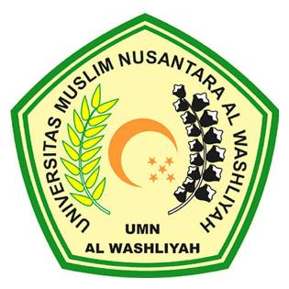
UNIVERSITAS MUSLIM NUSANTARA AL-WASHLIYAH
FAKULTAS SASTRA
Kampus A: Jl. Garu II No. 93, Kampus B: Jl. Garu II No. 2
Telp. (061) 7867004 – 7868487 Fax. (061) 7862747 Medan 20147

APPROVAL SHEET

NAME : KHAIRUNNISA AYU WIRDANI PANE
REGISTRATION NUMBER : 166224017
MAJORS : SASTRA
STUDY PROGRAM : SASTRA INGGRIS
EDUCATIONAL STAGE : Strata 1 (S-1)
THESIS TITLE : AN ANALYSIS OF CODE MIXING IN MASTERCHEF INDONESIA THROUGH RCTI PROGRAMS

APPROVED BY
First Adviser |  |  | Second Adviser
(Dewi Nurmala, S.S M.Hum) |  |  | (Diana Sopha, S.S. M.Hum)
 | Head of Department
 | (Dewi Nurmala, S.S M.Hum)

