ACKNOWLEDGEMENT
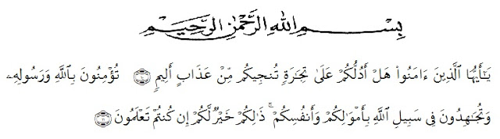
Artinya: Wahai orang-orang yang beriman, sukakah kamu aku tunjukkan suatu perniagaan yang dapat menyelamatkanmu dari azab yang pedih? (10), (yaitu) kamu beriman kepada Allah dan RasulNya dan berjihad di jalan Allah dengan harta dan jiwamu. Itulah yang lebih baik bagimu, jika kamu mengetahui (11). (As-Shaff: 10-11)
Alhamdulillah, in the Name of Allah, the most Gracious, the most Merciful All praises be to Allah, king of the king, the Lord of the world, and the master of the day after, who has given us blessing and guidance. Because of His graciousness and mercifulness the writer can write well. This thesis entitled “The Impact Of American Policy Toward Afghanistan, Iraq And Taliban Wars In Khaled Hosseini’s A Thousand Splendid Suns” is presented to the Faculty of Letters in University of Muslim Nusantara Al-washliyah Medan (UMN) as one of requirements for sarjana sastra at the Faculty of Letters.
In arranging this thesis, a lot of people have provided motivation, advice, and support for the researcher. In this valuable chance, the researcher intended to express her gratitude and appreciation to :
- H. Hardi Mulyono Surbakti, SE, MAP. As a Rector at University of Muslim Nusantara Al-Wasliyah Medan.
- Dr. Hj. Risnawaty M.Hum as the Dean of Faculty of letters , The University of Muslim Nusantara Al-Wasliyah Medan.
- Diana Sopha, SS, M.Hum, as the first vice Dean, Harianto S.S, M.S, as the second vice Dean, and Junaidi, SS, S.Pd, M.Si as the third vice Dean.
- Dewi Nurmala SS.M.Hum as the Head of the English Department of the Faculty of Leters, The University of Muslim Nusantara Al-Wasliyah Medan.
- Dr. Hj. Risnawaty M.Hum and Diana Sopha, SS, M.Hum as my consultant who have educated, supported, directed and given me countless advice, suggestion and recommendation writing this graduating paper from beginning until the end. Thanks for patient and guidance.
- All lectures of English Literature The University of Muslim Nusantara Al-Washliyah Medan. The writer gives thanks to them for the valuable knowledge and guidance during study at English Literature.
- My beloved family especially for my father Haris Hidayat (Alm), my mother Ratna Khairani Lubis, my brother M.Fitra Aulia and also my second father Zulkifli Lubis.
- Thanks for my classmate and all my friends who always support all my time.
- And special thanks for my partner in every situation that I ever have Rian Agustian.
The writer realizes that this thesis is still far from perfect. Therefore, the writer will be glad to receive any recommendation and constructive criticism to make this thesis better.
Finally, the writer expects that this thesis will be useful to the reader who wishes to learn something about impact of american policy.
Medan, 28 January 2020

Dinda Khairisda

