Lampiran 1. Surat Hasil Determinasi Tanaman Jambu Bol (Syzigium malaccense L.)
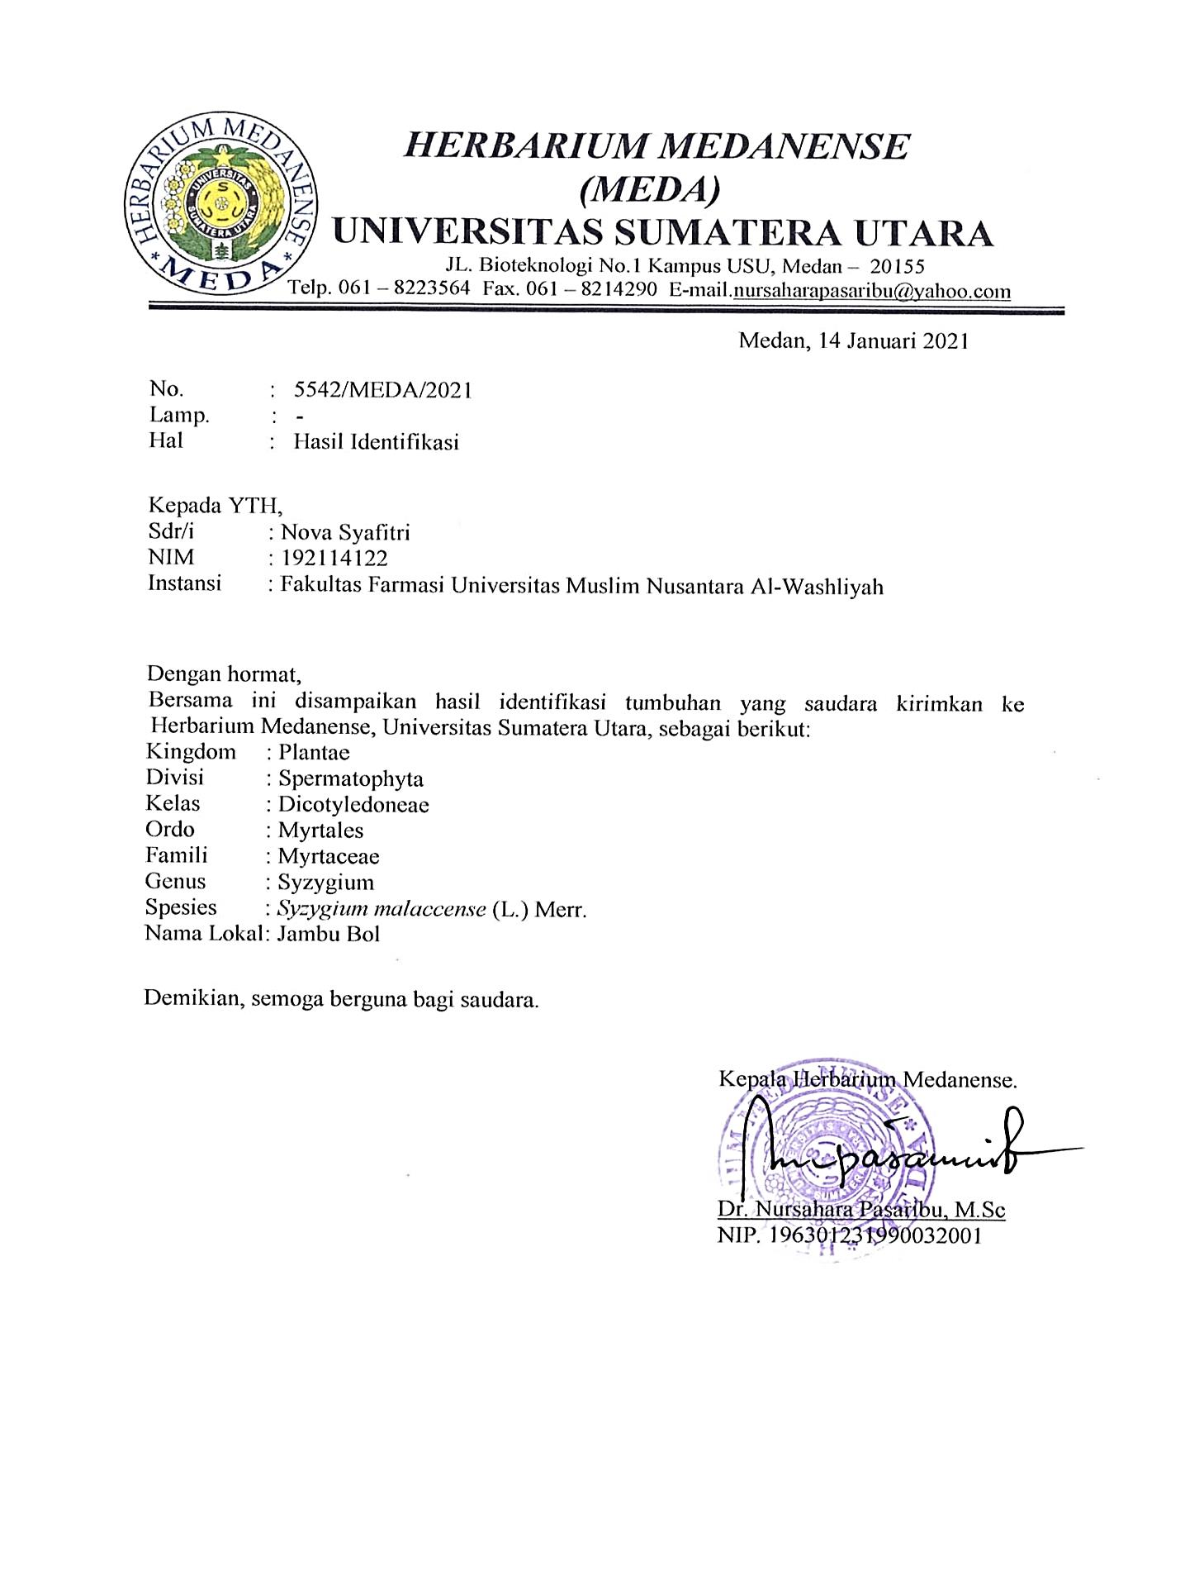
Lampiran 2. Bagan Alir Prosedur Kerja

Pengumpulan sampel daun jambu bol (Syzigium malaccense L.)

Daun jambu bol
Disortasi basah
Dicuci dengan air kran mengalir
Ditiriskan
Dirajang tipis-tipis
Ditimbang

Berat basah daun jambu bol

Dikeringkan dalam lemari pengering dengan suhu ±40ºC
Disortasi kering
Ditimbang kembali

Berat kering simplisia daun jambu bol

Dihaluskan menggunakan blender
Disimpan dalam wadah tertutup rapat

Berat serbuk simplisia daun jambu bol

Karakterisasi simplisia

Lampiran 3. Bagan Alir Karakterisasi Simplisia Daun Jambu Bol (Syzigium malaccense L.)

Simplisia daun jambu bol

- Kadar air
- Kadar sari larut air
- Kadar sari larut etanol
- Kadar abu total
- Kadar abu tidak larut asam
Pemeriksaan Mikroskopis
Pemeriksaan Makroskopik

Lampiran 4. Bagan Alir Ekstraksi Serbuk Simplisia Daun Jambu Bol (Syzigium malaccense L.)

Serbuk simplisia daun jambu bol

Ditimbang serbuk simplisia 500 gram

Dimasukkan kedalam bejana maserasi

Ditambahkan 75 bagian etanol 96% (3750 ml) diamkan selama 5 hari
Diaduk sesekali dan disaring

Ampas 1
Maserat 1

Dibilas 25 bagian etanol 96% (1250 ml)

Maserat I dan II dicampur

Diamkan selama 2 hari
Diamkan selama 2 hari
Diamkan selama 2 hari
Dienap tuangkan atau saring
Maserat

Dipekatkan dengan rotary evaporator

Ekstrak kental
Lampiran 5.Bagan Alir Skrining Fitokimia Simplisia dan Ekstrak Daun Jambu Bol (Syzigium malaccense L.)

Ekstrak daun jambu bol
Serbuk simplisia daun jambu bol

Skrining fitokimia

Golongan alkaloid
Golongan glikosida
Golongan triterpenoid / steroid
Golongan tanin
Golongan saponin
Golongan flavonoid

Lampiran 6. Bagan Alir Uji Sitotoksisitas Ekstrak Etanol Daun Jambu Bol (Syzigium malaccense L.)
10 mg ekstrak daun jambu bol

Dilarutkan dengan air garam 10 ml

Konsentrasi1000 µg/ml (LIB 1)

Dibuat dalam beberapa variasi konsetrasi

100
µg/ml
300 µg/ml
500 µg/ml
700 µg/ml
kontrol

200 µg/ml
600 µg/ml
400 µg/ml

Disiapkan vial yang telah berisi 10 ekor larva artemia salina dalam 10 ml ekstrak yang sudah dilarutkan dengan air garam
Masing-masing konsentrasi dibuat dengan 3 kali pengulangan
Mortalitas dihitung setelah 24 jam

% Mortalitas

Lampiran 7. Pengelolaan Sampel Daun Jambu Bol (Syzigium malaccense L.)

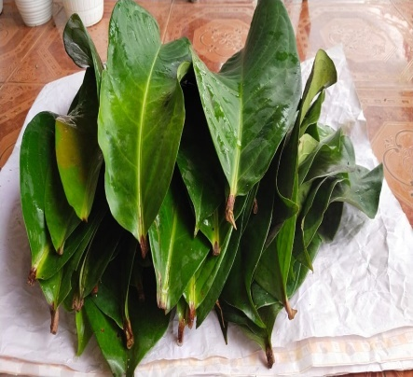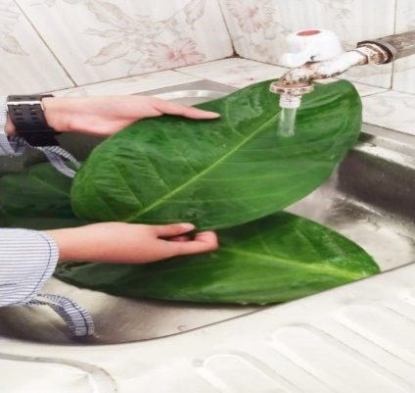
Sortasi basah Pencucian
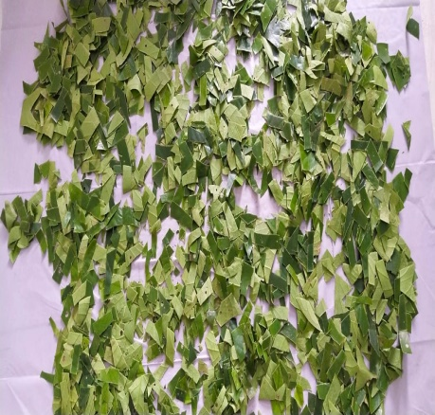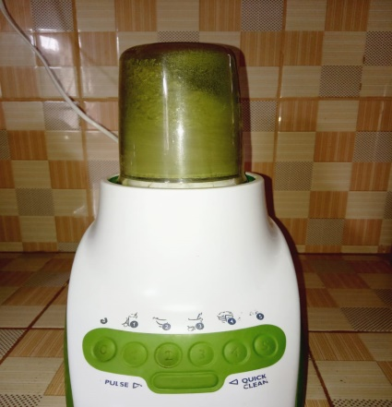
Perajangan Penghalusan
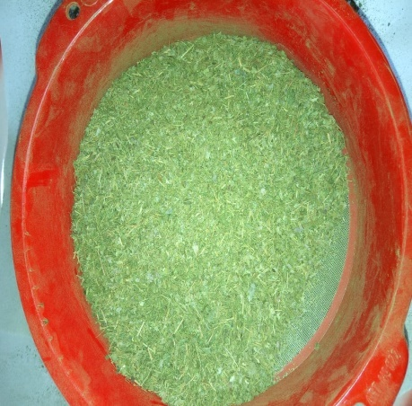
Pengayakan

Lampiran 8. Perhitungan Susut Pengeringan

Diketahui :
Bobot tumbuhan segar = 10.000 gram
Bobot simplisia = 1200 gram
% susut pengeringan = $\frac{Berat tumbuhan segar-bobot simplisia}{berat tumbuhan segar}$ x 100%

% susut pengeringan = $\frac{10.000 gram-1200 gram}{10.000 gram}$ x 100%
= 88 %

Lampiran 9.Proses Ekstraksi Daun Jambu Bol (Syzigium malaccense L.)

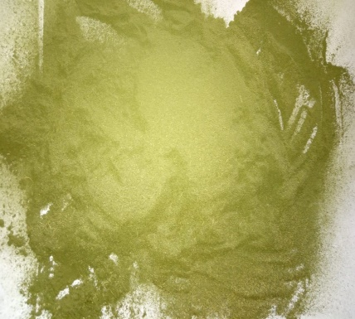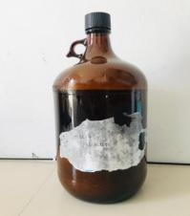
Hasil maserat daun jambu bol
Serbuk simplisia daun jambu bol

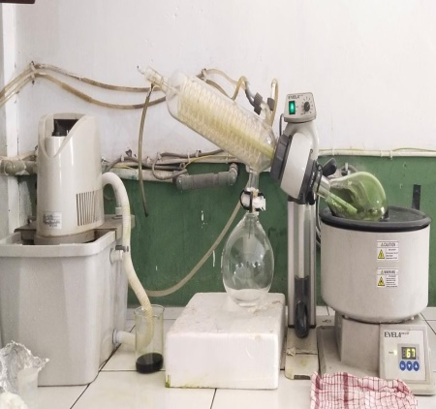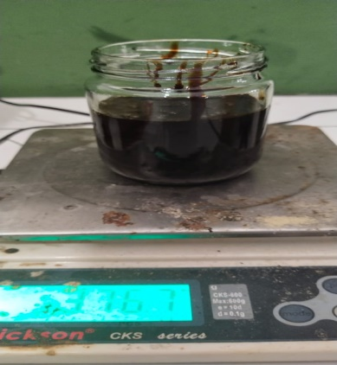
Ekstrak kental daun jambu bol
Pengentalan ekstrak daun jambu bol

Lampiran 10. Perhitungan Randemen Ekstrak

Diketahui :
Bobot serbuk simplisia = 500 gram
Volume pelarut = 5000 ml
Bobot ekstrak = 157,2 gram

% Rendemen ekstrak = $\frac{bobot ekstrak}{bobot serbuk simplisia}$ x 100 %
% Rendemen ekstrak = $\frac{157,2 gram}{500 gram }$ x 100 %
= 31,44 %

Lampiran 11. Pemeriksaan Mikroskopik Simplisia Daun Jambu Bol (Syzigium malaccense L.)

1
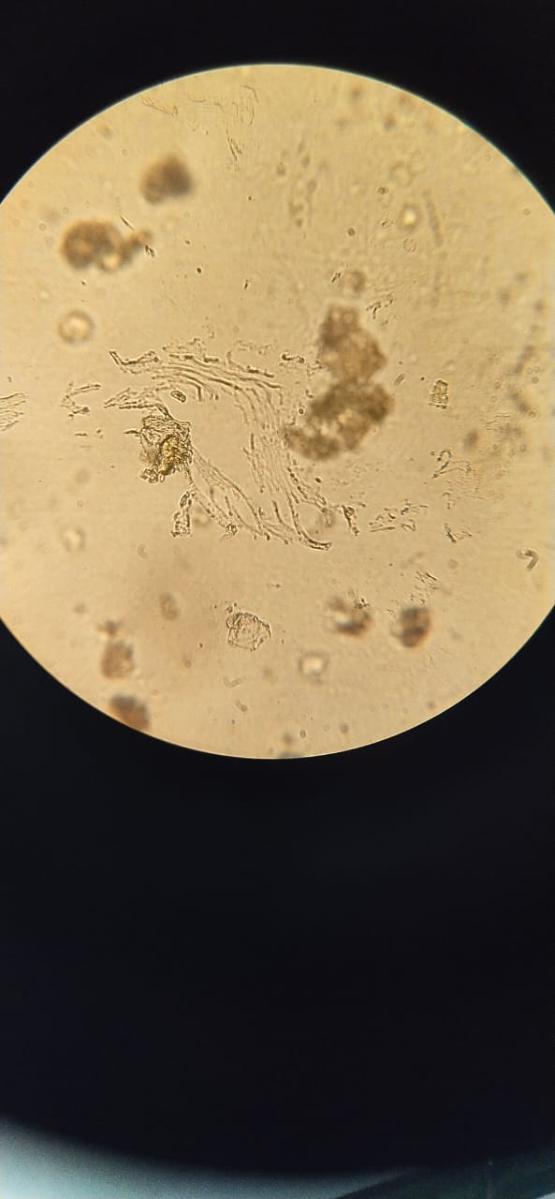
2
3

Keterangan :
1. Epidermis bawah dengan stomata
2. Serabut
3. Hablur kalsium oksalat
Lampiran 12.Perhitungan Penetapan Kadar Air Simplisia Daun Jambu Bol (Syzigium malaccense L.)

% kadar air =$\frac{V1-V0}{Berat sampel}$ x 100%
Keterangan : V₀ = Volume destilasi dari penjenuhan toluen
V₁ = Volume destilasi air dari simplisia
- Sampel pengulangan I
V₀ = 1,3 ml
V₁ = 1,7 ml
Berat simplisia = 5 gram
% kadar air = $\frac{1,7 ml - 1,3 ml}{5 g}$ x 100% = 8 %
- Sampel pengulangan II
V₀ = 1,2 ml
V₁ = 1,6 ml
Berat simplisia = 5 gram
% kadar air = $\frac{1,6 ml - 1,2 ml}{5 g}$ x 100% = 8 %
- Sampel pengulangan III
V₀ = 1,5 ml
V₁ = 1,8 ml
Berat simplisia = 5 gram
% kadar air = $\frac{1,8 ml - 1,5 ml}{5 g}$ x 100% = 6 %
Kadar air rata-rata = $\frac{8\%+8\%+6\% }{3}$ = 7,33 %
Lampiran 13. Perhitungan Penetapan Kadar Sari Larut Air dan Kadar Sari Larut
Etanol Simplisia Daun Jambu Bol (Syzigium malaccense L.)

- Perhitungan penetapan kadar sari larut air
% kadar = $\frac{[\left(berat cawan+sampel\right)-berat cawan kosong)] x 5}{berat sampel}$ x 100%
- Pengulangan 1
Berat sampel = 5 gram
Berat cawan kosong = 35,6702 gram
B₁ = 35,8434 gram
B₂ = 35,8411 gram
B₃ = 35,8411 gram
B_{rata-rata} = 35,8418 gram
% kadar = $\frac{[\left(35,8418 gram\right)-35,6702 gram] x 5}{5 gram}$ x 100% = 17,16 %
- Pengulangan 2
Berat sampel = 5 gram
Berat cawan kosong = 32,3895 gram
B₁ = 32,6281 gram
B₂ = 32,6272 gram
B₃ = 32,6272 gram
B_{rata-rata} = 32,6275 gram
% kadar = $\frac{[\left(32,6275 gram\right)-32,3895 gram] x 5}{5 gram}$ x 100% = 23,8 %

Lampiran 13. (Lanjutan)
- Pengulangan 3
Berat sampel = 5 gram
Berat cawan kosong = 26,5050 gram
B₁ = 26,8245 gram
B₂ = 26,8243 gram
B₃ = 26,8243 gram
B_{rata-rata} = 26,8243 gram
% kadar = $\frac{[\left(26,8243 gram\right)-26,5050 gram] x 5}{5 gram}$ x 100% = 31,93 %
Kadar sari larut air rata-rata = $\frac{17,16\% + 23,8\% + 31,93\%}{3}$ = 24,29 %
- Perhitungan penetapan kadar sari larut etanol
% kadar = $\frac{[\left(berat cawan+sampel\right)-berat cawan kosong)] x 5}{berat sampel}$ x 100%
- Pengulangan 1
Berat sampel = 5 gram
Berat cawan kosong = 32,3130 gram
B₁ = 32,6859 gram
B₂ = 32,6851 gram
B₃ = 32,6851 gram
B_{rata-rata} = 32,6853 gram
% kadar = $\frac{[\left(32,6853 gram\right)-32,3130 gram] x 5}{5 gram}$ x 100% = 37,23 %

Lampiran 13. (Lanjutan)
- Pengulangan 2
Berat sampel = 5 gram
Berat cawan kosong = 32,2930 gram
B₁ = 32,5370 gram
B₂ = 32,5366 gram
B₃ = 32,5366 gram
B_{rata-rata} = 32,5367 gram
% kadar = $\frac{[\left(32,5367 gram\right)-32,2930 gram] x 5}{5 gram}$ x 100% = 24,37 %
- Pengulangan 3
Berat sampel = 5 gram
Berat cawan kosong = 32,4662 gram
B₁ = 32,7321 gram
B₂ = 32,7317 gram
B₃ = 32,7317 gram
B_{rata-rata} = 32,7318 gram
% kadar =$\frac{[\left(32,7318 gram\right)-32,4662 gram] x 5}{5 gram}$ x 100% = 26,56 %

kadarsari larut etanol rata-rata =$\frac{37,23\%+24,37\%+26,56\%}{3}$ x 100% = 29 %

Lampiran 14.Perhitungan Penetapan Kadar Abu Total dan Kadar Abu Tidak Larut Asam Simplisia Daun Jambu Bol (Syzigium malaccense L.)

- Perhitungan penetapan kadar abu total
% kadar = $\frac{[\left(berta cawan+berat isi\right)-berat cawan kosong] }{berat sampel}$ x 100%
- Pengulangan 1
Berat sampel = 2 gram
Berat cawan kosong = 40,9183 gram
B₁ = 40,9423 gram
B₂ = 40,9986 gram
B₁ = 40,9986 gram
B_{rata-rata} = 40,9798 gram
% kadar = $\frac{[\left(40,9798 gram\right)-40,9183 gram] }{2 gram}$ x 100% = 3,075 %
- Pengulangan 2
Berat sampel = 2 gram
Berat cawan kosong = 34,0687 gram
B₁ = 34,1832 gram
B₂ = 34,2122 gram
B₁ = 34,2122 gram
B_{rata-rata} = 34,2025 gram
% kadar = $\frac{[\left(34,2025 gram\right)-34,0687 gram] }{2 gram}$ x 100% = 6,69 %

Lampiran 14.(Lanjutan)
- Pengulangan 3
Berat sampel = 2 gram
Berat cawan kosong = 26,1649 gram
B₁ = 26,2113 gram
B₂ = 26,1933 gram
B₁ = 26,1933 gram
B_{rata-rata} = 26,1993 gram
% kadar = $\frac{[\left(26,1993 gram\right)-26,1649 gram] }{2 gram}$ x 100% = 1,72 %
Kadar abut total rata-rata = $\frac{3,075 \%+6,69 \%+1,72 \%}{3}$ = 3,82%
- Perhitungan penetapan kadar abu tidak larut asam
% kadar = $\frac{[\left(berta cawan+berat isi\right)-berat cawan kosong] }{berat sampel}$ x 100%
- Pengulangan 1
Berat sampel = 2 gram
Berat cawan kosong = 26,4626 gram
B₁ = 26,4913 gram
B₂ = 26,4822 gram
B₃ = 26,4822 gram
B_{rata-rata} = 26,4852 gram
% kadar = $\frac{[\left(26,4852 gram\right)-26,4626 gram] }{2 gram}$ x 100% = 1,13 %

Lampiran 14.(Lampiran)
- Pengulangan 2
Berat sampel = 2 gram
Berat cawan kosong = 26,4045 gram
B₁ = 26,4164 gram
B₂ = 26,4112 gram
B₃ = 26,4112 gram
B_{rata-rata} = 26,4129 gram
% kadar = $\frac{[\left(26,4129 gram\right)-26,4045 gram] }{2 gram}$ x 100% = 0,17 %
- Pengulangan 3
Berat sampel = 2 gram
Berat cawan kosong = 26,4980 gram
B₁ = 26,5081 gram
B₂ = 26,5022 gram
B₃ = 26,5022 gram
B_{rata-rata} = 26,5041 gram
% kadar = $\frac{[\left(26,5041 gram\right)-26,4980 gram] }{2 gram}$ x 100% = 0,305 %
% kadar = $\frac{1,13 \%+0,17\%+0,305\% }{3}$ x 100% = 0,53 %

Lampiran 15. Uji Sitotoksisitas Ekstrak Etanol Daun Jambu Bol (Syzigium malaccense L.)
a. Penetasan telur artemia
Air garam buatan
Telur artemia

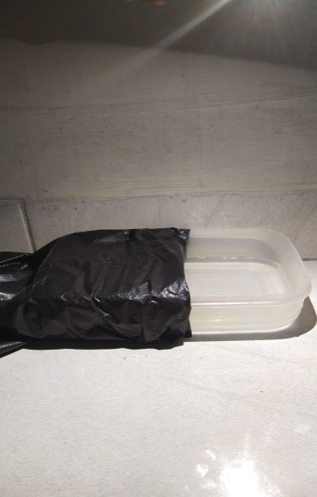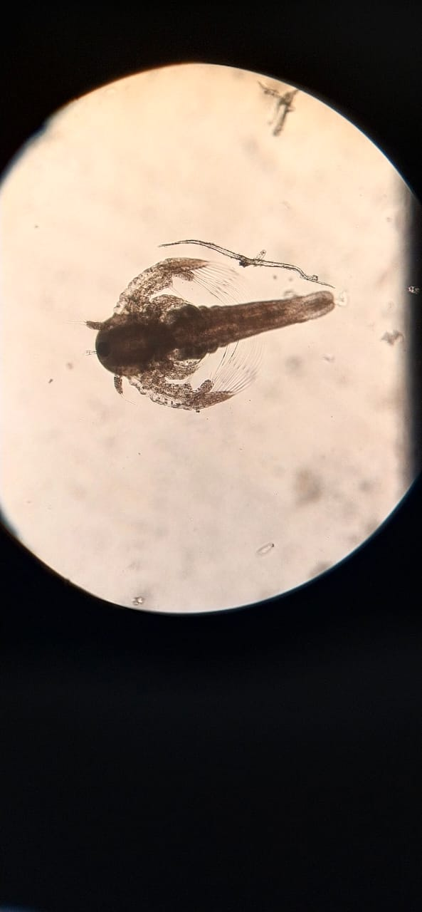
Artemia salina
Proses penetasan

  - Pengujian sitotoksisitas ekstrak etanol daun jambu bol (Syzigium malaccense L.) dengan berbagai variasi konsentrasi

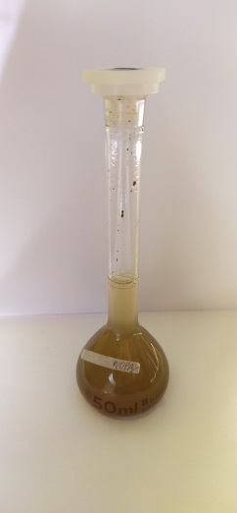

LIB
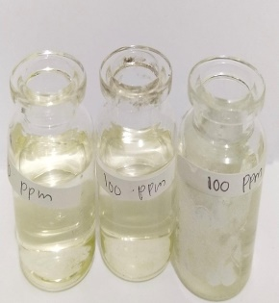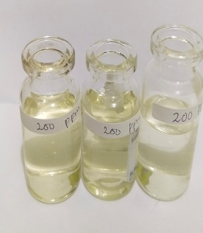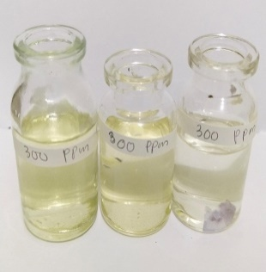
300 µg/mL
200 µg/mL
100 µg/mL

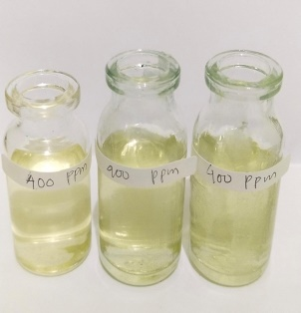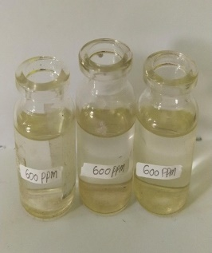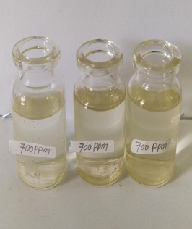
600 µg/mL
500 µg/mL
400 µg/mL

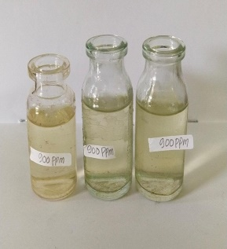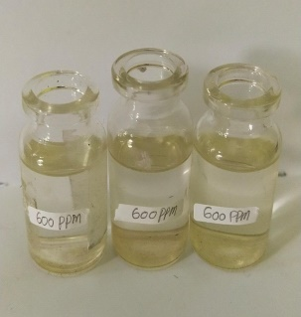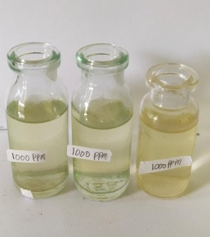
900 µg/mL
800 µg/mL
700 µg/mL

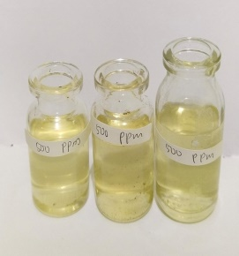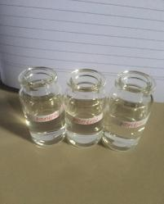
Blanko
1000 µg/mL

Lampiran 16. Perhitungan Pembuatan Variasi Pengenceran Ekstrak Etanol Daun Jambu Bol (Syzigium malaccense L.)

100 mg ekstrak daun jambu bol dalam labu tentukur 50 ml
Lib 1 = 100 mg (C = 100.000 µg/50 mL) maka C = 2.000 µg/mL

C₁ = 2000 µg/mL X 5 ml = $\frac{10000 µg/mL}{10 ml}$ = 1000 µg/mL
C₂ = 2000 µg/mL X 4,5 ml = $\frac{9000 µg/mL}{10 ml}$ = 900 µg/mL
C₃= 2000 µg/mL X 4 ml = $\frac{8000 µg/mL}{10 ml}$ = 800 µg/mL
C₄= 2000 µg/mL X 3,5 ml = $\frac{7000 µg/mL}{10 ml}$ = 700 µg/mL
C₅= 2000 µg/mL X 3 ml = $\frac{6000 µg/mL}{10 ml}$ = 600 µg/mL
C₆= 2000 µg/mL X 2,5 ml = $\frac{5000 µg/mL}{10 ml}$ = 500 µg/mL
C₇= 2000 µg/mL X 2 ml = $\frac{4000 µg/mL}{10 ml}$ = 400 µg/mL
C₈= 2000 µg/mL X 1,5 ml = $\frac{3000 µg/mL}{10 ml}$ = 300 µg/mL
C₉= 2000 µg/mL X 1 ml = $\frac{2000 µg/mL}{10 ml}$ = 200 µg/mL
C₁₀= 2000 µg/mL X 0,5 ml = $\frac{1000 µg/mL}{10 ml}$ = 100 µg/mL

Lampiran 17. Perhitungan LC₅₀ Ekstrak Etanol Daun Jambu Bol (Syzigium malaccense L.)

% Kematian Larva = $\frac{jumlah kematian larva uji}{jumlah larva uji}$ x 100%

d (C(µg /mL)) | N (jumlah larva) | r (jmlh larva mati) | P (% mortalitas) | X  (log C) | Y (Nilai probit) | XY | X²
100 | 30 | 7 | 23,33 | 2,0000 | 4,2710 | 8,542 | 4,0000
200 | 30 | 12 | 40 | 2,3010 | 4,7467 | 10,9221 | 5,2946
300 | 30 | 14 | 46,66 | 2,4771 | 4,9172 | 12,1803 | 6,1360
400 | 30 | 18 | 60 | 2,6020 | 5,2533 | 13,6690 | 6,7704
500 | 30 | 21 | 70 | 2,6989 | 5,5244 | 14,9098 | 7,2840
600 | 30 | 23 | 76,66 | 2,7781 | 5,7200 | 15,8907 | 7,7178
700 | 30 | 25 | 83,33 | 2,8451 | 5,9661 | 16,9735 | 8,0940
 |  |  |  | ƩX =  17,7022 | ƩY =  36,3987 | ƩXY =  93,0874 | ƩX² =  45,2968

Persamaan garis regresi linier : Y = b X + a
Y = konsentrasi kematian
X = log konsentrasi
b = $\frac{n \left(ƩXY\right)-(ƩXƩY)}{n \left(ƩX^{2}\right)-(Ʃ{X)}^{2}}$
b = $\frac{7 \left(93,0874\right)-(17,7022 X 36,3987)}{7 \left(45,2968\right)-(17,7022)^{2}}$
b = $\frac{7 \left(93,0874\right)-(644,3371)}{7 \left(45,2968\right)-(313,3679)}$
b = $\frac{651,6118 - 644,3371}{317.0776 -313,3679}$
b = $\frac{7,2747}{3,7097}$= 1.9609
Lampiran 17.(Lanjutan)
a = $\frac{ƩY-b ƩX}{n}$
a = $\frac{ 36,3987 - 1,9609 (17,7022)}{7}$
a = $\frac{36,3987 - 34,7122}{7}$
a = 0,2409

Nilai LC₅₀ diperoleh dari antilog X, dimana X merupakan logaritma konsentrasi bahan toksik pada Y = 5, yaitu nilai probit 50% hewan uji. Sehingaa diperoleh persamaan regresi Y = 1,9609 X + 0,2409
Jadi, 5 = 1,9609 X + 0,2409
X = $\frac{5-0,2409}{1,9609}$
X = 2,42
Maka nilai LC₅₀ antilog 2,42 = 253,02 µg/mL.

Lampiran 18. Kurva Hubungan Antara Log Konsentrasi (x) dan Nilai Probit (y) Menggunakan SPSS 20 for windows

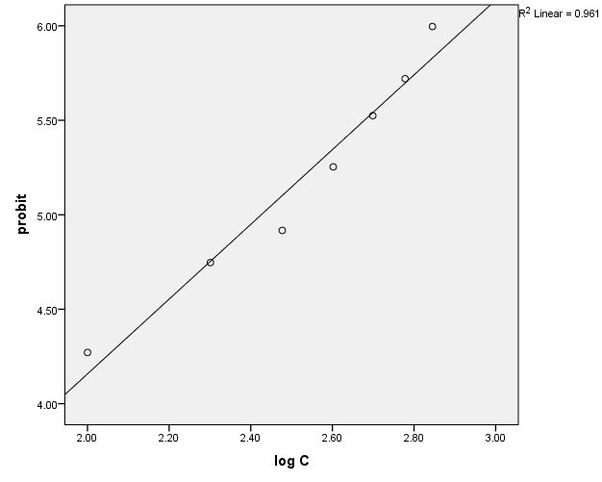

Lampiran 19. Nilai Probit Sesuai dengan Besarnya Presentase Kematian
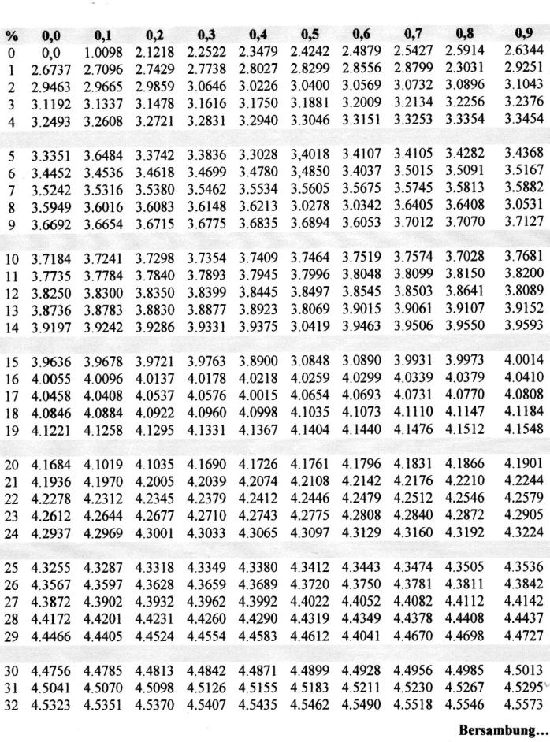
Nilai Probit

Lampiran 19. (Lanjutan)
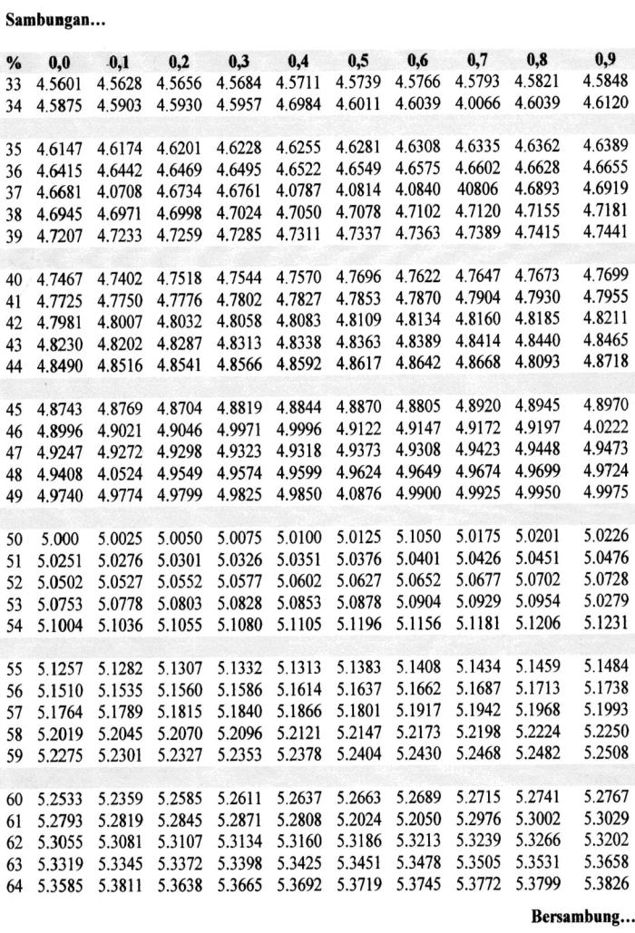

Lampiran 19. (Lanjutan)
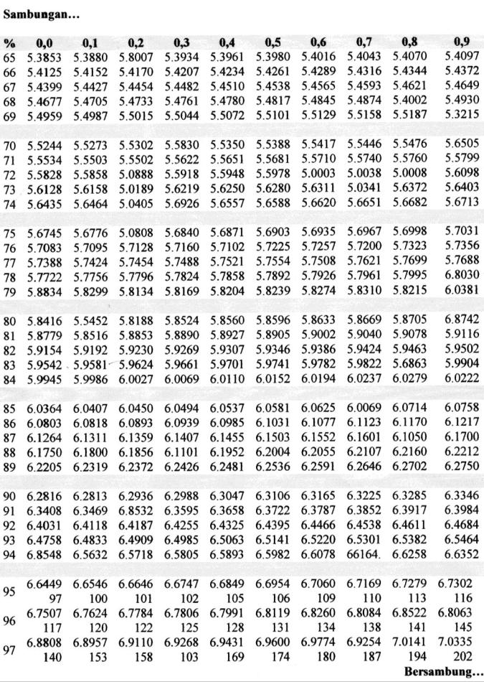

Lampiran 19. (Lanjutan)
