APPENDIX I
LESSON PLAN (RPP)
(Experimental Class)

School : SMP Swasta Al-Hikmah
Class / Semester : VIII/ 2
Subject : English
Skill : Reading (Narrative Text)
Time : 2 x 30 minutes

- Standard Competency
Reading: Understanding the meaning of short functional text in narrative in daily life context and to get an access of knowledge.

- Basic Competency
Responding the meaning of written languages accurately, fluently and accepted in daily life context and to get access the knowledge in the form of narrative text.

- Indicators

Indicator of Achieving Competence | Culture Value and Nation Character
a. Identifying word meaning of the narrative text  b. Identifying the certain information of the narrative text  c. Identifying aspects that exist in the narrative text | Religious, tolerance, creative, curious, self-supporting, communicative, responsibility.

- Aims of Learning
In the end of study, students are able to:
- Identify word meaning of the narrative text
- Identify the certain information of the narrative text
- Identify aspects that exist in the narrative text

- Teaching Method
Method that is used: Team Quiz Method
Strategy that is used : Discussion

- Learning Material
Narrative text
Kinds of Narrative:
- Fable
- Fiction
- Romance
- Adventure
- Folklore : Fable, myth, story
- Fairy tale
- Science fiction
- Fantasy
- Mystery

Function : to amuse or entertain, to deal with actual/imaginative experiences in different ways
Generic structure:
- Orientation
- Evaluation
- Complication
- Resolution
Language features:
- A narrative focuses on specific participants.
- There are many action verbs, verbal and mental processes
- It usually uses Past Tense
- The use of direct and indirect speech in form of dialogues
- Descriptive language is used to create listener’s or reader’s imagination
- Use temporal conjunction and temporal circumstances,
Example of NarrativeText :
The Donkey of Guizhou
Once upon a time, there was a donkey in Guizhou. Someone officious shipped one there, but finding no use for it, he set it loose at the foot of the mountain.
A tiger ran out from the mountains. When he saw this big tall thing, he thought it must be divine. He quickly hid himself in the forest and surveyed it from under over, sometimes the tiger ventured a little nearer but still kept a respectful distance.
One day the tiger came out again. Just then the donkey gave a loud bray, I thinking the donkey was going to eat him, the tiger hurriedly ran away. After a while, he sneaked back and watched the donkey carefully. He found that though it had a huge body it seemed to have no special ability.
After a few days, the tiger gradually became accustomed to its braying and was no longer so afraid. Sometimes, he even came near and circled around the donkey.
Later the tiger became bolder. Once, he walked in front of the donkey and purposely bumped it. This made the donkey so angry that it struck out his hind legs and kicked wildly.
Seeing this the tiger was very gleeful, Such a big thing as you can do so little!’ With a roar, he pounced on the donkey and ate it up.

- Learning Activity

Learning activity | Activities | Character Building  (Values)
Pre activity  (10 minutes) | - The Researcher greets the students  - The researcher checks attendance list  - The researcher prepares the students’ physically and psychology to follow the teaching learning process  - The researcher gives motivation to students. | Religious, honest, discipline,communicative, creative, and independent.
Main activity  - minutes)  - Exploration steps : | - The students study and read the narrative text.  - The researcher explains about narrative text.  - The researcher make 3 groups | Communicative, independent, discussion, discipline, creative, hard work, curious, honesty, friendship.
- Elaboration steps: | - The researcher asks team A to prepare a short answer quiz, while team B and team C use time to check their notes.  - Team A gives a quiz to team B, if team B cannot answer the question, team C immediately answers it  - Team A directs the next question to team C members, and repeats the process.  - Evalution Material in Quiz
Post activity  (10 minutes) | - The researcher together with students make a conclusion about the material.  - The researcher makes a reflection about the teaching learning process consistently. | Communicative, honesty, responsible.

- Source and Media
Source : Internet and Papper
Media : Laptop and Sheet of Story of Narrative text

- Assesment
Test type : Multiple-Choice test
Scoring guidance :
No | Test Type | Score
1. | Multiple choice | 10
Total Score |  | 10

The English Teacher, Researcher

Sunardi S.Pd. Shally Ari Adinda

APPENDIX II
LESSON PLAN (RPP)
(Control Class)

School : SMP Swasta Al-Hikmah
Class / Semester : VIII/ 2
Subject : English
Skill : Reading (Narrative Text)
Time : 2 x 30 minutes

- Standard Competency
Reading: Understanding the meaning of short functional text in narrative in daily life context and to get an access of knowledge.

- Basic Competency
Responding the meaning of written languages accurately, fluently and accepted in daily life context and to get access the knowledge in the form of narrative text.

- Indicators

Indicator of Achieving Competence | Culture Value and Nation Character
a. Identifying word meaning of the narrative text  b. Identifying the certain information of the narrative text  c. Identifying aspects that exist in the narrative text | Religious, tolerance, creative, curious, self-supporting, communicative, responsibility.

- Aims of Learning
In the end of study, students are able to:
- Identify word meaning of the narrative text
- Identify the certain information of the narrative text
- Identify aspects that exist in the narrative text

- Teaching Method
Method that is used : Conventional Method

- Learning Material
Narrative text
Kinds of Narrative:
- Fable
- Fiction
- Romance
- Adventure
- Folklore : Fable, myth, story
- Fairy tale
- Science fiction
- Fantasy
- Mystery

Function : to amuse or entertain, to deal with actual/imaginative experiences in different ways
Generic structure:
- Orientation
- Evaluation
- Complication
- Resolution
Language features:
- A narrative focuses on specific participants.
- There are many action verbs, verbal and mental processes
- It usually uses Past Tense
- The use of direct and indirect speech in form of dialogues
- Descriptive language is used to create listener’s or reader’s imagination
- Use temporal conjunction and temporal circumstances,
Example of NarrativeText :
The Donkey of Guizhou
Once upon a time, there was a donkey in Guizhou. Someone officious shipped one there, but finding no use for it, he set it loose at the foot of the mountain.
A tiger ran out from the mountains. When he saw this big tall thing, he thought it must be divine. He quickly hid himself in the forest and surveyed it from under over, sometimes the tiger ventured a little nearer but still kept a respectful distance.
One day the tiger came out again. Just then the donkey gave a loud bray, I thinking the donkey was going to eat him, the tiger hurriedly ran away. After a while, he sneaked back and watched the donkey carefully. He found that though it had a huge body it seemed to have no special ability.
After a few days, the tiger gradually became accustomed to its braying and was no longer so afraid. Sometimes, he even came near and circled around the donkey.
Later the tiger became bolder. Once, he walked in front of the donkey and purposely bumped it. This made the donkey so angry that it struck out his hind legs and kicked wildly.
Seeing this the tiger was very gleeful, Such a big thing as you can do so little!’ With a roar, he pounced on the donkey and ate it up.

- Learning Activity

Learning activity | Activities | Character Building  (Values)
Pre activity  (10 minutes) | - The Researcher greets the students  - The researcher checks attendance list  - The researcher prepares the students’ physically and psychology to follow the teaching learning process  - The researcher gives motivation to students. | Religious, honest, discipline,communicative, creative, and independent.
Main activity  - minutes)  - Exploration steps : | - The students study and read the narrative text.  - The researcher explains about narrative text. | Communicative, independent, discussion, discipline, creative, hard work, curious, honesty, friendship.
Post activity  (10 minutes) | - The researcher together with students make a conclusion about the material.  - The researcher makes a reflection about the teaching learning process consistently.
 |  | Communicative, honesty, responsible.

- Source and Media
Source : Internet and Papper
Media : Laptop and Sheet of Story of Narrative text

- Assesment
Test type : Multiple-Choice test
Scoring guidance :
No | Test Type | Score
1. | Multiple choice | 10
Total Score |  | 10

The English Teacher, Researcher

Sunardi S.Pd. Shally Ari Adinda

APPENDIX III
PRETEST
Multiple Choice Narrative Text
Name :
Class : VIII

Read the following text to answer question number 1-4
Choose either a, b, c, or d for the correct answer.

Redfeathers the Hen
Redfeathers, the hen, was so-called ause all her feathers were red. One day, the fox caught sight of her in the armyard and his mouth began to water.
He ran home and told his wife to put n water for boiling a chicken, and the e rushed back, and before Redfeathers knew what was happening, she found herself snapped up and inside a sack, not even able to call for help.
Luckily for her, her friend the dove saw what had happened. She fluttered on the path in the woods, and lay there, pretending to have a broken wing. The fox was delighted to find that he now had a first course as well as a main dish. e put down the sack with the hen in it, and chased off after the dove, who began cleverly to hop futher and futher away.
Redfeathers slipped out of the sack and put a stone in her place, then she stoo ran off. When the dove saw that her iend was safe, she flew up into a tree. e fox then went back and picked up he sack, thinking that the hen was still it. When he got home, the fox tipped -the sack into the pot of boiling water, but the stone splashed it all over him, and he burned his greedy paws.
- What the title of the text above?
- Redfeathers the Hen
- Redfeathers the Mouse
- Redfather the Hen
- Redfeather

- What Kind of text above ?
- Descriptive text
- Recount Text
- Procedure Text
- Narrative Text

- She fluttered on to the path in the woods, and lay there
She refers to ….
- The hen
- The duck
- The dove
- The swan

- What did the fox think when he found the dove?
- The fox thought that he had to
- The fox thought that he had better go back.
- The fox thought he had a first course.
- The fox thought that he had to boil water.

Read the following text to answer question number 5-7

The Bear and the Two Friends

Once, two friends were walking through the forest. They knew that anything dangerous can happen to them at any time in the forest. So they promised each other that they would remain united in case of danger.

Suddenly, they saw a large bear approaching tern. One of the friends at once climbed a nearby tree. But the other one did not know how to climb. So being led by his common sense, he lay down on the ground breathless, pretending to be a dead man.

The bear came near the man lying on the ground. It smelt his ears and slowly left the place. Because the bear did not touch him, the friend on the tree came down and asked his friend on the ground, "Friend, what did the bear tell you into your ears?"The other friend replied, "He advised me not to believe a false friend.

- What can we get from the story?
- We have to save ourselves
- We have to learn how to climb
- Bear will not harm a dead man
- True friend always stand by us in ups and downs

- He advised me not to believe a false friend." (Paragraph 3) The underlined word refers to ....
- The bear
- The dead man
- The friend who cannot climb
- The friend who climb the tree

- Where do you think the story happened?
- In the river
- In the park
- In the woods
- In the zoo

Read the following text to answer question number 9-10

An ant nimbly running in search of food came across a chrysalis that was close its time to change. The chrysalis moved and this attracted the attention of the ant who for the first time realized that it was a living thing. "Poor, pitiable animal!", cried the ant disdainfully "what a sad fate is yours! While I can run with my pleasure, you lie imprisoned here in your shell". The chrysalis heard all this, but did not try to make any reply.

After a few days, when the ant passed that way again, nothing but the shell remained. Wondering what had happened to its content, he felt himself suddenly shaded and fanned by the gorgeous wings of a beautiful butterfly. "Behold in me," said the butterfly, "your much pitied friend!". So the butterfly rose in the air and lost in the summer breeze.

- What happened to the chrysalis after few days?
  - The chrysalis had gone from the shell
  - The chrysalis had become a butterfly
  - The ant felt sad about chrysalis death
  - The ant felt happy for the butterfly

- What is the main idea of the first paragraph?
  - Chrysalis is a animal
  - The chrysalis lie imprisoned
  - The ant was feeling sorry for the chrysalis
  - The ant goes around to have fun

- From the text we can learn that story ?
  - We have to be arrogant to others
  - Freedom is everything in life
  - We have to take revenge
  - The appearance may be deceptive

APPENDIX IV
POST TEST
Multiple Choice Narrative Text
Name :
Class : VIII
Read the following text to answer question number 1-4
Choose either a, b, c, or d for the correct answer.

Mouse Deer and Mr. Crocodile
One day, a mouse deer was walking by the river. He was very starving because he hadn't eaten since morning. It was midday. But he found nothing in the land but dying trees. "Huh... I hate this branches, I don't like it!
Across the river, there was green grassland, with young leaves. 'Hmm.. it seems delicious' imagined the mouse deer, 'but how can I get there? I can't swim, the current is very rapid?'
The mouse deer was figuring out the way how to reach there. Suddenly, he jumped to the air,'aha.: he then walked to the edge of the river. He didn't see the reflection because the water flowed very fast. He dipped one of his fore legs into the water. A few moment later, appeared Mr. Crocodile showing his sharp teeth. He then laughed, "Ha... ha... ha, you can't run away from me, You'll be my tasty lunch!" said the crocodile.
"Of course I can't. You are very strong, Mr. Croco," replied the mouse deer frightenedly. Then, the other crocodiles approached moving slowly.They approached the edge of the river.
"But, before you all have a party, I wonder how many your members are there in the river. If I know your number exactly, I can distribute my meat evenly,"said the mouse deer.
"Oh...o, great, good idea! But we are a large group, I can't count it precisely," Mr. Croco moaned. "Leave it to me, and I can make it for you!" Now, can you ask the others to line up, from one edge to the other edge of the river? The mouse deer requested. Then the crocodiles arranged themselves in line from one edge to the other edge of the river. The mouse deer jumped to the body of one crocodile to the others while he was counting, 'one, two, three; and so forth up to ten. Then at last he arrived at grassland, and he thanked to the dumb crocodiles.
- What is the title of the text?
- Mouse deer and Crocodilles
- Crocodilles and Horse
- Deer and Mouse
- Mouse deer and Mr. Crocodille

- What Kind of text above ?
  - Descriptive text
  - Recount Text
  - Procedure Text
  - Narrative Text

- How many crocodiles were there in the story above?
- Three Crocodiles
- Ten Crocodiles
- Thirteen Crocodiles
- Not Mentioned Bottom of Form

- Why did mouse deer want to go across the river?
- Because he was very hungry
- Because he wanted to cheat Mr. Crocodile
- He wanted to eat some dying trees
- He was afraid of the current of the river

Read the following text to answer question number 5-7

The Fox and The Sun

Once upon a time the foxes were angry with Sun. They had a council about the matter. Then, twelve fox were selected-twelve of the bravest to catch the Sun and tie him down. They made ropes of sinew. Then the twelve watched until the Sun, as he followed the downward trail in the sky, touched the top of a certain hill. Then the fox caught the Sun, and tied him fast to the hill. Do you know what happened next? The Indian saw it, and they kill the fox with arrows. Then, they cut the sinews and released the Sun. But the Sun had burned a great hole in the ground. You know, the Indians believe that the story is true because they can see the hole which the sun burned.

- What is the purpose of the text?
- To entertain the readers.
- To retell past event.
- To describe a particular thing.
- To describe something in general.

- What did the foxes do with the Sun?
- The buried the Sun
- They exploded the Sun
- They caught the Sun
- They run away from the Sun

“Then, they cut the sinews and released the Sun.”

- What does the underlined word refers to?
- The foxes
- The Indians
- The sun
- The holes

Read the following text to answer question number 8-10

A Story From The Farm Yard

Two roosters were fighting fiercely to be the king of the farm yard. One finally gained advantage and the other surrendered.

The loosing rooster slunk away and hid itself in a quiet corner. The winner flew up to a high wall, flapped its wings and crowed its victory, as loud as it could.

Suddenly, an eagle came sailing through the air and carried it off, with its talons. The loosing rooster immediately came out of its corner and ruled the farm yard from then on.

- From the text we know that ....
- Only one rooster can rule the roost
- The roosters are fighting to flap their wings
- The eagle had watched them all day
- The farm needs a new king

- What is the main idea of paragraph 3?
- An eagle watching the rooster from a distance
- The loosing rooster came out from its hiding place
- The eagle took the winning rooster as its prey
- The winning rooster celebrates its winning proudly

- What can we learn from the story?
- There's always a bigger enemy in this life
- Your friend can be your enemy
- Always grab an opportunity before you
- Don't be cocky when we have achieved our goal

APPENDIX V
SHEETS OF STUDENTS’ WORK
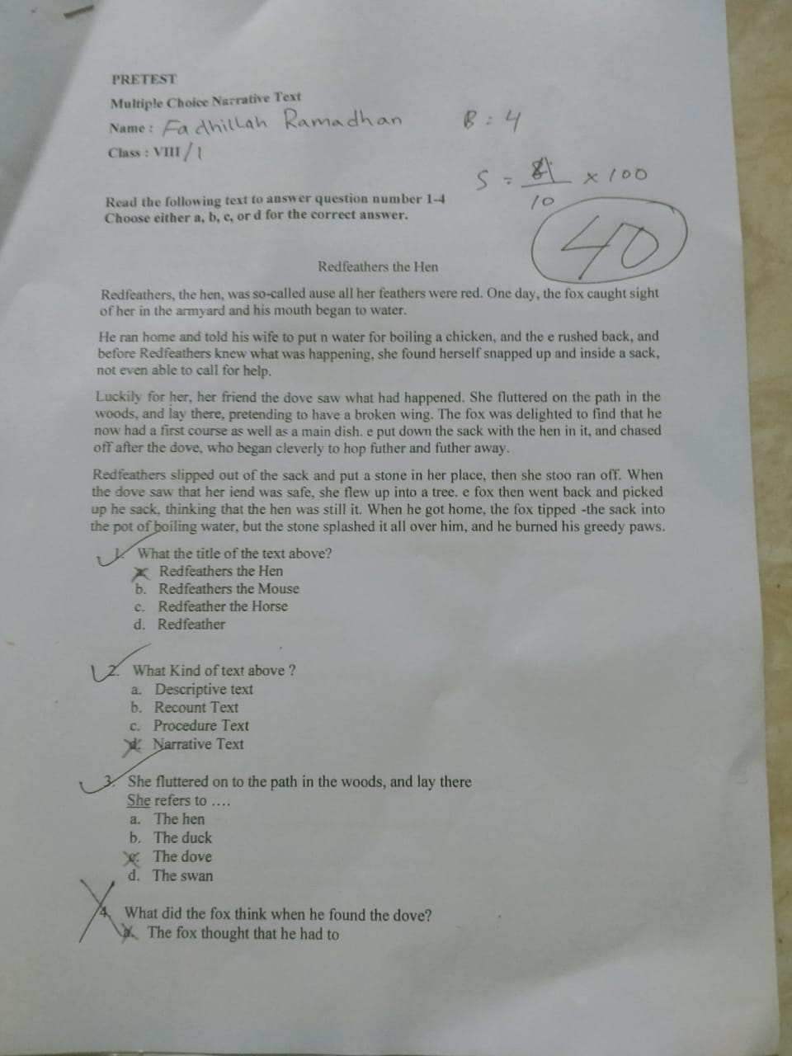

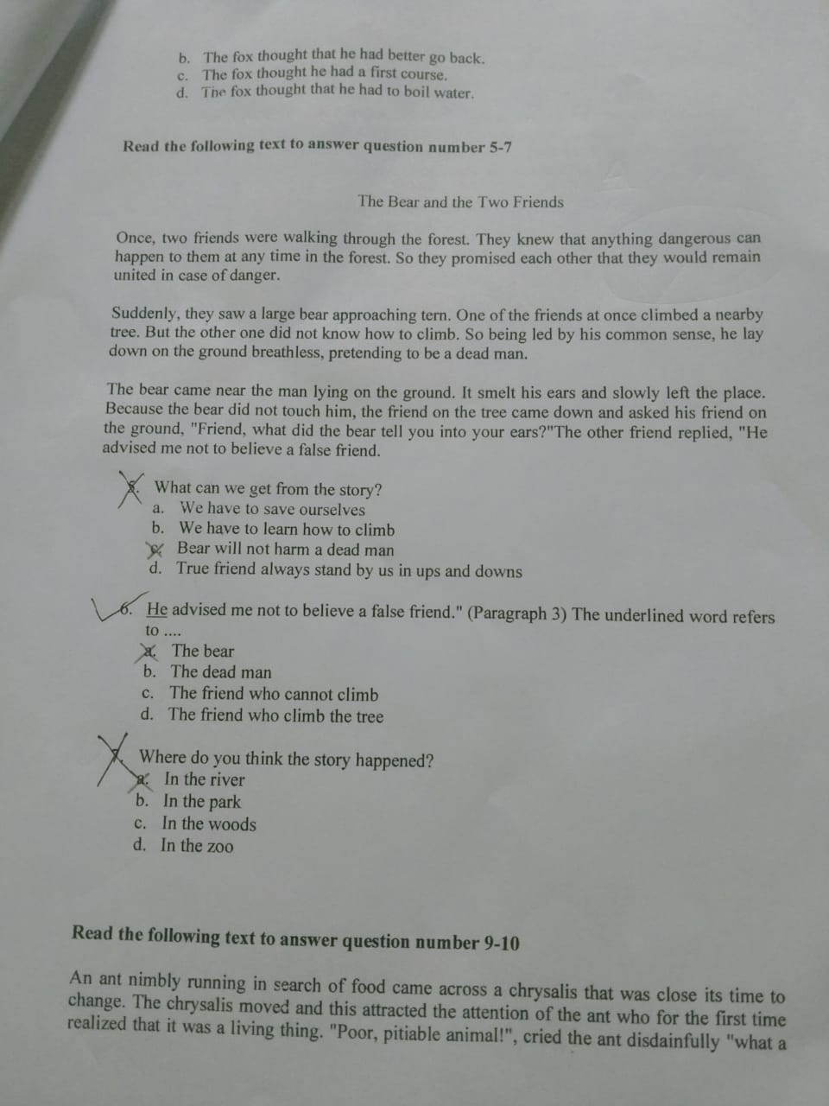

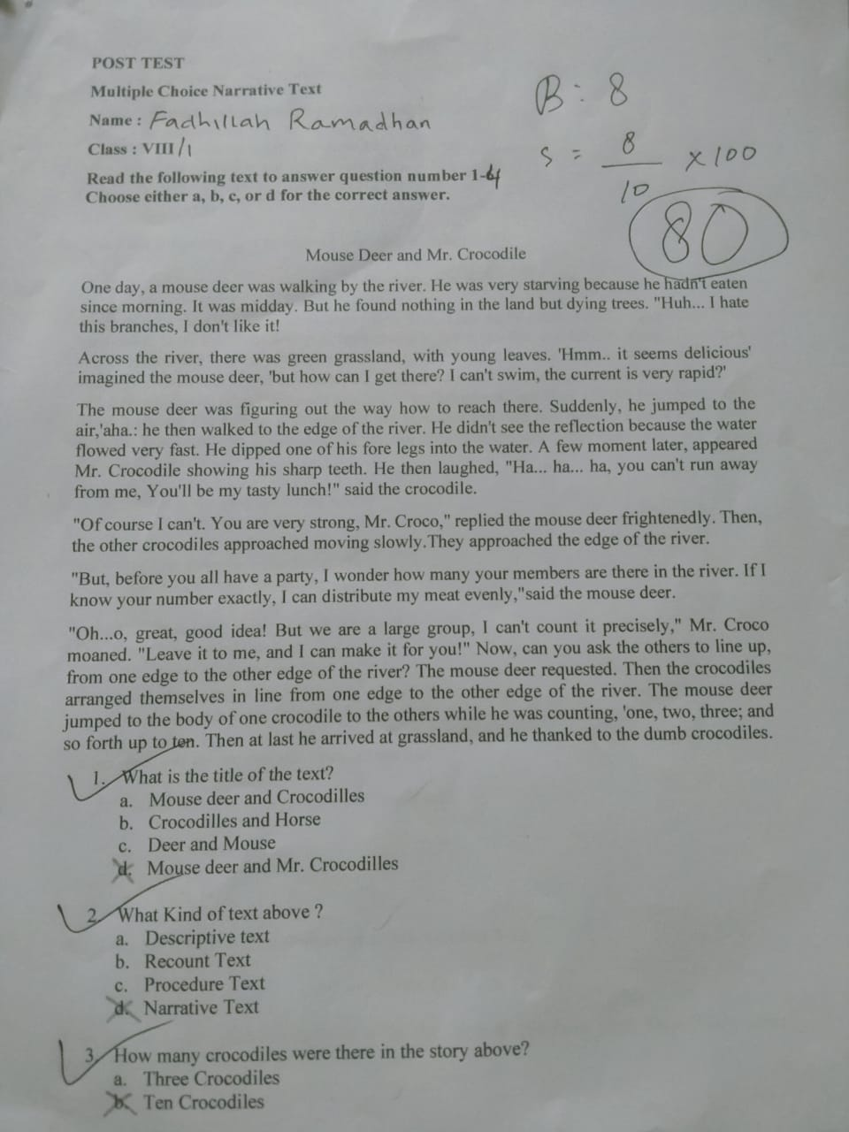

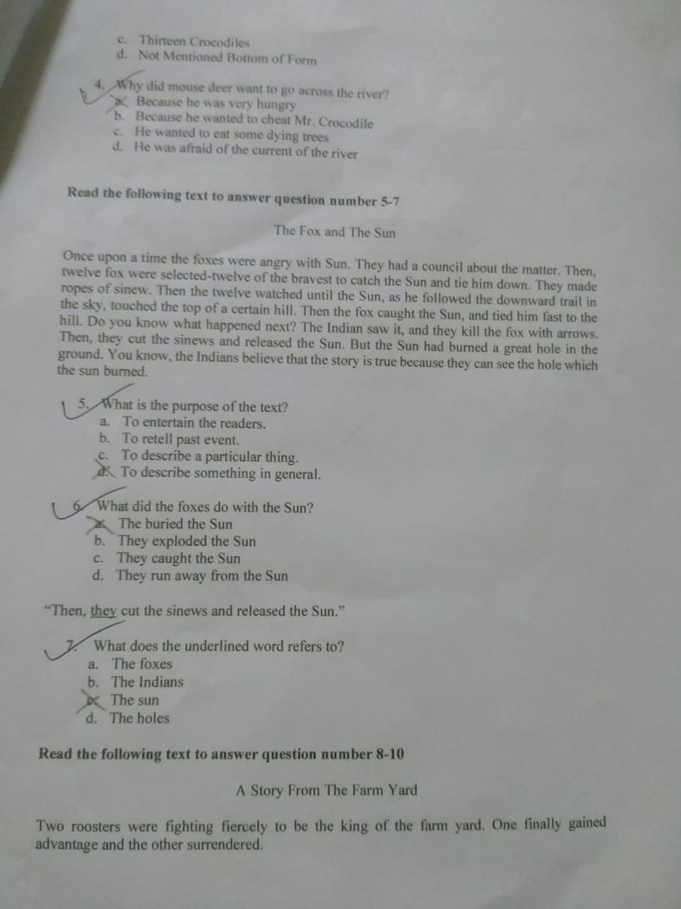

APPENDIX VI

DOCUMENTATION OF EXPERIMENTAL CLASS
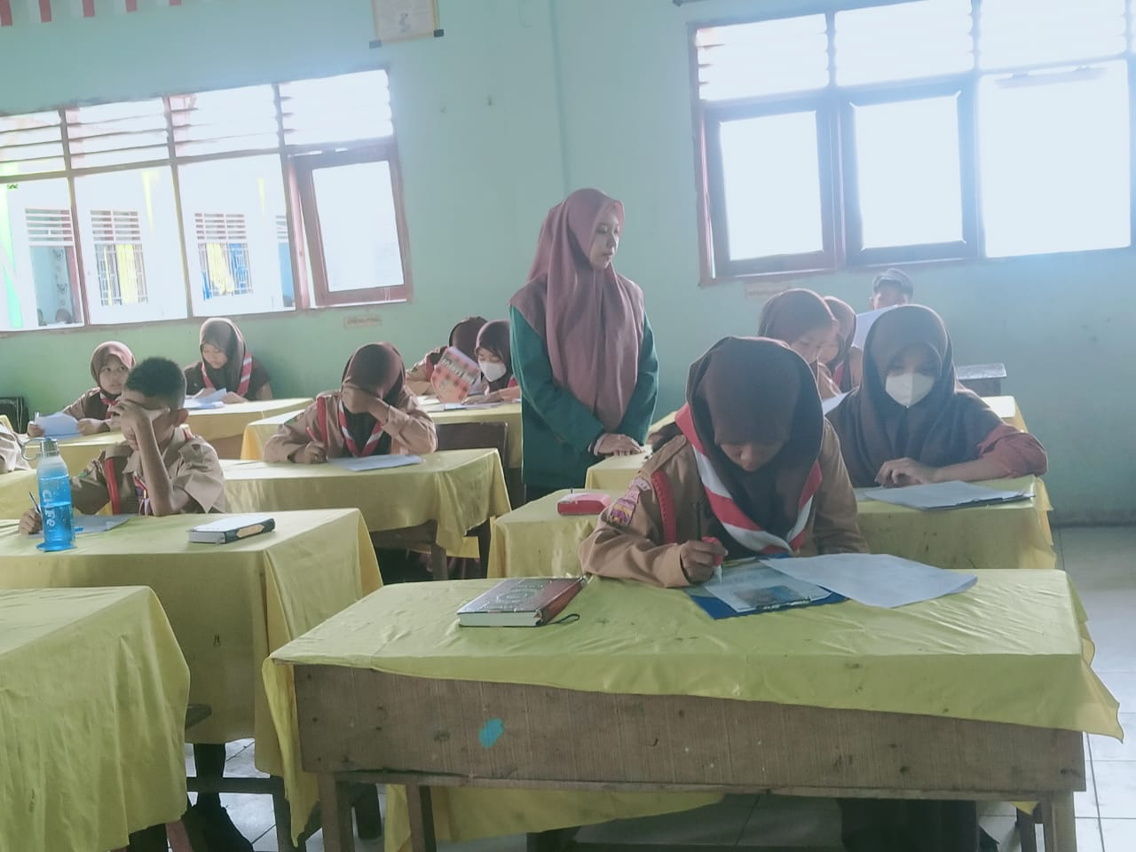

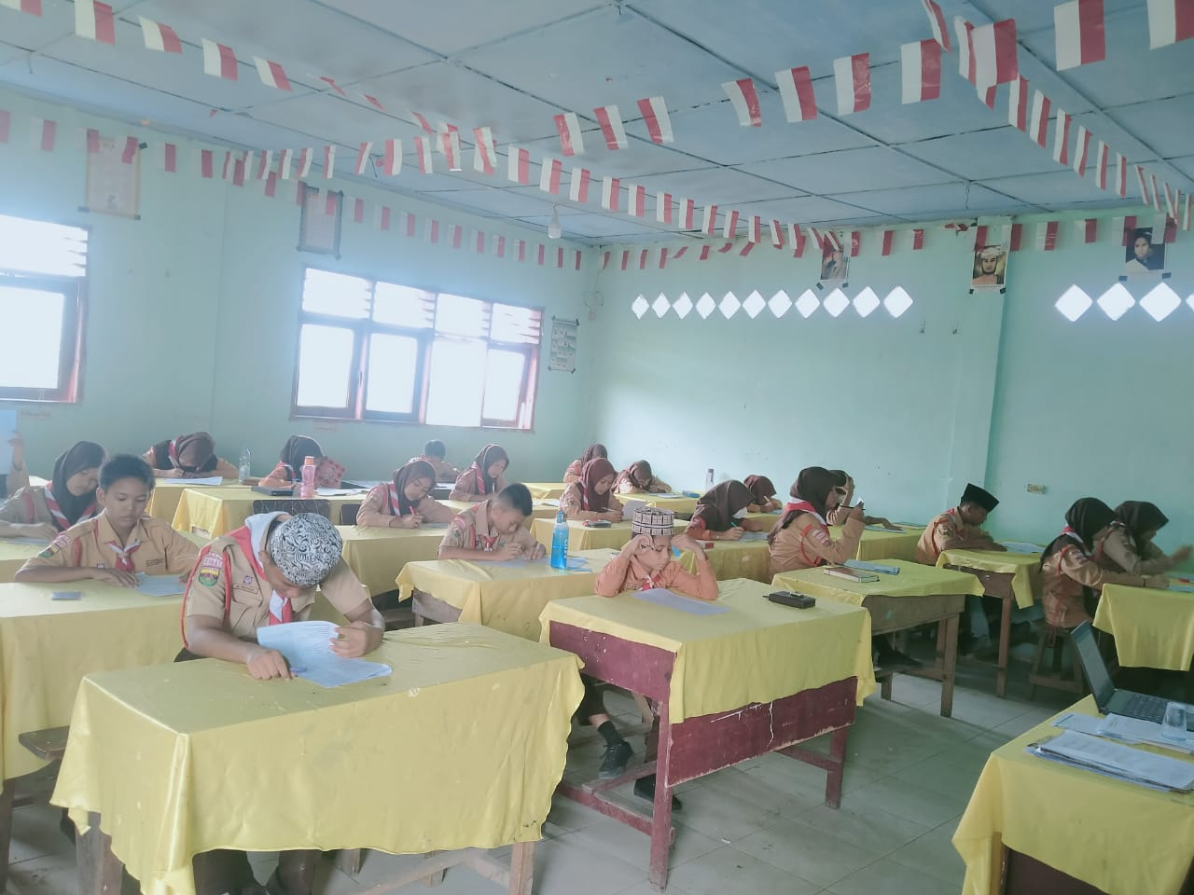

APPENDIX VII

DOCUMENTATION OF CONTROL CLASS
