THE EFFECT OF USING CARTOON FILM ON STUDENTS’ ENGLISH VOCABULARY MASTERY

A THESIS

BY

SELLY ARISKA
NPM 181224038

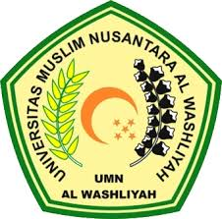

ENGLISH EDUCATION DEPARTMENT FACULITY OF TEACHER TRAINING AND ADUCATION UNIVERSITAS
MUSLIM NUSANTARA AL WASLIYAH
MEDAN
2022
THE EFFECT OF USING CARTOON FILM ON STUDENTS’ ENGLISH VOCABULARY MASTERY

A THESIS

Submitted to the Department of English Language Education in Partial Fulfillment of the Requirements for the Degree of
Bachelor of Education

BY

SELLY ARISKA
NPM 181224038

ENGLISH EDUCATION DEPARTMENT FACULITY OF TEACHER TRAINING AND ADUCATION UNIVERSITAS
MUSLIM NUSANTARA AL WASLIYAH
MEDAN
2022

