APPENDIX 1
LESSON PLAN

School : MTS. Yp.Haji Datuk Abdullah

Subject/Class : English/VIII

Skill : Vocabulary

Tame : 45 x 2 menit

Learning Material:Listen And Understanding Vocabulary

A.Core Competencies
- Living and practicing religious teachingsembraced
- Appreciate and practice honest behavior, discipline,responsibility, caring (tolerance, mutual cooperation), polite, confident,in interacting effectively with the social and natural environment inrange of association and existence.
- Understanding knowledge (factual, conceptual, andprocedural) based on his curiosity about science,technology, art, culture related to visible phenomena and events.
- Trying, processing, and presenting in a concrete realm (using,parse, assemble, modify, and create) and the abstract realm (writing, reading, counting, drawing, and composing) appropriatewith what is learned in school and other sources that are similar in terms ofview/theory.
B. Basic Competencies And Indicators of Competency Achievement:
Basic Competencies :

  - Grateful for the opportunity to learn English as a language
introduction to international communication embodied in the spirit ofstudy
  - Demonstrate polite and caring behavior in carrying out communicationinterpersonal relationships with teachers and friends.
1.3. Demonstrate honest, disciplined, confident, and responsible behavior
in carrying out transactional communication with teachers and friends.

1.4.Demonstrate responsible, caring, cooperative, and peace-loving behavior,in carryinout functional communication.

1.5. Understanding social functions, text structure, and linguistic elements in the textto state and ask the difference between singular and plural noun

Indicators:

1.1 Grateful for the opportunity to learn English as a language
introduction to international communication embodied in the spirit ofstudy
1.2 Demonstrate polite and caring behavior in carrying out relationships
with teachers and friends.

1.3. Demonstrate honest, disciplined, confident, and responsible behaviorin carrying out transactional communication with teachers and friends.

  - Demonstrate responsible, caring, cooperative, and peace-loving behavior,in carryingout functional communication.
1.5. Understanding social functions, text structure, and linguistic elements in theTextto state and ask for the name and number of animals, objects, andpublic buildings that are close to the daily life of students.

  - Compose spoken and written texts to state and ask namesanimals, objects, and public buildings that are close to student lifeeveryday life, taking into account the social function, text structure, and elements ofcorrect language and in context.

C. Learning Objectives:

- Capture some English vocabulary in the content of the story in the filmdisplayed correctly.

- Demonstrate polite and caring behavior in carrying out communicationabout the names and numbers of animals, objects, and public buildings.Understand the meaning or content of the story in the film correctlyidentify social functions, text structures, and linguistic elements of the text about the names and numbers of animals, objects, and public buildings.

D. Learning Method
Approach: Scientific approach
Media: laptop, speakers, infocus, film.

Learning Resources : frozen movie and vocabulary

E. Learning Step Post Test
Activity | Description | Time location
Preliminary | -Teacher greets  -The teacher asks the students to pray  -Teacher absent student  -Explaining the learning objectives | 10 minutes
Core | First meeting  - Observasi  - The teacher asks again the lessons that have been learned at the been learned at the previous meeting.  - The teacher will explain the material to be studied, namely the vocabulary section.  - Explain vocabulary material and its parts  - Ask  - The teacher asks that nouns, properties and verbs students know  - Exploration  - Student discuss with their classmates about vocabulary and adjectives and verbs  - -student look for various kins of vocabulary according to what they know  - Associate  - Divide student into 2 groups  - show frozen cartoon  Second meeting  - Observasi  - -The teacher asks again vocabulary, parts of vocabulary, and pronouns.  - -The teacher will explain what material will be explained.  - -The teacher gives an example of the lesson to be studied.  - Aks  - -The teacher asks again what vocabulary they know  - Exploration  - -Students observe the material about vocabulary and observe it.  - -Students understand about prnoun  - -Students look for vocabulary in the film that will be show.  - Associate  - -Students work on the questions that will be given. | 40 minutes

G. Rating
1. Types/techniques of assessment
- Knowledge aspect
-Type/technique of assessment : written test
- Skill Aspect
-Type of assessmest : Performance
- Attitude Aspect
-Type of Assessment : Observation, Peer Rating.
2. Instrument shape
a. Format : Written test (multiple choice questions)
3. Assessment rubic
Pronuncation, spellin and meaning, vocabulary.

Informations :
- Scoring guidelines
-For each correct answer =10
-Wrong answer = 0
Vaule = total of correct X 100
Total of item test

Medan,……………2022
Known by.

English Teacher The Reseacher

FitrahSundari, S.Pd Selly Ariska

Headmaster of MTS. Yp.H.Datuk Abdullah

WahonoSupranghadi, S.Ag.

APPENDIX 2
Vocabulary Test for Pre-Test and Post-Test (Control Class)
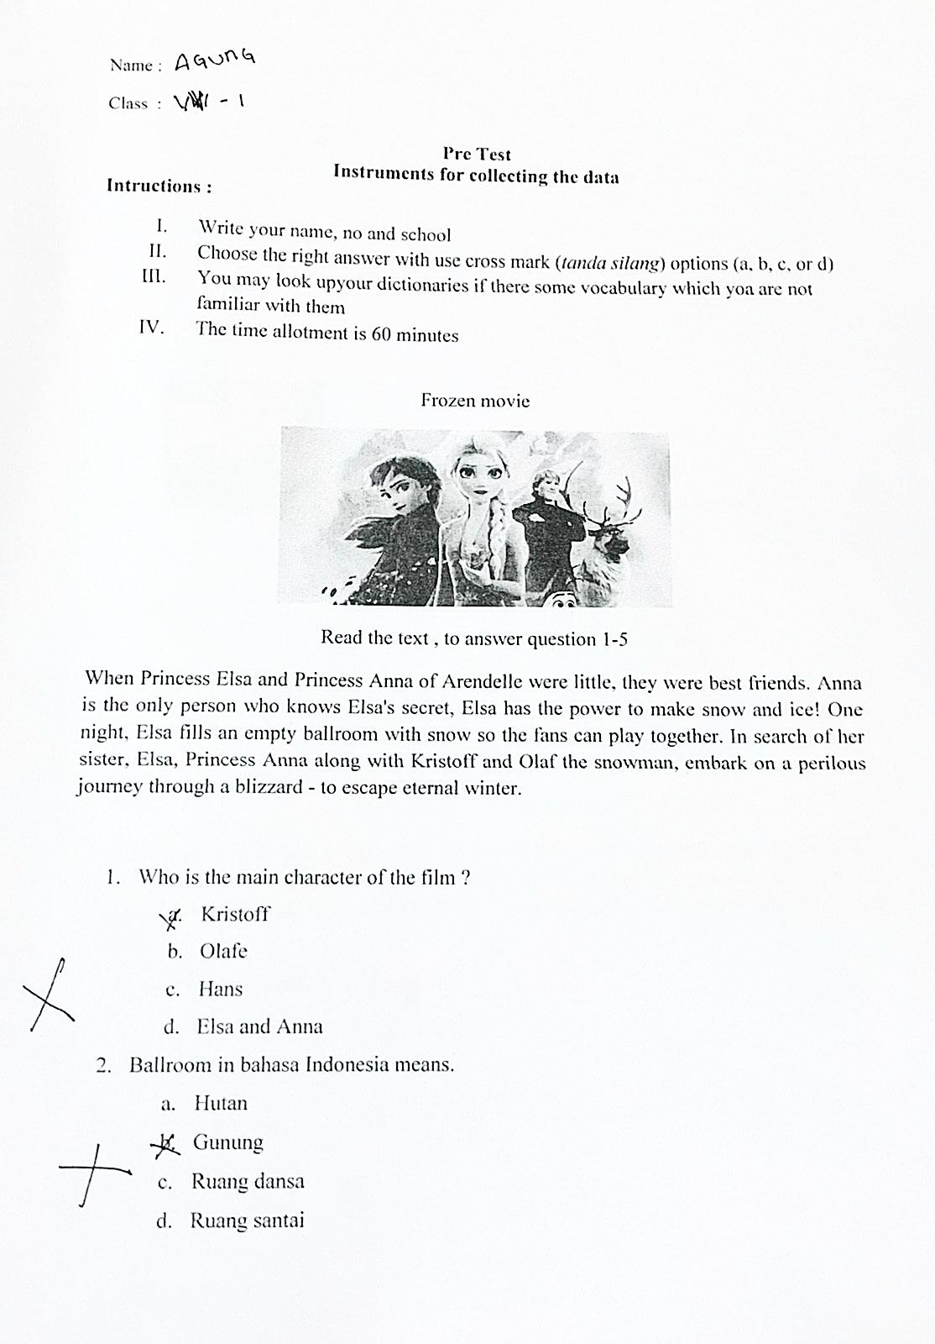

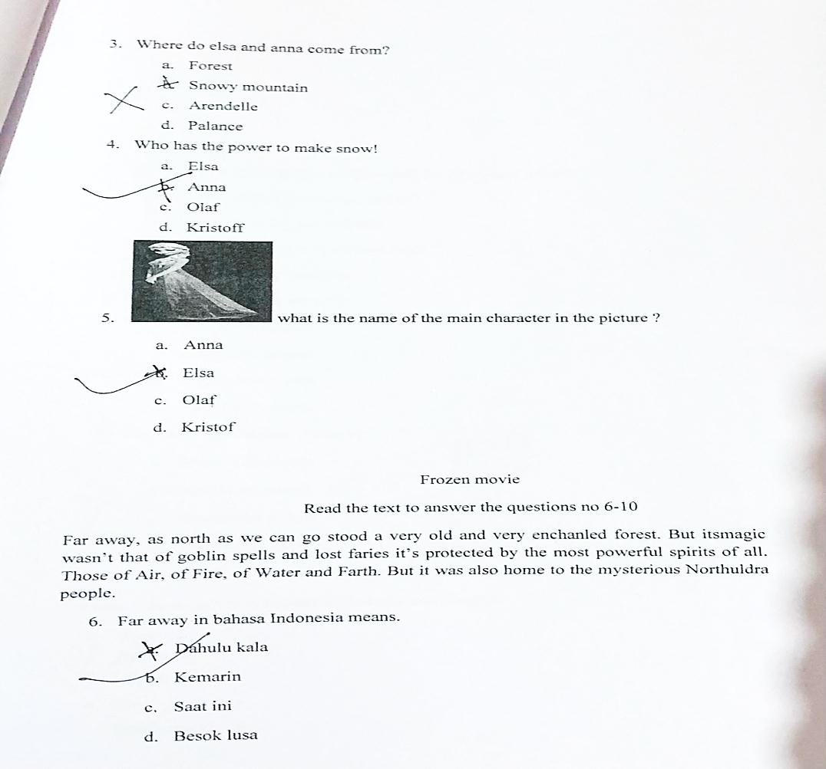

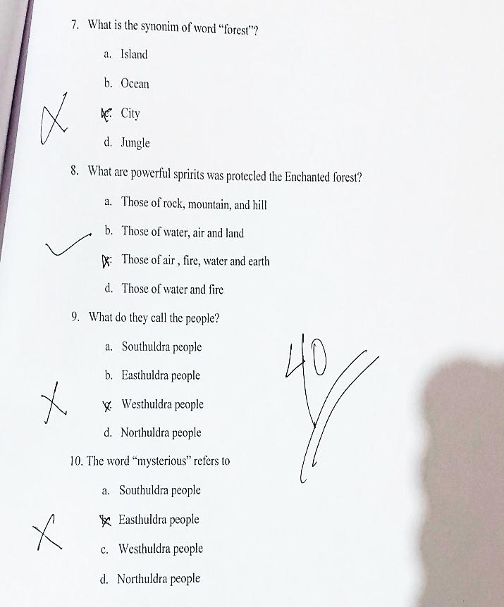

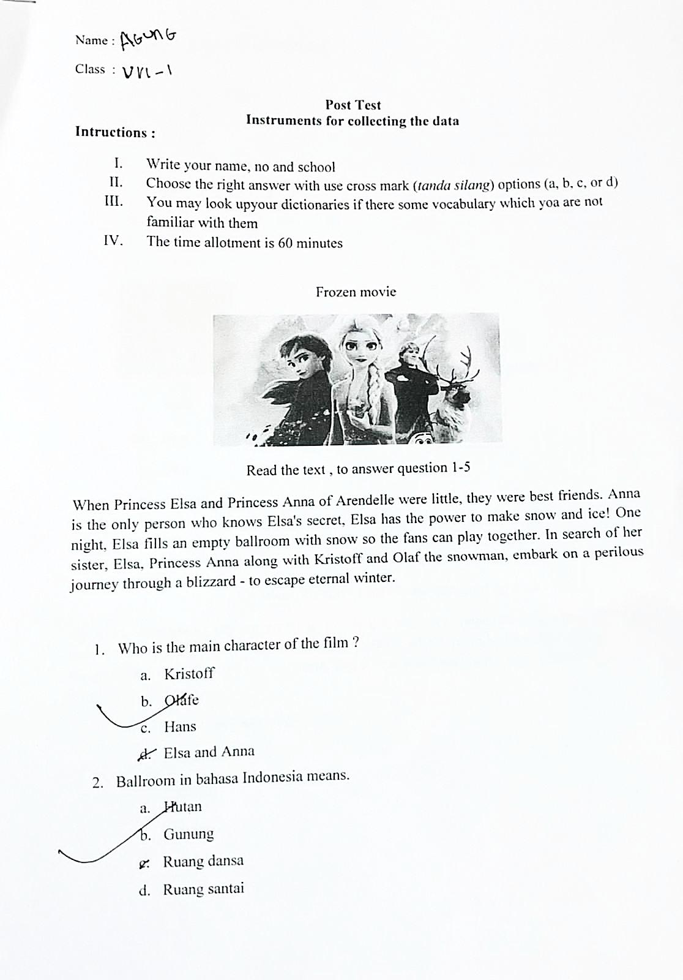

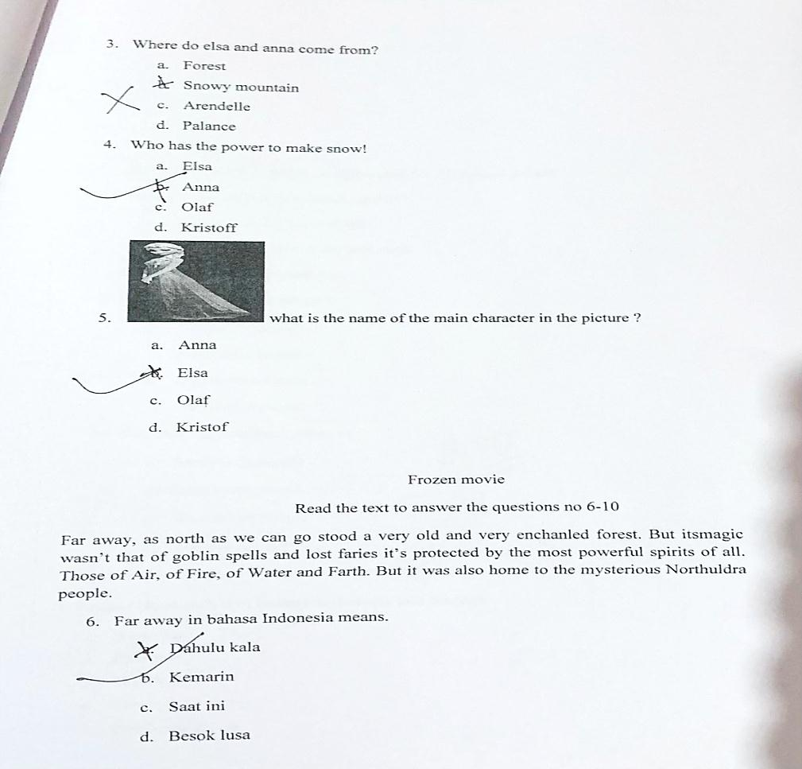

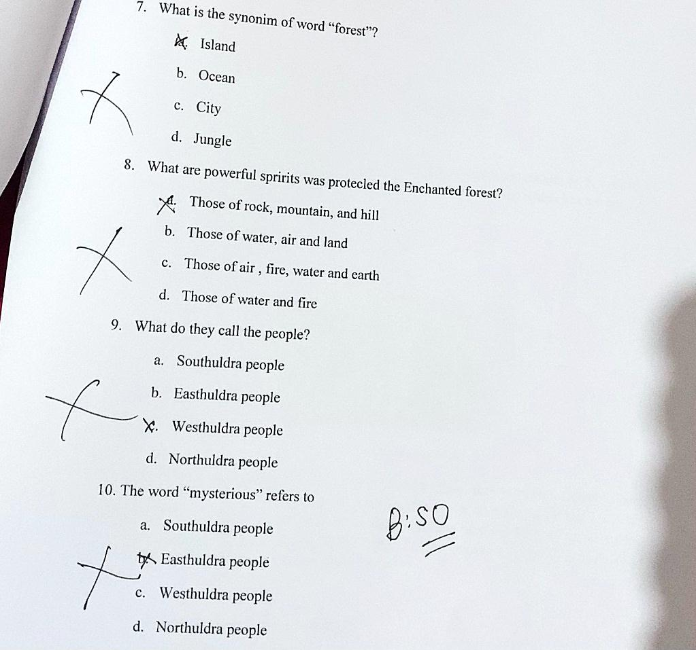

APPENDIX 3
Vocabulary Test for Pre-Test and Post-Test (Experimental Class)
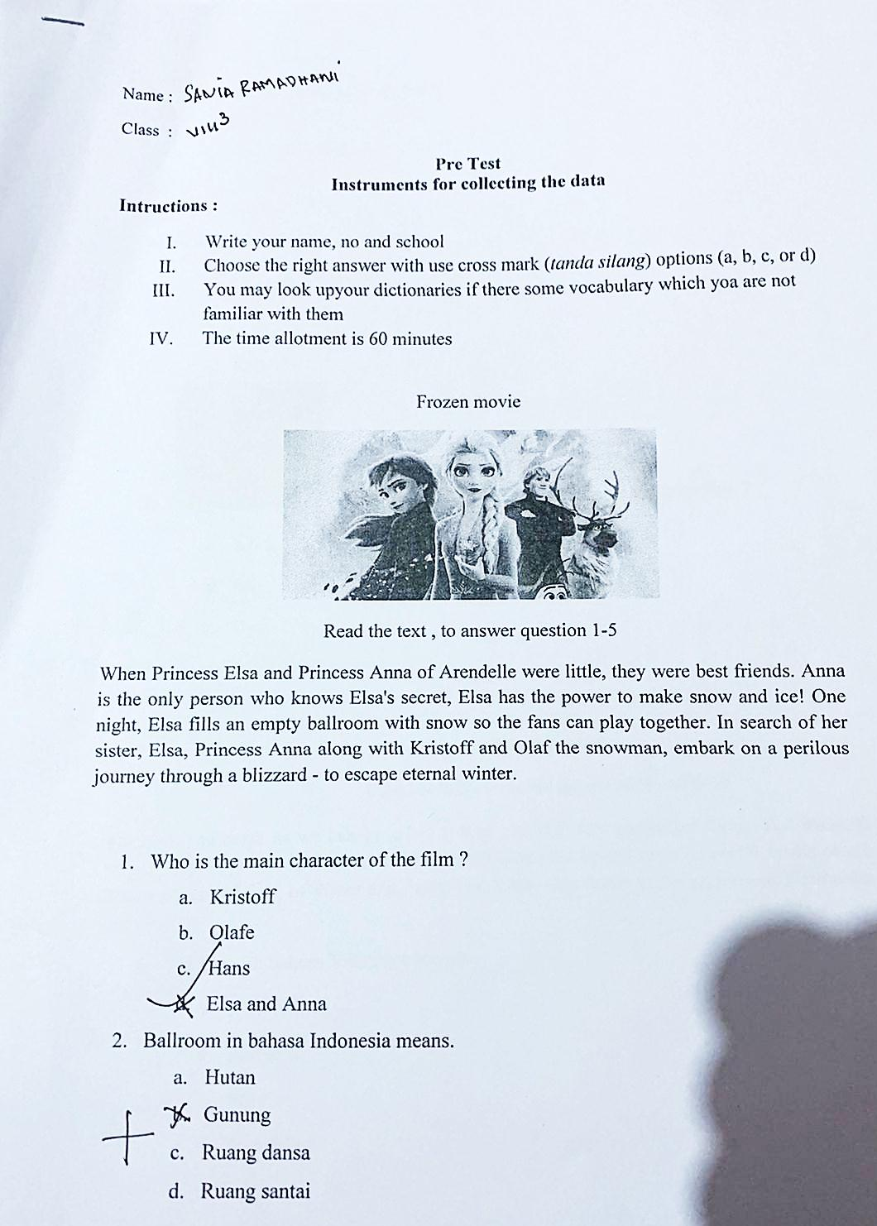

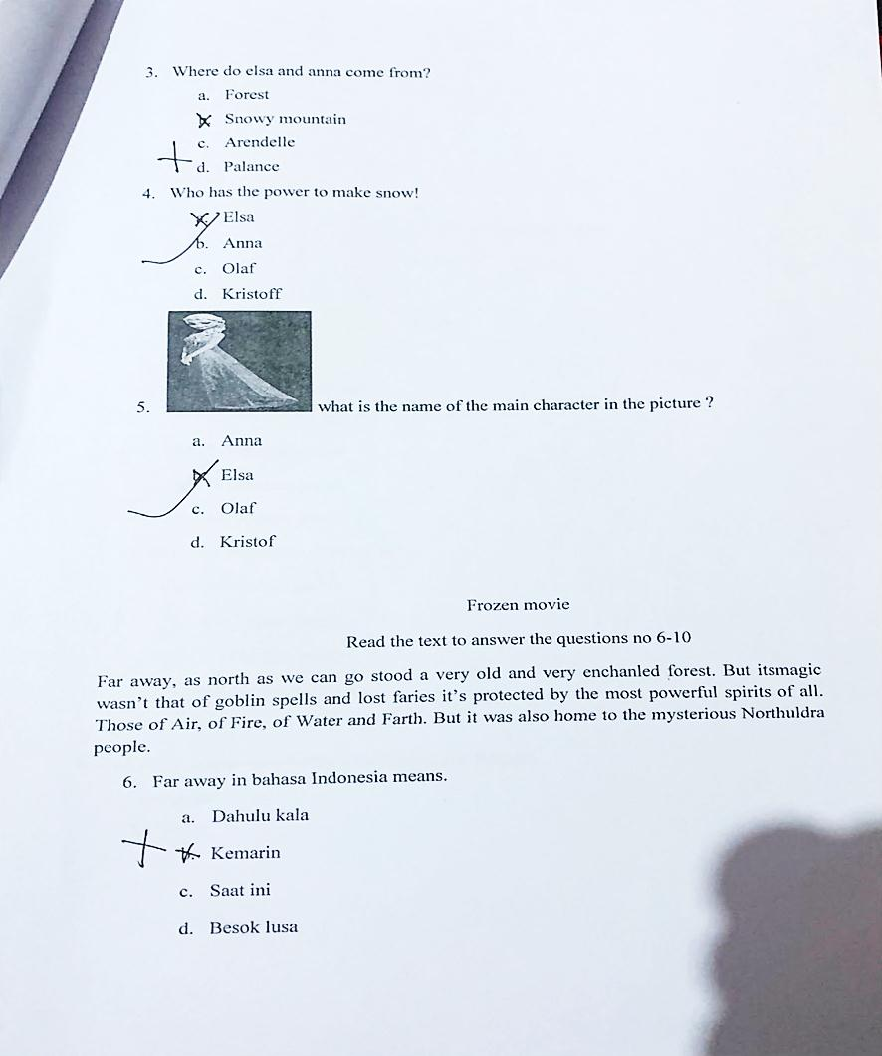

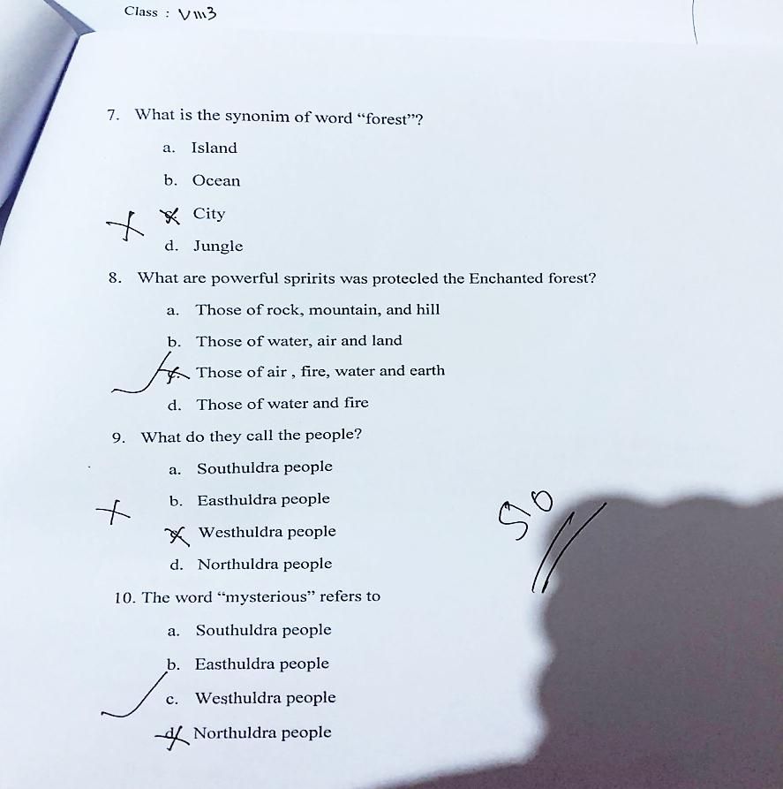

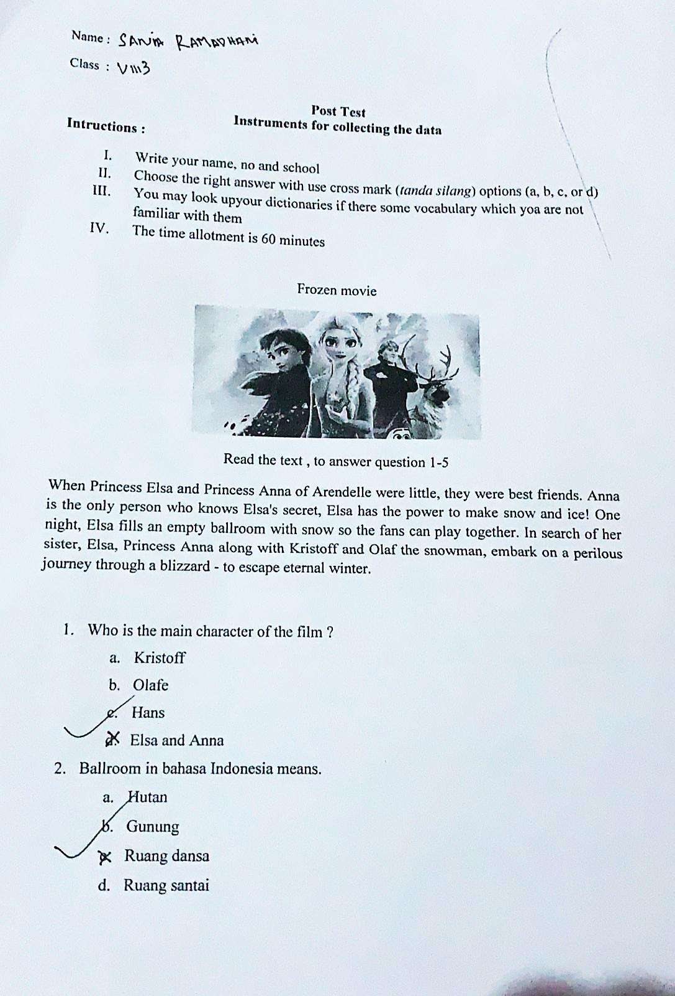

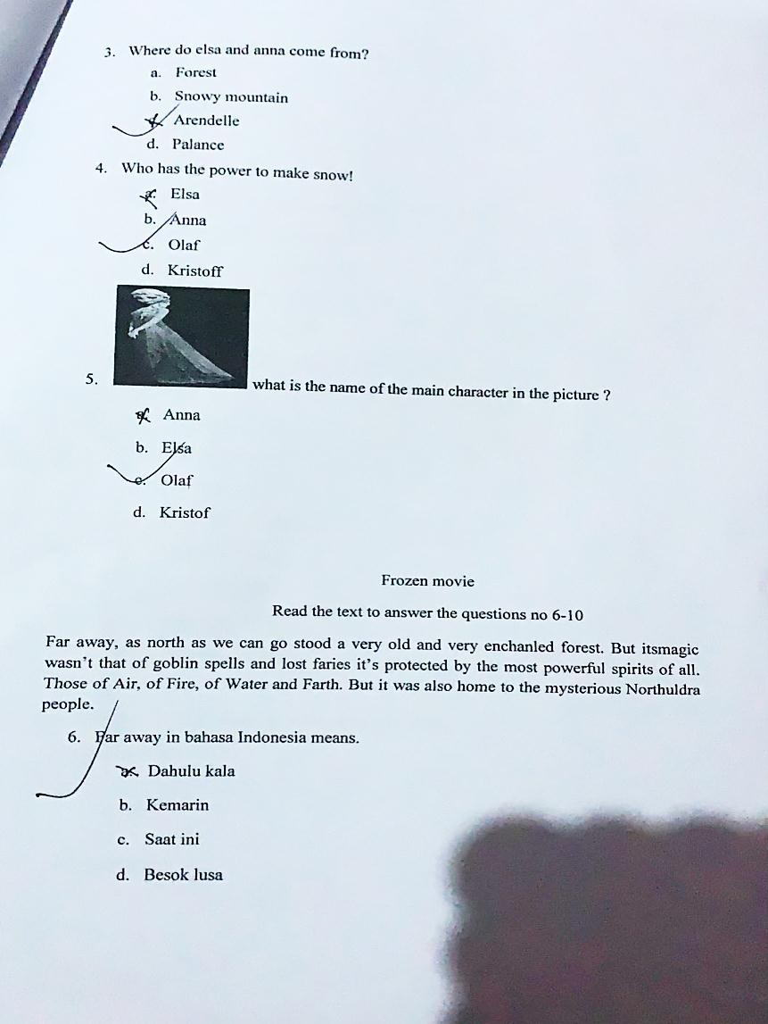

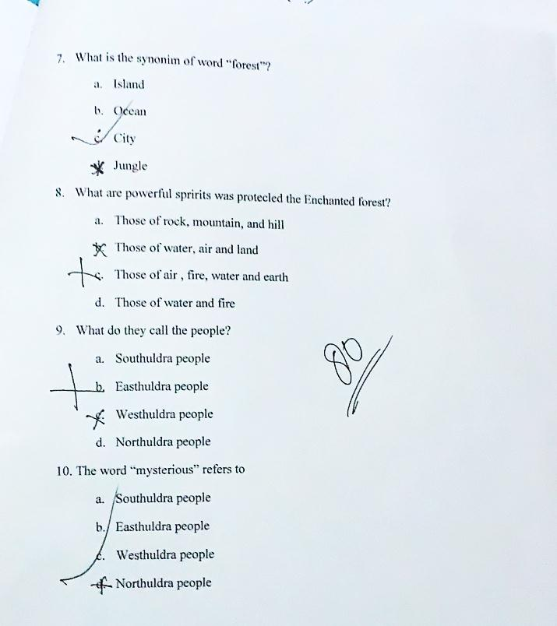

APPENDIX 4
DOCUMENTATION

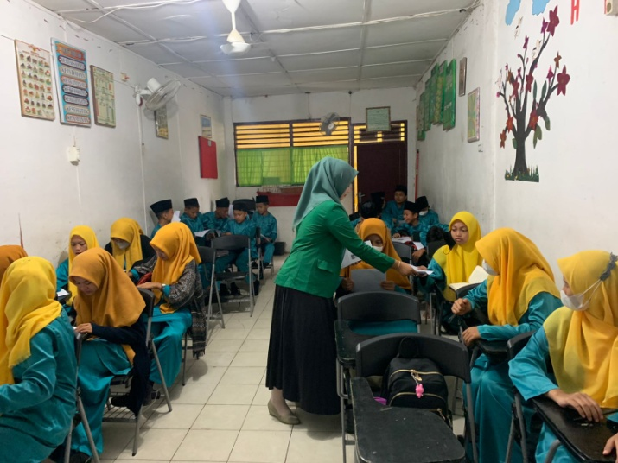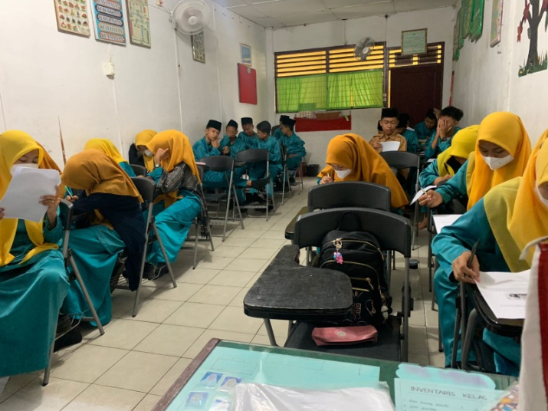
(Students in Control Class)

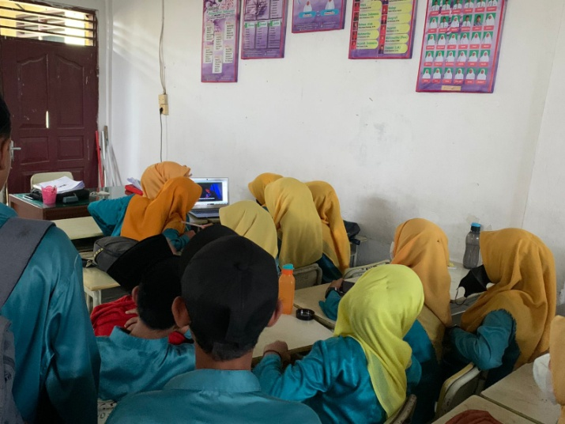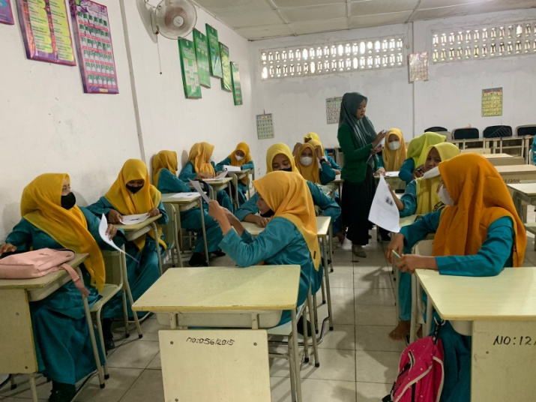
(Students in Experimental Class)

