APPENDIX 1
LESSON PLAN
(EXPERIMENTAL CLASS)
School : MAS YP. Haji Datuk Abdullah
Subject : English
Class : XI-IPA
Time : 2 x 45 minutes
Skill : Reading
Learning Material : Analytical Exposition Text

- Standard Competency
- Appreciate and practice the teachings of their religion.
- Appreciate and practice honest, disciplined, responsible, caring behavior (mutual cooperation, cooperation, tolerance, peace), polite, responsive and pro-active and show attitudes as part of the solution to various problems in interacting effectively with the social and natural environment as well as in placing oneself as a reflection of the nation in world relations.
- Understand, apply, analyze and evaluate factual, conceptual, procedural and metacognitive knowledge based on their curiosity about science, technology, art, culture, and humanities with insight into humanity, nationality, statehood, and civilization related to the causes of phenomena and events, and apply knowledge procedural in a specific field of study according to their talents and interests to solve problems
- Processing, reasoning, presenting, and creating in the concrete and abstract realms are related to the development of what they learn in school independently and to act effectively and creatively, and to be able to use methods according to scientific rules.

Basic Competence
- Be grateful for the opportunity to learn English as the language of instruction for international communication which is manifested in the spirit of learning.
- Demonstrate responsible, caring, cooperative, and peace-loving behavior, in carrying out functional communication.
- Analyzing the social function, text structure, and linguistic elements of the analytical exposition text on topics that are hotly discussed in general, according to context.
- Prepare analytical exposition texts, spoken and written, on topics that are hotly discussed in general, taking into account social functions, text structures, and linguistic elements that are correct and in context.

- Indicators
- Determining the main ideas
- Detail information
- Vocabulary
- Making inference
- Identifying reference

- Learning Objective
- Students are able to determine the main idea or idea of the analytical exposition text.
- Students know the information and details of the text.
- Students know new vocabulary.
- Students are able to make conclusions based on the opinions and thoughts of students.
- Students are able to analyze text instructions.

- Learning Material
Analytical Exposition Text
Definition of Analytical Exposition Text: Analytical exposition text is a text that elaborates the writer’s idea about the phenomenon surrounding. (Analytical Exposition Text adalah teks yang menguraikan gagasan penulis tentang fenomena disekitarnya).
Social function: is to persuade the reader that the idea is important matter. (Fungsi sosialnya adalah untuk meyakinkan pembaca bahwa gagasan itu penting).

Generic structure of Analytical Exposition Text:
- Thesis : Introducing the topic and indicating the
writer’s position.
- Argument 1 : Explaining the argument to support the
writer’s position.
- Argumen 2 : Explaining the other arguments to support
more on the writer’s position, etc.
- Reiteration : Restating the writer’s position.
Laguage features:
    - Using relational process
    - Using internal conjunction
    - Using casual conjunction
The Importance of Reading

Thesis
According to UNESCO data, Indonesian people's interest in reading is very concerning, only 0.001%. This means that out of 1,000 Indonesians, only 1 person is an avid reader. Why is that? However, reading is an important aspect of life.
Arguments
Firstly, by reading we can get a lot of information about many things in the world such as science, technology, sports, arts and culture.
Secondly, by reading we can get a lot of news and knowledge about something happening in any part of the world which we can see directly.
Thirdly, reading can give us pleasure. When we are tired, we can read books, newspapers or magazines on the entertainment column such as short stories, comedies or quizzes to make us relax.
Fourthly, reading can also take us to other parts of the world. By reading a book about Irian Jaya we may feel that we’re really sitting in the jungles, not at home in our rooms.
Reiteration
Based on the facts above, it is obvious that everyone needs to read books, newspapers, magazines or others to get knowledge, news, information and also entertainment. In other words, we can say reading is truly important in our life.

Mind Mapping
Mind mapping is a creative note taking technique in a visualization and graphic to make people easy to get and understand information.
How To Make?
- Start in the centre of the landscape blank paper.
- Make a central image that represents the topic about which you are writing or thinking.
- Use multiple colours throughout the mind map.
- The lines should be connected, starting from the central image.
- Make curve lines, not straight lines.
- Use a keyword in each line.
- Use images as much as you can.

Example:
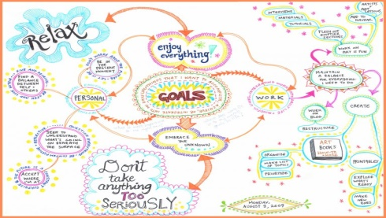

- Learning Method
- Methods : Lectures, discussions and assignments
- Strategy : Mind Mapping

- Learning Activities
LEARNING ACTIVITIES | CHARACTER
Opening (15 minutes)  Apperception  - The teacher opens the lesson by greeting and asking students how they are and ensuring that students are ready to take part in the lesson.  - Students pray together led by the class leader.  - The teacher checks student attendance.  - The teacher explains the definition, objectives, benefits and basic competencies of learning and motivates. | Curiosity
Core Activities (60 minutes)  a. Exploration  - The teacher explains the Analytical exposition text material to students and the main ideas, detailed information from certain information in the Analytical exposition text.  - The teacher will motivate students by asking some questions related to the topic of teaching materials.  b. Elaboration  - The teacher explains the Analytical exposition text material that will be studied.  - The teacher asks the students to convey the difficulties in understanding the Analytical exposition text material.  - The teacher gives the Analytical exposition text reading to the students to read and the students read the text under the supervision of the teacher.  - After the teacher distributes the reading text and asks students to sit in pairs to discuss the reading material that has been given with their respective partners.  - Students are asked to exchange ideas and answer the questions that have been distributed.  c. Confirmation  - Each student collects the questions that have been answered. | Critical  Think catch  Cooperation  Concentration  Appreciate friends
Closing (15 minutes)  - The teacher checks and rechecks the results of student work.  - The teacher and students conclude the learning material.  - Teachers and students evaluate. | Responsibility

- Learning Tool/Resources
- Media/Tool:
- Whiteboard, marker
- Infocus
- Laptop
- Student worksheet
- The assessment sheet
- Learning Resources:
- English textbooks/textbooks
- Analytical exposition text from the internet
- Dictionary

Assesment
- Knowledge Assessment
Technique : Written Test
Format : Multiple Choice
- Skills Assessment
Technique : Reading
Instruments : Assignments
  - Reading text
  - Practice understanding the content of the text, finding and answering questions.

- Scoring Guidelines
Scores for Pre Test and Post Test questions
Score 1 question :
Maximum score : 100
Final score : $\frac{correct answer}{maximum score (100)} X 100$

Medan, 17 Mei 2022
Known by,
English Teacher The Reseacher

KASI SETIANI, S.Pd FAUZIAH

Headmaster of MAS YP. Haji Datuk Abdullah

FADILLAH ADHA NASUTION, S.Pd.I.

APPENDIX 2
LESSON PLAN
(CONTROL CLASS)
School : MAS YP. Haji Datuk Abdullah
Subject : English
Class : XI-IPS
Time : 2 x 45 minutes
Skill : Reading
Learning Material : Analytical Exposition Text

- Standard Competency
1. Appreciate and practice the teachings of their religion.
2. Appreciate and practice honest, disciplined, responsible, caring behavior (mutual cooperation, cooperation, tolerance, peace), polite, responsive and pro-active and show attitudes as part of the solution to various problems in interacting effectively with the social and natural environment as well as in placing oneself as a reflection of the nation in world relations.
3. Understand, apply, analyze and evaluate factual, conceptual, procedural and metacognitive knowledge based on their curiosity about science, technology, art, culture, and humanities with insight into humanity, nationality, statehood, and civilization related to the causes of phenomena and events, and apply knowledge procedural in a specific field of study according to their talents and interests to solve problems.
4. Processing, reasoning, presenting, and creating in the concrete and abstract realms are related to the development of what they learn in school independently and to act effectively and creatively, and to be able to use methods according to scientific rules.

Basic Competence
1. Be grateful for the opportunity to learn English as the language of instruction for international communication which is manifested in the spirit of learning.
2. Demonstrate responsible, caring, cooperative, and peace-loving behavior, in carrying out functional communication.
3. Analyzing the social function, text structure, and linguistic elements of the analytical exposition text on topics that are hotly discussed in general, according to context.
4. Prepare analytical exposition texts, spoken and written, on topics that are hotly discussed in general, taking into account social functions, text structures, and linguistic elements that are correct and in context.

- Indicators
1. Determining the main ideas
2. Detail information
3. Vocabulary
4. Making inference
5. Identifying reference

- Learning Objective
1. Students are able to determine the main idea or idea of the analytical exposition text.
2. Students know the information and details of the text.
3. Students know new vocabulary.
4. Students are able to make conclusions based on the opinions and thoughts of students.
5. Students are able to analyze text instructions.

- Learning Material
Analytical Exposition Text
Definition of Analytical Exposition Text: Analytical exposition text is a text that elaborates the writer’s idea about the phenomenon surrounding. (Analytical Exposition Text adalah teks yang menguraikan gagasan penulis tentang fenomena disekitarnya).
Social function: is to persuade the reader that the idea is important matter. (Fungsi sosialnya adalah untuk meyakinkan pembaca bahwa gagasan itu penting).

Generic structure of Analytical Exposition Text:
- Thesis : Introducing the topic and indicating the
writer’s position.
- Argument 1 : Explaining the argument to support the
writer’s position.
- Argumen 2 : Explaining the other arguments to support
more on the writer’s position, etc.
- Reiteration : Restating the writer’s position.
Laguage features:
    - Using relational process
    - Using internal conjunction
    - Using casual conjunction

Learning English
Learning English through music and songs can be very enjoyable. You can mix pleasure with learning when you listen to a song and exploit the song as a means to your English progress. Some underlying reason can be drawn to support the idea why we use songs in language learning.
Firstly, “the song stuck in my head” Phenomenon (the echoing in our minds of the last song we heard after leaving a restaurant, shopping malls, etc) can be both enjoyable and sometimes unnerving. This phenomenon also seems to reinforce the idea that songs work on our short-and-long term memory.
Secondly, songs in general also use simple conversational language, with a lot of repetition, which is just what many learners look for sample text. The fact that they are effective makes them many times more motivating than other text. Although usually simple, some songs can be quite complex syntactically, lexically and poetically, and can be analyzed in the same way as any other literary sample.
Furthermore, song can be appropriated by listener for their own purpose. Most pop songs and probably many other types don’t have precise people, place or time reference.
In addition, songs are relaxing. They provide variety and fun, and encourage harmony within oneself and within one group. Little wonder they are important tools in sustaining culture, religion, patriotism and yeas, even revolution.
Last but not least, there are many learning activities we can do with songs such as studying grammar, practicing selective listening comprehension, translating songs, learning vocabulary, spelling and culture.
From the elaboration above, it can be concluded that learning through music and songs, learning English can be enjoyable and fun.

The Importance of Reading

According to UNESCO data, Indonesian people's interest in reading is very concerning, only 0.001%. This means that out of 1,000 Indonesians, only 1 person is an avid reader. Why is that? However, reading is an important aspect of life.
Firstly, by reading we can get a lot of information about many things in the world such as science, technology, sports, arts and culture.
Secondly, by reading we can get a lot of news and knowledge about something happening in any part of the world which we can see directly.
Thirdly, reading can give us pleasure. When we are tired, we can read books, newspapers or magazines on the entertainment column such as short stories, comedies or quizzes to make us relax.
Fourthly, reading can also take us to other parts of the world. By reading a book about Irian Jaya we may feel that we’re really sitting in the jungles, not at home in our rooms.
Based on the facts above, it is obvious that everyone needs to read books, newspapers, magazines or others to get knowledge, news, information and also entertainment. In other words, we can say reading is truly important in our life.

- Learning Method
1. Methods : Lectures, discussions and assignments
2. Strategy : Explanation

- Learning Activities
LEARNING ACTIVITIES | CHARACTER
Opening (15 minutes)  Apperception  - The teacher opens the lesson by greeting and asking students how they are and ensuring that students are ready to take part in the lesson.  - Students pray together led by the class leader.  - The teacher checks student attendance.  - The teacher explains the definition, objectives, benefits and basic competencies of learning and motivates. | Curiosity
Core Activities (60 minutes)  a. Exploration  - The teacher explains the Analytical exposition text material to students and the main ideas, detailed information from certain information in the Analytical exposition text.  - The teacher will motivate students by asking some questions related to the topic of teaching materials.  b. Elaboration  - The teacher explains the Analytical exposition text material that will be studied.  - The teacher asks the students to convey the difficulties in understanding the Analytical exposition text material.  - The teacher gives the Analytical exposition text reading to the students to read and the students read the text under the supervision of the teacher.  - After the teacher distributes the reading text and asks students to sit in pairs to discuss the reading material that has been given with their respective partners.  - Students are asked to exchange ideas and answer the questions that have been distributed.  c. Confirmation  - Each student collects the questions that have been answered. | Critical  Think catch  Cooperation  Concentration  Appreciate friends
Closing (15 minutes)  - The teacher checks and rechecks the results of student work.  - The teacher and students conclude the learning material.  - Teachers and students evaluate. | Responsibility
- Learning Tool/Resources
1. Media/Tool:
- Whiteboard, marker
- Student worksheet
- The assessment sheet
2. Learning Resources:
- English textbooks/textbooks
- Analytical exposition text from the internet
- Dictionary

Assesment
1. Knowledge Assessment
Technique : Written Test
Format : Multiple Choice
2. Skills Assessment
Technique : Reading
Instruments : Assignments
  - Reading text
  - Practice understanding the content of the text, finding and answering questions.
- Scoring Guidelines
Scores for Pre Test and Post Test questions
Score 1 question :
Maximum score : 100
Final score : $\frac{correct answer}{maximum score (100)} X 100$

Medan, 17 Mei 2022
Known by,
English Teacher The Reseacher

KASI SETIANI, S.Pd FAUZIAH

Headmaster of MAS YP. Haji Datuk Abdullah

FADILLAH ADHA NASUTION, S.Pd.I.
APPENDIX 3
Read the following text to answer questions number 1 to 4.
Learning English
Learning English through music and songs can be very enjoyable. You can mix pleasure with learning when you listen to a song and exploit the song as a means to your English progress. Some underlying reason can be drawn to support the idea why we use songs in language learning.
Firstly, “the song stuck in my head” Phenomenon (the echoing in our minds of the last song we heard after leaving a restaurant, shopping malls, etc) can be both enjoyable and sometimes unnerving. This phenomenon also seems to reinforce the idea that songs work on our short-and-long term memory.
Secondly, songs in general also use simple conversational language, with a lot of repetition, which is just what many learners look for sample text. The fact that they are effective makes them many times more motivating than other text. Although usually simple, some songs can be quite complex syntactically, lexically and poetically, and can be analyzed in the same way as any other literary sample.
Furthermore, song can be appropriated by listener for their own purpose. Most pop songs and probably many other types don’t have precise people, place or time reference.
In addition, songs are relaxing. They provide variety and fun, and encourage harmony within oneself and within one group. Little wonder they are important tools in sustaining culture, religion, patriotism and yeas, even revolution.
Last but not least, there are many learning activities we can do with songs such as studying grammar, practicing selective listening comprehension, translating songs, learning vocabulary, spelling and culture.
From the elaboration above, it can be concluded that learning through music and songs, learning English can be enjoyable and fun.
1. The type of the text above is.......
A. Analytical exposition
B. Hortatory exposition
C. Narrative
D. Explanation

2. What is the communicative purpose of the text?
A. To tell the reader about the songs
B. To persuade the reader to use songs in learning language
C. To show the reader the use of songs
D. To explain above the songs

3. The generic structures of the text are.....
A. Thesis – Arguments - Recommendation
B. General statement – Arguments
C. Newsworthy events – Background events - Sources
D. Thesis – Arguments - Reiteration

4. What is the text about?
A. Learning songs
B. Very enjoyable music
C. Using songs in language learning
D. Music listeners

Read the following text to answer questions number 5 to 8.
Use of Formalin and Other Additives in Foods
The use of formalin and other dangerous preservatives in food has been serious problem for three reasons.
Firstly, formalin is not for human beings, but it is for biological specimens and experiments. Formalin in Biology is a 10% solution of formaldehyde in water which is usually used as a disinfectant or to preserve biological specimens. Thus, it is not for food preservatives. Of course when it is used for food preservative, it will be very dangerous to human’s body.
The second reason is that there is no tight control from the government. This condition makes the people’s health is really in a threat. When the control is weak and the use formalin was spread wide all over the Indonesian regions, and these days it has really happened, the citizen's bodies will be badly contaminated with the poisons. Fish or food traders still sell their products which contain formalin and dangerous preservatives. Can you imagine that our digestive system absorbs the substance that should be for the human and animal corpses?
Considering the reasons, we can make a conclusion that the use of formalin and other preservatives is really a serious problem if it is not resolved immediately.
5. Why is formalin dangerous for human`s body?
A. It is not food preservatives
B. It is a disinfectant for human beings
C. It is used to preserve biological specimens
D. It is 10% solution of formaldehyde in water

6. The main idea of paragraph two is ....
A. The human`s bodies will be harmful after consuming the formalin
B. The government has not controlled the use of formalin firmly
C. The weak control of using formalin is not threatening the human
D. The human`s bodies will be harmful after consuming the formalin
7. Based on the facts above, the writer suggest that ....
A. People have to avoid consuming formalin in their food
B. The use of formal dehyde is necessary to control the food
C. People should add 100% solution of formaldehyde in water
D. The food preservative is required to make the food delicious

8. What is the generic structure of the text?
A. Arguments-Recommendation-Thesis
B. Thesis-Argument-Recommendation
C. Thesis-Argument-Reiteration
D. Thesis-Supporting Points-Contrasting Points-Reiteration

Read the following text to answer questions number 9 to 10.
The government should Provide rehabilitation Program for Drug Users
Drug users are actually ill people who need help. Rehabilitation is one of the main things they should get. Instead of punishing drug users in prisons, the government should provide rehabilitation for them.
Most users are actually victims of persuasive peddlers and they suffer from consuming the drugs. Therefore, by rehabilitating them, we are actually helping them out from traps, which they might accidentally step on.
If we only arrest drug users and send them to jail, this doesn't solve the problem as drug users will still be addicted unless proper rehabilitation is imposed to them. Providing rehabilitation programs for drug users and forcing them to participate in the programs is better than only arresting them and doing nothing to their illness. Only drug dealers, traffickers, and wholesalers should be imprisoned.
9. Sending the drug users to prison is not a good solution because ....
A. They can't consume harmful drugs
B. They are treated normally
C. They may still be infected with harmful drugs
D. They can be freed as soon as possible

10. "...drug users will still be addicted unless proper rehabilitation is imposed to them." (Paragraph 3) The underlined word is closest in meaning to ....
A. Influenced
B. Treated
C. Forced
D. Burdened

APPENDIX 4

ANSWERS KEY
- A
- B
- D
- C
- A
- B
- A
- C
- C
- C

APPENDIX 5
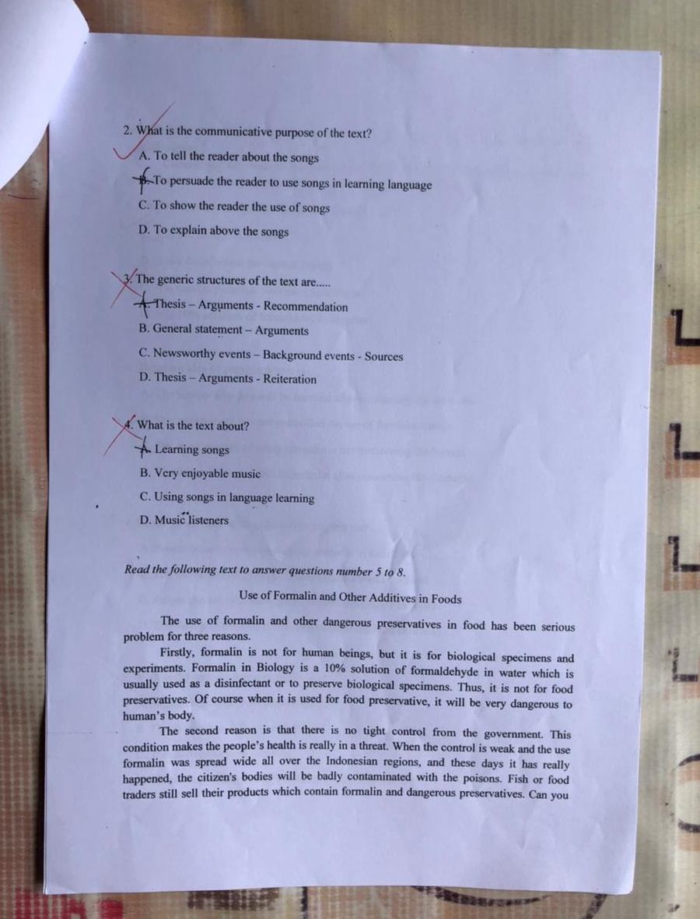
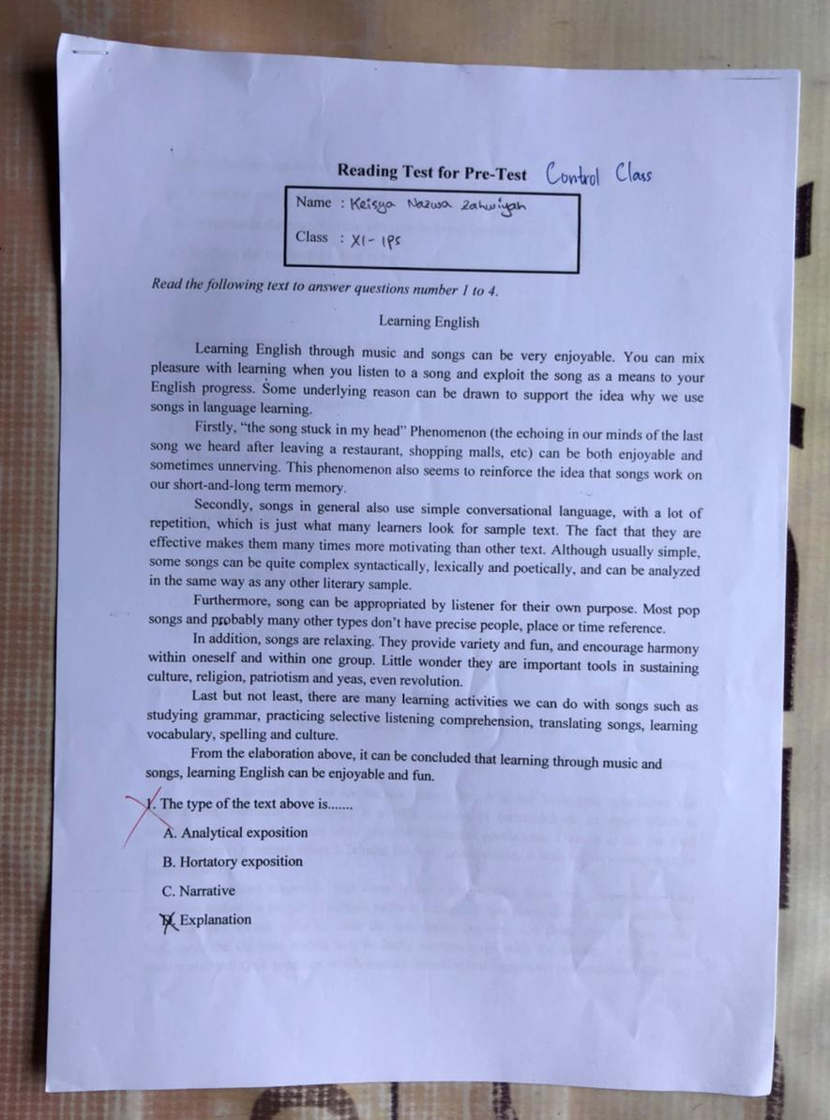

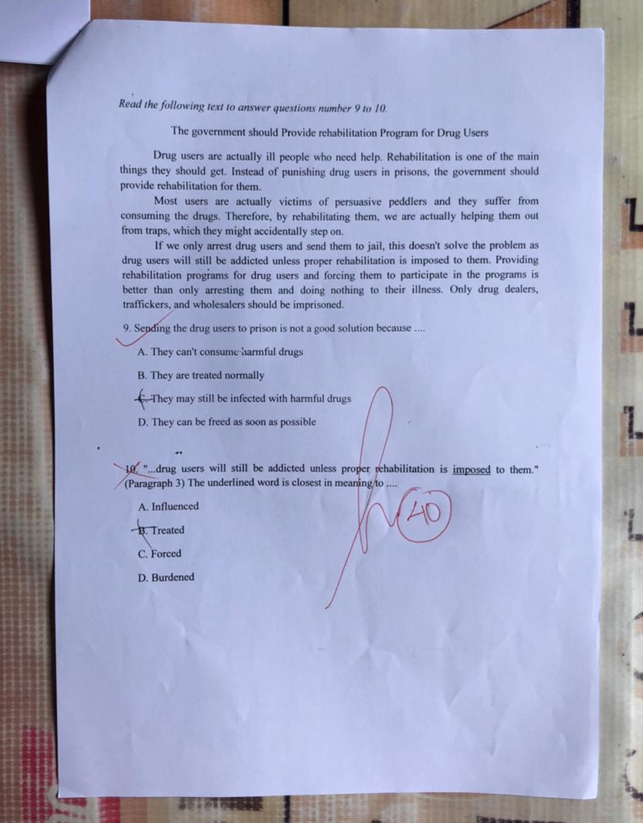
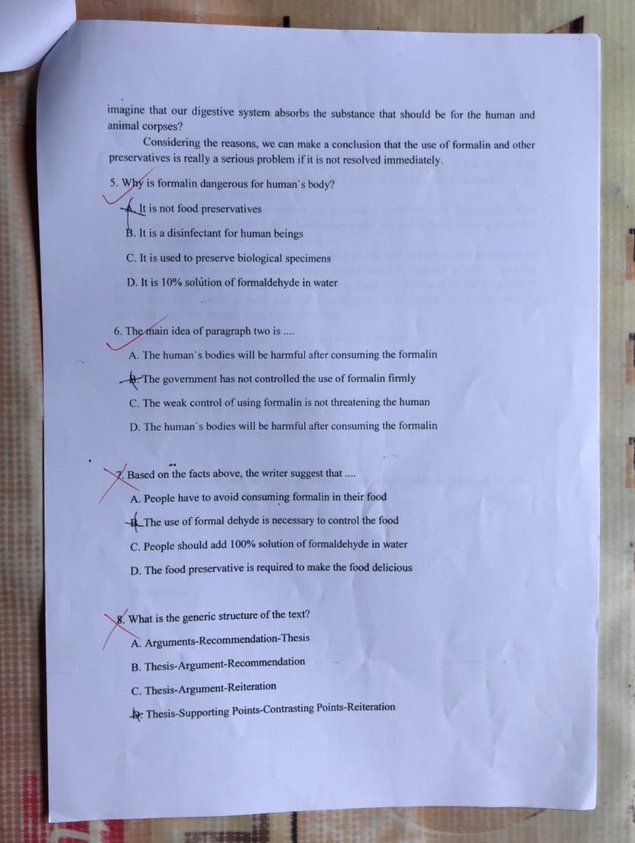

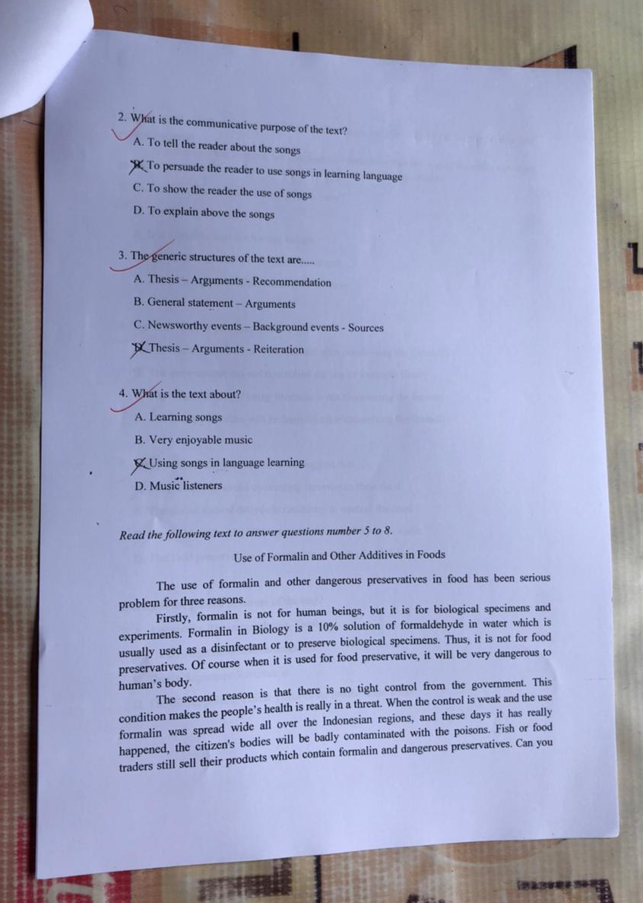
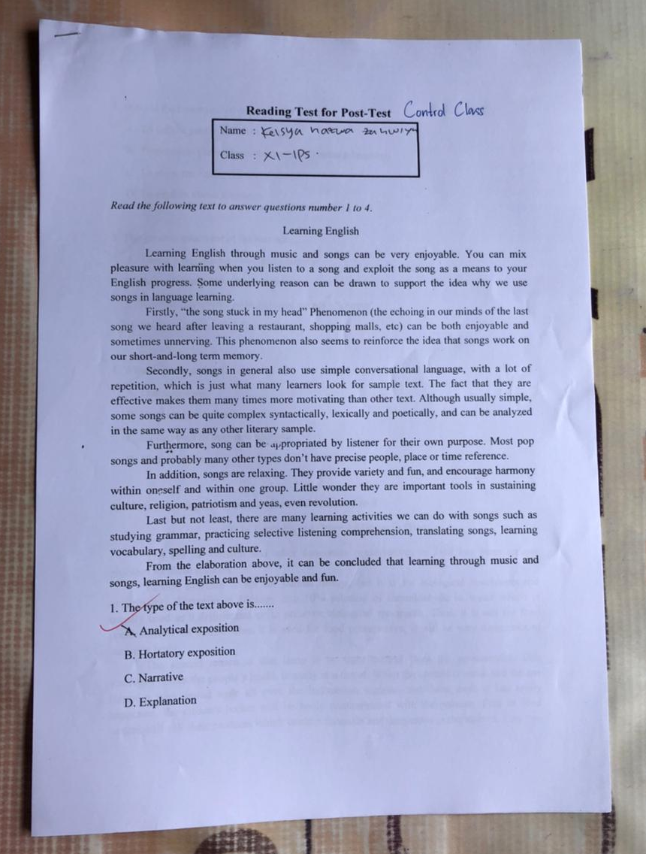

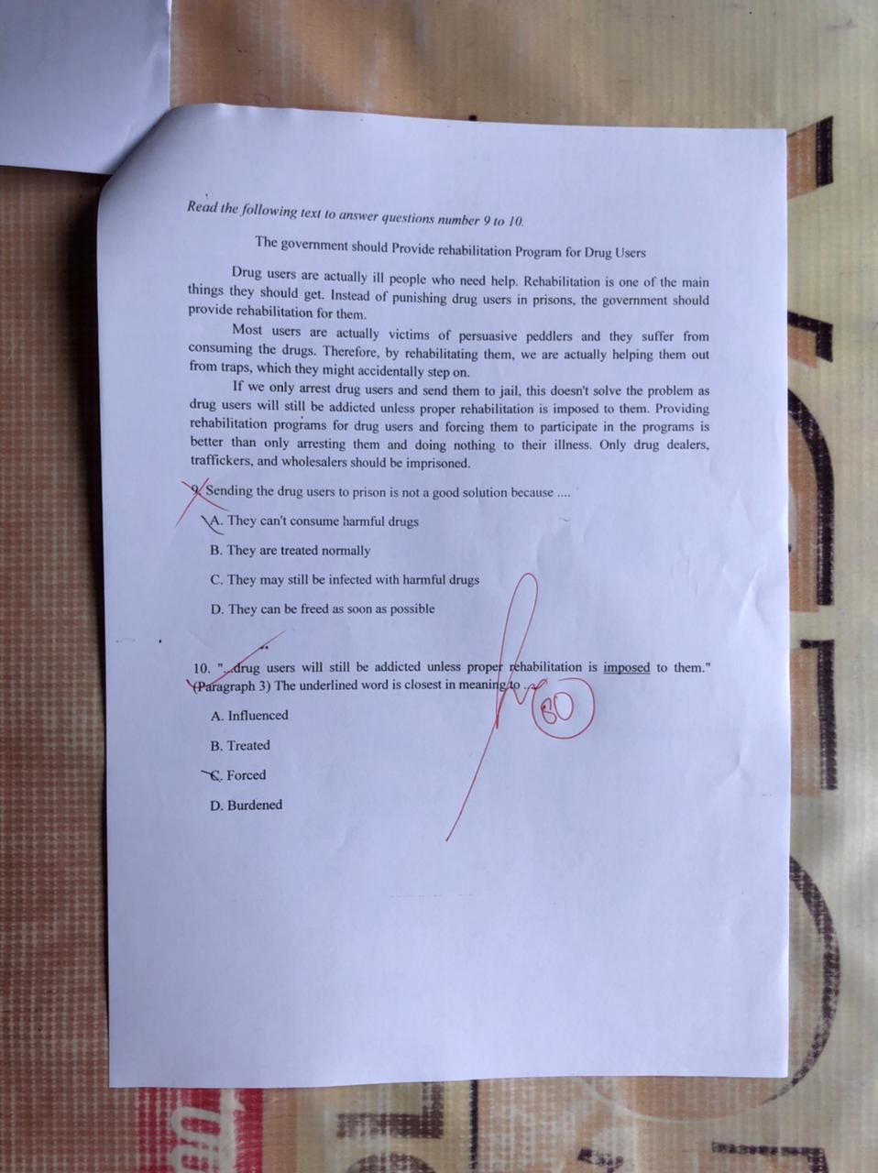
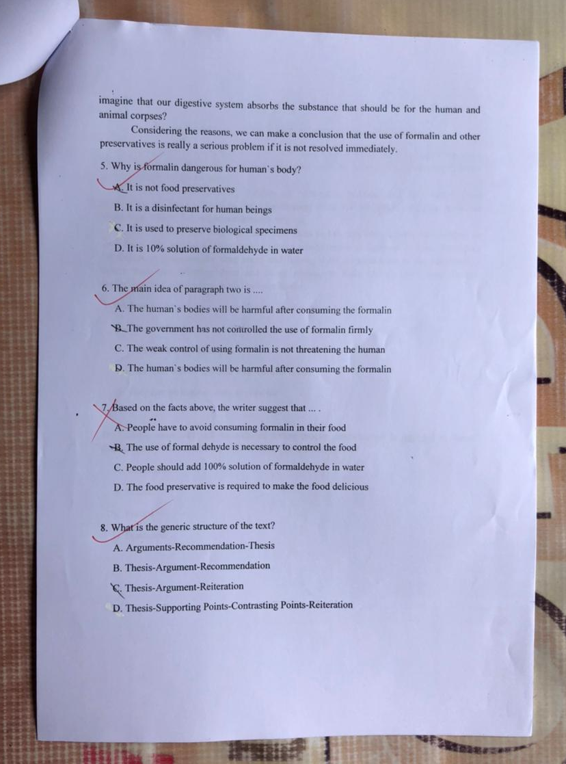

APPENDIX 6
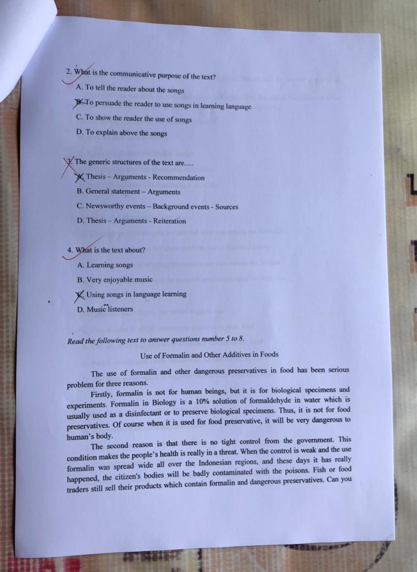
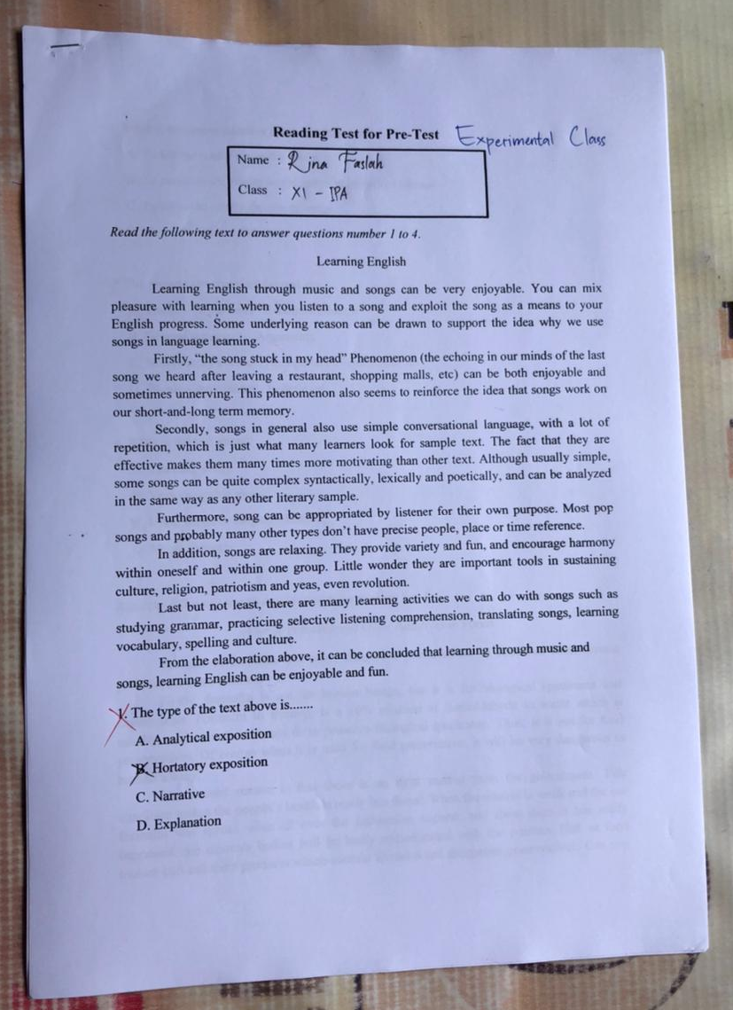

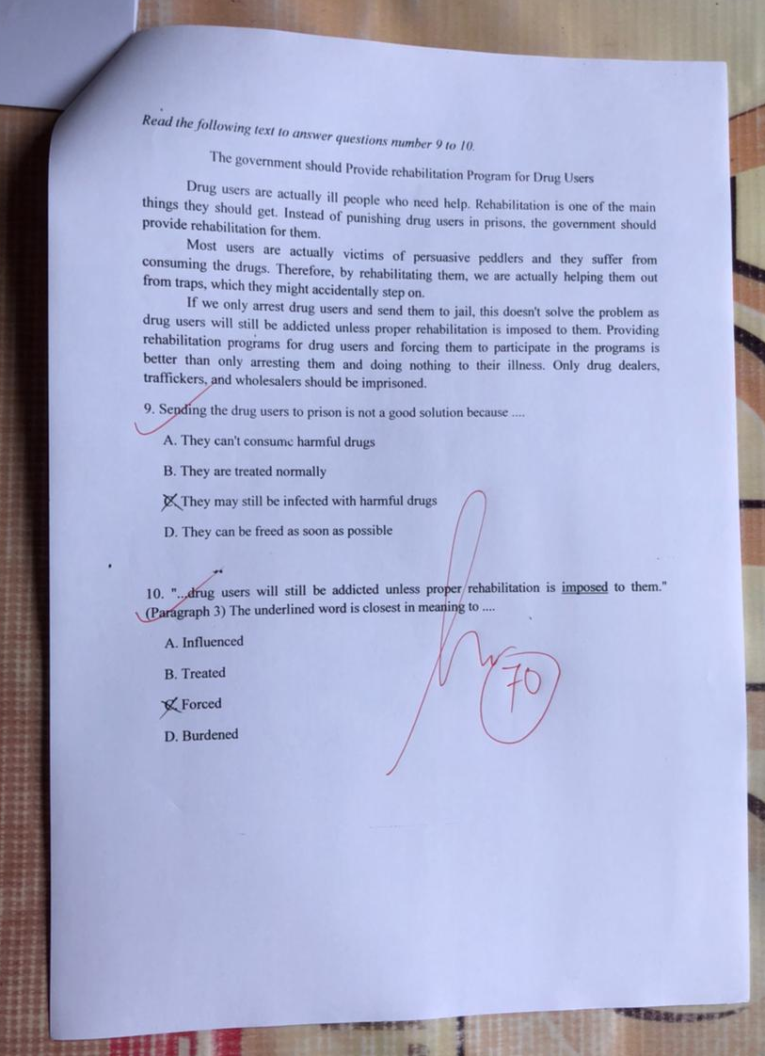
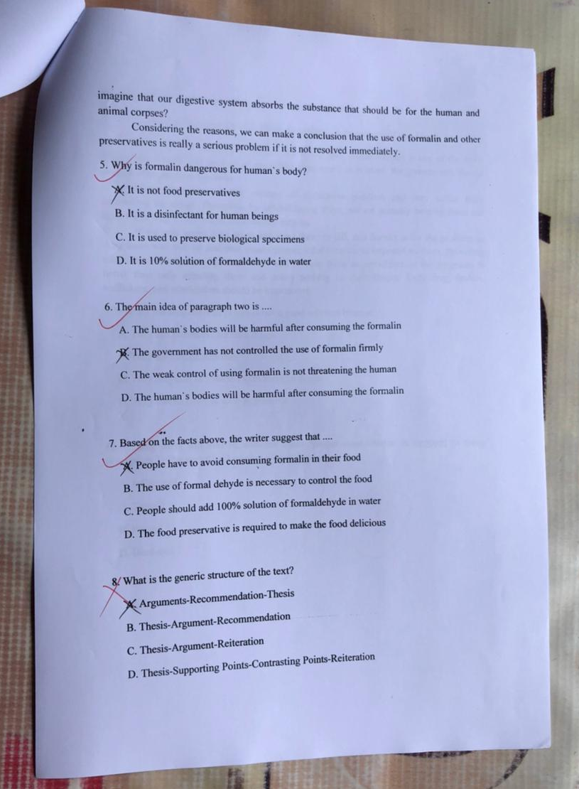

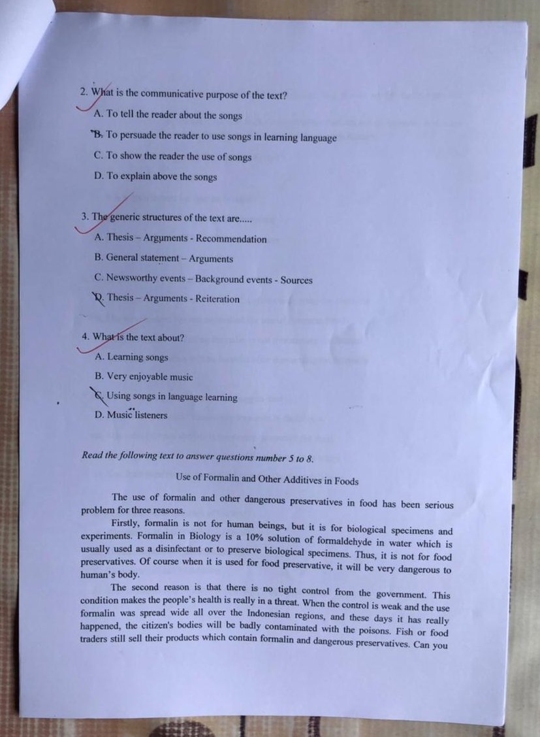
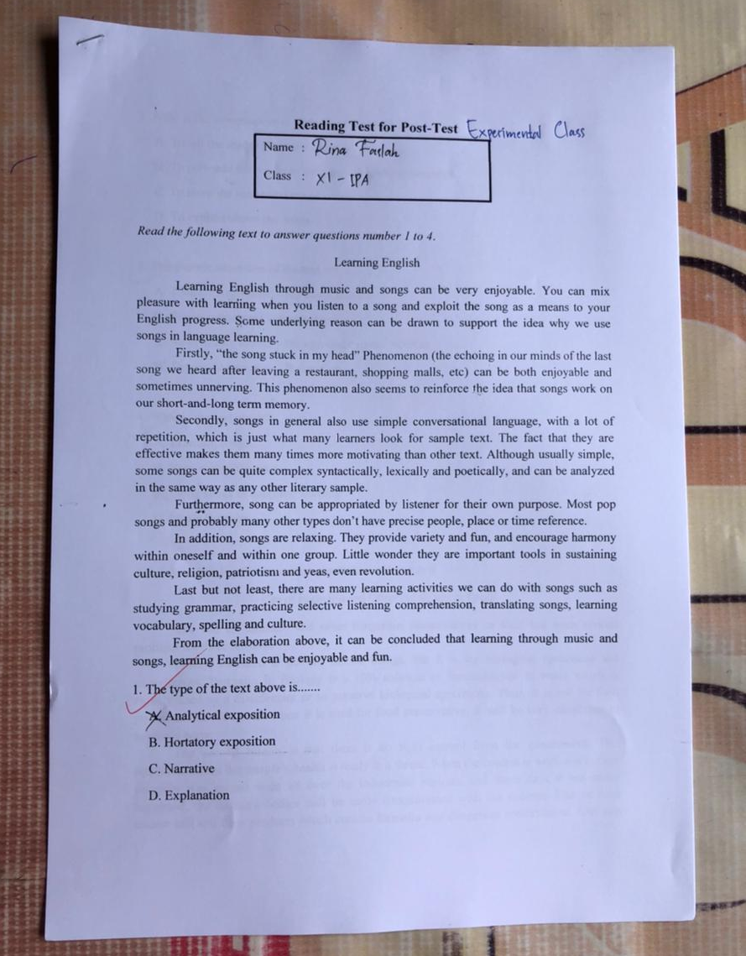

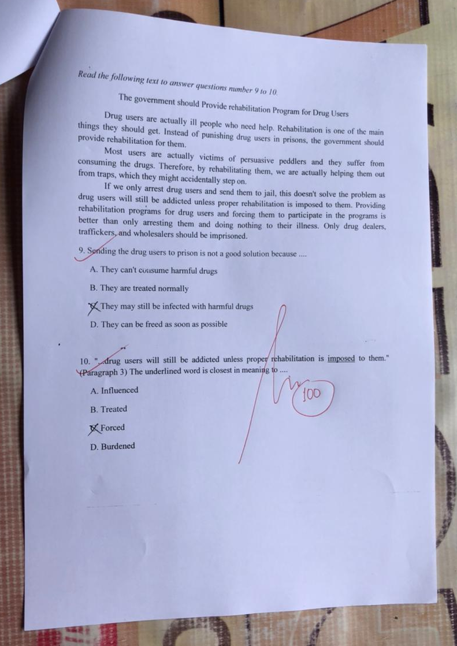
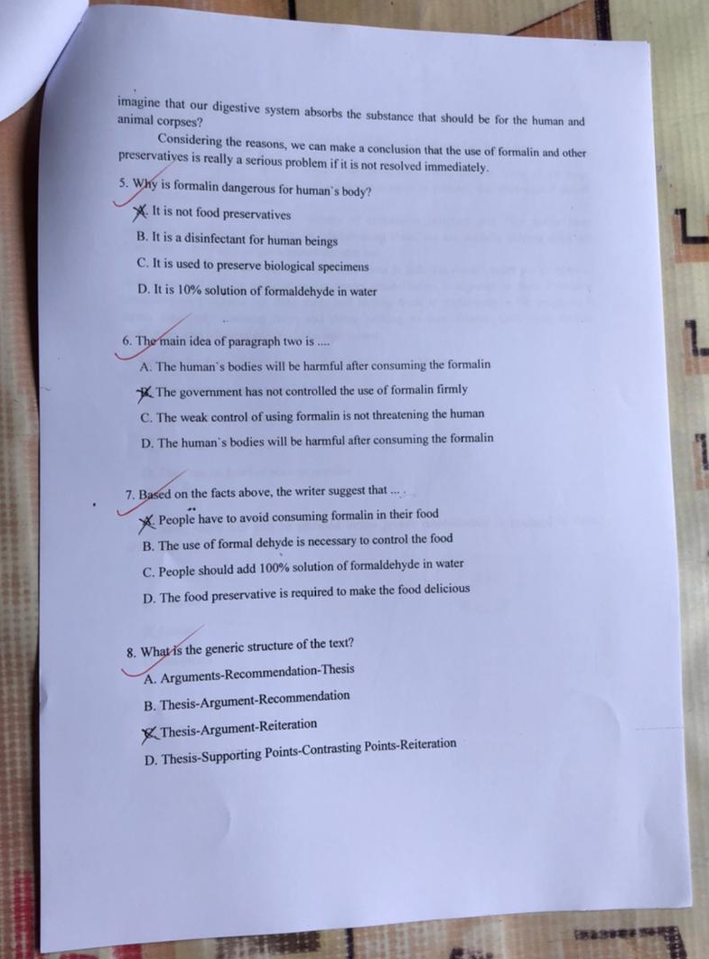

APPENDIX 7
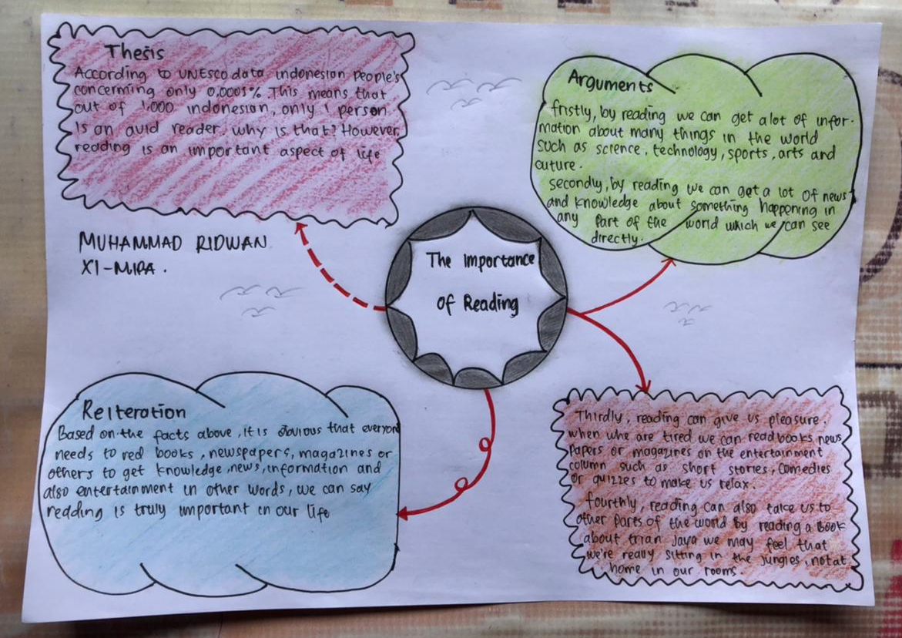

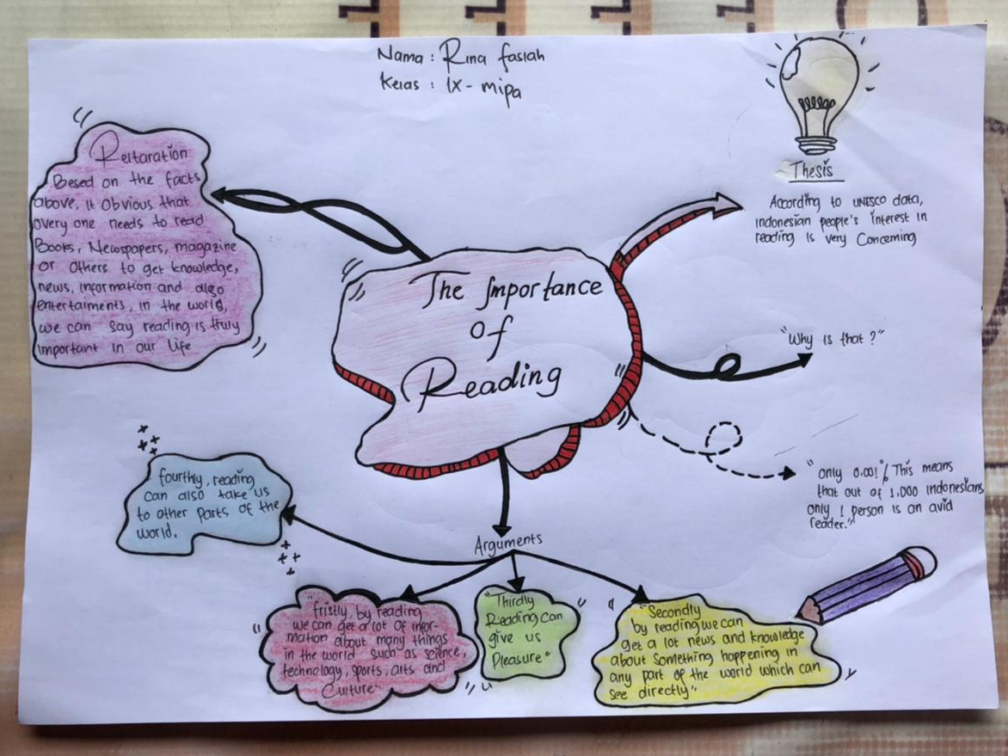

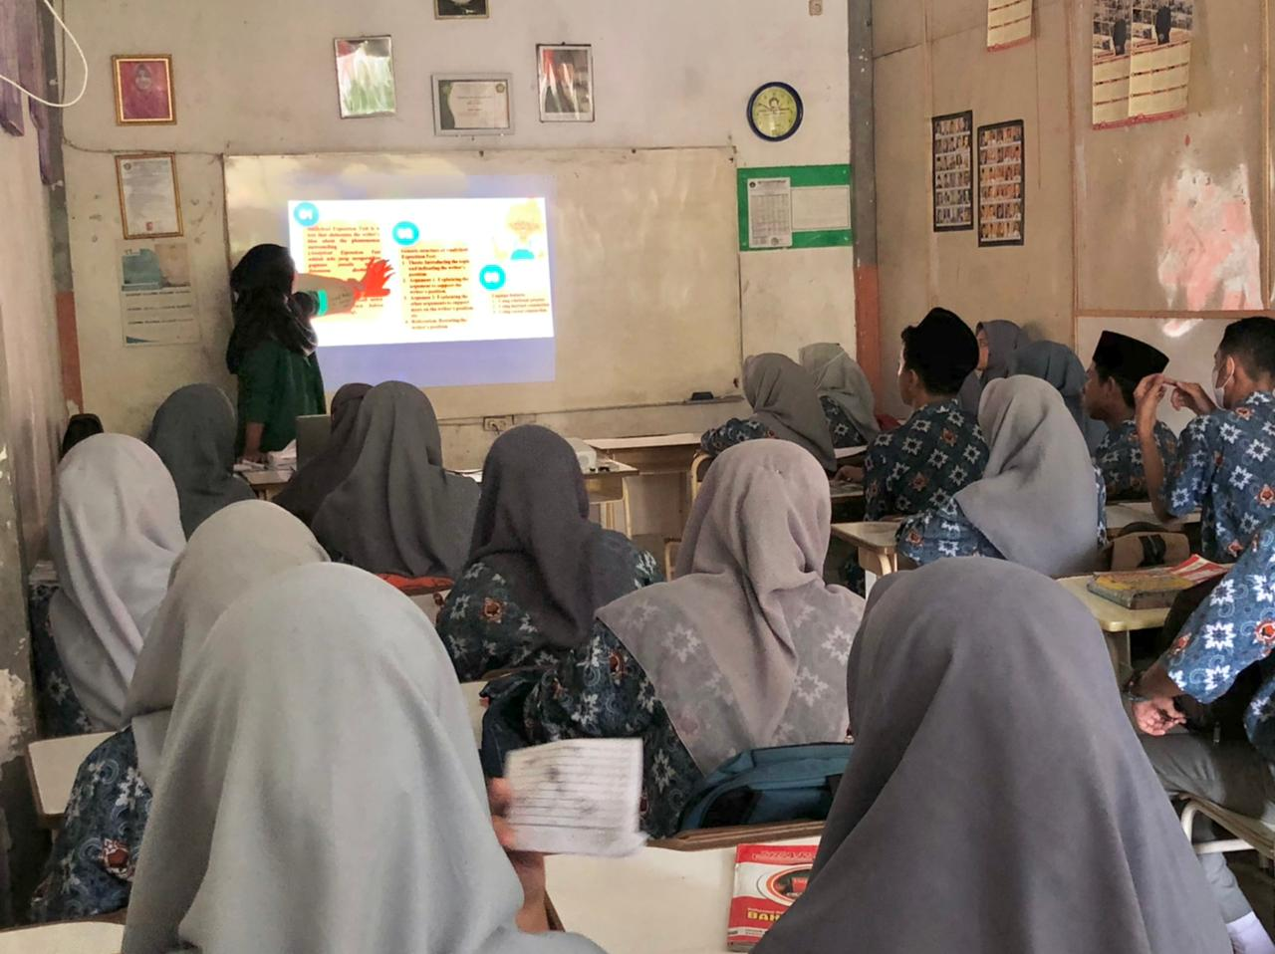
APPENDIX 8

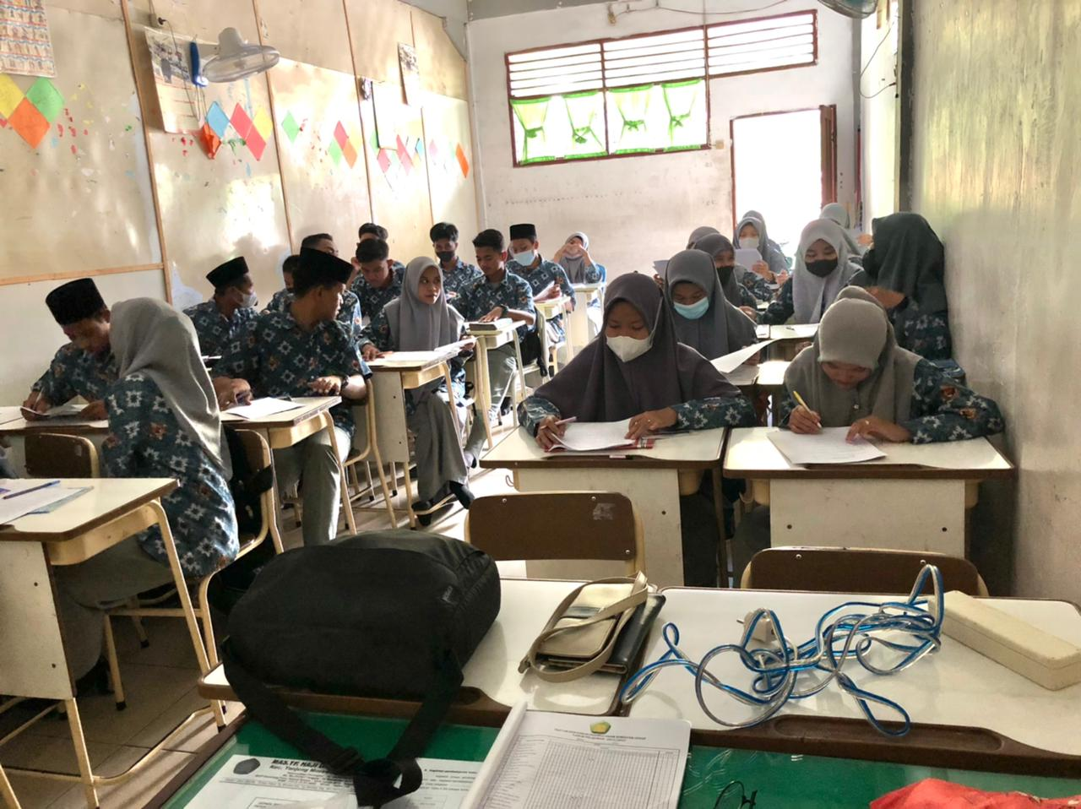

(Students in Experimental Class)

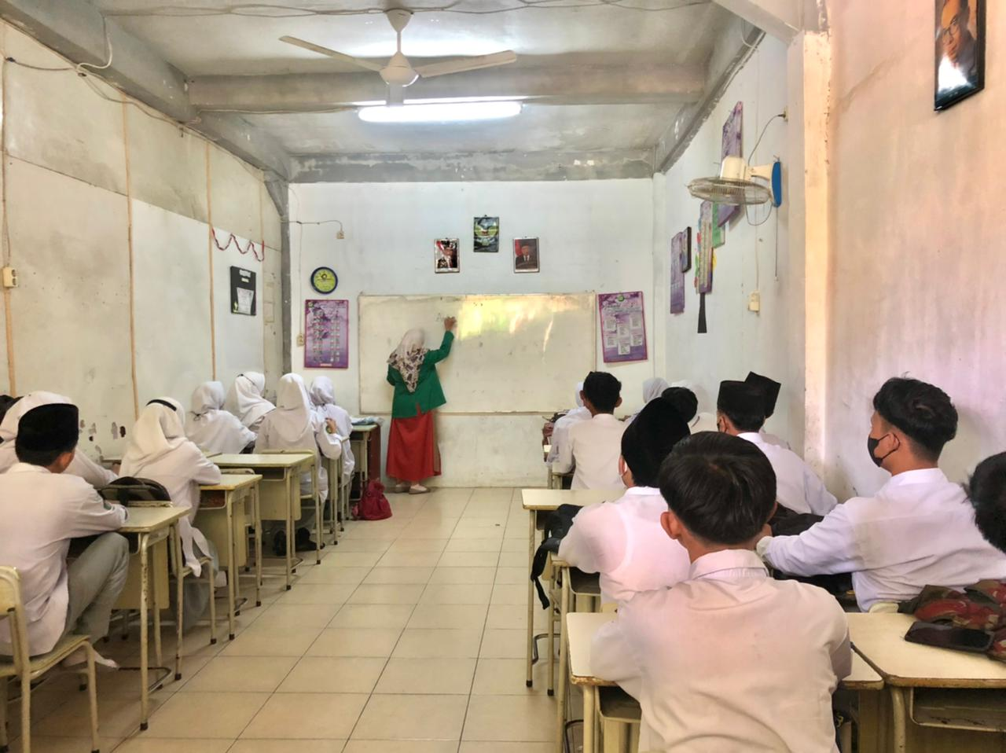

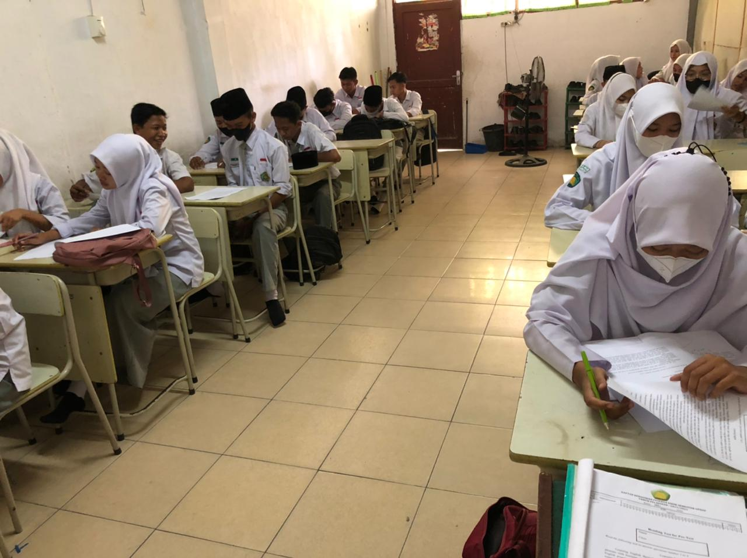

(Students in Control Class)

