ACKNOWLEDGEMENTS

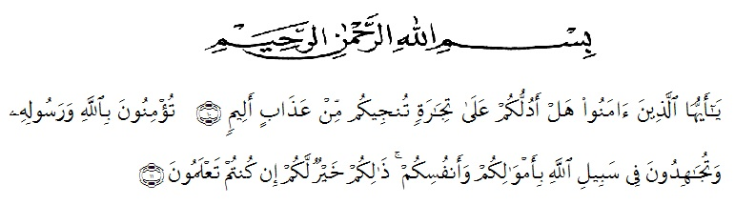

Artinya : “Wahai orang-orang yang beriman! Maukah kamu Aku tunjukkan suatu perdagangan yang dapat menyelamatkan kamu dari azab yang pedih?(Yaitu) kamu beriman kepada Allah dan Rasul-Nya dan berjihad di jalan Allah dengan harta dan jiwamu. Itulah yang lebih baik bagi kamu jika kamu mengetahui.” (QS. Ash-Shaff : 10-11).

Alhamdulillahirabbil’alamin, first of all the researcher expresses her highest gratitude to Allah SWT for blessing, love, opportunity, health, and mercy that have been given to the writer so that the finally accomplished her research. Shalawat and salam to our prophet Muhammad SAW with his followers.
In arranging this research, a lot of people have provided motivation, advice, support, and even remark that had helped the researcher aims to express her gratitude and appreciation to all of them. The writer also would like to give the special thanks for:
- Dr. KRT. Hardi Mulyono K. Surbakti as a Rector of University Muslim Nusantara Al-Washliyah Medan.
- Drs. Samsul Bahri, M.Si as a Dean of FKIP University Muslim Nusantara Al-Washliyah Medan.
- Zulfitri, S.S., M.A as a Head of English Language Education Department of University Muslim Nusantara Al-Washliyah Medan.
- H. Asnawi, S.Pd., M.Hum as a consultant who has the researcher supervision, advice, and guidance from very early stage of this research.
- Yugi Diraga Prawiyata, S.Pd., M.Hum as a first examiner lecturer who has provided direction to the researcher since the beginning of this research.
- Nurlaili, S.Pd.I., M.Hum as a second examiner lecturer who has provided direction to the researcher since the beginning of the research.
- All lecturers of the English Education for teaching precious knowledge, sharing philosophy of live and giving wonderful experience.
- All of the academic administration staff of Universitas Muslim Nusantara Al Washliyah Medan.
- Fadillah Adha Nasution, S.Pd.I as the headmaster of MAS YP. HAJI DATUK ABDULLAH who has allowed researcher to conduct research at the school.
- Kasi Setiani, S.Pd as an English teacher at MAS YP. HAJI DATUK ABDULLAH.
- Class XI IPA and XI IPS students who has helped and collaborated in this research.
- Her beloved parents (Alm. Dadang and Siti Aisah) who always supported the researcher to finish this research.
- Her beloved adoptive parents who always entertain and motivation for the researcher to finish this research.
- Her best friend (Nining Astari, Siti Yohana, Jihan Salsabila, Selly, Leli, Dinda Renita Br. Tarigan, Silviana Nababan, Yulia Ayu Utami Tarigan, Agung Maulana Ibrahim and Albert Tarigan) who always supported the researcher in finishing this research and always give a solution when there was a problem, who always help the researcher kindly in drafting proposal.
- Her friends in college students class 8A English Department in academic 2021-2022 who always have researcher a lot motivation, suggestion, and advice.
Finally, the researcher would like to say thank you very much for all of support which are given so that this research can be finished.

Medan, May 2022
The researcher

FAUZIAH
NPM. 181224017

