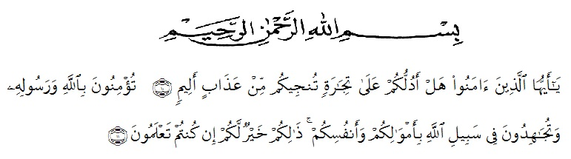
ACKNOWLEDGEMENTS

Artinya: “Hai orang-orang yang beriman, sukakah kamu Aku tunjukkan suatu perniagaan yang dapat menyelamatkan kamu dari azab yang pedih? (Yaitu) kamu beriman kepada Allah dan Rasul-Nya dan berjihad di jalan Allah dengan harta dan jiwamu. Itulah yang lebih baik bagimu jika kamu mengetahuinya”. (As-Saff 10-11).

Assalamualaikum wr.wb
Alhamdulillah, all praises belong to Allah STW who had bestowed mercy, chance and knowledge to the Researcher. Secondly, peace and salutation always be given prophet Muhammad SAW who has guided us from the darkness to the lightness. therefore the Researcher can finish this graduating paper as one of the requiretment for Sarjana English Department of Education Faculty of Universitas Muslim Nusantara AL- Washliyah. However, this success would not be achieved without those supports, guidance, advice, help and encouragement from individual and institution, and the writer somehow realize that an appropriate moment for her deepest gratitude for:
- Mr. Dr. KRT. Hardi Mulyono K. Surbakti as a Rector of the Universitas Muslim Nusantara Al Washliyah who has given the researcher the opportunity to study at the institution he leads.
- Mr. Drs. Samsul Bahri, M.Si as the Dean of FKIP UMN Al Washliyah who has given this research permission.
- Mrs. Zulfitri S.S.,M.A the head of English Language Education Department which has provide invaluable guidance and ssistance for researcher.
- Prof, Dr. H. Ahmad Laut Hasibuan, M.PD as adviser who has given a bunch of reliance, guidance,supports,suggestions and corrections in order to finish this thesis from the very start to the last.
- All of the lectures in FKIP UMN Al Washliyah for the precious knowledge sharing, and giving wonderful study experiences which had built who the researcher is now.
- Thanks to Mrs. Lina as teacher at Smp Dharma Karya Beringin
- For researcher, who has allowed her to conduct research at the school he is leading and assist her in conducting research.
- Her beloved parents of the Research Alm Mr. Ngatiman and Mrs. Aminah who always love the researcher unconditionally, support, facilitate the researcher to finished study.
Her beloved siblings, Nia, Lisa Sulis and Bagas who have supports researchers to finished her study and who provide supports, advice to finished study.
- Her beloved grandmother Mrs Rominah.
- To her beloved friends, Sekar Sari Nst , Ummul Khair, Rindi Rantika , Rika Nurwayuni, Firda Lizami Siregar , Faisal Ramdhani , and Amir Ardiansyah Thank you for always beside her and help her for sharing information and supports researcher to finished study.
- To All of her friends in English Department Class H 2017 who had given her a lot of life experiences in this college life even they are conscious or uninconscious.
- Mr. Ari who always support her and motivated her to finished the study.
- For everyone whom she has not mention yet, thank you very much for all your support.
- The last but not least , Thank you for the researcher for doing this hard work, for having no days off, for never quitting, for just being herself all the time.
Researcher realized that this thesis is far from perfect. All constructive criticisim and suggestions are indispensable for the perfection of this thesis, with the hope that this thesis will be useful for everyone. Aamiin.

Medan, December 2021
Researcher

ARMITA SARI

