FACULTY OF TEACHER TRAINING AND EDUCATION
UNIVERSITAS MUSLIM NUSANTARA AL WASHLIYAH

APPROVAL OF THESIS

Name : Arti Dwi Maulia
NPM : 181224027
Major : Language Education and Art
Department : English Education
Qualification : Bachelor (S-1)
Tittle : The Effect of Using U-Dictionary Application on Students’
Pronunciation Mastery at the Eleventh Grade of SMK Negeri 1 Perbaungan

Approved by :
Adviser
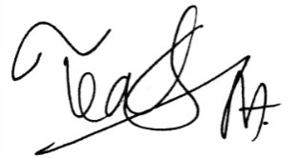

Teguh Satria Amin, S.Pd., M.Hum
NIDN.0113038602

This thesis was examined on :
Judicium :
Examination Committee
Chaiman, Secretary,

Dr. KRT. Hardi Mulyono K.Surbakti Dr. Samsul Bahri, M.Si
NIDN. 0111116303 NIDN. 0017036702

