ACKNOWLEDGEMENT

- O ye who believe! Shall I show you a commeree that will save you from a painful doom?
- Ye should believe in Allah and His messenger, and should strive for the cause of Allah with your wealth and your lives. That is better for you, if ye did but know.
Artinya:
- Hai orang-orang yang beriman, sukakah aku tunjukkan suatu perniagaan yang dapat menyelamatkanmy dari azab yang pedih?
- (yaitu) kamu beriman kepada Allah dan Rasul-Nya dan berjihad di jalan Allah dengan harta dan jiwamu. Itulah yang lebih baik bagimu, jika kamu mengetahuinya.
First of all, the greatest gratitude to Allah SWT, the Almighty God for the
blessing which has been given to the researcher so that the researcher finally completed this thesis in partial fulfillment of the requirements for the degree of Bachelor at the English Education, the Faculty of Teachers’ Training and Education, the University of Muslim Nusantara Al Washliyah Medan. This thesis could not have been accomplished without the advices, suggetions, and comments of a number of people, so the researcher would like to take this opportunity to express the deep gratitude to the following people:
- Dr. KRT. Hardi Mulyono K. Surbakti., the Rector of Universitas Muslim Nusantara Al Washliyah.
- Dr. Samsul Bahri, M.Si., the Dean of the Teacher Training and Education Faculty of Universitas Muslim Nusantara Al Washliyah.
- Zulfitri, S.S., M.A., the head of English Education Department of Universitas Muslim Nusantara Al Washliyah.
- Teguh Satria Amin, S.Pd., M.Hum., the adviser who gave the suggestions, comments and criticisms toward the researcher in finishing the skripsi.
- All of the lectures of English Education Department of Universitas Muslim Nusantara Al Washliyah.
- All of the Academic Administration Staffs of Universitas Muslim Nusantara Al Washliyah.
- The researcher’s beloved parents, Jumirin and Nurlaili, who always love, care, pray and give the advices and spirit so that the researcher can grow up and can reach this position.
- Novrial Pratama, S.T, Dede Irma Suryani, S.Keb, Bd., Cahya Agustini, S.Pd, Isti Kesuma Ningrum, Amd. Farm., and Sri Rachmayuni, the researcher’s brother and sisters who have encouraged and supported the researcher during the writing of this skripsi.
- Sri Wahyu Jasmin Pratiwi Tarigan, S.Pd and Revi Restu Ayanda, S.Pd, the college seniors who help and support the researcher to complete this skripsi.
- The researcher’s friends in Class V of English Education Department 2018, especially Asmai Lala, Pingki Youlanda, Siti Fatimah and Safitri who always beside the researcher for sharing information and supports during the writing of this skripsi.
- The last for everyone who has not be mentioned yet, thank you very much for all your supports.
At the end of this acknowledgement, the researcher realizes that this skripsi will has many shortcomings. Therefore, all criticisms and suggestions are gratefully accepted for the perfection of this thesis. However, the researcher hopes that this skripsi will be useful for interested parties.

Medan, Juli 2022
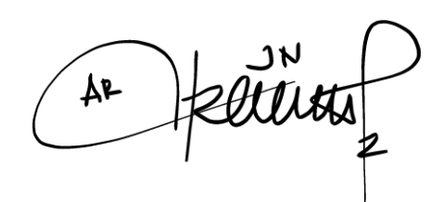
The Researcher

Arti Dwi Maulia

