Simple fried rice

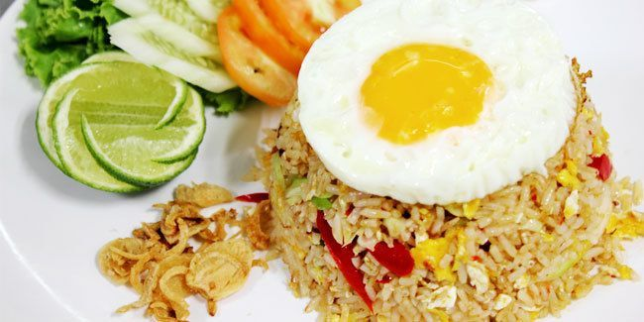

Material :
White rice 1 plate
Garlic 2 cloves, finely chopped
Sweet soy sauce or salty soy sauce according to taste
Chili sauce according to taste
Oyster sauce according to taste
Salt to taste
Powdered broth with chicken or beef flavor according to taste
Green onion 1 stem, finely chopped
Chicken egg 1 grain
Chicken sausage 1 piece, thinly sliced
Margarine or cooking oil 3 tbsp
How to make :
Prepare a frying pan over medium heat, pour margarine or cooking oil.
Add the finely chopped garlic and chives. Sauté until fragrant or until golden in color.
Add sausage and 1 chicken egg. Saute for a minute.
Add the ground spices and rice. Stir until well mixed.
Pour in sweet soy sauce, chili sauce, oyster sauce, salt and broth powder. Stir until the color of the rice changes evenly.
Simple and delicious plain fried rice is ready to be served.

