APPENDIX 1 : LESSON PLAN
LESSON PLAN
(EXPERIMENTAL GROUP)

School : SMA NEGERI 2 PERBAUNGAN
Class/Semester : XII-MIA¹
Skill : Reading
Topic : Descriptive Text
Sub Topic : Place
Allocation Time : 3x45 menit
A. Kompetensi Inti
- Menghayati dan mengamalkan ajaran agama yang dianutnya
- Menghayati dan mengamalkan perilaku jujur, disiplin, tanggungjawab, peduli (gotong royong, kerjasama, toleran, damai), santun, responsif dan pro-aktif dan menunjukkan sikap sebagai bagian dari solusi atas berbagai permasalahan dalam berinteraksi secara efektif dengan lingkungan sosial dan alam serta dalam menempatkan diri sebagai cerminan bangsa dalam pergaulan dunia
- Memahami ,menerapkan, menganalisis pengetahuan faktual, konseptual, prosedural berdasarkan rasa ingintahunya tentang ilmu pengetahuan, teknologi, seni, budaya, dan humaniora dengan wawasan kemanusiaan, kebangsaan, kenegaraan, dan peradaban terkait penyebab fenomena dan kejadian, serta menerapkan pengetahuan prosedural pada bidang kajian yang spesifik sesuai dengan bakat dan minatnya untuk memecahkan masalah
- Mengolah, menalar, dan menyaji dalam ranah konkret dan ranah abstrak terkait dengan pengembangan dari yang dipelajarinya di sekolah secara mandiri, dan mampu menggunakan metoda sesuai kaidah keilmuan
B. Kompetensi Dasar
- Mensyukuri kesempatan dapat mempelajari bahasa Inggris sebagai bahasa pengantar komunikasi internasional yang diwujudkan dalam semangat belajar.
- Menunjukkan perilaku tanggung jawab, peduli, kerjasama, dan cinta damai, dalam melaksanakan komunikasi fungsional.
- Menganalisis fungsi sosial, struktur teks, dan unsur kebahasaan dari teks deskriptif sederhana tentang orang, tempat wisata, dan bangunan bersejarah terkenal, sesuai dengan konteks penggunaannya.
- Menyunting teks deskriptif tulis, sederhana, tentang orang, tempat wisata, dan bangu nan bersejarah terkenal, dengan memperhatikan fungsi sosial, struktur teks, dan unsur kebahasaan yang benar dan sesuai konteks.
- Menyusun teks deskriptif lisan dan tulis, sederhana, tentang orang, tempat wisata, dan bangunan bersejarah terkenal, dengan memperhatikan fungsi sosial, struktur teks, dan unsur kebahasaan yang benar dan sesuai konteks.
C. Indikator Pencapaian Kompetensi
- Menemukan informasi
- Memahami teks
- Menemukan Generic Structure

D. Tujuan pembelajaran
- Siswa dapat menemukan informasi yang terdapat didalam teks deskripsi
- Siswa mampu memahami teks deskripsi
- Siswa dapat mememukan Generic Structure pada teks

E. Materi Pembelajaran
- Definition of Descriptive Text
The Suramadu Bridge (Indonesian: JembatanSuramadu), also known as the Surabaya–Madura Bridge, is a bridge with three cable-stayed sections constructed between Surabaya on the island of Java and the town of Bangkalan on the island of Madura in IndonesiA. Opened on June 10, 2009, the 5.4-km bridge is the longest in Indonesia and the first bridge to cross the Madura Strait.The cable-stayed portion has three spans with lengths 192 m, 434 m and 192 m. The bridge has two lanes in each direction plus an emergency lane and a dedicated lane for motorcycles. The first toll bridge in Indonesia, fares have been initially set at Rp. 30,000 (US$3 in 2009) for four-wheeled vehicles and Rp. 3,000 (US$0.30) for two-wheelers.
The bridge was built by a consortium of Indonesian companies PT AdhiKarya and PT WaskitaKarya working with China Road and Bridge Corp. and China Harbor Engineering Co. LtD. The total cost of the project, including connecting roads, has been estimated at 4.5 trillion rupiah(US$ 445 million).Construction was started on August 20, 2003. In July 2004, a girder collapsed, killing one worker and injuring nine others. Work on the bridge halted at the end of 2004 due to lack of funds, but was restarted in November 2005. The main span of the bridge was connected on March 31, 2009, and the bridge was opened to the public in June 10, 2009.Within a week of the opening, it was discovered that nuts and bolts as well as maintenance lamps had been stolen and that there was evidence of vandalism of cables supporting the main span.
1. Suramadu’s bridge also known as….
A. Longest bridge
B. sura and madu
C. Surabaya-Madura bridge
D. toll bridge
E. cable bridge
2. Suramadu’s bridge connects the island….
A. Java and Sumatra
B. Java and Bali
C. Sumatra and Kalimantan
D. Java and Madura
E. Java and Surabaya

3. Length of the Suramadu’s bridge is….
A. 5.400 meters
B. 192 meters
C. 494 meters
D. 526 meters
E. 2004 meters

4. The following statement is true, except ….
A. Suramadu’s bridge is also known Surabaya-Madura bridge
B. the long of Suramadu’s bridge is 5400 meters
C. suramadu’s bridge connects the islands of Java and Madura
D. bridge was opened on March 31, 2009
E The bridge was built by Surabaya government

- Generic Structure
- Definition of Question Answer Relationship (QAR) Strategy

F. Metode Pembelajaran
Question-Answer Relationship (QAR) Strategy

G. Media Pembelajaran
Buku, Teks

H. Langkah-Langkah Kegiatan Pembelajaran
Kegiatan | Deskripsi Kegiatan | Alokasi Waktu
Pembukaan | Memberi salam  Memberi motivasi belajar kepada siswa | 10 menit
Kegiatan Inti | Menyampaikan tujuan dari pelaksanaan penelitian  Menjelaskan tujuan pembelajaran yang akan dicapai  Menyampaikan cakupan materi dan uraian kegiatan  Memperkenalkan Question Answer Relationship (QAR) Strategy | 30 menit
Penutup | Melakukan refleksi terhadap pembelajaran  Memberikan motivasi untuk mengembangkan skill membaca dengan baik  Mengucapkan salam | 5 menit

I. Penilaian
- Technique : Reading
- Form of Instrument : Multiple Choice
- Example of Instrument : Answer the question correctly

Perbaungan, 25 Juli 2022
Peneliti

Wahyuni Dwi Tiya
NPM : 191224013

LESSON PLAN
(CONTROL GROUP)

School : SMA NEGERI 2 PERBAUNGAN
Class/Semester : XII-IPS¹
Skill : Reading
Topic : Descriptive Text
Sub Topic : Place
Allocation Time : 3x45 menit
A. Kompetensi Inti
- Menghayati dan mengamalkan ajaran agama yang dianutnya
- Menghayati dan mengamalkan perilaku jujur, disiplin, tanggungjawab, peduli (gotong royong, kerjasama, toleran, damai), santun, responsif dan pro-aktif dan menunjukkan sikap sebagai bagian dari solusi atas berbagai permasalahan dalam berinteraksi secara efektif dengan lingkungan sosial dan alam serta dalam menempatkan diri sebagai cerminan bangsa dalam pergaulan dunia
- Memahami ,menerapkan, menganalisis pengetahuan faktual, konseptual, prosedural berdasarkan rasa ingintahunya tentang ilmu pengetahuan, teknologi, seni, budaya, dan humaniora dengan wawasan kemanusiaan, kebangsaan, kenegaraan, dan peradaban terkait penyebab fenomena dan kejadian, serta menerapkan pengetahuan prosedural pada bidang kajian yang spesifik sesuai dengan bakat dan minatnya untuk memecahkan masalah
- Mengolah, menalar, dan menyaji dalam ranah konkret dan ranah abstrak terkait dengan pengembangan dari yang dipelajarinya di sekolah secara mandiri, dan mampu menggunakan metoda sesuai kaidah keilmuan
B. Kompetensi Dasar
- Mensyukuri kesempatan dapat mempelajari bahasa Inggris sebagai bahasa pengantar komunikasi internasional yang diwujudkan dalam semangat belajar.
- Menunjukkan perilaku tanggung jawab, peduli, kerjasama, dan cinta damai, dalam melaksanakan komunikasi fungsional.
- Menganalisis fungsi sosial, struktur teks, dan unsur kebahasaan dari teks deskriptif sederhana tentang orang, tempat wisata, dan bangunan bersejarah terkenal, sesuai dengan konteks penggunaannya.
- Menyunting teks deskriptif tulis, sederhana, tentang orang, tempat wisata, dan bangu nan bersejarah terkenal, dengan memperhatikan fungsi sosial, struktur teks, dan unsur kebahasaan yang benar dan sesuai konteks.
- Menyusun teks deskriptif lisan dan tulis, sederhana, tentang orang, tempat wisata, dan bangunan bersejarah terkenal, dengan memperhatikan fungsi sosial, struktur teks, dan unsur kebahasaan yang benar dan sesuai konteks.
C. Indikator Pencapaian Kompetensi
- Menemukan informasi
- Memahami teks
- Menemukan Generic Structure

D. Tujuan pembelajaran
- Siswa dapat menemukan informasi yang terdapat didalam teks deskripsi
- Siswa mampu memahami teks deskripsi
- Siswa dapat mememukan Generic Structure pada teks
E. Materi Pembelajaran
- Definition of Descriptive Text
The Suramadu Bridge (Indonesian: JembatanSuramadu), also known as the Surabaya–Madura Bridge, is a bridge with three cable-stayed sections constructed between Surabaya on the island of Java and the town of Bangkalan on the island of Madura in IndonesiA. Opened on June 10, 2009, the 5.4-km bridge is the longest in Indonesia and the first bridge to cross the Madura Strait.The cable-stayed portion has three spans with lengths 192 m, 434 m and 192 m. The bridge has two lanes in each direction plus an emergency lane and a dedicated lane for motorcycles. The first toll bridge in Indonesia, fares have been initially set at Rp. 30,000 (US$3 in 2009) for four-wheeled vehicles and Rp. 3,000 (US$0.30) for two-wheelers.
The bridge was built by a consortium of Indonesian companies PT AdhiKarya and PT WaskitaKarya working with China Road and Bridge Corp. and China Harbor Engineering Co. LtD. The total cost of the project, including connecting roads, has been estimated at 4.5 trillion rupiah(US$ 445 million). Construction was started on August 20, 2003. In July 2004, a girder collapsed, killing one worker and injuring nine others. Work on the bridge halted at the end of 2004 due to lack of funds, but was restarted in November 2005. The main span of the bridge was connected on March 31, 2009, and the bridge was opened to the public in June 10, 2009.Within a week of the opening, it was discovered that nuts and bolts as well as maintenance lamps had been stolen and that there was evidence of vandalism of cables supporting the main span.
1. Suramadu’s bridge also known as….
A. Longest bridge
B. sura and madu
C. Surabaya-Madura bridge
D. toll bridge
E. cable bridge

2. Suramadu’s bridge connects the island….
A. Java and Sumatra
B. Java and Bali
C. Sumatra and Kalimantan
D. Java and Madura
E. Java and Surabaya

3. Length of the Suramadu’s bridge is….
A. 5.400 meters
B. 192 meters
C. 494 meters
D. 526 meters
E. 2004 meters

4. The following statement is true, except ….
A. Suramadu’s bridge is also known Surabaya-Madura bridge
B. the long of Suramadu’s bridge is 5400 meters
C. suramadu’s bridge connects the islands of Java and Madura
D. bridge was opened on March 31, 2009
E The bridge was built by Surabaya government

- Generic Structure
- Definition of Question Answer Relationship (QAR) Strategy

F. Metode Pembelajaran
Direct Method

G. Media Pembelajaran
Buku, Teks

H. Langkah-Langkah Kegiatan Pembelajaran
Kegiatan | Deskripsi Kegiatan | Alokasi Waktu
Pembukaan | Memberi salam  Memberi motivasi belajar kepada siswa | 10 menit
Kegiatan Inti | Menyampaikan tujuan dari pelaksanaan penelitian  Menjelaskan tujuan pembelajaran yang akan dicapai  Menyampaikan cakupan materi dan uraian kegiatan | 30 menit
Penutup | Melakukan refleksi terhadap pembelajaran  Memberikan motivasi untuk mengembangkan skill membaca dengan baik  Mengucapkan salam | 5 menit

I. Penilaian
- Technique : Reading
- Form of Instrument : Multiple Choice
- Example of Instrument : Answer the question correctly

Perbaungan, 25 Juli 2022
Peneliti

Wahyuni Dwi Tiya
NPM : 191224013

APPENDIX 2 : PRE-TEST AND POST-TEST
Pre-test
Name :
Class :

Read the following text and answer question number 1-5, choose the best answer !
Orchard Road
Orchard Road is a Boulevard which becomes business and entertainment center in Singapore. Orchard Road is surrounded by a lush tropical and flower gardens which are beautiful. At first, Orchard Road is just a suburban street lined with orchards, plantations nutmeg, and pepper farming. However, in the 1970s, it turned into a shopping center in Singapore. In 1960 and 1970 entertainment industries began to enter this road. Shopping centers such as mall and Plaza was built in 1974.
Orchard Road runs along about 2.2 km. This road is one-way street flanked by a variety of shopping malls, hotels and restaurants. The shopping area which is nearly 800,000 square meters provides a wide range of Things, food, and entertainment. In this area there are many options that can satisfy visitors from all walks of life starting from the luxury branded things to the Popular branded, from exclusive restaurants to fast food.
There are so many ways that can be accessed to get to Orchard road such as: by taxi, bus or drive your own car. For those who are driving to Orchard Road can be entered from the west through the Napier Road. Vehicles from Dunearn Road can turn to left at the intersection of the Marriott Hotel junction. Vehicles that come from Paterson can turn right onto Orchard Road. Orchard is always crowded so you have to be careful in order not to get lost.

1. The text mainly focuses on
a. Singapore
b. Orchard Plantation
c. Plaza and Mall
d. Orchard road as business and entertainment center
e. Shopping Center

2. Which statement is TRUE?
a. At first Orchard Road is a crowded settlement
b. Orchard road became business and entertainment center since 1974
c. Vehicles from Dunrean road turn to the left at intersection of the Marriott Hotel junction
d. Orchard road is infamous place at Singapore
e. Orchard road is not surrounded by flower garden

3. In the third paragraph the writer describes about?
a. The location of Orchard Road
b. The things that we can see at orchard road
c. The direction to get to Orchard Road
d. The history of Orchard Road
e. The distance of Orchard Road

4. Words “it” in line 4 refers to?
a. The plantation
b. Luxury branded things
c. The plaza
d. Singapore
e. Suburban street

5. The word “satisfy” in line eighth has the closet meaning with?
a. Pleased
b. Free
c. Frighten
d. Threat
e. Loved
Read the following text and answer question number 6-10, choose the best answer !
Petruk Cave
Petruk cave is one of the leading tourist attractions in Kebumen, Central Java. The cave is located in the dukuh Mandayana Candirenggo Village, Ayah District, Kebumen regency. In the petruk cave there is no lighting that illuminates the cave. It is still very natural cave so that petruk cave is very dark to be entered. Petruk cave’s name is taken from the punokawan of puppet characters that is Petruk. The cave Named Petruk cave because the length of cave is as long as petruk’s nose.
In the cave there are 3 floors that are the first is a basic cave, Hindu caves and Petruk cave. The base cave is a short cave which is just 100 meters away. The cave is used for tourist attractions. Hindu cave is part of the cave that is usually used to put offerings to the ancestor. Inside Petruk cave there are so many stalactites and stalagmites which are really awesome. If you want to explore this cave, you must be led by guides who are ready to take you through the cave. After arriving at the end of the cave, you can see the beach or waterfall located near at the end of the cave.

6. What is the text purpose?
a. To inform readers about tourism in Kebumen
b. To entertain reader about Petruk Cave
c. To explain the reader about floors in Petruk Cave
d. To Introduce The Local tourism in Kebumen
e. To describe Petruk Cave

7. Why did Petruk cave named as one of character in Punokawan puppet?
a. Because the cave is belong to Petruk
b. Because Petruk is the first explorer of the cave
c. Because Petruk is buried at the cave
d. Because the cave’s length is as long as Petruk’s nose
e. Because the cave’s depth is as deep as Petruk’s hair

8. Which part of Petruk Cave which used for place to put foods for ancestor?
a. In the basic cave
b. In petruk cave
c. In Hindu cave
d. In front of the cave
e. Inside the cave

9. What is stalactites means?
a. A type of formation that hangs from the ceiling of caves
b. Types of formation that lay on the floor of caves
c. Types of food given to ancestor
d. Someone who guide the visitor in the cave
e. Kind of animals in the cave

10. What is “lead” means in paragraph 2?
a. Guide
b. Take
c. Bring
d. Put
e. Place

Read the following text and answer question number 11-13, choose the best answer!
Kediri is a name of a town. It is situated in a valley between the Kelud and Willis mountains and inhabited by about 1.3 million peoplE. In the centre of the town there is a large hill which is called the Dathok Mountain. Because of the topography of the region, Kediri is called a chilly town by the locals. There is a big river called Brantas cutting off the centre of the town.
Beside the temples, Kediri is also famous for its products like cigarettes and a special kind of tofu or bean curD. This highly nutritious food is delicacy of Kediri and has a distinctive tastE. The cigarettes factory dominates the town economy and employs the majority of the women labor forcE. Kediri and the cigarettes factory are inseparable and it is considered the biggest cigarette factory in Indonesia. Most of the local people work in this factory. Those who do not work here are farmers or traders.

11. What does the above text tell about?
A. The history of Kediri
B. The famous products of Kediri
C. The description of Kediri
D. The people
E. 1.3 million people

12. Which one has a distinctive taste?
A. The cigarette
B. The special food
C. The bean curd
D. The highly nutritious food
E. Tofu
13. “Those who do not work here …” (last sentence). The “those” word refers to ….
A. The local people
B. The factory workers
C. The farmers
D. The traders
E. Woman labour force
Read the following text and answer question number 14-17, choose the best answer!
Venice is a city in northern Italy. It has been known as the “Queen of the Adriatic”, “City of Bridges”, and “The City of Light”. The city stretches across 117 small islands in the marshy Venetian Lagoon along the Adriatic Sea in northeast Italy.
Venice is world famous for its canals. It is built on an archipelago of 117 islands formed by about 150 canals in a shallow lagoon. The islands on which the city is built are connected by about 400 bridges. In the old centre, the canals serve the function of roads, and every form of transport is on water or on foot.
You can ride gondola therE. It is the classical Venetian boat which nowadays is mostly used for tourists, or weddings, funerals, or other ceremonies. Now, most Venetians travel by motorised waterbuses which ply regular routes along the major canals and between the city’s islands. The city has many private boats. The only gondolas still in common use by Venetians are the Traghetti, foot passenger ferries crossing the Grand Canal at certain points without bridges.

14. What does the text tell you about?
A. Gondola.
B. Traghetti.
C. Venice
D. Italy.
E. Venetian boat

15. What transport crosses the Grand Canal for foot passengers at certain points without bridges?
A. Gondolas.
B. Traghetti.
C. Waterbuses.
D. Lagoon.
E. Ship

16. From the text we can say that Venice belongs to a city of ….
A. water
B. ceremonies
C. buses
D. funerals
E. Gondola

17. What does the second paragraph of the text tell us about?
A. The forms of transport in the world.
B. The canals and roads that people like to usE.
C. The archipelago that has a lot of islands.
D. Venice as the world famous for its canals.
E. Venice is the city of light

Read the following text and answer question number 18-20, choose the best answer!
Natural Bridge National Park is luscious tropical rainforest. It is located 110 kilometers from south of Brisbane and is reached by following the Pacific Highway to Nerang and then by travelling through the Numinbah Valley. This scenic roadway lies in the shadow of Lamington National Park.
The phenomenon of the rock formed into a natural ‘arch’ and the cave through which a waterfall cascades is a short one-kilometer walk below a dense rainforest canopy from the main picnic areA. Swimming is permitted in the rock pools. Night-time visitors to the cave will discover the unique feature of the glow worms. Picnic areas offers toilets, barbeque, shelter sheds, water and fireplaces; however, overnight camping is not permitted.

18. What is the function of paragraph 1?
A. as an identification
B. as an orientation
C. as a thesis
D. as a classification
E. as an abstract

19. The text above is in form of ?
A. hortatory exposition
B. narrative
C. description
D. report
E. explanation

20. What is the communicative purpose of the text?
A. to present two points of views about natural bridge national park
B. to explain the bridge national park
C. to describe the bridge national park
D. to retell the bridge national park
E. to persuade readers to treat preserve the bridge nationl park

Post-test
Name :
Class :

Read the following text and answer question number 1-4, choose the best answer !
Angkor Wat was faced a Hindu temple, a manof Budhist temple completed in Cambodia. It isthe largest religious monument in the world. The temple was built by the Khmer King, Suryawarman II in the early twelveth century in Yosadapura, the capital of the Khmer Empire as this temple of eventual moslem.
It is dedicated to Wisnu. It is designed to represent Khmer Meru, frame of the Devis in Hindu mithology within the mouth and has an outer wall which is 3 to 7 km long. It has three rectangular galleries which races about the neck. At the centre of the temple stand Queen Cap of Tower.
1. What is the monolog about?
A. Gallery complex.
B. Buddhist mythology.
C. Cambodia.
D. Khmer Empire.
E. Angkor Wat.
2. In the twelveth century which Empire was strong enough to build the biggest temple of the world?
A. Old Empire.
B. Yosadapura Empire.
C. Meru Empire.
D. The King Empire.
E. Khmer Empire
3. What is the monologue about?
A. Paris
B. The Louvre
C. Notre Dame
D. The crowded city
E. The city of light
4. What has become the symbol of Paris?
A. The Louvre
B. The Cathedral
C. The Eiffel Tower
D. The lovely garden
E. The light structure
Read the following text and answer question number 5-6, choose the best answer !
This museum is located in Ambarawa in central JavA. The musseum focuses on the collection of steam locomotivE. Ambarawa was a military city during the dutch colonial government. King Willem I ordered the construction of the new railway station to enable the government to transport it’s troops to Semarang. On may the 21st 1873, the Ambarawa railway station was built on 100,027,500 squares meter lanD. Back then it was known as the Willem I station. The Ambarawa railway museum was established much later on October 16, 1976 in the Ambarawa station to preserve the steam locomotivE. They were coming to the end of their useful life when the 3 feet 6 inches guard railway or the Indonesian state railway or Perusahaan Negara Kereta Api was closed. The steam locomotives are parked in the open air next to the original station.
5. What was the Ambarawa called during the dutch colonial government?
A. A military city
B. A railway museum,
C. A new railway town,
D. King Willem I station.
E. Steam locomotives station,
6. Why was the Ambarawa railway museum established?
A. To build new railway museums.
B. To transport government troops.
C. To preserve the steam locomotives
D. To build a new government station.
E. To park the locomotives at the original station
Read the following text and answer question number 7-8, choose the best answer !
On the banks of the Chao Phraya, Bangkok’s “River of Kings”, lies a hotel that has already set new standards of hospitality for this celebrated city.Set in magnificently lanscaped tropical gardens, the Shangri-La Bangkok provides guests with all the charm and warmth of the orient and, at the same time, unsurpassed range of facilities and leisure activities. There is a choice of 12 superb settings in which to wine and dine, a large free-form swimming pool that overlooks the river, conventoin and meeting facilities for up to 2000 people, and a 24-hour business centre.
And, from every single guest room and suite, there is a breathtaking view of all the exotic hustle and bustle of the fabled “River of Kings”. One might expect such a well-equipped and positioned hotel to be miles away from the city center but, at Shangri-La Bangkok the busness district and main shopping areas are mere minutes away.From more than 200 years, Bangkok’s granduer has been reflected in the waters of the Chao Phraya. Today, the Shangri-La Bangkok towers beside this majestic river, offers its guests the golden promise of the East.
7. For how many people the meeting facilities are up to?
A. 5000 people.
B. 4000 people.
C. 2000 people.
D. 1000 people.
E. 500 people.
8. The text mainly focuses on…
A. Bangkok’s granduer.
B. Bangkok’s ”River Kings.”
C. The water of the Chao Praya.
D. The majestic river in Bangkok.
E. Shangri-La Bangkok.
Read the following text and answer question number 9-12, choose the best answer !
The Shard is an 87-storey skyscraper, which sits in the heart of London. It is known as the shard of glass. Construction began in 2009 and was completed three years later in 2012, making it Western European’s tallest building. Designed by architect Renzo Piano, The Shart is the second tallest free standing structure in the UK. Its exterior boasts 11,000 glass panels — that’s equivalent in area to eight football pitches or two-and-a-half Trafalgar Squares. The building was developed to have multiple uses, describes on the website as a ‘vertical city where people can live, work and relax’. This motto was clearly taken on board that was found on the 72nd floor towards the end of construction.

9. What is the text about?
A. The architect Renzo Piano
B. The Shard glass panels
C. The Shard, building in London
D. The tallest building in London
E. The heart of London

10. In Europe, the Shard gains popularity on its …
A. Location
B. Function
C. Height
D. Age
11. What probably makes people interested to stay in the Shard?
A. It has multiple uses
B. It is the tallest building in UK
C. It was built by famous architect
D. It is located in the heart of London
E. It is very cheap
12. “…, making it Western European’s tallest building.” What does the underlined word “it” refer to?
A. The Shard
B. The glass
C. London
D. Skyscraper
E. Renzo Piano
Read the following text and answer question number 13-14, choose the best answer!
Masjid Sultan Suriansyah is a historical mosquE. Built 300 years ago, this building is the oldest mosque in South Kalimantan. The mosque is located in the North Kuin Village of Banjarmasin. It was built in the reign of Sultan Suriansyah known as Pangeran SamuderA. He was the first Banjarnese King who converted into Islam. This mosque was found on the bank of the Kuin River, near KampungKraton, which was destroyed by the Dutch colonial.
The construction of Masjid Sultan Suriansyah was uniquE. The roof is layereD. It took the Banjar’s past architecture before Islam came. Different from any other old mosques in Banjar, the mihrab has its own roof, separated from the main building.
13. Masjid Sultan Suriansyah was constructed in the era of ….
A. Banjar people
B. Dutch colonial
C. Kalimantan King
D. Sultan Suriansyah
14. What is mainly discussed in the text?
A. A king reign
B. A palace complex
C. An Islamic location
D. A historical mosque
Read the following text and answer question number 15-16, choose the best answer!
Bale Kambang is a small village in the Southern coast of East Java, seventy kilometers from Malang town and two hours’ drive from South. It is well known for its long beautiful white sandy beach as well as the similarity of its temple to the one of Tanah Lot in Bali.In Bale Kambang, there are three small rocky islands namely Ismaya Island, Wisanggeni Island, and Anoman Island, those names are taken from “wayang” figures (Java traditional puppets). These islands are surrounded by Indonesian Ocean which huge waves frighten most overseas cruisers.

15. What makes Bale Kambang famous?
A. Small rocky islands
B. Long beautiful beach
C. Huge waves of ocean
D. Overseas cruisers
E. three small rocky islands

16. What is the main idea of the second paragraph?
A. There are three rocky islands in Bale Kambang
B. Huge waves frighten many overseas cruisers
C. Names of rocky islands are taken from “wayang”figures
D. The rocky islands are in the middle of the sea
E. Small village of Bale Kambang

Read the following text and answer question number 17-20, choose the best answer!
Natural Bridge National Park is luscious tropical rainforest. It is located 110 kilometers from south of Brisbane and is reached by following the Pacific Highway to Nerang and then by travelling through the Numinbah Valley. This scenic roadway lies in the shadow of Lamington National Park.
The phenomenon of the rock formed into a natural ‘arch’ and the cave through which a waterfall cascades is a short one-kilometer walk below a dense rainforest canopy from the main picnic area. Swimming is permitted in the rock pools. Night-time visitors to the cave will discover the unique feature of the glow worms. Picnic areas offers toilets, barbeque, shelter sheds, water and fireplaces; however, overnight camping is not permitted.

17. Where is the natural bridge national park located?
A. 110 kilometers from South of Brisbane
B. 110 kilometers from Pacific Highway
C. 110 kilometers from Numinbah Valley
D. 110 kilometers from Lamington National Park
E. 110 kilometers from Nerang
18. What the visitors will see in the night?
A. a common glow worm
B. the unique feature of the glow worms
C. a great dark cave
D. the unique rocks
E. the fantastic bridge

19. The word ‘luscious’ in the text means…
A. succulent
B. dense
C. dull
D. dry
E. arid

20. Below is the picnic areas in the National Park, except...
A. barbeque
B. shelter sheds
C. toilets
D. fireplaces
E. hotel

APPENDIX 3 : DOCUMENTATION
EXPERIMENTAL GROUP
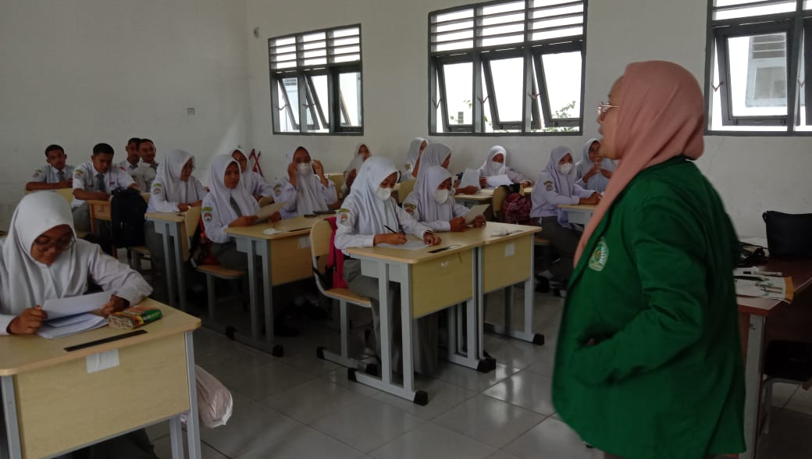
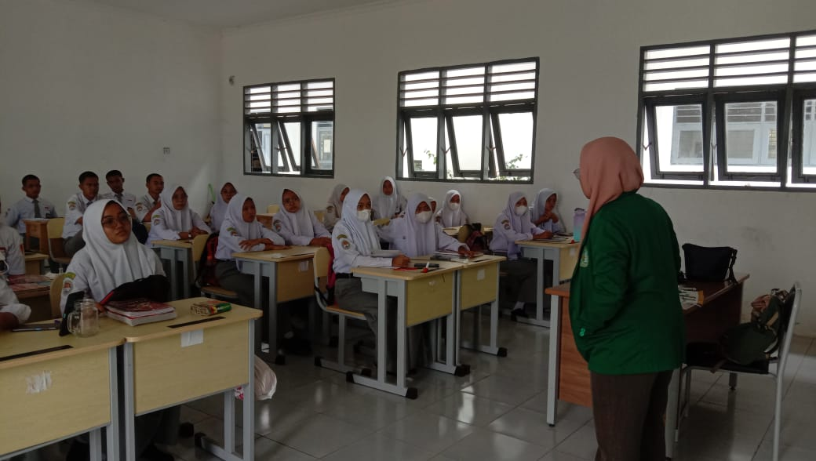

CONTROL GROUP
