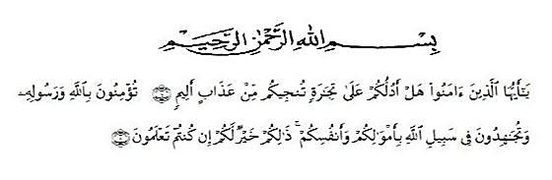**ACKNOWLEDMENTS**

Artinya:

*“Hai orang-orang yang beriman, sukakah kamu aku tunjukkan suatu perniagaan yang dapat menyelamatkanmu dari azab yang pedih?10. (yaitu) kamu beriman kepada Allah dan Rasul-Nya dan berjihad di jalan Allah dengan harta dan jiwamu. Itulah yang lebih baik bagimu, jika kamu mengetahui11.”* (QS. Ash-Shaff: 10-11).

In the name of Allah, the Lord of the World. The beneficent and the Most

Merciful. Firstly the researcher would like to thanks to the Almighty Allah SWT for all the blessing and guidance that gave to me for finishing this thesis andcomplete this academic requirement to finish bachelor degree.

Secondly, may sholawat and salam always be presented to the lastmesennger of Allah, Prophet Muhammad SAW who has inspired and lightened many people up all around the world.

The researcher realizes that the thesis is far from being perfect and without

defect. Constructive criticisms and suggestion are needed in order to improve the research. In finishing this research, the researcher got many valuable help andsupport by family, lectures, friend, and people around her while give great contribution

Therefore, in this research would like to delivery the writer’s thanks to :

1. Dr. KRT. Hardi Mulyono K, Surbakti as a Rector of the University of Muslim Nusantara Al-Washliyah Medan.
2. Drs. Samsul Bahri, M.Si as the Head of the Faculty of teacher Training and Education at the UMN Al-WashliyahMedan.
3. Zulfitri, S.S., M.A as the Head of the English Education Department of University Muslim Nusantara Al-Washliyah Medan.
4. Nurlaili, S.PdI., M.Hum as Adviser who help and provided ideas, suggestions, motivation for the completion of this thesis.
5. Headmaster of SMP Lestari Beringin, Mrs. Donna Aqsa Febrina, S.Pd and the English teacher Mrs. Nur Hikmah Saragih, S.Pd who has helped me in carrying out research to compile this thesis.
6. The lecturers of the English Language Department of FKIP University of Muslim Nusantara Medan for their nice and valuable discussing to enrich the researcher’s knowledge.
7. All of the Academic Administration Staffs of UMN Al-Washliyah Medan.
8. All of my colleague, especially my classmate who has makes me feel special and impressive memories.
9. All of my family, especially my parents and special person Endo Aldoni who have always been the side in facing all the laughter and tears during me make of this thesis.

Medan, October 2022

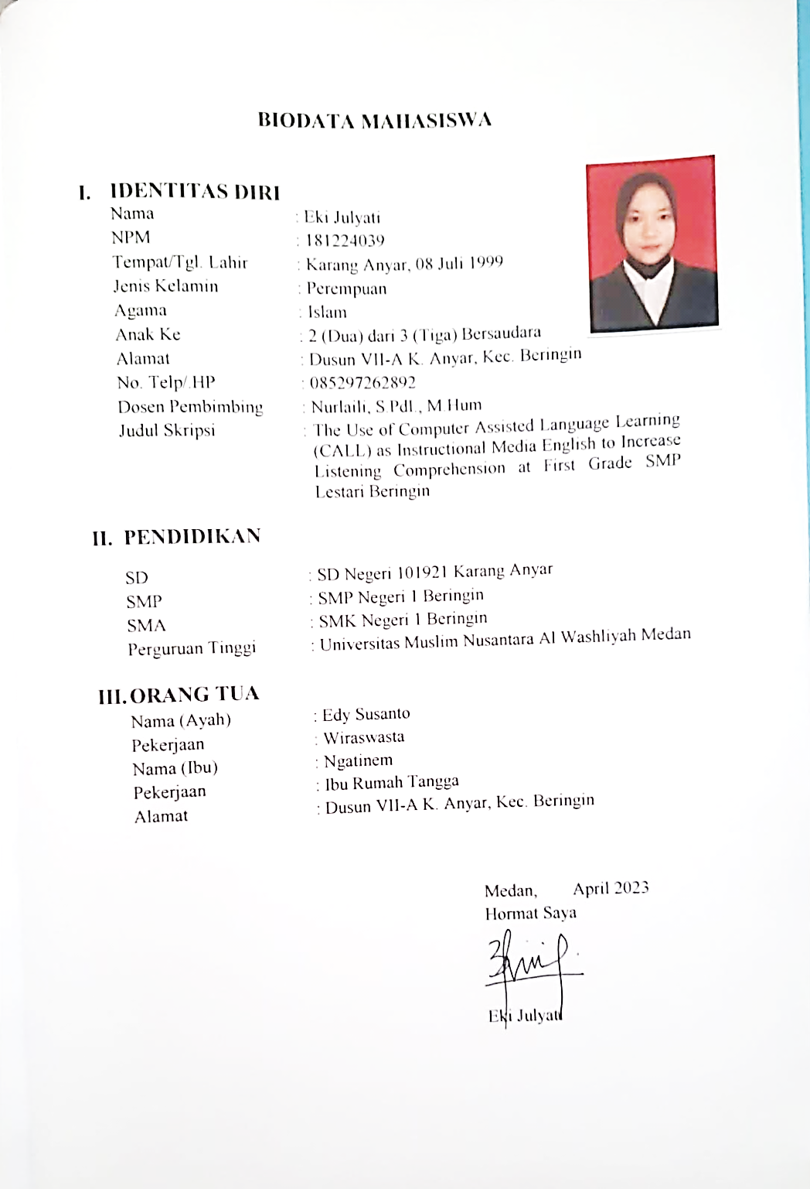The writer

Eki Julyati