**LAMPIRAN**

**Lampiran 1**. Surat Hasil Identifikasi Sampel Daun Jengkol (*Archidendron pauciflorum* Benth*.*)

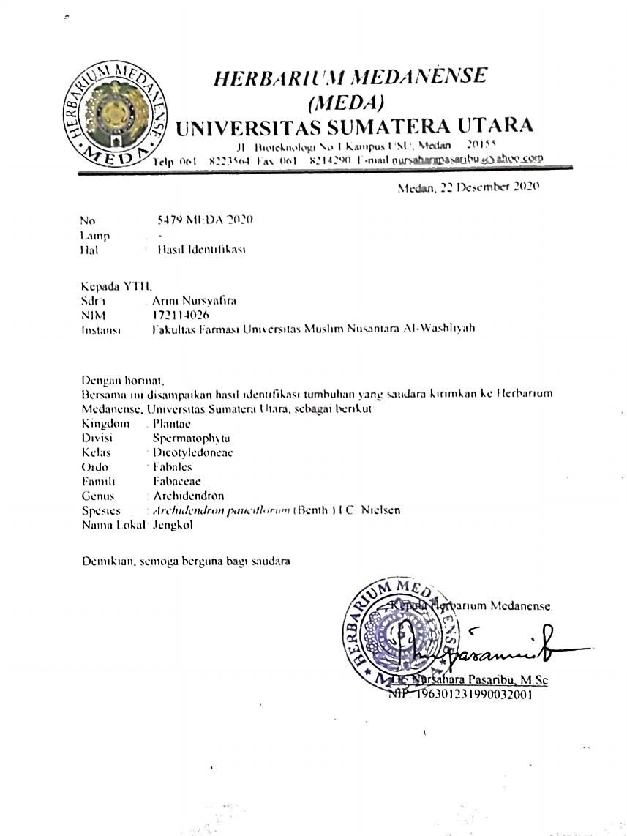

**Lampiran 2.** Daun Segar Jengkol dan Simplisia Daun Jengkol (*Archidendron pauciflorum* Benth*.*) I.C. Nielsen

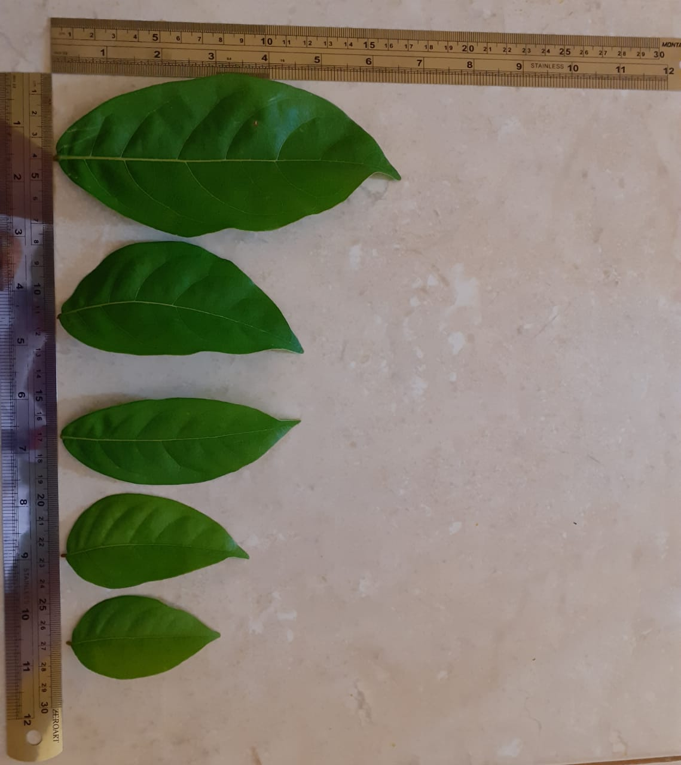

Daun Segar Jengkol (*Archidendron pauciflorum* Benth*.*) I.C. Nielsen

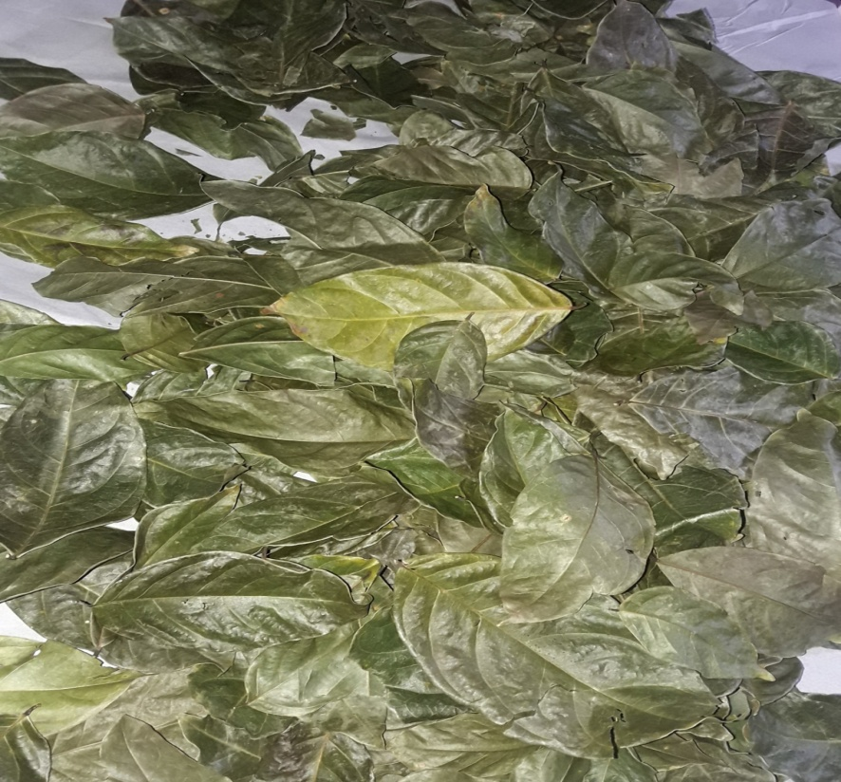

Simplisia Daun Jengkol (*Archidendronis folium)*

**Lampiran 3.** Serbuk Simplisia dan Ekstrak Etanol Daun Jengkol (*Archidendron pauciflorum* Benth*.*) I.C. Nielsen

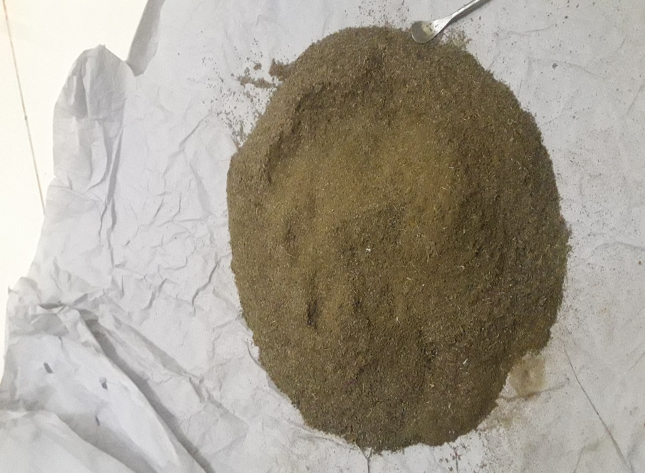

Serbuk Simplisia Daun Jengkol (*Archidendron pauciflorum* Benth*.*) I.C. Nielsen

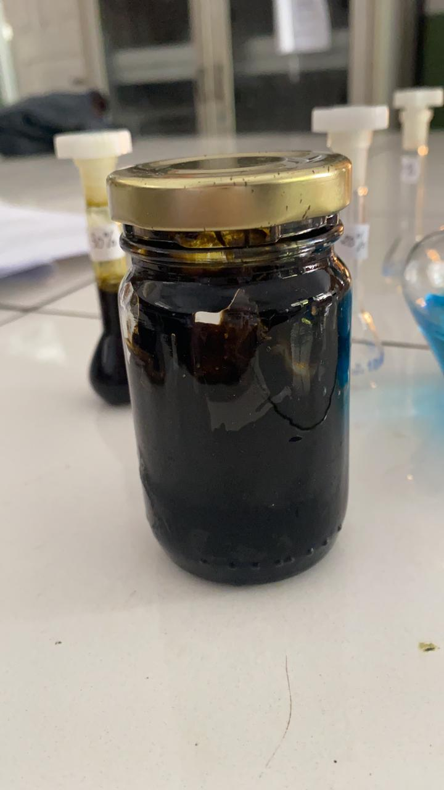

Ekstrak Etanol Daun Jengkol (*Archidendron pauciflorum* Benth*.*) I.C. Nielsen

**Lampiran 4.** Hasil Karakterisasi Mikroskopik Daun Jengkol (*Archidendron pauciflorum* Benth.) I.C. Nielsen.

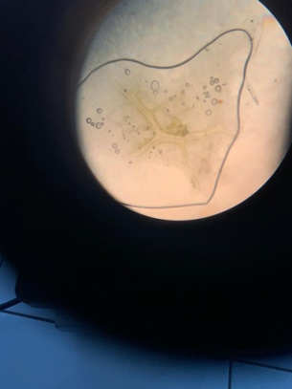

b. Epidermis Atas

1. Hablur Kalsium Oksalat

Keterangan : a. Hablur Kalsium Oksalat Pada Tulang Daun

1. Epidermis Atas

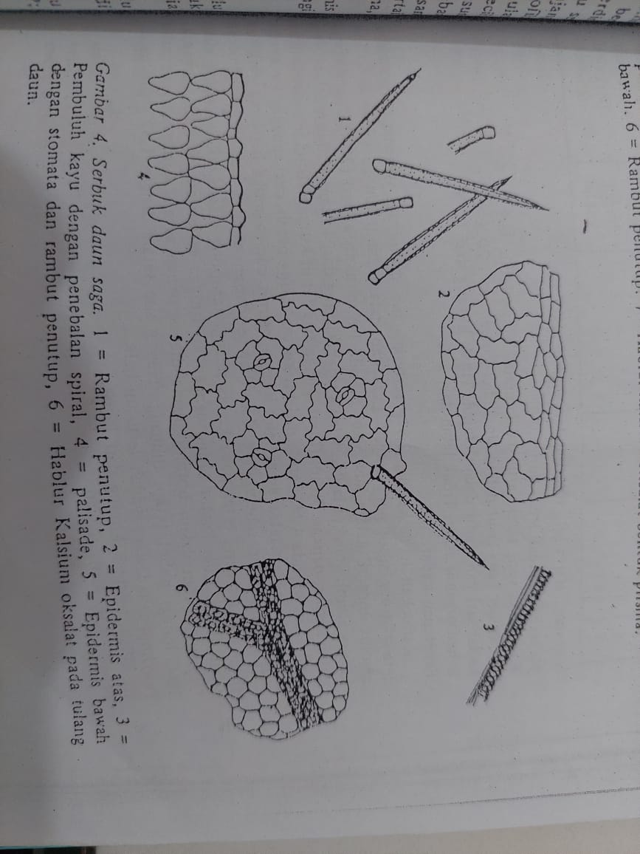Pembanding mikroskopik dipilih dengan ketentuan sampel daun dengan 1 family yang sama yaitu Daun Saga (*Abri Folium*).

b. Epidermis Atas

1. Hablur Kalsium Oksalat

Sumber : Materia Medika Indonesia

Keterangan : a. Hablur Kalsium Oksalat pada Tulang Daun

1. Epidermis Atas

**Lampiran 5.** Hasil Skrining Fitokimia Daun Jengkol (*Archidendron pauciflorum* Benth.) I.C. Nielsen.

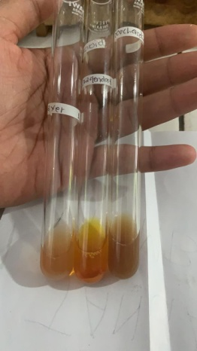 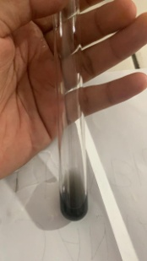

Tanin

Alkaloid

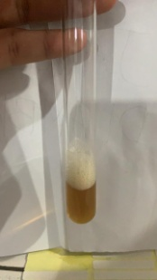 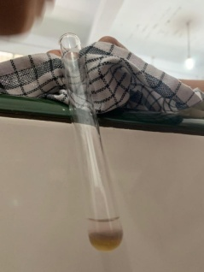

Glikosida

Saponin

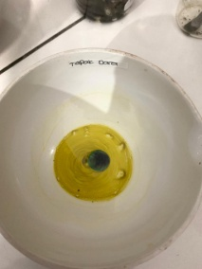 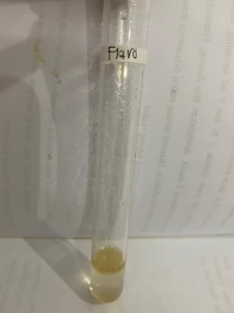

Flavonoid

Steroid/Triterpenoid

**Lampiran 6.** Bagan Alir Pembuatan Simplisia Daun Jengkol (*Archidendron pauciflorum* Benth*.*)

Daun Jengkol

Disortasi basah

Dicuci dengan air mengalir

Ditiriskan

Ditimbang

Dikeringkan dilemari

Pengering

Disortasi kering

Ditimbang kembali

Simplisia

Dihaluskan menggunakan

blender

Dimasukkan kedalam wadah tertutup

Serbuk Simplisia

Pembuatan Ekstrak

Karakterisasi Simplisia

* Pemeriksaan Makroskopik
* Pemeriksaan Mikroskopik
* Kadar air
* Kadar sari larut air
* Kadar sari larut etanol
* Kadar abu total
* Kadar abu tak larut asam

Skrinning Fitokimia

* Alkaloid
* Saponin
* Tannin
* Flavonoid
* Glikosida
* Steroid/Triterpenoid

UJi Antibakteri *Propionibacterium acnes* dan *Staphylococcus epidermidis*

**Lampiran 7.** Bagan Alir Pembuatan Ekstrak Etanol Daun Jengkol

Serbuk simplisia 500 gram

Dimasukkan kedalam bejana tertutup

Dituang etanol 96% sebanyak 3.75 L

Didiamkan selama 5 hari sambil

sesekali diaduk

Disaring

Ampas

Maserat I

Dicuci kembali dengan etanol 96% sebanyak 1.25 L

Ampas

Maserat II

Maserat I dan II

Didiamkan 2 hari

Di enap tuangkan atau saring

Diuapkan dengan Rotary Evaporator

Ekstrak Kental Daun Jengkol

**Lampiran 8.** Bagan Alir Aktivitas Antibakteri dari Larutan Uji

Biakan Bakteri Murni

Diambil dengan jarum ose

Ditanam pada media Nutrient Agar Miring

Diinkubasi pada suhu 35-37˚C selama 18-24

jam

Stok Kultur Bakteri

Diambil dengan jarum ose steril

Disuspensikan dalam 10 ml NaCl 0.9% steril

Dihomogenkan sampai kekeruhan yang

sama dengan standart Mc. Farland

Inokulum Bakteri

Dipipet 0.1 ml kedalam cawan petri

Ditambahkan 20 ml Media MHA ke dalam cawan petri

Media Padat

Diletakkan kertas cakram yang telah direndam dengan larutan uji.

Hasil Inkubasi

Diukur diameter zona hambat daerah bening

disekitar kertas cakram menggunakan jangka sorong

Diameter hambatan

**Lampiran 9.** Hasil Uji Identifikasi Bakteri *Staphylococcus epidermidis* dan *Propionibacterium acnes*

**

Bakteri *Staphylococcus epidermidis*



Bakteri *Propionibacterium acnes*

**Lampiran 10.** Hasil Uji Aktivitas Antibakteri

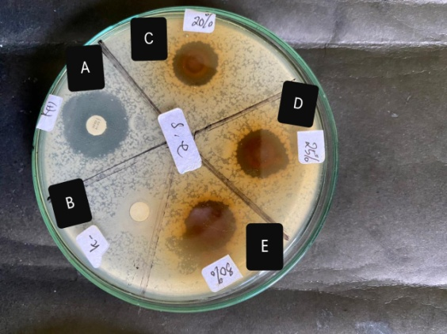 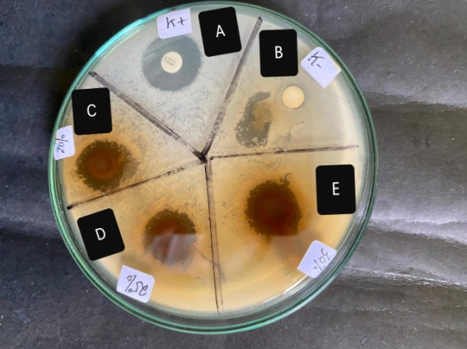

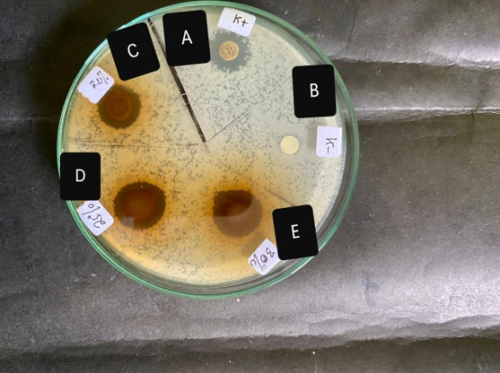

Ekstrak Etanol Daun Jengkol (*Archidendron pauciflorum* Benth*.*) Terhadap Bakteri *Staphylococcus epidermidis*

Keterangan : A. Kontrol Positif

B. Kontrol Negatif

C. Konsentrasi 20%

D. Konsentrasi 25%

E. Konsentrasi 30%

**Lampiran 10.** Lanjutan

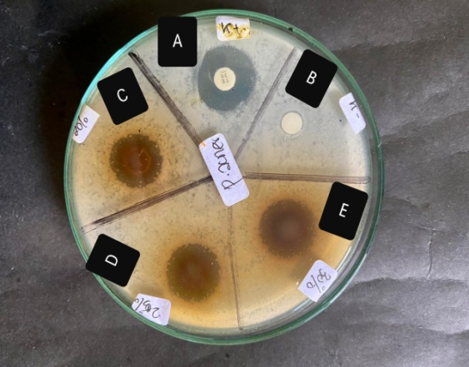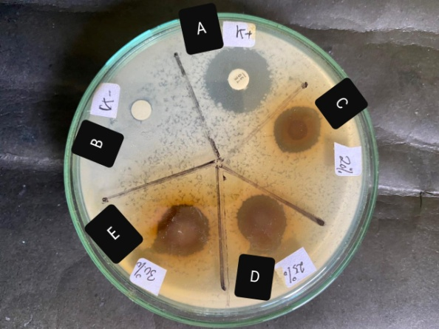

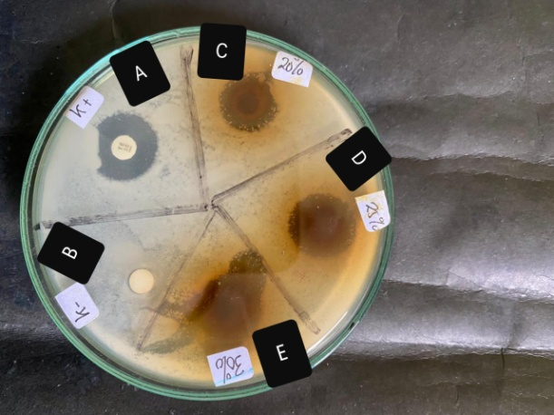

Ekstrak Etanol Daun Jengkol (*Archidendron pauciflorum* Benth*.*) terhadap bakteri *Propionibacterium acnes.*

Keterangan : A. Kontrol Positif

B. Kontrol Negatif

C. Konsentrasi 20%

D. Konsentrasi 25%

E. Konsentrasi 30%

**Lampiran 11.** Perhitungan Hasil Karakterisasi Simplisia

1. Penetapan kadar air

Kadar Air = $\frac{\left( volume air akhir-volume air awal \right)mL ×100 \%}{berat simplisia ( g )}$

1. Sampel 1

* Berat sampel : 5 g
* Volume akhir air : 2 ml
* Volume air awal : 1.6 ml

Kadar Air = $\frac{\left( 2 - 1.6 \right) mL ×100 \%}{5 ( g )}$ = 8%

1. Sampel 2

* Berat sampel : 5 g
* Volume akhir air : 2.1 ml
* Volume awal air : 1.7 ml

Kadar Air = $\frac{\left( 2.1 -1.7\right) mL ×100 \%}{5 ( g )}$ = 8%

1. Sampel 3

* Berat sampel : 5 g
* Volume akhir air : 1.9 ml
* Volume awal air : 1.5 ml

Kadar Air = $\frac{\left( 1.9 -1.5 \right) mL ×100 \%}{5 ( g )}$ = 8%

Kadar air rata rata : $\frac{8+8+8}{3}$ = 8%

**Lampiran 11.** Lanjutan

1. Penetapan kadar sari larut air

Kadar Sari Larut Air (%) = $\frac{Cawan berisi –Cawan kosong(g)}{Bobot sampel (g)} × \frac{100}{20}×100\%$

1. Sampel 1

* Berat sampel : 5 g
* Cawan berisi : 61.30 g
* Cawan kosong : 61.05 g

Kadar Sari Larut Air (%) = $\frac{61.30 -61.05( g)}{5(g)} × \frac{100}{20}×100\%$ = 25%

1. Sampel 2

* Berat sampel : 5 g
* Cawan berisi : 51.26 g
* Cawan kosong : 51.01 g

Kadar Sari Larut Air (%) = $\frac{51.26 -51.01( g)}{5(g)} × \frac{100}{20}×100\%$ = 25%

1. Sampel 3

* Berat sampel : 5 g
* Cawan berisi : 61.49 g
* Cawan kosong : 61.24 g

Kadar Sari Larut Air (%) = $\frac{61.49 - 61.24( g)}{5(g)} × \frac{100}{20}×100\%$ = 25%

Kadar sari larut air rata rata = $\frac{25+25+25}{3}$ = 25%

**Lampiran 11.** Lanjutan

1. Kadar sari larut etanol

Kadar sari larut etanol (%) = $\frac{Cawan berisi –Cawan kosong(g)}{Bobot sampel (g)} × \frac{100}{20}×100\%$

1. Sampel 1

* Berat sampel : 5 g
* Cawan berisi : 51.20 g
* Cawan kosong : 51.03 g

Kadar sari larut etanol (%) = $\frac{51.20-51.03(g)}{ 5(g)} × \frac{100}{20}×100\%$ = 17%

1. Sampel 2

* Berat sampel : 5 g
* Cawan berisi : 63.46 g
* Cawan kosong : 63.29 g

Kadar sari larut etanol (%) = $\frac{63.46-63.29(g)}{5 (g)} × \frac{100}{20}×100\%$ = 17%

1. Sampel 3

* Berat sampel : 5 g
* Cawan berisi : 54.63 g
* Cawan kosong : 54.46 g

Kadar sari larut etanol (%) = $\frac{54.63-54.46(g)}{5 (g)} × \frac{100}{20}×100\%$ = 17%

Kadar sari larut etanol rata rata = $\frac{17+17+17}{3}$ =17%

**Lampiran 11.** Lanjutan

1. Kadar Abu Total

Kadar abu total = $\frac{Berat cawan berisi-berat cawan kosong}{Berat sampel} ×100\%$

1. Sampel 1

* Berat Sampel : 2 g
* Cawan berisi : 63.5321 g
* Cawan kosong : 63.4326 g

Kadar abu total = $\frac{63.5321-63.4326 (g)}{2 (g)} ×100\%$ = 4.975%

1. Sampel 2

* Berat sampel : 2 g
* Cawan berisi : 63.6372 g
* Cawan kosong : 63.5377 g

Kadar abu total = $\frac{63.6372-63.5377 (g)}{2 (g)} ×100\%$ = 4.975%

1. Sampel 3

* Berat sampel : 2 g
* Cawan berisi : 54.0920 g
* Cawan kosong : 53.9925 g

Kadar abu total = $\frac{54.0920-53.9925 (g)}{2 (g)} ×100\%$ = 4.975%

Kadar abu total rata rata = $\frac{4.975+4.975+4.975}{3}$ = 4.975%

**Lampiran 11.** Lanjutan

1. Kadar abu tak larut asam

Kadar abu tidak larut asam = $\frac{Berat cawan berisi-berat cawan kosong}{Berat sampel}x 100\%$

1. Sampel 1

* Berat sampel : 2 g
* Cawan berisi : 63.4175 g
* Cawan kosong : 63.4158 g

Kadar abu tidak larut asam = $\frac{63.4175-63.4158 (g)}{2 (g)}x 100\%$ = 0.085%

1. Sampel 2

* Berat sampel : 2 g
* Cawan berisi : 51.6325 g
* Cawan kosong : 51.6218 g

Kadar abu tidak larut asam = $\frac{51.6325-51.6218 (g)}{2 (g)}x 100\%$ = 0.085%

1. Sampel 3

* Berat sampel : 2 g
* Cawan berisi : 58.9564 g
* Cawan kosong : 58.9547 g

Kadar abu tidak larut asam = $\frac{58.9564-58.9547 (g)}{2 (g)}x 100\%$ = 0.085%

Kadar abu tak larut asam rata rata = $\frac{0.085+0.085+0.085}{3}$ = 0.085%

**Lampiran 12.** Hasil Data Statistik

1. *Staphylococcus epidermidis*

|  |  |  |  |  |  |  |  |  |
| --- | --- | --- | --- | --- | --- | --- | --- | --- |
| **Descriptives** | | | | | | | | |
| zona hambat staphylococcus epidermidis | | | | | | | | |
|  | N | Mean | Std. Deviation | Std. Error | 95% Confidence Interval for Mean | | Minimum | Maximum |
| Lower Bound | Upper Bound |
| EEDJ 20% | 3 | 15.0667 | .35119 | .20276 | 14.1943 | 15.9391 | 14.70 | 15.40 |
| EEDJ 25% | 3 | 16.0333 | .70238 | .40552 | 14.2885 | 17.7781 | 15.30 | 16.70 |
| EEDJ 30% | 3 | 17.8333 | .55076 | .31798 | 16.4652 | 19.2015 | 17.30 | 18.40 |
| KONTROL POSITIF | 3 | 18.6667 | 2.95691 | 1.70717 | 11.3213 | 26.0120 | 15.60 | 21.50 |
| KONTROL NEGATIF | 3 | .0000 | .00000 | .00000 | .0000 | .0000 | .00 | .00 |
| Total | 15 | 13.5200 | 7.21657 | 1.86331 | 9.5236 | 17.5164 | .00 | 21.50 |

|  |  |  |  |  |  |
| --- | --- | --- | --- | --- | --- |
| **ANOVA** | | | | | |
| zona hambat staphylococcus epidermidis | | | | | |
|  | Sum of Squares | df | Mean Square | F | Sig. |
| Between Groups | 709.777 | 4 | 177.444 | 91.813 | .000 |
| Within Groups | 19.327 | 10 | 1.933 |  |  |
| Total | 729.104 | 14 |  |  |  |

|  |  |  |  |  |  |  |
| --- | --- | --- | --- | --- | --- | --- |
| **Multiple Comparisons** | | | | | | |
| Dependent Variable: zona hambat staphylococcus epidermidis | | | | | | |
| Tukey HSD | | | | | | |
| (I) sediaan | (J) sediaan | Mean Difference (I-J) | Std. Error | Sig. | 95% Confidence Interval | |
| Lower Bound | Upper Bound |
| EEDJ 20% | EEDJ 25% | -.96667 | 1.13510 | .908 | -4.7024 | 2.7690 |
| EEDJ 30% | -2.76667 | 1.13510 | .182 | -6.5024 | .9690 |
| KONTROL POSITIF | -3.60000 | 1.13510 | .060 | -7.3357 | .1357 |
| KONTROL NEGATIF | 15.06667* | 1.13510 | .000 | 11.3310 | 18.8024 |
| EEDJ 25% | EEDJ 20% | .96667 | 1.13510 | .908 | -2.7690 | 4.7024 |
| EEDJ 30% | -1.80000 | 1.13510 | .537 | -5.5357 | 1.9357 |
| KONTROL POSITIF | -2.63333 | 1.13510 | .215 | -6.3690 | 1.1024 |
| KONTROL NEGATIF | 16.03333* | 1.13510 | .000 | 12.2976 | 19.7690 |
| EEDJ 30% | EEDJ 20% | 2.76667 | 1.13510 | .182 | -.9690 | 6.5024 |
| EEDJ 25% | 1.80000 | 1.13510 | .537 | -1.9357 | 5.5357 |
| KONTROL POSITIF | -.83333 | 1.13510 | .943 | -4.5690 | 2.9024 |
| KONTROL NEGATIF | 17.83333* | 1.13510 | .000 | 14.0976 | 21.5690 |
| KONTROL POSITIF | EEDJ 20% | 3.60000 | 1.13510 | .060 | -.1357 | 7.3357 |
| EEDJ 25% | 2.63333 | 1.13510 | .215 | -1.1024 | 6.3690 |
| EEDJ 30% | .83333 | 1.13510 | .943 | -2.9024 | 4.5690 |
| KONTROL NEGATIF | 18.66667* | 1.13510 | .000 | 14.9310 | 22.4024 |
| KONTROL NEGATIF | EEDJ 20% | -15.06667* | 1.13510 | .000 | -18.8024 | -11.3310 |
| EEDJ 25% | -16.03333* | 1.13510 | .000 | -19.7690 | -12.2976 |
| EEDJ 30% | -17.83333* | 1.13510 | .000 | -21.5690 | -14.0976 |
| KONTROL POSITIF | -18.66667* | 1.13510 | .000 | -22.4024 | -14.9310 |
| *. The mean difference is significant at the 0.05 level. | | | | | | |

|  |  |  |  |
| --- | --- | --- | --- |
| **zona hambat staphylococcus epidermidis** | | | |
| Tukey HSDa | | | |
| Sediaan | N | Subset for alpha = 0.05 | |
| 1 | 2 |
| KONTROL NEGATIF | 3 | .0000 |  |
| EEDJ 20% | 3 |  | 15.0667 |
| EEDJ 25% | 3 |  | 16.0333 |
| EEDJ 30% | 3 |  | 17.8333 |
| KONTROL POSITIF | 3 |  | 18.6667 |
| Sig. |  | 1.000 | .060 |
| Means for groups in homogeneous subsets are displayed. | | | |
| a. Uses Harmonic Mean Sample Size = 3.000. | | | |

1. *Propionibacterium acnes*

|  |  |  |  |  |  |  |  |  |
| --- | --- | --- | --- | --- | --- | --- | --- | --- |
| **Descriptives** | | | | | | | | |
| zona hambat Propionibacterium acnes | | | | | | | | |
|  | N | Mean | Std. Deviation | Std. Error | 95% Confidence Interval for Mean | | Minimum | Maximum |
| Lower Bound | Upper Bound |
| EEDJ 20% | 3 | 15.8667 | .45092 | .26034 | 14.7465 | 16.9868 | 15.40 | 16.30 |
| EEDJ 25% | 3 | 18.1667 | .61101 | .35277 | 16.6488 | 19.6845 | 17.50 | 18.70 |
| EEDJ 30% | 3 | 18.1000 | .91652 | .52915 | 15.8233 | 20.3767 | 17.10 | 18.90 |
| KONTROL POSITIF | 3 | 17.4333 | .35119 | .20276 | 16.5609 | 18.3057 | 17.10 | 17.80 |
| KONTROL NEGATIF | 3 | .0000 | .00000 | .00000 | .0000 | .0000 | .00 | .00 |
| Total | 15 | 13.9133 | 7.26684 | 1.87629 | 9.8891 | 17.9376 | .00 | 18.90 |

|  |  |  |  |  |  |
| --- | --- | --- | --- | --- | --- |
| **ANOVA** | | | | | |
| zona hambat Propionibacterium acnes | | | | | |
|  | Sum of Squares | df | Mean Square | F | Sig. |
| Between Groups | 736.217 | 4 | 184.054 | 597.579 | .000 |
| Within Groups | 3.080 | 10 | .308 |  |  |
| Total | 739.297 | 14 |  |  |  |

|  |  |  |  |  |  |  |
| --- | --- | --- | --- | --- | --- | --- |
| **Multiple Comparisons** | | | | | | |
| Dependent Variable: zona hambat Propionibacterium acnes | | | | | | |
| Tukey HSD | | | | | | |
| (I) sediaan | (J) sediaan | Mean Difference (I-J) | Std. Error | Sig. | 95% Confidence Interval | |
| Lower Bound | Upper Bound |
| EEDJ 20% | EEDJ 25% | -2.30000* | .45314 | .003 | -3.7913 | -.8087 |
| EEDJ 30% | -2.23333* | .45314 | .004 | -3.7246 | -.7420 |
| KONTROL POSITIF | -1.56667* | .45314 | .039 | -3.0580 | -.0754 |
| KONTROL NEGATIF | 15.86667* | .45314 | .000 | 14.3754 | 17.3580 |
| EEDJ 25% | EEDJ 20% | 2.30000* | .45314 | .003 | .8087 | 3.7913 |
| EEDJ 30% | .06667 | .45314 | 1.000 | -1.4246 | 1.5580 |
| KONTROL POSITIF | .73333 | .45314 | .519 | -.7580 | 2.2246 |
| KONTROL NEGATIF | 18.16667* | .45314 | .000 | 16.6754 | 19.6580 |
| EEDJ 30% | EEDJ 20% | 2.23333* | .45314 | .004 | .7420 | 3.7246 |
| EEDJ 25% | -.06667 | .45314 | 1.000 | -1.5580 | 1.4246 |
| KONTROL POSITIF | .66667 | .45314 | .601 | -.8246 | 2.1580 |
| KONTROL NEGATIF | 18.10000* | .45314 | .000 | 16.6087 | 19.5913 |
| KONTROL POSITIF | EEDJ 20% | 1.56667* | .45314 | .039 | .0754 | 3.0580 |
| EEDJ 25% | -.73333 | .45314 | .519 | -2.2246 | .7580 |
| EEDJ 30% | -.66667 | .45314 | .601 | -2.1580 | .8246 |
| KONTROL NEGATIF | 17.43333* | .45314 | .000 | 15.9420 | 18.9246 |
| KONTROL NEGATIF | EEDJ 20% | -15.86667* | .45314 | .000 | -17.3580 | -14.3754 |
| EEDJ 25% | -18.16667* | .45314 | .000 | -19.6580 | -16.6754 |
| EEDJ 30% | -18.10000* | .45314 | .000 | -19.5913 | -16.6087 |
| KONTROL POSITIF | -17.43333* | .45314 | .000 | -18.9246 | -15.9420 |
| *. The mean difference is significant at the 0.05 level. | | | | | | |

|  |  |  |  |  |
| --- | --- | --- | --- | --- |
| **zona hambat Propionibacterium acnes** | | | | |
| Tukey HSDa | | | | |
| Sediaan | N | Subset for alpha = 0.05 | | |
| 1 | 2 | 3 |
| KONTROL NEGATIF | 3 | .0000 |  |  |
| EEDJ 20% | 3 |  | 15.8667 |  |
| KONTROL POSITIF | 3 |  |  | 17.4333 |
| EEDJ 30% | 3 |  |  | 18.1000 |
| EEDJ 25% | 3 |  |  | 18.1667 |
| Sig. |  | 1.000 | 1.000 | .519 |
| Means for groups in homogeneous subsets are displayed. | | | | |
| a. Uses Harmonic Mean Sample Size = 3.000. | | | | |