FACULTY OF TEACHER TRAINING AND EDUCATION UNIVERSITAS MUSLIM NUSANTARA AL WASHLIYAH

LETTER OF APPROVAL

NAME : Andra Amelia
REG.NUMBER 181224035
MAJOR : Language Education and Literature STUDY PROGRAM : English Language Education QUALIFICATION : Bachelor (S-1)
TITLE : Students’ Anxiety in Speaking English at SMA Al- Washliyah 3 Medan
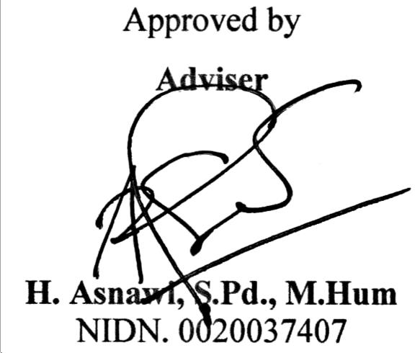

Examination Committee
