UJI AKTIVITAS ANTIOKSIDAN EKSTRAK ETANOL DAUN PETAI GAJAH (Parkia speciosaHassk.) DI DAERAH KUTACANE,DENGANMETODE DPPH( 1,1-Diphenyl-2-Picrylhydrazil)

MAKHFIRAH
NPM.182114016

ABSTRAK
Antioksidan mampu menginaktivasi berkembangnya reaksi oksidasi dengan cara mencegah terbentuknya radikal bebas. daun petai mengandung senyawa fenolik dan flavonoid yang dapat digunakan sebagai antioksidan. Penelitian ini bertujuan untuk mengetahui aktivitas antioksidan ekstrak etanol daun petai gajah, juga untuk mengetahui golongan senyawa dalam daun Petai Gajah.
Penelitian ini bersifat deskriftif, ekstrak etanol daun petai gajah diperoleh dengan cara maserasi adapun pengujian yang dilakukan meliputi pengujian kadar air, kadar sari laraut dalam air, kadar sari larut dalam etanol, kadar abu, kadar abu tidak larut asam, pengujian skrining fitokimia dan pengujian aktivitas antioksidan.
Hasil karakterisasi serbuk simplisia daun Petai gajah diperoleh kadar air 8%, kadar sari yang larut dalam air12,0%, kadar sari larut dalam etanol 5,4%, kadar abu total 10,7%, dan kadar abu yang tidak larut asam 1,3%. Hasil skrining fitokimia daun petai gajah mengandung senyawa alkaloid,flavonoid, saponin, tanin dan steroid. Hasil pengujian aktivitas antioksidan menunjukan bahwa ekstrak etanol daun petai gajah memiliki nilai IC₅₀221,9828 µg/ml. Hasil penelitian menunjukkan bahwa ekstrak etanol daun petai gajah memiliki antioksidan lemah.

Kata kunci:Ekstrak Daun Petai Gajah (Parkia speciosa Hassk.), Antioksidan, DPPH, Spektrofotometri UV – Visible

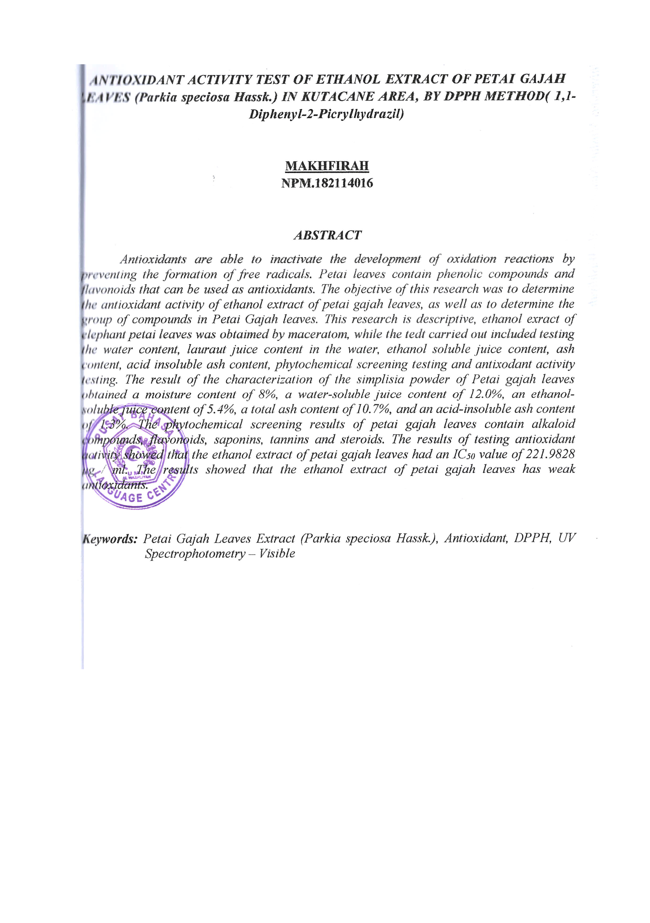
ANTIOXIDANT ACTIVITY TEST OF ETHANOL EXTRACT OF PETAI GAJAH LEAVES (Parkia speciosa Hassk.) IN KUTACANE AREA, BY DPPH METHOD ( 1,1-Diphenyl-2-Picrylhydrazil)

MAKHFIRAH
NPM.182114016

ABSTRACT
Antioxidants are able to inactivate the development of oxidation reactions by preventing the formation of free radicals. Petai leaves contain phenolic compounds and flavonoids that can be used as antioxidants. The objective of this research was to determine the group of compounds in petai gajah leaves.
This research is descriptive, ethanol extract of elephant petai leaves was obtained by maceration, while the tests carried out included testing the water content, laraut juice content in water, ethanol soluble juice content, ash content, acid insoluble ash content, phytochemical screening testing and antioxidant activity testing.
The result of the characterization of the simplisia powder of Petai gajah leaves obtained a moisture content of 8%, a water-soluble juice content of 12.0%, an ethanol-soluble juice content of 5.4%, a total ash content of 10.7%, and an acid-insoluble ash content of 1.3%. The phytochemical screening results of elephant petai leaves contain alkaloid compounds, flavonoids, saponins, tannins and steroids. The results of testing antioxidant activity showed that the ethanol extract of petai gajah leaves had an IC₅₀ value of 221.9828 μg / ml . The results showed that the ethanol extract of petai gajah leaves has weak antioxidants.
.
Keywords: Elephant Petai Leaf Extract (Parkia speciosa Hassk.), Antioxidant, DPPH, UV Spectrophotometry – Visible

