EFEKTIVITAS ANTIBAKTERI EKSTRAK ETANOL DAUN MURBEI (Morus alba L.) TERHADAP BAKTERI Staphylococcus aureus dan Escherichia coli

DEWI FIRMAYANI
NPM. 212114115

ABSTRAK

Murbei (Morus alba L.) merupakan tanaman yang tumbuh secara liar diseluruh wilayah Indonesia. Kandungan senyawa aktif yang terdapat pada murbei yaitu alkaloid, flavonoid, dan polifenol. Penelitian ini bertujuan untuk mengetahui golongan senyawa metabolit sekunder yang terdapat dalam simplisia, ekstrak etanol daun murbei (Morus alba L.) dan untuk mengetahui efektivitas antibakteri ekstrak etanol daun murbei (Morus alba L.) terhadap bakteri Staphylococcus aureus dan Escherichia coli.
Penelitian ini dilakukan dengan metode eksperimental meliputi pemeriksaan makroskopis, mikroskopis, pemeriksaan karakteristik, skrining fitokimia, pengujian efektivitas antibakteri terhadap bakteri Staphylococcus aureus dan Escherichia coli.
Hasil pemeriksaan makroskopis daun murbei berwarna hijau segar bentuk bulat telur hingga berbentuk mirip jantung, ujung meruncing, tepi bergerigi, pertulangan menyirip agak menonjol, permukaan atas dan bawah kasar, panjang daun murbei 12 cm dan lebar daun 9 cm. Hasil pemeriksaan mikroskopis, daun murbei terdapat stomata, rambut penutup, dan krital kalsium oksalat. Hasil penetapan kadar air simplisia daun murbei diperoleh 2,6%, penetapan kadar sari larut air serbuk simplisia 11,01%, kadar sari larut etanol 10,7% penetapan kadar abu total 10,73%, kadar abu tidak larut asam 4,3%. Skrining fitokimia serbuk dan ekstrak simplisia daun murbei menunjukkan adanya kandungan alkaloid, flavonoid, tanin, saponin, steroid dan glikosida. Hasil uji efektivitas antibakteri ekstrak etanol daun murbei (Morus alba L.). Zona hambat bakteri Staphylococcus aureus konsentrasi 70%, 80%, 90%, 100% didapatkan rata-rata 13,91 mm, 13,95 mm, 14,51 mm, 16 mm. Untuk daya hambat bakteri Escherichia coli dengan konsntrasi 70%, 80%, 90%, 100% rata-rata 13,6 mm, 14,05 mm, 14,53 mm, 16,3 mm.

Kata Kunci : murbei, Ekstrak , Antibakteri, Staphylococcus aureus,
Escherichia coli.

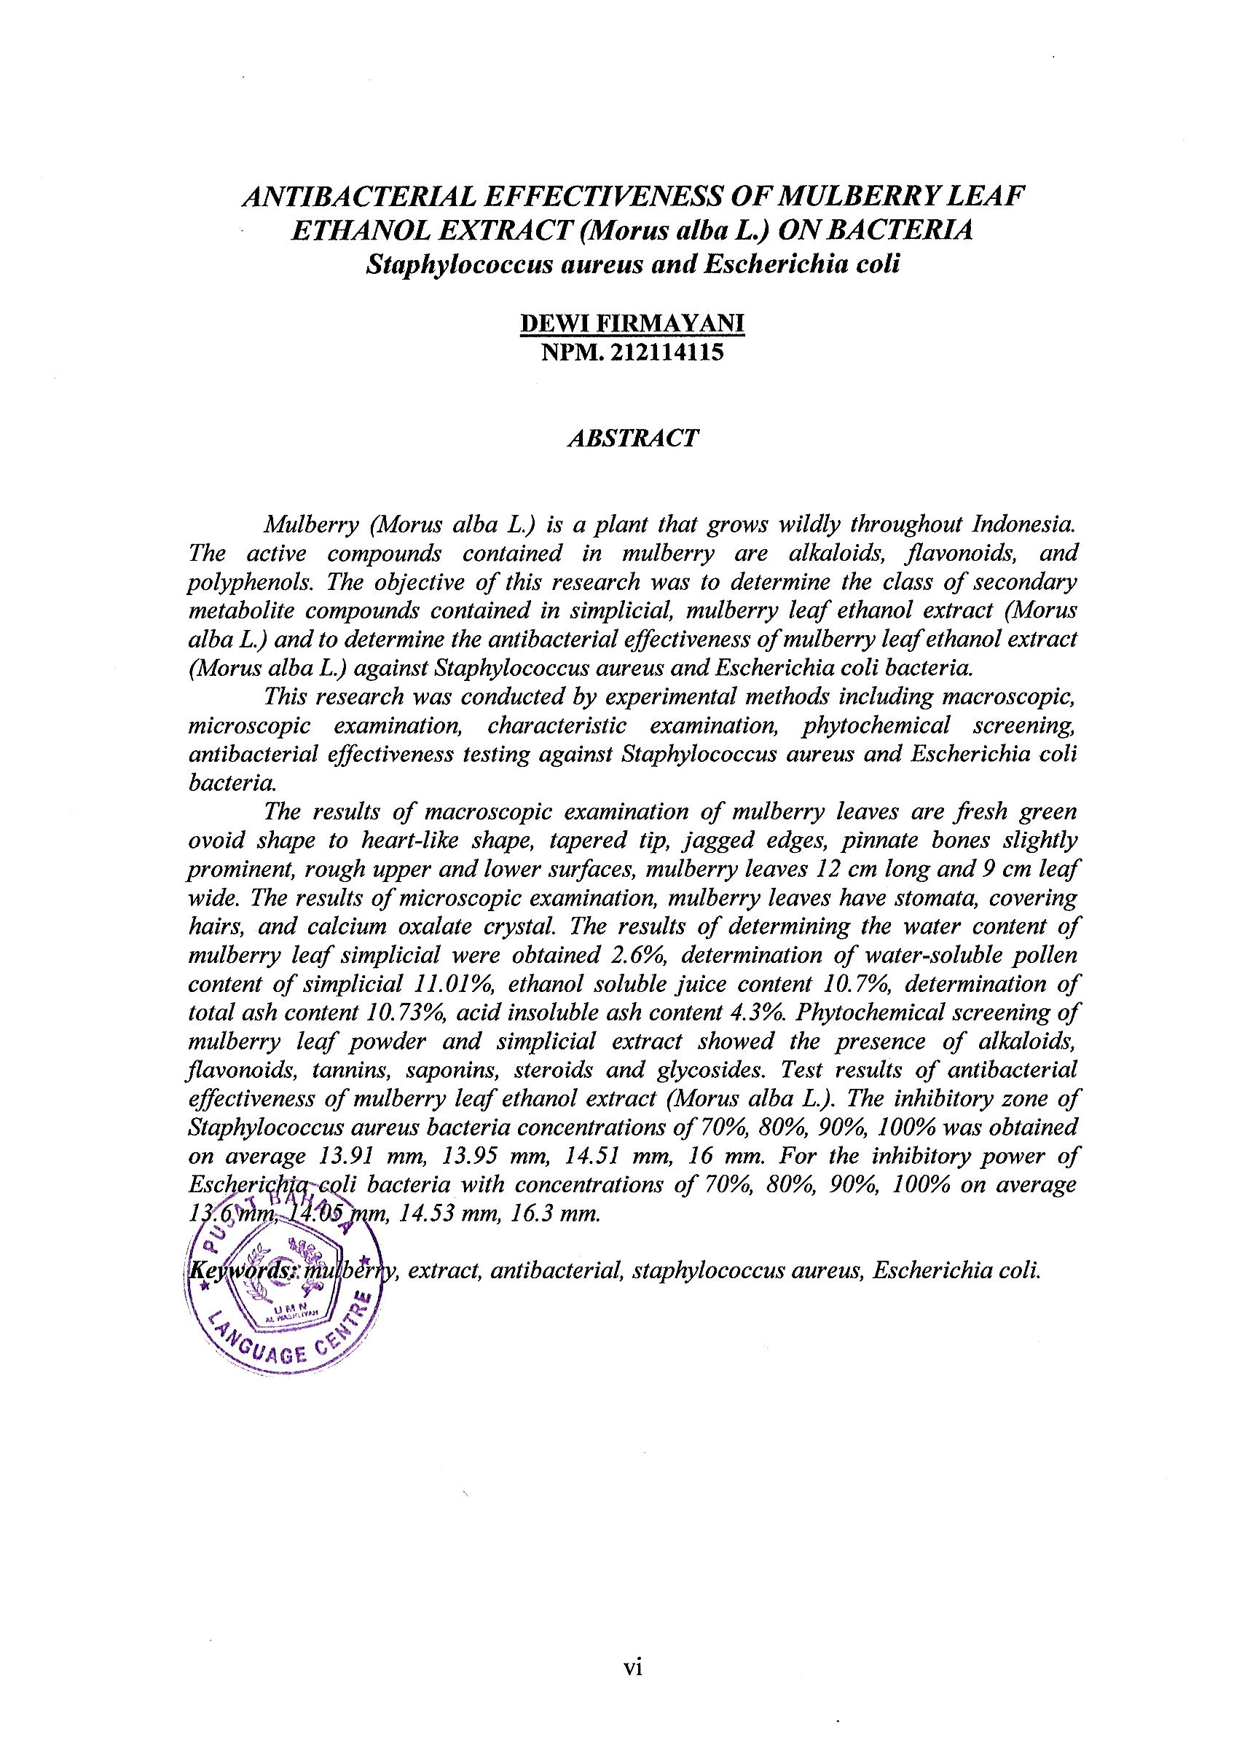
ANTIBACTERIAL EFFECTIVENESS OF MULBERRY LEAF ETHANOL EXTRACT (Morus alba L.) ON BACTERIA
Staphylococcus aureus and Escherichia coli

DEWI FIRMAYANI
NPM. 212114115

ABSTRACT

Mulberry (Morus alba L.) is a plant that grows wildly throughout Indonesia. The active compounds contained in mulberry are alkaloids, flavonoids, and polyphenols. The objective of this research was to determine the class of secondary metabolite compounds contained in simplicial, mulberry leaf ethanol extract (Morus alba L.) and to determine the antibacterial effectiveness of mulberry leaf ethanol extract (Morus alba L.) against Staphylococcus aureus and Escherichia coli bacteria.
This research was conducted by experimental methods including macroscopic, microscopic examination, characteristic examination, phytochemical screening, antibacterial effectiveness testing against Staphylococcus aureus and Escherichia coli bacteria.
The results of macroscopic examination of mulberry leaves are fresh green ovoid shape to heart-like shape, tapered tip, jagged edges, pinnate bones slightly prominent, rough upper and lower surfaces, mulberry leaves 12 cm long and 9 cm leaf wide. The results of microscopic examination, mulberry leaves have stomata, covering hairs, and calcium oxalate crystal. The results of determining the water content of mulberry leaf simplicial were obtained 2.6%, determination of water-soluble pollen content of simplicial 11.01%, ethanol soluble juice content 10.7%, determination of total ash content 10.73%, acid insoluble ash content 4.3%. Phytochemical screening of mulberry leaf powder and simplicial extract showed the presence of alkaloids, flavonoids, tannins, saponins, steroids and glycosides. Test results of antibacterial effectiveness of mulberry leaf ethanol extract (Morus alba L.). The inhibitory zone of Staphylococcus aureus bacteria concentrations of 70%, 80%, 90%, 100% was obtained on average 13.91 mm, 13.95 mm, 14.51 mm, 16 mm. For the inhibitory power of Escherichia coli bacteria with concentrations of 70%, 80%, 90%, 100% on average 13.6 mm, 14.05 mm, 14.53 mm, 16.3 mm.
Keywords: mulberry, extract, antibacterial, staphylococcus aureus, Escherichia coli.

