ANALISIS CEMARAN BAKTERI Staphylococcus aureus
PADA DAGING AYAM KRISPY PINGGIR JALAN
DAN FAST FOOD DI DAERAH
TELADAN KOTA MEDAN

ADELIA RAMADANI
192114017

ABSTRAK

Ayam merupakan bahan pangan yang bergizi tinggi mengandung protein, lemak, mineral dan zat yang lain yang sangat diperlukan tubuh. Namun daging ayam juga dapat tercemar bakteri patogen Staphylococcus aureus yang dapat menyebabkan penyakit Staph Food Poisioning (SFP) atau keracunan makanan yang terkontaminasi dari kurangnya kebersihan dan hygienitas pedagang atau lingkungannya. Dilakukan penelitian dengan tujuan untuk mengidentifikasi keberadaan bakteri patogen Staphylococcus aureus pada daging ayam goreng krispy pinggir jalan dan merek fast food terkenal di daerah Teladan kota Medan dan menganalisis nilai cemaran bakteri patogen Staphylococcus aureus memenuhi Standar Nasional Indonesia (SNI) yaitu 1X10² CFU/ml.
Metode Penelitian Angka Lempeng Total (ALT). Untuk menghitung serta mengetahui keberadaan bakteri dalam suatu sampel uji, maka terlebih dahulu dilakukan uji identifikasi adanya keberadaan bakteri patogen Staphylococcus aureus kemudian diidentifikasi spesifik kembali menggunakan uji pewarnaan gram, uji koagulase, dan uji katalase. Dilanjutkan uji Angka Lempeng Total (ALT) untuk mengetahui jumlah nilai cemaran bakteri patogen Staphylococcus aureus.
Hasil penelitian menunjukkan bahwa pada sampel daging ayam goreng krispy pinggir jalan positif adanya keberadaan bakteri patogen Staphylococcus aureus dan nilai cemaran bakteri patogen Staphylococcus aureus melebihi ambang batas dan tidak memenuhi Standar Nasional Indonesia (SNI) yaitu 1X10² CFU/ml. pada sampel daging ayam goreng krispy fast food negatif adanya keberadaan bakteri patogen Staphylococcus aureus dan nilai cemaran bakteri patogen Staphylococcus aureus tidak melebihi ambang batas dan memenuhi Standar Nasional Indonesia (SNI) yaitu 1X10² CFU/ml.

Kata Kunci: Staphylococcus aureus, Angka Lempeng Total (ALT), Staph Food Poisioning, Ayam

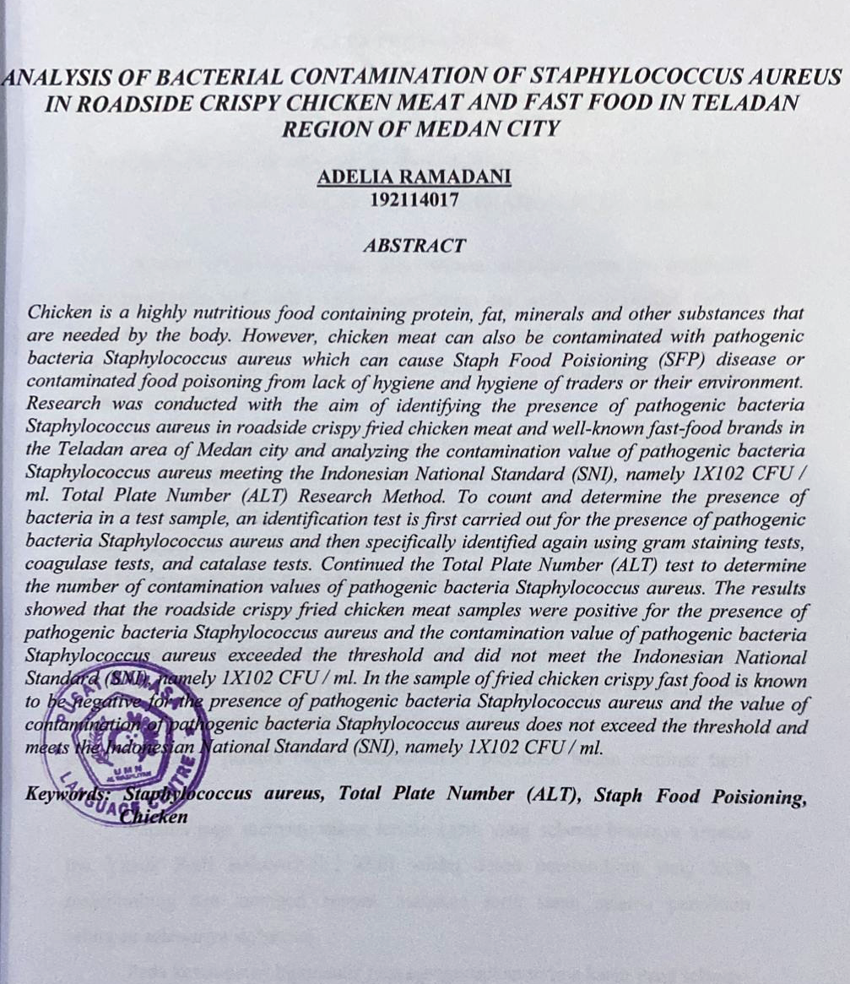
ANALYSIS OF BACTERIALCONTAMINATION
Staphylococcus aureus ON ROADSIDE KRISPY
CHICKEN MEAT AND FAST FOOD IN THE
EXEMPLARY AREA OF MEDAN CITY

ADELIA RAMADANI
192114017

ABSTRACT

Chicken is a highly nutritious food containing protein, fat, minerals and other substances that are needed by the body. However, chicken meat can also be contaminated with pathogenic bacteria Staphylococcus aureus which can cause Staph Food Poisioning (SFP) disease or contaminated food poisoning from lack of hygiene and hygiene of traders or their environment. Research was conducted with the aim of identifying the presence of pathogenic bacteria Staphylococcus aureus in roadside krispy fried chicken meat and well-known fast food brands in the Teladan area of Medan city and analyzing the contamination value of pathogenic bacteria Staphylococcus aureus meeting the Indonesian National Standard (SNI), namely 1X10² CFU / ml.
Total Plate Number (ALT) Research Method. To count and determine the presence of bacteria in a test sample, an identification test is first carried out for the presence of pathogenic bacteria Staphylococcus aureus and then specifically identified again using gram staining tests, coagulase tests, and catalase tests. Continued the Total Plate Number (ALT) test to determine the number of contamination values of pathogenic bacteria Staphylococcus aureus.
The results showed that the roadside krispy fried chicken meat samples were positive for the presence of pathogenic bacteria Staphylococcus aureus and the contamination value of pathogenic bacteria Staphylococcus aureus exceeded the threshold and did not meet the Indonesian National Standard (SNI), namely 1X102 CFU / ml. In the sample of fried chicken krispy fast food is known to be negative for the presence of pathogenic bacteria Staphylococcus aureus and the value of contamination of pathogenic bacteria Staphylococcus aureus does not exceed the threshold and meets the Indonesian National Standard (SNI), namely 1X102 CFU / ml.
Keywords: Staphylococcus aureus, Total Plate Number (ALT), Staph Food Poisioning, Chicken

