PENETAPAN KADAR FENOLIK TOTAL EKSTRAK KAYU
BAJAKAH (Spatholobus littolaris Hassk.) BERDASARKAN PERBEDAAN KONSENTRASI ETANOL DENGAN METODE SPEKTROFOTOMETRI UV-VIS

INDAH TRIUTAMI HARAHAP NPM : 192114072

ABSTRAK

Tumbuhan akar bajakah tampala (Spatholobus littolaris Hassk.) salah satu tumbuhan yang secara empiris di gunakan oleh masyarakat pedalaman Kalimantan Tengah sebagai obat tradisonal. sesuai uji pendahuluan yang dilakukan, bajakah tampala mengandung fenolik. Senyawa fenolik ialah senyawa yg dapat mempunyai aktivitas antioksidan. Tujuan untuk mengetahui golongan senyawa yang terdapat di dalam serbuk simplisia, ekstrak etanol dan kadar fenolik total dan rendemen ekstrak maserasi dalam akar bajakah.
Tahapan penelitian ini meliputi pengolahan bahan tumbuhan, pembuatan ekstrak maserasi dan akar bajakah, pemeriksaan karakterisasi, skrining fitokimia dan pengaruh terhadap rendemen kadar fenolik total akar bajakah dengan metode spektrofotometri UV-Vis.
Hasil penelitian menunjukkan bahwa serbuk simplisia akar kayu bajakah mengandung senyawa alkaloid, glikosida, steroid/triterpenoid, flavonoid, uji fenolik, saponin, dan tanin, sedangkan ekstrak etanol akar kayu bajakah menunjukkan adanya senyawa alkaloid, steroid/triterpenoid, tanin, saponin, flavonoid dan uji fenolik. Penentuan kadar fenolik total dilakukan dengan menentukan panjang gelombang maksimum asam galat dan perhitungan kadar fenolik total berdasarkan perbedaan konsentrasi etanol dengan menggunakan metode spektrofotometri UV-Vis. Hasil penentuan kadar fenolik total pada ekstrak etanol 96% sebesar 33,872 ± 0,0420 mg GAE/g, ekstrak etanol 70%
sebesar 29,345 ± 0,2149 mg GAE/g, dan ekstrak etanol 50% sebesar 18,512 ± 0,1355 mg GAE/g. Maka dapat disimpulkan kadar fenolik total esktrak etanol 96
% lebih tinggi dibandingkan dengan ekstrak etanol 70% dan ekstrak etanol 50%.

Kata Kunci : Akar bajakah, Fenolik, Spektrofotometri UV-Vis.

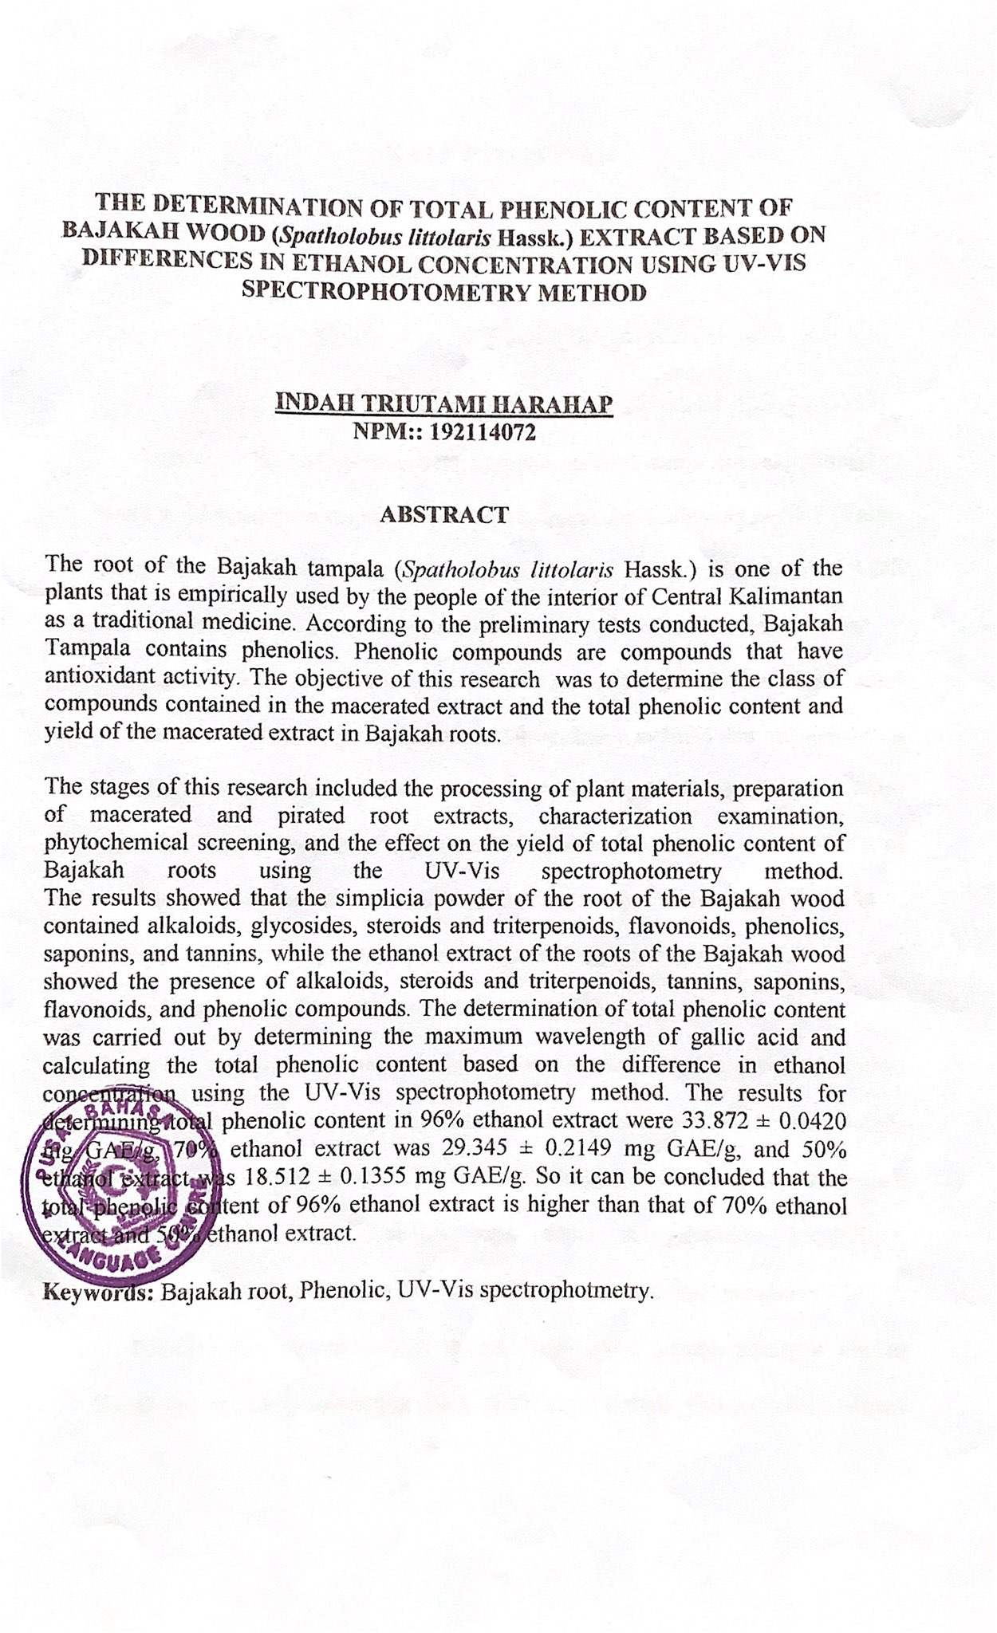
THE DETERMINATION OF TOTAL PHENOLIC CONTENT OF BAJAKAH WOOD (Spatholobus littolaris Hassk.) EXTRACT BASED ON DIFFERENCES IN ETHANOL CONCENTRATION USING UV-VIS SPECTROPHOTOMETRY METHOD
INDAH TRIUTAMI HARAHAP
NPM : 192114072

The root of the Bajakah tampala (Spatholobus littolaris Hassk.) is one of the plants that is empirically used by the people of the interior of Central Kalimantan as a traditional medicine. According to the preliminary tests conducted, Bajakah Tampala contains phenolics. Phenolic compounds are compounds that have antioxidant activity. The objective of this research was to determine the class of compounds contained in the macerated extract and the total phenolic content and yield of the macerated extract in Bajakah roots.

The stages of this research included the processing of plant materials, preparation of macerated and pirated root extracts, characterization examination, phytochemical screening, and the effect on the yield of total phenolic content of Bajakah roots using the UV-Vis spectrophotometry method.
The results showed that the simplicia powder of the root of the Bajakah wood contained alkaloids, glycosides, steroids and triterpenoids, flavonoids, phenolics, saponins, and tannins, while the ethanol extract of the roots of the Bajakah wood showed the presence of alkaloids, steroids and triterpenoids, tannins, saponins, flavonoids, and phenolic compounds. The determination of total phenolic content was carried out by determining the maximum wavelength of gallic acid and calculating the total phenolic content based on the difference in ethanol concentration using the UV-Vis spectrophotometry method. The results for determining total phenolic content in 96% ethanol extract were 33.872 ± 0.0420 mg GAE/g, 70% ethanol extract was 29.345 ± 0.2149 mg GAE/g, and 50% ethanol extract was 18.512 ± 0.1355 mg GAE/g. So it can be concluded that the total phenolic content of 96% ethanol extract is higher than that of 70% ethanol extract and 50% ethanol extract.
Keywords: Bajakah root, Phenolic, UV-Vis spectrophotmetry.

