UJI AKTIVITAS ANTIBAKTERI FRAKSI N-HEKSAN DAN ETIL ASETAT DAUN KENANGA (Cananga odorata (Lam.) Hook. F. & Thomson) TERHADAP BAKTERI Staphylococcus epidermidis

ANANDA SEPRIANI
192114083

ABSTRAK

Kehidupan manusia selalu berdampingan dengan berbagai jenis-jenis mikroba. Salah satunya daun kenaga (Cananga odorata (Lam.) Hook. F. & Thomson) yang merupakan salah satu tanaman yang bias digunakan sebagai obat tradisional salah satu dapat digunakan untuk obat gatal-gatal pada kulit manusia dan dapat menghambat bakteri salah satu bakteri Stapylococcus epidermidis. Tujuan penelitian ini adalah untuk mengetahui golongan senyawa metabolit sekunder yang terkandung dalam daun kenanga (Cananga odorata (Lam.) Hook. F. & Thomson), dan uji aktivitas antibakteri dari fraksi n-heksan dan etil asetat daun kenanga (Cananga odorata (Lam.) Hook. F. & Thomson).
Metode penelitian ini meliputi karakterisasi simplisia, skrining fitokimia dilakukan terhadap serbuk simplisia dan ekstrak etanol 96%. Ekstraksi dilakukan dengan cara maserasi dengan pelarut etanol 96%, kemudian fraksinansi cair-cair dengan pelarut n-heksan dan etilasetat. Uji aktivitas antibakteri dilakukan dengan mengukur diameter zona hambat menggunakan metode diifusi agar.
Hasil pemeriksaan karakteristik serbuk simplisia daun kenanga (Cananga odorata (Lam.) Hook. F. & Thomson) diperoleh kadar air 7,33%, kadar sari larut dalam air 26,48%, kadar sari larut dalam etanol 20,89%, kadar abu total 3,52%, dan kadar abu tidak larut dalam asam 0,18%. Hasil skrining fitokimia diperoleh adanya senyawa golongan alkaloid, flavonoid, saponon, glikosida, tannin, steroid. Hasil uji aktivitas pada fraksi n-heksan, etilasetat dan ekstrak etanol mempunyai aktivitas antibakteri. Pada fraksi n-heksan memberikan hasil yang kuat terhadap bakteri Staphylococcus epidermidis pada konsentrasi 70 mg/ml diameter zona hambat 12,37 mm. Fraksi etilasetat kuat terhadap bakteri Staphylococcus epidermidis pada konsentrasi 70 mg/ml diameter zona hambat 12,98 mm.

Kata kunci: Daun kenanga, Stapylococcus epidermidis, fraksi-fraksi, aktivitas antibakteri

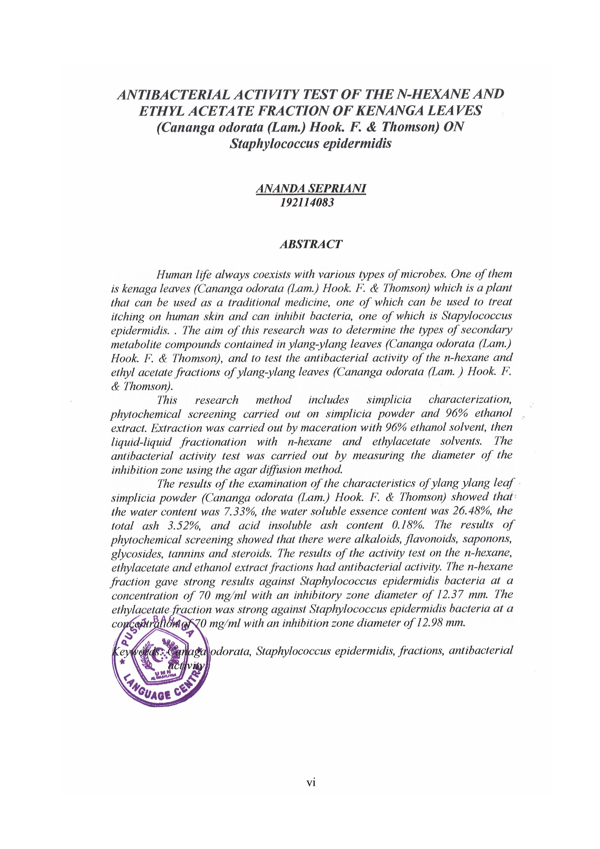
ANTIBACTERIAL ACTIVITY TEST OF THE N-HEXANE AND ETHYL ACETATE FRACTION OF KENANGA LEAVES (Cananga odorata (Lam.) Hook. F. & Thomson) ON Staphylococcus epidermidis

ANANDA SEPRIANI
192114083

ABSTRACT

Human life always coexists with various types of microbes. One of them is kenaga leaves (Cananga odorata (Lam.) Hook. F. & Thomson) which is a plant that can be used as a traditional medicine, one of which can be used to treat itching on human skin and can inhibit bacteria, one of which is Stapylococcus epidermidis. . The aim of this research was to determine the types of secondary metabolite compounds contained in ylang-ylang leaves (Cananga odorata (Lam.) Hook. F. & Thomson), and to test the antibacterial activity of the n-hexane and ethyl acetate fractions of ylang-ylang leaves (Cananga odorata (Lam. ) Hook. F. & Thomson).
This research method includes simplicia characterization, phytochemical screening carried out on simplicia powder and 96% ethanol extract. Extraction was carried out by maceration with 96% ethanol solvent, then liquid-liquid fractionation with n-hexane and ethylacetate solvents. The antibacterial activity test was carried out by measuring the diameter of the inhibition zone using the agar diffusion method.
The results of the examination of the characteristics of ylang ylang leaf simplicia powder (Cananga odorata (Lam.) Hook. F. & Thomson) showed that the water content was 7.33%, the water soluble essence content was 26.48%, the total ash 3.52%, and acid insoluble ash content 0.18%. The results of phytochemical screening showed that there were alkaloids, flavonoids, saponons, glycosides, tannins and steroids. The results of the activity test on the n-hexane, ethylacetate and ethanol extract fractions had antibacterial activity. The n-hexane fraction gave strong results against Staphylococcus epidermidis bacteria at a concentration of 70 mg/ml with an inhibitory zone diameter of 12.37 mm. The ethylacetate fraction was strong against Staphylococcus epidermidis bacteria at a concentration of 70 mg/ml with an inhibition zone diameter of 12.98 mm.

Keywords: Canaga odorata, Staphylococcus epidermidis, fractions, antibacterial activity

