**ACKNOWLEDGEMENT**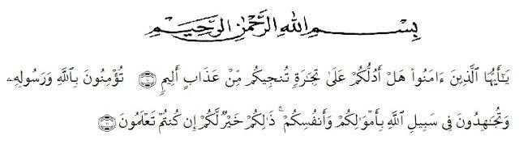

Artinya: *Wahai orang-orang yang beriman, sukakah kamu aku tunjukkan suatu perniagaan yang dapat menyelamatkanmu dari azab yang pedih? (10), (yaitu) kamu beriman kepada Allah dan RasulNya dan berjihad di jalan Allah dengan harta dan jiwamu. Itulah yang lebih baik bagimu, jika kamu mengetahui (11). (As-Shaff: 10-11)*

Alhamdulillah, in the Name of Allah, the most Gracious, the most Merciful All praises be to Allah, king of the king, the Lord of the world, and the master of the day after, who has given us blessing and guidance. Because of His graciousness and mercifulness the writer can write well. This thesis entitled **“An Analysis On Optimism Of The British As Reflected In Burnett The Secret Garden”,** is presented to the Faculty of Letters in University of Muslim Nusantara Al-washliyah Medan (UMN) as one of requirements for sarjana sastra at the Faculty of Letters.

In arranging this thesis, a lot of people have provided motivation, advice, and support for the researcher. In this valuable chance, the researcher intended to express her gratitude and appreciation to :

1. H. Hardi Mulyono Surbakti, SE, MAP. As a Rector at University  of  Muslim Nusantara Al-Wasliyah Medan.
2. Dr. Hj. Risnawaty M.Hum as the Dean of Faculty of letters , The University of Muslim Nusantara Al-Wasliyah Medan.
3. Harianto, S.S, MS, PhD as the Firts, the Second and the Third Vice Dean The University of Muslim Nusantara Al-Wasliyah Medan.
4. Dewi Nurmala SS.M.Hum as the Head of the English Department of the Faculty of Letters.
5. Dr. Yulia Arfanti, M.Hum and Harianto SS, MS as my consultant who have educated, supported, directed and given me countless advice, suggestion and recommendation writing this graduating paper from beginning until the end. Thanks for patient and guidance.
6. All lecturers of English Literature The University of Muslim Nusantara Al-Wasliyah Medan. The writer gives thanks to them for the valuable knowledge and guidance during her study at English Literature.
7. My beloved family especially for my father Suriadi Legiman, and my mother Sri Kusmawati, and my younger sister Tuti Merri Anggini and Aqmal Alfaro Bimasya And thanks for my classmate and all friends who always support all my time.
8. Thanks for my best friend ever i have Adinda Syahfitri and Neni Gustiana Ketaren which supporting me in all situation.The writer realizes that this thesis is still far from perfect. Therefore, the writer will be glad to receive any recommendation and constructive criticism to make this thesis better. Also thanks to my friends. Imaniar, Maike, Opy, Ika, Arfa, Ica Pane, for being so kind.

May Allah always be with us and gives us the power and guidance in our life, Aamiin. Eventually, this thesis is expected to be able to provide useful knowledge and information for all readers. The writers is pleased to accept more contribution and suggestion for the improvement of this graduating paper.

Medan, July 2020

Prahara Surya Citra