ACKNOWLEDGEMENT
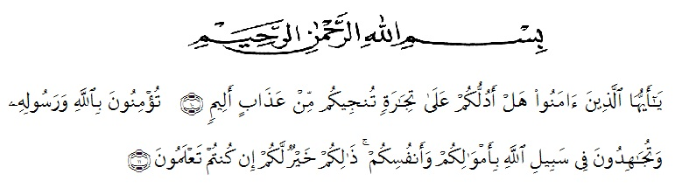
Artinya: Wahai orang-orang yang beriman, sukakah kamu aku tunjukkan suatu perniagaan yang dapat menyelamatkanmu dari azab yang pedih? (10), (yaitu) kamu beriman kepada Allah dan RasulNya dan berjihad di jalan Allah dengan harta dan jiwamu. Itulah yang lebih baik bagimu, jika kamu mengetahui (11). (As-Shaff: 10-11)
Alhamdulillah, first of all my biggest thankful appreciation is certainly to Allah SWT for giving me a blessing every day, and our Prophet Muhammad SAW as a messenger of Allah SWT, so that the writer could finish this thesis.
This thesis entitled “An Analysis of the Discrimination as Reflected in the Novel The Bluest Eye” is presented to the Faculty Of Letters of Muslim Nusantara Al-Washliyah Medan as one of requirements for Bachelor of Literature.
However, the writer would like to express his sincere gratitude for :
- Allah SWT who has given me health to finish this thesis.
- Dr. KRT. Hardi Mulyono, K. Surbakti, as the Rector of University Of Muslim Nusantara Al-Washliyah Medan.
- Dewi Nurmala, SS, M.Hum., as the Dean of Faculty of Letters.
- Ayu Melati Ningsih, S.Pd, M.S., as the Chairman of Departement.
- Dr. Azhary Tambusai, M.A., and Dewi Nurmala, SS, M.Hum., as the writer’s consultants who have educated, supported, directed, and given countless advice, suggestion, and recommendation in writing this thesis from the beginning until the end. Thanks for their patience and guidance.
- All Lecturers of the Faculty of Letters, I deeply thanks for all of them for not only giving knowledge but also insight and values.
- My big Family, especially for my parents Papi, Mami and my aunt Magda Budiman who always giving support to me, and my brother who gave suggestions for completing this thesis. Big thanks for my special friend Ika who always accompany and support everyday and always angry when I am lazy to do this thesis.
- My classmate Maike and Niar who help me and accompany me in completely this thesis.
Eventually, the thesis is expected to be able to provide useful knowledge and information for all readers. The writer is please to accept more suggestion and contribution for the improvement of this thesis.

Medan, Maret 2021

Jimmy Adrian Budiman

