ACKNOWLEDGEMENTS
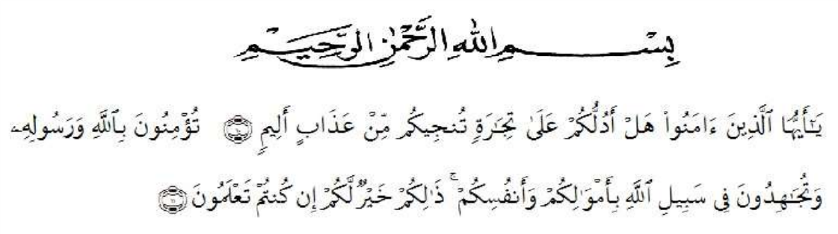

“O you who believe! Shall I show you a commerce that will save you from a painful doom? You should believe in Allah and His messenger, and should strive for the cause of Allah with your wealth and your lives. That it better for you if you did but know”. (QS. As-Shaff : v. 10-11)
By saying thanks you to the presence of Allah SWT, because only with abundance of mercy, His blessing, so that the writer can finish Proposal within the allotted time. The proposal is entitled “An Analysis Of Social Changes In Romanticism Period In Jane Austen’s Novel Pride And Prejudice”.
First and foremost, The writer would like to express gratitude to Allah swt. The almight God for the blessing, kindness and inspirations in lending her to accomplish the final script without Allah, I could not stay patient and in control in writing this final thesis from the first page to the last page.
Sholawat and salam for the prophet Muhammad Saw, who brings us from darkness to the brightness.
The writer realizes this is thesis still long from being the best skill. The writer needs the readers because limited skill of my acknowledgement and skill who the writer have. So for that the writer need your criticism and suggestion
which is contractive from the lectures and also reader for the best this thesis. Second, the writer would express her thanks to distinguished people who have done outstanding care and energy to help her finish her study at University of Muslim Nusantara Al-Washliyah, Medan.
The writer also would like to extend her thanks:
- H. Hardi Muliyono Surbakti, SE., MAP. As a rector at University of Muslim Nusantara Al-Washliyah, Medan.
- Dr. Hj. Risnawaty, M.hum, the Dekan of Faculty of Letters.
- Harianto , SS., MS. As the vice Dekan of Faculty of Letters.
- Vera Kristiana, S.Pd, M.Pd, the first supervisor for her guidance, advices, suggestions and previous time she has given during the complementation of this thesis and her study.
- Ayu Melati Ningsih, S.Pd, M.S, the second supervisor for her guidance, advices, suggestions and previous time she has given during the complementation of this thesis and her study.
- Dr. Azhary Tambusai, MA. The examiner for he guidance, advices, suggestion and previous time he has given during the completion of this thesis and his study.
- Dita Deviana Fadhilah, S.TP. the administrator of Faculty of Letters, for her administrative help in the process of completing the requirement.
- Dewi Nurmala, S.S, M.Hum, as head of Department/Head of Study Program Faculty of Letters, University of Muslim Nusantara Al-Washliyah , Medan.
- To her beloved parents, Trianto Silalahi and Nurasiah Butar-Butar, they always give the writer prayer, encourage, love, support, motivation and patience to the writer during finishing this script and waiting for writer’s graduation. For her uncle Jonny Butar-Butar, for moral support. For her aunts Tin Sulistiowati and Sabariah Butar-Butar, for moral support and give the writer pray. For her young brothers Fitra and Naldi, for her young sister Nazwa.
- To her best friend Rani Ramadanti and her best friend at boarding house Rama Safitri and Sarmi Ningsih, for a lot of support, laughter, sadness, happiness that they shared together. Those all were so nice.
- To her beloved friend Muhammad Irsandi Kandau, for motivation and inspiration her a lot of with advice, support, love, time and prayer.
- All student 2016 , Faculty of Letters and at last but not least, the writer say a thanks for all she can not mention detail without their moral and spiritual support, this study and this script have never been completed.

Medan, Desember 2020
The writer

PutriAstriSilalahi
166224015

