Appendix 1
RENCANA PELAKSANAAN PEMBELAJARAN
(RPP)

Nama Sekolah : SMAN 1 LAWE ALAS
Kelas : XI /IPA 1 DAN IPA 2
Materi : English Songs
Skill : Listening
Alokasi Waktu : 2x45 menit

- Kompetensi Inti
KI 1 : Menghargai dan menghayati ajaran agama yang dianutnya.
KI 2 :Menghargai dam menghayati perilaku jujur, disiplin, Tanggung jawab, peduli (toleransi, gotong royong.), suntun, percaya diri dalam berinteruksi secara efektif dengan lingkungan social dan alam dalam jangka pergaulan dan keberadaannya.
KI 3 : Memahami pengetahuan (faktual, konseptual, dun procedural)
KI 4 : Mencoba, mengnlah, dan menyaji dalam ranah konkret (menggunakan, mengurai, merangkai. miemodifikasi, dan membuat) dan ranah abstrak (menalis, membaca, menghitung, menggambar, dam mengarang) sesuai dengan yang dipelajari di sekolah dan sumber lain yung sama dalam sudut pandang/ teori.

- Kompetensi Dasar dan Pencapaian Kompetensi
Kompetensi Dasar | Indikator Pencapaian Kompetensi
Mensyukuri kesempatan dapat mempelajari bahasa inggris sebagai bahasa pengantar komunikasi internasional yang diwujudkan dalam semangat belajar. | - Mengungkapkan rasa syukur atau kesempatan dapat belajar bahasa Inggris.
Menikmati proses pembelajaran dengan respon yang positif. | - Menggunakan bahasa yang baik.  - Menunjukkan sikap saling menghargai dan menghormati.
Menyimak dengan bagus agar memahami isi kandungan lagu serta mengaplikasikannya dalam kehidupan sehari-hari. | - Merespon dan menyimak lirik lagu.  - Mengaplikasikan dengan tulisan sesuai ririk dengan benar.

- Tujuan pembelajaran
Setelah mengikuti serangkaian pembelajaran, peserta didik:
- Siswa dapat mengidentifikasi makna lagu.
- Siswa dapat menyimak lirik lagu dengan baik dan benar serta dapat mengisi lirik yang kosong.
- Siswa mampu merespon lirik yang di dengar melalui audio.
- Materi Pembelajaran
Students’ are able to improve listening skill English song by using fill the blank.
- Metodeters
Contextual Teaching Learning (CTL)
- Media, Alat dan Sumber Pembelajaran
- Media : song, speaker, laptop
- Sumber belajar : lyric lagu
- Langkah-langkah Pembelajaran
- Pendahuluan (5 menit)
Guru
- Guru menyapa siswa dan memperkenalkan diri
- Guru mengabsen siswa.
- Tanya jawab dengan murid mengenai materi sebelumnya.
- Menyiapkan peserta didik secara fisik untuk mengikuti proses pembelajaran.
- Guru mengantarkan peserta didik kepada suatu permasalahan atau tugas yang akan dilakukan untuk mempelajari suatu materi dan menjelaskan tujuan pembelajaran atau kompetensi dasar yang akan dicapai.
- Kegiatan inti
- Siswa mendengarkan lagu yang di perdengarkan melalui laptop, video atau yang dinyanyikan oleh guru atau teman.
- Guru menanyakan kosa kata yang terdapat dalam lirik lagu tersebut.
- Guru memotivasi siswa untuk menyanyikan lagu secara bersama-sama.
- Penutup
- Memberi feedback terhadap hasil belajar kerjasiswa.
- Memberi kesimpulan.
- Memberi penilaian atau pun efleksi terhadap kegiatan pembelajaran yang telah berlangsung.
- Penilaian
Technique : writing test
The form of instrument : multiple choice and fill in the blank
- Instrument soal
"Love Is Gone"
(feat. Dylan Matthew)

Don't go tonight
Stay here one more time
Remind me what it's like, oh
And let's fall in love one more time
I need you now by my side
It tears me up when you turn me down
I'm begging please, just stick around
I'm sorry, don't leave me, I want you here with me
I know that your love is gone
I can't breathe, I'm so weak, I know this isn't easy
Don't tell me that your love is gone
That your love is gone
I'm sorry, don't leave me, I want you here with me
I know that your love is gone
I can't breathe, I'm so weak, I know this isn't easy
Don't tell me that your love is gone
That your love is gone
Don't tell me that your love is gone, that your love is gone
Don't tell me that your love is gone, that your love is gone
That your love is gone
I know this isn't easy (Easy)
That your love is gone

Manual assessment
Cara penilaian ini menggunakan rumus =S=X100
Dimana : S = Nilai tes
R = Jumlah benar
N = Jumlah soal

Guru Bahasa Inggris Medan, Maret 2021

Nurhayati, S.Pd Ratna Sari
Npm : 171224072

Appendix 2.
"Love Is Gone"
(feat. Dylan Matthew)

Don't go tonight
Stay here one more time
Remind me what it's like, oh
And let's fall in love one more time
I need you now by my side
It tears me up when you turn me down
I'm begging please, just stick around

I'm sorry, don't leave me, I want you here with me
I know that your love is gone
I can't breathe, I'm so weak, I know this isn't easy
Don't tell me that your love is gone
That your love is gone

I'm sorry, don't leave me, I want you here with me
I know that your love is gone
I can't breathe, I'm so weak, I know this isn't easy
Don't tell me that your love is gone
That your love is gone
Don't tell me that your love is gone, that your love is gone
Don't tell me that your love is gone, that your love is gone
That your love is gone
I know this isn't easy (Easy)
That your love is gone

Answer the question below!

- What is theme of the song above?
- Your love
- Love is gone
- Falling in love
- To be my side
- Who is Dylan Matthew ?
- A listener
- A child
- Singer
- author
- what does the singer want?
- let's fall in love one more time
- your love is gone
- stay here
- marry me
- what is the tone of the song above?
- Happy
- Romance
- Sad
- Lazy
- Why is the singer asking for one more chance?
- She was dead
- He still loves
- To get revenge
- He’s not used to being alone
- What does “isn’t easy” mean in the song’s lyrics?
- Losing love
- Easy is him love
- Looking for a replacement
- Looking for a new partner
- What does remind mean?
- Melupakan
- Menghapuskan
- Mengingatkan
- Mengenang
- What does “gone” mean?
- Datang
- Hilang
- Mencari
- Dapat
- What does “don’t go tonight” mean?
- Janganpergimalamini
- Janganpergi
- Jangandatang
- Diaakanpergi
- Who opologized to the lyrics of the song?
- She
- Child
- He
- They
Key answer of pre-test
- b 6. a
- c 7. c
- a 8. b
- c 9. a
- b 10. c

Appendix 3.
TABLE
Students’ Score in Pre-test
Eleventh Grade of IPA 1

No | Name | Multiple Choice | Number of Question | Individual Score | Ranting Category
1 | PL | 4 | 10 | 12 | Low
2 | FA | 2 | 10 | 6 | Low
3 | LY | 4 | 10 | 12 | Medium
4 | D | 2 | 10 | 6 | Low
5 | R | 2 | 10 | 6 | Low
6 | SG | 1 | 10 | 3 | Low
7 | NS | 2 | 10 | 6 | Low
8 | M | 2 | 10 | 6 | Low
9 | IU | 4 | 10 | 12 | Medium
10 | MS | 1 | 10 | 3 | Low
11 | MJ | 2 | 10 | 6 | Low
12 | P | 4 | 10 | 12 | Medium
13 | DP | 1 | 10 | 3 | Low
14 | RS | 2 | 10 | 6 | Low
15 | KH | 4 | 10 | 12 | Medium
16 | TP | 2 | 10 | 6 | Low
17 | H | 1 | 10 | 3 | Low
18 | CP | 1 | 10 | 3 | Low
19 | SP | 4 | 10 | 12 | Medium
20 | RP | 2 | 10 | 6 | Low
21 | SA | 4 | 10 | 12 | Medium
22 | SS | 2 | 10 | 6 | Low
23 | MS | 4 | 10 | 12 | Medium
24 | S | 1 | 10 | 3 | Low
25 | SW | 2 | 10 | 6 | Low
26 | R | 4 | 10 | 12 | Medium
27 | D | 4 | 10 | 12 | Medium
28 | PS | 1 | 10 | 3 | Low
29 | MH | 4 | 10 | 12 | Medium
30 | P | 2 | 10 | 6 | Low
31 | KP | 1 | 10 | 3 | Low
32 | YF | 1 | 10 | 3 | Low
33 | SH | 2 | 10 | 6 | Low
34 | G | 4 | 10 | 12 | Medium
35 | AP | 1 | 10 | 3 | Low
 | Total | 84 | 350 | 250

Individual score :$\frac{84}{350}$ x 100
= 0.24 x 100
= 24%
The table above shows the students’ in the pre-test scores of 35 students’ in the experimental class. The lowest category was achieved by 24 students, the medium category was achieved by 11 students, while the high category did not exist. Therefore, based on the description above it can be said that students’ listening ability is still low.

Appendix 4.
TABLE
Students’ Score in Pre-test
Eleventh Grade of IPA 2

No | Name | Multiple Choice | Number of Question | Individual Score | Ranting Category
1 | SS | 4 | 10 | 12 | Medium
2 | R | 2 | 10 | 6 | Low
3 | DSP | 1 | 10 | 3 | Low
4 | MA | 1 | 10 | 3 | Low
5 | A | 4 | 10 | 12 | Medium
6 | LY | 4 | 10 | 12 | Medium
7 | SA | 2 | 10 | 6 | Low
8 | J | 2 | 10 | 6 | Low
9 | SW | 2 | 10 | 6 | Low
10 | A | 1 | 10 | 3 | Low
11 | SP | 2 | 10 | 6 | Low
12 | S | 2 | 10 | 6 | Low
13 | AR | 1 | 10 | 3 | Low
14 | S | 2 | 10 | 6 | Low
15 | M | 5 | 10 | 15 | Medium
16 | ST | 2 | 10 | 6 | Low
17 | SM | 3 | 10 | 9 | Low
18 | B | 3 | 10 | 9 | Low
19 | N | 4 | 10 | 12 | Medium
20 | RF | 3 | 10 | 9 | Low
21 | RU | 2 | 10 | 6 | Low
22 | SWY | 2 | 10 | 6 | Low
23 | RS | 2 | 10 | 6 | Low
24 | SV | 2 | 10 | 6 | Low
25 | UM | 2 | 10 | 6 | Low
26 | TB | 4 | 10 | 12 | Medium
27 | YY | 2 | 10 | 6 | Low
28 | AH | 1 | 10 | 3 | Low
29 | AB | 1 | 10 | 3 | Low
30 | RSI | 1 | 10 | 3 | Low
31 | IA | 2 | 10 | 6 | Low
32 | AD | 4 | 10 | 12 | Medium
33 | CA | 2 | 10 | 6 | Low
34 | DAP | 2 | 10 | 6 | Low
35 | NS | 2 | 10 | 6 | Low
 | Total | 81 | 350 | 228

Individual score :$\frac{81}{350}$ x 100
= 0.2314 x 100
= 23.14%
Based on the table above shows the students’ in the pre-test scores of 35 students’ in the control class. The lowest category was achieved by 28 students, the medium category was achieved by 7 students, while the high category did not exist. Therefore, based on the description above it can be said that students’ listening ability is very low.

Appendix 5.
“WHOLE NEW WORLD”
by ZAYN, Zhavia Ward

I can show you the world
Shining, 1.........., splendid
Tell me, princess, now when did
You last let your 2..........decide?
I can open your eyes
3..........you wonder by wonder
Over, 4..........and under
On a magic carpet ride
Reff: A whole new world
A new 5..........point of view
No one to tell us, “no”
Or where to go
Or say we’re only 6..........
A whole new world
A 7..........place I never knew
But when I’m way up here
It’s crystal clear
That now I’m in a 8..........new world with you
Unbelievable sights
9..........feeling
Soaring, 10.........., freewheeling
Through an endless world
A hundred thousand things to see
I’m like a shooting star
I’ve come so far
I can’t go back to where I used to be
A whole new world
With new horizons to fursue
I’ll chase them anywhere
There’s time to spare
Let me share this whole new world with you

The answers of post-test
- Shimmering 6. Dreaming
- Hearth 7. Dazzling
- Take 8. Whole
- Sideways 9. Indescribable
- Fantastic 10. Tumbling

Appendix 6.
Table 1
The description students’ scores in post-test
IPA 1 students’ first song

No | Name | Fill the blank | Number of Question | Individual Score | Ranting Category
1 | PL | 2 | 10 | 6 | Low
2 | FA | 2 | 10 | 6 | Low
3 | LY | 1 | 10 | 3 | Low
4 | D | 1 | 10 | 3 | Low
5 | R | 1 | 10 | 3 | Low
6 | SG | 0 | 10 | 0 | Low
7 | NS | 1 | 10 | 3 | Low
8 | M | 1 | 10 | 3 | Low
9 | IU | 1 | 10 | 3 | Low
10 | MS | 0 | 10 | 0 | Low
11 | MJ | 1 | 10 | 3 | Low
12 | P | 2 | 10 | 6 | Low
13 | DP | 0 | 10 | 0 | Low
14 | RS | 1 | 10 | 3 | Low
15 | KH | 2 | 10 | 6 | Low
16 | TP | 1 | 10 | 3 | Low
17 | H | 0 | 10 | 0 | Low
18 | CP | 1 | 10 | 3 | Low
19 | SP | 4 | 10 | 12 | Medium
20 | RP | 3 | 10 | 9 | Low
21 | SA | 1 | 10 | 3 | Low
22 | SS | 1 | 10 | 3 | Low
23 | MS | 1 | 10 | 3 | Low
24 | S | 3 | 10 | 9 | Low
25 | SW | 1 | 10 | 3 | Low
26 | R | 2 | 10 | 6 | Low
27 | D | 1 | 10 | 3 | Low
28 | PS | 0 | 10 | 0 | Low
29 | MH | 0 | 10 | 0 | Low
30 | P | 1 | 10 | 3 | Low
31 | KP | 0 | 10 | 0 | Low
32 | YF | 0 | 10 | 0 | Low
33 | SH | 1 | 10 | 3 | Low
34 | G | 4 | 10 | 12 | Medium
35 | AP | 0 | 10 | 0 | Low
 | Total | 41 | 350 | 123

Individual score :$\frac{41}{350}$ x 100
= 0.1171 x 100
= 11.71%

Appendix 7.
“AT MY WORST”
By

Can i call you baby?
Can you be my friend?
Can you be my 1..........up until the very end?
Let me show you love, oh i don't 2.........
Stick by my side even when the world is 3......... in (Yeah)
Oh, oh, oh, don't
Don't you 4.........
I'll be there, whenever you want me
Reff: I need somebody 5.........can love me at my 6.........
Know i'm not perfect but i hope you see my worth
'7........ it's only you, nobody new, I put you first
And for you, girl, i 8.........i'll do the worst
Ooh, ooh-ooh, ooh-ooh-ooh
Ooh, ooh, ooh, ooh-ooh-ooh
If you stay forever, let me 9.........you hand
I can fill those places in your heart no else can
Let me show you love, oh i don't pretend (Yeah)
I'll be right here, baby, you know i'll 10........or swim
Oh, oh, oh, don't
Don't you worry
I'll be there, whenever you want me (Back to reff)
Ooh, ooh-ooh, ooh-ooh-ooh
Ooh, ooh, ooh, ooh-ooh-ooh
Ooh, ooh-ooh, ooh-ooh-ooh
(Back to reff)

The answers of post-test
- Lover 6. Worst
- Pretent 7. Cause
- Givin’ 8. Swear
- Worry 9. Hold
- Who 10. Sink

Appendix 8.

Table II
The description students’ scores in post-test
IPA 1 students’ second song

No | Name | Fill the blank | Number of Question | Individual Score | Ranting Category
1 | PL | 6 | 10 | 18 | Medium
2 | FA | 5 | 10 | 15 | Medium
3 | LY | 6 | 10 | 18 | Medium
4 | D | 4 | 10 | 12 | Medium
5 | R | 8 | 10 | 24 | High
6 | SG | 6 | 10 | 18 | Medium
7 | NS | 7 | 10 | 21 | High
8 | M | 5 | 10 | 15 | Medium
9 | IU | 5 | 10 | 15 | Medium
10 | MS | 7 | 10 | 21 | High
11 | MJ | 6 | 10 | 18 | Medium
12 | P | 5 | 10 | 15 | Medium
13 | DP | 6 | 10 | 18 | Medium
14 | RS | 5 | 10 | 15 | Medium
15 | KH | 7 | 10 | 21 | High
16 | TP | 5 | 10 | 15 | Medium
17 | H | 8 | 10 | 24 | High
18 | CP | 6 | 10 | 18 | Medium
19 | SP | 7 | 10 | 21 | High
20 | RP | 5 | 10 | 15 | Medium
21 | SA | 5 | 10 | 15 | Medium
22 | SS | 7 | 10 | 21 | High
23 | MS | 6 | 10 | 18 | Medium
24 | S | 8 | 10 | 24 | High
25 | SW | 7 | 10 | 21 | High
26 | R | 6 | 10 | 18 | Medium
27 | D | 6 | 10 | 18 | Medium
28 | PS | 5 | 10 | 15 | Medium
29 | MH | 5 | 10 | 15 | Medium
30 | P | 6 | 10 | 18 | Medium
31 | KP | 7 | 10 | 21 | High
32 | YF | 5 | 10 | 15 | Medium
33 | SH | 5 | 10 | 15 | Medium
34 | G | 7 | 10 | 21 | High
35 | AP | 6 | 10 | 18 | Medium
 | Total | 210 | 350 | 630

Individual score :$\frac{210}{150}$ x 100
= 0.6 x 100
= 60%

Appendix 9.
“BEFORE YOU GO”
By Lewis Capaldi

I fell by the wayside like everyone else
I hate you, i hate you, i hate you, but i was just kidding myself
Our every moment, i start to 1.........
'Cause now that they're 2........., all i hear are the words that i needed to say
When you hurt under the 3.........
Like troubled water 4.........cold
Well, time can heal, but this won't
Reff: So, before you go
Was there something i 5......... said to make your heart beat better?
If only i'd have known you had a 6.........to weather
So, before you go
Was there something i could've said to make it all stop 7.........?
It kills me how your mind can make you feel so worthless
So, before you go
Was never the right time, whenever you called
Went little by little by little until there was nothing at all
Our every moment, i start to replay
But all i can think about is 8..........that look on your face
When you hurt under the surface
Like troubled water running cold
Well, some can heal, but this won't (Back to reff)
Would we be better off by now
If i'd have let my 9..........come down?
Maybe, i 10.........we'll never know
You know, you know
(Back to reff)

The answers of post-test
- Replace 6. Storm
- Gone 7. Hurting
- Surface 8. Seeing
- Running 9. Walls
- Could’ve 10. Guess

Appendix 10.
Table III
The description students’ scores in post-test
IPA 1 students’ last song

No | Name | Fill the blank | Number of Question | Individual Score | Ranting Category
1 | PL | 10 | 10 | 30 | High
2 | FA | 9 | 10 | 27 | High
3 | LY | 8 | 10 | 24 | High
4 | D | 7 | 10 | 21 | High
5 | R | 8 | 10 | 24 | High
6 | SG | 9 | 10 | 27 | High
7 | NS | 8 | 10 | 24 | High
8 | M | 9 | 10 | 27 | High
9 | IU | 6 | 10 | 18 | Medium
10 | MS | 10 | 10 | 30 | High
11 | MJ | 9 | 10 | 27 | High
12 | P | 7 | 10 | 21 | High
13 | DP | 10 | 10 | 30 | High
14 | RS | 9 | 10 | 27 | High
15 | KH | 9 | 10 | 27 | High
16 | TP | 8 | 10 | 24 | High
17 | H | 8 | 10 | 24 | High
18 | CP | 10 | 10 | 30 | High
19 | SP | 7 | 10 | 21 | High
20 | RP | 8 | 10 | 24 | High
21 | SA | 9 | 10 | 27 | High
22 | SS | 7 | 10 | 21 | High
23 | MS | 8 | 10 | 24 | High
24 | S | 8 | 10 | 24 | High
25 | SW | 10 | 10 | 30 | High
26 | R | 10 | 10 | 30 | High
27 | D | 9 | 10 | 27 | High
28 | PS | 8 | 10 | 24 | High
29 | MH | 8 | 10 | 24 | High
30 | P | 9 | 10 | 27 | High
31 | KP | 7 | 10 | 21 | High
32 | YF | 8 | 10 | 24 | High
33 | SH | 9 | 10 | 27 | High
34 | G | 9 | 10 | 27 | High
35 | AP | 8 | 10 | 24 | High
 | Total | 296 | 350 | 888

Individual score :$\frac{296}{350}$ x 100
= 0.8457 x 100
= 84.57%

Appendix 11. Validity
No | Nama | Number Questions |  |  |  |  |  |  |  |  |  |  |  |  |  |  | Y | Y2 | X1^2 |  | X1Y | X2^2 | X2Y
 |  | 1(3) | 2(3) | 3(3) | 4(3) | 5(3) | 6(3) | 7(3) | 8(3) | 9(3) | 10(3)
1 | PL | 3 | 3 | 3 | 3 | 3 | 3 | 3 | 3 | 3 | 3 | 30 | 900 | 9 | 90 | 9 | 90 | 9 | 90 |  | 9 | 90 | 9
2 | FA | 3 | 3 | 3 | 3 | 3 | 3 | 3 | 3 | 3 | 3 | 30 | 900 | 9 | 90 | 9 | 90 | 9 | 90 |  | 9 | 90 | 9
3 | LY | 3 | 3 | 3 | 3 | 3 | 3 | 3 | 3 | 3 | 3 | 30 | 900 | 9 | 90 | 9 | 90 | 9 | 90 |  | 9 | 90 | 9
4 | D | 3 | 3 | 0 | 3 | 3 | 3 | 3 | 0 | 3 | 3 | 24 | 576 | 9 | 72 | 9 | 72 | 0 | 0 |  | 9 | 72 | 9
5 | R | 3 | 3 | 3 | 0 | 3 | 3 | 3 | 0 | 3 | 3 | 24 | 576 | 9 | 72 | 9 | 72 | 9 | 72 |  | 0 | 0 | 9
6 | SG | 3 | 3 | 3 | 3 | 3 | 3 | 3 | 3 | 3 | 3 | 30 | 900 | 9 | 90 | 9 | 90 | 9 | 90 |  | 9 | 90 | 9
7 | NS | 3 | 3 | 3 | 3 | 3 | 3 | 3 | 3 | 3 | 3 | 30 | 900 | 9 | 90 | 9 | 90 | 9 | 90 |  | 9 | 90 | 9
8 | M | 3 | 3 | 3 | 3 | 3 | 3 | 3 | 3 | 3 | 3 | 30 | 900 | 9 | 90 | 9 | 90 | 9 | 90 |  | 9 | 90 | 9
9 | IU | 3 | 3 | 3 | 3 | 3 | 3 | 3 | 3 | 0 | 3 | 27 | 729 | 9 | 81 | 9 | 81 | 9 | 81 |  | 9 | 81 | 9
10 | MS | 0 | 3 | 3 | 3 | 3 | 3 | 3 | 3 | 3 | 3 | 27 | 729 | 0 | 0 | 9 | 81 | 9 | 81 |  | 9 | 81 | 9
11 | MJ | 3 | 3 | 3 | 3 | 3 | 3 | 0 | 3 | 3 | 3 | 27 | 729 | 9 | 81 | 9 | 81 | 9 | 81 |  | 9 | 81 | 9
12 | P | 0 | 3 | 3 | 3 | 3 | 3 | 3 | 3 | 3 | 0 | 24 | 576 | 0 | 0 | 9 | 72 | 9 | 72 |  | 9 | 72 | 0
13 | DP | 3 | 3 | 3 | 3 | 3 | 3 | 3 | 3 | 3 | 3 | 30 | 900 | 9 | 90 | 9 | 90 | 9 | 90 |  | 9 | 90 | 9
14 | RS | 0 | 3 | 3 | 3 | 3 | 3 | 3 | 0 | 3 | 3 | 24 | 576 | 0 | 0 | 9 | 72 | 9 | 72 |  | 9 | 72 | 9
15 | KH | 3 | 3 | 3 | 3 | 3 | 3 | 3 | 3 | 3 | 3 | 30 | 900 | 9 | 90 | 9 | 90 | 9 | 90 |  | 9 | 90 | 9
16 | TP | 3 | 3 | 0 | 3 | 3 | 3 | 0 | 3 | 3 | 3 | 24 | 576 | 9 | 72 | 9 | 72 | 0 | 0 |  | 9 | 72 | 9
17 | H | 0 | 3 | 3 | 0 | 3 | 3 | 3 | 0 | 3 | 0 | 18 | 324 | 0 | 0 | 9 | 54 | 9 | 54 |  | 0 | 0 | 0
18 | CP | 3 | 3 | 3 | 3 | 3 | 3 | 3 | 3 | 3 | 0 | 27 | 729 | 9 | 81 | 9 | 81 | 9 | 81 |  | 9 | 81 | 0
19 | SP | 0 | 3 | 3 | 0 | 3 | 3 | 3 | 0 | 3 | 3 | 21 | 441 | 0 | 0 | 9 | 63 | 9 | 63 |  | 0 | 0 | 9
20 | RP | 3 | 3 | 3 | 3 | 3 | 3 | 3 | 3 | 3 | 3 | 30 | 900 | 9 | 90 | 9 | 90 | 9 | 90 |  | 9 | 90 | 9
21 | SA | 3 | 3 | 3 | 3 | 3 | 3 | 3 | 3 | 3 | 3 | 30 | 900 | 9 | 90 | 9 | 90 | 9 | 90 |  | 9 | 90 | 9
22 | SS | 3 | 3 | 0 | 3 | 3 | 3 | 3 | 0 | 3 | 3 | 24 | 576 | 9 | 72 | 9 | 72 | 0 | 0 |  | 9 | 72 | 9
23 | MS | 3 | 3 | 3 | 3 | 3 | 3 | 3 | 3 | 3 | 3 | 30 | 900 | 9 | 90 | 9 | 90 | 9 | 90 |  | 9 | 90 | 9
24 | S | 3 | 3 | 3 | 3 | 3 | 3 | 3 | 3 | 0 | 3 | 27 | 729 | 9 | 81 | 9 | 81 | 9 | 81 |  | 9 | 81 | 9
25 | SW | 3 | 3 | 3 | 3 | 3 | 3 | 3 | 3 | 3 | 0 | 27 | 729 | 9 | 81 | 9 | 81 | 9 | 81 |  | 9 | 81 | 0
26 | R | 3 | 3 | 3 | 3 | 3 | 3 | 3 | 3 | 3 | 3 | 30 | 900 | 9 | 90 | 9 | 90 | 9 | 90 |  | 9 | 90 | 9
27 | D | 3 | 3 | 3 | 3 | 3 | 3 | 3 | 3 | 3 | 3 | 30 | 900 | 9 | 90 | 9 | 90 | 9 | 90 |  | 9 | 90 | 9
28 | PS | 3 | 3 | 0 | 0 | 3 | 3 | 3 | 3 | 3 | 3 | 24 | 576 | 9 | 72 | 9 | 72 | 0 | 0 |  | 0 | 0 | 9
29 | MH | 3 | 3 | 3 | 3 | 3 | 3 | 3 | 0 | 3 | 0 | 24 | 576 | 9 | 72 | 9 | 72 | 9 | 72 |  | 9 | 72 | 0
30 | P | 3 | 3 | 3 | 3 | 3 | 3 | 3 | 3 | 3 | 3 | 30 | 900 | 9 | 90 | 9 | 90 | 9 | 90 |  | 9 | 90 | 9
31 | KP | 3 | 3 | 3 | 0 | 3 | 3 | 3 | 0 | 3 | 3 | 21 | 441 | 9 | 63 | 9 | 63 | 9 | 63 |  | 0 | 0 | 9
32 | YF | 3 | 3 | 3 | 3 | 3 | 0 | 3 | 0 | 3 | 3 | 24 | 576 | 9 | 72 | 9 | 72 | 9 | 72 |  | 9 | 72 | 9
33 | SH | 3 | 3 | 3 | 0 | 3 | 3 | 0 | 3 | 0 | 3 | 27 | 729 | 9 | 72 | 9 | 72 | 9 | 72 |  | 0 | 72 | 9
34 | G | 3 | 3 | 3 | 3 | 3 | 2 | 3 | 3 | 3 | 3 | 29 | 841 | 9 | 87 | 9 | 87 | 9 | 87 |  | 9 | 87 | 9
35 | AP | 3 | 3 | 3 | 3 | 3 | 3 | 3 | 3 | 3 | 3 | 30 | 900 | 9 | 90 | 9 | 90 | 9 | 90 |  | 9 | 90 | 9
∑X |  | 90 | 105 | 93 | 96 | 90 | 96 | 90 | 117 | 99 | 87 | 944 | 25834 | 8100 | 2481 | 315 | 2823 | 279 | 2535 |  | 261 | 2499 | 270
(∑ X)2 |  | 8100 | 11025 | 8649 | 9216 | 8100 | 9216 | 8100 | 13689 | 9801 | 7569
∑X2 |  | 270 | 315 | 279 | 261 | 2823 | 279 | 2535 | 261 | 2499 | 270
∑XY |  | 2481 | 2823 | 2535 | 2499 | 279 | 2535 | 261 | 2499 | 270 | 2463
rtabel |  | 0.361 | 0.361 | 0.361 | 0.361 | 0.361 | 0.361 | 0.361 | 0.361 | 0.361 | 0.361
rxy |  | 21.590 | 33.257 | -2.063 | 33.850 | 20.805 | 34.208 | 22.324 | 9.765 | -0.014 | -2.300
keterangan |  | Valid | Valid | Tidak Valid | Valid | Valid | Valid | Valid | Valid | Tidak Valid | Tidak Valid

Appendix 12.pre-test
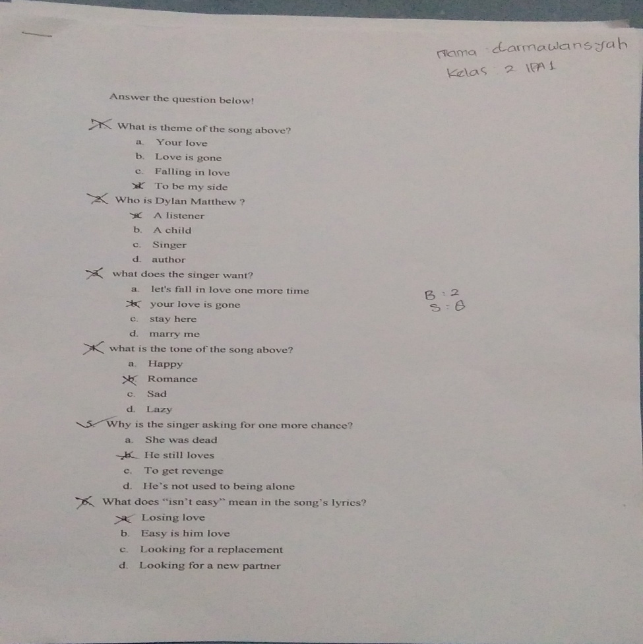
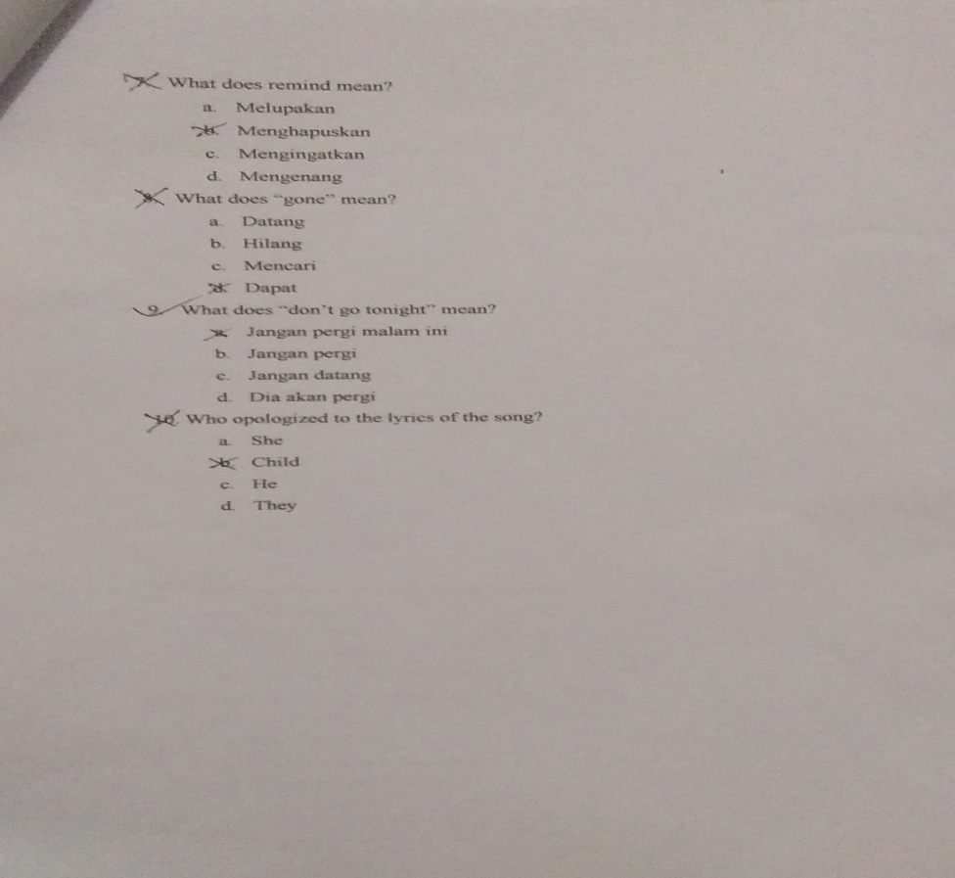
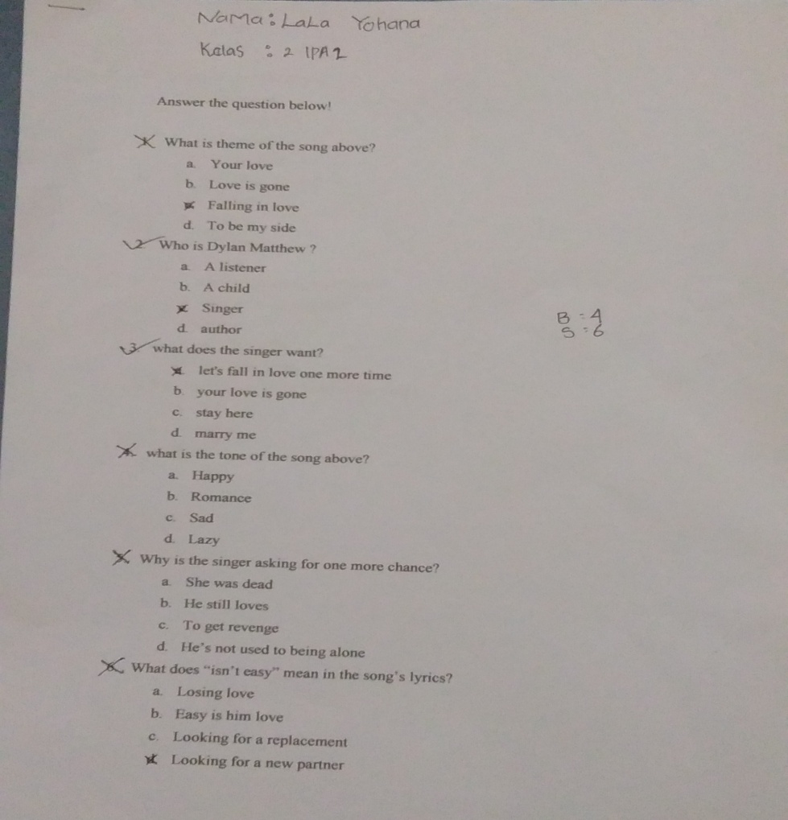
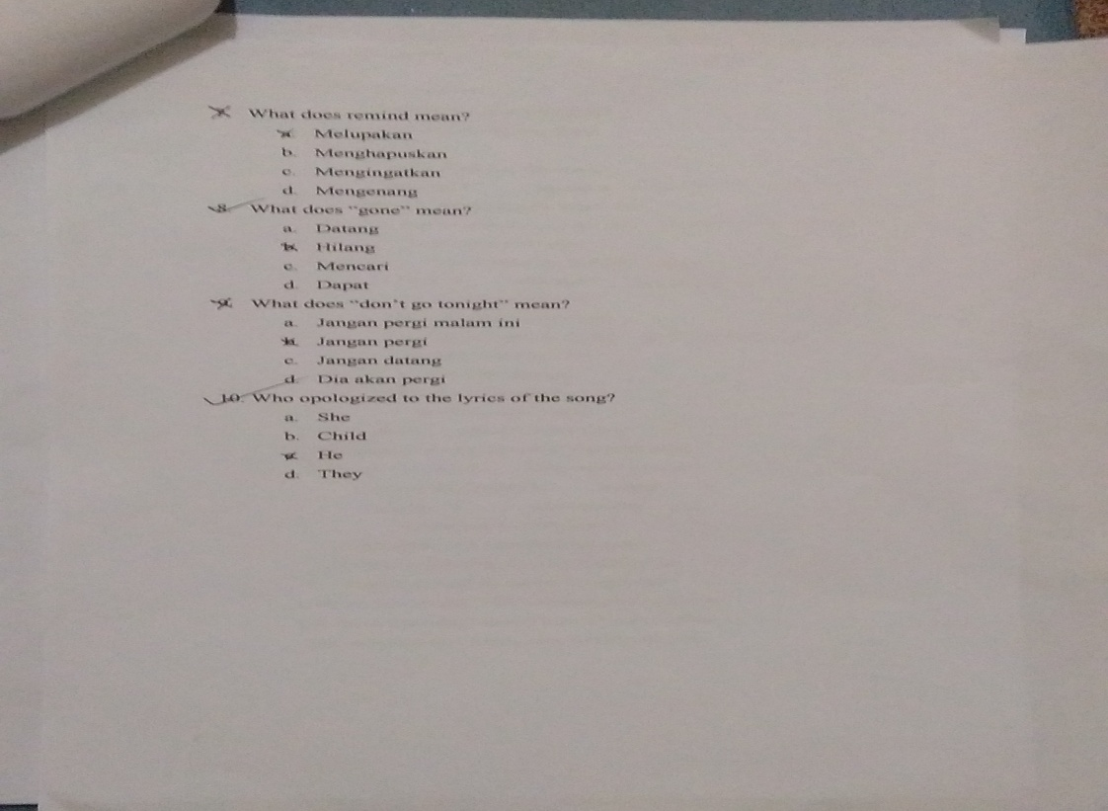

Appendix 13.post-test
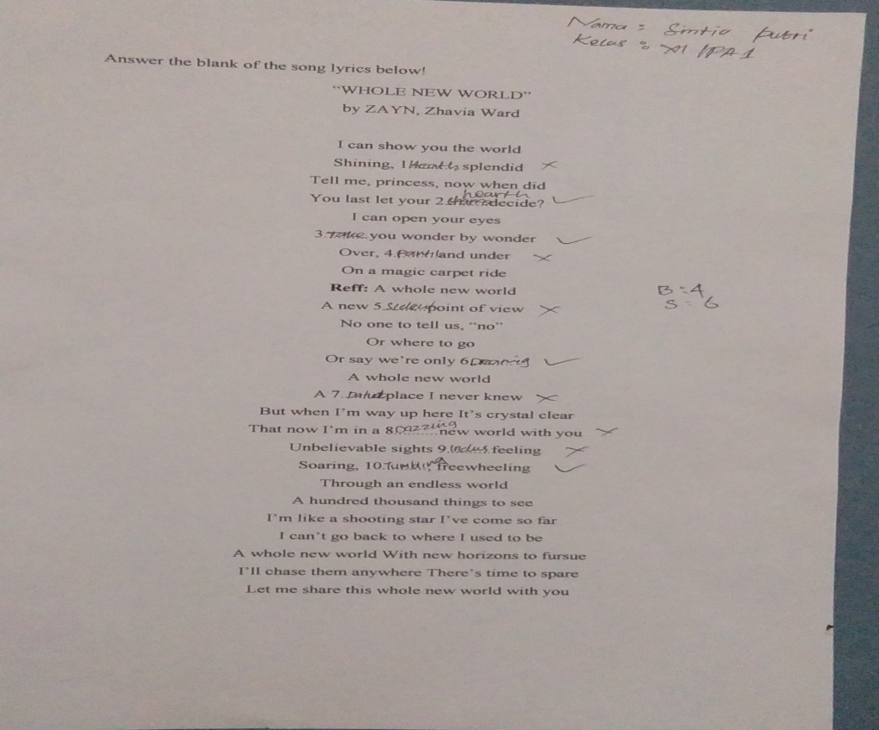
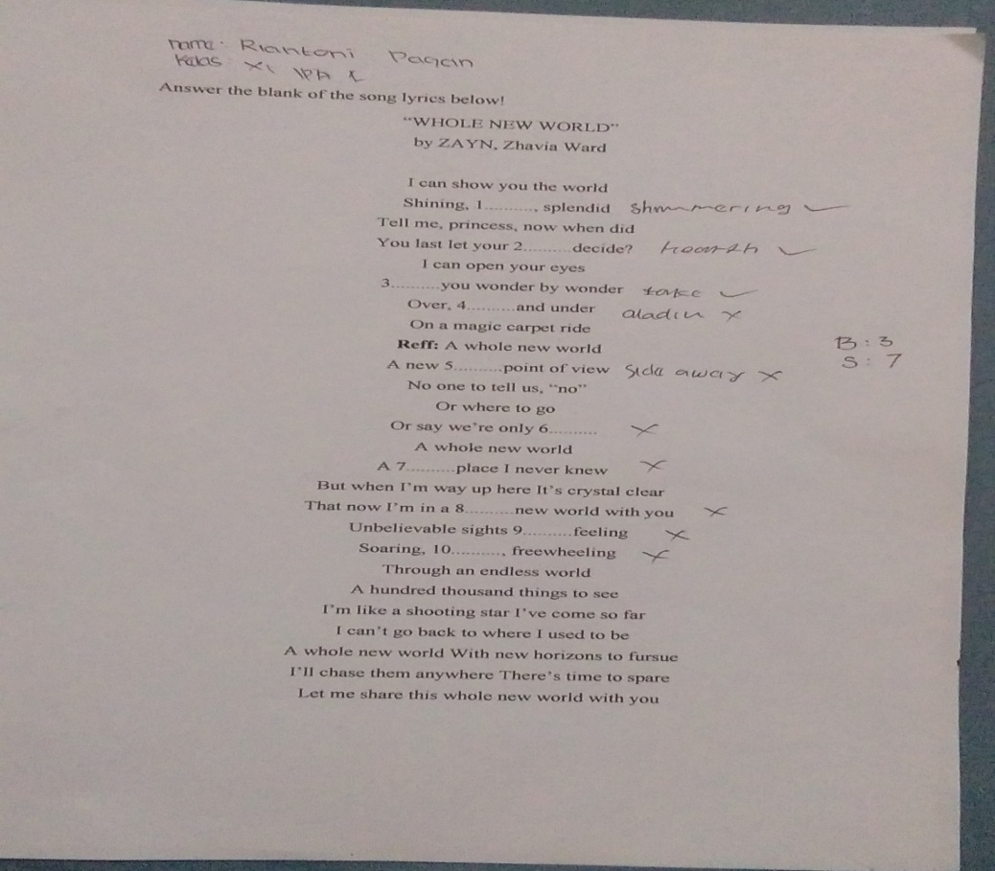
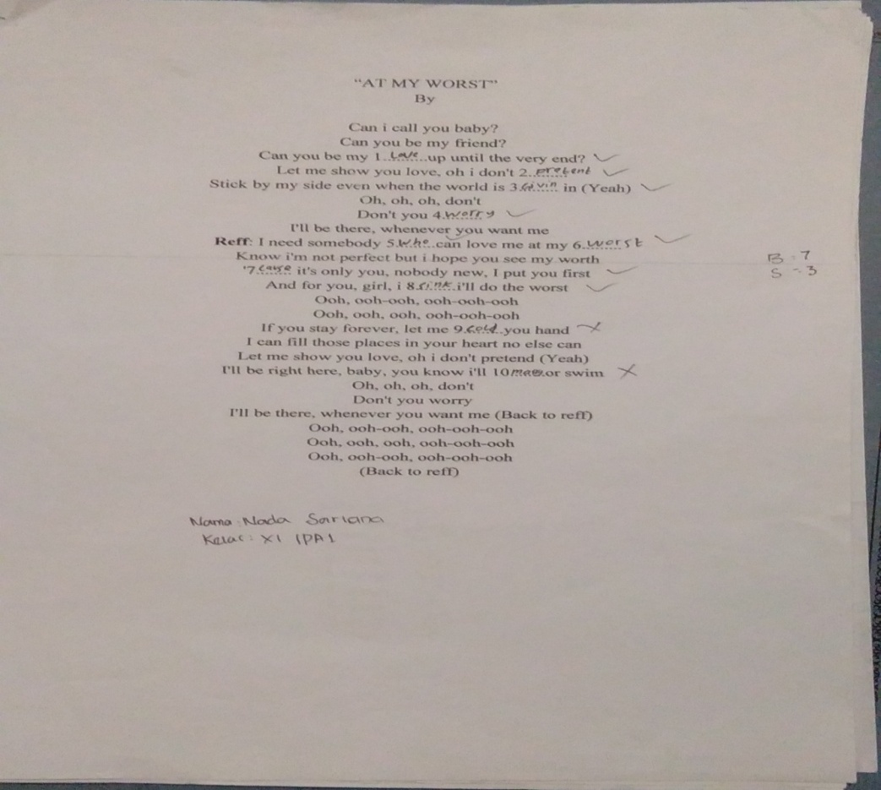
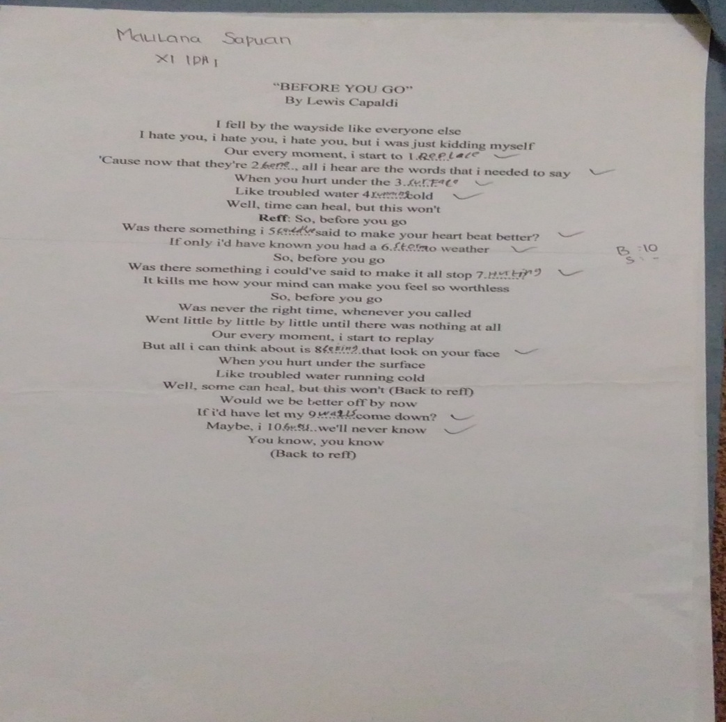

Documentation
Pre-test (IPA 1)
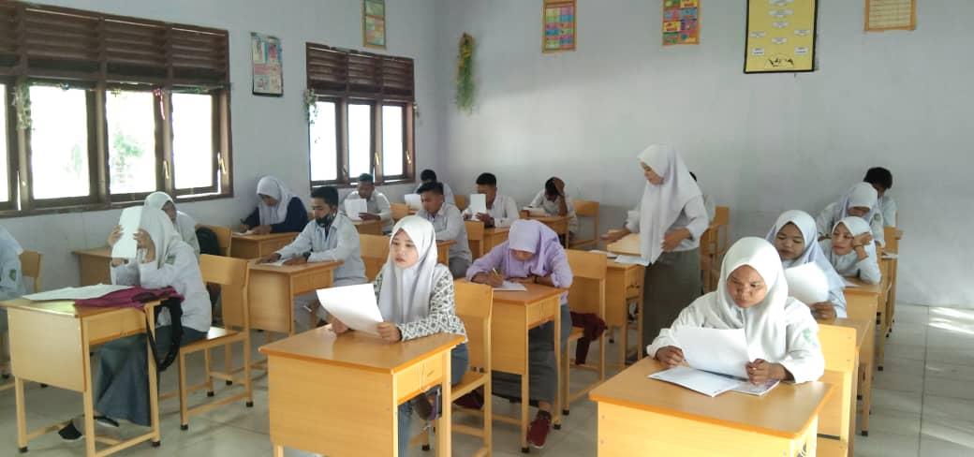
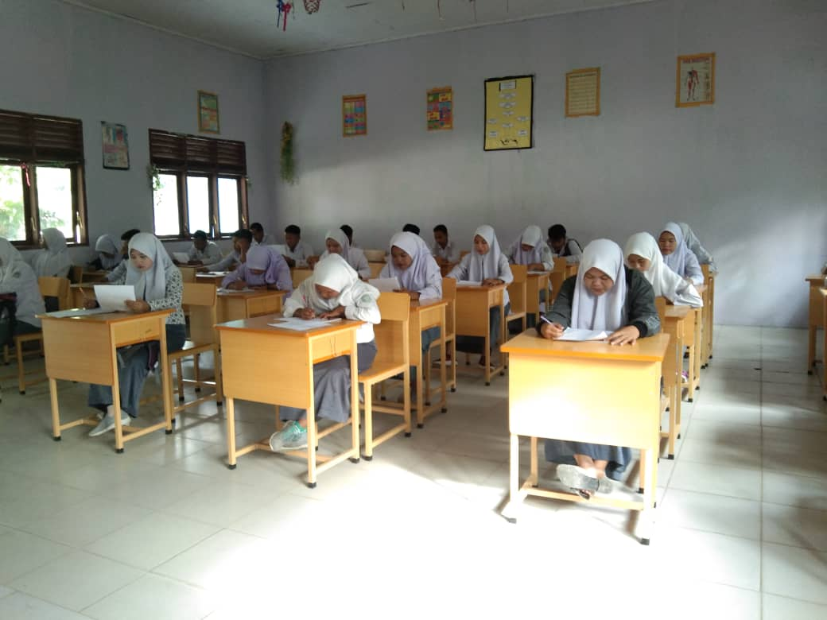
Pre-test (IPA 2)

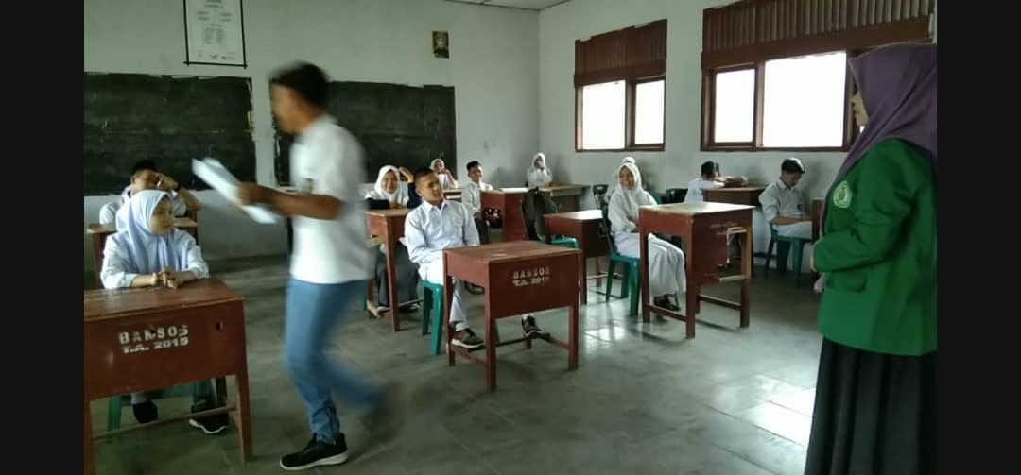
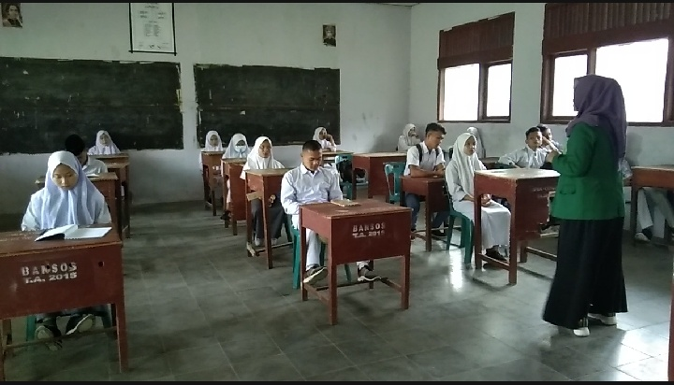
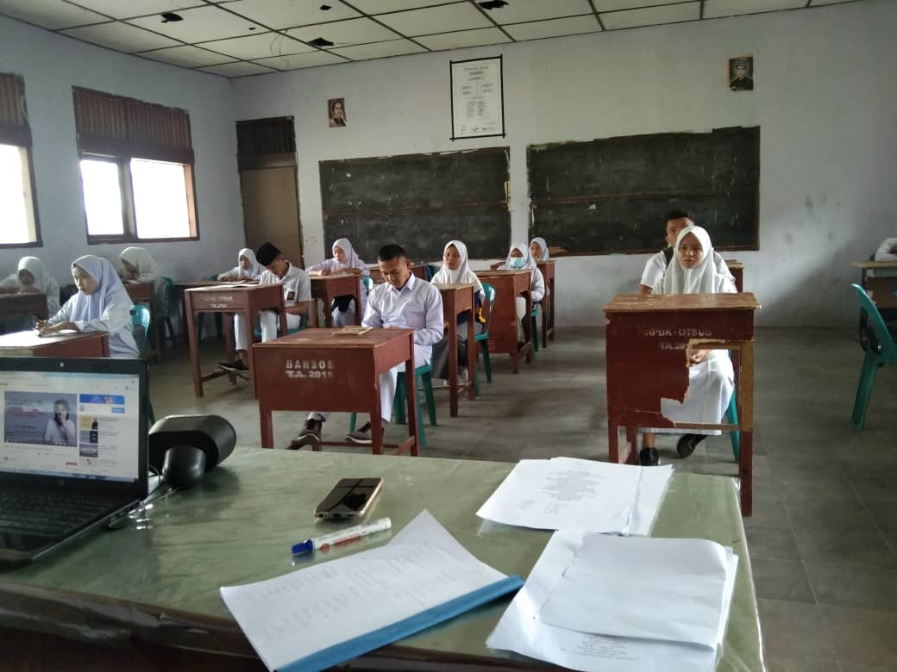

Post-test (IPA 1)
