ACKNOWLEDGEMENTS
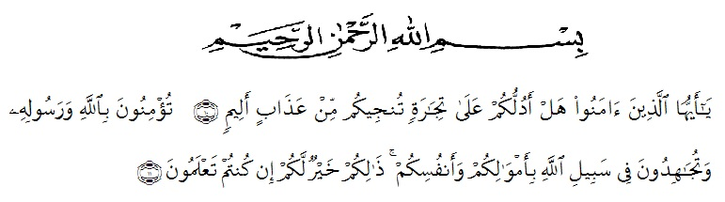

Artinya : “Hai orang –orang yang beriman, sukakah kamu Aku tunjukkan suatu perniagaan yang dapat menyelamatkanmu dari azab yang pedih? ( 10) (yaitu) kamu yang beriman kepada Allah dan Rasulnya dan berjihad di jalan Allah dengan harta dan jiwamu. Itulah yang lebih baik bagimu, jika kamu mengetahui. (11) (as-shaffayat 10-11)”.
In the name of Allah, the most Almighty, the most Gracious and the most Merciful. Praise to be Allah, firstly the writer would like to express thanks to Allah the most Almighty for giving her ideas and inspiration in finishing and completing the study. Secondly, bless and peace be upon the prophet Muhammad SAW as the figure of good civilization, intellectual, braveness, and loving knowledge.
This research entitled” Impeoving Srudents’ Interest In listening English Songs By Using Fill In The Blank At SMAN 1 LAWE ALAS Eleventh Grade in academic years 2021-2022 It was not easy for the writer in finishing this study. There were many difficulties and problems faced by her, physically and mentally. Without helping the following people, it might be impossible for her to finish it. Therefore, the writer would like to thank and express her gratitude and appreciation to:
- Dr. KRT Hardi Mulyono K.Surbakti, the respect Rector of Universitas Muslim Nusantara Al Washliyah Medan, who had encouraged along her education in UMN AW Medan.
- Drs. Samsul Bahri, M.Si as the Dean of FKIP UMN Al Washliyah Medan.
- Zulfitri, S.S., M.Aas the Head of English Education Department of FKIP UMN Al Washliyah who had given suggestion in implementing this research.
- Wariyati S.Pd., M.Hum as the advicer, who has contributed his time, knowledge, suggestion and comment to help the writer on supervising the draft writing this skripsi.
- Yulia Sari Harahap S.Pd., M.Hum as the first examiner, who has giving suggestion and comment.
- Nurafni Siregar S.Pd., M.Hum as the second examiner, who has giving suggestion and comment.
- All lectures, especially those of English Education Department for their guidance, advices, suggestions, and encouragements during her academic years at UMN Al Washliyah Medan.
- The Headmaster of SMAN 1 Lawe Alas Estate in Academic years 2021-2022who had given permission for her to conduct this research at that school.
- The writer’s beloved father ABD Khali and my strongest woman Samine who has given every affection, prayer and endless support, and strunggle and sacrifice which has been done for the writer so far.
- The writer’s lovely best partner Pirmansyah,who always love, care and helped her in finishing this study, Thanks for the motivation, supports, and care.
- The writer classmate 8H education in 2017, which extraordinary, thank you for being the best class.
- The writer best friend Nuryani Rustaman, Milda Wijaya, Munawarah, Agnes Monica and Kasma Wahyini always support and care.
- The writer best friend Dewi Hartati and Irmasari, who always love, care thank for supports and motivation and helped finishing this study.
- Finally, for all people whose names cannot mentioned, thank you for everything, may Allah SWT bless us. Aamiin.

Medan, 2 April 2021
The Writer,

Ratna Sari
vi

