**Lampiran**

|  |  |  |  |
| --- | --- | --- | --- |
| PT. BANK BNI SYARIAH KANTOR CABANG MEDAN | | | |
| Data Al-Istishna | | | |
| PER BULAN, TAHUN 2015/ 2017 | | | |
|  |  |  |  |
| BULAN | TAHUN | | |
| 2015 | 2016 | 2017 |
| JANUARI | 15.088.157,58 | 17.708.678,17 | 20.799.060,42 |
| FEBRUARI | 15.688.157,58 | 19.308.678,17 | 22.099.060,42 |
| MARET | 15.888.157,58 | 19.208.678,17 | 22.509.060,42 |
| APRIL | 16.058.157,58 | 19.608.678,17 | 23.289.060,42 |
| MEI | 16.688.157,58 | 20.008.678,17 | 23.799.060,42 |
| JUNI | 17.089.057,58 | 20.408.678,17 | 24.599.090,42 |
| JULI | 17.588.157,58 | 20.708.678,17 | 24.999.030,42 |
| AGUSTUS | 17.998.197,58 | 18.708.678,17 | 25.369.090,42 |
| SEPTEMBER | 18.099.157,58 | 20.588.678,17 | 25.799.060,42 |
| OKTOBER | 18.389.157,58 | 21.308.678,17 | 25.899.760,42 |
| NOVEMBER | 18.697.167,58 | 21.403.678,17 | 26.497.060,42 |
| DESEMBER | 19.080.157,58 | 21.780.678,17 | 26.999.060,42 |

PT. Bank BNI Syariah

Kantor Cabang Medan

Muhammad Ichsan

Operational Manager

|  |  |  |  |
| --- | --- | --- | --- |
| PT. BANK BNI SYARIAH KANTOR CABANG MEDAN | | | |
| Data *Non Performing Financing (NPF)* | | | |
| PER BULAN, TAHUN 2015/ 2017 | | | |
|  |  |  |  |
| BULAN | TAHUN | | |
| 2015 | 2016 | 2017 |
| JANUARI | 6.818.636,00 | 6.818.636,00 | 9.650.387,00 |
| FEBRUARI | 7.218.636,00 | 7.218.636,00 | 9.770.387,00 |
| MARET | 7.618.636,00 | 7.618.636,00 | 9.750.387,00 |
| APRIL | 7.818.636,00 | 7.818.636,00 | 8.950.387,00 |
| MEI | 7.410.636,00 | 7.410.636,00 | 9.950.387,00 |
| JUNI | 8.008.636,00 | 8.008.636,00 | 10.050.387,00 |
| JULI | 8.218.636,00 | 8.218.636,00 | 10.350.387,00 |
| AGUSTUS | 8.791.636,00 | 8.791.636,00 | 10.530.387,00 |
| SEPTEMBER | 8.910.036,00 | 8.910.036,00 | 11.370.387,00 |
| OKTOBER | 9.008.636,00 | 9.008.636,00 | 11.950.387,00 |
| NOVEMBER | 9.181.066,00 | 9.181.066,00 | 12.550.387,00 |
| DESEMBER | 9.381.636,00 | 9.381.636,00 | 12.850.387,00 |

PT. Bank BNI Syariah

Kantor Cabang Medan

Muhammad Ichsan

Operational Manager

|  |  |  |  |
| --- | --- | --- | --- |
| PT. BANK BNI SYARIAH KANTOR CABANG MEDAN | | | |
| Dana Bai' | | | |
| PER BULAN, TAHUN 2015/ 2017 | | | |
|  |  |  |  |
| BULAN | TAHUN | | |
| 2015 | 2016 | 2017 |
| JANUARI | 122.488.512,60 | 298.582.852,30 | 355.058.603,20 |
| FEBRUARI | 142.488.512,60 | 498.582.852,30 | 335.058.603,20 |
| MARET | 132.488.512,60 | 398.982.852,30 | 405.058.603,20 |
| APRIL | 232.488.512,60 | 398.182.852,30 | 455.058.603,20 |
| MEI | 232.498.512,60 | 498.582.852,30 | 355.058.603,20 |
| JUNI | 230.478.512,60 | 298.582.852,30 | 378.058.603,20 |
| JULI | 334.488.512,60 | 398.582.832,30 | 335.058.603,20 |
| AGUSTUS | 332.488.512,60 | 458.582.872,30 | 455.059.603,20 |
| SEPTEMBER | 302.488.512,60 | 398.582.852,30 | 475.057.603,20 |
| OKTOBER | 362.488.512,60 | 368.582.852,30 | 460.058.903,20 |
| NOVEMBER | 332.488.512,60 | 307.582.852,30 | 450.058.303,20 |
| DESEMBER | 432.488.512,60 | 398.582.852,30 | 500.058.603,20 |

PT. Bank BNI Syariah

Kantor Cabang Medan

Muhammad Ichsan

Operatssional Manager

|  |  |  |  |  |
| --- | --- | --- | --- | --- |
| **Model Summaryb** | | | | |
| Model | R | R Square | Adjusted R Square | Std. Error of the Estimate |
| 1 | ,797a | ,635 | ,554 | 103703590,80067 |
| a. Predictors: (Constant), Non Performing Financing, Bai'i Al-Istishna | | | | |
| b. Dependent Variable: Dana Bai'i | | | | |

|  |  |  |  |  |  |  |
| --- | --- | --- | --- | --- | --- | --- |
| **ANOVAa** | | | | | | |
| Model | | Sum of Squares | df | Mean Square | F | Sig. |
| 1 | Regression | 168711111884305888,000 | 2 | 84355555942152944,000 | 7,844 | ,011b |
| Residual | 96789912704581392,000 | 9 | 10754434744953488,000 |  |  |
| Total | 265501024588887296,000 | 11 |  |  |  |
| a. Dependent Variable: Dana Bai'i | | | | | | |
| b. Predictors: (Constant), Non Performing Financing, Bai'i Al-Istishna | | | | | | |

|  |  |  |  |  |  |  |  |  |
| --- | --- | --- | --- | --- | --- | --- | --- | --- |
| **Coefficientsa** | | | | | | | | |
| Model | | Unstandardized Coefficients | | Standardized Coefficients | t | Sig. | Collinearity Statistics | |
| B | Std. Error | Beta | Tolerance | VIF |
| 1 | (Constant) | 527973401,925 | 588865324,293 |  | ,897 | ,393 |  |  |
| Bai'i Al-Istishna | 19,291 | 21,662 | ,530 | 3,891 | ,396 | ,114 | 8,740 |
| *Non Performing Financing* | 15,211 | 32,545 | ,278 | 3,467 | ,651 | ,114 | 8,740 |
| a. Dependent Variable: Dana Bai'i | | | | | | | | |

**Charts**

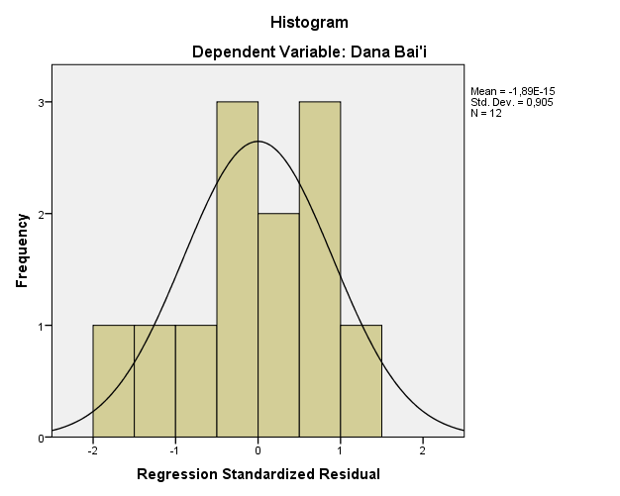

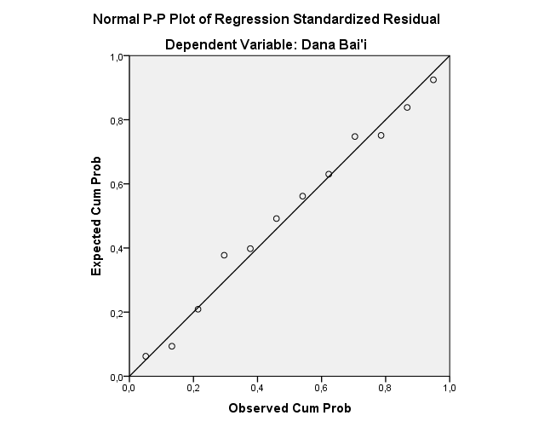

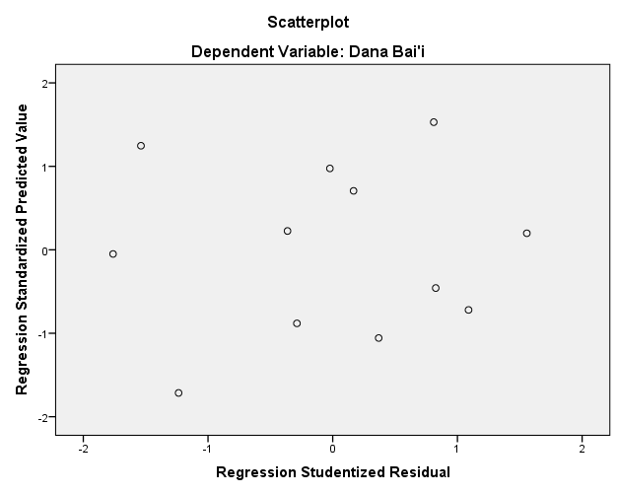



|  |  |  |
| --- | --- | --- |
| **Df** | **Level Of Significance** | |
| **Two-Tails** | |
| **0,05** | **0,10** |
| **1** | 12,706 | 6,314 |
| **2** | 4,303 | 2,920 |
| **3** | 3,182 | 2,353 |
| **4** | 2,776 | 2,132 |
| **5** | 2,571 | 2,015 |
| **6** | 2,447 | 1,943 |
| **7** | 2,365 | 1,895 |
| **8** | 2,306 | 1,860 |
| **9** | 2,262 | 1,833 |
| **10** | 2,228 | 1,812 |
| **11** | 2,201 | 1,796 |
| **12** | 2,179 | 1,782 |
| **13** | 2,160 | 1,771 |
| **14** | 2,145 | 1,761 |
| **15** | 2,131 | 1,753 |
| **16** | 2,120 | 1,746 |
| **17** | 2,110 | 1,740 |
| **18** | 2,101 | 1,740 |
| **19** | 2,093 | 1,729 |
| **20** | 2,086 | 1,725 |
| **21** | 2,080 | 1,721 |
| **22** | 2,074 | 1,717 |
| **23** | 2,069 | 1,714 |
| **24** | 2,064 | 1,711 |
| **25** | 2,060 | 1,708 |
| **26** | 2,056 | 1,706 |
| **27** | 2,052 | 1,703 |
| **28** | 2,048 | 1,701 |
| **29** | 2,045 | 1,699 |
| **30** | 2,042 | 1,697 |
| **31** | 2,040 | 1,696 |
| **32** | 2,037 | 1,694 |
| **33** | 2,035 | 1,692 |
| **34** | 2,032 | 1,691 |
| **35** | 2,030 | 1,690 |
| **36** | 2,208 | 1,688 |
| **37** | 2,026 | 1,687 |
| **38** | 2,024 | 1,686 |
| **39** | 2,023 | 1,685 |
| **40** | 2,021 | 1,684 |
| **41** | 2,020 | 1,683 |
| **42** | 2,018 | 1,682 |
| **43** | 2,017 | 1,681 |
| **44** | 2,015 | 1,680 |
| **45** | 2,014 | 1,679 |
| **46** | 2,013 | 1,679 |
| **47** | 2,012 | 1,678 |
| **48** | 2,011 | 1,677 |
| **49** | 2,010 | 1,677 |
| **50** | 2,009 | 1,676 |
| **51** | 2,008 | 1,675 |
| **52** | 2,007 | 1,675 |
| **53** | 2,006 | 1,674 |
| **54** | 2,005 | 1,674 |
| **55** | 2,004 | 1,673 |
| **56** | 2,003 | 1,673 |
| **57** | 2,002 | 1,672 |
| **58** | 2,002 | 1,672 |
| **59** | 2,001 | 1,671 |
| **60** | 2,000 | 1,671 |
| **61** | 1,999 | 1,670 |
| **62** | 1,998 | 1,669 |
| **63** | 1,998 | 1,669 |
| **64** | 1,996 | 1,668 |
| **65** | 1,996 | 1,667 |
| **66** | 1,996 | 1,667 |
| **67** | 1,995 | 1,666 |
| **68** | 1,995 | 1,665 |
| **69** | 1,994 | 1,665 |
| **70** | 1,994 | 1,664 |