ACKNOWLEADGEMENTS
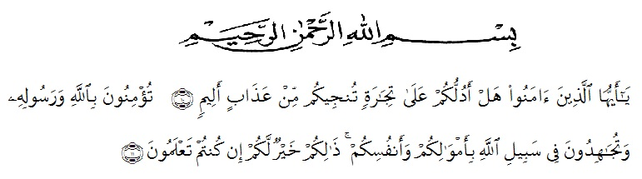
Artinya: “Hai orang-orang yang beriman, maukah kamu aku tunjukkan suatu perniagaan yang dapat menyelamatkanmu dari azab yang pedih? (10). (Yaitu) kamu beriman kepada Allah dan Rasul-Nya danberjihad di jalan Allah dengan harta dan jiwamu. Itulah yang lebih baik bagimu, jika kamu mengetahui (11) {As- Shaffayat 10-11}”
The writer wants to deliver her great thank to Allah Swt for blessing, love, opportunity, health, and mercy. In compliting this research, the writer got suggestion assistance, critictism and guidance from many persons. In this occasion, the writer would like to express her thank to:
- H. Hardi Mulyono, SE, MAP. as the Rector of Universitas of Muslim Nusantara Al Washliyah Medan.
- Drs. Mhd. Ayyub Lubis, M.Pd, Ph.D, as the Decan of FKIP UMN Al Washliyah Medan and staff for the facilities given to her during her study at the university.
- Junaidi, SS, S.Pd, M.Si, as the Chairman in English Study Program.
- Dr. Salamuddin Selian, M.Hum, the first consultant who has given her a lot of valuable suggestion, comments, critism, and responses for completing this research.
- Yugi Diraga Prawiyata, S.Pd., M.Hum, the second consultant who has never stopped helping her guiding and correcting the draft of research and also always give encouragement to never give up in revisions.
- Dr. H. M. Khalid, M.Hum, as the examiner of her research.
- The headmaster of MTS.s Al Washliyah Stabat, for facilities given her in conducting this research.
- All the lecturers of UMN Al Washliyah Medan especially those English Departement who guidance and knowledge that they have given during any academic time.
- The librarian of FKIP UMN, for the books needed in eriiting this reseach.
- Her beloved parents, her brother and her sisters that always support her unconditionally.
- Her beloved friends Dita Amanah, Retty, Widiah Aprillah, Mawaddah Delima Sari, Yulia Nasti, Indri Octa Miransyah and Afifah Ulya Pasaribu who have never felt bored to give help, support, suggestion and as movators who always say we have to complete this research and graduations together.
- Her beloved classmate in 8A English Departement of UMN Al Washliyah Medan. Thank for support, and careness to finish her study, she proud all of you friends.
Medan, 2019
The writer

Mustika Dewi

