APPENDIXES III
Students writing achievement of experimental group
Pre-test
Name : Cici Devina
Class : X AP 1
Score : 50 with higher score
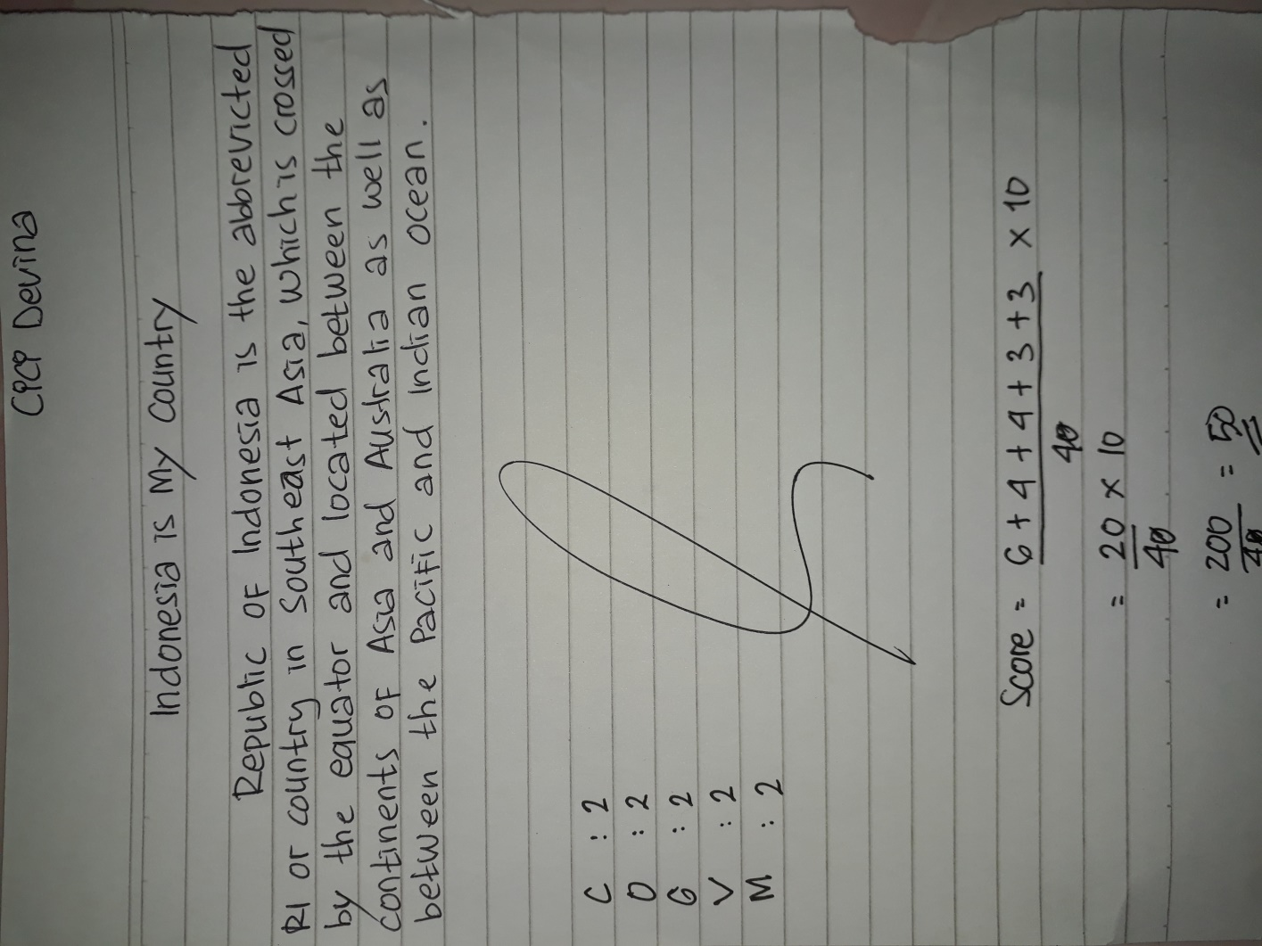
The Score of the writing descriptive text
Content : The topic is complete and clear but the details are almost
relating to the topic.
Organization : Identification is not complete
Grammar : Numerous grammatical or agreement
Vocabulary : Limited range confusing words
Mechanics : It has frequent errors of spelling and capitalization

Score = $\frac{3C + 20+2G+1.5V+1.5M}{4}×10$

