DAFTAR PUSTAKA
Arikunto,S. 2018. Prosedur Penelitian: Suatu Pendekatan Praktik. Jakarta: Rineka Cipta.

A, Hallen. 2005. Bimbingan dan Konseling. Edisi Revisi. Jakarta: Quantum Teaching

Astriyani, Dian Novita. 2010. Kemampuan Manajemen Diri Mahasiswa Jurusan Bimbingan dan Konseling di Universitas Negeri Semarang.

Comier, L. J., & Comier, L. S. (1985).Interviewing Strategies for Helpers(2nded). California: Brocks Cole Publishing Company.

Corey, Gerald. 2013 .Teori dan Praktek Konseling & Psikoterapi. Terjemah E. Koswara. Bandung. Refika Aditama.

Dety Tamsisva. (2017), Pengaruh Bimbingan Kelompok Dengan Teknik Self Management Untuk Meningkatkan Pemahaman Kemandirian Siswa (Penelitian pada Siswa Kelas VIII B SMP Negeri 13 Magelang T.A 2016/2017). Program Studi Bimbingan Dan Konseling Fakultas Keguruan Dan Ilmu Pendidikan Universitas Muhammadiyah Magelang 2017

Desmita. 2012. Psikologi Perkembangan Peserta Didik. Bandung: PT Remaja Rosdakarya

Dina Putri Arianto. 2018. Pengaruh Layanan Bimbingan Kelompok Terhadap Self Management Dalam Belajar Siswa Kelas X Sma Istiqlal Delitua. Program Studibimbingan Konseling Islam Fakultas Ilmu Tarbiyah Dan Keguruan Universitas Islam Negeri Sumatera Utara

Eka Nuryanti 2018. Pengaruh Layanan Bimbingan Kelompok Dengan Teknik Self-Management Untuk Meningkatkan Kedisiplinan Peserta Didik Kelas X Sma Negeri 3 Bandar Lampung Tahun Ajaran 2018/2019. Fakultas Tarbiyah Dan Keguruan Universitas Islam Negeri Raden Intan Lampung 2018

Gie, T. L. 2000. Cara Belajar yang Baik Bagi Mahasiswa (2nded). Yogyakarta: Gadjah Mada University Press

Gunarsa, Singgih D. 2004. Psikologi Praktis Anak, Remaja dan Keluarga, Cetakan. 7. Jakarta : PT. Gunung Mulia.

Hamdun. D. 2013. Bimbingan dan Konseling. Yogyakarta: Fakultas Ilmu Tarbiyah UIN Sunan Kali Jaga.

Harvey P. W. 2011. Self-management and the health care consumer. Nova Science Publishers. New York, N.Y

Haris Mudjiman. (2011). Belajar Mandiri. Surakarta: UNS PRESS

Komalasari, Gantina, Wahyuni dan Karsih. 2016. Teori dan Teknik Konseling. Jakarta: PT. Indeks.

Makhfud. 2011.Hubungan Antara Manajemen Diri Dengan ProkrastinasiAkademik Pada Siswa Aktivis Bem Iain Sunan Ampel Surabaya. Psikologi Pendidikan dan Bimbingan volume 10

Miltenberger, Raymond G. 2012. Behavior Modification: Principle and procedures (5th ed.). University of South Florida: Wadsworth, Cengage Learning.

Mudjiman, Haris. (2006). Belajar Mandiri. Surakarta: UNS dan UNS Press.

Nursalim, M., & fauziah, N. R. 2013. Penerapan Konseling Kelompok Realita Teknik Wdep Untuk Meningkatkan Motivasi Belajar Siswa Kelas VIII-H SMP Negeri 2 Mojosari. Jurnal Bk Unesa. 3 (1). 402-407. ISSN: 1335936558

Nidhomun Ni’am, Pengaruh Layanan Konseling Kelompok Dengan Teknik Self Management Untuk Mengurangi Perilaku Prokrastinasi Akademik Peserta Didik Kelas IX SMP Negeri 3 Bandar Lampung Tahun Pelajaran 2017/2018. Fakultas Tarbiyah Dan Keguruan Universitas Islam Negeri Raden Intan Lampung 2018
Prayitno, Erman Amti, Dasar-dasar Bimbingan dan Konseling,

Prijosaksono, Astriyani., 2001, Self Mangement Series. Jakarta: Gramedia.

Rusman. 2010. Model-model pembelajaran (Mengembangkan Profesionalisme Guru Edisi Kedua). Jakarta: Raja Grafindo Persada.

Santrock, J.B. 2003 Adolescence: Perkembangan masa remaja edisi keenam Alih Bahasa: Achmad Chusairi dan Juda Damanik Erlangga Jakarta

Siradj, Shahudi, 2012. Pengantar Bimbingan dan Konseling, Surabaya: Revka Petra Media

Sugiyono, Metode Penelitian Kuantitatif, Kualitatif Dan R&D, Bandung: Alfabeta, 2014.

Sys Maf’qhul Umi 2018. Pengaruh Layanan Bimbingan Kelompok Dengan Teknik Self Management Terhadap Kontrol Diri Siswa Dalam Penggunaan Handphone Kelas XI SMA Mardisiswa. [VOLUME 5 NOMOR 1, APRIL] 2018. ISSN 2406-8691

Tohirin, 2007, Bimbingan Konseling di Sekolah dan Madrasah, Jakarta: Raja Grafindo Persada.

Watson, D., & Tharp, R. 2007. self-directed behaviour (9 th ed.). Belmont: CA: Wadsworth

Yamin, Martinis. 2008. Paradigma Pendidikan Konstruktivistik. Jakarta: Gaung Persada Press

LAMPIRAN

Skala layanan bimbingan kelompok teknik self – manajemen

Kontrol Diri try out

INSTRUKSI:
Berilah tanda ceklis (√) pada salah satu dari 4 kotak yang adik-adik anggap paling menggambarkan kondisi adik-adik. Tiap kotak tersebut berisi angka yang mengandung jawaban sebagai berikut:
- Sangat setuju (SS) 3. Tidak setuju (TS)
- Setuju (S) 4. Sangat tidak sejutu (STS)

Pernyataan | SS | S | TS | STS
layanan bimbingan kelompok teknik self – manajemen | √

NO | PERNYATAAN | SS | S | TS | STS
 | Mengenal Diri Sendiri
1. | Saya melakukan tugas tanpa diperintahkan orang lain
2. | Saya mempunyai kepuasan dengan  usaha sendiri
3. | Saya bersikap terbuka terhadap kritik, saran orang lain, dan mau menerima apa adanya demi perkembangan dirinya;
4. | Saya adalah orang yang pemalu ketika sedang bergabung dengan teman-teman lainnya
5. | Saya adaah orang yang senang bertukar pikiran
 | Mempunyai Komitmen
6. | Saya tidak puas, jika hanya mendapatkan nilai yang sama dengan teman saya
7. | Saya belajar lebih giat lagi ketika memperoleh nilai jelek
8. | Saya berusaha untuk mendapat nilai yang bagus dengan mengulang pelajaran di rumah
9. | Saya akan mendapatkan nilai yang bagus dengan mengeriakan apa yang disuruh guru
10. | Saya dapat menyelesaikan tugas tanpa bantuan orang lain
 | Memilik Kemauan
11. | Saya akan berusaha memperbaiki nilai saya supaya prestasi saya meningkat
12. | Walaupun tugas sekolah sangat banyak, saya tetap mengerjakannya dengan senang hati
13. | Saya akan bertanya pada teman atau guru ketika mengalami kesulitan mengerjakan tugas
14. | Saya senang mengerjakan tugas yang belum pernah dikerjakan orang lain
15. | Saya cenderung ingin mendapatkan nilai rata-rata sama dengan teman-teman saya
 | Penyesuaian diri
16. | Saya biasa lebih memilih diam saja saat berkumpul bersama teman-teman di sekolah
17. | Saya biasa mendengarkan aktif saat teman sekolah berbicara
18. | Saya lebih menghargai perbedaan agama teman-teman saya
19. | Saya biasa menyapa teman saya menggunakan nama sebenarnya
20. | Saya suka berteman dengan siapa saja tanpa mengenal perbedaan suku, asal dan budaya

Skala Kemandirian Belajar
INSTRUKSI:
Berilah tanda ceklis (√) pada salah satu dari 4 kotak yang adik-adik anggap paling menggambarkan kondisi adik-adik. Tiap kotak tersebut berisi angka yang mengandung jawaban sebagai berikut:
- Sangat setuju (SS) 3. Tidak setuju (TS)
- Setuju (S) 4. Sangat tidak sejutu (STS)

Pernyataan | SS | S | TS | STS
Kemandirian Belajar dalan peoses belajar mengajar |  | √

No | Pernyataan | SS | S | TS | STS
 | Percaya Diri
1. | Berani tampil di muka umum
2. | Percaya kepada kemandiran diri sendiri
3. | Berani bertanya saat menemui kesulitan
4. | Berani mengemukakan pendapat
5. | Berbicara lancar saat berada di hadapan orang banyak
 | Aktif dalam Belajar
6. | Saya menghadapi kesulitan mengerjakan tugas, berupaya membahasnya dengan guru
7. | Dalam mencatat, saya cenderung mencatat bahan yang kemudian ternyata kurang berguna
8. | Saya menyimpan kertas tes, laporan tugas rumah yang sudah dikembalikan tanpa mengindahkan catatan perbaikan dari guru
9. | Saya senang membuat catatan sendiri untuk mempermudah saya belajar
10. | Saya tidak terpengaruh jika teman mengajak mengobrol saat belajar
 | Disiplin Dalam Belajar
11. | Saya membuat jadwal kegiatan sehari-hari
12. | Saya melakukan kegiatan sesuai jadwal yang telah dibuat
13. | Saya memanfaatkan waktu luang untuk kegiatan yang bermanfaat
14. | Saya tidak menunda pekerjaan rumah yang diberikan guru
15. | Saya selalu tepat waktu dalam mengerjakan yang diberikan guru
 | Tanggung Jawab Dalam Belajar
16. | Saya Menyelesaikan tugas yang diberikan dengan penuh tanggung Jawab
17. | Saya berani mengakui kesalahan
18. | Saya berani menerima risiko atas perbuatan yang dilakukan dalam menyelesaian pekerjaan rumah yang diberikan
19. | Saya menyelesaikan tugas tanpa bantuan orang lain
20. | Menyelesaikan tugas yang diberikan dengan penuh tanggung jawab.

LAYANAN BIMBINGAN KELOMPOK TEKNIK SELF MANAGEMEN
No. | Pernyataan |  |  |  |  |  |  |  |  |  |  |  |  |  |  | Total
 | 1 | 2 | 3 | 4 | 5 | 6 | 7 | 8 | 9 | 10 | 11 | 12 | 13 | 14 | 15
1 | 3 | 4 | 4 | 4 | 4 | 4 | 2 | 4 | 4 | 4 | 4 | 4 | 3 | 4 | 4 | 56
2 | 4 | 4 | 4 | 4 | 4 | 4 | 4 | 4 | 4 | 4 | 4 | 4 | 4 | 4 | 4 | 60
3 | 4 | 3 | 4 | 4 | 4 | 4 | 4 | 4 | 4 | 4 | 4 | 4 | 4 | 4 | 4 | 59
4 | 4 | 4 | 4 | 3 | 4 | 4 | 4 | 3 | 4 | 3 | 3 | 4 | 4 | 4 | 4 | 56
5 | 4 | 4 | 4 | 4 | 4 | 4 | 2 | 4 | 4 | 4 | 4 | 4 | 4 | 4 | 4 | 58
6 | 4 | 4 | 4 | 3 | 4 | 4 | 4 | 4 | 4 | 3 | 4 | 4 | 4 | 4 | 4 | 58
7 | 4 | 4 | 4 | 4 | 4 | 4 | 4 | 4 | 4 | 4 | 4 | 4 | 4 | 4 | 4 | 60
8 | 4 | 4 | 4 | 3 | 4 | 3 | 3 | 3 | 4 | 3 | 3 | 3 | 4 | 3 | 3 | 51
9 | 4 | 4 | 4 | 4 | 3 | 4 | 4 | 4 | 4 | 4 | 3 | 4 | 4 | 4 | 4 | 58
10 | 4 | 4 | 3 | 4 | 4 | 3 | 4 | 4 | 4 | 4 | 4 | 4 | 4 | 4 | 4 | 58
11 | 4 | 4 | 4 | 4 | 4 | 4 | 4 | 4 | 4 | 4 | 4 | 4 | 4 | 4 | 4 | 60
12 | 4 | 3 | 4 | 3 | 2 | 4 | 3 | 3 | 4 | 3 | 3 | 2 | 4 | 4 | 4 | 50
13 | 4 | 4 | 4 | 4 | 4 | 4 | 4 | 4 | 4 | 3 | 4 | 4 | 4 | 3 | 4 | 58
14 | 4 | 4 | 4 | 4 | 4 | 4 | 4 | 4 | 4 | 4 | 4 | 4 | 4 | 4 | 4 | 60
15 | 4 | 3 | 4 | 3 | 4 | 4 | 3 | 4 | 2 | 3 | 4 | 4 | 4 | 4 | 4 | 54
16 | 4 | 4 | 4 | 4 | 3 | 4 | 4 | 4 | 4 | 4 | 4 | 4 | 4 | 4 | 2 | 57
17 | 4 | 4 | 4 | 4 | 4 | 4 | 4 | 2 | 4 | 4 | 4 | 3 | 3 | 4 | 4 | 56
18 | 4 | 4 | 4 | 4 | 4 | 3 | 4 | 4 | 4 | 4 | 4 | 4 | 4 | 3 | 4 | 58
19 | 4 | 4 | 4 | 4 | 4 | 4 | 4 | 3 | 4 | 3 | 3 | 4 | 4 | 4 | 4 | 57
20 | 4 | 4 | 4 | 4 | 4 | 4 | 4 | 4 | 4 | 4 | 4 | 4 | 4 | 4 | 4 | 60
21 | 4 | 4 | 4 | 4 | 4 | 4 | 4 | 4 | 4 | 4 | 4 | 4 | 4 | 4 | 4 | 60
22 | 4 | 4 | 4 | 4 | 4 | 4 | 4 | 4 | 4 | 4 | 4 | 4 | 4 | 4 | 4 | 60
23 | 4 | 4 | 4 | 4 | 4 | 4 | 4 | 3 | 4 | 4 | 3 | 4 | 4 | 4 | 4 | 58
24 | 4 | 4 | 4 | 4 | 4 | 4 | 4 | 4 | 4 | 4 | 4 | 4 | 4 | 4 | 4 | 60
25 | 4 | 4 | 4 | 4 | 4 | 4 | 4 | 4 | 3 | 4 | 3 | 4 | 4 | 4 | 4 | 58
26 | 4 | 4 | 4 | 4 | 4 | 3 | 4 | 4 | 4 | 4 | 4 | 4 | 4 | 4 | 4 | 59
27 | 4 | 4 | 4 | 4 | 4 | 4 | 4 | 4 | 4 | 3 | 4 | 4 | 4 | 3 | 4 | 58
28 | 4 | 4 | 4 | 3 | 4 | 4 | 4 | 4 | 3 | 4 | 4 | 4 | 4 | 4 | 4 | 58
29 | 4 | 3 | 4 | 3 | 4 | 3 | 3 | 3 | 4 | 3 | 3 | 4 | 4 | 4 | 4 | 53
30 | 3 | 3 | 3 | 3 | 3 | 2 | 3 | 3 | 2 | 3 | 3 | 4 | 3 | 3 | 3 | 44

KEMANDIRIAN BELAJAR SISWA KELAS X SMK NEGERI 1 BERINGIN TAHUN PELAJARAN 2020-2021
No. |  |  |  |  |  |  |  |  |  |  |  |  |  |  |  | Total
 | 1 | 2 | 3 | 4 | 5 | 6 | 7 | 8 | 9 | 10 | 11 | 12 | 13 | 14 | 15
1 | 4 | 4 | 4 | 4 | 4 | 4 | 4 | 4 | 4 | 4 | 4 | 4 | 4 | 4 | 4 | 60
2 | 4 | 4 | 4 | 4 | 4 | 4 | 4 | 4 | 4 | 4 | 3 | 4 | 4 | 4 | 4 | 59
3 | 4 | 4 | 4 | 4 | 4 | 4 | 4 | 4 | 4 | 4 | 4 | 4 | 4 | 4 | 3 | 59
4 | 2 | 4 | 4 | 4 | 4 | 4 | 4 | 2 | 4 | 4 | 3 | 4 | 4 | 3 | 3 | 53
5 | 3 | 2 | 4 | 4 | 4 | 4 | 4 | 3 | 2 | 4 | 4 | 3 | 4 | 4 | 4 | 53
6 | 4 | 3 | 3 | 3 | 3 | 3 | 3 | 2 | 3 | 3 | 3 | 4 | 3 | 3 | 3 | 46
7 | 4 | 4 | 4 | 4 | 4 | 4 | 4 | 3 | 4 | 2 | 4 | 4 | 4 | 4 | 3 | 56
8 | 4 | 3 | 4 | 4 | 4 | 4 | 4 | 4 | 3 | 4 | 4 | 4 | 4 | 3 | 4 | 57
9 | 3 | 3 | 3 | 3 | 3 | 3 | 3 | 3 | 3 | 2 | 3 | 3 | 3 | 3 | 3 | 44
10 | 4 | 4 | 4 | 3 | 4 | 4 | 3 | 2 | 4 | 4 | 3 | 4 | 4 | 4 | 3 | 54
11 | 4 | 3 | 4 | 4 | 3 | 3 | 4 | 2 | 3 | 4 | 4 | 4 | 4 | 3 | 4 | 53
12 | 3 | 3 | 4 | 4 | 4 | 4 | 3 | 3 | 4 | 3 | 4 | 3 | 4 | 4 | 4 | 54
13 | 4 | 3 | 4 | 3 | 4 | 4 | 3 | 4 | 4 | 3 | 3 | 4 | 4 | 4 | 3 | 54
14 | 2 | 4 | 3 | 4 | 4 | 3 | 2 | 2 | 4 | 2 | 4 | 4 | 4 | 4 | 4 | 50
15 | 3 | 4 | 4 | 4 | 4 | 4 | 4 | 3 | 2 | 4 | 4 | 3 | 4 | 4 | 4 | 55
16 | 3 | 3 | 3 | 3 | 3 | 3 | 3 | 3 | 3 | 3 | 3 | 3 | 3 | 3 | 3 | 45
17 | 3 | 3 | 3 | 3 | 3 | 3 | 3 | 2 | 3 | 2 | 3 | 4 | 3 | 3 | 3 | 44
18 | 4 | 3 | 3 | 4 | 3 | 4 | 4 | 3 | 3 | 3 | 4 | 4 | 3 | 4 | 4 | 53
19 | 4 | 4 | 4 | 4 | 4 | 3 | 4 | 4 | 4 | 4 | 3 | 4 | 4 | 4 | 4 | 58
20 | 4 | 4 | 4 | 2 | 4 | 4 | 4 | 3 | 4 | 2 | 3 | 4 | 4 | 4 | 4 | 54
21 | 4 | 4 | 4 | 4 | 4 | 4 | 4 | 4 | 4 | 4 | 4 | 4 | 4 | 4 | 4 | 60
22 | 4 | 4 | 4 | 4 | 4 | 4 | 4 | 3 | 4 | 4 | 4 | 4 | 4 | 4 | 4 | 59
23 | 4 | 4 | 2 | 4 | 4 | 4 | 4 | 4 | 3 | 4 | 4 | 4 | 4 | 2 | 4 | 55
24 | 4 | 4 | 4 | 4 | 4 | 4 | 4 | 4 | 4 | 4 | 4 | 4 | 4 | 4 | 4 | 60
25 | 4 | 4 | 4 | 4 | 4 | 4 | 4 | 4 | 4 | 4 | 4 | 4 | 4 | 2 | 4 | 58
26 | 4 | 4 | 4 | 4 | 2 | 4 | 4 | 4 | 4 | 3 | 4 | 4 | 4 | 4 | 4 | 57
27 | 4 | 4 | 4 | 4 | 4 | 4 | 4 | 4 | 4 | 4 | 3 | 4 | 4 | 4 | 4 | 59
28 | 4 | 2 | 4 | 4 | 4 | 2 | 4 | 4 | 3 | 2 | 3 | 2 | 3 | 4 | 4 | 49
29 | 3 | 4 | 4 | 4 | 3 | 2 | 3 | 3 | 2 | 2 | 4 | 4 | 4 | 2 | 4 | 48
30 | 4 | 4 | 4 | 2 | 4 | 4 | 3 | 4 | 2 | 2 | 2 | 4 | 3 | 4 | 2 | 48

Correlations
 |  | x1 | x2 | x3 | x4 | x5 | x6 | x7 | x8 | x9 | x10 | x11 | x12 | x13 | x14 | x15 | x16 | x17 | x18 | x19 | x20 | Totalx
x1 | Pearson Correlation | 1 | .239 | .464** | .069 | .141 | .196 | .413* | .547** | .117 | .102 | .395* | .094 | .117 | -.083 | .802** | .168 | .239 | .230 | .141 | .109 | .523**
 | Sig. (2-tailed) |  | .203 | .010 | .719 | .457 | .298 | .023 | .002 | .539 | .593 | .031 | .619 | .539 | .661 | .000 | .374 | .203 | .222 | .457 | .567 | .003
 | N | 30 | 30 | 30 | 30 | 30 | 30 | 30 | 30 | 30 | 30 | 30 | 30 | 30 | 30 | 30 | 30 | 30 | 30 | 30 | 30 | 30
x2 | Pearson Correlation | .239 | 1 | .239 | .596** | .539** | .427* | .331 | .382* | -.098 | .255 | .495** | .443* | .293 | .279 | .149 | .000 | .040 | .070 | -.067 | -.052 | .609**
 | Sig. (2-tailed) | .203 |  | .203 | .001 | .002 | .018 | .074 | .037 | .608 | .174 | .005 | .014 | .116 | .135 | .432 | 1.000 | .834 | .714 | .723 | .785 | .000
 | N | 30 | 30 | 30 | 30 | 30 | 30 | 30 | 30 | 30 | 30 | 30 | 30 | 30 | 30 | 30 | 30 | 30 | 30 | 30 | 30 | 30
x3 | Pearson Correlation | .464** | .239 | 1 | .069 | .141 | .196 | .683** | .091 | .408* | .102 | .395* | .094 | .117 | -.083 | .356 | .168 | .239 | .230 | .141 | .342 | .523**
 | Sig. (2-tailed) | .010 | .203 |  | .719 | .457 | .298 | .000 | .632 | .025 | .593 | .031 | .619 | .539 | .661 | .053 | .374 | .203 | .222 | .457 | .065 | .003
 | N | 30 | 30 | 30 | 30 | 30 | 30 | 30 | 30 | 30 | 30 | 30 | 30 | 30 | 30 | 30 | 30 | 30 | 30 | 30 | 30 | 30
x4 | Pearson Correlation | .069 | .596** | .069 | 1 | .155 | .151 | .069 | .438* | -.224 | .000 | .189 | .073 | .000 | .080 | .000 | -.108 | -.092 | -.040 | -.193 | -.149 | .269
 | Sig. (2-tailed) | .719 | .001 | .719 |  | .414 | .426 | .717 | .016 | .234 | 1.000 | .316 | .703 | 1.000 | .674 | 1.000 | .571 | .630 | .834 | .306 | .432 | .150
 | N | 30 | 30 | 30 | 30 | 30 | 30 | 30 | 30 | 30 | 30 | 30 | 30 | 30 | 30 | 30 | 30 | 30 | 30 | 30 | 30 | 30
x5 | Pearson Correlation | .141 | .539** | .141 | .155 | 1 | .277 | .325 | .334 | -.066 | .373* | .473** | .693** | .428* | .341 | .050 | .063 | .135 | .165 | .148 | .114 | .641**
 | Sig. (2-tailed) | .457 | .002 | .457 | .414 |  | .138 | .080 | .071 | .730 | .043 | .008 | .000 | .018 | .065 | .792 | .740 | .477 | .384 | .436 | .549 | .000
 | N | 30 | 30 | 30 | 30 | 30 | 30 | 30 | 30 | 30 | 30 | 30 | 30 | 30 | 30 | 30 | 30 | 30 | 30 | 30 | 30 | 30
x6 | Pearson Correlation | .196 | .427* | .196 | .151 | .277 | 1 | .124 | .188 | .080 | .210 | .136 | .208 | .401* | .574** | .123 | .309 | .033 | .402* | .277 | -.043 | .553**
 | Sig. (2-tailed) | .298 | .018 | .298 | .426 | .138 |  | .515 | .319 | .673 | .266 | .474 | .270 | .028 | .001 | .519 | .097 | .863 | .028 | .138 | .823 | .002
 | N | 30 | 30 | 30 | 30 | 30 | 30 | 30 | 30 | 30 | 30 | 30 | 30 | 30 | 30 | 30 | 30 | 30 | 30 | 30 | 30 | 30
x7 | Pearson Correlation | .413* | .331 | .683** | .069 | .325 | .124 | 1 | .218 | .279 | .243 | .323 | .238 | .279 | .011 | .291 | .085 | .511** | .326 | .020 | .133 | .593**
 | Sig. (2-tailed) | .023 | .074 | .000 | .717 | .080 | .515 |  | .247 | .136 | .196 | .082 | .206 | .136 | .956 | .118 | .656 | .004 | .079 | .915 | .484 | .001
 | N | 30 | 30 | 30 | 30 | 30 | 30 | 30 | 30 | 30 | 30 | 30 | 30 | 30 | 30 | 30 | 30 | 30 | 30 | 30 | 30 | 30
x8 | Pearson Correlation | .547** | .382* | .091 | .438* | .334 | .188 | .218 | 1 | -.211 | .141 | .231 | .241 | .161 | .240 | .398* | -.096 | .076 | .107 | -.180 | -.139 | .452*
 | Sig. (2-tailed) | .002 | .037 | .632 | .016 | .071 | .319 | .247 |  | .263 | .459 | .219 | .199 | .394 | .202 | .029 | .615 | .689 | .575 | .341 | .464 | .012
 | N | 30 | 30 | 30 | 30 | 30 | 30 | 30 | 30 | 30 | 30 | 30 | 30 | 30 | 30 | 30 | 30 | 30 | 30 | 30 | 30 | 30
x9 | Pearson Correlation | .117 | -.098 | .408* | -.224 | -.066 | .080 | .279 | -.211 | 1 | .041 | .027 | .000 | -.270 | -.034 | .267 | .642** | .293 | .307 | .428* | .583** | .353
 | Sig. (2-tailed) | .539 | .608 | .025 | .234 | .730 | .673 | .136 | .263 |  | .828 | .888 | 1.000 | .149 | .858 | .154 | .000 | .116 | .099 | .018 | .001 | .056
 | N | 30 | 30 | 30 | 30 | 30 | 30 | 30 | 30 | 30 | 30 | 30 | 30 | 30 | 30 | 30 | 30 | 30 | 30 | 30 | 30 | 30
x10 | Pearson Correlation | .102 | .255 | .102 | .000 | .373* | .210 | .243 | .141 | .041 | 1 | .023 | .403* | .595** | .564** | .444* | -.106 | .085 | .119 | -.057 | .287 | .519**
 | Sig. (2-tailed) | .593 | .174 | .593 | 1.000 | .043 | .266 | .196 | .459 | .828 |  | .902 | .027 | .001 | .001 | .014 | .575 | .655 | .532 | .764 | .124 | .003
 | N | 30 | 30 | 30 | 30 | 30 | 30 | 30 | 30 | 30 | 30 | 30 | 30 | 30 | 30 | 30 | 30 | 30 | 30 | 30 | 30 | 30
x11 | Pearson Correlation | .395* | .495** | .395* | .189 | .473** | .136 | .323 | .231 | .027 | .023 | 1 | .261 | .161 | -.115 | .287 | .103 | .165 | .173 | .056 | .043 | .503**
 | Sig. (2-tailed) | .031 | .005 | .031 | .316 | .008 | .474 | .082 | .219 | .888 | .902 |  | .163 | .395 | .544 | .124 | .587 | .383 | .361 | .770 | .822 | .005
 | N | 30 | 30 | 30 | 30 | 30 | 30 | 30 | 30 | 30 | 30 | 30 | 30 | 30 | 30 | 30 | 30 | 30 | 30 | 30 | 30 | 30
x12 | Pearson Correlation | .094 | .443* | .094 | .073 | .693** | .208 | .238 | .241 | .000 | .403* | .261 | 1 | .463** | .276 | .000 | .149 | .443* | .110 | .213 | .164 | .608**
 | Sig. (2-tailed) | .619 | .014 | .619 | .703 | .000 | .270 | .206 | .199 | 1.000 | .027 | .163 |  | .010 | .140 | 1.000 | .433 | .014 | .561 | .258 | .385 | .000
 | N | 30 | 30 | 30 | 30 | 30 | 30 | 30 | 30 | 30 | 30 | 30 | 30 | 30 | 30 | 30 | 30 | 30 | 30 | 30 | 30 | 30
x13 | Pearson Correlation | .117 | .293 | .117 | .000 | .428* | .401* | .279 | .161 | -.270 | .595** | .161 | .463** | 1 | .307 | .024 | -.122 | .098 | .136 | .099 | -.178 | .439*
 | Sig. (2-tailed) | .539 | .116 | .539 | 1.000 | .018 | .028 | .136 | .394 | .149 | .001 | .395 | .010 |  | .099 | .899 | .520 | .608 | .473 | .604 | .348 | .015
 | N | 30 | 30 | 30 | 30 | 30 | 30 | 30 | 30 | 30 | 30 | 30 | 30 | 30 | 30 | 30 | 30 | 30 | 30 | 30 | 30 | 30
x14 | Pearson Correlation | -.083 | .279 | -.083 | .080 | .341 | .574** | .011 | .240 | -.034 | .564** | -.115 | .276 | .307 | 1 | .156 | -.131 | .070 | .085 | -.188 | .127 | .388*
 | Sig. (2-tailed) | .661 | .135 | .661 | .674 | .065 | .001 | .956 | .202 | .858 | .001 | .544 | .140 | .099 |  | .410 | .489 | .714 | .654 | .319 | .503 | .034
 | N | 30 | 30 | 30 | 30 | 30 | 30 | 30 | 30 | 30 | 30 | 30 | 30 | 30 | 30 | 30 | 30 | 30 | 30 | 30 | 30 | 30
x15 | Pearson Correlation | .802** | .149 | .356 | .000 | .050 | .123 | .291 | .398* | .267 | .444* | .287 | .000 | .024 | .156 | 1 | .093 | .149 | .156 | .050 | .426* | .507**
 | Sig. (2-tailed) | .000 | .432 | .053 | 1.000 | .792 | .519 | .118 | .029 | .154 | .014 | .124 | 1.000 | .899 | .410 |  | .624 | .432 | .410 | .792 | .019 | .004
 | N | 30 | 30 | 30 | 30 | 30 | 30 | 30 | 30 | 30 | 30 | 30 | 30 | 30 | 30 | 30 | 30 | 30 | 30 | 30 | 30 | 30
x16 | Pearson Correlation | .168 | .000 | .168 | -.108 | .063 | .309 | .085 | -.096 | .642** | -.106 | .103 | .149 | -.122 | -.131 | .093 | 1 | .188 | .689** | .697** | .293 | .421*
 | Sig. (2-tailed) | .374 | 1.000 | .374 | .571 | .740 | .097 | .656 | .615 | .000 | .575 | .587 | .433 | .520 | .489 | .624 |  | .320 | .000 | .000 | .116 | .020
 | N | 30 | 30 | 30 | 30 | 30 | 30 | 30 | 30 | 30 | 30 | 30 | 30 | 30 | 30 | 30 | 30 | 30 | 30 | 30 | 30 | 30
x17 | Pearson Correlation | .239 | .040 | .239 | -.092 | .135 | .033 | .511** | .076 | .293 | .085 | .165 | .443* | .098 | .070 | .149 | .188 | 1 | .279 | .135 | .104 | .416*
 | Sig. (2-tailed) | .203 | .834 | .203 | .630 | .477 | .863 | .004 | .689 | .116 | .655 | .383 | .014 | .608 | .714 | .432 | .320 |  | .135 | .477 | .585 | .022
 | N | 30 | 30 | 30 | 30 | 30 | 30 | 30 | 30 | 30 | 30 | 30 | 30 | 30 | 30 | 30 | 30 | 30 | 30 | 30 | 30 | 30
x18 | Pearson Correlation | .230 | .070 | .230 | -.040 | .165 | .402* | .326 | .107 | .307 | .119 | .173 | .110 | .136 | .085 | .156 | .689** | .279 | 1 | .341 | -.009 | .500**
 | Sig. (2-tailed) | .222 | .714 | .222 | .834 | .384 | .028 | .079 | .575 | .099 | .532 | .361 | .561 | .473 | .654 | .410 | .000 | .135 |  | .065 | .962 | .005
 | N | 30 | 30 | 30 | 30 | 30 | 30 | 30 | 30 | 30 | 30 | 30 | 30 | 30 | 30 | 30 | 30 | 30 | 30 | 30 | 30 | 30
x19 | Pearson Correlation | .141 | -.067 | .141 | -.193 | .148 | .277 | .020 | -.180 | .428* | -.057 | .056 | .213 | .099 | -.188 | .050 | .697** | .135 | .341 | 1 | .245 | .335
 | Sig. (2-tailed) | .457 | .723 | .457 | .306 | .436 | .138 | .915 | .341 | .018 | .764 | .770 | .258 | .604 | .319 | .792 | .000 | .477 | .065 |  | .191 | .071
 | N | 30 | 30 | 30 | 30 | 30 | 30 | 30 | 30 | 30 | 30 | 30 | 30 | 30 | 30 | 30 | 30 | 30 | 30 | 30 | 30 | 30
x20 | Pearson Correlation | .109 | -.052 | .342 | -.149 | .114 | -.043 | .133 | -.139 | .583** | .287 | .043 | .164 | -.178 | .127 | .426* | .293 | .104 | -.009 | .245 | 1 | .355
 | Sig. (2-tailed) | .567 | .785 | .065 | .432 | .549 | .823 | .484 | .464 | .001 | .124 | .822 | .385 | .348 | .503 | .019 | .116 | .585 | .962 | .191 |  | .054
 | N | 30 | 30 | 30 | 30 | 30 | 30 | 30 | 30 | 30 | 30 | 30 | 30 | 30 | 30 | 30 | 30 | 30 | 30 | 30 | 30 | 30
Totalx | Pearson Correlation | .523** | .609** | .523** | .269 | .641** | .553** | .593** | .452* | .353 | .519** | .503** | .608** | .439* | .388* | .507** | .421* | .416* | .500** | .335 | .355 | 1
 | Sig. (2-tailed) | .003 | .000 | .003 | .150 | .000 | .002 | .001 | .012 | .056 | .003 | .005 | .000 | .015 | .034 | .004 | .020 | .022 | .005 | .071 | .054
 | N | 30 | 30 | 30 | 30 | 30 | 30 | 30 | 30 | 30 | 30 | 30 | 30 | 30 | 30 | 30 | 30 | 30 | 30 | 30 | 30 | 30
**. Correlation is significant at the 0.01 level (2-tailed).
*. Correlation is significant at the 0.05 level (2-tailed).

Correlations
 |  | y1 | y2 | y3 | y4 | y5 | y6 | y7 | y8 | y9 | y10 | y11 | y12 | y13 | y14 | y15 | y16 | y17 | y18 | y19 | y20 | Totaly
y1 | Pearson Correlation | 1 | .468** | .199 | .098 | -.079 | -.253 | .057 | .199 | .129 | .105 | -.013 | .197 | -.018 | -.071 | -.215 | .176 | -.020 | -.143 | .015 | -.147 | .201
 | Sig. (2-tailed) |  | .009 | .291 | .607 | .680 | .178 | .764 | .291 | .498 | .581 | .946 | .298 | .925 | .711 | .255 | .353 | .915 | .452 | .937 | .438 | .286
 | N | 30 | 30 | 30 | 30 | 30 | 30 | 30 | 30 | 30 | 30 | 30 | 30 | 30 | 30 | 30 | 30 | 30 | 30 | 30 | 30 | 30
y2 | Pearson Correlation | .468** | 1 | .023 | .229 | -.171 | -.033 | .011 | .023 | .135 | .451* | .191 | .219 | -.110 | -.107 | -.219 | .060 | .116 | -.146 | .033 | .244 | .284
 | Sig. (2-tailed) | .009 |  | .904 | .223 | .367 | .861 | .953 | .904 | .478 | .012 | .313 | .244 | .562 | .573 | .244 | .754 | .540 | .442 | .864 | .194 | .129
 | N | 30 | 30 | 30 | 30 | 30 | 30 | 30 | 30 | 30 | 30 | 30 | 30 | 30 | 30 | 30 | 30 | 30 | 30 | 30 | 30 | 30
y3 | Pearson Correlation | .199 | .023 | 1 | .110 | .223 | -.062 | .073 | .271 | .501** | .176 | .567** | .213 | .240 | .254 | -.013 | .386* | .271 | .056 | .184 | .097 | .545**
 | Sig. (2-tailed) | .291 | .904 |  | .561 | .237 | .746 | .700 | .148 | .005 | .353 | .001 | .258 | .201 | .176 | .945 | .035 | .148 | .767 | .329 | .608 | .002
 | N | 30 | 30 | 30 | 30 | 30 | 30 | 30 | 30 | 30 | 30 | 30 | 30 | 30 | 30 | 30 | 30 | 30 | 30 | 30 | 30 | 30
y4 | Pearson Correlation | .098 | .229 | .110 | 1 | .162 | .061 | .216 | .379* | .122 | .167 | .173 | .426* | -.003 | .220 | .090 | -.081 | .652** | .508** | .030 | .023 | .511**
 | Sig. (2-tailed) | .607 | .223 | .561 |  | .392 | .751 | .251 | .039 | .520 | .378 | .360 | .019 | .986 | .243 | .636 | .670 | .000 | .004 | .876 | .904 | .004
 | N | 30 | 30 | 30 | 30 | 30 | 30 | 30 | 30 | 30 | 30 | 30 | 30 | 30 | 30 | 30 | 30 | 30 | 30 | 30 | 30 | 30
y5 | Pearson Correlation | -.079 | -.171 | .223 | .162 | 1 | .146 | .322 | .223 | .365* | -.026 | .264 | .224 | .249 | .239 | .031 | -.098 | .018 | .482** | .442* | .127 | .456*
 | Sig. (2-tailed) | .680 | .367 | .237 | .392 |  | .443 | .083 | .237 | .047 | .892 | .158 | .233 | .185 | .204 | .871 | .608 | .927 | .007 | .014 | .504 | .011
 | N | 30 | 30 | 30 | 30 | 30 | 30 | 30 | 30 | 30 | 30 | 30 | 30 | 30 | 30 | 30 | 30 | 30 | 30 | 30 | 30 | 30
y6 | Pearson Correlation | -.253 | -.033 | -.062 | .061 | .146 | 1 | .106 | .031 | .443* | -.028 | .193 | .182 | .067 | .502** | .730** | -.140 | -.038 | .485** | -.028 | .648** | .450*
 | Sig. (2-tailed) | .178 | .861 | .746 | .751 | .443 |  | .576 | .872 | .014 | .884 | .306 | .335 | .726 | .005 | .000 | .461 | .844 | .007 | .884 | .000 | .013
 | N | 30 | 30 | 30 | 30 | 30 | 30 | 30 | 30 | 30 | 30 | 30 | 30 | 30 | 30 | 30 | 30 | 30 | 30 | 30 | 30 | 30
y7 | Pearson Correlation | .057 | .011 | .073 | .216 | .322 | .106 | 1 | .388* | .197 | .019 | .279 | .257 | .102 | .327 | -.023 | -.127 | -.013 | .435* | .294 | .081 | .453*
 | Sig. (2-tailed) | .764 | .953 | .700 | .251 | .083 | .576 |  | .034 | .297 | .921 | .135 | .171 | .591 | .078 | .906 | .505 | .947 | .016 | .114 | .670 | .012
 | N | 30 | 30 | 30 | 30 | 30 | 30 | 30 | 30 | 30 | 30 | 30 | 30 | 30 | 30 | 30 | 30 | 30 | 30 | 30 | 30 | 30
y8 | Pearson Correlation | .199 | .023 | .271 | .379* | .223 | .031 | .388* | 1 | .400* | .011 | .281 | .367* | .141 | .512** | .183 | -.165 | .382* | .448* | .350 | -.003 | .627**
 | Sig. (2-tailed) | .291 | .904 | .148 | .039 | .237 | .872 | .034 |  | .029 | .954 | .133 | .046 | .456 | .004 | .333 | .382 | .037 | .013 | .058 | .986 | .000
 | N | 30 | 30 | 30 | 30 | 30 | 30 | 30 | 30 | 30 | 30 | 30 | 30 | 30 | 30 | 30 | 30 | 30 | 30 | 30 | 30 | 30
y9 | Pearson Correlation | .129 | .135 | .501** | .122 | .365* | .443* | .197 | .400* | 1 | .012 | .469** | .151 | .266 | .567** | .311 | -.030 | .053 | .351 | .113 | .442* | .682**
 | Sig. (2-tailed) | .498 | .478 | .005 | .520 | .047 | .014 | .297 | .029 |  | .949 | .009 | .427 | .156 | .001 | .094 | .873 | .780 | .057 | .553 | .014 | .000
 | N | 30 | 30 | 30 | 30 | 30 | 30 | 30 | 30 | 30 | 30 | 30 | 30 | 30 | 30 | 30 | 30 | 30 | 30 | 30 | 30 | 30
y10 | Pearson Correlation | .105 | .451* | .176 | .167 | -.026 | -.028 | .019 | .011 | .012 | 1 | .082 | -.005 | -.154 | -.101 | -.041 | .100 | .228 | .031 | -.070 | .285 | .249
 | Sig. (2-tailed) | .581 | .012 | .353 | .378 | .892 | .884 | .921 | .954 | .949 |  | .668 | .981 | .415 | .595 | .828 | .601 | .226 | .869 | .715 | .127 | .184
 | N | 30 | 30 | 30 | 30 | 30 | 30 | 30 | 30 | 30 | 30 | 30 | 30 | 30 | 30 | 30 | 30 | 30 | 30 | 30 | 30 | 30
y11 | Pearson Correlation | -.013 | .191 | .567** | .173 | .264 | .193 | .279 | .281 | .469** | .082 | 1 | .153 | .067 | .246 | .056 | .065 | -.012 | .191 | .160 | .232 | .546**
 | Sig. (2-tailed) | .946 | .313 | .001 | .360 | .158 | .306 | .135 | .133 | .009 | .668 |  | .420 | .725 | .190 | .767 | .734 | .951 | .313 | .399 | .218 | .002
 | N | 30 | 30 | 30 | 30 | 30 | 30 | 30 | 30 | 30 | 30 | 30 | 30 | 30 | 30 | 30 | 30 | 30 | 30 | 30 | 30 | 30
y12 | Pearson Correlation | .197 | .219 | .213 | .426* | .224 | .182 | .257 | .367* | .151 | -.005 | .153 | 1 | -.081 | .247 | .088 | -.047 | .379* | .444* | .323 | .151 | .563**
 | Sig. (2-tailed) | .298 | .244 | .258 | .019 | .233 | .335 | .171 | .046 | .427 | .981 | .420 |  | .672 | .188 | .642 | .807 | .039 | .014 | .081 | .427 | .001
 | N | 30 | 30 | 30 | 30 | 30 | 30 | 30 | 30 | 30 | 30 | 30 | 30 | 30 | 30 | 30 | 30 | 30 | 30 | 30 | 30 | 30
y13 | Pearson Correlation | -.018 | -.110 | .240 | -.003 | .249 | .067 | .102 | .141 | .266 | -.154 | .067 | -.081 | 1 | .061 | -.028 | .239 | .044 | .193 | .355 | .047 | .275
 | Sig. (2-tailed) | .925 | .562 | .201 | .986 | .185 | .726 | .591 | .456 | .156 | .415 | .725 | .672 |  | .751 | .882 | .204 | .817 | .307 | .055 | .804 | .142
 | N | 30 | 30 | 30 | 30 | 30 | 30 | 30 | 30 | 30 | 30 | 30 | 30 | 30 | 30 | 30 | 30 | 30 | 30 | 30 | 30 | 30
y14 | Pearson Correlation | -.071 | -.107 | .254 | .220 | .239 | .502** | .327 | .512** | .567** | -.101 | .246 | .247 | .061 | 1 | .329 | -.234 | .226 | .542** | .027 | .352 | .603**
 | Sig. (2-tailed) | .711 | .573 | .176 | .243 | .204 | .005 | .078 | .004 | .001 | .595 | .190 | .188 | .751 |  | .076 | .213 | .230 | .002 | .886 | .056 | .000
 | N | 30 | 30 | 30 | 30 | 30 | 30 | 30 | 30 | 30 | 30 | 30 | 30 | 30 | 30 | 30 | 30 | 30 | 30 | 30 | 30 | 30
y15 | Pearson Correlation | -.215 | -.219 | -.013 | .090 | .031 | .730** | -.023 | .183 | .311 | -.041 | .056 | .088 | -.028 | .329 | 1 | .030 | .088 | .524** | -.095 | .637** | .369*
 | Sig. (2-tailed) | .255 | .244 | .945 | .636 | .871 | .000 | .906 | .333 | .094 | .828 | .767 | .642 | .882 | .076 |  | .876 | .644 | .003 | .618 | .000 | .045
 | N | 30 | 30 | 30 | 30 | 30 | 30 | 30 | 30 | 30 | 30 | 30 | 30 | 30 | 30 | 30 | 30 | 30 | 30 | 30 | 30 | 30
y16 | Pearson Correlation | .176 | .060 | .386* | -.081 | -.098 | -.140 | -.127 | -.165 | -.030 | .100 | .065 | -.047 | .239 | -.234 | .030 | 1 | .269 | -.079 | -.075 | -.030 | .090
 | Sig. (2-tailed) | .353 | .754 | .035 | .670 | .608 | .461 | .505 | .382 | .873 | .601 | .734 | .807 | .204 | .213 | .876 |  | .150 | .679 | .694 | .873 | .635
 | N | 30 | 30 | 30 | 30 | 30 | 30 | 30 | 30 | 30 | 30 | 30 | 30 | 30 | 30 | 30 | 30 | 30 | 30 | 30 | 30 | 30
y17 | Pearson Correlation | -.020 | .116 | .271 | .652** | .018 | -.038 | -.013 | .382* | .053 | .228 | -.012 | .379* | .044 | .226 | .088 | .269 | 1 | .376* | -.104 | -.070 | .410*
 | Sig. (2-tailed) | .915 | .540 | .148 | .000 | .927 | .844 | .947 | .037 | .780 | .226 | .951 | .039 | .817 | .230 | .644 | .150 |  | .040 | .584 | .714 | .024
 | N | 30 | 30 | 30 | 30 | 30 | 30 | 30 | 30 | 30 | 30 | 30 | 30 | 30 | 30 | 30 | 30 | 30 | 30 | 30 | 30 | 30
y18 | Pearson Correlation | -.143 | -.146 | .056 | .508** | .482** | .485** | .435* | .448* | .351 | .031 | .191 | .444* | .193 | .542** | .524** | -.079 | .376* | 1 | .114 | .495** | .687**
 | Sig. (2-tailed) | .452 | .442 | .767 | .004 | .007 | .007 | .016 | .013 | .057 | .869 | .313 | .014 | .307 | .002 | .003 | .679 | .040 |  | .548 | .005 | .000
 | N | 30 | 30 | 30 | 30 | 30 | 30 | 30 | 30 | 30 | 30 | 30 | 30 | 30 | 30 | 30 | 30 | 30 | 30 | 30 | 30 | 30
y19 | Pearson Correlation | .015 | .033 | .184 | .030 | .442* | -.028 | .294 | .350 | .113 | -.070 | .160 | .323 | .355 | .027 | -.095 | -.075 | -.104 | .114 | 1 | .021 | .359
 | Sig. (2-tailed) | .937 | .864 | .329 | .876 | .014 | .884 | .114 | .058 | .553 | .715 | .399 | .081 | .055 | .886 | .618 | .694 | .584 | .548 |  | .911 | .052
 | N | 30 | 30 | 30 | 30 | 30 | 30 | 30 | 30 | 30 | 30 | 30 | 30 | 30 | 30 | 30 | 30 | 30 | 30 | 30 | 30 | 30
y20 | Pearson Correlation | -.147 | .244 | .097 | .023 | .127 | .648** | .081 | -.003 | .442* | .285 | .232 | .151 | .047 | .352 | .637** | -.030 | -.070 | .495** | .021 | 1 | .511**
 | Sig. (2-tailed) | .438 | .194 | .608 | .904 | .504 | .000 | .670 | .986 | .014 | .127 | .218 | .427 | .804 | .056 | .000 | .873 | .714 | .005 | .911 |  | .004
 | N | 30 | 30 | 30 | 30 | 30 | 30 | 30 | 30 | 30 | 30 | 30 | 30 | 30 | 30 | 30 | 30 | 30 | 30 | 30 | 30 | 30
Totaly | Pearson Correlation | .201 | .284 | .545** | .511** | .456* | .450* | .453* | .627** | .682** | .249 | .546** | .563** | .275 | .603** | .369* | .090 | .410* | .687** | .359 | .511** | 1
 | Sig. (2-tailed) | .286 | .129 | .002 | .004 | .011 | .013 | .012 | .000 | .000 | .184 | .002 | .001 | .142 | .000 | .045 | .635 | .024 | .000 | .052 | .004
 | N | 30 | 30 | 30 | 30 | 30 | 30 | 30 | 30 | 30 | 30 | 30 | 30 | 30 | 30 | 30 | 30 | 30 | 30 | 30 | 30 | 30
**. Correlation is significant at the 0.01 level (2-tailed).
*. Correlation is significant at the 0.05 level (2-tailed).

Uji Reliabilitas
Layanan Bimbingan Kelompok Teknik Self - Manajemen

Reliability Statistics
Cronbach's Alpha | N of Items
.825 | 15

Hasil Uji Reliabilitas Kemandirian Belajar Siswa

Reliability Statistics
Cronbach's Alpha | N of Items
.822 | 15

Uji Nirmalitas

One-Sample Kolmogorov-Smirnov Test
 |  | Unstandardized Residual
N |  | 30
Normal Parameters^{a,b} | Mean | .0000000
 | Std. Deviation | 4.80203929
Most Extreme Differences | Absolute | .138
 | Positive | .090
 | Negative | -.138
Kolmogorov-Smirnov Z |  | .754
Asymp. Sig. (2-tailed) |  | .620
a. Test distribution is Normal.
b. Calculated from data.

Uji Linieritas

ANOVA Table
 |  |  | Sum of Squares | df | Mean Square | F | Sig.
Kenandirian Belajar Siswa * Layanan Bimbingan Kelompok Teknik Self - Manajemen | Between Groups | (Combined) | 201.258 | 9 | 22.362 | .854 | .578
 |  | Linearity | 56.072 | 1 | 56.072 | 2.142 | .159
 |  | Deviation from Linearity | 145.186 | 8 | 18.148 | .693 | .693
 | Within Groups |  | 523.542 | 20 | 26.177
 | Total |  | 724.800 | 29
Uji Korelasi

Correlations
 |  | Layanan Bimbingan Kelompok Teknik Self - Manajemen | Kenandirian Belajar Siswa
Layanan Bimbingan Kelompok Teknik Self - Manajemen | Pearson Correlation | 1 | .278
 | Sig. (2-tailed) |  | .137
 | N | 30 | 30
Kenandirian Belajar Siswa | Pearson Correlation | .278 | 1
 | Sig. (2-tailed) | .137
 | N | 30 | 30

DOKUMENTASI
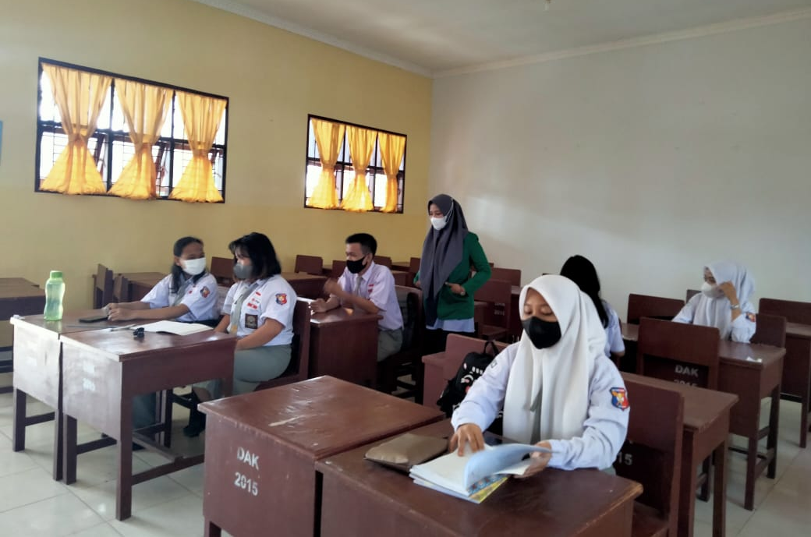

Gambar 1…

Gambar 1.
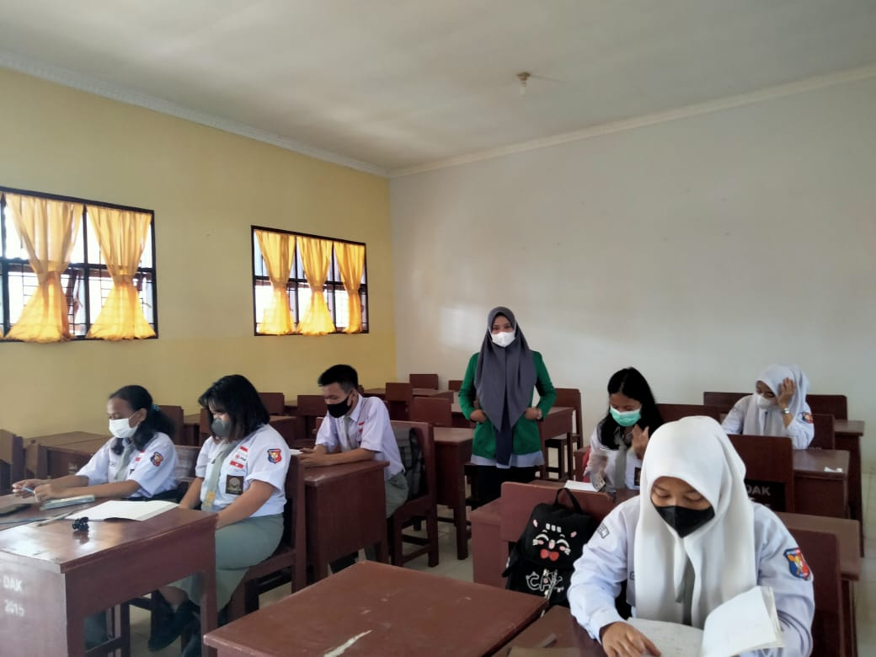

Gambar 2

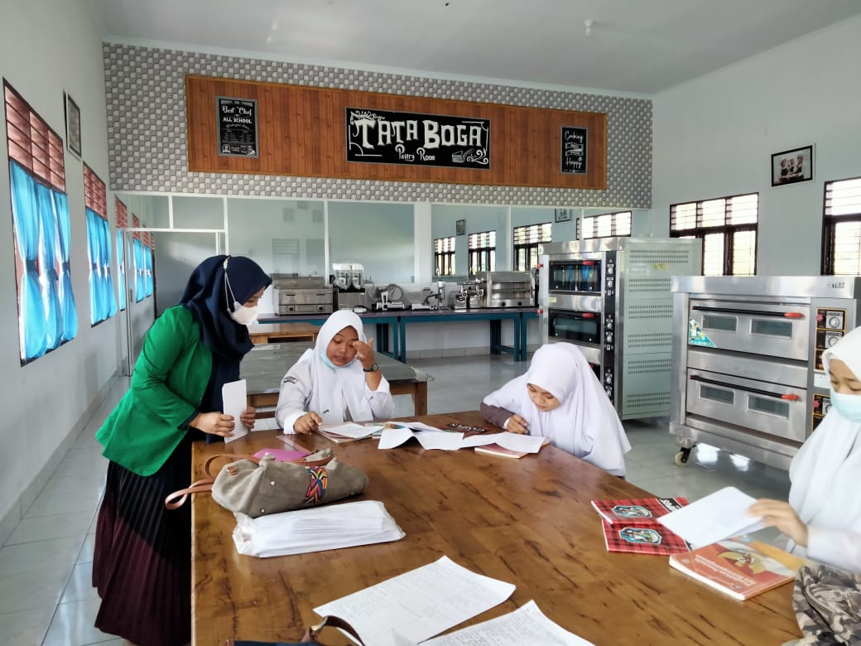

Gambar 3.
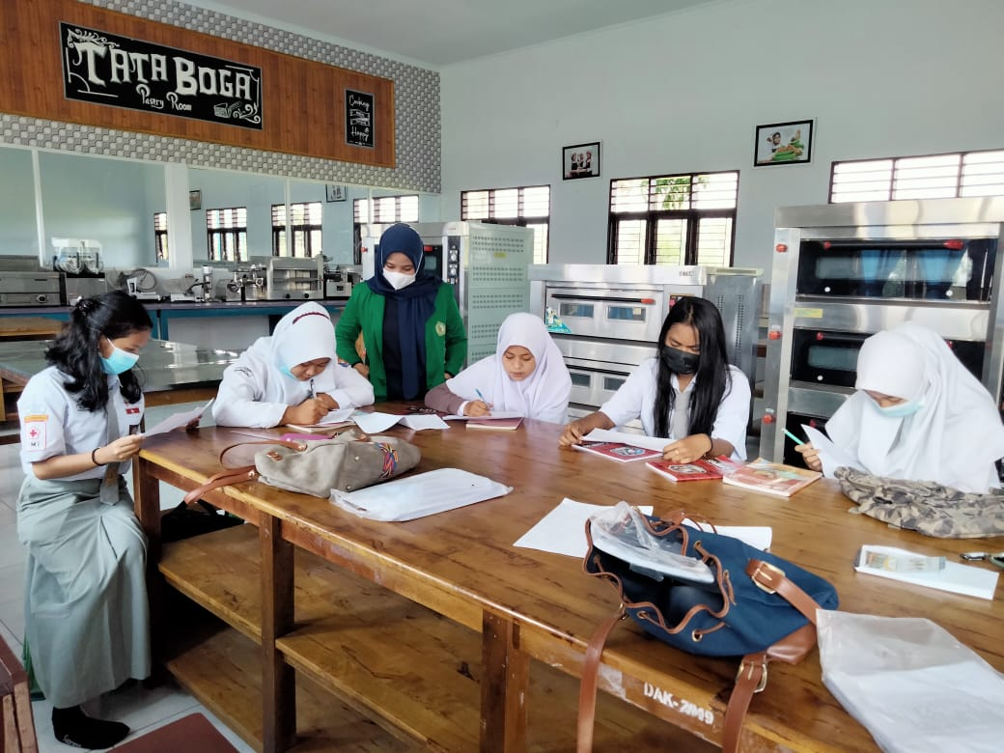

Gambar 4.

