PENGARUH PEMBERIAN EKSTRAK DAUN BINAHONG (Anredera cordifolia (Ten.) Steenis) TERHADAP
TOKSISITAS AKUT DAN HISTOPATOLOGI
GINJAL MENCIT JANTAN
(Mus musculus)

SKRIPSI

OLEH :

FENNI DWI HARSIKA
NPM. 152114052

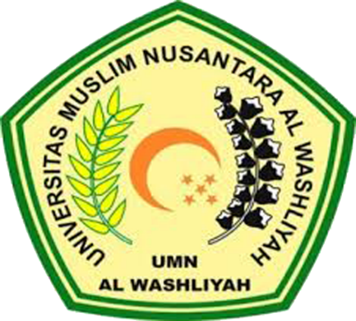

PROGRAM STUDI SARJANA FARMASI
FAKULTAS FARMASI
UNIVERSITAS MUSLIM NUSANTARA AL-WASHLIYAH
MEDAN
2019
PENGARUH PEMBERIAN EKSTRAK DAUN BINAHONG (Anredera cordifolia (Ten.) Steenis) TERHADAP
TOKSISITAS AKUT DAN HISTOPATOLOGI
GINJAL MENCIT JANTAN
(Mus musculus)

SKRIPSI

Skripsi Ini Diajukan Untuk Melengkapi Dan Memenuhi Syarat-Syarat Untuk Memperoleh Gelar Sarjana Jurusan Farmasi Program Studi Farmasi Fakultas Farmasi Universitas Muslim Nusantara Al-Washliyah

OLEH :

FENNI DWI HARSIKA
NPM. 152114052

PROGRAM STUDI SARJANA FARMASI
FAKULTAS FARMASI
UNIVERSITAS MUSLIM NUSANTARA AL-WASHLIYAH
MEDAN
2019
THE EFFECT OF GIVING BINAHONG LEAF EXTRACT
(Anredera cordifolia (Ten.) Steenis) AGAINST
ACUTE TOXICITY AND HISTOPATHOLOGY
KIDNEY OF MALE MOUSE
(Mus musculus)

FENNI DWI HARSIKA
NPM.15214052

ABSTRACT

Toxicity test is carried out as a preclinical test to identify the safety of a drug compound. Binahong leaves are widely used by the community as traditional medicine because they contain natural chemical compounds in the form of flavonoids, saponins, alkaloids and others. The purpose of this study was to determine the toxicity of the leaf extract of Binahong (Anredera cordifolia (Ten.) Steenis) on the kidneys of male mice (Mus musculus) using the Weil C.S. method.
This research was conducted by means of sample identification, sampling, and sample management, characterization, phytochemical screening, extract preparation and toxicity test with post test only control group design using 30 mice divided into 6 groups randomly. The control group was given 0.5% CMC, the sequential treatment group was given extract at a dose of 5 mg/kgBW, 50 mg/kgBW, 500 mg/kgBW and 2000 mg/kgBW orally once a day and observed for 14 days. On the 15th day, surgery was performed and the kidneys were removed for histopathological examination of the kidneys. The LD50 calculation was carried out using the Weil C.S method and data analysis using SPSS 21.
Based on the research that has been done, the LD50 value obtained is 15.65 g/kgBB and is categorized as practically non-toxic. The dose that is toxic to the kidneys of mice is at a dose of 2000 mg/kgBW. The condition of the kidney of mice that experienced toxicity was the presence of cell damage that appeared in the form of hemorrhage, glomerular, fat degeneration, and narrowing of Bowman's capsule. The One Way ANOVA result is 0.211, which means the value is > 0.05. This shows that there is a difference in each treatment (there is a difference in weight in each animal).

Keywords: binahong leaf, toxicity, mice, histopathology, kidney organ

