Lampiran 1. Hasil Determinasi Tumbuhan
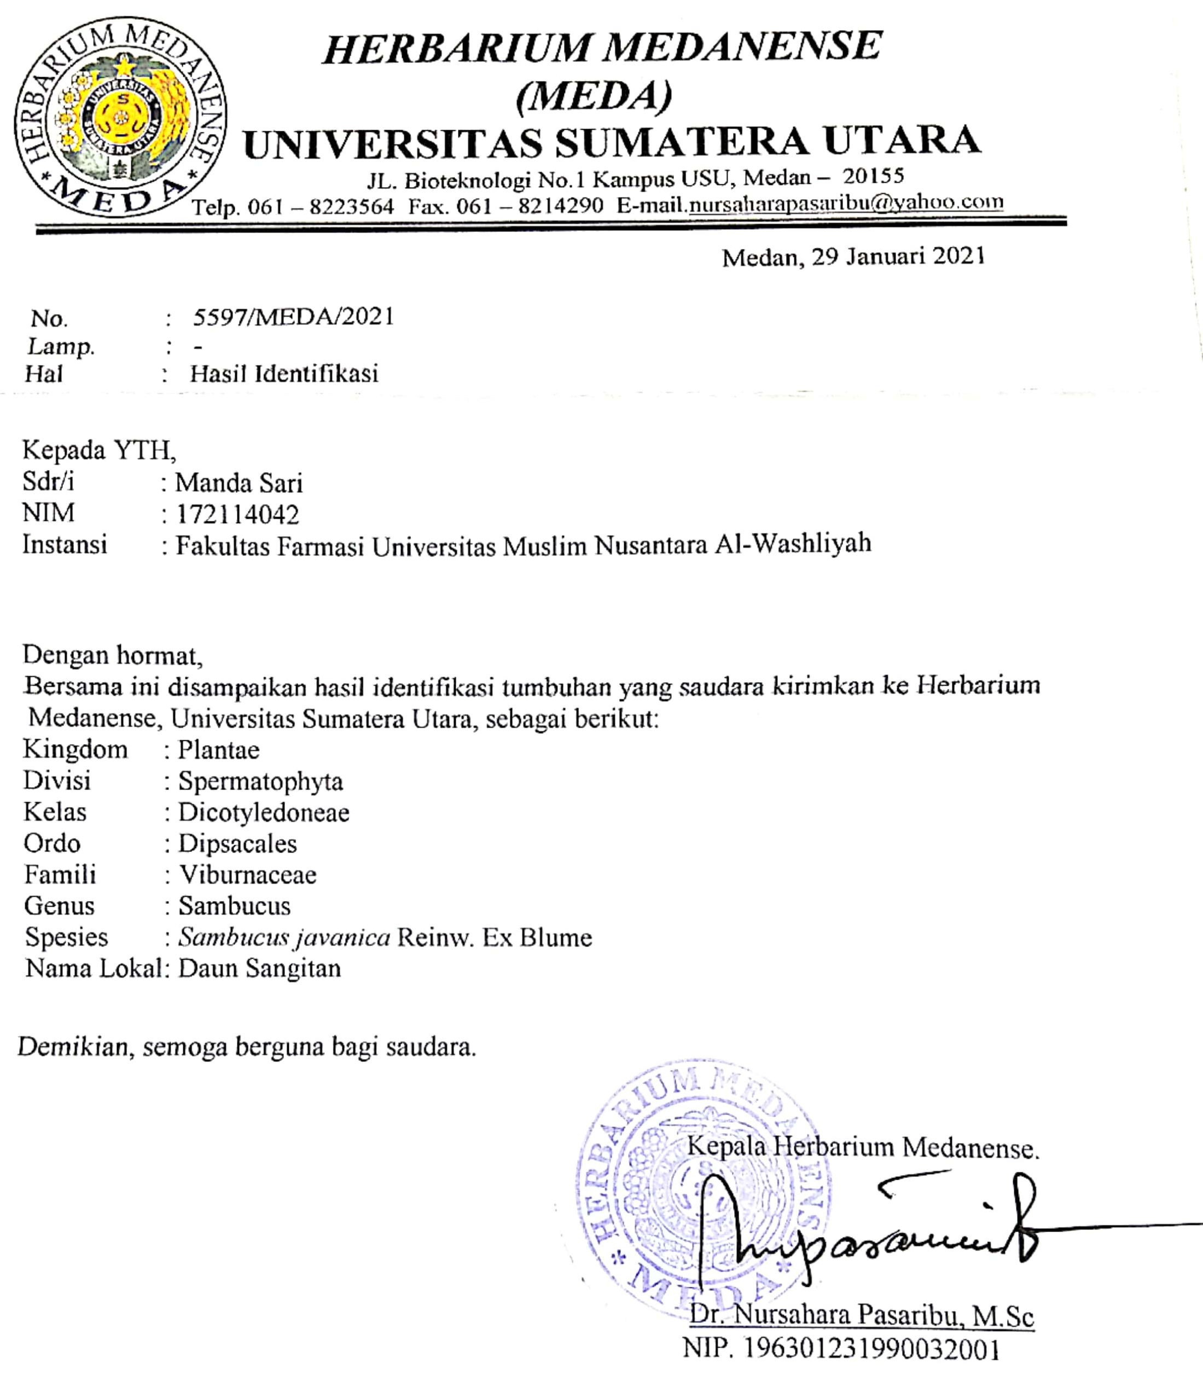

Lampiran 2. Ethical Clearance
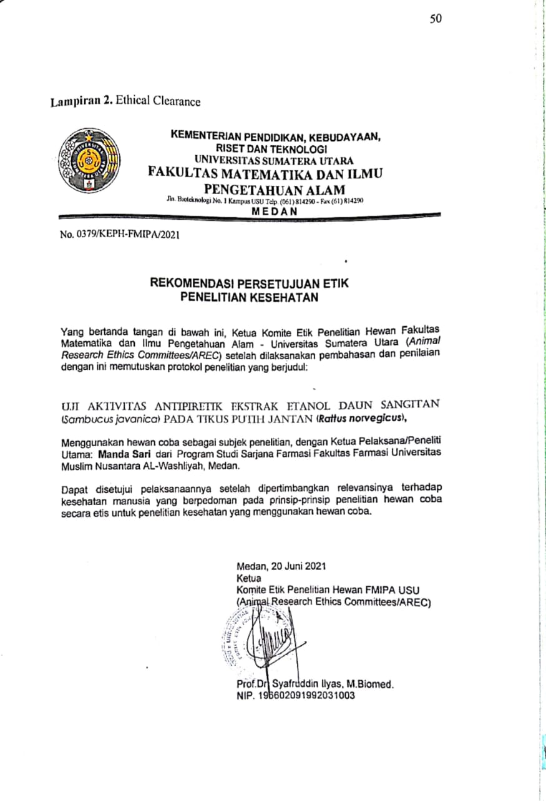

Lampiran 3. Daun sangitan, makroskopik daun sangitan dan serbuk daun Sangitan

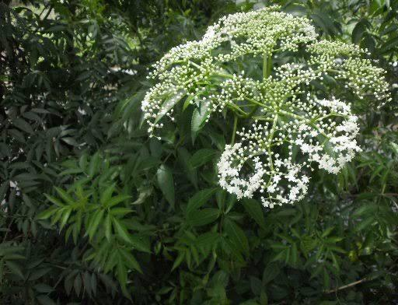

Tumbuhan Daun Sangitan

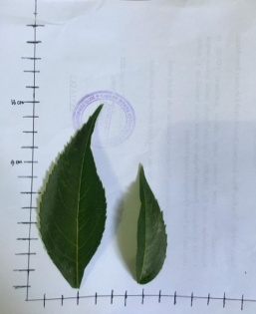

Tinggi Daun Sangitan

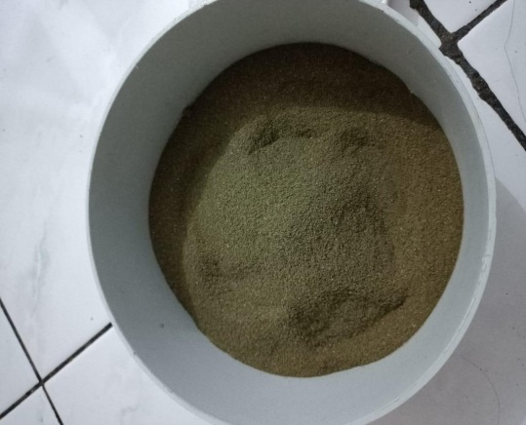

Serbuk Daun Sangitan

Lampiran 4. Hasil Meserasi, Ekstrak sangitan dan rotary

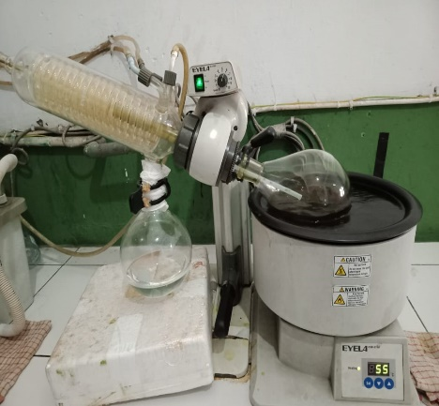

Proses Dalam Pembuatan Ekstrak (Rotary)

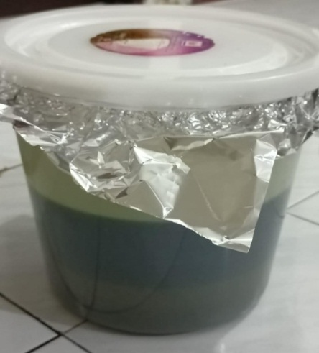

Maserat Daun Sangitan
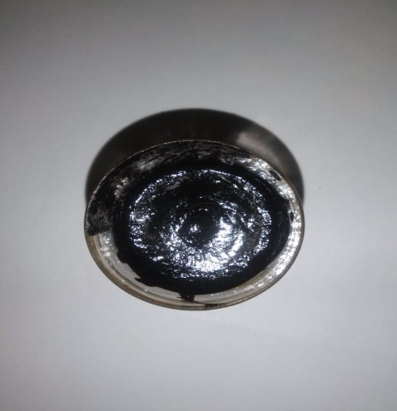

Ekstrak Etanol Daun Sangitan

Lampiran 5. Vaksin DPT HB (Penginduksi), Paracetamol Dan Termometer

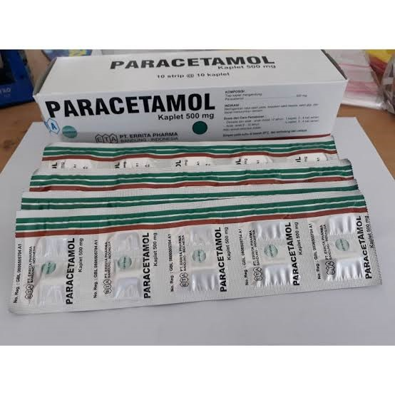
Vaksin DPT HB

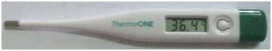
Paracetamol

Termometer

Lampiran 6. Hasil Pemeriksaan Mikroskopik Daun Sangitan

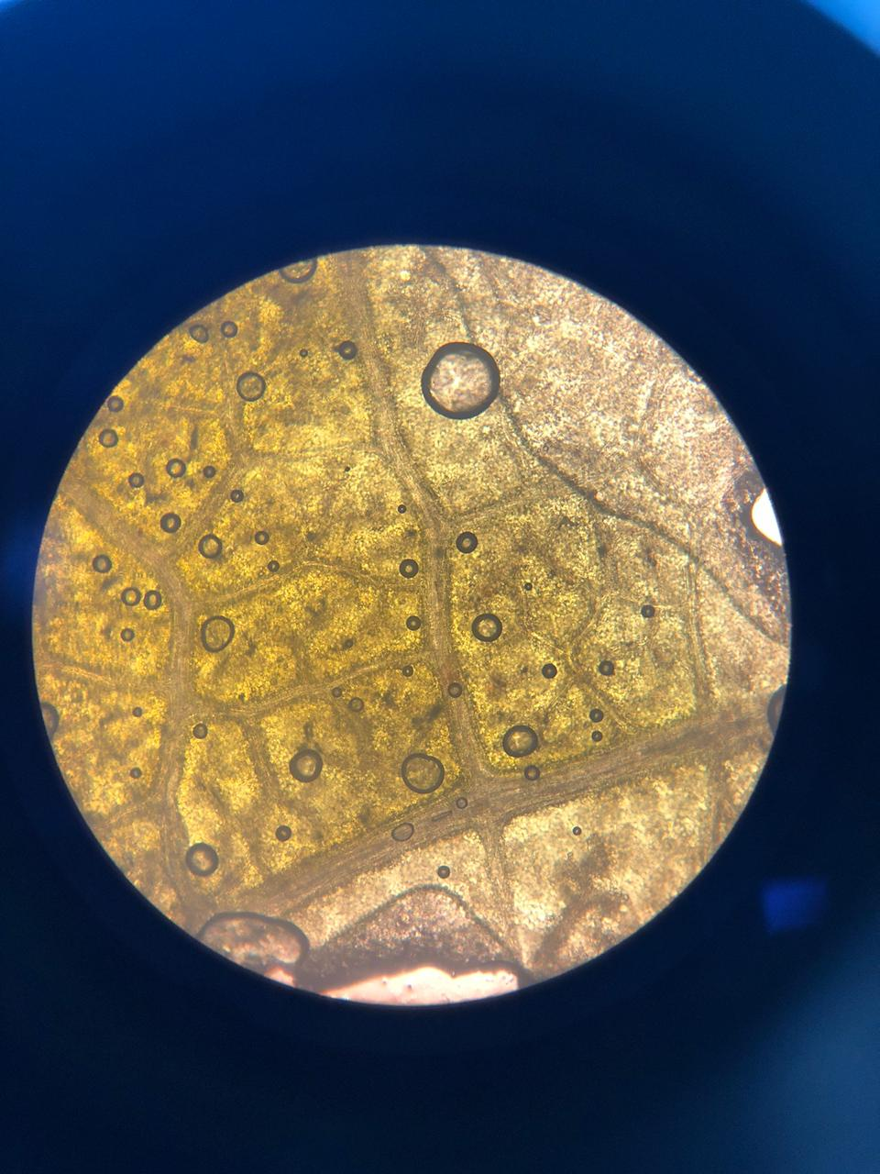
Sel Pidermisdaun Sangitan

Mikroskopik Daun Sangitan
Keterangan
- Sel epidermis Daun Sangitan

Lampiran 7. Skrining Fitokimia Serbuk Simplisia
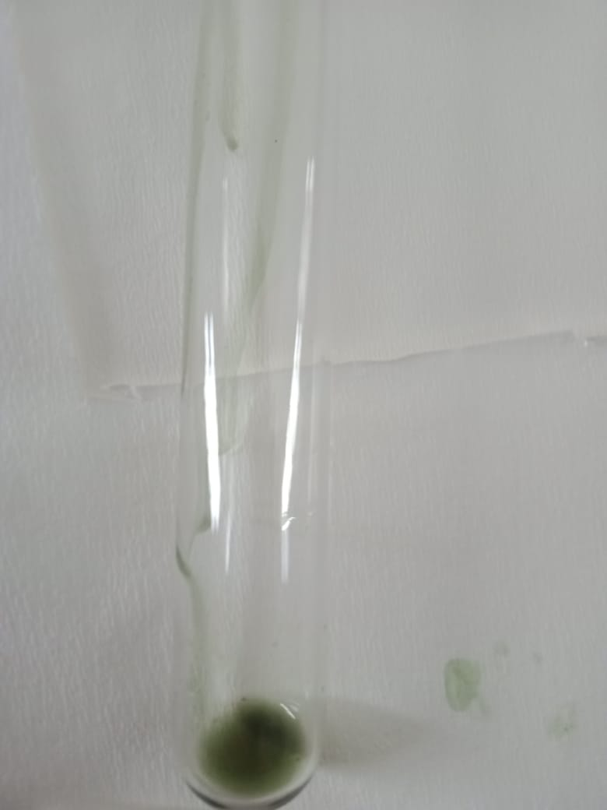
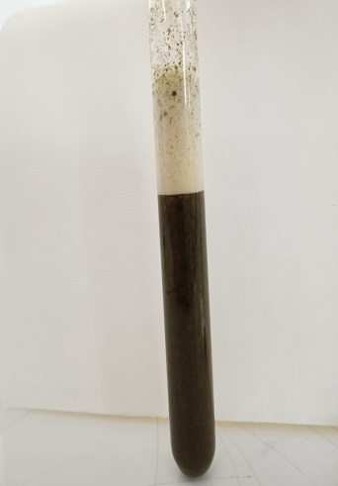

Steroid/Triterpernoid
Tanin
Saponin
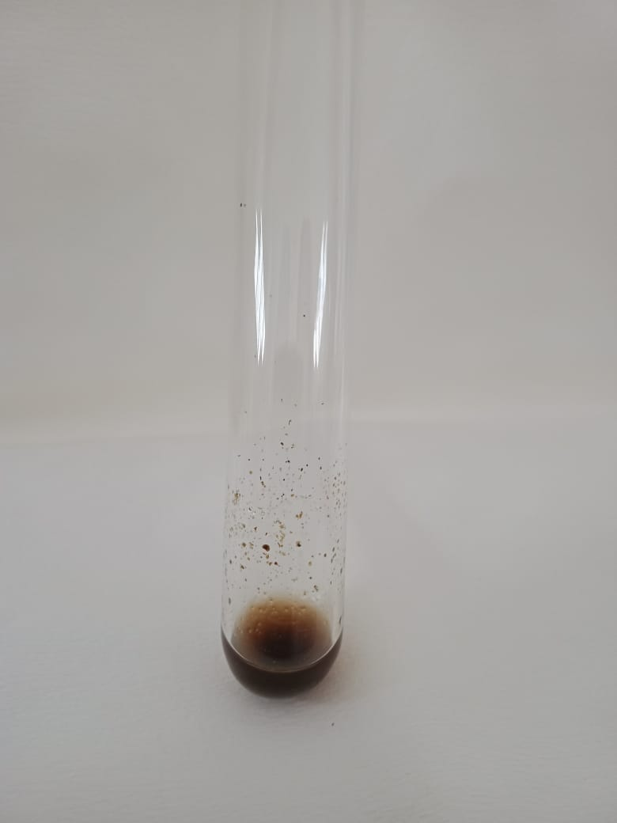
Alkaloid
Flavanoid

Lampiran 8. Skrining Fitokimia Ekstrak Simplisia

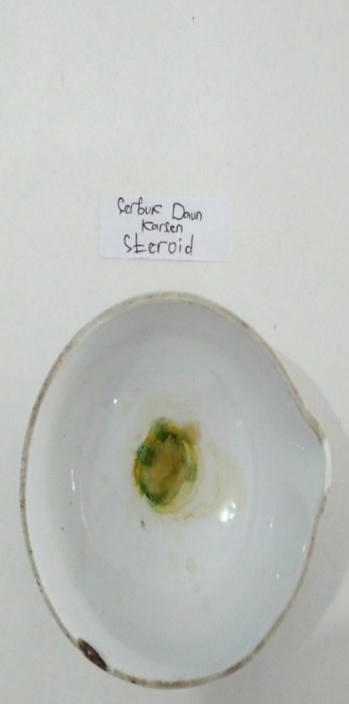
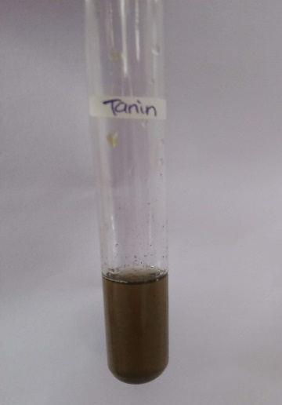
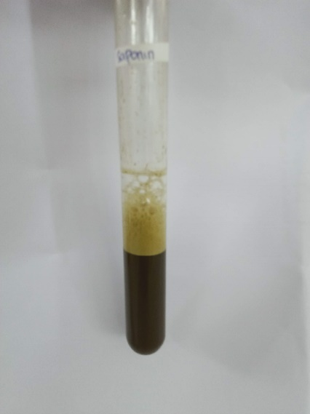

Steroid/Triterpernoid
Tanin

Saponin

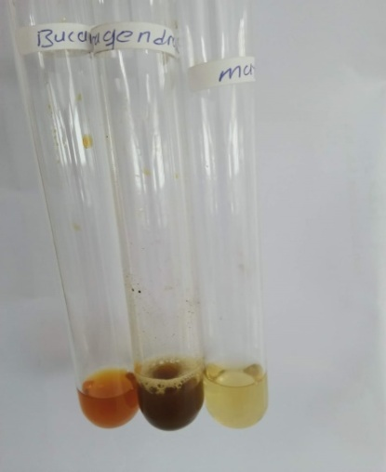
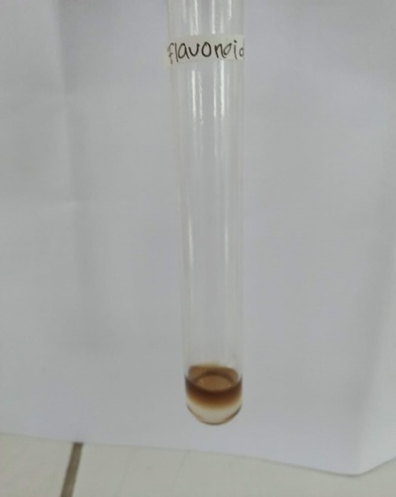

Alkaloid
Flavanoid

Lampiran 9. Karakterisasi Simplisia

- Penetapan kadar air simplisia
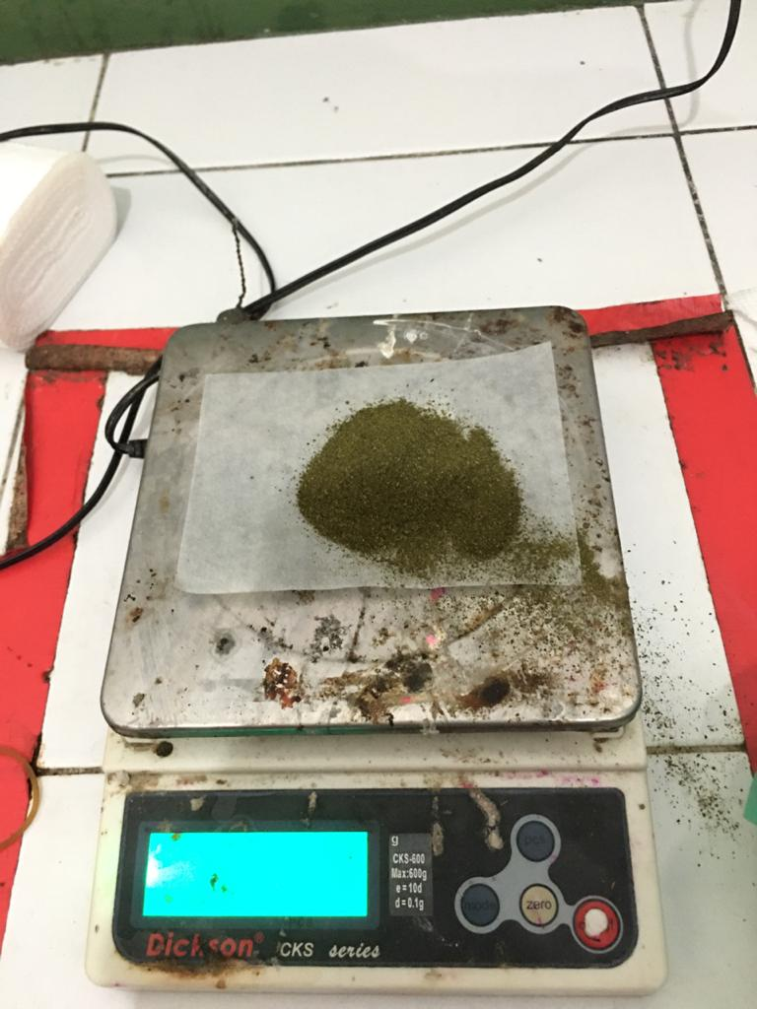

Proses penimbangan sampelAzeotrop

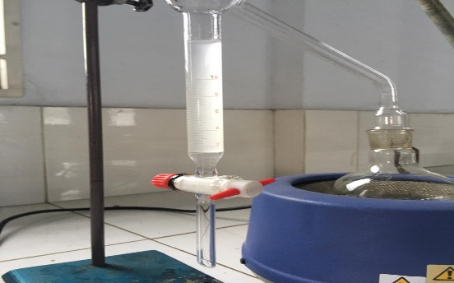
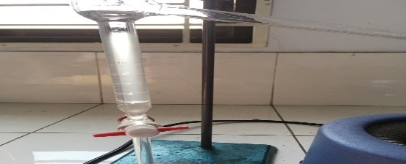

Volume Akhir
Volume Awal

Lampiran 9. (Lanjutan)

- Penetapan Kadar Sari Yang Larut Dalam Etanol
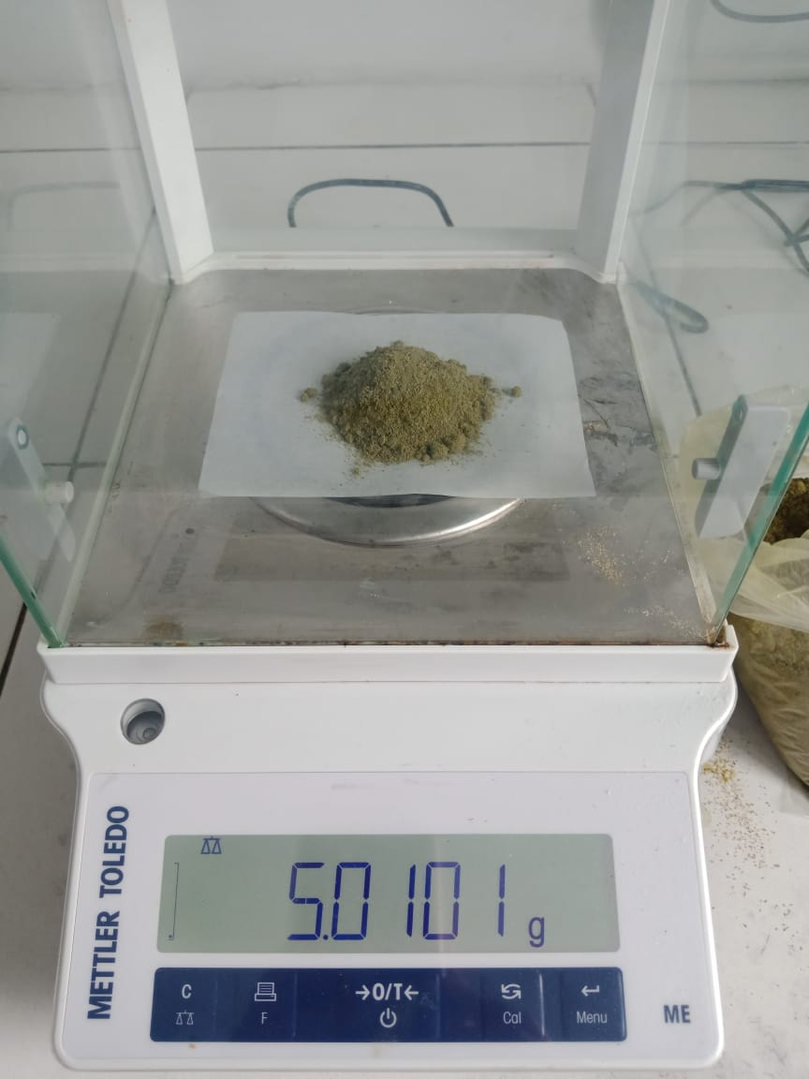

Proses penimbangan sampel
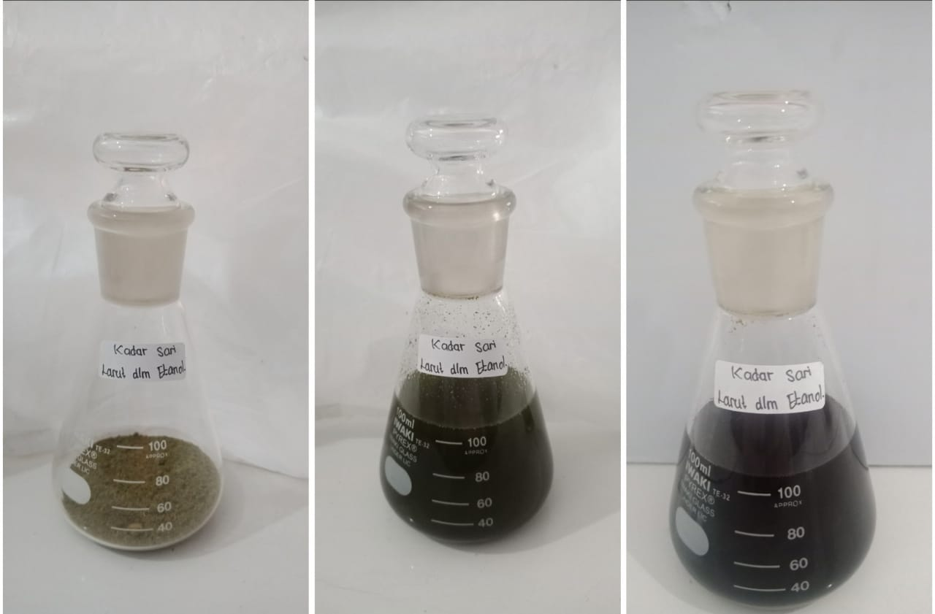

Proses Maserasi

Lampiran 9. (Lanjutan)
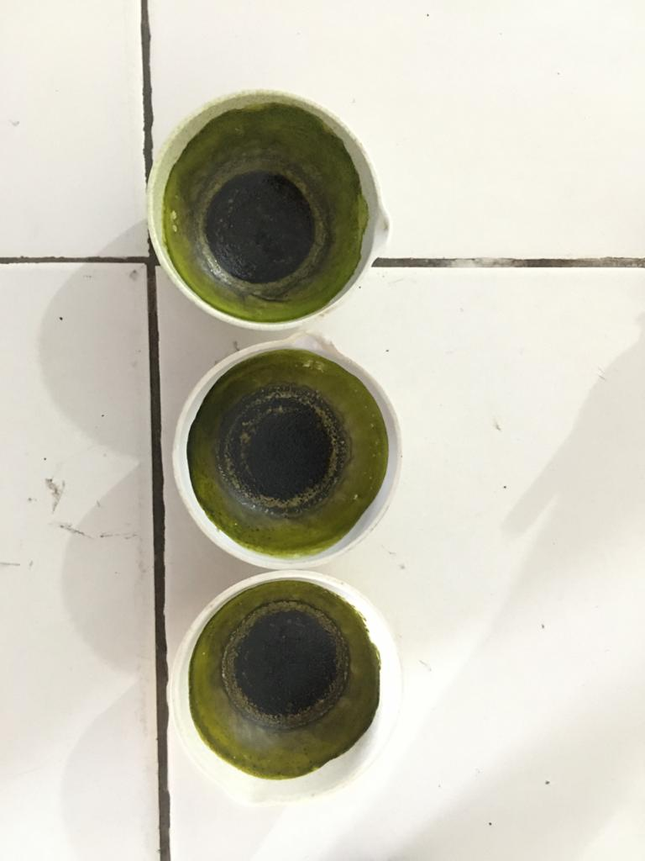

Setelah diuapkan
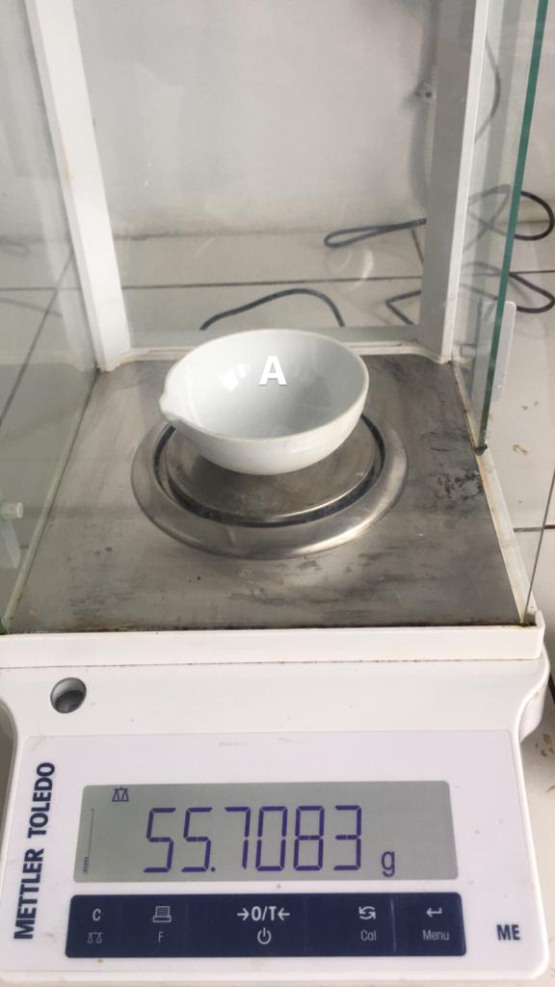
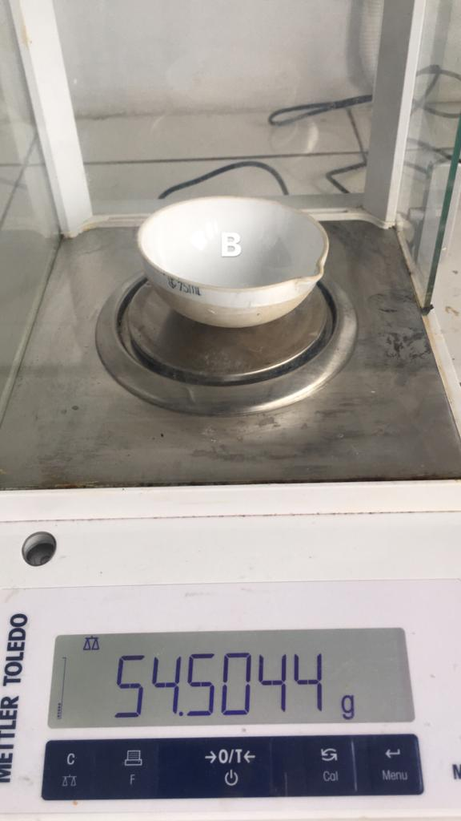
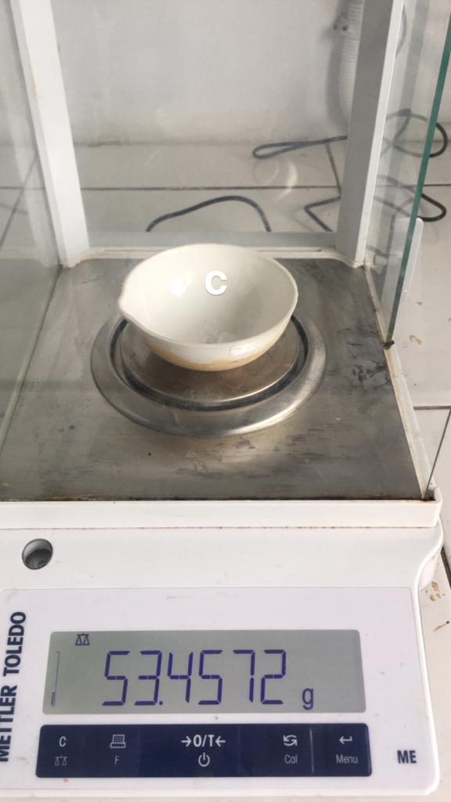

Penimbangan Cawan Kosong
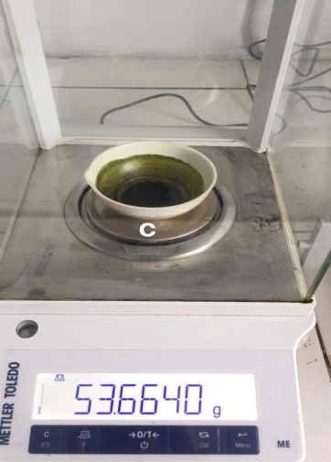
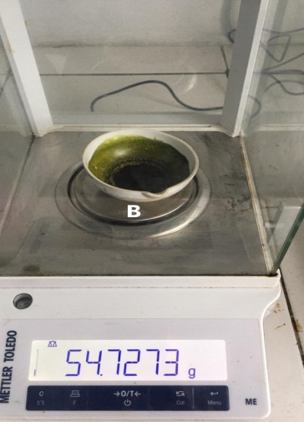
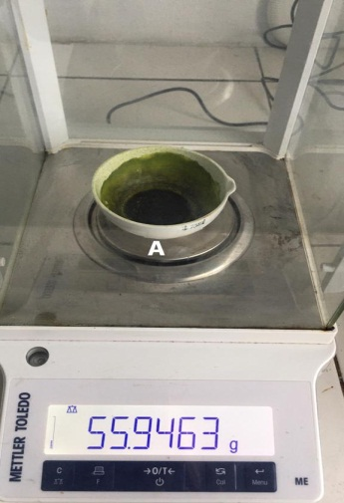

Penimbangan Cawan Isi
Lampiran 9. (Lanjutan)

    - Penetapan Kadar Sari Yang Larut Dalam Air
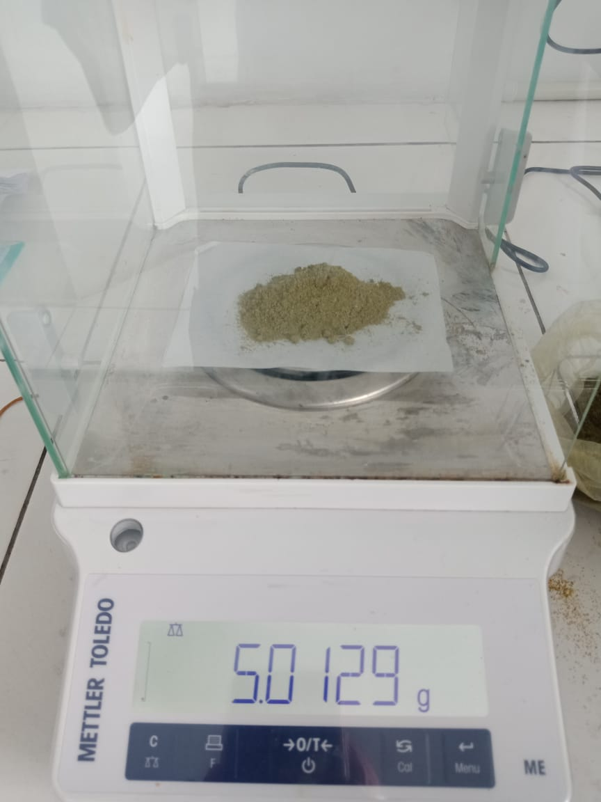

Proses penimbangan sampel

Setelah Penguapan

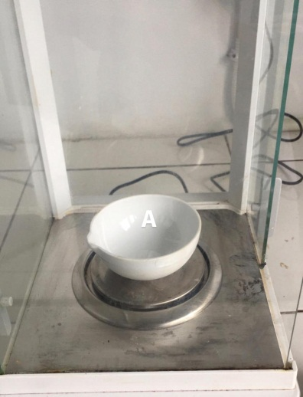
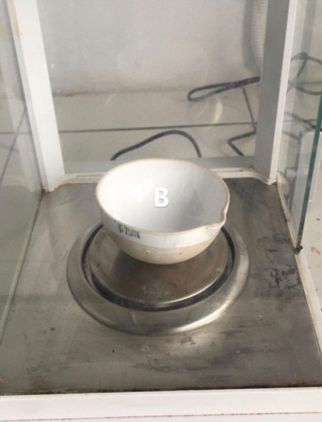
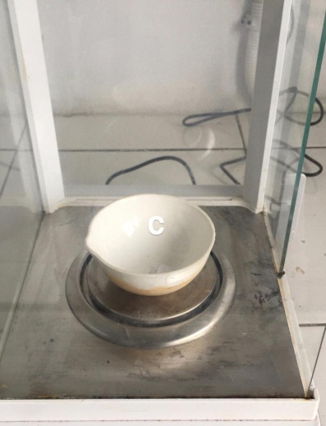

Penimbangan cawan kosong
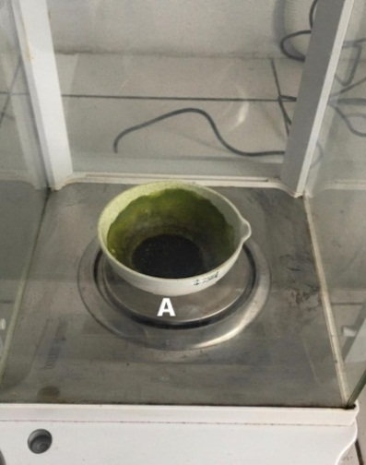
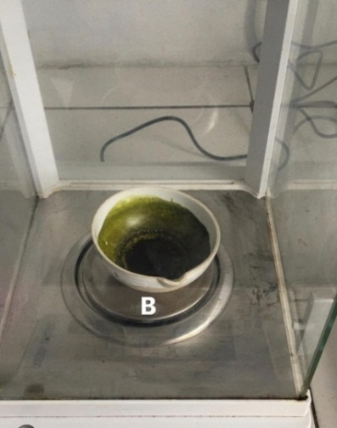
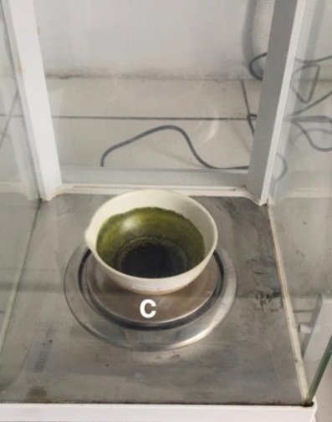

Penimbangan cawan isi
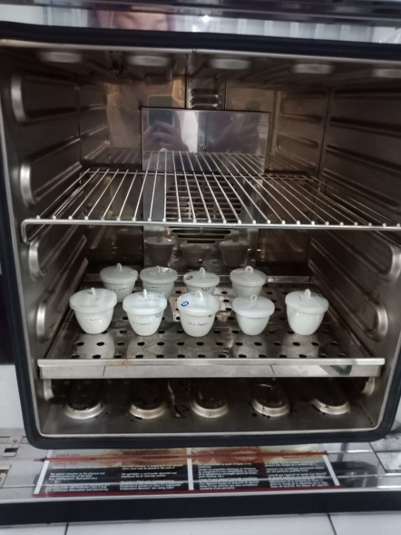

Peoses sterilisasi

Lampiran 9. (Lanjutan)

    - Penetapan Kadar Abu Total
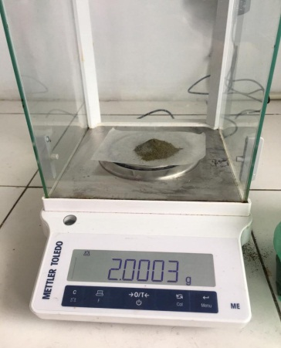

Peoses penimbangan sampel
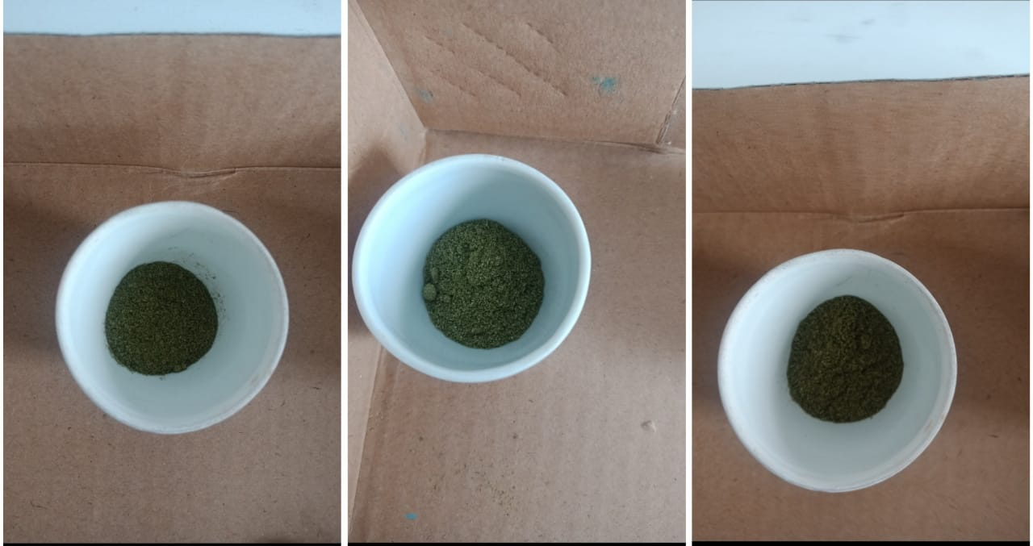

Sampel setelah didalam krus
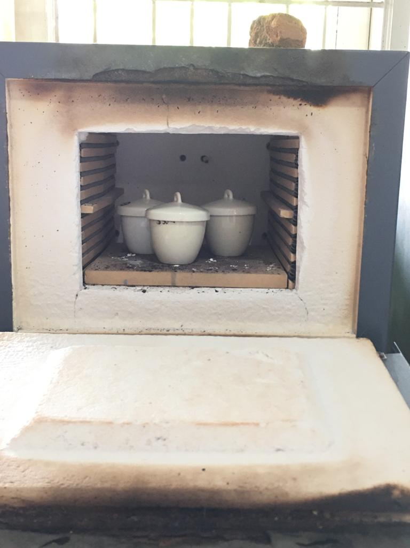

Proses Pengabuan
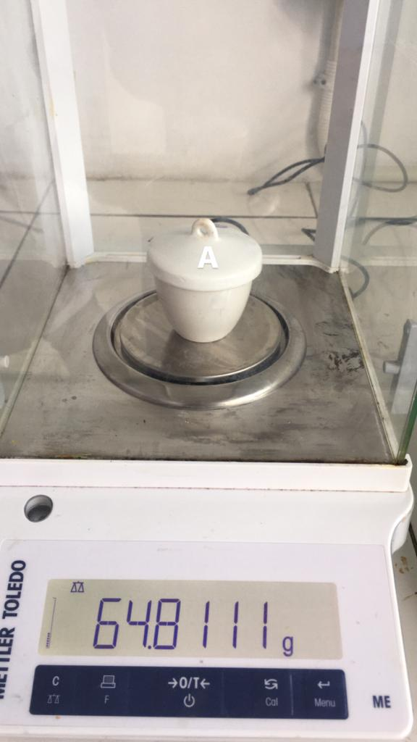
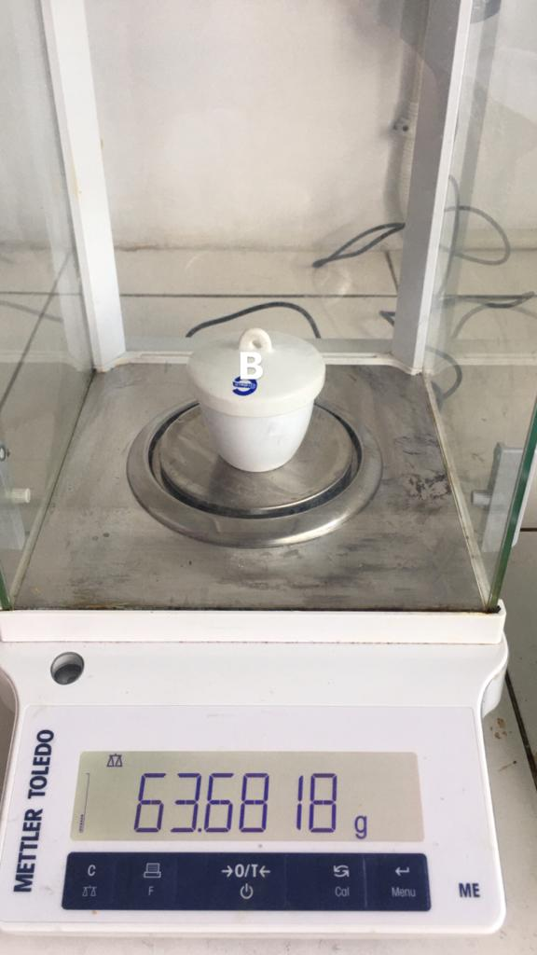
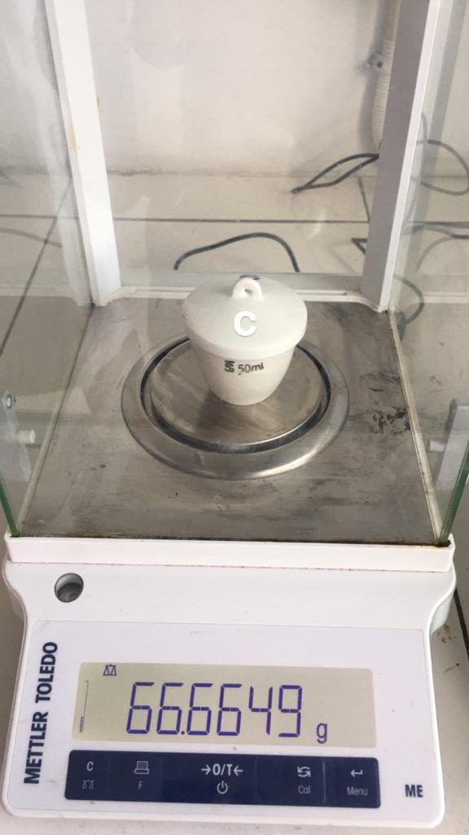

Penimbangan krus kosong

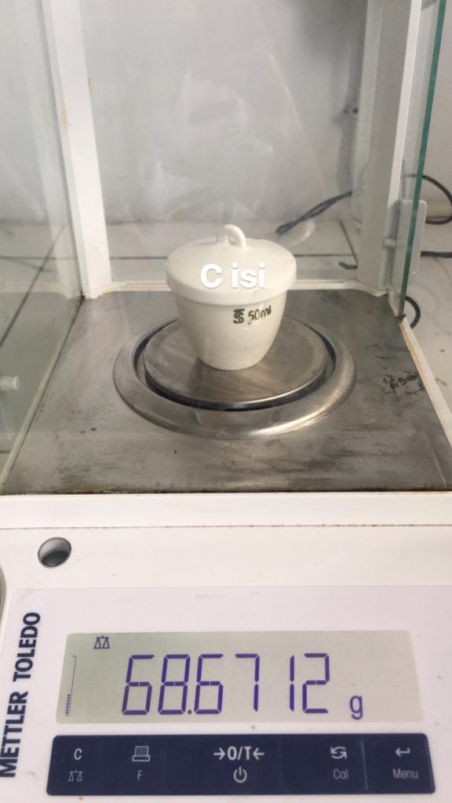
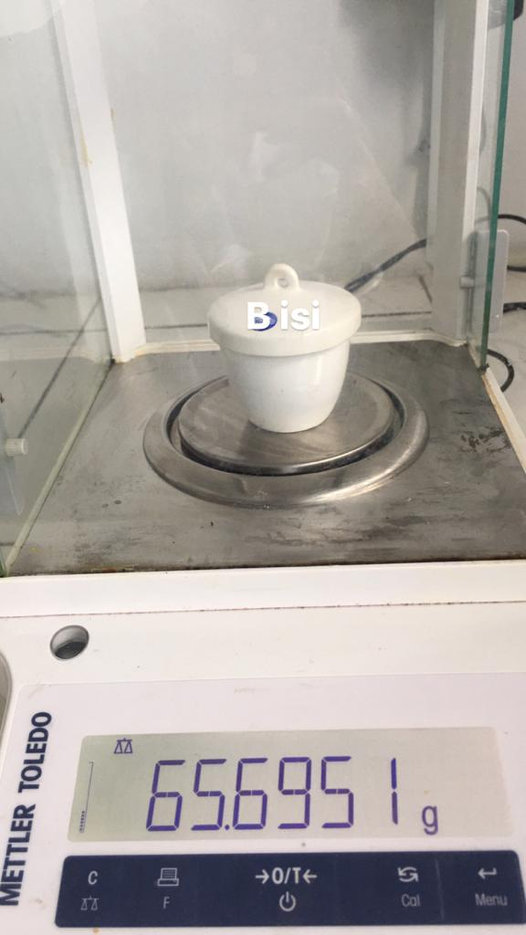
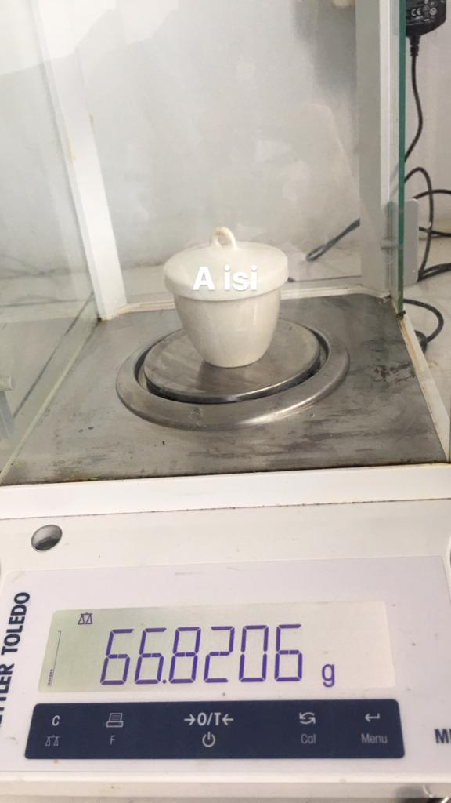

Penimbangan Krus Isi

    - Penetapan Kadar Abu Yang Tidak Larut Dalam Asam
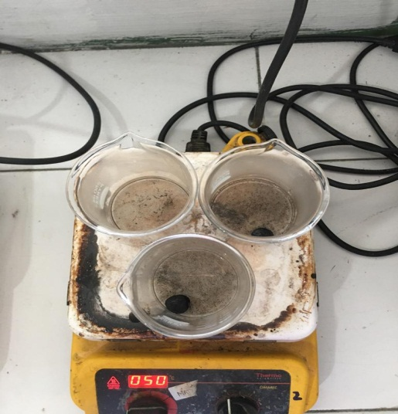
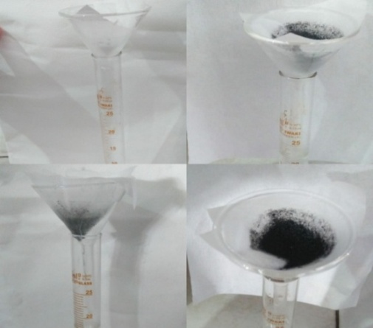

Proses pemanasan dengan HCl Proses penyaringan

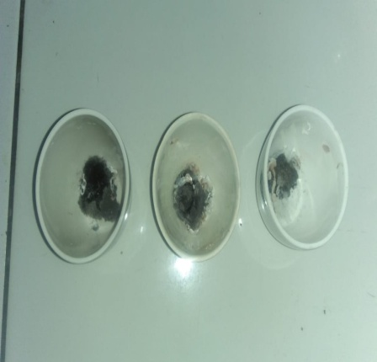
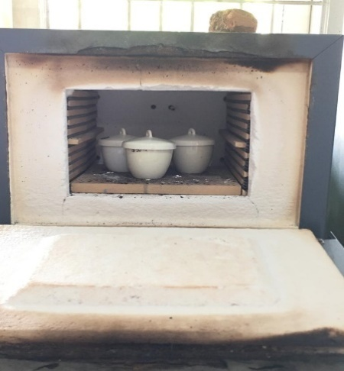

Proses pemasukan kembali kedalam tanur Proses setelah pengabuan

Penimbangan Krus Kosong
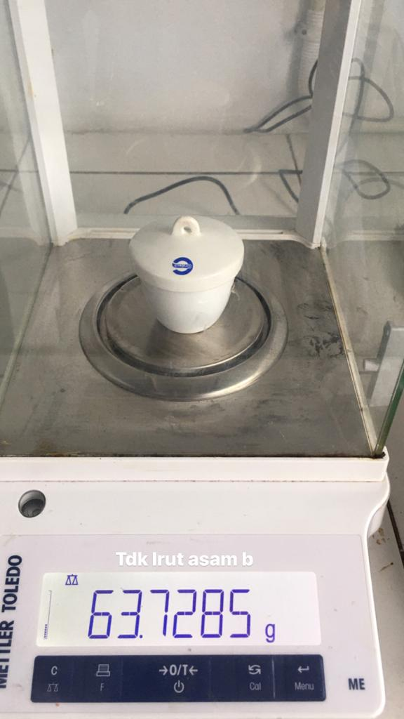
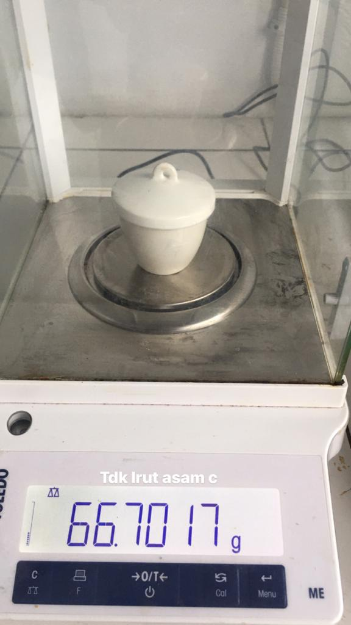
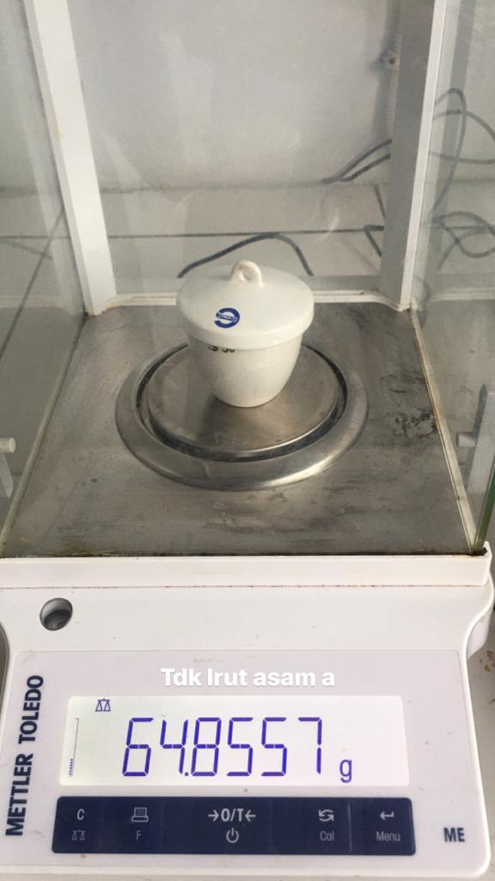

Penimbangan Krus Isi
Lampiran 10. Perhitungan Hasil Karakterisasi Simplisia Daun Sangitan

- Penetapan Kadar Air
$$Kadar Air = \frac{Volume Akhir-Volume Awal}{Berat Sampel} x 100\%$$
Sampel 1
Berat Sampel = 5 g
Volume awal = 2,2 ml
Volume akhir = 2,5 ml
$$\% Kadar Air =\frac{2,5 ml-2,2 ml}{5 gram} x 100\% = 6\%$$
- Penetapan Kadar Abu Total
$$Kadar Abu= \frac{Berat Abu}{Berat Sampel}x100\%$$

Sampel 1
Berat sampel = 2,000 g
Berat Abu = 0,29 g
$$\% Kadar Abu Total=\frac{0,29 g}{2 gram}x100\% = 14,5\%$$

Sampel 2
Berat sampel = 2,000 g
Berat Abu = 0,234 g
$$\% Kadar Abu Total=\frac{0,234 g}{2 gram}x100\%= 11,7 \%$$
Sampel 3
Berat sampel = 2,000 g
Berat Abu = 0,187 g
$$\% Kadar Abu Total= \frac{0,187 g}{2 gram}x100\%= 9,35 \%$$

$$\% Kadar Abu Total rata-rata= \frac{14,5\%+11,7\%+9,35\%}{3}= 11,85 \%$$

- Penetapan Kadar yang tidak larut dalam Asam
$$Kadar Abu yang tidak larut dalam asam=\frac{Berat Abu}{Berat Simplisia}x100\%$$
Sampel 1
Berat sampel = 2,000 g
Berat Abu = 0,044 g
$$\% Kadar Abu yang tidak larut asam= \frac{0,044 g}{2 gram}x100\%= 2,2 \%$$

Sampel 2
Berat sampel = 2,000 g
Berat Abu = 0,047 g
$$\% Kadar Abu yang tidak larut asam= \frac{0,047 g}{2 gram}x100\%= 2,35 \%$$

Sampel 3
Berat sampel = 2,000 g
Berat Abu = 0,037 g
$$\% Kadar Abu yang tidak larut asam= \frac{0,037 g}{2 gram}x100\%= 1,85 \%$$

$$\% Kadar Abu yang tidak larut asam rata-rata= \frac{2,2\%+2,35\%+1,85\%}{3}= 2,133 \%$$

- Kadar Sari Larut dalam Air
$$\% Kadar Sari Larut dalam Air= \frac{Berat Sari}{Berat Simplisia}x \frac{100}{20} x100\%$$
Simplisia 1
Berat Simplisia = 5 g
Berat Sari = 0,9 g
$$\% Kadar Sari Larut dalam Air=\frac{0,09 g}{5 g}x \frac{100}{20} x100\%= 9 \%$$

Simplisia 2
Berat Simplisia = 5 g
Berat Sari = 0,038 g
$$\% Kadar Sari Larut dalam Air=\frac{0,038 g}{5 g} x \frac{100}{20} x100\%= 3,8 \%$$

Simplisia 3
Berat Simplisia = 5 g
Berat Sari = 0,051 g
$$\% Kadar Sari Larut dalam Air=\frac{0,051 g}{5 g}x \frac{100}{20} x100\% = 5,1 \%$$

$$\% Kadar Sari Larut dalam Air rata-rata=\frac{9\%+3,8\%+5,1\%}{3}= 5,966 \%$$

- Kadar Sari Larut dalam Etanol
$$\% Kadar Sari Larut dalam Etanol=\frac{Berat Sari}{Berat Simplisia}x \frac{100}{20} x100\%$$
Simplisia 1
Berat Simplisia = 5 g
Berat Sari = 0,238 g
$$\% Kadar Sari Larut dalam Etanol=\frac{0,238 g}{5 g}x \frac{100}{20} x100\% = 23,8 \%$$

Simplisia 2
Berat Simplisia = 5 g
Berat Sari = 0,223 g
$$\% Kadar Sari Larut dalam Etanol=\frac{0,223 g}{5 g}x \frac{100}{20} x100\% = 22,3 \%$$

Simplisia 3
Berat Simplisia = 5 g
Berat Sari = 0,207 g
$$\% Kadar Sari Larut dalam Etanol=\frac{0,207g}{5 g}x \frac{100}{20} x100\% = 20,7 \%$$

$$\% Kadar Sari Larut Dalam etanol rata-rata=\frac{23,8\%+22,3\%+20,7\%}{3}= 22,26 \%$$

Lampiran 11. Bagan Alir Penelitian, Bagan Pembuatan Simplisia, Bagan Alir Pembuatan Ekstrak Dan Bagan Alir Uji Efektivitas Antipiretik

- Bagan Alir Penelitian
Daun Sangitan Segar
Dibersihkan dari pengotor
Dicuci bersih dan ditiriskan
Diangin-anginkan

Daun Sangitan
Dikeringkan pada suhu 40ºC
Ditimbang
Simplisia kering
Dihaluskan
Ditimbang Ditimbang
Serbuk simplisia

Karakterisasi Sampel

Dibuat Ekstrak

- Penetapan kadar air
- Penetapan kadar abu
- Penetapan kadar abu tidak larut asam
- Penetapan kadar sari larut dalam air
- Penetapan kadar sari larut dalam etanol

DiMaserasi denganetanol 96%
Perkolat

Diuapkan dengan rotary evaporator

Perkolat

Suspensi Daun
Sangitan

Skrining
Fitokimia

Uji efektivitas antipiretik pada tikus putih jantan

- Alkaloid
- Flavonoid
- Steroid/Triterpenoid
- Saponi
- Tanin

Lampiran 11. (Lanjutan)

- Bagan Alir Pembuatan Simplisia

Daun Sangitan

Dimasukkan kedalam wadah tertutup rapat
Berat serbuk simplisia 700 g

Ditimbang
Dihaluskan menggunakan blender
Berat simplisia
5.000 kg
Ditimbang
Disortasi kering
Dikeringkan di dalam lemari pengering pada suhu ± 40ºC
Berat Daun Sangitan setelah dirajang
Ditimbang
Dirajang
Diangin-anginkan
Ditiriskan
Dicuci dengan air mengalir
Dikeringkan pada suhu 40ºC

Serbuk simplisia

Lampiran 11. (Lanjutan)

- Bagan Alir Pembuatan Ekstrak
Skrining fitokimia
- Alkaloid
- Flavonoid
- Saponin
- Tanin
- Steroid/triterpenoid

Pengujian efektivitas antipiretik terhadap tikus putih jantan
Suspensi EEDS

Ekstrak kental

Diekstraksi dengan cara dimaserasi menggunakan pelarut
500 g Serbuk Simplisia Daun Sangitan

Karakterisasi simplisia
- Makroskopi
- Mikroskopik
- PK Air
- PK sari larut dalam etanol
- PK sari larut dalam air
- 6.PK abu total
- PK tidak larut dalam asam

4.PK

Lampiran 11. (Lanjutan)
- Bagan Alir Pengujian Farmakologi
25 ekor tikus putih jantan
Dipuasakan ± 18 jam
Kelompok 2
( 5 ekor )
Kelompok 5
( 5 ekor )
Pengukuran suhu awal
Kelompok 1
(5 ekor )
Kelompok 4
( 5 ekor )
Kelompok 3
( 5 ekor )
Pengukuran suhu awal 1 jam setelah pemberian vaksin DTP-HB
Diberi EEDS 300 mg/kg BB
Diberi EEDS 100 mg/kg BB
Kontrol negatif diberi suspensi CMC 0,5%
Diberi EEDS 200 mg/kg BB
kontrol positif diberi suspensi parasetamol 0,5%
Analisis data
Pengukuran suhu rektak dilakukan setiap 30 menit selama 3 jam
Lampiran 12. Perhitungan Dosis
- Perhitungan dosis CMC 0,5%
CMC 0,5% = jumlah cmc / volume suspensi
= 0,5 g / 100 ml
= 500 mg / 100 ml
= 5 mg / ml
Perhitungan CMC 0,5% pada tikus dengan BB = 200 g
$$=\frac{50}{100}X 200 g$$
= 1 ml

- Perhitungan dosis parasetamol
Konversi dosis parasetamol dari manusia (70 kg) ke tikus (200 g) = 0,018
Dosis parasetamol untuk manusia dewasa dengan BB (70 kg) = 500 mg
Maka dosis parasetamol pada tikus = dosis terapi manusia x 0,018
= 500 mg x 0,018
= 9 ml
Tikus 200 g 0,2 kg
$$=\frac{9 mg}{0,2 kg}$$
= 45 mg / kg BB

Konsentrasi suspensi parasetamol
Suspensi parasetamol 0,5% = jumlah parasetamol / volume suspensi
= 5 g / 100 ml
= 500 mg / 100 ml
= 5 mg / ml

Lampiran 12. (Lanjutan)
Dosis untuk tikus = Dosis parasetamol X BB tikus
= 45 mg x 0,2 kg
= 9 ml
$$Volume suspense yang diambil =\frac{dosis parasetamol untuk tikus}{Konsentrasi suspense parasetamol}$$

$$=\frac{9 mg}{5 mg / ml}= 1,8 ml$$
- Perhitungan dosis EEDS 100 mg/kg
- Konsentrasi suspense EEDS
Konsentrasi EED 2% = jumlah EEDS / volume suspense
= 2000 mg /100 ml
= 20 mg/ml
- BB tikus 200 g atau 0,2 kg
- Perhitungan dosis 100 mg/kg BB
$$=\frac{100}{1000}x200 g$$
= 20 mg
$$Volume suspensi yang diberikan=\frac{Dosis EEDS}{Konsentrasi}$$
$$=\frac{20 mg}{20 mg/ml}= 1 ml$$

- Perhitungan dosis EEDS 200 mg/kg BB
- Konsentrasi suspensi EEDS
Konsentrasi EEDS 2% = jumlah EEDS / volume suspense
= 2000 mg / 100 ml
= 20 mg/ml
- BB tikus 200 g atau 0,2 kg
- Perhitungan dosis 100 mg/kg BB

Lampiran 12. (Lanjutan)

$$=\frac{200 mg}{1000 g}= X 200 g$$
$$=40 mg$$
$$Volume suspensi yang diberikan=\frac{Dosis EEDS}{Konsentrasi}$$
$$=\frac{40 mg}{20 mg/ml}= 2 ml$$

- Perhitungan dosis EEDS 300 mg/kg BB
- Konsentrasi suspensi EEDS
Konsentrasi EEDS 2% = jumlah EEDS / volume suspensi
= 2000 mg / 100 ml
= 20 mg/ml
- BB tikus 200 g atau 0,2 kg
- Perhitungan dosis 300 mg/kg BB
$$=\frac{300 mg}{1000 g}= X 200 g$$
= 60
$$Volume suspensi yang diberikan=\frac{Dosis EEDS}{Konsentrasi}$$
$$=\frac{60 mg}{20 mg/ml}= 3 ml$$

Lampiran 13. Data perlakuan hewan
Perlakuan | Hewan | Suhu awal | Suhu demam | Suhu rektal tikus (⁰C) selang 30 menit
 |  |  |  | 30 | 60 | 90 | 120 | 150 | 180
Kontrol Negatif CMC 0,5% | 1 | 37,9 | 38,1 | 37,1 | 37,8 | 37,5 | 37,3 | 37,2 | 37,1
 | 2 | 37 | 38,4 | 38,2 | 37,8 | 37,7 | 37,6 | 37,5 | 37,2
 | 3 | 36,8 | 38,2 | 37,8 | 37,7 | 37,5 | 37,4 | 37,2 | 37
 | 4 | 37,3 | 38,9 | 38,8 | 38,6 | 38,4 | 38,3 | 38,2 | 37,9
 | 5 | 37,5 | 38,6 | 38,5 | 38,4 | 38,1 | 37,8 | 37,6 | 37,2
Kontrol positif parasetamol | 1 | 37,1 | 38,1 | 37,9 | 37,7 | 37,6 | 37,4 | 37,2 | 37,1
 | 2 | 36,5 | 38,2 | 37,8 | 37,6 | 37,4 | 37,2 | 37,1 | 36,2
 | 3 | 37,6 | 38,8 | 38,5 | 38,2 | 38,1 | 37,7 | 37,5 | 37,3
 | 4 | 37,3 | 38,6 | 37,8 | 37,6 | 37,4 | 37,2 | 37,1 | 36
 | 5 | 36,2 | 38,3 | 38,1 | 37,9 | 37,7 | 37,5 | 37,3 | 37,1
EEDS 100 mg/kg BB | 1 | 36,2 | 38,3 | 38,1 | 37,9 | 37,7 | 37,6 | 37,5 | 37,3
 | 2 | 37,4 | 38,5 | 38,3 | 38 | 37,9 | 37,7 | 37,5 | 37,2
 | 3 | 36,8 | 38,6 | 38,5 | 38,3 | 37,8 | 37,6 | 37,4 | 37,1
 | 4 | 37,2 | 38,2 | 38 | 37,8 | 37,6 | 37,4 | 37,2 | 37
 | 5 | 37,1 | 38 | 37,8 | 37,6 | 37,5 | 37,4 | 37,3 | 37,6
EEDS 200 mg/kg BB | 1 | 37,2 | 38,2 | 38 | 37,8 | 37,7 | 37,5 | 37,3 | 36,6
 | 2 | 37,4 | 38,3 | 38 | 37,8 | 37,6 | 37,4 | 37,2 | 36,5
 | 3 | 36,5 | 38,1 | 37,9 | 37,7 | 37,5 | 37,3 | 37,1 | 36,2
 | 4 | 36,8 | 38 | 37,9 | 37,6 | 37,4 | 37,2 | 37 | 36,7
 | 5 | 37,1 | 38,1 | 37,6 | 37,5 | 37,2 | 37,2 | 37 | 36,8
EEDS 300 mg/kg BB | 1 | 37,1 | 38,1 | 37,8 | 37,6 | 37,3 | 37,2 | 3,9 | 36,7
 | 2 | 37,2 | 38,2 | 37,7 | 37,5 | 37,3 | 37,1 | 36,8 | 36,6
 | 3 | 36,8 | 38 | 37,5 | 37,3 | 37,1 | 36,7 | 36,5 | 36,2
 | 4 | 36,7 | 38,3 | 37,4 | 37,1 | 36,8 | 36,5 | 36,2 | 36
 | 5 | 37,3 | 38,4 | 37,5 | 37,3 | 37,1 | 36,4 | 36,2 | 36,1

Lampiran 14. Tabel Konversi Dosis (g).

Konvensi | Mencit  20 g | Tikus  200 g | Marmut  400 g | Kelinci  1,5 kg | Kucing  1,5 kg | Kera  4 kg | Anjing  12 kg | Manusia  70 kg
Mencit  20 g | 1,0 | 7,0 | 12,23 | 27,80 | 29,70 | 64,10 | 124,20 | 387,9
Tikus  200 g | 0,14 | 1,0 | 1,74 | 3,90 | 4,20 | 9,20 | 17,80 | 56,0
Marmut  400 g | 0,08 | 0,57 | 1,0 | 2,25 | 2,40 | 5,20 | 10,20 | 31,50
Kelinci  1,5 g | 0,04 | 0,25 | 0,44 | 1,0 | 1,08 | 2,40 | 4,50 | 14,20
Kucing  1,5 g | 0,03 | 0,23 | 0,41 | 0,92 | 1,0 | 2,20 | 4,10 | 13,0
Kera  4 kg | 0,016 | 0,11 | 0,19 | 0,42 | 0,43 | 0,1 | 1,9 | 6,1
Anjing  12 kg | 0,008 | 0,06 | 0,10 | 0,22 | 1,24 | 0,52 | 1,0 | 3,10
Manusia  70 kg | 0,0026 | 0,018 | 0,031 | 0,07 | 0,076 | 0,16 | 0,32 | 1,0

Lampiran 15. Tabel Volume Maksimum Lambung Pada Hewan (ml)
Jenis hewan  Uji | Volume maksimum ( ml) sesuai jalur pemberian
 | i.v | i.m | i.p | s.c | p.o
Mencit  (20-30 g) | 0,5 | 0,05 | 1,0 | 0,5-1,0 | 1,0
Tikus  (200 g) | 1,0 | 0,1 | 2-5 | 2-5 | 5,0
Hamster  (50 g) | - | 0,1 | 1-2 | 2,5 | 2,5
Marmut  (250 g) | - | 0,25 | 2-5 | 5,0 | 10,0
Kelinci  (3 kg) | 5-10 | 0,5 | 10-20 | 5-10 | 20,0
Kucing  (3kg) | 5-10 | 1,0 | 10-20 | 5-10 | 50,0
Anjing  (5 kg) | 10-20 | 5,0 | 20-50 | 10,0 | 100,0

Lampiran 16. Hasil SPSS, ANOVA, Dan DUNCAN
 | Perlakuan | Kolmogorov-Smirnovª |  |  | Shapiro-Wilk
 |  | Statistic | Df | Sig. | Statistic | df | Sig.
@To | CMC 0,5% | ,157 | 5 | ,200* | ,980 | 5 | ,937
 | PCT 0,5 % | ,209 | 5 | ,200* | ,948 | 5 | ,721
 | EEDS 100 Mg/Kg BB | ,234 | 5 | ,200* | ,917 | 5 | ,509
 | EEDS 200 Mg/Kg BB | ,211 | 5 | ,200* | ,965 | 5 | ,844
 | EEDS 300 Mg/kg BB | ,221 | 5 | ,200* | ,915 | 5 | ,501
Tinduksi | CMC 0,5% | ,173 | 5 | ,200* | ,958 | 5 | ,794
 | PCT 0,5 % | ,234 | 5 | ,200* | ,928 | 5 | ,585
 | EEDS 100 Mg/Kg BB | ,175 | 5 | ,200* | ,974 | 5 | ,899
 | EEDS 200 Mg/Kg BB | ,237 | 5 | ,200* | ,961 | 5 | ,814
 | EEDS 300 Mg/kg BB | ,136 | 5 | ,200* | ,987 | 5 | ,967
@30menit | CMC 0,5% | ,172 | 5 | ,200* | ,965 | 5 | ,843
 | PCT 0,5 % | ,258 | 5 | ,200* | ,831 | 5 | ,141
 | EEDS 100 Mg/Kg BB | ,159 | 5 | ,200* | ,990 | 5 | ,980
 | EEDS 200 Mg/Kg BB | ,348 | 5 | ,047 | ,779 | 5 | ,054
 | EEDS 300 Mg/kg BB | ,287 | 5 | ,200* | ,914 | 5 | ,490
@60menit | CMC 0,5% | ,337 | 5 | ,065 | ,821 | 5 | ,120
 | PCT 0,5 % | ,253 | 5 | ,200* | ,854 | 5 | ,207
 | EEDS 100 Mg/Kg BB | ,179 | 5 | ,200* | ,984 | 5 | ,955
 | EEDS 200 Mg/Kg BB | ,221 | 5 | ,200* | ,902 | 5 | ,421
 | EEDS 300 Mg/kg BB | ,221 | 5 | ,200* | ,953 | 5 | ,758
@90menit | CMC 0,5% | ,238 | 5 | ,200* | ,873 | 5 | ,281
 | PCT 0,5 % | ,218 | 5 | ,200* | ,871 | 5 | ,269
 | EEDS 100 Mg/Kg BB | ,136 | 5 | ,200* | ,987 | 5 | ,967
 | EEDS 200 Mg/Kg BB | ,141 | 5 | ,200* | ,979 | 5 | ,928
 | EEDS 300 Mg/kg BB | ,261 | 5 | ,200* | ,862 | 5 | ,236
@120menit | CMC 0,5% | ,181 | 5 | ,200* | ,923 | 5 | ,547
 | PCT 0,5 % | ,227 | 5 | ,200* | ,910 | 5 | ,468
 | EEDS 100 Mg/Kg BB | ,273 | 5 | ,200* | ,852 | 5 | ,201
 | EEDS 200 Mg/Kg BB | ,221 | 5 | ,200* | ,902 | 5 | ,421
 | EEDS 300 Mg/kg BB | ,215 | 5 | ,200* | ,901 | 5 | ,415
@150menit | CMC 0,5% | ,242 | 5 | ,200* | ,862 | 5 | ,236
 | PCT 0,5 % | ,201 | 5 | ,200* | ,881 | 5 | ,314
 | EEDS 100 Mg/Kg BB | ,221 | 5 | ,200* | ,902 | 5 | ,421
 | EEDS 200 Mg/Kg BB | ,221 | 5 | ,200* | ,902 | 5 | ,421
 | EEDS 300 Mg/kg BB | ,236 | 5 | ,200* | ,870 | 5 | ,265
@180menit | CMC 0,5% | ,389 | 5 | ,013 | ,762 | 5 | ,039
 | PCT 0,5 % | ,328 | 5 | ,084 | ,828 | 5 | ,134
 | EEDS 100 Mg/Kg BB | ,197 | 5 | ,200* | ,943 | 5 | ,685
 | EEDS 200 Mg/Kg BB | ,197 | 5 | ,200* | ,943 | 5 | ,685
 | EEDS 300 Mg/kg BB | ,250 | 5 | ,200* | ,885 | 5 | ,332
*. This is a lower bound of the true significance.
a. Lilliefors Significance Correction

Oneway
Descriptives
 |  | N | Mean | Std. Deviation | Std. Error | 95% Confidence Interval for Mean |  | Minimum | Maximum
 |  |  |  |  |  | Lower Bound | Upper Bound
@To | CMC 0,5% | 5 | 37,300 | ,4301 | ,1924 | 36,766 | 37,834 | 36,8 | 37,9
 | PCT 0,5 % | 5 | 36,940 | ,5771 | ,2581 | 36,223 | 37,657 | 36,2 | 37,6
 | EEDS 100 Mg/Kg BB | 5 | 36,940 | ,4669 | ,2088 | 36,360 | 37,520 | 36,2 | 37,4
 | EEDS 200 Mg/Kg BB | 5 | 37,000 | ,3536 | ,1581 | 36,561 | 37,439 | 36,5 | 37,4
 | EEDS 300 Mg/kg BB | 5 | 37,020 | ,2588 | ,1158 | 36,699 | 37,341 | 36,7 | 37,3
 | Total | 25 | 37,040 | ,4163 | ,0833 | 36,868 | 37,212 | 36,2 | 37,9
Tinduksi | CMC 0,5% | 5 | 38,440 | ,3209 | ,1435 | 38,042 | 38,838 | 38,1 | 38,9
 | PCT 0,5 % | 5 | 38,400 | ,2915 | ,1304 | 38,038 | 38,762 | 38,1 | 38,8
 | EEDS 100 Mg/Kg BB | 5 | 38,320 | ,2387 | ,1068 | 38,024 | 38,616 | 38,0 | 38,6
 | EEDS 200 Mg/Kg BB | 5 | 38,140 | ,1140 | ,0510 | 37,998 | 38,282 | 38,0 | 38,3
 | EEDS 300 Mg/kg BB | 5 | 38,200 | ,1581 | ,0707 | 38,004 | 38,396 | 38,0 | 38,4
 | Total | 25 | 38,300 | ,2466 | ,0493 | 38,198 | 38,402 | 38,0 | 38,9
@30menit | CMC 0,5% | 5 | 38,080 | ,6611 | ,2956 | 37,259 | 38,901 | 37,1 | 38,8
 | PCT 0,5 % | 5 | 38,020 | ,2950 | ,1319 | 37,654 | 38,386 | 37,8 | 38,5
 | EEDS 100 Mg/Kg BB | 5 | 38,140 | ,2702 | ,1208 | 37,805 | 38,475 | 37,8 | 38,5
 | EEDS 200 Mg/Kg BB | 5 | 37,880 | ,1643 | ,0735 | 37,676 | 38,084 | 37,6 | 38,0
 | EEDS 300 Mg/kg BB | 5 | 37,580 | ,1643 | ,0735 | 37,376 | 37,784 | 37,4 | 37,8
 | Total | 25 | 37,940 | ,3873 | ,0775 | 37,780 | 38,100 | 37,1 | 38,8
@60menit | CMC 0,5% | 5 | 38,060 | ,4099 | ,1833 | 37,551 | 38,569 | 37,7 | 38,6
 | PCT 0,5 % | 5 | 37,800 | ,2550 | ,1140 | 37,483 | 38,117 | 37,6 | 38,2
 | EEDS 100 Mg/Kg BB | 5 | 37,920 | ,2588 | ,1158 | 37,599 | 38,241 | 37,6 | 38,3
 | EEDS 200 Mg/Kg BB | 5 | 37,680 | ,1304 | ,0583 | 37,518 | 37,842 | 37,5 | 37,8
 | EEDS 300 Mg/kg BB | 5 | 37,360 | ,1949 | ,0872 | 37,118 | 37,602 | 37,1 | 37,6
 | Total | 25 | 37,764 | ,3439 | ,0688 | 37,622 | 37,906 | 37,1 | 38,6
@90menit | CMC 0,5% | 5 | 37,840 | ,3975 | ,1778 | 37,346 | 38,334 | 37,5 | 38,4
 | PCT 0,5 % | 5 | 37,640 | ,2881 | ,1288 | 37,282 | 37,998 | 37,4 | 38,1
 | EEDS 100 Mg/Kg BB | 5 | 37,700 | ,1581 | ,0707 | 37,504 | 37,896 | 37,5 | 37,9
 | EEDS 200 Mg/Kg BB | 5 | 37,480 | ,1924 | ,0860 | 37,241 | 37,719 | 37,2 | 37,7
 | EEDS 300 Mg/kg BB | 5 | 37,120 | ,2049 | ,0917 | 36,866 | 37,374 | 36,8 | 37,3
 | Total | 25 | 37,556 | ,3477 | ,0695 | 37,412 | 37,700 | 36,8 | 38,4
@120menit | CMC 0,5% | 5 | 37,680 | ,3962 | ,1772 | 37,188 | 38,172 | 37,3 | 38,3
 | PCT 0,5 % | 5 | 37,400 | ,2121 | ,0949 | 37,137 | 37,663 | 37,2 | 37,7
 | EEDS 100 Mg/Kg BB | 5 | 37,540 | ,1342 | ,0600 | 37,373 | 37,707 | 37,4 | 37,7
 | EEDS 200 Mg/Kg BB | 5 | 37,320 | ,1304 | ,0583 | 37,158 | 37,482 | 37,2 | 37,5
 | EEDS 300 Mg/kg BB | 5 | 36,780 | ,3564 | ,1594 | 36,338 | 37,222 | 36,4 | 37,2
 | Total | 25 | 37,344 | ,3990 | ,0798 | 37,179 | 37,509 | 36,4 | 38,3
@150menit | CMC 0,5% | 5 | 37,540 | ,4099 | ,1833 | 37,031 | 38,049 | 37,2 | 38,2
 | PCT 0,5 % | 5 | 37,240 | ,1673 | ,0748 | 37,032 | 37,448 | 37,1 | 37,5
 | EEDS 100 Mg/Kg BB | 5 | 37,380 | ,1304 | ,0583 | 37,218 | 37,542 | 37,2 | 37,5
 | EEDS 200 Mg/Kg BB | 5 | 37,120 | ,1304 | ,0583 | 36,958 | 37,282 | 37,0 | 37,3
 | EEDS 300 Mg/kg BB | 5 | 36,520 | ,3271 | ,1463 | 36,114 | 36,926 | 36,2 | 36,9
 | Total | 25 | 37,160 | ,4282 | ,0856 | 36,983 | 37,337 | 36,2 | 38,2
@180menit | CMC 0,5% | 5 | 37,280 | ,3564 | ,1594 | 36,838 | 37,722 | 37,0 | 37,9
 | PCT 0,5 % | 5 | 36,740 | ,5941 | ,2657 | 36,002 | 37,478 | 36,0 | 37,3
 | EEDS 100 Mg/Kg BB | 5 | 37,240 | ,2302 | ,1030 | 36,954 | 37,526 | 37,0 | 37,6
 | EEDS 200 Mg/Kg BB | 5 | 36,560 | ,2302 | ,1030 | 36,274 | 36,846 | 36,2 | 36,8
 | EEDS 300 Mg/kg BB | 5 | 36,320 | ,3114 | ,1393 | 35,933 | 36,707 | 36,0 | 36,7
 | Total | 25 | 36,828 | ,5120 | ,1024 | 36,617 | 37,039 | 36,0 | 37,9

ANOVA
 |  | Sum of Squares | df | Mean Square | F | Sig.
@To | Between Groups | ,448 | 4 | ,112 | ,603 | ,665
 | Within Groups | 3,712 | 20 | ,186
 | Total | 4,160 | 24
Tinduksi | Between Groups | ,328 | 4 | ,082 | 1,449 | ,255
 | Within Groups | 1,132 | 20 | ,057
 | Total | 1,460 | 24
@30menit | Between Groups | ,996 | 4 | ,249 | 1,912 | ,148
 | Within Groups | 2,604 | 20 | ,130
 | Total | 3,600 | 24
@60menit | Between Groups | 1,418 | 4 | ,354 | 4,992 | ,006
 | Within Groups | 1,420 | 20 | ,071
 | Total | 2,838 | 24
@90menit | Between Groups | 1,522 | 4 | ,380 | 5,513 | ,004
 | Within Groups | 1,380 | 20 | ,069
 | Total | 2,902 | 24
@120menit | Between Groups | 2,366 | 4 | ,591 | 8,124 | ,000
 | Within Groups | 1,456 | 20 | ,073
 | Total | 3,822 | 24
@150menit | Between Groups | 3,052 | 4 | ,763 | 11,320 | ,000
 | Within Groups | 1,348 | 20 | ,067
 | Total | 4,400 | 24
@180menit | Between Groups | 3,558 | 4 | ,890 | 6,512 | ,002
 | Within Groups | 2,732 | 20 | ,137
 | Total | 6,290 | 24

Post Hoc Tests

Multiple Comparisons
Tukey HSD
Dependent Variable | (I) Perlakuan | (J) Perlakuan | Mean Difference (I-J) | Std. Error | Sig. | 95% Confidence Interval
 |  |  |  |  |  | Lower Bound | Upper Bound
@To | CMC 0,5% | PCT 0,5 % | ,3600 | ,2725 | ,682 | -,455 | 1,175
 |  | EEDS 100 Mg/Kg BB | ,3600 | ,2725 | ,682 | -,455 | 1,175
 |  | EEDS 200 Mg/Kg BB | ,3000 | ,2725 | ,804 | -,515 | 1,115
 |  | EEDS 300 Mg/kg BB | ,2800 | ,2725 | ,840 | -,535 | 1,095
 | PCT 0,5 % | CMC 0,5% | -,3600 | ,2725 | ,682 | -1,175 | ,455
 |  | EEDS 100 Mg/Kg BB | ,0000 | ,2725 | 1,000 | -,815 | ,815
 |  | EEDS 200 Mg/Kg BB | -,0600 | ,2725 | ,999 | -,875 | ,755
 |  | EEDS 300 Mg/kg BB | -,0800 | ,2725 | ,998 | -,895 | ,735
 | EEDS 100 Mg/Kg BB | CMC 0,5% | -,3600 | ,2725 | ,682 | -1,175 | ,455
 |  | PCT 0,5 % | ,0000 | ,2725 | 1,000 | -,815 | ,815
 |  | EEDS 200 Mg/Kg BB | -,0600 | ,2725 | ,999 | -,875 | ,755
 |  | EEDS 300 Mg/kg BB | -,0800 | ,2725 | ,998 | -,895 | ,735
 | EEDS 200 Mg/Kg BB | CMC 0,5% | -,3000 | ,2725 | ,804 | -1,115 | ,515
 |  | PCT 0,5 % | ,0600 | ,2725 | ,999 | -,755 | ,875
 |  | EEDS 100 Mg/Kg BB | ,0600 | ,2725 | ,999 | -,755 | ,875
 |  | EEDS 300 Mg/kg BB | -,0200 | ,2725 | 1,000 | -,835 | ,795
 | EEDS 300 Mg/kg BB | CMC 0,5% | -,2800 | ,2725 | ,840 | -1,095 | ,535
 |  | PCT 0,5 % | ,0800 | ,2725 | ,998 | -,735 | ,895
 |  | EEDS 100 Mg/Kg BB | ,0800 | ,2725 | ,998 | -,735 | ,895
 |  | EEDS 200 Mg/Kg BB | ,0200 | ,2725 | 1,000 | -,795 | ,835
Tinduksi | CMC 0,5% | PCT 0,5 % | ,0400 | ,1505 | ,999 | -,410 | ,490
 |  | EEDS 100 Mg/Kg BB | ,1200 | ,1505 | ,928 | -,330 | ,570
 |  | EEDS 200 Mg/Kg BB | ,3000 | ,1505 | ,304 | -,150 | ,750
 |  | EEDS 300 Mg/kg BB | ,2400 | ,1505 | ,517 | -,210 | ,690
 | PCT 0,5 % | CMC 0,5% | -,0400 | ,1505 | ,999 | -,490 | ,410
 |  | EEDS 100 Mg/Kg BB | ,0800 | ,1505 | ,983 | -,370 | ,530
 |  | EEDS 200 Mg/Kg BB | ,2600 | ,1505 | ,440 | -,190 | ,710
 |  | EEDS 300 Mg/kg BB | ,2000 | ,1505 | ,677 | -,250 | ,650
 | EEDS 100 Mg/Kg BB | CMC 0,5% | -,1200 | ,1505 | ,928 | -,570 | ,330
 |  | PCT 0,5 % | -,0800 | ,1505 | ,983 | -,530 | ,370
 |  | EEDS 200 Mg/Kg BB | ,1800 | ,1505 | ,753 | -,270 | ,630
 |  | EEDS 300 Mg/kg BB | ,1200 | ,1505 | ,928 | -,330 | ,570
 | EEDS 200 Mg/Kg BB | CMC 0,5% | -,3000 | ,1505 | ,304 | -,750 | ,150
 |  | PCT 0,5 % | -,2600 | ,1505 | ,440 | -,710 | ,190
 |  | EEDS 100 Mg/Kg BB | -,1800 | ,1505 | ,753 | -,630 | ,270
 |  | EEDS 300 Mg/kg BB | -,0600 | ,1505 | ,994 | -,510 | ,390
 | EEDS 300 Mg/kg BB | CMC 0,5% | -,2400 | ,1505 | ,517 | -,690 | ,210
 |  | PCT 0,5 % | -,2000 | ,1505 | ,677 | -,650 | ,250
 |  | EEDS 100 Mg/Kg BB | -,1200 | ,1505 | ,928 | -,570 | ,330
 |  | EEDS 200 Mg/Kg BB | ,0600 | ,1505 | ,994 | -,390 | ,510
@30menit | CMC 0,5% | PCT 0,5 % | ,0600 | ,2282 | ,999 | -,623 | ,743
 |  | EEDS 100 Mg/Kg BB | -,0600 | ,2282 | ,999 | -,743 | ,623
 |  | EEDS 200 Mg/Kg BB | ,2000 | ,2282 | ,902 | -,483 | ,883
 |  | EEDS 300 Mg/kg BB | ,5000 | ,2282 | ,223 | -,183 | 1,183
 | PCT 0,5 % | CMC 0,5% | -,0600 | ,2282 | ,999 | -,743 | ,623
 |  | EEDS 100 Mg/Kg BB | -,1200 | ,2282 | ,984 | -,803 | ,563
 |  | EEDS 200 Mg/Kg BB | ,1400 | ,2282 | ,971 | -,543 | ,823
 |  | EEDS 300 Mg/kg BB | ,4400 | ,2282 | ,335 | -,243 | 1,123
 | EEDS 100 Mg/Kg BB | CMC 0,5% | ,0600 | ,2282 | ,999 | -,623 | ,743
 |  | PCT 0,5 % | ,1200 | ,2282 | ,984 | -,563 | ,803
 |  | EEDS 200 Mg/Kg BB | ,2600 | ,2282 | ,784 | -,423 | ,943
 |  | EEDS 300 Mg/kg BB | ,5600 | ,2282 | ,142 | -,123 | 1,243
 | EEDS 200 Mg/Kg BB | CMC 0,5% | -,2000 | ,2282 | ,902 | -,883 | ,483
 |  | PCT 0,5 % | -,1400 | ,2282 | ,971 | -,823 | ,543
 |  | EEDS 100 Mg/Kg BB | -,2600 | ,2282 | ,784 | -,943 | ,423
 |  | EEDS 300 Mg/kg BB | ,3000 | ,2282 | ,686 | -,383 | ,983
 | EEDS 300 Mg/kg BB | CMC 0,5% | -,5000 | ,2282 | ,223 | -1,183 | ,183
 |  | PCT 0,5 % | -,4400 | ,2282 | ,335 | -1,123 | ,243
 |  | EEDS 100 Mg/Kg BB | -,5600 | ,2282 | ,142 | -1,243 | ,123
 |  | EEDS 200 Mg/Kg BB | -,3000 | ,2282 | ,686 | -,983 | ,383
@60menit | CMC 0,5% | PCT 0,5 % | ,2600 | ,1685 | ,548 | -,244 | ,764
 |  | EEDS 100 Mg/Kg BB | ,1400 | ,1685 | ,918 | -,364 | ,644
 |  | EEDS 200 Mg/Kg BB | ,3800 | ,1685 | ,201 | -,124 | ,884
 |  | EEDS 300 Mg/kg BB | ,7000* | ,1685 | ,004 | ,196 | 1,204
 | PCT 0,5 % | CMC 0,5% | -,2600 | ,1685 | ,548 | -,764 | ,244
 |  | EEDS 100 Mg/Kg BB | -,1200 | ,1685 | ,951 | -,624 | ,384
 |  | EEDS 200 Mg/Kg BB | ,1200 | ,1685 | ,951 | -,384 | ,624
 |  | EEDS 300 Mg/kg BB | ,4400 | ,1685 | ,106 | -,064 | ,944
 | EEDS 100 Mg/Kg BB | CMC 0,5% | -,1400 | ,1685 | ,918 | -,644 | ,364
 |  | PCT 0,5 % | ,1200 | ,1685 | ,951 | -,384 | ,624
 |  | EEDS 200 Mg/Kg BB | ,2400 | ,1685 | ,620 | -,264 | ,744
 |  | EEDS 300 Mg/kg BB | ,5600* | ,1685 | ,025 | ,056 | 1,064
 | EEDS 200 Mg/Kg BB | CMC 0,5% | -,3800 | ,1685 | ,201 | -,884 | ,124
 |  | PCT 0,5 % | -,1200 | ,1685 | ,951 | -,624 | ,384
 |  | EEDS 100 Mg/Kg BB | -,2400 | ,1685 | ,620 | -,744 | ,264
 |  | EEDS 300 Mg/kg BB | ,3200 | ,1685 | ,350 | -,184 | ,824
 | EEDS 300 Mg/kg BB | CMC 0,5% | -,7000* | ,1685 | ,004 | -1,204 | -,196
 |  | PCT 0,5 % | -,4400 | ,1685 | ,106 | -,944 | ,064
 |  | EEDS 100 Mg/Kg BB | -,5600* | ,1685 | ,025 | -1,064 | -,056
 |  | EEDS 200 Mg/Kg BB | -,3200 | ,1685 | ,350 | -,824 | ,184
@90menit | CMC 0,5% | PCT 0,5 % | ,2000 | ,1661 | ,749 | -,297 | ,697
 |  | EEDS 100 Mg/Kg BB | ,1400 | ,1661 | ,914 | -,357 | ,637
 |  | EEDS 200 Mg/Kg BB | ,3600 | ,1661 | ,232 | -,137 | ,857
 |  | EEDS 300 Mg/kg BB | ,7200* | ,1661 | ,003 | ,223 | 1,217
 | PCT 0,5 % | CMC 0,5% | -,2000 | ,1661 | ,749 | -,697 | ,297
 |  | EEDS 100 Mg/Kg BB | -,0600 | ,1661 | ,996 | -,557 | ,437
 |  | EEDS 200 Mg/Kg BB | ,1600 | ,1661 | ,868 | -,337 | ,657
 |  | EEDS 300 Mg/kg BB | ,5200* | ,1661 | ,038 | ,023 | 1,017
 | EEDS 100 Mg/Kg BB | CMC 0,5% | -,1400 | ,1661 | ,914 | -,637 | ,357
 |  | PCT 0,5 % | ,0600 | ,1661 | ,996 | -,437 | ,557
 |  | EEDS 200 Mg/Kg BB | ,2200 | ,1661 | ,680 | -,277 | ,717
 |  | EEDS 300 Mg/kg BB | ,5800* | ,1661 | ,017 | ,083 | 1,077
 | EEDS 200 Mg/Kg BB | CMC 0,5% | -,3600 | ,1661 | ,232 | -,857 | ,137
 |  | PCT 0,5 % | -,1600 | ,1661 | ,868 | -,657 | ,337
 |  | EEDS 100 Mg/Kg BB | -,2200 | ,1661 | ,680 | -,717 | ,277
 |  | EEDS 300 Mg/kg BB | ,3600 | ,1661 | ,232 | -,137 | ,857
 | EEDS 300 Mg/kg BB | CMC 0,5% | -,7200* | ,1661 | ,003 | -1,217 | -,223
 |  | PCT 0,5 % | -,5200* | ,1661 | ,038 | -1,017 | -,023
 |  | EEDS 100 Mg/Kg BB | -,5800* | ,1661 | ,017 | -1,077 | -,083
 |  | EEDS 200 Mg/Kg BB | -,3600 | ,1661 | ,232 | -,857 | ,137
@120menit | CMC 0,5% | PCT 0,5 % | ,2800 | ,1706 | ,490 | -,231 | ,791
 |  | EEDS 100 Mg/Kg BB | ,1400 | ,1706 | ,921 | -,371 | ,651
 |  | EEDS 200 Mg/Kg BB | ,3600 | ,1706 | ,255 | -,151 | ,871
 |  | EEDS 300 Mg/kg BB | ,9000* | ,1706 | ,000 | ,389 | 1,411
 | PCT 0,5 % | CMC 0,5% | -,2800 | ,1706 | ,490 | -,791 | ,231
 |  | EEDS 100 Mg/Kg BB | -,1400 | ,1706 | ,921 | -,651 | ,371
 |  | EEDS 200 Mg/Kg BB | ,0800 | ,1706 | ,989 | -,431 | ,591
 |  | EEDS 300 Mg/kg BB | ,6200* | ,1706 | ,013 | ,109 | 1,131
 | EEDS 100 Mg/Kg BB | CMC 0,5% | -,1400 | ,1706 | ,921 | -,651 | ,371
 |  | PCT 0,5 % | ,1400 | ,1706 | ,921 | -,371 | ,651
 |  | EEDS 200 Mg/Kg BB | ,2200 | ,1706 | ,701 | -,291 | ,731
 |  | EEDS 300 Mg/kg BB | ,7600* | ,1706 | ,002 | ,249 | 1,271
 | EEDS 200 Mg/Kg BB | CMC 0,5% | -,3600 | ,1706 | ,255 | -,871 | ,151
 |  | PCT 0,5 % | -,0800 | ,1706 | ,989 | -,591 | ,431
 |  | EEDS 100 Mg/Kg BB | -,2200 | ,1706 | ,701 | -,731 | ,291
 |  | EEDS 300 Mg/kg BB | ,5400* | ,1706 | ,035 | ,029 | 1,051
 | EEDS 300 Mg/kg BB | CMC 0,5% | -,9000* | ,1706 | ,000 | -1,411 | -,389
 |  | PCT 0,5 % | -,6200* | ,1706 | ,013 | -1,131 | -,109
 |  | EEDS 100 Mg/Kg BB | -,7600* | ,1706 | ,002 | -1,271 | -,249
 |  | EEDS 200 Mg/Kg BB | -,5400* | ,1706 | ,035 | -1,051 | -,029
@150menit | CMC 0,5% | PCT 0,5 % | ,3000 | ,1642 | ,386 | -,191 | ,791
 |  | EEDS 100 Mg/Kg BB | ,1600 | ,1642 | ,863 | -,331 | ,651
 |  | EEDS 200 Mg/Kg BB | ,4200 | ,1642 | ,117 | -,071 | ,911
 |  | EEDS 300 Mg/kg BB | 1,0200* | ,1642 | ,000 | ,529 | 1,511
 | PCT 0,5 % | CMC 0,5% | -,3000 | ,1642 | ,386 | -,791 | ,191
 |  | EEDS 100 Mg/Kg BB | -,1400 | ,1642 | ,911 | -,631 | ,351
 |  | EEDS 200 Mg/Kg BB | ,1200 | ,1642 | ,947 | -,371 | ,611
 |  | EEDS 300 Mg/kg BB | ,7200* | ,1642 | ,002 | ,229 | 1,211
 | EEDS 100 Mg/Kg BB | CMC 0,5% | -,1600 | ,1642 | ,863 | -,651 | ,331
 |  | PCT 0,5 % | ,1400 | ,1642 | ,911 | -,351 | ,631
 |  | EEDS 200 Mg/Kg BB | ,2600 | ,1642 | ,524 | -,231 | ,751
 |  | EEDS 300 Mg/kg BB | ,8600* | ,1642 | ,000 | ,369 | 1,351
 | EEDS 200 Mg/Kg BB | CMC 0,5% | -,4200 | ,1642 | ,117 | -,911 | ,071
 |  | PCT 0,5 % | -,1200 | ,1642 | ,947 | -,611 | ,371
 |  | EEDS 100 Mg/Kg BB | -,2600 | ,1642 | ,524 | -,751 | ,231
 |  | EEDS 300 Mg/kg BB | ,6000* | ,1642 | ,012 | ,109 | 1,091
 | EEDS 300 Mg/kg BB | CMC 0,5% | -1,0200* | ,1642 | ,000 | -1,511 | -,529
 |  | PCT 0,5 % | -,7200* | ,1642 | ,002 | -1,211 | -,229
 |  | EEDS 100 Mg/Kg BB | -,8600* | ,1642 | ,000 | -1,351 | -,369
 |  | EEDS 200 Mg/Kg BB | -,6000* | ,1642 | ,012 | -1,091 | -,109
@180menit | CMC 0,5% | PCT 0,5 % | ,5400 | ,2338 | ,183 | -,159 | 1,239
 |  | EEDS 100 Mg/Kg BB | ,0400 | ,2338 | 1,000 | -,659 | ,739
 |  | EEDS 200 Mg/Kg BB | ,7200* | ,2338 | ,042 | ,021 | 1,419
 |  | EEDS 300 Mg/kg BB | ,9600* | ,2338 | ,004 | ,261 | 1,659
 | PCT 0,5 % | CMC 0,5% | -,5400 | ,2338 | ,183 | -1,239 | ,159
 |  | EEDS 100 Mg/Kg BB | -,5000 | ,2338 | ,243 | -1,199 | ,199
 |  | EEDS 200 Mg/Kg BB | ,1800 | ,2338 | ,936 | -,519 | ,879
 |  | EEDS 300 Mg/kg BB | ,4200 | ,2338 | ,403 | -,279 | 1,119
 | EEDS 100 Mg/Kg BB | CMC 0,5% | -,0400 | ,2338 | 1,000 | -,739 | ,659
 |  | PCT 0,5 % | ,5000 | ,2338 | ,243 | -,199 | 1,199
 |  | EEDS 200 Mg/Kg BB | ,6800 | ,2338 | ,059 | -,019 | 1,379
 |  | EEDS 300 Mg/kg BB | ,9200* | ,2338 | ,007 | ,221 | 1,619
 | EEDS 200 Mg/Kg BB | CMC 0,5% | -,7200* | ,2338 | ,042 | -1,419 | -,021
 |  | PCT 0,5 % | -,1800 | ,2338 | ,936 | -,879 | ,519
 |  | EEDS 100 Mg/Kg BB | -,6800 | ,2338 | ,059 | -1,379 | ,019
 |  | EEDS 300 Mg/kg BB | ,2400 | ,2338 | ,840 | -,459 | ,939
 | EEDS 300 Mg/kg BB | CMC 0,5% | -,9600* | ,2338 | ,004 | -1,659 | -,261
 |  | PCT 0,5 % | -,4200 | ,2338 | ,403 | -1,119 | ,279
 |  | EEDS 100 Mg/Kg BB | -,9200* | ,2338 | ,007 | -1,619 | -,221
 |  | EEDS 200 Mg/Kg BB | -,2400 | ,2338 | ,840 | -,939 | ,459
*. The mean difference is significant at the 0.05 level.

Homogeneous Subsets

@To
Tukey HSDª
Perlakuan | N | Subset for alpha = 0.05
 |  | 1
PCT 0,5 % | 5 | 36,940
EEDS 100 Mg/Kg BB | 5 | 36,940
EEDS 200 Mg/Kg BB | 5 | 37,000
EEDS 300 Mg/kg BB | 5 | 37,020
CMC 0,5% | 5 | 37,300
Sig. |  | ,682
Means for groups in homogeneous subsets are displayed.
a. Uses Harmonic Mean Sample Size = 5,000.

Tinduksi
Tukey HSDª
Perlakuan | N | Subset for alpha = 0.05
 |  | 1
EEDS 200 Mg/Kg BB | 5 | 38,140
EEDS 300 Mg/kg BB | 5 | 38,200
EEDS 100 Mg/Kg BB | 5 | 38,320
PCT 0,5 % | 5 | 38,400
CMC 0,5% | 5 | 38,440
Sig. |  | ,304
Means for groups in homogeneous subsets are displayed.
a. Uses Harmonic Mean Sample Size = 5,000.
@30menit
Tukey HSDª
Perlakuan | N | Subset for alpha = 0.05
 |  | 1
EEDS 300 Mg/kg BB | 5 | 37,580
EEDS 200 Mg/Kg BB | 5 | 37,880
PCT 0,5 % | 5 | 38,020
CMC 0,5% | 5 | 38,080
EEDS 100 Mg/Kg BB | 5 | 38,140
Sig. |  | ,142
Means for groups in homogeneous subsets are displayed.
a. Uses Harmonic Mean Sample Size = 5,000.

@60menit
Tukey HSDª
Perlakuan | N | Subset for alpha = 0.05
 |  | 1 | 2
EEDS 300 Mg/kg BB | 5 | 37,360
EEDS 200 Mg/Kg BB | 5 | 37,680 | 37,680
PCT 0,5 % | 5 | 37,800 | 37,800
EEDS 100 Mg/Kg BB | 5 |  | 37,920
CMC 0,5% | 5 |  | 38,060
Sig. |  | ,106 | ,201
Means for groups in homogeneous subsets are displayed.
a. Uses Harmonic Mean Sample Size = 5,000.

@90menit
Tukey HSDª
Perlakuan | N | Subset for alpha = 0.05
 |  | 1 | 2
EEDS 300 Mg/kg BB | 5 | 37,120
EEDS 200 Mg/Kg BB | 5 | 37,480 | 37,480
PCT 0,5 % | 5 |  | 37,640
EEDS 100 Mg/Kg BB | 5 |  | 37,700
CMC 0,5% | 5 |  | 37,840
Sig. |  | ,232 | ,232
Means for groups in homogeneous subsets are displayed.
a. Uses Harmonic Mean Sample Size = 5,000.

@120menit
Tukey HSDª
Perlakuan | N | Subset for alpha = 0.05
 |  | 1 | 2
EEDS 300 Mg/kg BB | 5 | 36,780
EEDS 200 Mg/Kg BB | 5 |  | 37,320
PCT 0,5 % | 5 |  | 37,400
EEDS 100 Mg/Kg BB | 5 |  | 37,540
CMC 0,5% | 5 |  | 37,680
Sig. |  | 1,000 | ,255
Means for groups in homogeneous subsets are displayed.
a. Uses Harmonic Mean Sample Size = 5,000.

@120menit
Tukey HSDª
Perlakuan | N | Subset for alpha = 0.05
 |  | 1 | 2
EEDS 300 Mg/kg BB | 5 | 36,780
EEDS 200 Mg/Kg BB | 5 |  | 37,320
PCT 0,5 % | 5 |  | 37,400
EEDS 100 Mg/Kg BB | 5 |  | 37,540
CMC 0,5% | 5 |  | 37,680
Sig. |  | 1,000 | ,255
Means for groups in homogeneous subsets are displayed.
a. Uses Harmonic Mean Sample Size = 5,000.

@150menit
Tukey HSDª
Perlakuan | N | Subset for alpha = 0.05
 |  | 1 | 2
EEDS 300 Mg/kg BB | 5 | 36,520
EEDS 200 Mg/Kg BB | 5 |  | 37,120
PCT 0,5 % | 5 |  | 37,240
EEDS 100 Mg/Kg BB | 5 |  | 37,380
CMC 0,5% | 5 |  | 37,540
Sig. |  | 1,000 | ,117
Means for groups in homogeneous subsets are displayed.
a. Uses Harmonic Mean Sample Size = 5,000.

@180menit
Tukey HSDª
Perlakuan |  | N |  | Subset for alpha = 0.05
 |  |  |  | 1 |  | 2 | 3
EEDS 300 Mg/kg BB |  | 5 |  | 36,320
EEDS 200 Mg/Kg BB |  | 5 |  | 36,560 |  | 36,560
PCT 0,5 % |  | 5 |  | 36,740 |  | 36,740 | 36,740
EEDS 100 Mg/Kg BB |  | 5 |  |  |  | 37,240 | 37,240
CMC 0,5% |  | 5 |  |  |  |  | 37,280
Sig. |  |  |  | ,403 |  | ,059 | ,183
Means for groups in homogeneous subsets are displayed.
a. Uses Harmonic Mean Sample Size = 5,000.
@To
Duncanª
Perlakuan | N |  | Subset for alpha = 0.05
 |  |  | 1
PCT 0,5 % | 5 |  | 36,940
EEDS 100 Mg/Kg BB | 5 |  | 36,940
EEDS 200 Mg/Kg BB | 5 |  | 37,000
EEDS 300 Mg/kg BB | 5 |  | 37,020
CMC 0,5% | 5 |  | 37,300
Sig. |  |  | ,249
Means for groups in homogeneous subsets are displayed.
a. Uses Harmonic Mean Sample Size = 5,000.

@120menit
Tukey HSDª
Perlakuan | N | Subset for alpha = 0.05
 |  | 1 | 2
EEDS 300 Mg/kg BB | 5 | 36,780
EEDS 200 Mg/Kg BB | 5 |  | 37,320
PCT 0,5 % | 5 |  | 37,400
EEDS 100 Mg/Kg BB | 5 |  | 37,540
CMC 0,5% | 5 |  | 37,680
Sig. |  | 1,000 | ,255
Means for groups in homogeneous subsets are displayed.
a. Uses Harmonic Mean Sample Size = 5,000.

@150menit
Tukey HSDª
Perlakuan | N | Subset for alpha = 0.05
 |  | 1 | 2
EEDS 300 Mg/kg BB | 5 | 36,520
EEDS 200 Mg/Kg BB | 5 |  | 37,120
PCT 0,5 % | 5 |  | 37,240
EEDS 100 Mg/Kg BB | 5 |  | 37,380
CMC 0,5% | 5 |  | 37,540
Sig. |  | 1,000 | ,117
Means for groups in homogeneous subsets are displayed.
a. Uses Harmonic Mean Sample Size = 5,000.

@180menit
Tukey HSDª
Perlakuan |  | N |  | Subset for alpha = 0.05
 |  |  |  | 1 |  | 2 | 3
EEDS 300 Mg/kg BB |  | 5 |  | 36,320
EEDS 200 Mg/Kg BB |  | 5 |  | 36,560 |  | 36,560
PCT 0,5 % |  | 5 |  | 36,740 |  | 36,740 | 36,740
EEDS 100 Mg/Kg BB |  | 5 |  |  |  | 37,240 | 37,240
CMC 0,5% |  | 5 |  |  |  |  | 37,280
Sig. |  |  |  | ,403 |  | ,059 | ,183
Means for groups in homogeneous subsets are displayed.
a. Uses Harmonic Mean Sample Size = 5,000.
@To
Duncanª
Perlakuan | N |  | Subset for alpha = 0.05
 |  |  | 1
PCT 0,5 % | 5 |  | 36,940
EEDS 100 Mg/Kg BB | 5 |  | 36,940
EEDS 200 Mg/Kg BB | 5 |  | 37,000
EEDS 300 Mg/kg BB | 5 |  | 37,020
CMC 0,5% | 5 |  | 37,300
Sig. |  |  | ,249
Means for groups in homogeneous subsets are displayed.
a. Uses Harmonic Mean Sample Size = 5,000.

Tinduksi
Duncanª
Perlakuan | N | Subset for alpha = 0.05
 |  | 1
EEDS 200 Mg/Kg BB | 5 | 38,140
EEDS 300 Mg/kg BB | 5 | 38,200
EEDS 100 Mg/Kg BB | 5 | 38,320
PCT 0,5 % | 5 | 38,400
CMC 0,5% | 5 | 38,440
Sig. |  | ,087
Means for groups in homogeneous subsets are displayed.
a. Uses Harmonic Mean Sample Size = 5,000.

@30menit
Duncanª
Perlakuan | N | Subset for alpha = 0.05
 |  | 1 | 2
EEDS 300 Mg/kg BB | 5 | 37,580
EEDS 200 Mg/Kg BB | 5 | 37,880 | 37,880
PCT 0,5 % | 5 | 38,020 | 38,020
CMC 0,5% | 5 | 38,080 | 38,080
EEDS 100 Mg/Kg BB | 5 |  | 38,140
Sig. |  | ,056 | ,309
Means for groups in homogeneous subsets are displayed.
a. Uses Harmonic Mean Sample Size = 5,000.
@60menit
Duncanª
Perlakuan | N | Subset for alpha = 0.05
 |  | 1 | 2
EEDS 300 Mg/kg BB | 5 | 37,360
EEDS 200 Mg/Kg BB | 5 | 37,680 | 37,680
PCT 0,5 % | 5 |  | 37,800
EEDS 100 Mg/Kg BB | 5 |  | 37,920
CMC 0,5% | 5 |  | 38,060
Sig. |  | ,072 | ,050
Means for groups in homogeneous subsets are displayed.
a. Uses Harmonic Mean Sample Size = 5,000.

@90menit
Duncanª
Perlakuan | N | Subset for alpha = 0.05
 |  | 1 | 2
EEDS 300 Mg/kg BB | 5 | 37,120
EEDS 200 Mg/Kg BB | 5 |  | 37,480
PCT 0,5 % | 5 |  | 37,640
EEDS 100 Mg/Kg BB | 5 |  | 37,700
CMC 0,5% | 5 |  | 37,840
Sig. |  | 1,000 | ,059
Means for groups in homogeneous subsets are displayed.
a. Uses Harmonic Mean Sample Size = 5,000.
@120menit
Duncanª
Perlakuan | N | Subset for alpha = 0.05
 |  | 1 | 2
EEDS 300 Mg/kg BB | 5 | 36,780
EEDS 200 Mg/Kg BB | 5 |  | 37,320
PCT 0,5 % | 5 |  | 37,400
EEDS 100 Mg/Kg BB | 5 |  | 37,540
CMC 0,5% | 5 |  | 37,680
Sig. |  | 1,000 | ,066
Means for groups in homogeneous subsets are displayed.
a. Uses Harmonic Mean Sample Size = 5,000.

@150menit
Duncanª
Perlakuan | N | Subset for alpha = 0.05
 |  | 1 | 2 |  | 3
EEDS 300 Mg/kg BB | 5 | 36,520
EEDS 200 Mg/Kg BB | 5 |  | 37,120
PCT 0,5 % | 5 |  | 37,240 |  | 37,240
EEDS 100 Mg/Kg BB | 5 |  | 37,380 |  | 37,380
CMC 0,5% | 5 |  |  |  | 37,540
Sig. |  | 1,000 | ,149 |  | ,098
Means for groups in homogeneous subsets are displayed.
a. Uses Harmonic Mean Sample Size = 5,000.
@180menit
Duncanª
Perlakuan | N | Subset for alpha = 0.05
 |  | 1 |  | 2
EEDS 300 Mg/kg BB | 5 | 36,320
EEDS 200 Mg/Kg BB | 5 | 36,560
PCT 0,5 % | 5 | 36,740
EEDS 100 Mg/Kg BB | 5 |  |  | 37,240
CMC 0,5% | 5 |  |  | 37,280
Sig. |  | ,103 |  | ,866
Means for groups in homogeneous subsets are displayed.
a. Uses Harmonic Mean Sample Size = 5,000.

