ACKNOWLEDGEMENTS

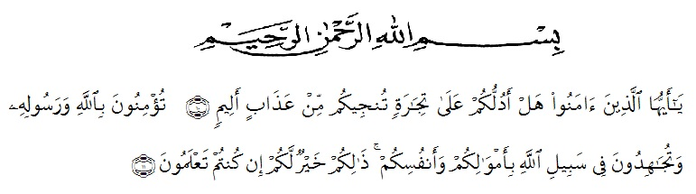

Meaning: "Hai orang-orang yang beriman, maukah kamu aku tujukkan Suatu perniagaan yang dapat menyelamatkan kamu dari azab yang pedih? (10) (Yaitu) kamu beriman kepada Allah dan Rasulnya dan berjihad dijalan Allah dengan harta dan jiwamu. Itulah yang lebih baik jika kamu mengetahui’’. (11) (As-Shaf Ayat 10-11).
Alhamdulillahirabbil’alamin. Firstly, the researcher expresses to ALLAH SWT the Lord of the universe for all blessing, chances and everything given to the researcher could complete this thesis entitled “An Error Analysis in Learning the Simple Present Tense by the 7th Grade Students of SMP Swasta Al Washliyah 27 Medan.” As the fullfillment of the requirement to get Degree of Bachelor of Education in University of Muslim Nusantara Al-Washliyah Medan. Secondly, sholawat and salam always be given to our prophet Muhammad SAW who has guided us from the darkness to the lightness.
The researcher realizes that this thesis would have not been completed without the help, support, contribution from many people. Therefore, the researcher would like express her deepest gratitude and appreciation to:
- Dr.KRT. H. Hardi Mulyono K. Surbakti., as the Rector of Universitas Muslim Nusantara Al Washliyah Medan.
- Drs. Samsul Bahri, M.Si., as the dean of faculty of Teacher Training and Education of Universitas Muslim Nusantara Al-Washliyah Medan.
- Zulfitri, SS.,MA., as the Head Department of English Education who has given knowledge and information.
- Yulia Sari Harahap, S.Pd.,M.Hum, as the adviser who has given guidance, advice, corrections, help and support the researcher during process of writing this thesis.
- All lecturers of the English Education for teaching precious knowledge, sharing philosophy of live and giving wonderful experience.
- All of the academic administration staff of Universitas Muslim Nusantara Al Washliyah Medan.
- Rasimah, S.Pd, as the Headmaster of SMP Swasta Al Washliyah 27 Medan for given permission to conduct the research.
- Her beloved parents, Alm. Legimin A.R, Rosmawati. Sisters and brother, Nurlaili, Sri Wahyunensih, Asdelina Lubis S,Ag, and Nazaruddin, for their endless love, support, continuous prayer and everything that will never be forgotten.
- Her husband, M. Hasanuddin Siregar. Who has always supported her financially and morally, patience, continuous prayer, material and motivation during her academic years at FKIP UMN Al Washliyah Medan.
- Her “Eager’s Squad”, Indah Eka Destry, Risma Yanti and Nur hasanah Batubara. Adorable friends Azaniah Suhartini, Nurul Annisa Khaidir, Raisa Maulia Abdul, Ismul Al Abud S.Pd, and Adry Arizona. Thank you for giving support, motivation, help and for our togetherness and all beautiful memories.
- All classmates of English Department Class O 2017.
The last but not least, researcher would like to say thanks to anyone whom cannot be mentioned one by one, it does not mean the researcher forget about you, but researcher deepest appreciation is dedicated for all of you.
The researcher realized that this thesis is still far from being perfect. Therefore, the researcher hopes constructive critics and suggestion will be highly appreciated much. May Allah SWT always give guidance and blessing to us. Aamiin Ya Rabbal Alaamiin.

Medan, July 2021
The Researcher

Siti Rohana

