APPENDIX I
Test 1

Name :
Class :
Study :
Task 1
- Please create an inquiry business letter by your own words! (Don’t cheating!)

APPENDIX II
Test 2

Name :
Class :
Study :
Task 2
- Please Create an inquiry business letter by following the interuption of digital picture series media! (Don’t Cheating)

APPENDIX III
The resut of task 1
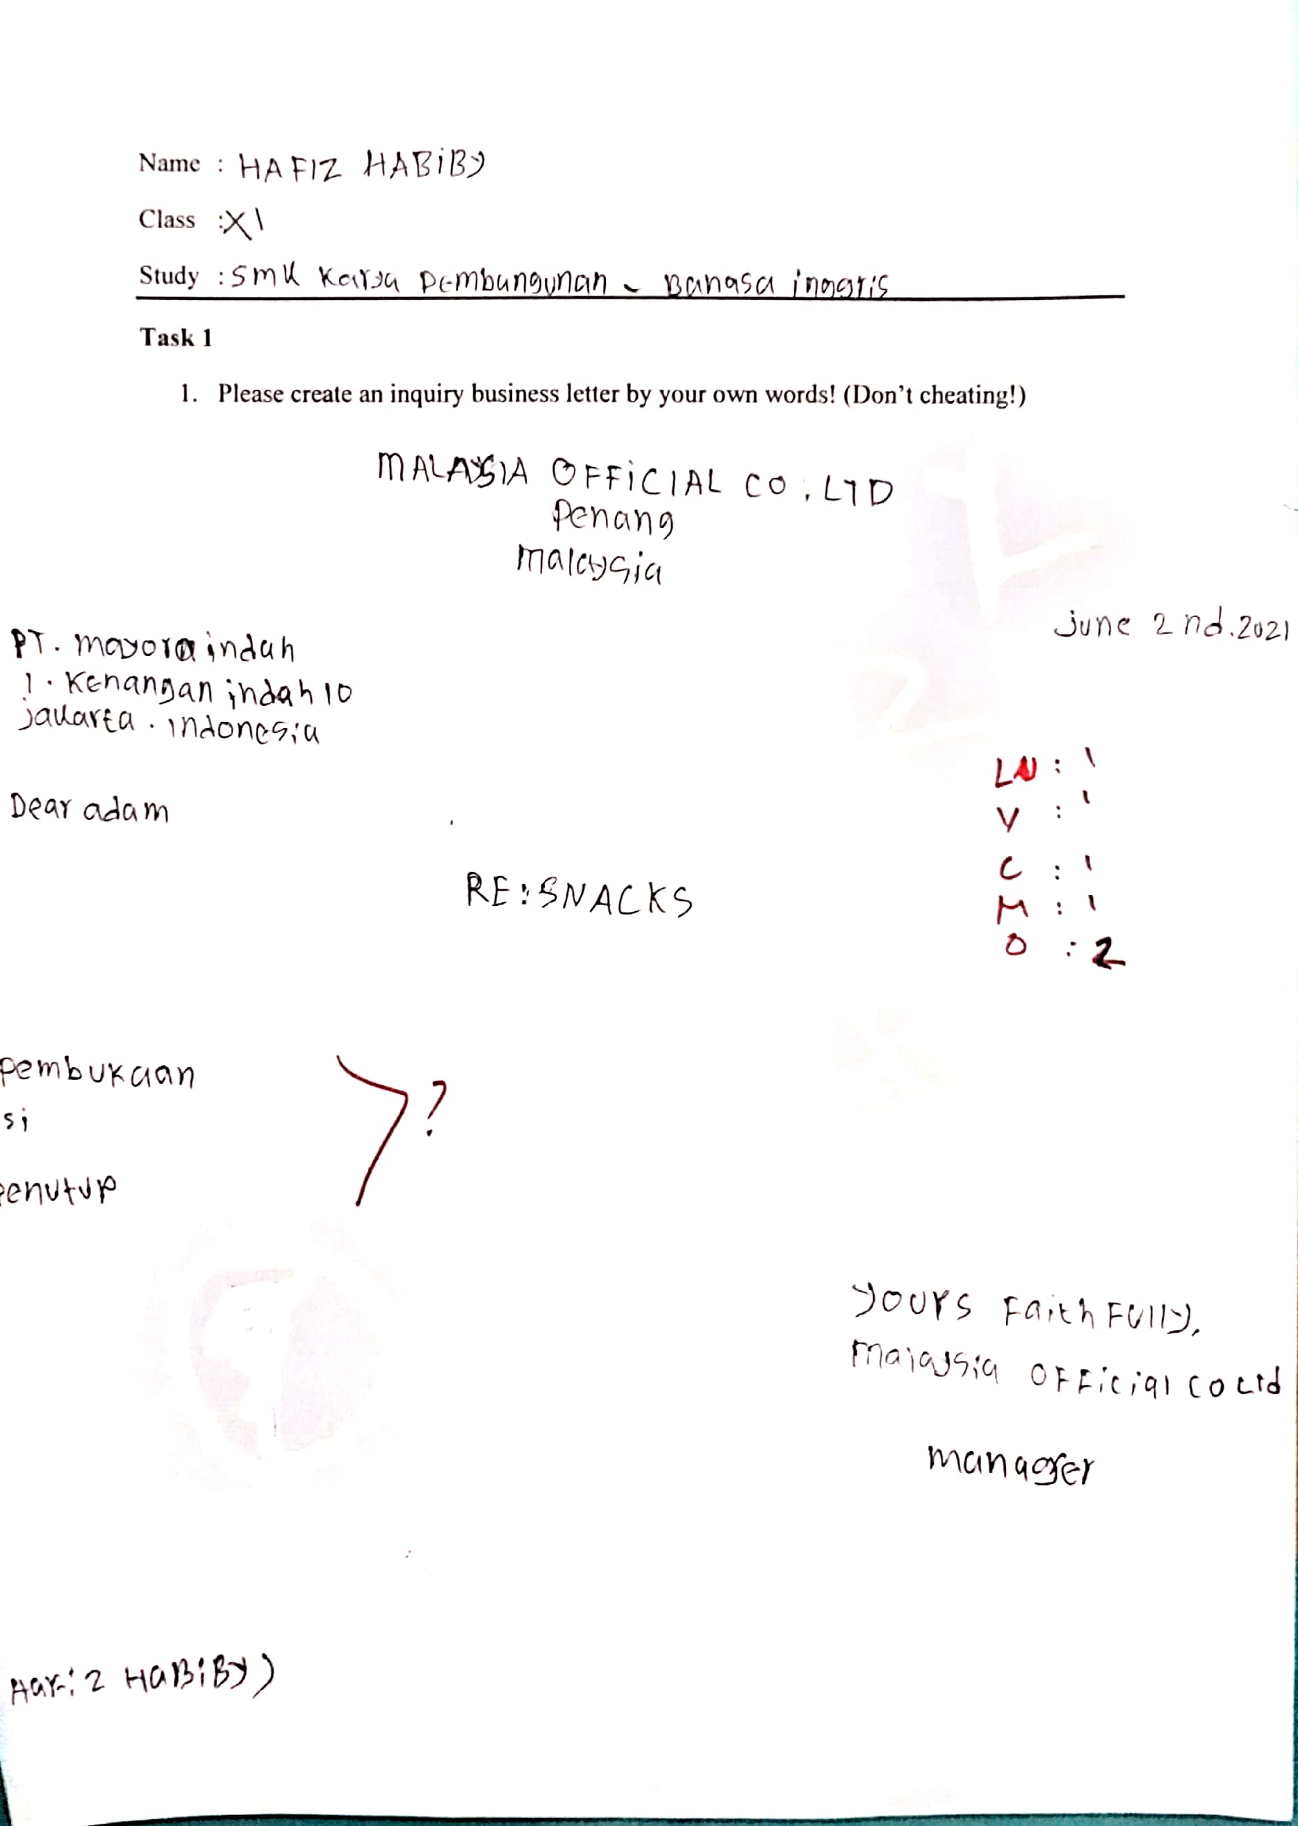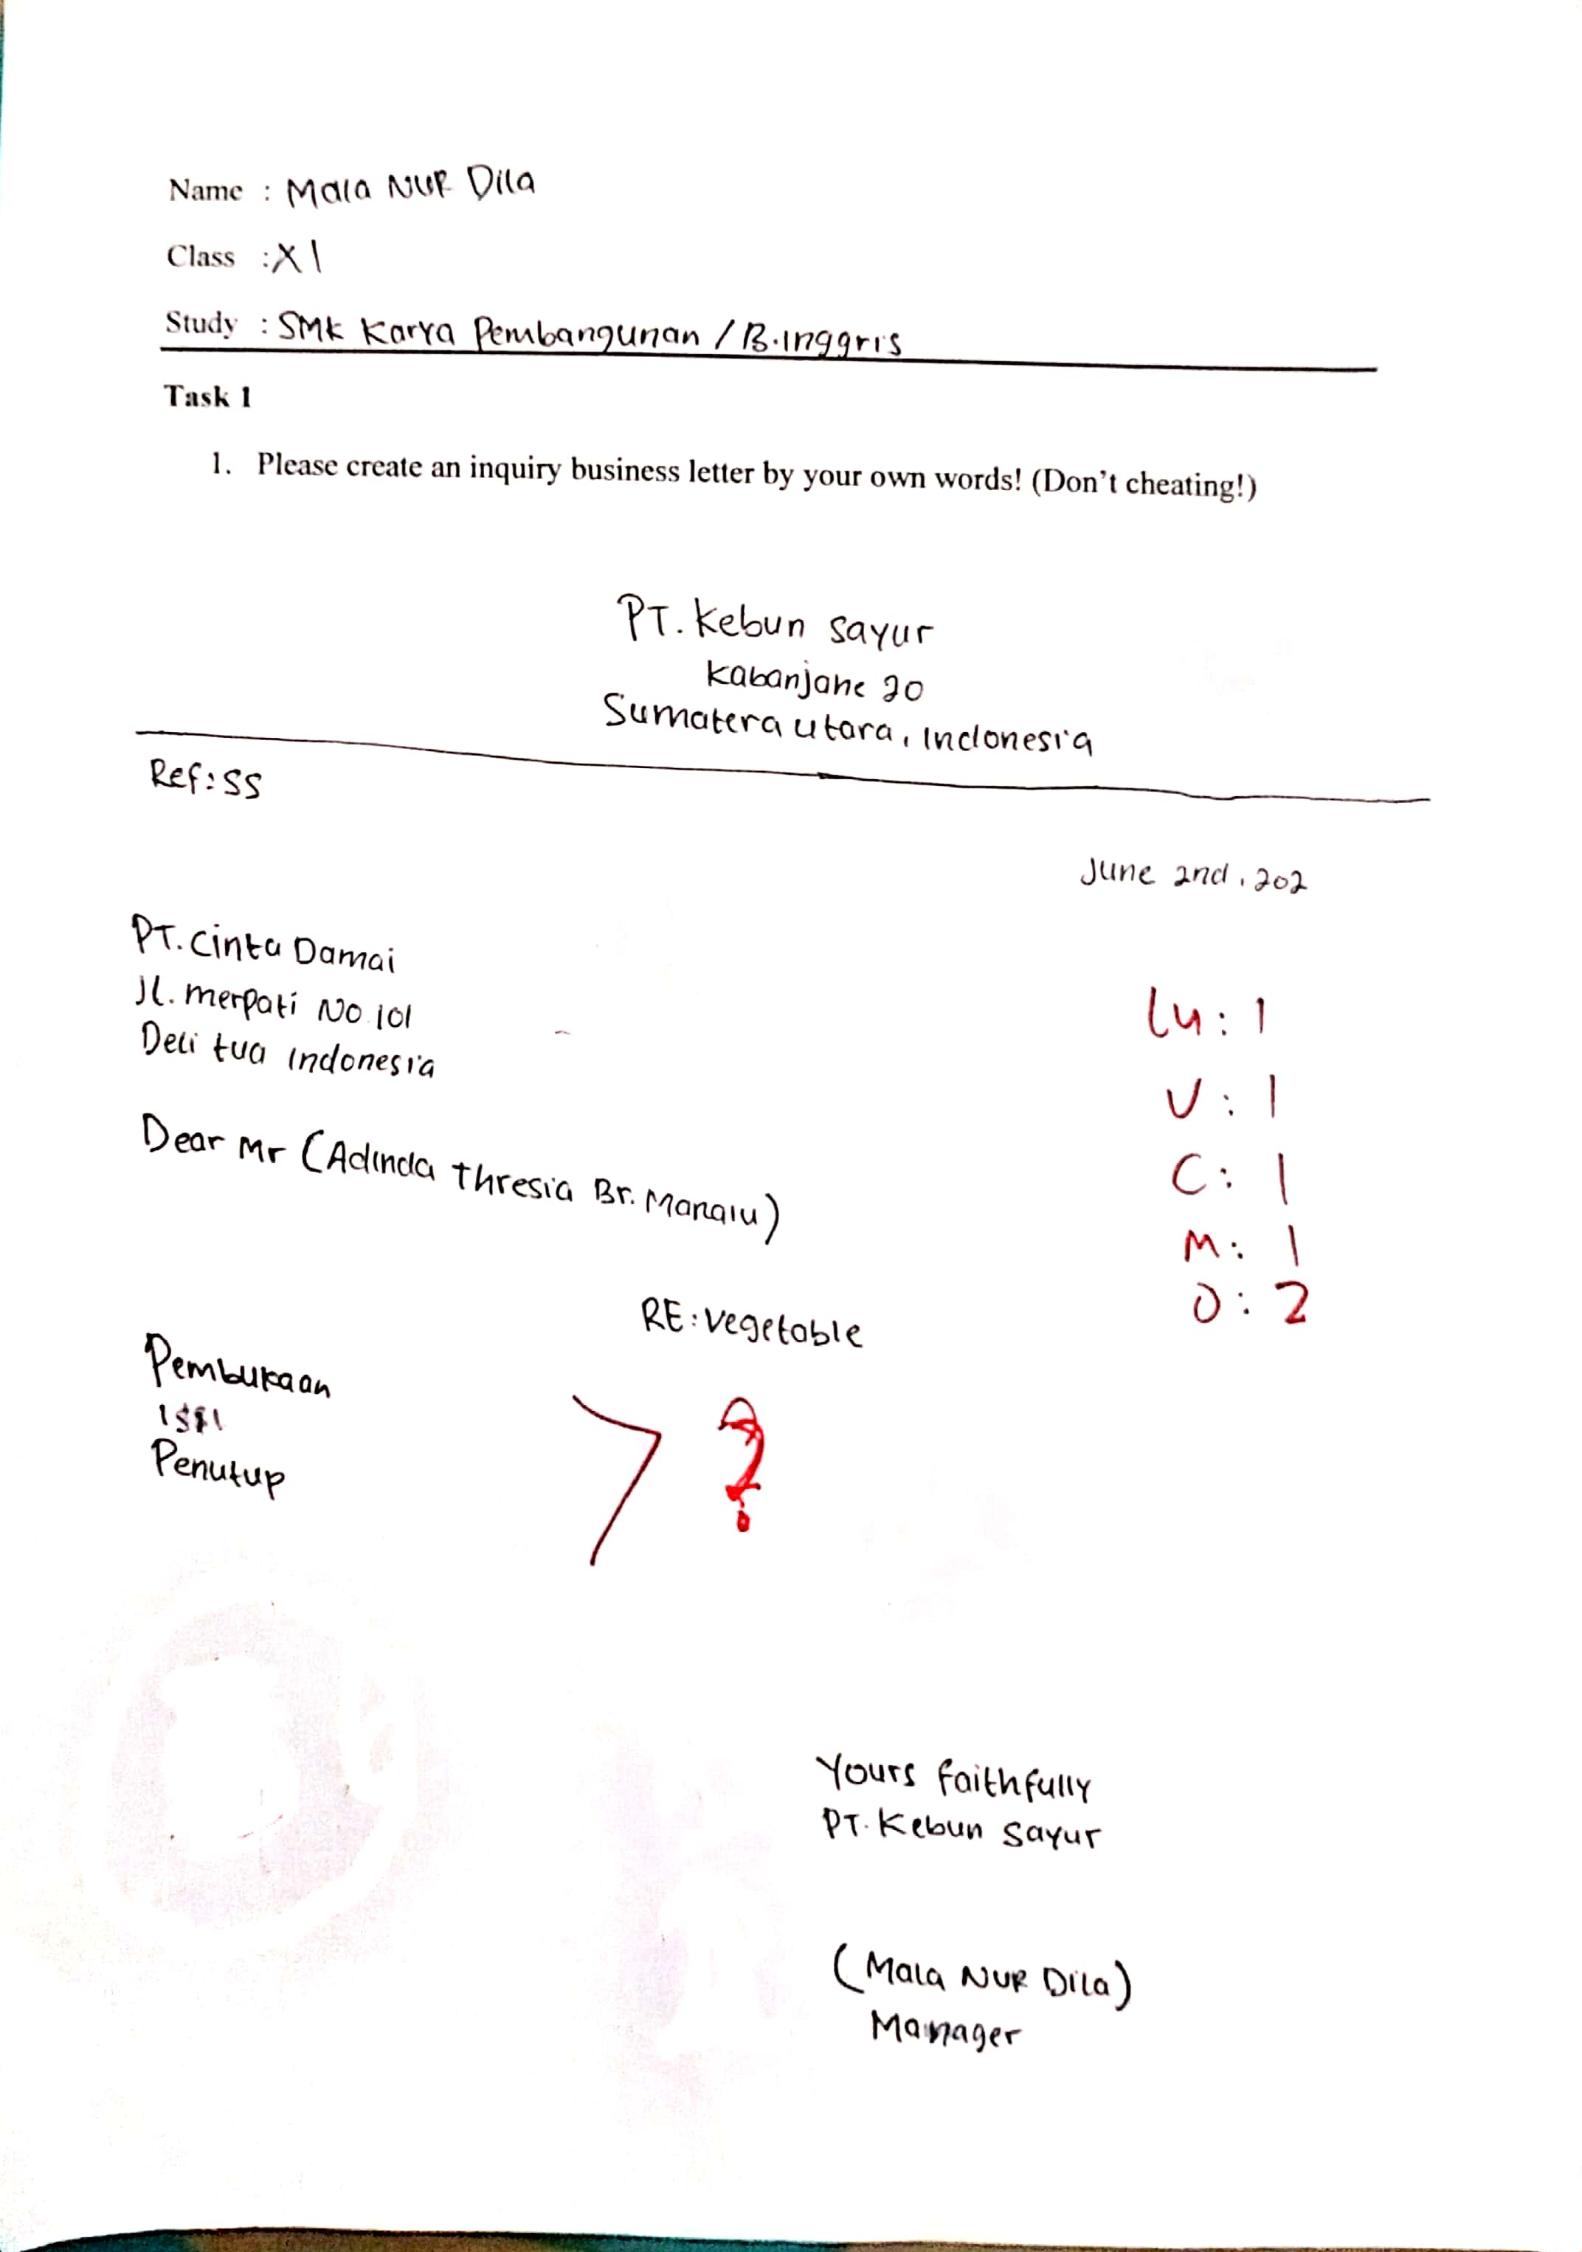

APPENDIX IV
The result of task 2
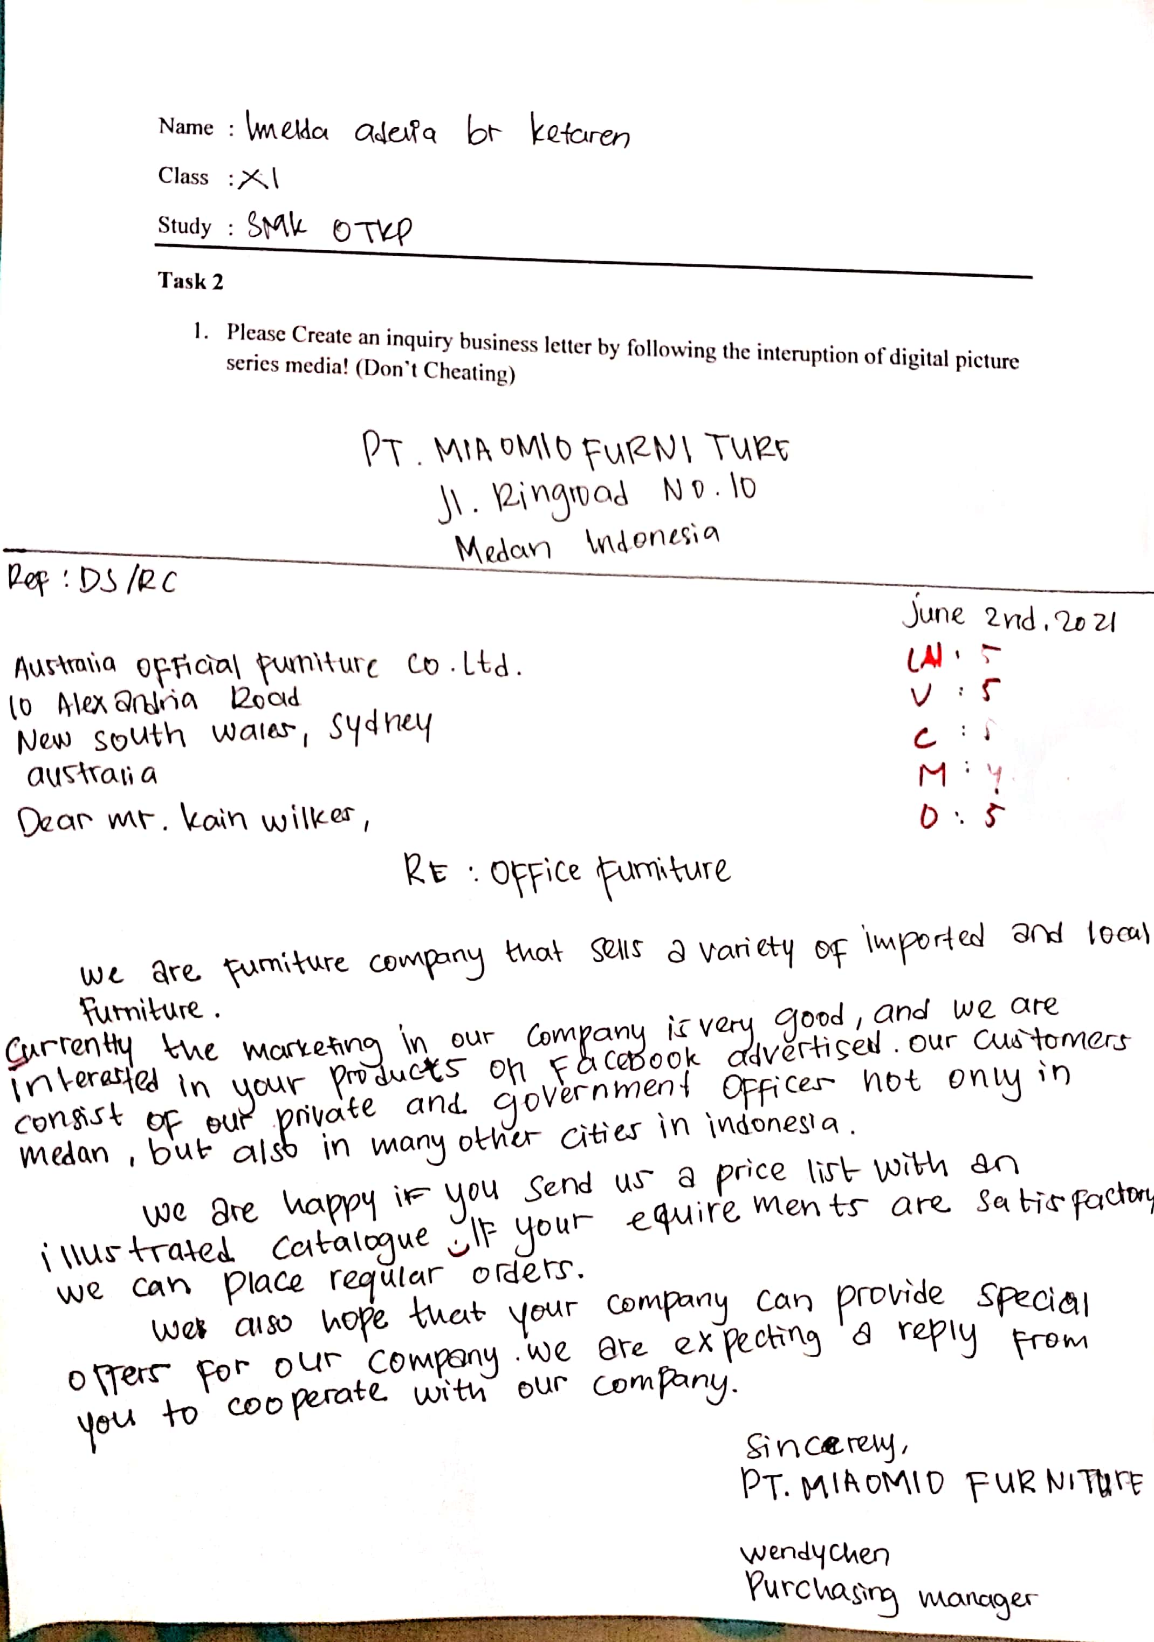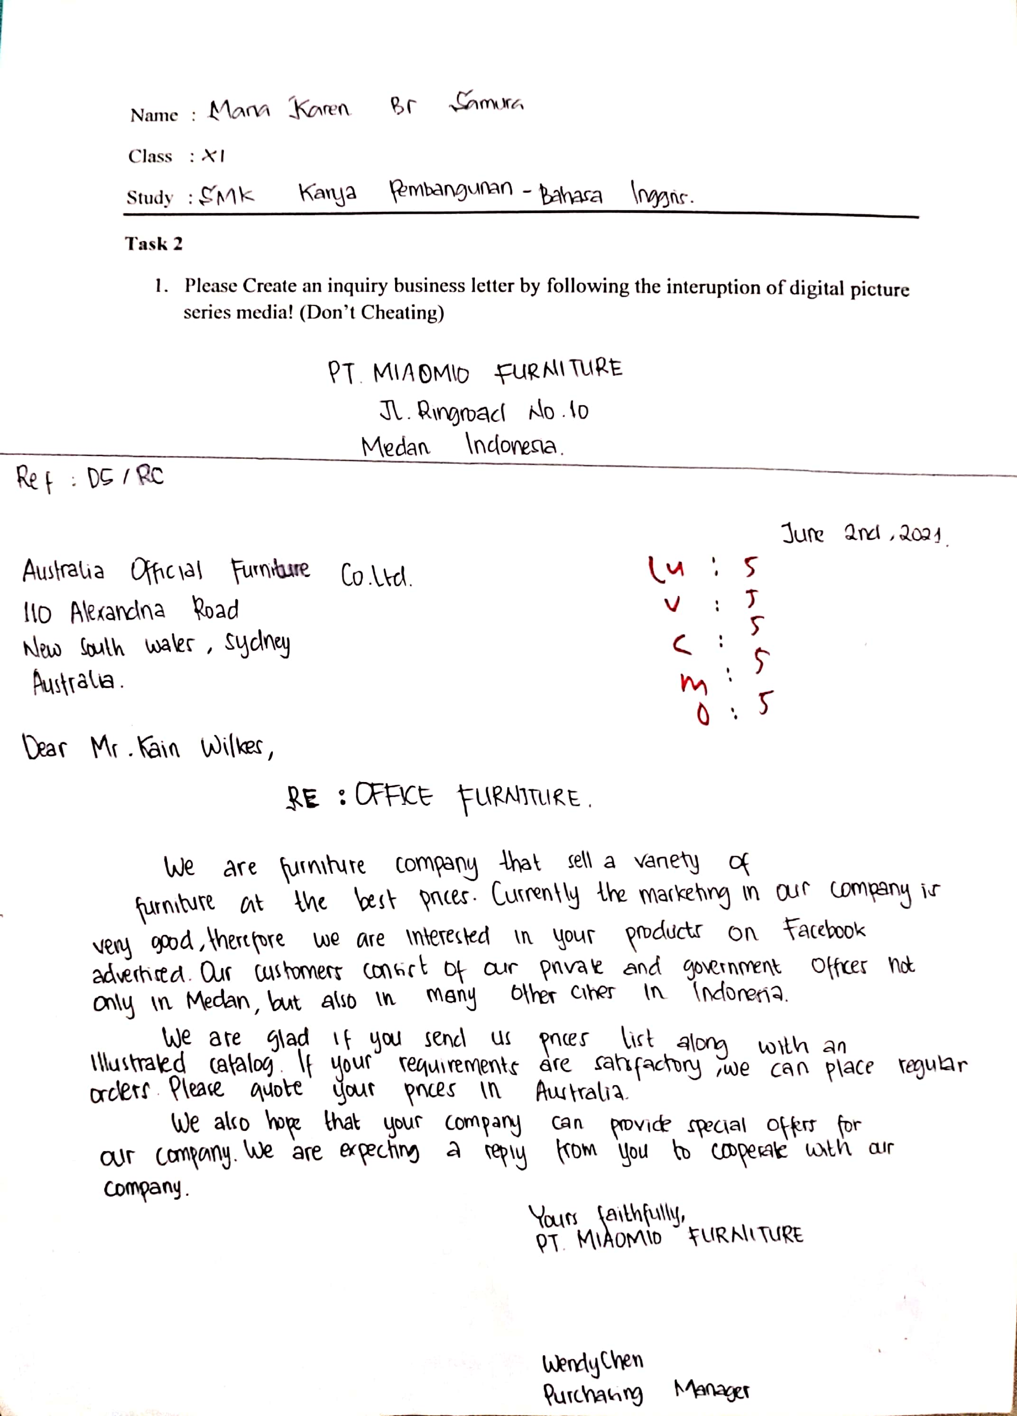
APPENDIX V
The Raw Score Of The Students Before Using Digital Picture Series
No | Students | Indicator |  |  |  |  | Total Task Score | Percentage
 |  | C | O | V | LU | M
1 | ATM | 1 | 2 | 1 | 1 | 1 | 6 | 24%
2 | IAK | 2 | 3 | 3 | 3 | 1 | 12 | 48%
3 | AS | 2 | 1 | 3 | 3 | 1 | 10 | 40%
4 | EPP | 2 | 1 | 2 | 3 | 1 | 9 | 36%
5 | AT | 1 | 2 | 1 | 1 | 1 | 6 | 24%
6 | MN | 1 | 2 | 1 | 1 | 1 | 6 | 24%
7 | NMA | 1 | 2 | 1 | 1 | 1 | 6 | 24%
8 | MKS | 2 | 3 | 3 | 3 | 2 | 13 | 52%
9 | AW | 1 | 2 | 1 | 1 | 1 | 6 | 24%
10 | SB | 1 | 2 | 1 | 1 | 1 | 6 | 24%
11 | HH | 1 | 2 | 1 | 1 | 1 | 6 | 24%
12 | ALG | 1 | 2 | 1 | 1 | 1 | 6 | 24%
Total Students Score |  |  |  |  |  |  |  | 1,046
Mean |  |  |  |  |  |  |  | 87.16

APPENDIX VI
The Raw Score Of The Students After Using Digital Picture Series
NO | STUDENTS | TASK I | TASK II | ATTENTION | RESPONSE | RESULT | EXP
 |  | TASK SCORE | TASK SCORE
1 | ATM | 24 | 88 | B | B | Excelent | Able
2 | IAK | 48 | 96 | A | B | Excelent | Able
3 | AS | 40 | 84 | A | B | Excelent | Able
4 | EPP | 36 | 80 | B | B | Excelent | Able
5 | AT | 24 | 92 | A | B | Excelent | Able
6 | MN | 24 | 92 | A | B | Excelent | Able
7 | NMA | 24 | 88 | A | B | Excelent | Able
8 | MKS | 52 | 100 | A | B | Excelent | Able
9 | AW | 24 | 84 | A | B | Excelent | Able
10 | SB | 24 | 80 | B | B | Excelent | Able
11 | HH | 24 | 76 | B | C | Good | Able
12 | ALG | 24 | 88 | B | B | Excelent | Able

APPENDIX VII
Observation sheet of evaluation students

 | Initial | Observation |  | Explanation
 |  | Attention | Response
1 | ATM | B | B | The Student focus with the material and follow the researcher instructions
2 | IAK | A | B | The Student focus with the material and follow the researcher instructions
3 | AS | A | A | The Student focus with the material, follow the researcher instructions, and also ask a question
4 | EPP | B | B | The Student focus with the material and follow the researcher instructions
5 | AT | A | B | The Student focus with the material and follow the researcher instructions
6 | MN | A | B | The Student focus with the material and follow the researcher instructions
7 | NMA | A | A | The Student focus with the material,follow the researcher instructions, and also ask a question
8 | MKS | A | B | The Student focus with the material and follow the researcher instructions
9 | AW | A | B | The Student focus with the material and follow the researcher instructions
10 | SB | B | C | The student do not focus while study and do not care with the material
11 | HH | B | B | The Student focus with the material and follow the researcher instructions
12 | ALG | B | B | The Student focus with the material and follow the researcher instructions

APPENDIX VIII
Documentation
